EXP 25: Create a SQL storage service and perform a basic query using any Public Cloud Service Provider (Azure/GCP/AWS) to demonstrate Database as a Service (DaaS) using Azure.

AIM: To create a SQL storage service and perform a basic query using any Public Cloud Service Provider (Azure/GCP/AWS) to demonstrate Database as a Service (DaaS) using Azure.

PROCEDURE:

STEP 1: GO TO AZURE AND GO TO SQLDATABASE. STEP 2: NOW CREATE A SQL DATABASE.

STEP 3: SELECT THE RESOURCE GROUP AND ENTER THE SERVERNAME THAT APPLICABLE.

STEP 4: IN NETWORKING SELECT ALLOW AZURE SERVICES AND RESOURCES TO ACCESS THIS SERVER.

STEP 5: IN ADDITIONAL SETTINGS SELECT SAMPLE. STEP 6:AND THE SQL DATABASE IS DEPLOYED

STEP 7: NOW GO TO QUERY EDITOR.

STEP 8:NOW AGAIN LOGIN TO THE SQL DATADATABASE

STEP 9: OUR TABLES WILL SHOWN AND TYPE THE QUERY TO EXECUTE.

IMPLEMENTATION:

STEP 1: GO TO AZURE AND GO TO SQLDATABASE. STEP 2: NOW CREATE A SQL DATABASE.

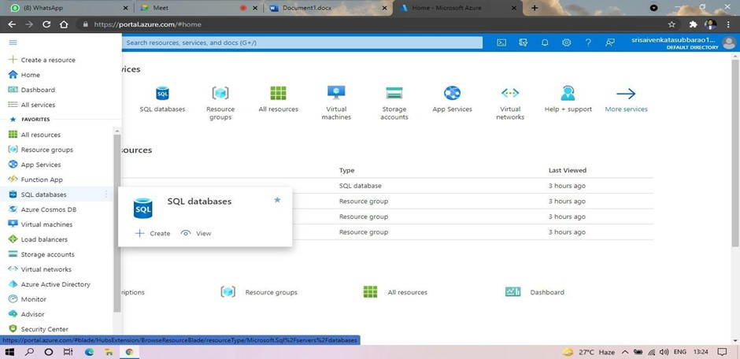

THAT APPLICABLE.

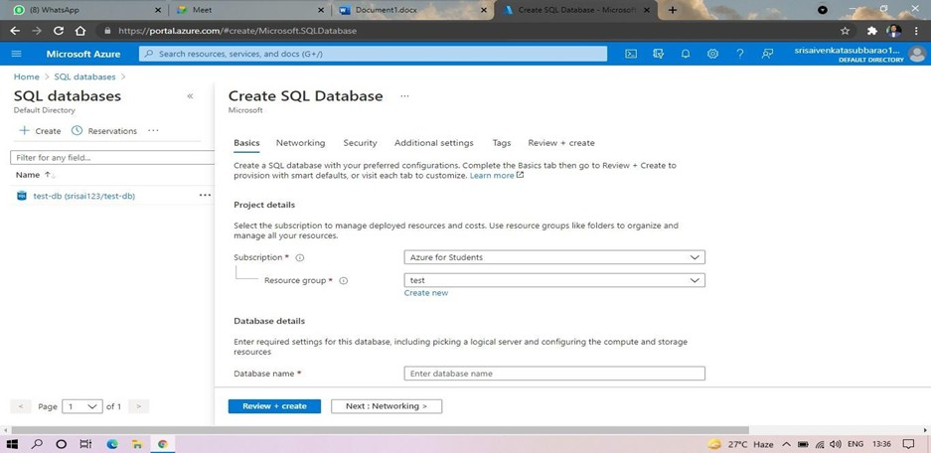

STEP 4: IN NETWORKING SELECT ALLOW AZURE SERVICES AND RESOURCES TO ACCESS THIS SERVER.

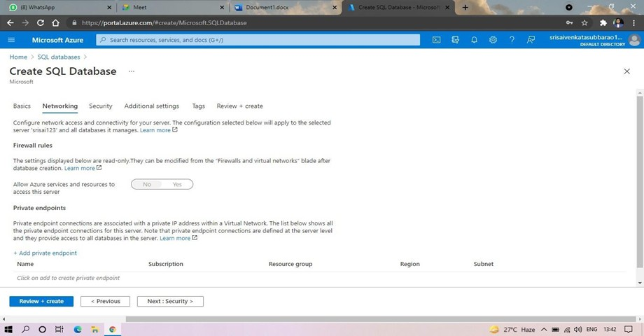

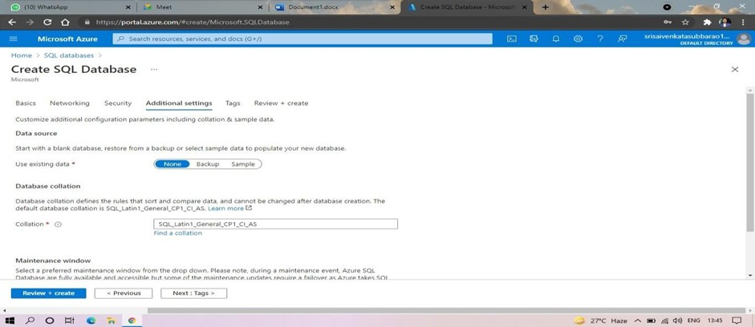

STEP 6: AND THE SQL DATABASE IS DEPLOYED.

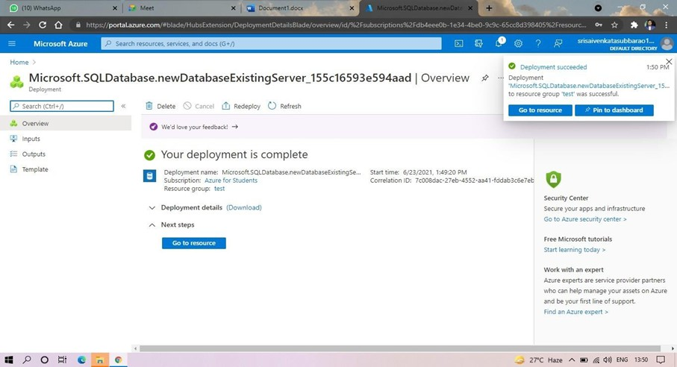

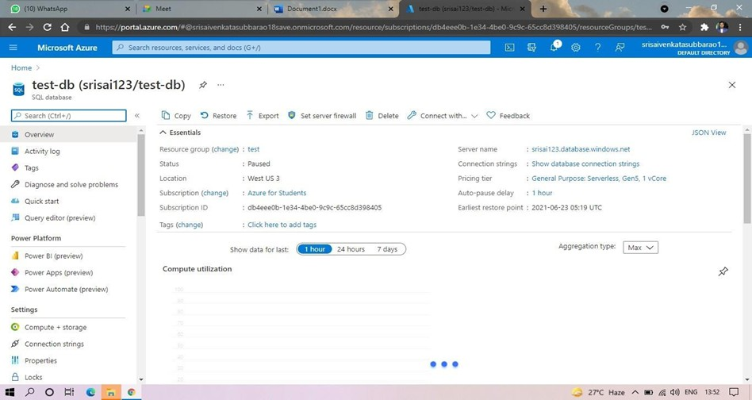

STEP 8: AND NOW AGAIN LOGIN TO THE SQL DATABASE

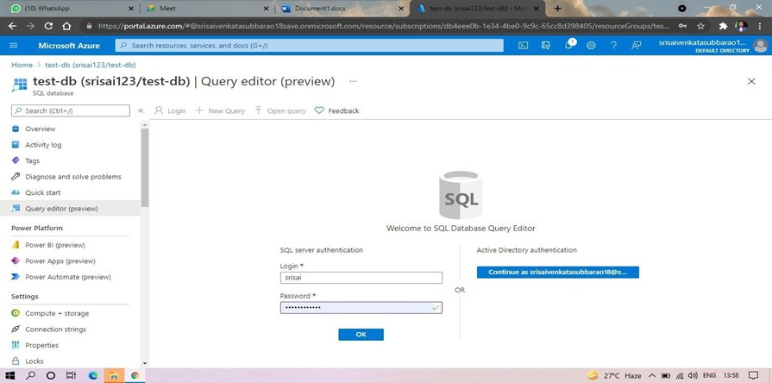

EXECUTE.

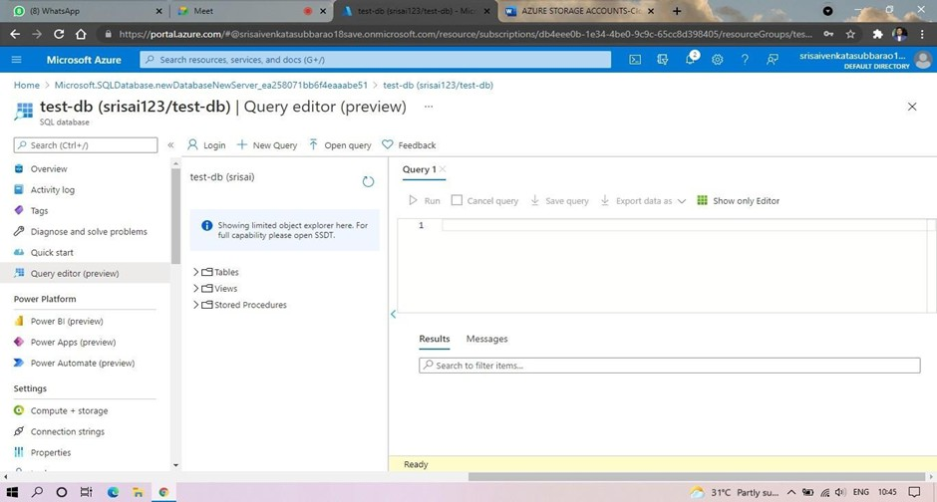

STEP 10: AND OUR OUTPUT IS READY.

