**Exp.3 Property buying and rental**

**Aim:**

To create a simple cloud software application for Property buying and rental system and provide it as a service usingany Cloud Service Provider to demonstrate Software as a Service (SaaS).

**Procedure:**

* Open Zoho Website and Login with your Zoho Account
* Select the Creator app and click on Create Application in the top right.
* Create the application from scratch with an appropriate name.
* Click on “create new form”. If required, choose a template from the available ones. If not, then create your own template.
* Click on “access this application” in the top, then enter data into the form, check if the data is stored properly after entering and saving the forms

**Output:**

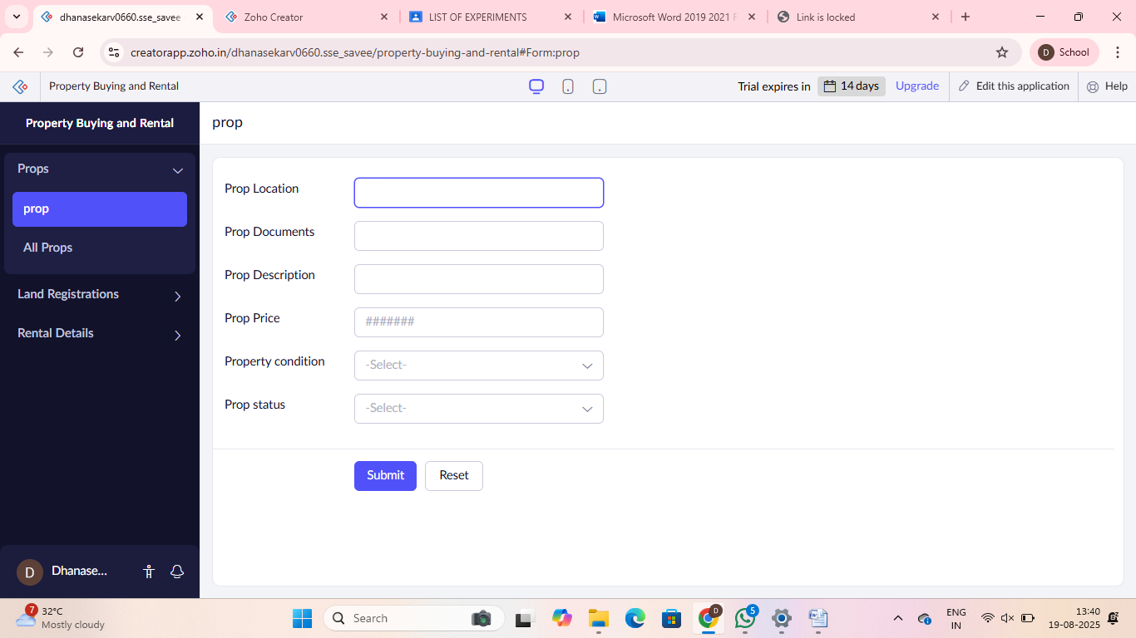

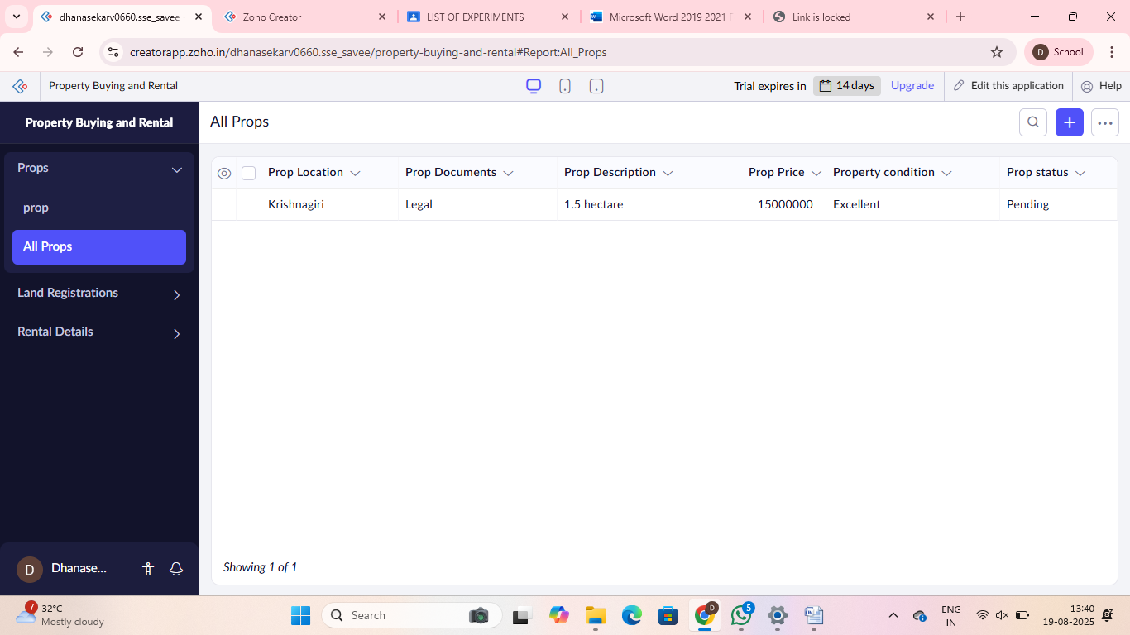

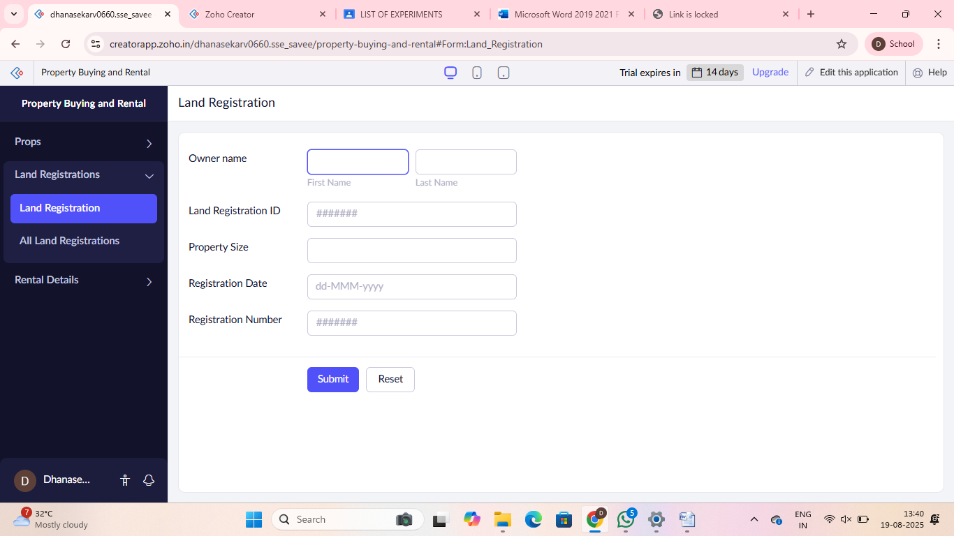

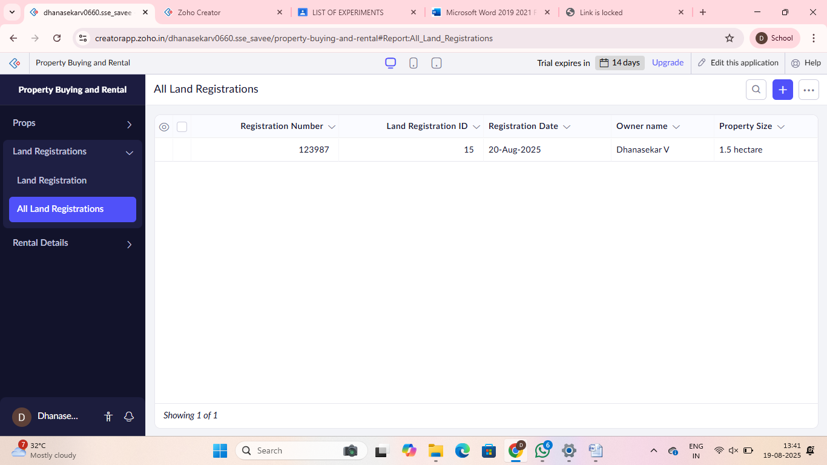

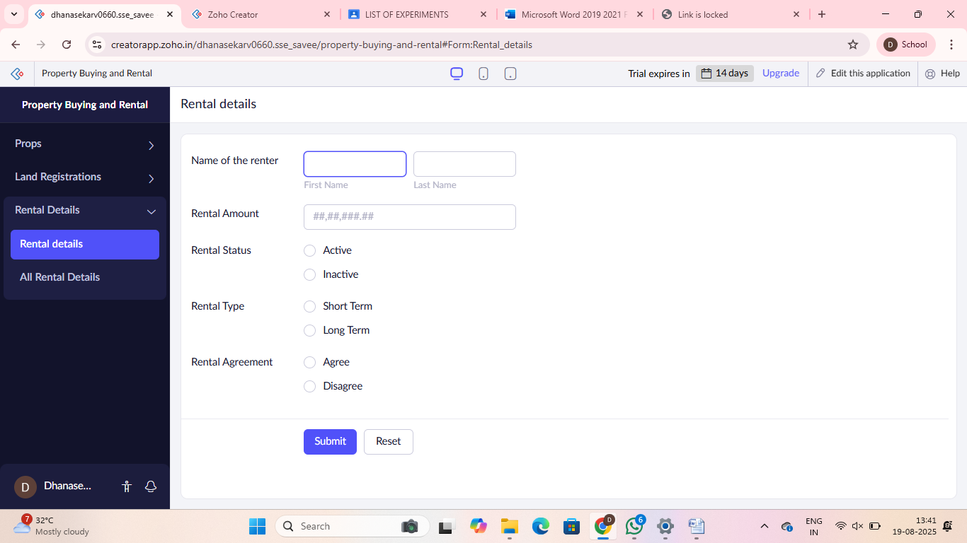

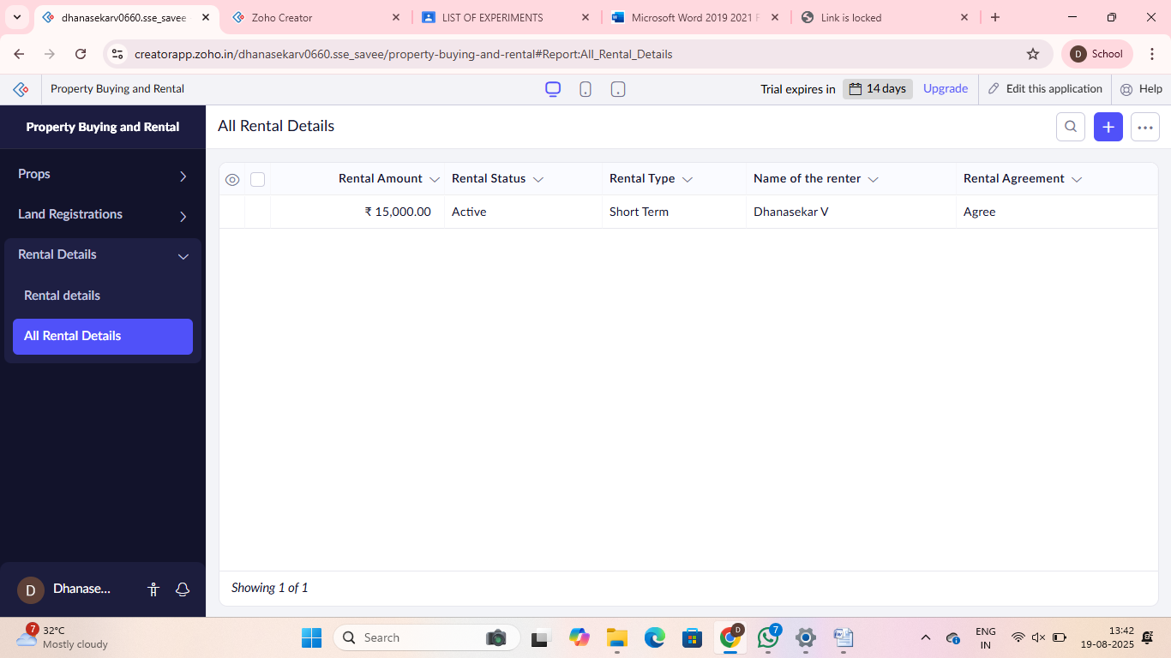

**Result:**

Thus the a cloud software application was created successfully