**CREDIT CARD FRAUD DETECTION USING MACHINE LEARNING**

**OBJECTIVE**

'Fraud' in credit card transactions is unauthorized and unwanted usage of an account by someone other than the owner of that account. Fraud transactions in credit card data transaction are increasing each year. The main objective is to develop novel techniques to detect and prevent such frauds in credit card data transaction.

**ABSTRACT:**

Credit card fraud detection is presently the most frequently occurring problem in the present world. We made an attempt for finding the frauds in the credit card business by using the algorithms which adopted machine learning techniques. We are using Decision Tree, Random Forest and Extreme Gradient boosting algorithms. The efficiency of the model can be decided by using some public data as sample. Then, an actual world credit card facts group from a financial institution is examined. Along with this, some clatter is supplemented to the data samples to auxiliary check the sturdiness of the systems. The significance of the methods used in the paper is the first method constructs a tree against the activities performed by the user and using this tree scams will be suspected. In the second method a user activity based forest will have constructed and using this forest an attempt will be made in identifying the suspect. The investigational outcomes absolutely show that the mainstream elective technique attains decent precision degrees in sensing scam circumstances in credit cards.

**Keywords:** Decision Tree, Random Forest and Extreme Gradient boosting algorithms.

**EXISTING SYSTEM:**

Much research has been done on studying credit card fraud detection. In past people manually detect fraud transactions. But, the entire problem of credit card fraud detection suffers from a problem of Imbalanced data (a very highly imbalanced data). This problem requires us to heavily process the data before training any machine learning model like Random Forest etc.

**Disadvantages:**

* Low accuracy.
* Time consuming.
* High complexities.

**PROPOSED SYSTEM:**

We propose this system to investigate a problem of whether it is valuable or not to use machine learning techniques of Decision Tree, Random Forest and XGBoost has best accuracy to detect whether the credit card is fraud or not fraud using XGBoost.

**Flow Chart:**

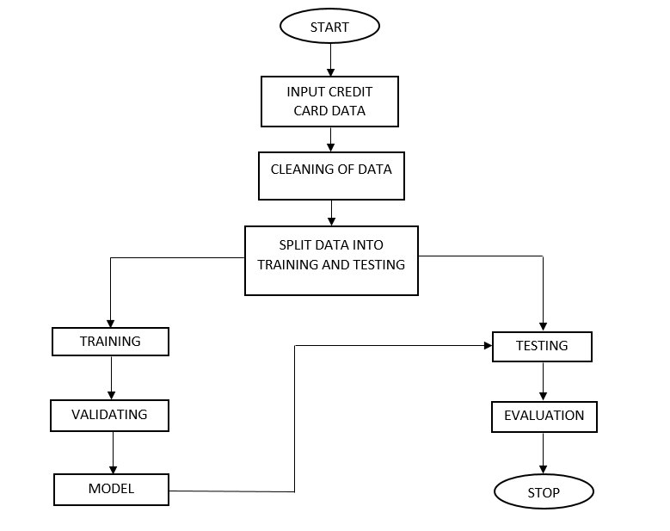

**Fig:** Block Diagram

**Advantages:**

* High accuracy.
* Time Saving.
* Low complexities.
* High reliability.

.

**SOFTWARE AND HARDWARE REQUIREMENTS:**

**Hardware:**

Operating system : Windows 7 or 7+

RAM : 8 GB

Hard disc or SSD : More than 500 GB

Processor : Intel 3rd generation or high or Ryzen with 8 GB Ram

**Software:**

Software’s : Python 3.6 or high version

IDE : PyCharm.

Framework : Flask

**LEARNING OUTCOMES:**

* About Classification in machine learning.
* About preprocessing techniques.
* About Random Forest.
* About Decision Tree.
* About XGBoost.
* Knowledge on PyCharm Editor.