# BYAGARI PAVAN PBL ID: J_251890123

**MINI PROJECT Mile1 Case study**

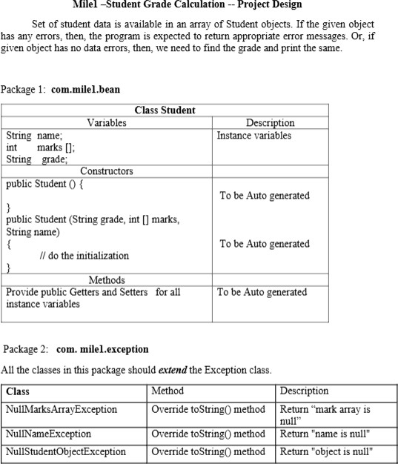

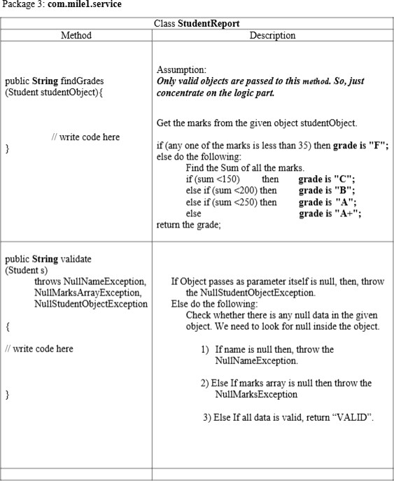

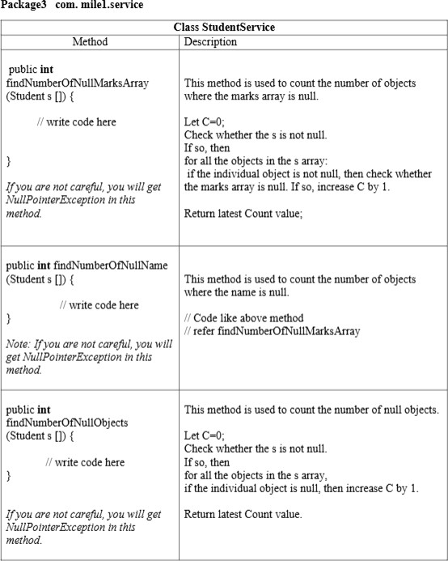

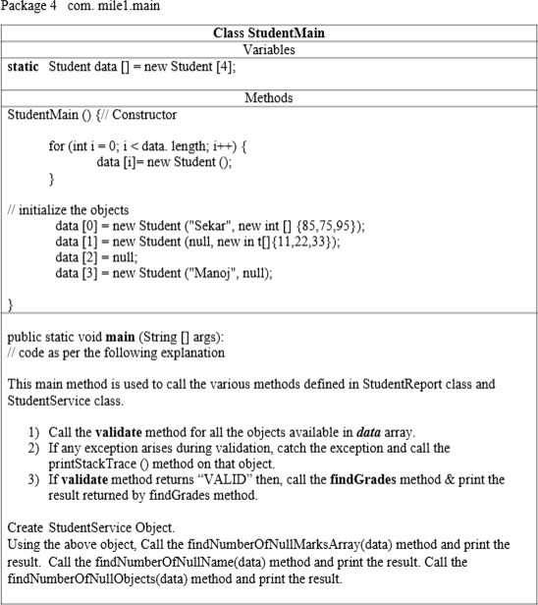

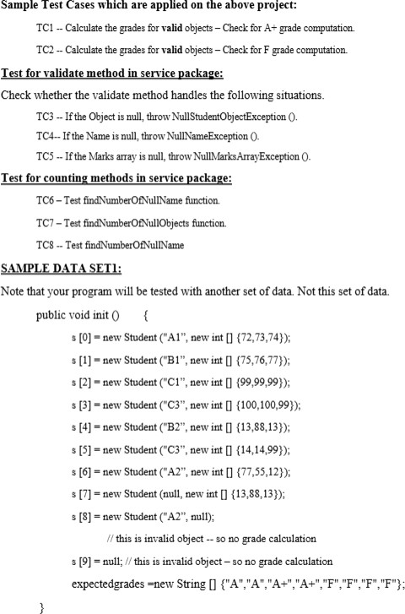

# Package 1: com.milel.bean Student.java

package com.milel.bean;

public class Student {

// Instance variables private String name; private int[] marks; private String grade;

// Default constructor public Student() {}

// Parameterized constructor

public Student(String name, int[] marks) { this.name = name;

this.marks = marks;

}

// Getters C Setters public String getName() {

return name;

}

public void setName(String name) { this.name = name;

}

public int[] getMarks() {

return marks;

}

public void setMarks(int[] marks) { this.marks = marks;

}

public String getGrade() { return grade;

}

public void setGrade(String grade) { this.grade = grade;

}

}

**Package 2: com.milel.exception NullMarksArrayException.java** package com.milel.exception;

public class NullMarksArrayException extends Exception { @Override

public String toString() { return "marks array is null";

}

}

# NullNameException.java

package com.milel.exception;

public class NullNameException extends Exception { @Override

public String toString() { return "name is null";

}

}

# NullStudentObjectException.java

package com.milel.exception;

public class NullStudentObjectException extends Exception { @Override

public String toString() { return "object is null";

}

}

# Package 3: com.milel.service StudentReport.java

package com.milel.service;

import com.milel.bean.Student; import com.milel.exception.*;

public class StudentReport {

// Grade Calculation

public String findGrades(Student studentObject) { int[] marks = studentObject.getMarks();

for (int m : marks) { if (m < 35) {

studentObject.setGrade("F"); return "F";

}

}

int sum = 0;

for (int m : marks) sum += m;

String grade;

if (sum < 150) grade = "C"; else if (sum < 200) grade = "B"; else if (sum < 250) grade = "A"; else grade = "A+";

studentObject.setGrade(grade); return grade;

}

// Validation Method

public String validate(Student s)

throws NullNameException, NullMarksArrayException, NullStudentObjectException {

if (s == null) {

throw new NullStudentObjectException();

}

if (s.getName() == null) {

throw new NullNameException();

}

if (s.getMarks() == null) {

throw new NullMarksArrayException();

}

return "VALID";

}

}

# StudentService.java

package com.milel.service;

import com.milel.bean.Student;

public class StudentService {

// Count null marks arrays

public int findNumberOfNullMarksArray(Student[] s) { int count = 0;

if (s != null) {

for (Student student : s) {

if (student != null CC student.getMarks() == null) { count++;

}

}

}

return count;

}

// Count null names

public int findNumberOfNullName(Student[] s) { int count = 0;

if (s != null) {

for (Student student : s) {

if (student != null CC student.getName() == null) { count++;

}

}

}

return count;

}

// Count null objects

public int findNumberOfNullObjects(Student[] s) { int count = 0;

if (s != null) {

for (Student student : s) { if (student == null) {

count++;

}

}

}

return count;

}

}

# Package 4: com.milel.main StudentMain.java

package com.milel.main;

import com.milel.bean.Student; import com.milel.exception.*;

import com.milel.service.StudentReport; import com.milel.service.StudentService;

public class StudentMain {

static Student data[] = new Student[4];

// Constructor

public StudentMain() {

for (int i = 0; i < data.length; i++) { data[i] = new Student();

}

// Initialize objects

data[0] = new Student("Sekar", new int[]{85, 75, 95}); data[1] = new Student(null, new int[]{11, 22, 33}); data[2] = null;

data[3] = new Student("Manoj", null);

}

public static void main(String[] args) { new StudentMain(); // initialize data

StudentReport report = new StudentReport();

for (int i = 0; i < data.length; i++) { try {

String validation = report.validate(data[i]); if (validation.equals("VALID")) {

String grade = report.findGrades(data[i]);

System.out.println("Grade of " + data[i].getName() + " : " +

grade);

}

} catch (Exception e) { e.printStackTrace();

}

}

// Service methods

StudentService service = new StudentService();

System.out.println("Number of objects with null marks array: " + service.findNumberOfNullMarksArray(data));

System.out.println("Number of objects with null names: " + service.findNumberOfNullName(data));

System.out.println("Number of null objects: " + service.findNumberOfNullObjects(data));

}

}

# Sample Expected Output

Grade of Sekar : A+

com.milel.exception.NullNameException: name is null at ...

com.milel.exception.NullStudentObjectException: object is null at ...

com.milel.exception.NullMarksArrayException: marks array is null at ...

Number of objects with null marks array: 1 Number of objects with null names: 1 Number of null objects: 1