**B PAVAN PBL ID: J_251890123**

**OOPS CONCEPTS**

**Mini-project**

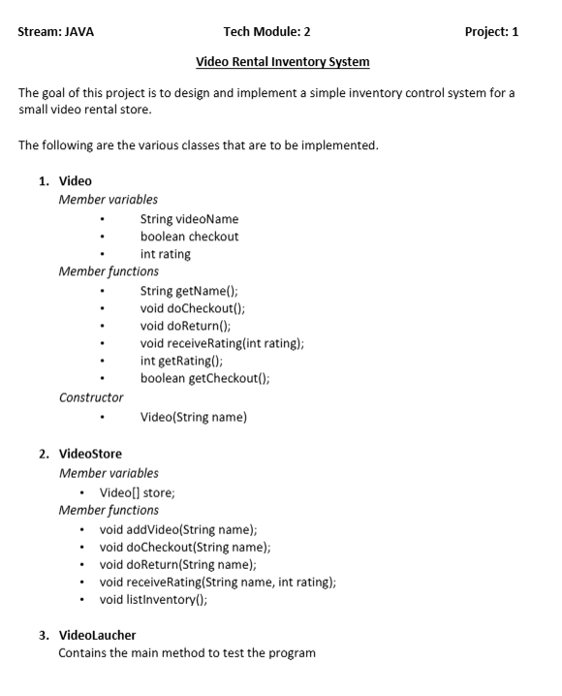

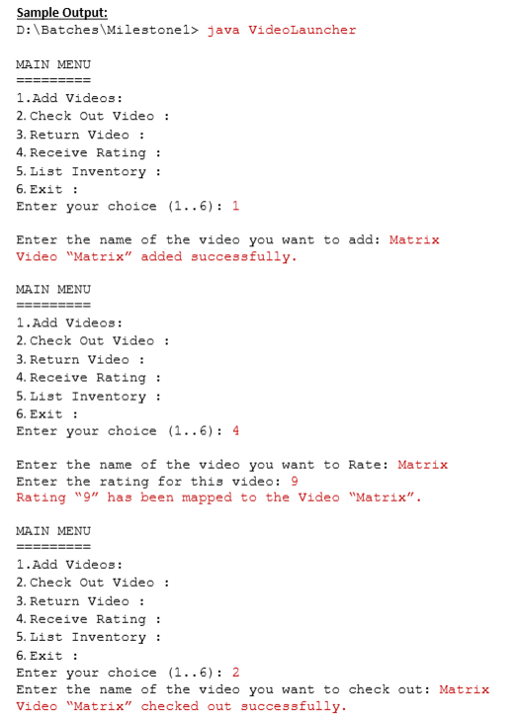

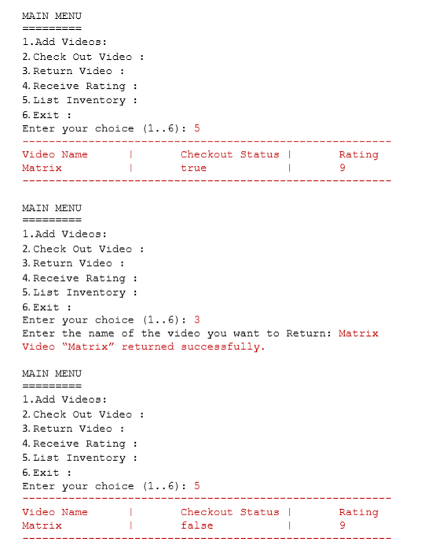

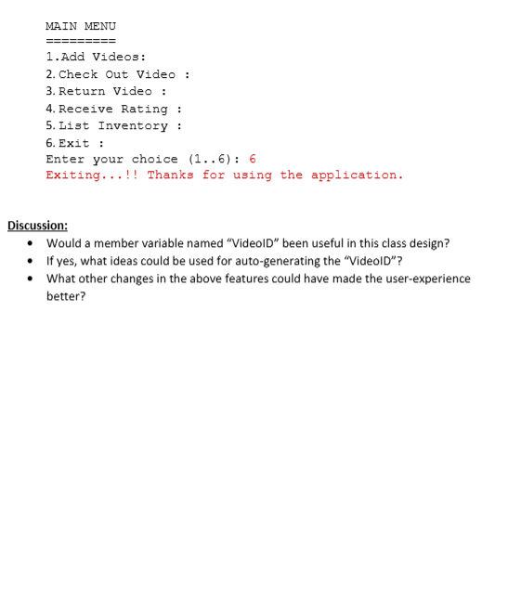

import java.util.Scanner;

// Video class

class Video {

String videoName;

boolean checkout;

int rating;

public Video(String name) {

this.videoName = name;

this.checkout = false;

this.rating = 0;

}

public String getName() {

return videoName;

}

public void doCheckout() {

checkout = true;

}

public void doReturn() {

checkout = false;

}

public void receiveRating(int rating) {

this.rating = rating;

}

public boolean getCheckout() {

return checkout;

}

public int getRating() {

return rating;

}

}

// VideoStore class

class VideoStore {

Video[] store = new Video[10];

int count = 0;

public void addVideo(String name) {

store[count] = new Video(name);

count++;

System.out.println("Video \"" + name + "\" added successfully.");

}

public void doCheckout(String name) {

for (int i = 0; i < count; i++) {

if (store[i].getName().equalsIgnoreCase(name)) {

store[i].doCheckout();

System.out.println("Video \"" + name + "\" checked out successfully.");

return;

}

}

System.out.println("Video not found.");

}

public void doReturn(String name) {

for (int i = 0; i < count; i++) {

if (store[i].getName().equalsIgnoreCase(name)) {

store[i].doReturn();

System.out.println("Video \"" + name + "\" returned successfully.");

return;

}

}

System.out.println("Video not found.");

}

public void receiveRating(String name, int rating) {

for (int i = 0; i < count; i++) {

if (store[i].getName().equalsIgnoreCase(name)) {

store[i].receiveRating(rating);

System.out.println("Rating \"" + rating + "\" has been mapped to the Video \"" + name + "\".");

return;

}

}

System.out.println("Video not found.");

}

public void listInventory() {

System.out.println("-----------------------------------------------------------");

System.out.println("Video Name\t|\tCheckout Status\t|\tRating");

for (int i = 0; i < count; i++) {

System.out.println(store[i].getName() + "\t|\t" + store[i].getCheckout() + "\t\t|\t" + store[i].getRating());

}

System.out.println("-----------------------------------------------------------");

}

}

// VideoLauncher class (main program)

public class VideoLauncher {

public static void main(String[] args) {

Scanner sc = new Scanner(System.in);

VideoStore store = new VideoStore();

while (true) {

System.out.println("\nMAIN MENU");

System.out.println("1. Add Videos :");

System.out.println("2. Check Out Video :");

System.out.println("3. Return Video :");

System.out.println("4. Receive Rating :");

System.out.println("5. List Inventory :");

System.out.println("6. Exit :");

System.out.print("Enter your choice (1..6): ");

int choice = sc.nextInt();

sc.nextLine();

switch (choice) {

case 1:

System.out.print("Enter the name of the video you want to add: ");

String name = sc.nextLine();

store.addVideo(name);

break;

case 2:

System.out.print("Enter the name of the video you want to check out: ");

name = sc.nextLine();

store.doCheckout(name);

break;

case 3:

System.out.print("Enter the name of the video you want to return: ");

name = sc.nextLine();

store.doReturn(name);

break;

case 4:

System.out.print("Enter the name of the video you want to Rate: ");

name = sc.nextLine();

System.out.print("Enter the rating for this video: ");

int rating = sc.nextInt();

store.receiveRating(name, rating);

break;

case 5:

store.listInventory();

break;

case 6:

System.out.println("Exiting...!! Thanks for using the application.");

sc.close();

return;

default:

System.out.println("Invalid choice! Please select between 1 to 6.");

}

}

}

}