# MINI PROJECT

**JUNIT**

**BYAGARI PAVAN**

**PBL_ID: J_251890123**

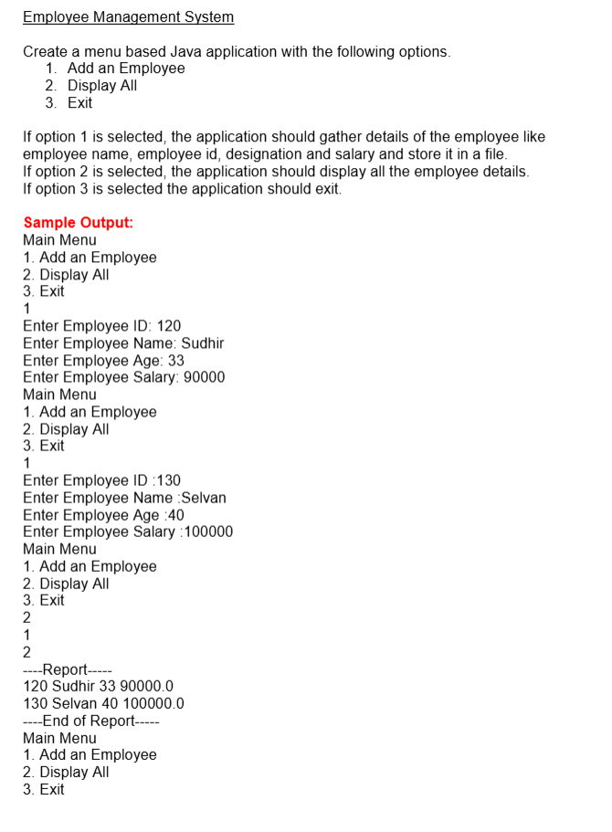

**Program:**

**package** com.ioStream.miniProject;

**import** java.io.*;

**import** java.util.*;

**class** Employee **implements** Serializable {

**int** id;

String name;

**int** age;

**double** salary;

**public** Employee(**int** id, String name, **int** age, **double** salary) {

**this**.id = id;

**this**.name = name;

**this**.age = age;

**this**.salary = salary;

}

@Override

**public** String toString() {

**return** id + " " + name + " " + age + " " + salary;

}

}

**public** **class** EmployeeManagementSystem {

**private** **static** **final** String ***FILE_NAME*** = "employees.dat";

**public** **static** **void** main(String[] args) {

Scanner sc = **new** Scanner(System.***in***);

List<Employee> employeeList = *loadEmployees*();

**while** (**true**) {

System.***out***.println("Main Menu");

System.***out***.println("1. Add an Employee");

System.***out***.println("2. Display All");

System.***out***.println("3. Exit");

System.***out***.print("Enter your choice: ");

**int** choice = sc.nextInt();

sc.nextLine(); // consume newline

**switch** (choice) {

**case** 1:

*addEmployee*(sc, employeeList);

*saveEmployees*(employeeList);

**break**;

**case** 2:

*displayEmployees*(employeeList);

**break**;

**case** 3:

System.***out***.println("Exiting...");

sc.close();

System.*exit*(0);

**default**:

System.***out***.println("Invalid choice. Try again.");

}

}

}

**private** **static** **void** addEmployee(Scanner sc, List<Employee> employeeList) {

System.***out***.print("Enter Employee ID: ");

**int** id = sc.nextInt();

sc.nextLine();

System.***out***.print("Enter Employee Name: ");

String name = sc.nextLine();

System.***out***.print("Enter Employee Age: ");

**int** age = sc.nextInt();

System.***out***.print("Enter Employee Salary: ");

**double** salary = sc.nextDouble();

Employee emp = **new** Employee(id, name, age, salary);

employeeList.add(emp);

System.***out***.println("Employee added successfully.\n");

}

**private** **static** **void** displayEmployees(List<Employee> employeeList) {

System.***out***.println("----Report-----");

**for** (Employee emp : employeeList) {

System.***out***.println(emp);

}

System.***out***.println("----End of Report-----");

}

**private** **static** **void** saveEmployees(List<Employee> employeeList) {

**try** (ObjectOutputStream oos = **new** ObjectOutputStream(**new** FileOutputStream(***FILE_NAME***))) {

oos.writeObject(employeeList);

} **catch** (IOException e) {

System.***out***.println("Error saving employees: " + e.getMessage());

}

}

@SuppressWarnings("unchecked")

**private** **static** List<Employee> loadEmployees() {

File file = **new** File(***FILE_NAME***);

**if** (!file.exists()) {

**return** **new** ArrayList<>();

}

**try** (ObjectInputStream ois = **new** ObjectInputStream(**new** FileInputStream(***FILE_NAME***))) {

**return** (List<Employee>) ois.readObject();

} **catch** (IOException | ClassNotFoundException e) {

System.***out***.println("Error loading employees: " + e.getMessage());

**return** **new** ArrayList<>();

}

}

}

**OUTPUT:-**

