**BYAGARI PAVAN PBL ID: J_251890123**

Object Serialization

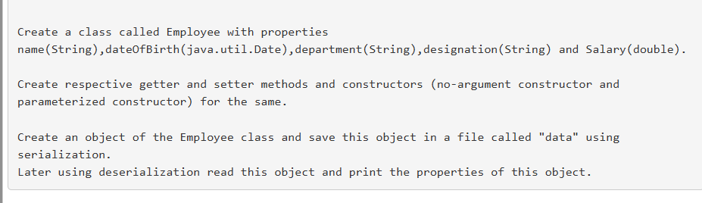

# Code:-

import java.io.*;

import java.util.*;

class Employee implements Serializable {

private String name;

private Date dateOfBirth;

private String department;

private String designation;

private double salary;

public Employee() {}

public Employee(String name, Date dateOfBirth, String department, String designation, double salary) {

this.name = name;

this.dateOfBirth = dateOfBirth;

this.department = department;

this.designation = designation;

this.salary = salary;

}

public String getName() { return name; }

public Date getDateOfBirth() { return dateOfBirth; }

public String getDepartment() { return department; }

public String getDesignation() { return designation; }

public double getSalary() { return salary; }

}

public class EmployeeSerialization {

public static void main(String[] args) {

try {

Employee emp = new Employee("Anitha", new GregorianCalendar(1995, Calendar.AUGUST, 22).getTime(), "HR", "Manager", 75000);

ObjectOutputStream oos = new ObjectOutputStream(new FileOutputStream("data"));

oos.writeObject(emp);

oos.close();

ObjectInputStream ois = new ObjectInputStream(new FileInputStream("data"));

Employee e = (Employee) ois.readObject();

ois.close();

System.out.println("Employee Details:");

System.out.println("Name: " + e.getName());

System.out.println("DOB: " + e.getDateOfBirth());

System.out.println("Department: " + e.getDepartment());

System.out.println("Designation: " + e.getDesignation());

System.out.println("Salary: " + e.getSalary());

} catch (Exception ex) {

ex.printStackTrace();

}

}

}

# Output:-

Employee Details:

Name: Anitha

DOB: Tue Aug 22 00:00:00 IST 1995

Department: HR

Designation: Manager

Salary: 75000.0