**BYAGARI PAVAN PBL ID: J_251890123**

I/O Operations

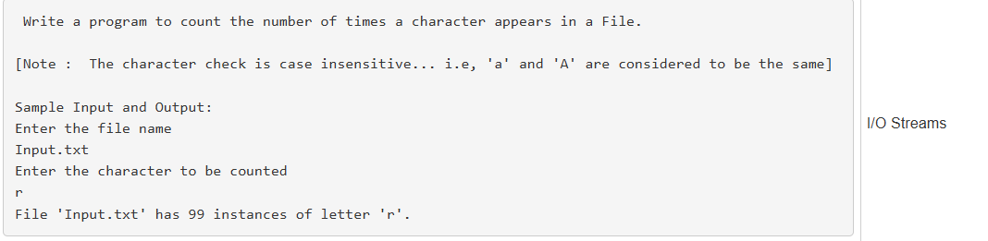

# Code:-

import java.io.*;

import java.util.Scanner;

public class Main {

public static void main(String[] args) {

Scanner sc = new Scanner(System.in);

try {

System.out.println("Enter the file name");

String fileName = sc.nextLine();

System.out.println("Enter the character to be counted");

char ch = sc.nextLine().charAt(0);

int count = 0;

FileInputStream fis = new FileInputStream(fileName);

int c;

while ((c = fis.read()) != -1) {

if (Character.toLowerCase((char) c) == Character.toLowerCase(ch)) {

count++;

}

}

fis.close();

System.out.println("File '" + fileName + "' has " + count + " instances of letter '" + ch + "'.");

} catch (IOException e) {

System.out.println("Error: " + e.getMessage());

}

}

}

# Output:-

Enter the file name

Input.txt

Enter the character to be counted

r

File 'Input.txt' has 99 instances of letter 'r'.

# 

# Code:-

# import java.io.*;

# import java.util.Scanner;

# public class FileCopy {

# public static void main(String[] args) {

# Scanner sc = new Scanner(System.in);

# try {

# System.out.println("Enter the input file name");

# String inputFile = sc.nextLine();

# System.out.println("Enter the output file name");

# String outputFile = sc.nextLine();

# FileInputStream fis = new FileInputStream(inputFile);

# FileOutputStream fos = new FileOutputStream(outputFile);

# int ch;

# while ((ch = fis.read()) != -1) {

# fos.write(ch);

# }

# fis.close();

# fos.close();

# System.out.println("File is copied.");

# } catch (Exception e) {

# System.out.println("Error: " + e.getMessage());

# }

# }

}

# Output:-

Enter the input file name

Input.txt

Enter the output file name

Output.txt

File is copied.

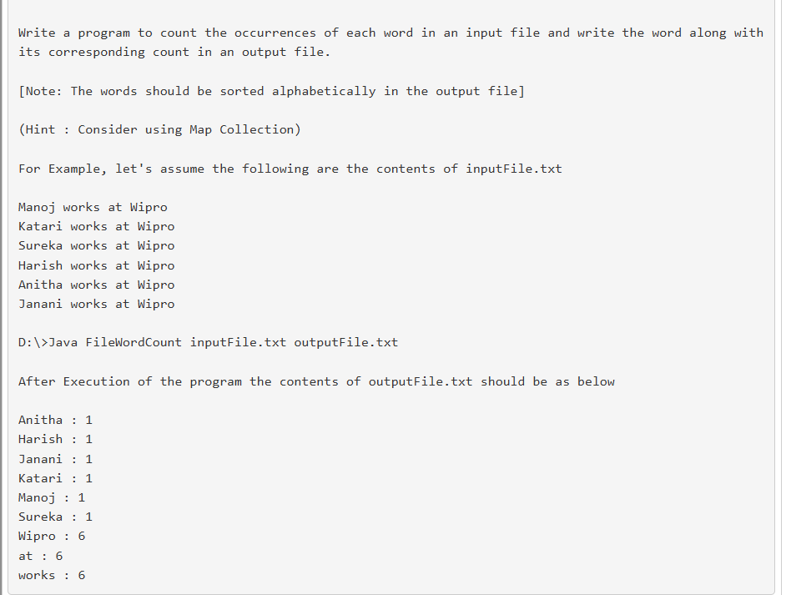

# Code:-

import java.io.*;

import java.util.*;

public class FileWordCount {

public static void main(String[] args) throws Exception {

if (args.length < 2) {

System.out.println("Usage: java FileWordCount inputFile.txt outputFile.txt");

return;

}

String inputFile = args[0];

String outputFile = args[1];

BufferedReader br = new BufferedReader(new FileReader(inputFile));

Map<String, Integer> wordCount = new TreeMap<>(String.CASE_INSENSITIVE_ORDER);

String line;

while ((line = br.readLine()) != null) {

String[] words = line.split("\\s+");

for (String word : words) {

word = word.replaceAll("[^a-zA-Z]", "");

if (!word.isEmpty()) {

wordCount.put(word, wordCount.getOrDefault(word, 0) + 1);

}

}

}

br.close();

BufferedWriter bw = new BufferedWriter(new FileWriter(outputFile));

for (Map.Entry<String, Integer> entry : wordCount.entrySet()) {

bw.write(entry.getKey() + ": " + entry.getValue());

bw.newLine();

}

bw.close();

System.out.println("Word count written to " + outputFile);

}

}

**Input:-**

**inputFile.txt:-**

Manoj works at Wipro

Katari works at Wipro

Sureka works at Wipro

Harish works at Wipro

Anitha works at Wipro

Janani works at Wipro

**Output:-**

**OutputFile.txt:-**

Anitha: 1

at: 6

Harish: 1

Janani: 1

Katari: 1

Manoj: 1

Sureka: 1

Wipro: 6

works: 6