# MINI PROJECT

**JUNIT**

**BYAGARI PAVAN**

**PBL_ID: J_251890123**

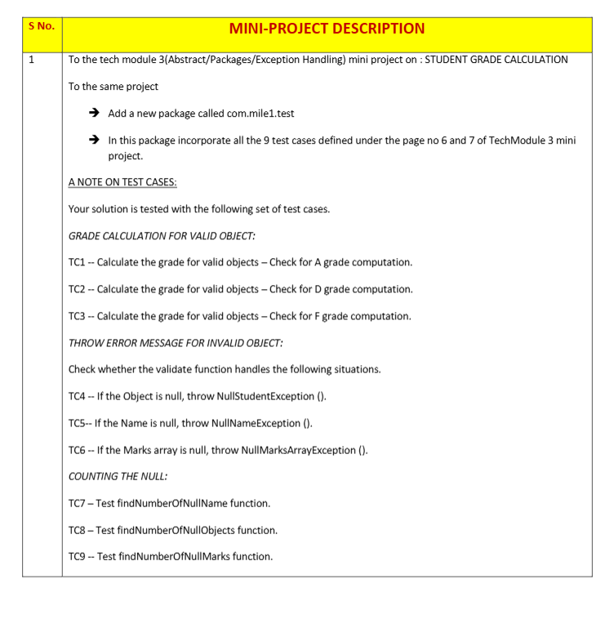

**Program:**

* Add a new package com.mile1.test.
* Implement 9 test cases:
  + **Grade Calculation for Valid Object**
    - TC1: Check A grade
    - TC2: Check D grade
    - TC3: Check F grade
  + **Throw Error Message for Invalid Object**
    - TC4: Null Object → NullStudentException
    - TC5: Null Name → NullNameException
    - TC6: Null Marks Array → NullMarksArrayException
  + **Counting Null**
    - TC7: findNumberOfNullName()
    - TC8: findNumberOfNullObjects()
    - TC9: findNumberOfNullMarks()

I will give you a **complete Java code structure** with:

✔ Student class  
✔ Custom Exceptions  
✔ Utility classes (StudentReport, StudentService)  
✔ Test cases in com.mile1.test

**✅ 1. Create Student.java**

package com.mile1.bean;

public class Student {

private String name;

private int[] marks;

public Student() {}

public Student(String name, int[] marks) {

this.name = name;

this.marks = marks;

}

public String getName() {

return name;

}

public void setName(String name) {

this.name = name;

}

public int[] getMarks() {

return marks;

}

public void setMarks(int[] marks) {

this.marks = marks;

}

}

**✅ 2. Create Custom Exceptions**

NullStudentException.java

package com.mile1.exception;

public class NullStudentException extends Exception {

public NullStudentException(String message) {

super(message);

}

}

NullNameException.java

package com.mile1.exception;

public class NullNameException extends Exception {

public NullNameException(String message) {

super(message);

}

}

NullMarksArrayException.java

package com.mile1.exception;

public class NullMarksArrayException extends Exception {

public NullMarksArrayException(String message) {

super(message);

}

}

**✅ 3. Create StudentReport.java (Grade Calculation)**

package com.mile1.service;

import com.mile1.bean.Student;

public class StudentReport {

public String findGrade(Student student) {

int[] marks = student.getMarks();

int sum = 0;

for (int mark : marks) {

if (mark < 35) {

return "F";

}

sum += mark;

}

int avg = sum / marks.length;

if (avg >= 80) return "A";

else if (avg >= 60) return "B";

else if (avg >= 50) return "C";

else if (avg >= 35) return "D";

else return "F";

}

}

**✅ 4. Create StudentService.java (Validation & Null Count)**

package com.mile1.service;

import com.mile1.bean.Student;

import com.mile1.exception.*;

public class StudentService {

public boolean validate(Student student) throws NullStudentException, NullNameException, NullMarksArrayException {

if (student == null) throw new NullStudentException("Object is null");

if (student.getName() == null) throw new NullNameException("Name is null");

if (student.getMarks() == null) throw new NullMarksArrayException("Marks array is null");

return true;

}

public int findNumberOfNullName(Student[] students) {

int count = 0;

for (Student s : students) {

if (s != null && s.getName() == null) count++;

}

return count;

}

public int findNumberOfNullObjects(Student[] students) {

int count = 0;

for (Student s : students) {

if (s == null) count++;

}

return count;

}

public int findNumberOfNullMarks(Student[] students) {

int count = 0;

for (Student s : students) {

if (s != null && s.getMarks() == null) count++;

}

return count;

}

}

**✅ 5. Test Cases in com.mile1.test (Main class)**

package com.mile1.test;

import com.mile1.bean.Student;

import com.mile1.exception.*;

import com.mile1.service.*;

public class MainClass {

public static void main(String[] args) {

Student[] students = new Student[9];

students[0] = new Student("John", new int[]{85, 90, 80}); // A grade

students[1] = new Student("Mike", new int[]{35, 40, 38}); // D grade

students[2] = new Student("Lucy", new int[]{30, 25, 28}); // F grade

students[3] = null;

students[4] = new Student(null, new int[]{50, 50, 50}); // Null name

students[5] = new Student("Sam", null); // Null marks

students[6] = new Student("Anne", new int[]{70, 72, 68});

students[7] = null;

students[8] = new Student("Tom", new int[]{90, 92, 88});

StudentReport report = new StudentReport();

StudentService service = new StudentService();

System.out.println("=== Test Cases ===");

// TC1, TC2, TC3

System.out.println("Grade of John: " + report.findGrade(students[0])); // A

System.out.println("Grade of Mike: " + report.findGrade(students[1])); // D

System.out.println("Grade of Lucy: " + report.findGrade(students[2])); // F

// TC4, TC5, TC6

try {

service.validate(students[3]);

} catch (Exception e) {

System.out.println("TC4: " + e.getMessage());

}

try {

service.validate(students[4]);

} catch (Exception e) {

System.out.println("TC5: " + e.getMessage());

}

try {

service.validate(students[5]);

} catch (Exception e) {

System.out.println("TC6: " + e.getMessage());

}

// TC7, TC8, TC9

System.out.println("TC7 Null Names: " + service.findNumberOfNullName(students));

System.out.println("TC8 Null Objects: " + service.findNumberOfNullObjects(students));

System.out.println("TC9 Null Marks: " + service.findNumberOfNullMarks(students));

}

}

OUTPUT:-

