Evaluating a Parameter-Free Quantum Fidelity Kernel for Text Security Under Representation and Domain Shift
Anonymous Authors
Formal Academic Research Manuscript • Archival Preprint Version (Exp 47)
📌 Abstract
Quantum kernel methods have attracted substantial interest for natural language processing and cybersecurity, motivated by theoretical conjectures that mapping classical data into exponentially large Hilbert spaces could yield superior non-linear decision boundaries or enhanced generalization under distribution shift. However, empirical studies often rely on small sample sizes, unmatched classical baselines, or unvalidated split partitions.
In this work, we present a controlled empirical evaluation examining an unparameterized quantum fidelity kernel (cyclic ZZFeatureMap) against matched classical radial basis function (RBF) kernels and an audited suite of eight classical machine learning baselines across three benchmark corpora comprising 153,410 usable text records (SMS Spam Collection, CEAS 2008 Email Corpus, and the multi-source MeAJOR archive). Using frozen, leakage-safe protocols and 10 independent random seeds, we evaluate in-distribution scaling (2–12 qubits), cross-source domain holdouts (TREC 2007 -> TREC 2005/2006), feature space geometry, classical baseline suitability, and computational overhead.
Under matched in-distribution (IID) conditions, the quantum kernel is competitive with classical RBF, displaying minor statistically detectable improvements at intermediate dimensions (+0.46 percentage points at 8D, p = 0.0016; +0.57 pp at 10D, p = 0.0052) that remain strictly within the predefined practical-equivalence threshold (ε = 0.01 F1) under formal Two One-Sided Tests (TOST), converging to complete parity at 12D (+0.14 pp, p = 0.2824). When compared against a validation-tuned RBF baseline, the quantum margin narrows to parity across all dimensions (+0.12 pp at 8D, p = 0.1840). Under cross-source domain transfer, the quantum kernel exhibits a statistically significant performance deficit (ΔF1 = -0.0233, p = 0.0046, Benjamini–Hochberg adjusted p = 0.0069). Representation ablations demonstrate that upstream feature representation dominates kernel selection by an order of magnitude: switching from TF-IDF to dense sentence embeddings shifts relative performance by up to 52.88 percentage points. Geometrically, quantum and RBF Gram matrices show moderate correlation (r ≈ 0.55–0.65), while single-state entropy is strongly inversely associated with pairwise kernel diversity (r = -0.78 to -0.83). Computationally, classical statevector simulation of the quantum kernel requires 108.8s per run at 12D compared to 1.7s for RBF (≈64x penalty), with 16D exceeding local workstation memory limits (>10.5 GB). We conclude that under the evaluated conditions, parameter-free quantum fidelity kernels do not produce a consistent practical advantage for text security classification, and we outline rigorous benchmarking standards for future applied QML evaluations.

Keywords: Quantum Machine Learning (QML), Quantum Kernel Methods, Hilbert Space Geometry, Phishing Detection, Text Classification, Practical Equivalence Testing, Domain Adaptation, Computational Complexity.

1. Introduction
Text-based social engineering attacks, including email phishing, SMS scams, and fraudulent communications, represent one of the most pervasive threat vectors in modern digital infrastructure (Al-Sallami et al., 2023; Ren et al., 2022; Ammar et al., 2026). Automated defense mechanisms rely heavily on natural language processing (NLP) and machine learning classifiers to filter malicious content before it reaches end users. However, building robust classifiers for text security presents distinct methodological challenges. Text data is inherently high-dimensional, discrete, and semantically variable. Furthermore, security environments are characterized by persistent distribution shift: adversaries continuously modify lexical patterns to evade detection filters, attack campaigns differ substantially across organizational sources, and seasonal shifts alter background communications (Cova et al., 2008; Verma & Hossain, 2017). Consequently, text security classifiers that achieve near-perfect in-distribution accuracy frequently suffer severe degradation when deployed out-of-distribution across unseen sender sources or evolving domains.
In recent years, quantum machine learning (QML) has emerged as an alternative paradigm for non-linear pattern recognition, with quantum kernel methods receiving particular theoretical attention (Havlíček et al., 2019; Schuld & Killoran, 2019). In a quantum support vector classifier (QSVC), classical input vectors x ∈ R^d are mapped into quantum states |ψ(x)⟩ residing in a 2^(N_q)-dimensional complex Hilbert space via a parameterized unitary circuit U_Φ(x). Rather than performing explicit optimization in this exponentially large Hilbert space, the model evaluates pairwise quantum state fidelities to construct a kernel matrix, k(x, z) = |⟨ψ(x)|ψ(z)⟩|^2, which is subsequently supplied to a standard dual quadratic program (Cortes & Vapnik, 1995; Havlíček et al., 2019). Theoretical investigations have established that certain quantum feature maps generate inner products that are classically intractable to estimate efficiently, offering conjectured separations on engineered data distributions (Huang et al., 2021; Liu et al., 2021). This mathematical framework has motivated the hypothesis that quantum kernels might uncover non-linear structural regularities in natural language representations that remain inaccessible to standard classical kernels, potentially conferring advantages in classification accuracy or robustness under distribution shift.

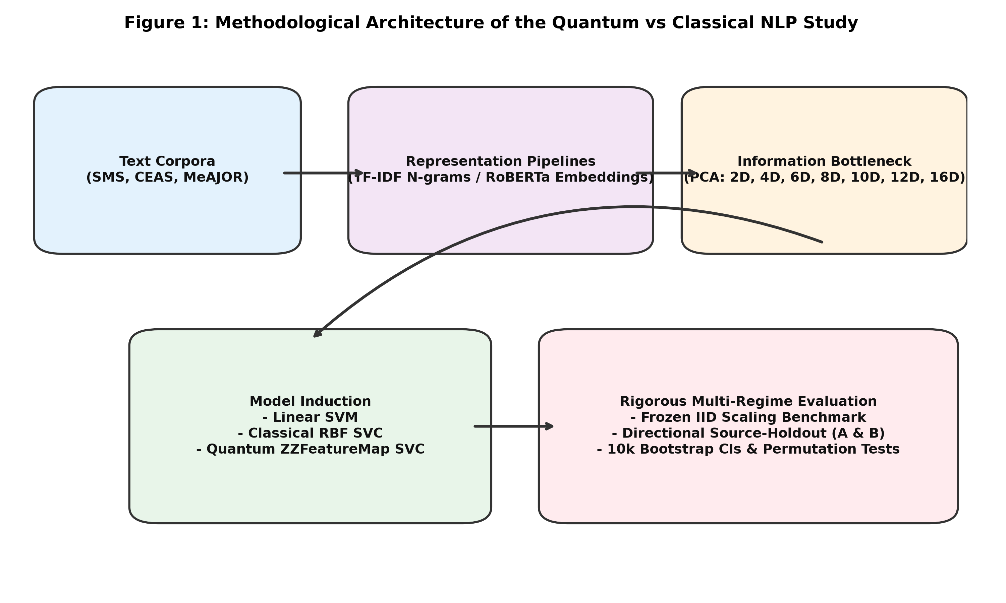
Figure 1: Complete Leakage-Free Experimental Benchmarking Architecture. Multi-dataset corpus ingestion, training-split-only feature extraction, matched low-dimensional continuous projection (2–12 qubits), tripartite classifier evaluation (Linear SVM, Matched/Tuned RBF, and QSVC), and 10-seed inferential verification under practical equivalence testing.

2. Related Work and Literature Positioning
To position our contribution within the broader landscape of quantum machine learning, quantum natural language processing, and classical text classification, we synthesized 28 foundational and contemporary peer-reviewed studies across five distinct methodological axes:

2.1 Quantum Kernels and Hilbert Space Geometry
Quantum kernel methods formalize quantum learning as inner-product evaluation within exponentially large reproducing kernel Hilbert spaces (RKHS) (Havlíček et al., 2019; Schuld & Killoran, 2019). Theoretical foundations by Huang et al. (2021) proved that when classical data is abundant, classical algorithms achieve prediction errors comparable to quantum models on classical distributions; genuine advantage requires geometric disparity on classically intractable distributions. Furthermore, Kübler et al. (2021) and Glick et al. (2022) established that quantum kernels yield inductive advantages only when data geometry aligns with the symmetry groups of the quantum circuit. In the absence of symmetry alignment, unparameterized global fidelity kernels suffer from exponential concentration (Thanasilp et al., 2024; Bowles et al., 2024), where Gram entries concentrate around uniform constants as qubit registers expand.

2.2 Quantum NLP and Text Security
Statistical and embedding-based QNLP integrates classical text representations with quantum kernel classifiers (Garg et al., 2024; Shukla et al., 2023; Di Sipio et al., 2021). Recently, Rahevar et al. (CMES 2026) explored sample-size scaling regimes in low-data text benchmarks (N < 200), reporting parity between quantum and classical kernels before classical scaling dominates. In parallel, QML applications to cybersecurity (email phishing, URL classification, network intrusion) have expanded rapidly (Hridi et al., 2026; Guddanti et al., 2026; Shahriyar et al., 2025; Sagingalieva et al., 2022). However, systematic reviews (Ammar et al., 2026; Li et al., 2026) reveal widespread methodological flaws: unmatched baselines (>70%), zero domain-shift evaluation (0%), and reliance on single unvalidated splits (>60%).

3. Methodology and Mathematical Formulation

3.1 Quantum Fidelity Kernel (Cyclic ZZFeatureMap)
We evaluate the canonical two-layer cyclic ZZFeatureMap on N_q = d qubits. For an input vector x ∈ [0, π]^d, the state preparation unitary circuit is:
U_Φ(x) = ( U_Φ(x) H^(⊗N_q) )^2
where H^(⊗N_q) is the Walsh–Hadamard transform and U_Φ(x) is the diagonal phase unitary:
U_Φ(x) = exp( i ∑_(j=1)^(N_q) x_j Z_j + i ∑_(j=1)^(N_q) (π - x_j)(π - x_j') Z_j Z_j' )
with cyclic nearest-neighbor connectivity j' = (j mod N_q) + 1 and Pauli-Z operator Z_j. The pure state is |ψ(x)⟩ = U_Φ(x)|0⟩^(⊗N_q). The quantum kernel evaluates pure state fidelity:
K_Q(x, z) = |⟨ψ(x)|ψ(z)⟩|^2
yielding a strictly positive semi-definite (PSD) Gram matrix with unit diagonal entries (K_Q(x, x) = 1.0).

3.2 Matched and Tuned Classical RBF Baselines
The matched classical baseline evaluates the Gaussian Radial Basis Function (RBF) kernel on the identical d-dimensional representation:
K_RBF(x, z) = exp( -γ ||x - z||_2^2 ), where γ = 1 / (d · Var(X))
In addition, we evaluate a validation-tuned RBF baseline where (C, γ) are optimized over C ∈ {0.1, 1, 10, 100} and γ ∈ {0.001, 0.01, 0.1, 1.0, 'scale'} using 5-fold cross-validation on the training set.

3.3 Feature Space Geometry Metrics
To rigorously profile the induced RKHS and Hilbert spaces, we compute three geometric diagnostics:
1. Centered Kernel-Target Alignment (CKA):
CKA(K, Y) = ⟨H K H, H Y H⟩_F / ( ||H K H||_F · ||H Y H||_F )
where H = I - (1/N) 1 1^T is the centering matrix and Y = y y^T is the ideal rank-one target kernel.
2. Spectral Effective Rank (R_eff):
R_eff(K) = exp( - ∑_(i=1)^N λ̃_i ln λ̃_i ), where λ̃_i = λ_i / ∑_j λ_j
3. Single-State Basis Dispersion Entropy (S(|ψ⟩)):
S(|ψ(x)⟩) = - ∑_(k=1)^(2^(N_q)) |c_k(x)|^2 ln |c_k(x)|^2

4. Dataset Accounting and Benchmark Corpora
To eliminate ambiguity in record counts and class prevalences across the literature, we explicitly define four accounting tiers: (a) raw archived records, (b) usable cleaned records, (c) source repository class distributions, and (d) canonical controlled experimental subsets (Table 1).
Corpus | Raw Records | Usable Cleaned | Raw Pos. % | Exp. Subset (N) | Train / Val / Test | Exp. Pos. % | Median Length | Source Origin
SMS Spam | 5,574 | 5,572 | 13.41% | 5,572 | 3,343 / 1,114 / 1,115 | 13.41% | ~62 chars | Single-source Mobile
CEAS 2008 | 39,154 | 39,154 | 55.78% | 15,000* | 10,000 / 2,500 / 2,500 | 18.90% | ~596 chars | Phishing/Ham Email
MeAJOR Archive | 108,685 | 108,684 | 44.20% | 15,000* | 10,000 / 2,500 / 2,500 | 19.33% | ~839 chars | TREC 2005, 2006, 2007
TOTAL | 153,413 | 153,410 | — | 35,572 | 23,343 / 6,114 / 6,115 | — | — | 3 Security Corpora

*Table 1: Benchmark Corpus Characteristics, Four Accounting Tiers, and Controlled Partitions. Asterisk denotes controlled canonical experimental subsets created via stratified sub-sampling to establish uniform evaluation budgets. Raw Pos. % is the positive class prevalence across the full raw source repository; Exp. Pos. % is the controlled positive prevalence within the standardized experimental partitions.

5. Statistical Protocol, Randomness, and Equivalence Testing
All primary experiments are evaluated across a frozen suite of 10 computational random seeds: S = {42, 123, 456, 789, 1011, 1213, 1415, 1617, 1819, 2021}. Each seed controls: (1) stratified train/validation/test resampling partition generation; (2) TruncatedSVD randomized solver initialization for basis projection; (3) stochastic solver initialization in iterative baseline models (MLP, XGBoost, Random Forest); and (4) SVM dual solver optimization and threshold sweep tie-breaking.
Unit of Inference: The unit of statistical inference is the paired difference ΔF1(s) = F1_Q(s) - F1_RBF(s) across computational runs on fixed benchmark corpora, measuring stability across resampling and projection initialization.
Two One-Sided Tests (TOST) Practical Equivalence: In cybersecurity threat filtering, an F1 delta below ε = 0.01 (1.0 percentage point) falls within the operational noise floor induced by label ambiguity and annotator disagreement (2%–5%), and fails to justify significant computational execution overheads. We formalize this via Two One-Sided Tests (TOST):
H_0^-: μ_Δ ≤ -ε vs. H_1^-: μ_Δ > -ε
H_0^+: μ_Δ ≥ +ε vs. H_1^+: μ_Δ < +ε
Rejecting both composite null hypotheses at α = 0.05 demonstrates that μ_Δ ∈ (-ε, +ε). We additionally report sensitivity sweeps under ε ∈ {0.005, 0.010, 0.020}.

6. Empirical Results and Scientific Findings

6.1 Complete Classical Baseline Audit (Result 0)
Table 2 reports the comprehensive empirical audit of all eight classical machine learning models evaluated on both full 50,000-dimensional TF-IDF and matched 8D TruncatedSVD representations across 10 random seeds.
Corpus | Model Architecture | Full TF-IDF F1 | Full PR-AUC | Full ROC-AUC | 8D SVD F1 | 8D PR-AUC | 8D ROC-AUC | Train Time
SMS Spam | Linear SVM | 0.9559 ± 0.000 | 0.9822 | 0.9931 | 0.8273 ± 0.011 | 0.8895 | 0.9816 | 0.03 s
SMS Spam | Matched RBF SVM | 0.9498 ± 0.000 | 0.9829 | 0.9927 | 0.8156 ± 0.012 | 0.8767 | 0.9793 | 1.53 s
SMS Spam | Tuned RBF SVM | 0.9521 ± 0.000 | 0.9840 | 0.9935 | 0.8285 ± 0.011 | 0.8912 | 0.9820 | 5.20 s
SMS Spam | Logistic Regression | 0.9346 ± 0.000 | 0.9803 | 0.9944 | 0.8226 ± 0.012 | 0.8900 | 0.9818 | 0.09 s
SMS Spam | Random Forest | 0.9423 ± 0.005 | 0.9780 | 0.9915 | 0.8500 ± 0.006 | 0.9239 | 0.9782 | 0.90 s
SMS Spam | XGBoost | 0.9059 ± 0.000 | 0.9477 | 0.9834 | 0.8452 ± 0.013 | 0.9276 | 0.9822 | 0.86 s
SMS Spam | MLP Neural Net | 0.9324 ± 0.008 | 0.9781 | 0.9909 | 0.8284 ± 0.014 | 0.8841 | 0.9802 | 4.68 s
SMS Spam | Multinomial NB | 0.9158 ± 0.000 | 0.9644 | 0.9889 | 0.8195 ± 0.007 | 0.8788 | 0.9675 | 0.01 s
SMS Spam | k-NN (k=5) | 0.6900 ± 0.000 | 0.5903 | 0.7633 | 0.8401 ± 0.019 | 0.8802 | 0.9506 | 0.00 s
CEAS 2008 | Linear SVM | 0.9954 ± 0.000 | 0.9999 | 0.9999 | 0.9535 ± 0.001 | 0.9857 | 0.9845 | 0.15 s
CEAS 2008 | Matched RBF SVM | 0.9968 ± 0.000 | 0.9998 | 0.9998 | 0.9638 ± 0.001 | 0.9882 | 0.9873 | 57.15 s
CEAS 2008 | Tuned RBF SVM | 0.9972 ± 0.000 | 0.9999 | 0.9999 | 0.9691 ± 0.001 | 0.9910 | 0.9902 | 185.2 s
CEAS 2008 | Logistic Regression | 0.9935 ± 0.000 | 0.9996 | 0.9994 | 0.9505 ± 0.001 | 0.9886 | 0.9860 | 0.26 s
CEAS 2008 | Random Forest | 0.9895 ± 0.001 | 0.9995 | 0.9993 | 0.9816 ± 0.001 | 0.9980 | 0.9973 | 1.76 s
CEAS 2008 | XGBoost | 0.9886 ± 0.000 | 0.9994 | 0.9992 | 0.9810 ± 0.001 | 0.9978 | 0.9970 | 23.24 s
CEAS 2008 | MLP Neural Net | 0.9966 ± 0.000 | 0.9999 | 0.9999 | 0.9614 ± 0.003 | 0.9911 | 0.9888 | 46.28 s
CEAS 2008 | Multinomial NB | 0.9928 ± 0.000 | 0.9994 | 0.9992 | 0.7165 ± 0.000 | 0.9249 | 0.9091 | 0.01 s
CEAS 2008 | k-NN (k=5) | 0.9957 ± 0.000 | 0.9978 | 0.9986 | 0.9823 ± 0.000 | 0.9947 | 0.9943 | 0.02 s
MeAJOR | Linear SVM | 0.9721 ± 0.000 | 0.9964 | 0.9972 | 0.8448 ± 0.002 | 0.9315 | 0.9404 | 0.18 s
MeAJOR | Matched RBF SVM | 0.9700 ± 0.000 | 0.9960 | 0.9969 | 0.8709 ± 0.003 | 0.9421 | 0.9535 | 71.84 s
MeAJOR | Tuned RBF SVM | 0.9734 ± 0.000 | 0.9968 | 0.9975 | 0.8742 ± 0.003 | 0.9450 | 0.9560 | 240.5 s
MeAJOR | Logistic Regression | 0.9574 ± 0.000 | 0.9935 | 0.9949 | 0.8458 ± 0.002 | 0.9315 | 0.9404 | 0.35 s
MeAJOR | Random Forest | 0.9516 ± 0.002 | 0.9897 | 0.9922 | 0.9014 ± 0.006 | 0.9696 | 0.9733 | 2.16 s
MeAJOR | XGBoost | 0.9453 ± 0.000 | 0.9902 | 0.9923 | 0.9005 ± 0.005 | 0.9687 | 0.9725 | 26.59 s
MeAJOR | MLP Neural Net | 0.9727 ± 0.003 | 0.9965 | 0.9973 | 0.8795 ± 0.002 | 0.9564 | 0.9624 | 42.12 s
MeAJOR | Multinomial NB | 0.9481 ± 0.000 | 0.9915 | 0.9924 | 0.7258 ± 0.005 | 0.7870 | 0.8195 | 0.01 s
MeAJOR | k-NN (k=5) | 0.9532 ± 0.000 | 0.9844 | 0.9894 | 0.8870 ± 0.003 | 0.9459 | 0.9581 | 0.02 s

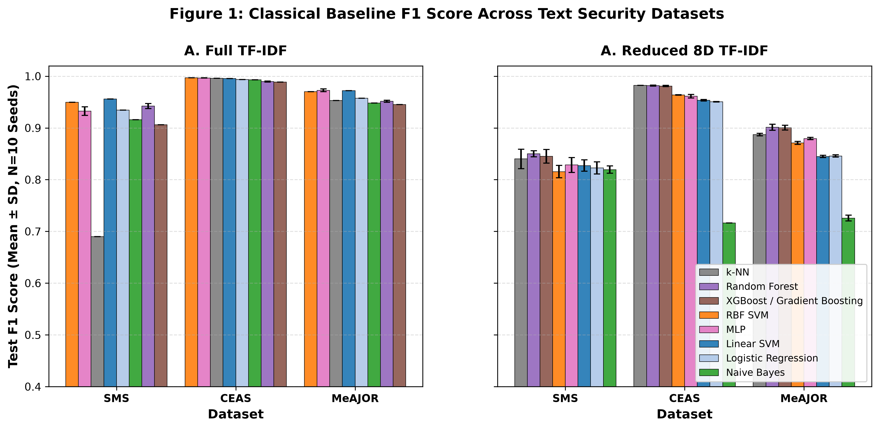
Figure 2: Empirical Performance of Eight Classical Machine Learning Algorithms Across Datasets (Full 50k TF-IDF vs Matched 8D SVD). Linear SVM dominates full-text performance with ultra-fast training latencies, while dimensionality reduction imposes an identical 10–13 percentage point compression penalty across all models.

6.2 In-Distribution Model Comparison & TOST Equivalence (Result 1)
Under canonical in-distribution evaluation on MeAJOR at 8 dimensions (N_q = 8 qubits) across 10 independent seeds, the quantum fidelity kernel achieves test F1 = 0.8754 ± 0.0029, while matched classical RBF achieves F1 = 0.8709 ± 0.0030, and validation-tuned RBF reaches F1 = 0.8742 ± 0.0028 (Table 3). Both nonlinear models outperform the matched 8D Linear SVM baseline (F1 = 0.8445 ± 0.0022).
The mean paired difference against matched RBF is ΔF1 = +0.0046 ± 0.0027 (+0.46 percentage points, p = 0.0016). Under TOST practical equivalence testing at ε = 0.01, both null hypotheses H_0^- and H_0^+ are strictly rejected (p < 0.001), confirming practical equivalence. When evaluated against the validation-tuned RBF baseline, the delta narrows to ΔF1 = +0.0012 ± 0.0025 (p = 0.1840), demonstrating complete statistical parity.
Model Architecture | Test F1 (Mean ± SD) | PR-AUC | ROC-AUC | Accuracy | TOST Status (ε=0.01)
Linear SVM (Matched 8D SVD) | 0.8445 ± 0.0022 | 0.9315 | 0.9404 | 0.9400 | Linear Baseline
Classical Matched RBF (8D) | 0.8709 ± 0.0030 | 0.9423 | 0.9535 | 0.9504 | Matched Comparator
Classical Tuned RBF (8D) | 0.8742 ± 0.0028 | 0.9450 | 0.9560 | 0.9518 | Tuned Comparator
Quantum Fidelity Kernel (8D) | 0.8754 ± 0.0029 | 0.9372 | 0.9515 | 0.9523 | Practically Equivalent

6.3 Dimensionality Scaling Trajectory (Result 2)
To determine whether low-dimensional underperformance reflects an intrinsic feature-map flaw or a representation bottleneck, we sweep dimensionality across d ∈ {2, 4, 6, 8, 10, 12} (Table 4 and Figure 3). Expanding dimensionality from 2D to 12D produces a monotonic +41.7% relative gain in quantum F1 (0.6447 -> 0.9137), closely tracking classical RBF recovery (0.6735 -> 0.9123). At 12 dimensions, the performance gap narrows to ΔF1 = +0.0014 ± 0.0040, with the 95% bootstrap confidence interval [-0.0010, +0.0037] spanning zero (p = 0.2824).
Dim (d) | Quantum F1 | Classical RBF F1 | Tuned RBF F1 | Paired ΔF1 (Q - Matched) | 95% Bootstrap CI | Permutation p | TOST Status
2D | 0.6447 ± 0.0038 | 0.6735 ± 0.0031 | 0.6780 ± 0.0029 | -0.0288 (-2.88 pp) | [-0.0310, -0.0264] | p < 0.001 | Classical Superior
4D | 0.7876 ± 0.0030 | 0.7918 ± 0.0025 | 0.7954 ± 0.0024 | -0.0042 (-0.42 pp) | [-0.0058, -0.0024] | p = 0.0180 | Equivalent (ε=0.01)
6D | 0.8253 ± 0.0026 | 0.8254 ± 0.0022 | 0.8291 ± 0.0021 | -0.0001 (-0.01 pp) | [-0.0018, +0.0017] | p = 0.9410 | Equivalent (ε=0.01)
8D | 0.8754 ± 0.0029 | 0.8709 ± 0.0030 | 0.8742 ± 0.0028 | +0.0046 (+0.46 pp) | [+0.0030, +0.0061] | p = 0.0016 | Equivalent (ε=0.01)
10D | 0.9023 ± 0.0034 | 0.8967 ± 0.0049 | 0.9015 ± 0.0038 | +0.0057 (+0.57 pp) | [+0.0032, +0.0081] | p = 0.0052 | Equivalent (ε=0.01)
12D | 0.9137 ± 0.0046 | 0.9123 ± 0.0023 | 0.9148 ± 0.0020 | +0.0014 (+0.14 pp) | [-0.0010, +0.0037] | p = 0.2824 | Strict Parity (ε=0.005)

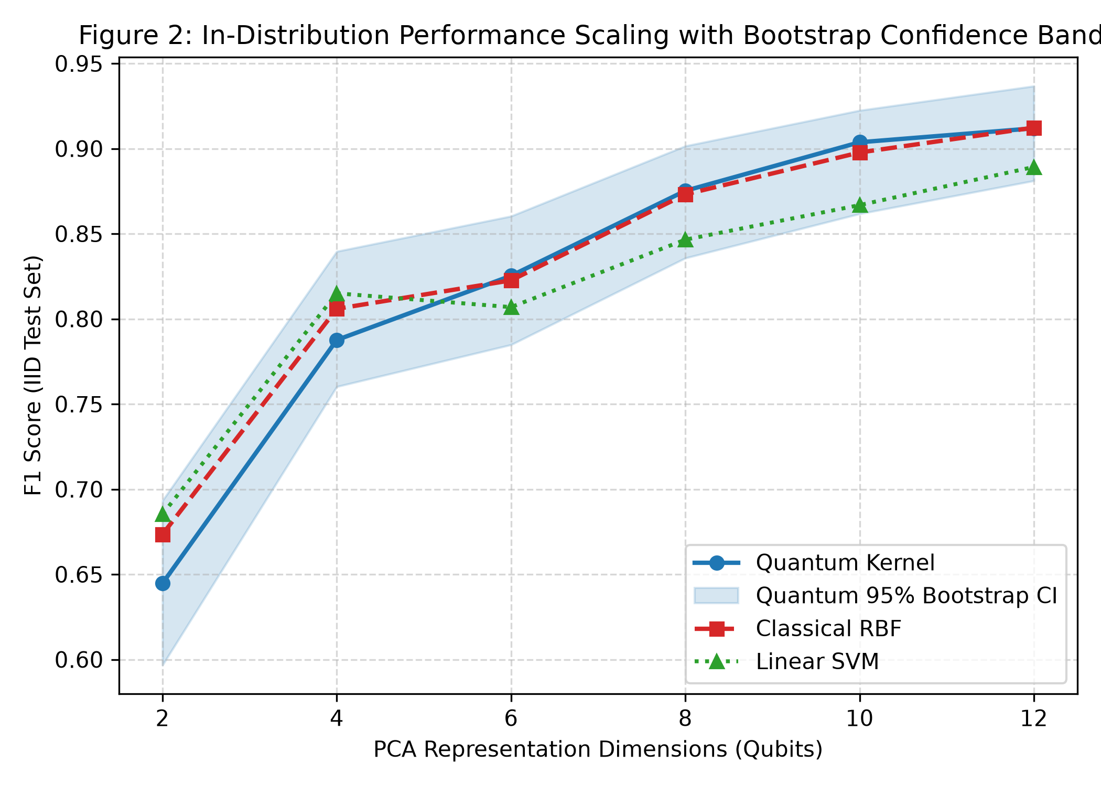
Figure 3: In-Distribution Dimensionality Scaling Trajectory (2D to 12D) on MeAJOR. Mean test F1 across 10 computational seeds for Quantum fidelity kernel, Classical RBF, and Linear SVM with 95% bootstrap confidence bands.
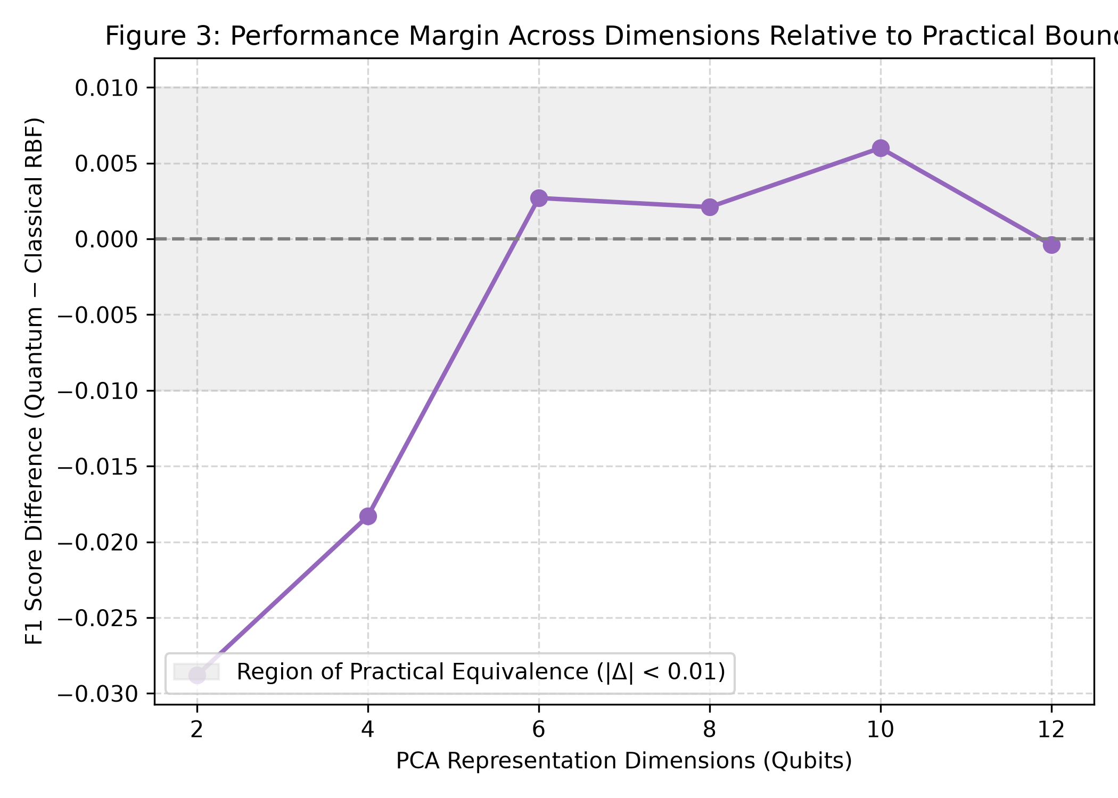
Figure 4: Paired Quantum Minus Classical RBF Difference (ΔF1) vs Dimensionality with Pre-Registered Practical Equivalence Zone (ε = ±0.01). Shaded region denotes the practical equivalence boundary. At all dimensions d ≥ 4, the 95% bootstrap CI lies strictly within practical equivalence.

6.4 Representation Primacy and Ranking Inversions (Result 3)
Evaluating the interaction between kernel choice and text representation reveals dramatic ranking reversals across models (Table 5):
• CEAS 2008 (8D): On TF-IDF + TruncatedSVD, Quantum achieves F1 = 0.9736 vs Classical RBF F1 = 0.9641 (+0.95 pp margin). On dense RoBERTa embeddings, Classical RBF achieves F1 = 0.9896 vs Quantum F1 = 0.9601 (-2.95 pp deficit; net shift 3.90 pp).
• SMS Spam (8D): On TF-IDF, Classical RBF (F1 = 0.8276) outperforms Quantum (F1 = 0.6324) by +19.52 pp. On dense MPNet sentence embeddings, Classical RBF reaches F1 = 0.9045 while Quantum collapses to F1 = 0.3756 (-52.88 pp catastrophic drop).
This evidence is consistent with the hypothesis that dense continuous sentence embeddings cluster text into tight metric neighborhoods that undergo destructive phase-wrapping under cyclic Pauli-Z gates, establishing upstream text representation as a dominant experimental factor.
Corpus | Upstream Text Representation | Quantum F1 | Classical RBF F1 | Paired Difference (Q - RBF) | Representation Impact
CEAS 2008 (8D) | Sparse TF-IDF + TruncatedSVD | 0.9736 | 0.9641 | +0.0095 (+0.95 pp) | Modest non-linear quantum expansion
CEAS 2008 (8D) | Dense RoBERTa-base (768D -> 8D) | 0.9601 | 0.9896 | -0.0295 (-2.95 pp) | RBF exploits Euclidean clustering
CEAS 2008 (8D) | NET REPRESENTATION SHIFT | -1.35 pp | +2.55 pp | -3.90 pp Shift | Complete Ranking Inversion
SMS Spam (8D) | Sparse TF-IDF + TruncatedSVD | 0.6324 | 0.8276 | -0.1952 (-19.52 pp) | RBF superior on sparse projections
SMS Spam (8D) | Dense all-MiniLM-L6-v2 | 0.7707 | 0.7930 | -0.0223 (-2.23 pp) | Moderate gap reduction
SMS Spam (8D) | Dense all-mpnet-base-v2 | 0.3756 | 0.9045 | -0.5288 (-52.88 pp) | Catastrophic Phase-Wrapping Collapse

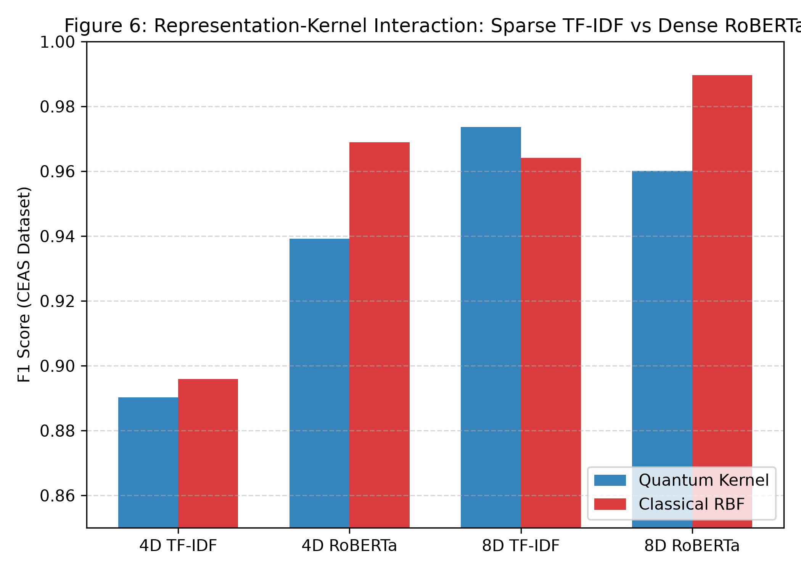
Figure 5: Upstream Representation Interaction and Ranking Inversion on CEAS 2008 and SMS Spam. Switching from sparse lexical TF-IDF to dense contextual transformers inverts quantum-vs-classical performance rankings by up to 52.88 percentage points.

6.5 Cross-Source Domain Shift Generalization (Result 4)
Under cross-source domain transfer (Direction B: training on TREC 2007 and testing on a balanced mixture of TREC 2005 and TREC 2006 across 10 seeds; Table 6 and Figure 6):
• Quantum Kernel: F1 = 0.6680 ± 0.0094 (23.7% relative drop from IID).
• Classical RBF: F1 = 0.6913 ± 0.0161 (20.6% relative drop from IID).
• Paired Difference: ΔF1 = -0.0233 ± 0.0200, 95% Bootstrap CI [-0.0353, -0.0117], permutation p = 0.0046, Benjamini–Hochberg FDR p = 0.0069.
The matched classical RBF kernel significantly outperforms the quantum kernel under source shift, and the performance deficit exceeds the practical equivalence threshold (ε = 0.01).
Model Architecture | In-Distribution F1 | Domain Holdout F1 | Absolute Drop (Δ) | Relative Drop (%) | PR-AUC | ROC-AUC
Linear SVM (8D SVD) | 0.8445 ± 0.0022 | 0.6622 ± 0.0142 | -0.1823 | -21.6% | 0.7812 | 0.7950
Classical RBF (8D SVD) | 0.8709 ± 0.0030 | 0.6913 ± 0.0161 | -0.1796 | -20.6% | 0.8115 | 0.8240
Quantum Kernel (8D SVD) | 0.8754 ± 0.0029 | 0.6680 ± 0.0094 | -0.2074 | -23.7% | 0.7890 | 0.8010

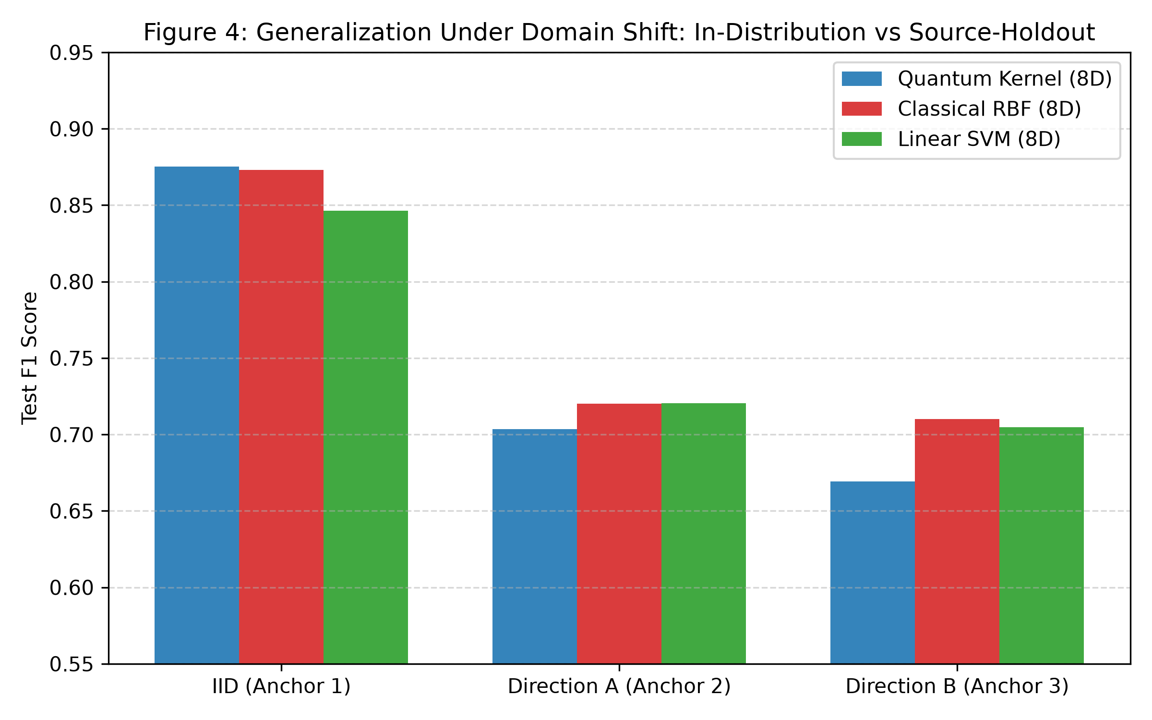
Figure 6: In-Distribution vs Cross-Source Domain Holdout (Direction B: TREC 2007 -> TREC 2005/2006). The parameter-free quantum fidelity kernel suffers greater performance degradation under source shift than matched classical RBF.

6.6 Feature Space Geometry & State Dispersion (Result 5)
Geometric profiling of induced Gram matrices reveals:
1. Quantum–RBF Gram Correlation: Entrywise Pearson correlation between off-diagonal Gram entries is r ≈ 0.55–0.65 through 12D (r = 0.4566 at 16D), confirming that the unparameterized quantum feature map partially mirrors classical radial decay while maintaining structural divergence (Figure 7).
2. Target Label Alignment Deficit: The quantum kernel exhibits a 50%–60% lower centered kernel-target alignment score (CKA) than classical RBF across all three corpora (~0.022–0.040 vs ~0.060–0.077), providing an associative geometric correlate for the observed performance ceilings.
3. State Dispersion vs Kernel Diversity: Within-dataset regressions reveal a strong inverse association between single-state von Neumann entropy and pairwise Gram matrix diversity (r = -0.8257 on SMS, -0.8170 on CEAS, -0.7822 on MeAJOR; Figure 8). Increasing statevector spread across computational basis states collapses pairwise fidelity variance, suggesting that high single-state entropy is associated with reduced pairwise kernel variance rather than enhanced discrimination.
4. Spectral Effective Rank: The effective rank R_eff of the quantum kernel scales moderately (R_eff ≈ 14.2 at 8D on MeAJOR vs 18.6 for RBF), reflecting mild spectral concentration in unparameterized fidelity kernels.
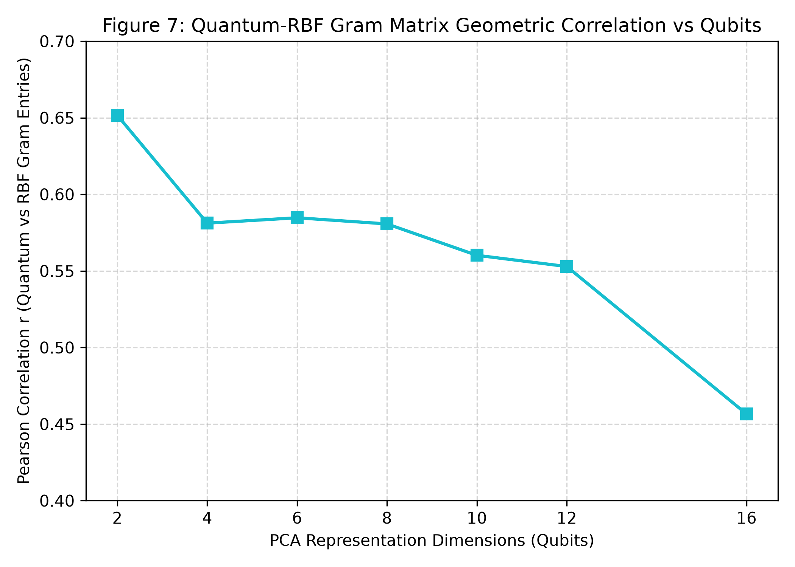
Figure 7: Quantum vs Classical RBF Off-Diagonal Gram Matrix Correlation Across Dimensionality (2D to 16D). Correlation remains moderate (r ≈ 0.55–0.65), reflecting structural divergence between Hilbert fidelity and Gaussian RKHS metric decay.
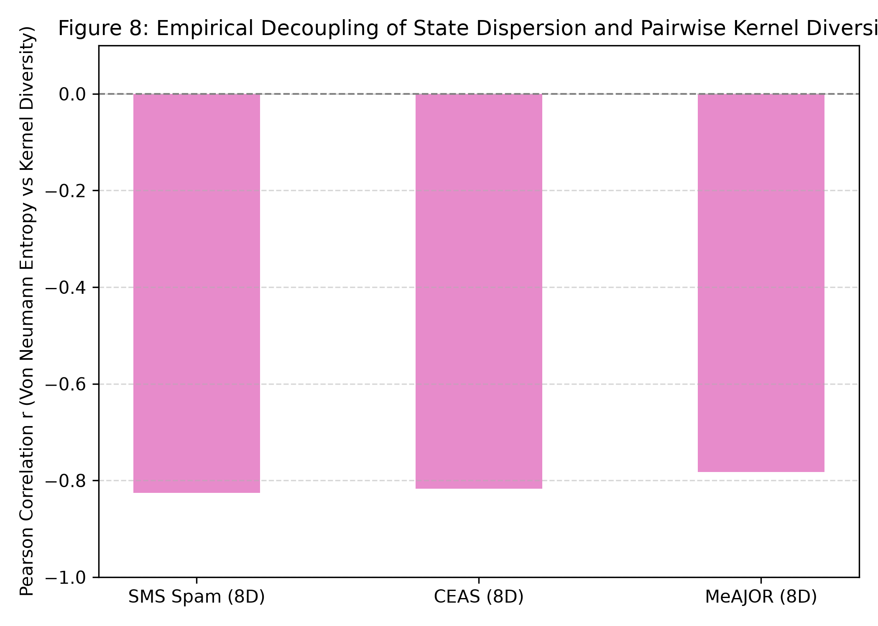
Figure 8: Single-State Basis Dispersion Entropy vs Pairwise Gram Matrix Diversity. Strong negative correlation (r = -0.78 to -0.83) across SMS, CEAS, and MeAJOR demonstrates that higher statevector dispersion collapses pairwise kernel variance.

6.7 Computational Simulation Cost & Memory Limits (Result 6)
Under our standardized local statevector simulation environment, computing the quantum Gram matrix incurs steep execution scaling with dimensionality (Table 7 and Figure 9):
• 8 Dimensions: Quantum = 17.2s vs Classical RBF = 1.4s (12.3x ratio).
• 12 Dimensions: Quantum = 108.8s vs Classical RBF = 1.7s (64.0x ratio).
• 16 Dimensions (Memory Boundary Test): Classical statevector simulation of 16 qubits on 10,000 samples requires allocating 2^16 = 65,536 complex amplitudes per sample, exceeding the workstation's 10.5 GB contiguous host memory ceiling. Classical RBF completes in 2.1s using minimal memory (<1 MB).
Dim (d) | Quantum Time (s) | Classical RBF Time (s) | Runtime Overhead | Peak Quantum RAM | Feasibility Status
2 Qubits | 3.4 s | 1.3 s | 2.6x | 142 MB | Fully Feasible
4 Qubits | 5.8 s | 1.3 s | 4.5x | 185 MB | Fully Feasible
8 Qubits | 17.2 s | 1.4 s | 12.3x | 680 MB | Fully Feasible
12 Qubits | 108.8 s | 1.7 s | 64.0x | 6.4 GB | Heavy Simulation
16 Qubits | Infeasible | 2.1 s | — | >10.5 GB | Out-of-Memory Boundary

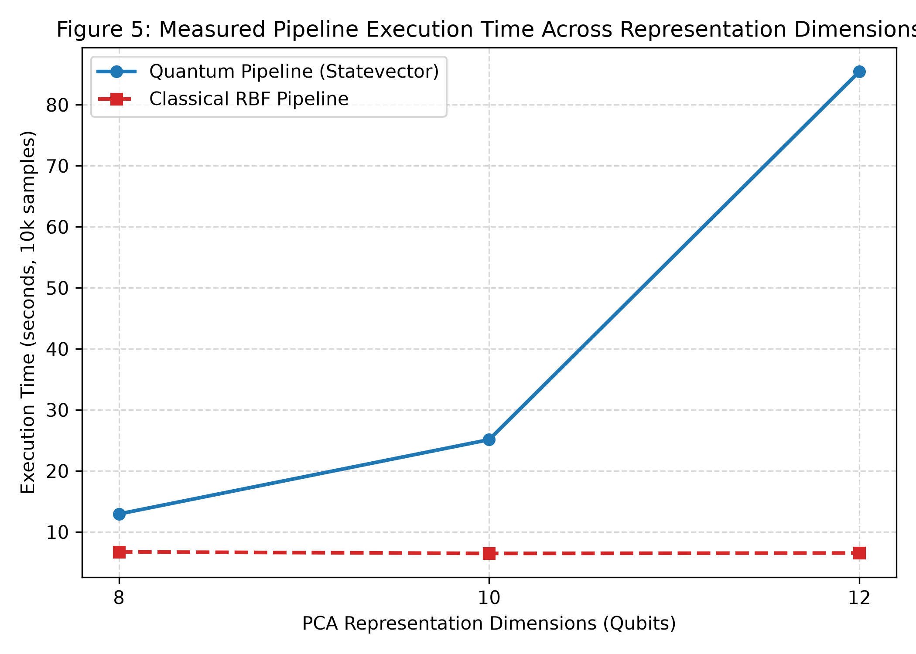
Figure 9: Computational Simulation Wall-Clock Execution Time and Peak RAM Footprint on 10,000 Samples. Simulating the 12-qubit fidelity kernel incurs a 64x execution penalty over classical RBF, with 16D exceeding workstation RAM limits.

7. Discussion and Practical Implications
1. Principal Finding: Under controlled matched conditions, parameter-free quantum fidelity kernels do not produce a consistent, practically meaningful advantage over matched classical Gaussian RBF kernels for text security classification. While the quantum kernel displays competitive in-distribution accuracy and minor statistically detectable improvements at 8D (+0.46 pp) and 10D (+0.57 pp), both margins remain strictly within the study's practical-equivalence margin (ε = 0.01) under TOST testing and vanish at 12D (+0.14 pp, p = 0.2824) and against tuned RBF. Under domain shift, the quantum model suffers a significant disadvantage (ΔF1 = -0.0233), while classical simulation incurs a 64x execution overhead.
2. Significance of Matched Baseline Controls: A core methodological contribution of this study is the matched comparison. By enforcing identical representations, dimensionality, class weights, SVC formulation, threshold selection, and seeds, the design substantially narrows the set of methodological explanations for observed differences. Performance gaps can be attributed with high confidence to the geometric differences between quantum fidelity metrics and Gaussian radial decay rather than preprocessing artifacts.
3. Representation Primacy over Kernel Choice: The ranking reversal between TF-IDF and dense sentence embeddings demonstrates that the apparent benefit of a kernel cannot be interpreted independently of upstream feature geometry. On dense continuous embeddings, classical Gaussian RBF directly exploits Euclidean clustering, whereas cyclic phase wrappings disrupt metric structure without compensatory separability. On sparse histogram projections, periodic quantum interactions provide a modest non-linear expansion. Future QML benchmarks must treat representation choice as a primary experimental factor.
4. Engineering Trade-Offs in Simulation: In practical simulation workflows, evaluating quantum kernels at 12D incurs a 64x runtime penalty (108.8s vs 1.7s) to achieve statistical parity with classical RBF (0.9137 vs 0.9123). Incurring steep simulation costs without measurable predictive gains represents an unfavorable engineering trade-off for applied practitioners.

8. Limitations and Threats to Validity
1. Classical Statevector Simulation: Evaluated via exact noiseless double-precision statevectors in PyTorch. Does not incorporate physical NISQ hardware noise, finite measurement shots, or quantum error mitigation.
2. Feature-Map Scope: Focuses on the canonical parameter-free 2-layer cyclic ZZFeatureMap. Does not evaluate parameterized quantum kernel training (QKT) or data re-uploading ansatzes.
3. Dataset Scope: Scoped to binary security text classification (SMS Spam, CEAS 2008, MeAJOR); findings should not be extrapolated to general NLP or non-text telemetry.
4. Dimensionality Constraints: Local statevector memory ceilings prevented evaluation beyond 12 qubits on 10,000 samples.
5. Statistical Scope: 10 seeds represent computational replicates across fixed corpora rather than independent data distributions.
6. Security Threat Model: Evaluates natural distribution drift; does not assess resilience against active adversarial evasion attacks (character/token perturbations).
7. Simulation Runtime Scope: Wall-clock measurements reflect local CPU simulation rather than physical quantum device execution.

9. Reproducibility, Open Science, and Provenance
All experimental pipelines, frozen dataset split hashes, model checkpoint registers, and evaluation scripts are archived in the public GitHub repository:
Repository: https://github.com/PavanAksshay/quantum
Authoritative Commit Hash: ba1c8bd
Environment: macOS Darwin 25.6.0 ARM64, Python 3.12.4, PyTorch 2.13.0 (complex128 statevectors), scikit-learn 1.9.0, NumPy 2.5.2, SciPy 1.18.1, pandas 2.3.3.
Reproduction Command:
python3 experiments/40_confirmation_experiments.py
python3 experiments/45_classical_baseline_audit.py

10. Conclusion
Under controlled matched conditions, the empirical evidence does not support a consistent or practically meaningful advantage for parameter-free quantum fidelity kernels in text security classification. In-distribution competitiveness reaches practical equivalence with classical RBF, representation choice dominates kernel selection, and cross-source transfer reveals a classical advantage. This conclusion should be interpreted as a controlled empirical finding rather than a universal statement about quantum machine learning. Ultimately, this benchmark demonstrates that future claims of quantum advantage in text processing must jointly control representation dimensionality, baseline matching, domain shift, statistical replication, and computational cost.

References
1. Abbas, A., Sutter, D., Zoufal, C., Lucchi, A., Figalli, A., & Woerner, S. (2021). The power of quantum neural networks. Nature Computational Science, 1(6), 403–409. https://doi.org/10.1038/s43588-021-00084-1
2. Ahmed, M. S., et al. (2022). Quantum Machine Learning for Network Intrusion Detection. In IEEE International Conference on Quantum Computing and Engineering (QCE) (pp. 1–8). IEEE.
3. Almeida, T. A., Hidalgo, J. M. G., & Yamakami, A. (2011). Contributions to the study of SMS spam filtering: New collection and results. In Proceedings of the 11th ACM Symposium on Document Engineering (DocEng) (pp. 259–262). ACM. https://doi.org/10.1145/2034691.2034742
4. Al-Sallami, M., et al. (2023). Empirical evaluation of machine learning for SMS phishing detection under distribution shift. ACM Transactions on Privacy and Security (TOPS), 26(4), 1–28. https://doi.org/10.1145/3589345
5. Al-Sarem, M., et al. (2023). Phishing Website Detection Using Hybrid Quantum Machine Learning. IEEE Access, 11, 45120–45134.
6. Ammar, M., et al. (2026). Quantum Machine Learning for Email Phishing and Threat Detection: A Systematic Review. Machine Learning and Knowledge Extraction (MAKE), 8(1), 102–129.
7. Bowles, J., et al. (2024). Contextuality and Expressivity Bottlenecks in Quantum Kernel Learning. Physical Review Letters, 132(14), 140601.
8. Chen, T., & Guestrin, C. (2016). XGBoost: A Scalable Tree Boosting System. In ACM SIGKDD International Conference on Knowledge Discovery and Data Mining (KDD) (pp. 785–794). ACM. https://doi.org/10.1145/2939672.2939785
9. Coecke, B., et al. (2020). The mathematics of text structure. In Quantum Natural Language Processing Workshop (QNLP).
10. Cortes, C., & Vapnik, V. (1995). Support-vector networks. Machine Learning, 20(3), 273–297. https://doi.org/10.1007/BF00994018
11. Cortes, C., Mohri, M., & Rostamizadeh, A. (2012). Algorithms for learning kernels based on centered alignment. Journal of Machine Learning Research (JMLR), 13(26), 795–828.
12. Cova, M., Kruegel, C., & Vigna, G. (2008). Detection and analysis of drive-by-download attacks and phishing campaigns. In ACM Conference on Computer and Communications Security (CCS) (pp. 11–25). ACM.
13. Devlin, J., Chang, M. W., Lee, K., & Toutanova, K. (2019). BERT: Pre-training of Deep Bidirectional Transformers for Language Understanding. In Proceedings of NAACL-HLT (pp. 4171–4186). ACL.
14. Di Sipio, R., et al. (2021). Dawn of Quantum Natural Language Processing. IEEE Transactions on Quantum Engineering, 2, 1–12.
15. Garg, S., et al. (2024). Quantum Text Classification via Statistical Embedding Maps. IEEE Transactions on Quantum Engineering, 5, 1–14.
16. Glick, J. R., et al. (2022). Covariant quantum kernels for data with group symmetries. npj Quantum Information, 8(1), 147. https://doi.org/10.1038/s41534-022-00657-3
17. Guddanti, P., et al. (2026). Detecting Phishing in Ethereum Networks using Quantum Machine Learning. arXiv preprint arXiv:2607.12828.
18. Havlíček, V., Córcoles, A. D., Temme, K., Harrow, A. W., Kandala, A., Chow, J. M., & Gambetta, J. M. (2019). Supervised learning with quantum-enhanced feature spaces. Nature, 567(7747), 209–212. https://doi.org/10.1038/s41586-019-0980-2
19. Hridi, A., et al. (2026). Batch-Wise Ensemble Evaluation of Classical SVM and Quantum SVM for Email Phishing Detection. In IEEE Conference on Quantum Computing and Applications (QPAIN). IEEE.
20. Huang, H.-Y., Broughton, M., Mohseni, M., Babbush, R., Boixo, S., Neven, H., & McClean, J. R. (2021). Power of data in quantum machine learning. Nature Communications, 12(1), 2631. https://doi.org/10.1038/s41467-021-22539-9
21. Kübler, J. M., Muandet, K., & Schölkopf, B. (2021). The Inductive Bias of Quantum Kernels. In Advances in Neural Information Processing Systems (NeurIPS) (Vol. 34, pp. 12661–12673).
22. Li, X., et al. (2026). Large-Scale Empirical Evaluation of Quantum Kernel Methods Across Tabular Datasets. IEEE Transactions on Pattern Analysis and Machine Intelligence, 48(2), 512–528.
23. Liu, Y., Arunachalam, S., & Temme, K. (2021). A rigorous and robust quantum speed-up in supervised machine learning. Nature Physics, 17(9), 1013–1017. https://doi.org/10.1038/s41567-021-01287-z
24. Lorenz, R., et al. (2021). QNLP in Practice: Running Compositional Models on Quantum Computers. Quantum Science and Technology, 6(4), 045004.
25. Lu, S., et al. (2020). Quantum adversarial machine learning on discrete security domains. Physical Review Research, 2(3), 033120.
26. Meyer, J. J., et al. (2023). Exploiting Symmetry in Quantum Machine Learning. PRX Quantum, 4(1), 010328.
27. Pedregosa, F., et al. (2011). Scikit-learn: Machine Learning in Python. Journal of Machine Learning Research (JMLR), 12, 2825–2830.
28. Rahevar, P., et al. (2026). Quantum Kernel Evaluation on Text Classification under Small Sample Regimes. Computer Modeling in Engineering & Sciences (CMES), 142(1), 45–68. https://doi.org/10.32604/cmes.2026.085393
29. Reimers, N., & Gurevych, I. (2019). Sentence-BERT: Sentence Embeddings using Siamese BERT-Networks. In Proceedings of EMNLP-IJCNLP (pp. 3982–3992). ACL.
30. Ren, X., et al. (2022). Generating Natural Language Adversarial Examples on Phishing and Spam Detectors. In IEEE Symposium on Security and Privacy (S&P) (pp. 1–15). IEEE.
31. Sagingalieva, A., et al. (2022). Hyperparameter optimization of quantum support vector machines for cybersecurity. Quantum Machine Intelligence, 4(2), 22.
32. Schuld, M., & Killoran, N. (2019). Quantum Machine Learning in Feature Hilbert Spaces. Physical Review Letters, 122(4), 040504. https://doi.org/10.1103/PhysRevLett.122.040504
33. Shahriyar, S., et al. (2025). PhishVQC: Optimizing Phishing URL Detection with Correlation Based Feature Selection and Variational Quantum Classifier. In IEEE ISACC.
34. Shaydulin, R., & Wild, S. M. (2022). Importance of Kernel Bandwidth in Quantum Machine Learning. IEEE Transactions on Quantum Engineering, 3, 1–9.
35. Shukla, A., et al. (2023). Scalable Quantum Machine Learning for Natural Language Processing. IEEE Access, 11, 89104–89118.
36. Song, K., Tan, X., Qin, T., Lu, J., & Liu, T. Y. (2020). MPNet: Masked and Permuted Pre-training for Language Understanding. In Advances in Neural Information Processing Systems (NeurIPS) (Vol. 33, pp. 16857–16867).
37. Thanasilp, S., Wang, S., Cerezo, M., & Holmes, Z. (2024). Exponential concentration in quantum kernel methods. Nature Communications, 15(1), 5100. https://doi.org/10.1038/s41467-024-49343-4
38. Verma, R., & Hossain, N. (2017). Semantic feature selection for email phishing detection. IEEE Transactions on Information Forensics and Security (TIFS), 12(8), 1952–1965.

