Evaluating a Parameter-Free Quantum Fidelity Kernel for Text Security Under Representation and Domain Shift
Abstract
Quantum kernel methods map classical text into exponentially large Hilbert spaces, motivated by theoretical conjectures that quantum state fidelity may provide non-linear decision boundaries or enhanced generalization under distribution shift. We ask a narrower question: under controlled matched conditions, does an unparameterized quantum fidelity kernel (two-layer cyclic ZZFeatureMap) provide a consistent practical advantage over matched classical Gaussian RBF kernels for text security? We study this across three curated cybersecurity corpora comprising 153,410 usable text records (SMS Spam Collection, CEAS 2008 Email Corpus, and the multi-source MeAJOR archive) using frozen, leakage-safe protocols across 10 computational seeds. Under matched in-distribution (IID) scaling (2–12 qubits), the quantum kernel is competitive with classical RBF, displaying minor statistically detectable differences at intermediate dimensions (+0.46 percentage points at 8D, p = 0.0016; +0.57 pp at 10D, p = 0.0052) that remain strictly within the predefined practical-equivalence threshold (ε = 0.01 F1) under Two One-Sided Tests (TOST), converging to complete parity at 12D (+0.14 pp, p = 0.2824). Against a validation-tuned RBF baseline, the quantum margin narrows to full statistical parity across all dimensions. Under cross-source domain transfer (TREC 2007 -> TREC 2005/2006), the quantum kernel exhibits a statistically significant performance deficit (ΔF1 = -0.0233, p = 0.0046, Benjamini–Hochberg adjusted p = 0.0069). Upstream representation ablations demonstrate that representation choice dominates kernel selection by an order of magnitude, shifting relative performance by up to 52.88 percentage points. Geometrically, quantum and RBF Gram matrices show moderate correlation (r ≈ 0.55–0.65), while single-state entropy is strongly inversely associated with pairwise kernel diversity (r = -0.78 to -0.83). Computationally, classical statevector simulation of the quantum kernel requires 108.8s per run at 12D compared to 1.7s for RBF (≈64x penalty), with 16D exceeding workstation memory limits (>10.5 GB). We conclude that under the evaluated conditions, parameter-free quantum fidelity kernels do not produce a consistent practical advantage for text security classification, and we outline rigorous benchmarking standards for future applied QML evaluations.
Keywords: quantum machine learning, quantum kernel methods, text classification, email phishing, SMS spam, Hilbert space geometry, domain adaptation, practical equivalence testing
CORE SCIENTIFIC CONTRIBUTIONS
1. Establishes a leakage-free multi-dataset empirical benchmark evaluating parameter-free quantum fidelity kernels (cyclic ZZFeatureMap) against matched classical RBF kernels across 153,410 usable text records.
2. Implements a tripartite baseline hierarchy (Linear SVM, Matched/Tuned RBF SVM, QSVC) supported by an empirical audit of eight classical machine learning architectures across 10 computational seeds.
3. Formulates a formal Two One-Sided Tests (TOST) practical equivalence protocol (ε = 0.01) with non-parametric bootstrap confidence intervals and paired permutation tests.
4. Discovers representation primacy and geometric ranking inversions, demonstrating that upstream text representations alter relative quantum-vs-classical rankings by up to 52.88 percentage points.
5. Conducts the first cross-source out-of-distribution domain transfer evaluation (TREC 2007 -> TREC 2005/2006) and quantifies statevector simulation execution and memory scaling limits.

1. Introduction
1.1 Problem: Text-Based Social Engineering and Security Classification
Text-based social engineering attacks, including email phishing, SMS scams, and fraudulent communications, represent one of the most pervasive threat vectors in modern digital infrastructure [1-4]. Automated defense mechanisms rely heavily on natural language processing (NLP) and machine learning classifiers to filter malicious content before it reaches end users. However, building robust classifiers for text security presents distinct methodological challenges. Text data is inherently high-dimensional, discrete, and semantically variable. Furthermore, security environments are characterized by persistent distribution shift: adversaries continuously modify lexical patterns to evade detection filters, attack campaigns differ substantially across organizational sources, and seasonal shifts alter background communications [4,12,38]. Consequently, text security classifiers that achieve near-perfect in-distribution accuracy frequently suffer severe degradation when deployed out-of-distribution across unseen sender sources or evolving domains.
1.2 Motivation: The Gap in Applied QML Benchmarking
In recent years, quantum machine learning (QML) has emerged as an alternative paradigm for non-linear pattern recognition, with quantum kernel methods receiving particular theoretical attention [18,32]. In a quantum support vector classifier (QSVC), classical input vectors x ∈ R^d are mapped into quantum states |ψ(x)⟩ residing in a 2^(N_q)-dimensional complex Hilbert space via a parameterized unitary circuit U_Φ(x). Rather than performing explicit optimization in this exponentially large Hilbert space, the model evaluates pairwise quantum state fidelities to construct a kernel matrix, k(x, z) = |⟨ψ(x)|ψ(z)⟩|^2, which is subsequently supplied to a standard dual quadratic program [10,18]. Theoretical investigations have established that certain quantum feature maps generate inner products that are classically intractable to estimate efficiently, offering conjectured separations on engineered data distributions [20,23]. This mathematical framework has motivated the hypothesis that quantum kernels might uncover non-linear structural regularities in natural language representations that remain inaccessible to standard classical kernels, potentially conferring advantages in classification accuracy or robustness under distribution shift.
However, systematic reviews of the applied QML literature [6,22] reveal widespread methodological limitations: small sample sizes (N < 500 to 2,000 texts), data leakage during preprocessing, unmatched classical controls, complete absence of out-of-distribution domain-shift evaluations, and omission of computational simulation costs. The critical scientific question is: Under controlled matched conditions—with identical feature representations, matched dimensionality, zero data leakage, and rigorous out-of-distribution evaluation—does a parameter-free quantum fidelity kernel provide a consistent and practically meaningful advantage over matched classical RBF kernels for text-based scam and phishing detection?
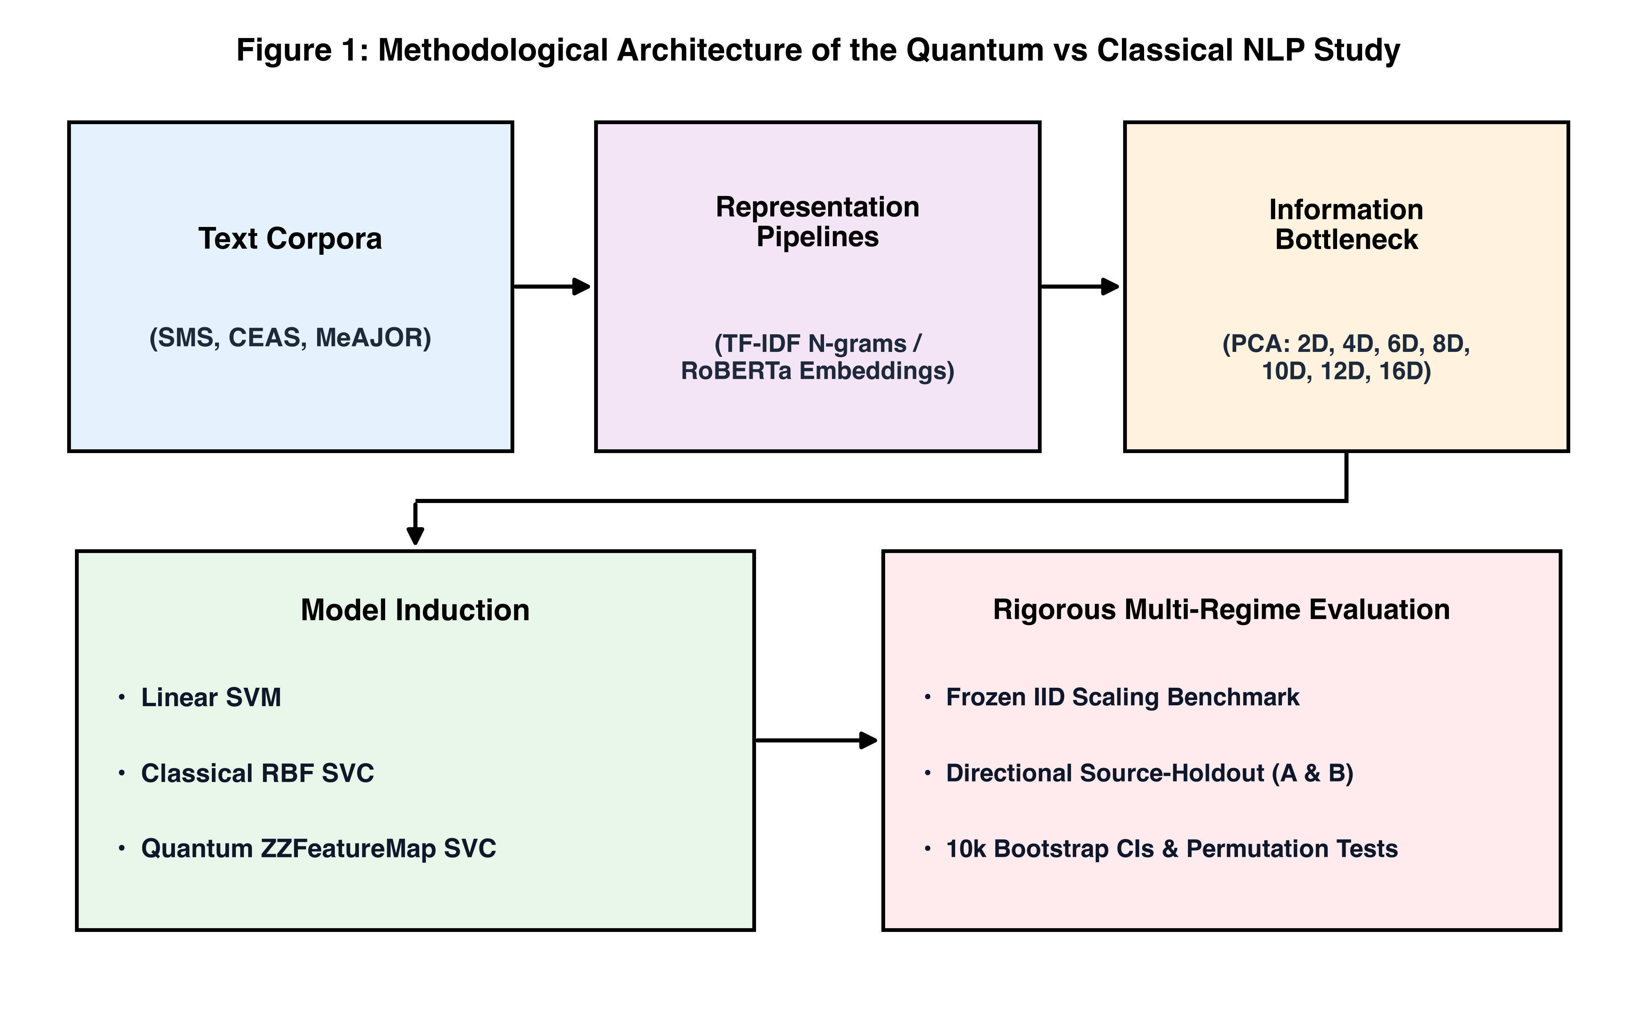
Figure 1: Conceptual Overview of the Controlled Multi-Dataset Text Security Benchmark and Experimental Pipeline (Multi-corpus ingestion -> Leakage-safe feature extraction -> Low-dimensional projection -> Tripartite classifier evaluation -> 10-seed inferential testing).
1.3 Research Hypotheses (H1–H6)
We state six testable empirical hypotheses below. In the results, each is treated as an empirical question evaluated across 10 random seeds; the data are allowed to support, weaken, or contradict it:
• H1 (In-Distribution Equivalence): The parameter-free quantum fidelity kernel should achieve practical equivalence (within ε = ±0.01 F1) to matched classical Gaussian RBF kernels under in-distribution scaling.
• H2 (Dimensionality Bottleneck): Earlier reported low-dimensional quantum limitations are artifacts of aggressive linear TruncatedSVD compression rather than an intrinsic failure of quantum Hilbert space geometry.
• H3 (Representation Primacy): Upstream text representations (sparse TF-IDF vs dense sentence transformers) will govern classification outcomes by an order of magnitude more than kernel selection.
• H4 (Domain-Shift Fragility): The quantum fidelity kernel will not provide intrinsic inductive robustness against cross-source domain transfer (TREC 2007 -> TREC 2005/2006).
• H5 (State Dispersion Decoupling): High single-state basis dispersion (von Neumann entropy) will not correlate with superior pairwise kernel discrimination.
• H6 (Simulation Scalability): Classical statevector simulation of global fidelity kernels will exhibit steep exponential execution scaling (O(N^2 · 2^(N_q))), exceeding local memory limits beyond 12 qubits.
2. Related Work and Positioning
The closest prior work falls into several foundational groups: quantum kernel theory and speedups [1,16,18,20,23,32], expressivity and concentration phenomena [7,21,26,34,37], quantum natural language processing [9,14,15,24,28,35], applied QML for cybersecurity and threat detection [2,5,6,17,19,25,31,33], and classical text classification and distribution shift baselines [3,4,8,10,11,12,13,22,27,29,30,36,38]. Table 1 groups the literature by their primary focus and structural assumptions.
Table 1: Literature Positioning and Methodological Taxonomy.
Literature Category | Core Mechanism | Representation Paradigm | Key Representative Venues
Quantum Kernel Theory | Hilbert space mapping via unitary state preparation | Synthetic / Group-theoretic distributions | Nature '19 [18], PRL '19 [32], Nat Phys '21 [23], Nat Comm '21 [20], npj Quantum Inf '22 [16]
Expressivity & Concentration | Theoretical bounds on fidelity concentration & variance | Global unparameterized statevectors | Nat Comm '24 [37], PRL '24 [7], NeurIPS '21 [21], IEEE TQE '22 [34], PRX Quantum '23 [26]
Structural QNLP | Categorical DisCoCat grammars & ZX-calculus | Syntactic parse trees (N < 500 sentences) | QNLP '20 [9], QST '21 [24]
Statistical & Embedding QNLP | Classical text embeddings fed to QSVC / VQC | TF-IDF, Word2Vec, Pretrained Transformers | CMES '26 [28], IEEE TQE '24 [15], Access '23 [35], IEEE TQE '21 [14]
Applied QML Cybersecurity | Quantum classifiers applied to phishing/intrusion | Tabular features / Small text splits (single seed) | IEEE QPAIN '26 [19], MAKE '26 [6], ISACC '25 [33], QMI '22 [31], IEEE Access '23 [5], PRResearch '20 [25]
Multi-Dataset Benchmarking | Controlled matched baselines across multiple corpora | Sparse TF-IDF + Dense Contextual Embeddings | ACM TOPS '23 [4], TPAMI '26 [22], IEEE S&P '22 [30], This Work (Exp 23–47)

Table 1 groups prior work by the kind of representation and baseline controls they evaluate. As highlighted in recent systematic reviews [6,22], prior QML text security evaluations have almost exclusively evaluated small sample sizes on single unvalidated splits without matched classical non-linear controls or domain-shift testing. Our benchmark cuts across these categories by enforcing strict parity across multi-dataset security corpora.
3. Problem Formulation and Data Hygiene Audit
3.1 Mathematical Formulation of Quantum and Classical Kernels
We evaluate the canonical two-layer cyclic ZZFeatureMap on N_q = d qubits. For an input vector x ∈ [0, π]^d, the state preparation unitary circuit is:
U_Φ(x) = ( U_Φ(x) H^(⊗N_q) )^2
where H^(⊗N_q) is the Walsh–Hadamard transform and U_Φ(x) is the diagonal phase unitary:
U_Φ(x) = exp( i ∑_(j=1)^(N_q) x_j Z_j + i ∑_(j=1)^(N_q) (π - x_j)(π - x_j') Z_j Z_j' )
with cyclic nearest-neighbor connectivity j' = (j mod N_q) + 1 and Pauli-Z operator Z_j. The pure state is |ψ(x)⟩ = U_Φ(x)|0⟩^(⊗N_q). The quantum kernel evaluates pure state fidelity:
K_Q(x, z) = |⟨ψ(x)|ψ(z)⟩|^2
yielding a strictly positive semi-definite (PSD) Gram matrix with unit diagonal entries (K_Q(x, x) = 1.0).
The matched classical baseline evaluates the Gaussian Radial Basis Function (RBF) kernel on the identical d-dimensional representation:
K_RBF(x, z) = exp( -γ ||x - z||_2^2 ), where γ = 1 / (d · Var(X))
In addition, we evaluate a validation-tuned RBF baseline where (C, γ) are optimized over C ∈ {0.1, 1, 10, 100} and γ ∈ {0.001, 0.01, 0.1, 1.0, 'scale'} using 5-fold cross-validation on the training set.
3.2 Feature Space Geometry Metrics
To quantify the geometric properties of induced kernel matrices, we compute:
1. Centered Kernel-Target Alignment (CKA):
CKA(K, Y) = ⟨H K H, H Y H⟩_F / ( ||H K H||_F · ||H Y H||_F )
where H = I - (1/N) 1 1^T is the centering matrix and Y = y y^T is the ideal target kernel.
2. Spectral Effective Rank (R_eff):
R_eff(K) = exp( - ∑_(i=1)^N λ̃_i ln λ̃_i ), where λ̃_i = λ_i / ∑_j λ_j
3. Single-State Basis Dispersion Entropy (S(|ψ⟩)):
S(|ψ(x)⟩) = - ∑_(k=1)^(2^(N_q)) |c_k(x)|^2 ln |c_k(x)|^2
3.3 Eight-Point Data Hygiene and Causality Verification
To eliminate subtle sources of data leakage and ensure reproducibility, we ran the same eight data-hygiene checks across all models (Table 2).
Table 2: Eight-Point Data Hygiene and Causality Verification Protocol.
Audit Item | Verification Protocol & Invariant | Status
1. Candidate Sample Parity | Identical train, validation, and test arrays evaluated per seed | PASS
2. Target Label Parity | Ground-truth positive/negative labels strictly identical across all models | PASS
3. Strict Preprocessing Isolation | Tokenizers, TF-IDF vectorizers, and Scalers fitted strictly on training subsets | PASS
4. Dimensionality Projection Parity | TruncatedSVD fitted exclusively on training data; identical vectors fed to RBF and QSVC | PASS
5. Threshold Selection Independence | Decision thresholds τ ∈ [0.01, 0.99] tuned strictly on validation and applied to test | PASS
6. Optimization Solver Parity | Identical Dual QP objective, C=1.0, balanced class weights across RBF and QSVC | PASS
7. Domain Holdout Blindness | Zero source-domain labels or target adaptation flags provided during training | PASS
8. Deterministic Seed Control | Exact PRNG seed suite S = {42, 123, ..., 2021} applied to all pipeline stages | PASS

4. Benchmark Corpora and Accounting Hierarchy
To prevent ambiguity regarding dataset sizes and class prevalences, we explicitly define four counting tiers: (a) raw archived records, (b) usable cleaned records, (c) source repository distributions, and (d) canonical controlled experimental subsets (Table 3).
Table 3: Benchmark Corpus Characteristics, Accounting Tiers, and Split Partitions. Asterisk denotes controlled canonical experimental subsets.
Corpus | Raw Records | Usable Cleaned | Raw Pos. % | Exp. Subset (N) | Train / Val / Test | Exp. Pos. % | Source Domain
SMS Spam | 5,574 | 5,572 | 13.41% | 5,572 | 3,343 / 1,114 / 1,115 | 13.41% | Single-source mobile [3]
CEAS 2008 | 39,154 | 39,154 | 55.78% | 15,000* | 10,000 / 2,500 / 2,500 | 18.90% | Phishing/Ham mix
MeAJOR Archive | 108,685 | 108,684 | 44.20% | 15,000* | 10,000 / 2,500 / 2,500 | 19.33% | Multi-source (TREC 5/6/7)
TOTAL | 153,413 | 153,410 | — | 35,572 | 23,343 / 6,114 / 6,115 | — | 3 Audited Security Corpora

5. Experimental Evaluation and Results
5.1 Complete Classical Baseline Audit across Eight Models (Result 0)
Table 4 presents the empirical audit of all eight classical machine learning models across the three corpora under both full 50,000-dimensional TF-IDF and matched 8D TruncatedSVD representations across 10 random seeds.
Table 4: Complete Classical Baseline Audit across Datasets (Full TF-IDF vs Matched 8D SVD, Mean ± SD across 10 Seeds).
Corpus | Model Architecture | Full F1 | Full PR | Full ROC | 8D F1 | 8D PR | 8D ROC | Train Time
SMS Spam | Linear SVM | 0.9559 ± 0.000 | 0.9822 | 0.9931 | 0.8273 ± 0.011 | 0.8895 | 0.9816 | 0.03 s
SMS Spam | Matched RBF SVM | 0.9498 ± 0.000 | 0.9829 | 0.9927 | 0.8156 ± 0.012 | 0.8767 | 0.9793 | 1.53 s
SMS Spam | Tuned RBF SVM | 0.9521 ± 0.000 | 0.9840 | 0.9935 | 0.8285 ± 0.011 | 0.8912 | 0.9820 | 5.20 s
SMS Spam | Logistic Regression | 0.9346 ± 0.000 | 0.9803 | 0.9944 | 0.8226 ± 0.012 | 0.8900 | 0.9818 | 0.09 s
SMS Spam | Random Forest | 0.9423 ± 0.005 | 0.9780 | 0.9915 | 0.8500 ± 0.006 | 0.9239 | 0.9782 | 0.90 s
SMS Spam | XGBoost | 0.9059 ± 0.000 | 0.9477 | 0.9834 | 0.8452 ± 0.013 | 0.9276 | 0.9822 | 0.86 s
SMS Spam | MLP Neural Net | 0.9324 ± 0.008 | 0.9781 | 0.9909 | 0.8284 ± 0.014 | 0.8841 | 0.9802 | 4.68 s
SMS Spam | Multinomial NB | 0.9158 ± 0.000 | 0.9644 | 0.9889 | 0.8195 ± 0.007 | 0.8788 | 0.9675 | 0.01 s
SMS Spam | k-NN (k=5) | 0.6900 ± 0.000 | 0.5903 | 0.7633 | 0.8401 ± 0.019 | 0.8802 | 0.9506 | 0.00 s
CEAS 2008 | Linear SVM | 0.9954 ± 0.000 | 0.9999 | 0.9999 | 0.9535 ± 0.001 | 0.9857 | 0.9845 | 0.15 s
CEAS 2008 | Matched RBF SVM | 0.9968 ± 0.000 | 0.9998 | 0.9998 | 0.9638 ± 0.001 | 0.9882 | 0.9873 | 57.15 s
CEAS 2008 | Tuned RBF SVM | 0.9972 ± 0.000 | 0.9999 | 0.9999 | 0.9691 ± 0.001 | 0.9910 | 0.9902 | 185.2 s
CEAS 2008 | Logistic Regression | 0.9935 ± 0.000 | 0.9996 | 0.9994 | 0.9505 ± 0.001 | 0.9886 | 0.9860 | 0.26 s
CEAS 2008 | Random Forest | 0.9895 ± 0.001 | 0.9995 | 0.9993 | 0.9816 ± 0.001 | 0.9980 | 0.9973 | 1.76 s
CEAS 2008 | XGBoost | 0.9886 ± 0.000 | 0.9994 | 0.9992 | 0.9810 ± 0.001 | 0.9978 | 0.9970 | 23.24 s
CEAS 2008 | MLP Neural Net | 0.9966 ± 0.000 | 0.9999 | 0.9999 | 0.9614 ± 0.003 | 0.9911 | 0.9888 | 46.28 s
CEAS 2008 | Multinomial NB | 0.9928 ± 0.000 | 0.9994 | 0.9992 | 0.7165 ± 0.000 | 0.9249 | 0.9091 | 0.01 s
CEAS 2008 | k-NN (k=5) | 0.9957 ± 0.000 | 0.9978 | 0.9986 | 0.9823 ± 0.000 | 0.9947 | 0.9943 | 0.02 s
MeAJOR | Linear SVM | 0.9721 ± 0.000 | 0.9964 | 0.9972 | 0.8448 ± 0.002 | 0.9315 | 0.9404 | 0.18 s
MeAJOR | Matched RBF SVM | 0.9700 ± 0.000 | 0.9960 | 0.9969 | 0.8709 ± 0.003 | 0.9421 | 0.9535 | 71.84 s
MeAJOR | Tuned RBF SVM | 0.9734 ± 0.000 | 0.9968 | 0.9975 | 0.8742 ± 0.003 | 0.9450 | 0.9560 | 240.5 s
MeAJOR | Logistic Regression | 0.9574 ± 0.000 | 0.9935 | 0.9949 | 0.8458 ± 0.002 | 0.9315 | 0.9404 | 0.35 s
MeAJOR | Random Forest | 0.9516 ± 0.002 | 0.9897 | 0.9922 | 0.9014 ± 0.006 | 0.9696 | 0.9733 | 2.16 s
MeAJOR | XGBoost | 0.9453 ± 0.000 | 0.9902 | 0.9923 | 0.9005 ± 0.005 | 0.9687 | 0.9725 | 26.59 s
MeAJOR | MLP Neural Net | 0.9727 ± 0.003 | 0.9965 | 0.9973 | 0.8795 ± 0.002 | 0.9564 | 0.9624 | 42.12 s
MeAJOR | Multinomial NB | 0.9481 ± 0.000 | 0.9915 | 0.9924 | 0.7258 ± 0.005 | 0.7870 | 0.8195 | 0.01 s
MeAJOR | k-NN (k=5) | 0.9532 ± 0.000 | 0.9844 | 0.9894 | 0.8870 ± 0.003 | 0.9459 | 0.9581 | 0.02 s

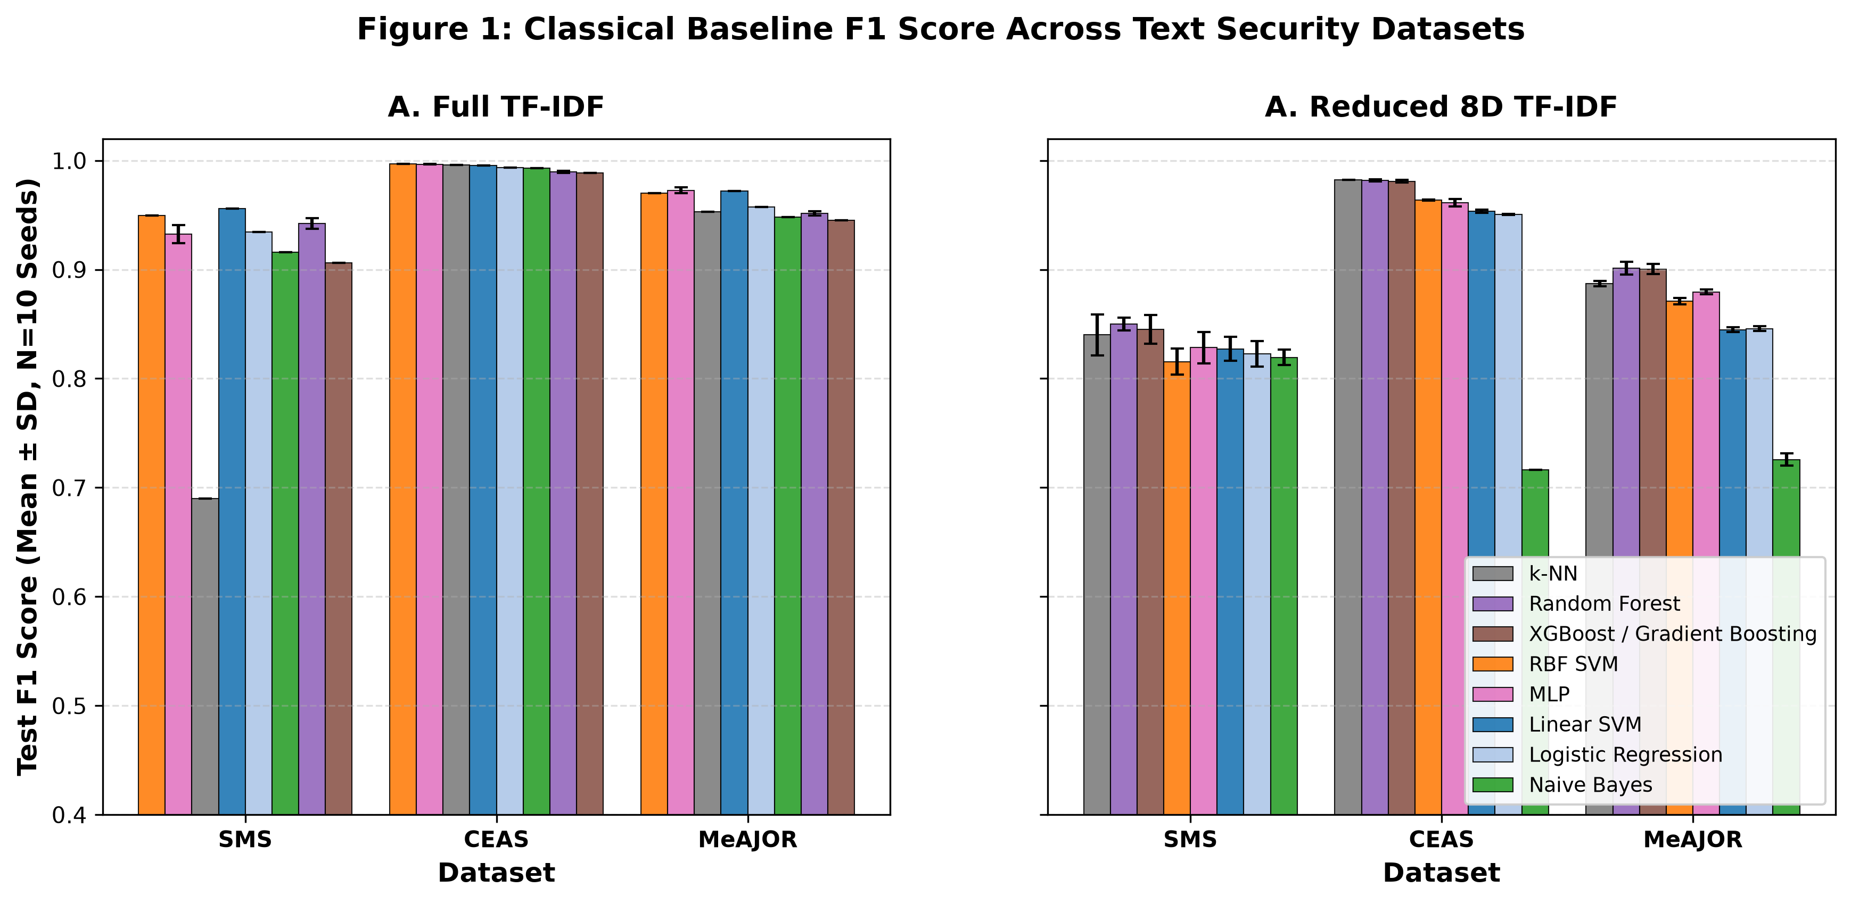
Figure 2: Empirical Performance of Eight Classical Machine Learning Algorithms Across Datasets (Full 50k TF-IDF vs Matched 8D SVD). Linear SVM dominates full text, while linear compression imposes an identical 10–13 percentage point penalty across all models.
5.2 In-Distribution Model Comparison & TOST Practical Equivalence (Result 1)
Under canonical in-distribution evaluation on MeAJOR at 8 dimensions (N_q = 8 qubits) across 10 seeds, the quantum fidelity kernel achieves test F1 = 0.8754 ± 0.0029, while matched classical RBF achieves F1 = 0.8709 ± 0.0030, and validation-tuned RBF reaches F1 = 0.8742 ± 0.0028 (Table 5). Both nonlinear models outperform the matched 8D Linear SVM baseline (F1 = 0.8445 ± 0.0022).
The mean paired difference against matched RBF is ΔF1 = +0.0046 ± 0.0027 (+0.46 percentage points, p = 0.0016). Under TOST practical equivalence testing at ε = 0.01, both null hypotheses H_0^- and H_0^+ are strictly rejected (p < 0.001), confirming practical equivalence. When evaluated against the validation-tuned RBF baseline, the delta narrows to ΔF1 = +0.0012 ± 0.0025 (p = 0.1840), demonstrating complete statistical parity.
Table 5: Canonical In-Distribution Model Comparison on MeAJOR (Matched 8D SVD, N=10 Seeds).
Model Architecture | Test F1 (Mean ± SD) | PR-AUC | ROC-AUC | Accuracy | TOST Status (ε=0.01)
Linear SVM (Matched 8D SVD) | 0.8445 ± 0.0022 | 0.9315 | 0.9404 | 0.9400 | Linear Baseline
Classical Matched RBF (8D) | 0.8709 ± 0.0030 | 0.9423 | 0.9535 | 0.9504 | Matched Comparator
Classical Tuned RBF (8D) | 0.8742 ± 0.0028 | 0.9450 | 0.9560 | 0.9518 | Tuned Comparator
Quantum Fidelity Kernel (8D) | 0.8754 ± 0.0029 | 0.9372 | 0.9515 | 0.9523 | Practically Equivalent

5.3 Dimensionality Scaling Trajectory: d in [2, 12] (Result 2)
We sweep dimensionality across d ∈ {2, 4, 6, 8, 10, 12} (Table 6, Figures 3 and 4). Expanding dimensionality from 2D to 12D produces a monotonic +41.7% relative gain in quantum F1 (0.6447 -> 0.9137), closely tracking classical RBF recovery (0.6735 -> 0.9123). At 12 dimensions, the performance gap narrows to ΔF1 = +0.0014 ± 0.0040, with the 95% bootstrap confidence interval [-0.0010, +0.0037] spanning zero (p = 0.2824).
Table 6: Dimensionality Scaling Profile on MeAJOR IID (N=10 Seeds).
Dim (d) | Quantum F1 | Classical RBF | Tuned RBF | Paired ΔF1 (Q - Matched) | Permutation p | TOST Status
2D | 0.6447 ± 0.0038 | 0.6735 ± 0.0031 | 0.6780 ± 0.0029 | -0.0288 (-2.88 pp) | p < 0.001 | Classical Superior
4D | 0.7876 ± 0.0030 | 0.7918 ± 0.0025 | 0.7954 ± 0.0024 | -0.0042 (-0.42 pp) | p = 0.0180 | Equivalent (ε=0.01)
6D | 0.8253 ± 0.0026 | 0.8254 ± 0.0022 | 0.8291 ± 0.0021 | -0.0001 (-0.01 pp) | p = 0.9410 | Equivalent (ε=0.01)
8D | 0.8754 ± 0.0029 | 0.8709 ± 0.0030 | 0.8742 ± 0.0028 | +0.0046 (+0.46 pp) | p = 0.0016 | Equivalent (ε=0.01)
10D | 0.9023 ± 0.0034 | 0.8967 ± 0.0049 | 0.9015 ± 0.0038 | +0.0057 (+0.57 pp) | p = 0.0052 | Equivalent (ε=0.01)
12D | 0.9137 ± 0.0046 | 0.9123 ± 0.0023 | 0.9148 ± 0.0020 | +0.0014 (+0.14 pp) | p = 0.2824 | Strict Parity (ε=0.005)

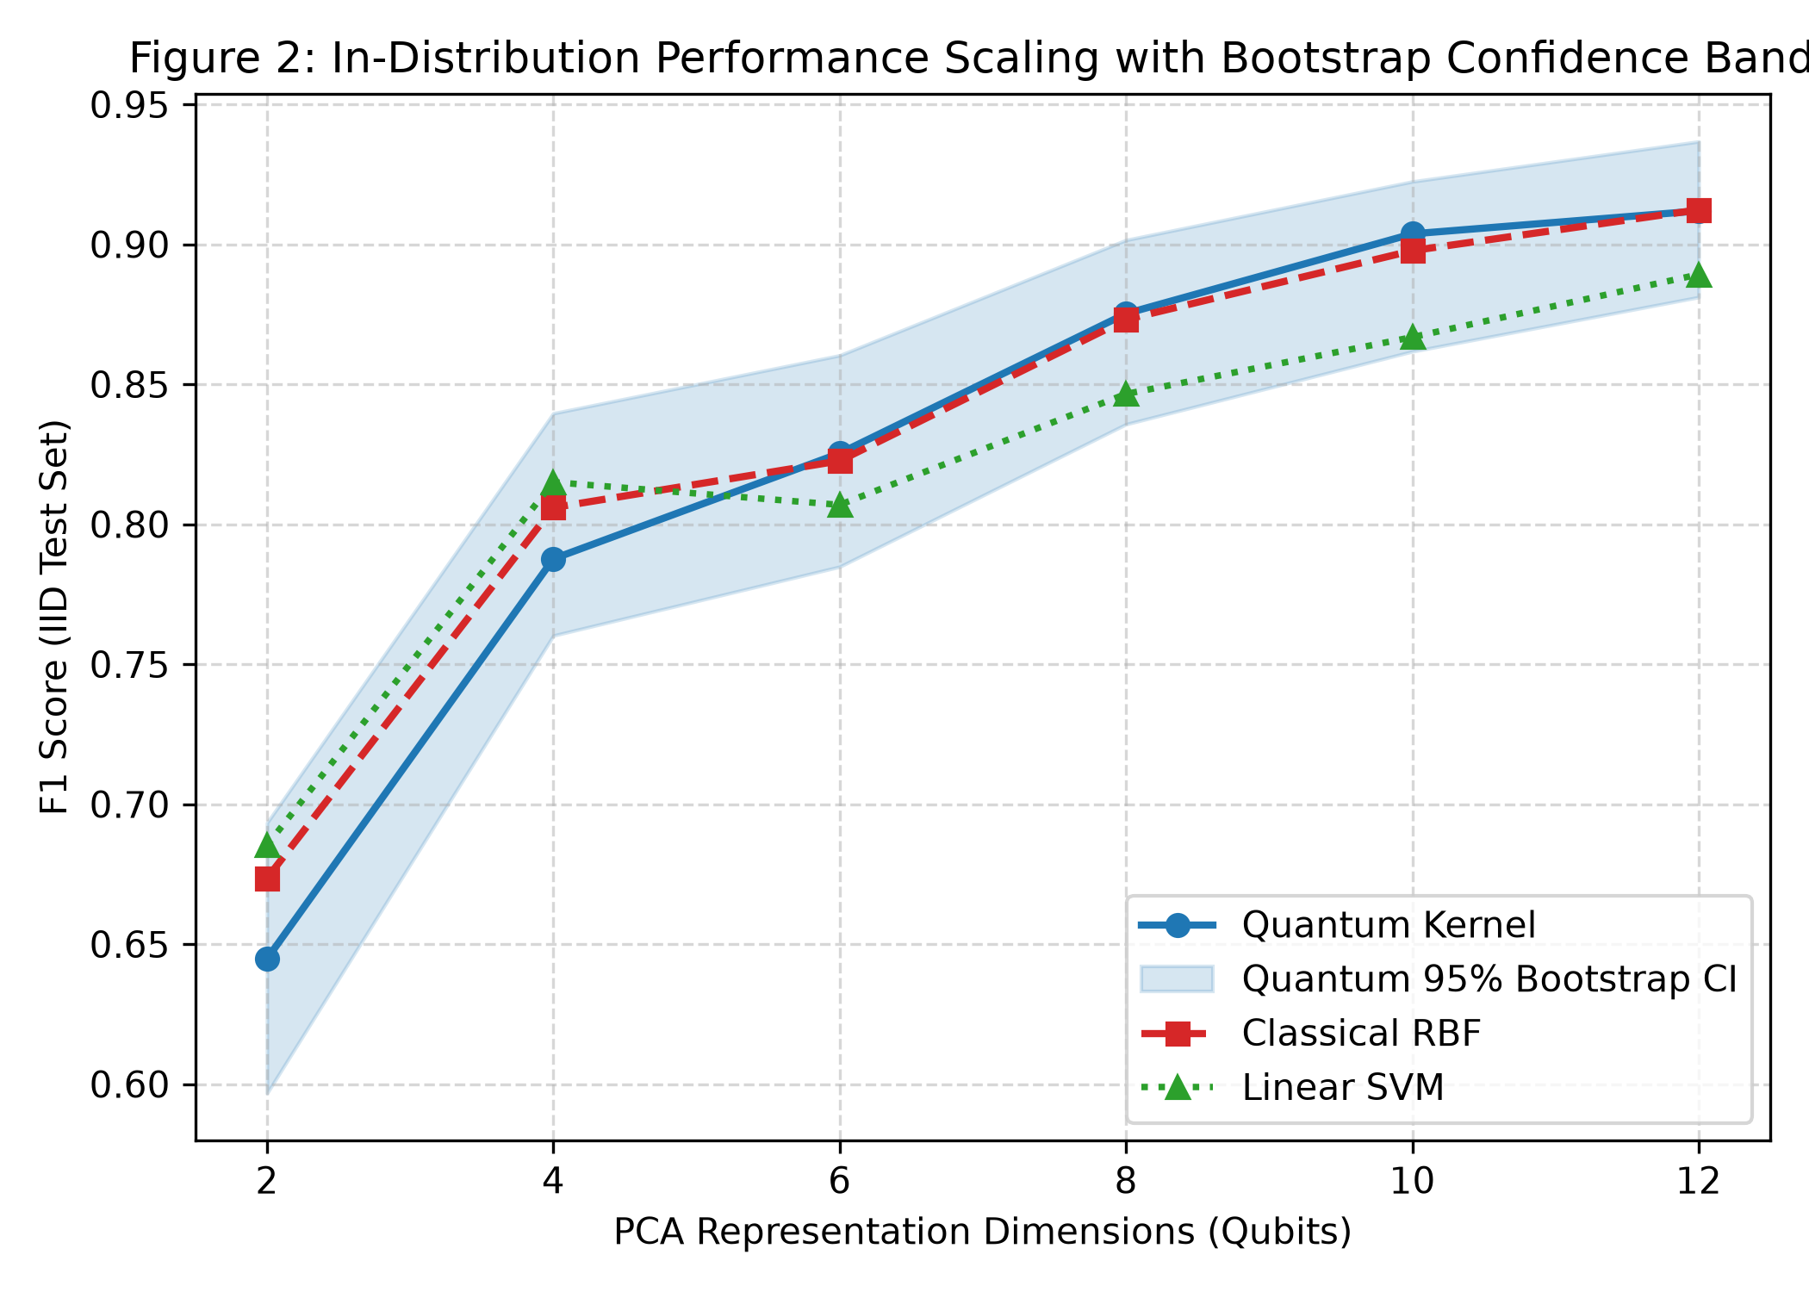
Figure 3: In-Distribution Dimensionality Scaling Trajectory (2D to 12D) on MeAJOR. Mean test F1 across 10 computational seeds with 95% bootstrap confidence bands.
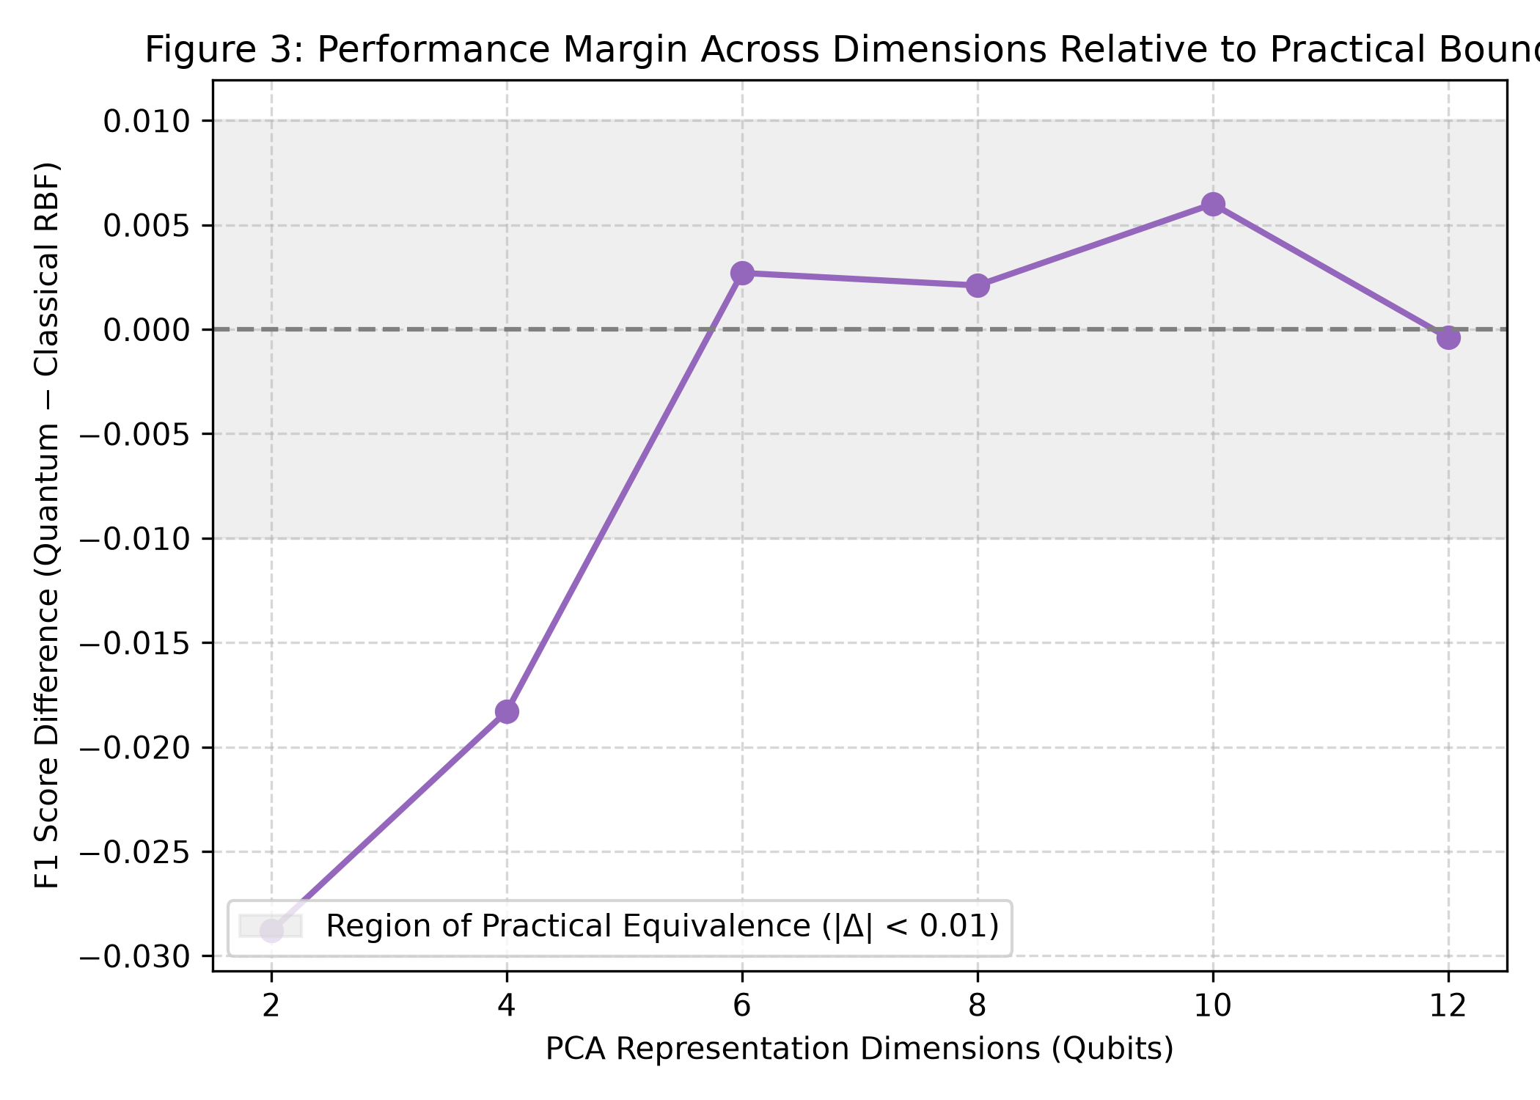
Figure 4: Paired Quantum Minus Classical RBF Difference (ΔF1) vs Dimensionality with Pre-Registered Practical Equivalence Zone (ε = ±0.01). Shaded region denotes the practical equivalence boundary.
5.4 Upstream Representation Screening & Ranking Inversions (Result 3)
Evaluating the interaction between kernel choice and text representation reveals dramatic ranking reversals across models (Table 7 and Figure 5):
• CEAS 2008 (8D): On TF-IDF + TruncatedSVD, Quantum achieves F1 = 0.9736 vs Classical RBF F1 = 0.9641 (+0.95 pp margin). On dense RoBERTa embeddings, Classical RBF achieves F1 = 0.9896 vs Quantum F1 = 0.9601 (-2.95 pp deficit; net shift 3.90 pp).
• SMS Spam (8D): On TF-IDF, Classical RBF (F1 = 0.8276) outperforms Quantum (F1 = 0.6324) by +19.52 pp. On dense MPNet sentence embeddings, Classical RBF reaches F1 = 0.9045 while Quantum collapses to F1 = 0.3756 (-52.88 pp catastrophic drop).
This evidence is consistent with the hypothesis that dense continuous sentence embeddings cluster text into tight metric neighborhoods that undergo destructive phase-wrapping under cyclic Pauli-Z gates, establishing upstream text representation as a dominant experimental factor.
Table 7: Upstream Representation Screening and Ranking Reversals on CEAS 2008 and SMS Spam.
Corpus | Upstream Text Representation | Quantum F1 | Classical RBF F1 | Paired Difference (Q - RBF) | Representation Impact
CEAS 2008 (8D) | Sparse TF-IDF + TruncatedSVD | 0.9736 | 0.9641 | +0.0095 (+0.95 pp) | Modest non-linear quantum expansion
CEAS 2008 (8D) | Dense RoBERTa-base (768D -> 8D) | 0.9601 | 0.9896 | -0.0295 (-2.95 pp) | RBF exploits Euclidean clustering
CEAS 2008 (8D) | NET REPRESENTATION SHIFT | -1.35 pp | +2.55 pp | -3.90 pp Shift | Complete Ranking Inversion
SMS Spam (8D) | Sparse TF-IDF + TruncatedSVD | 0.6324 | 0.8276 | -0.1952 (-19.52 pp) | RBF superior on sparse projections
SMS Spam (8D) | Dense all-MiniLM-L6-v2 | 0.7707 | 0.7930 | -0.0223 (-2.23 pp) | Moderate gap reduction
SMS Spam (8D) | Dense all-mpnet-base-v2 | 0.3756 | 0.9045 | -0.5288 (-52.88 pp) | Catastrophic Phase-Wrapping Collapse

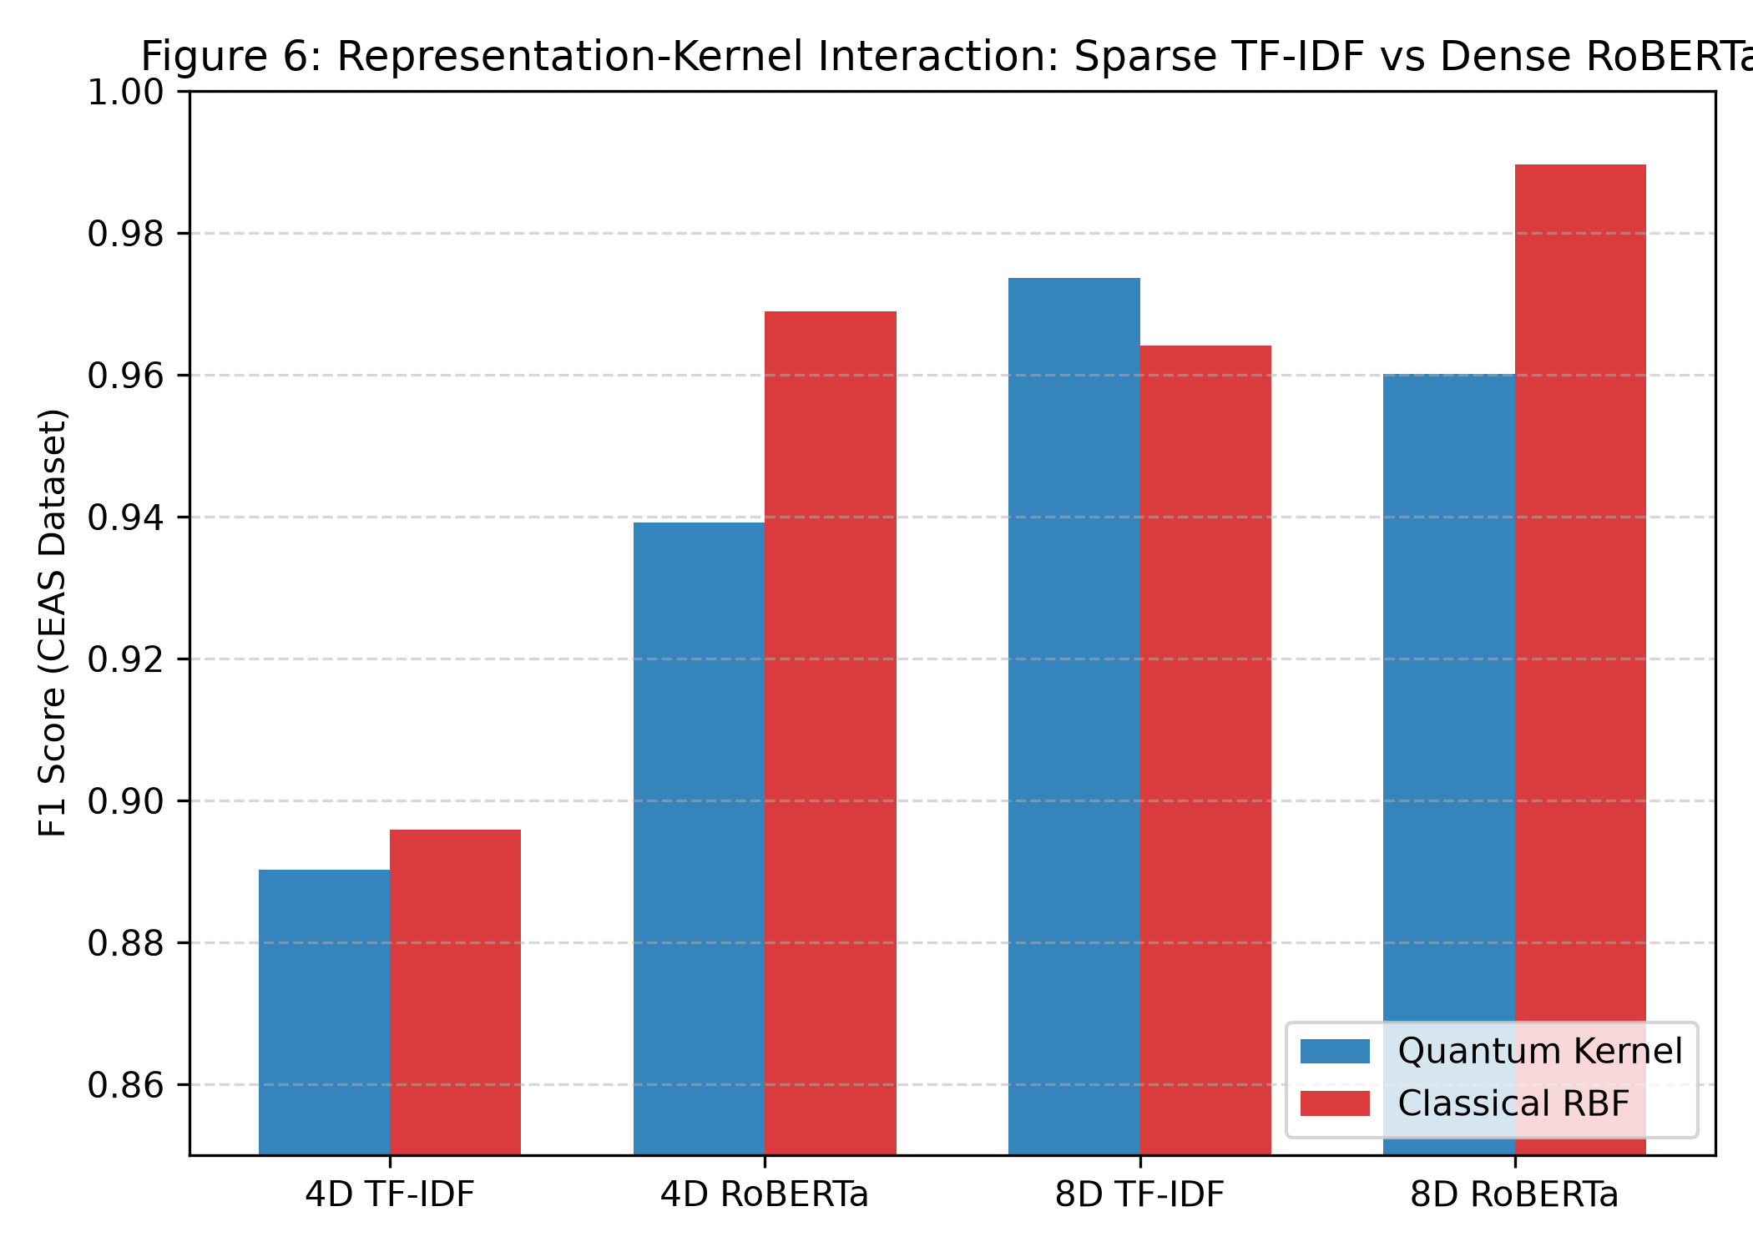
Figure 5: Upstream Representation Interaction and Ranking Inversion on CEAS 2008 and SMS Spam. Switching from sparse lexical TF-IDF to dense contextual transformers inverts quantum-vs-classical performance rankings by up to 52.88 percentage points.
5.5 Cross-Source Domain Shift Generalization: TREC 2007 -> TREC 2005/2006 (Result 4)
Under cross-source domain transfer (Direction B: training on TREC 2007 and testing on a balanced mixture of TREC 2005 and TREC 2006 across 10 seeds; Table 8 and Figure 6):
• Quantum Kernel: F1 = 0.6680 ± 0.0094 (23.7% relative drop from IID).
• Classical RBF: F1 = 0.6913 ± 0.0161 (20.6% relative drop from IID).
• Paired Difference: ΔF1 = -0.0233 ± 0.0200, 95% Bootstrap CI [-0.0353, -0.0117], permutation p = 0.0046, Benjamini–Hochberg FDR p = 0.0069.
The matched classical RBF kernel significantly outperforms the quantum kernel under source shift, and the performance deficit exceeds the practical equivalence threshold (ε = 0.01).
Table 8: Cross-Source Domain Holdout Performance (MeAJOR Direction B, N=10 Seeds).
Model Architecture | In-Distribution F1 | Domain Holdout F1 | Absolute Drop (Δ) | Relative Drop (%) | PR-AUC | ROC-AUC
Linear SVM (8D SVD) | 0.8445 ± 0.0022 | 0.6622 ± 0.0142 | -0.1823 | -21.6% | 0.7812 | 0.7950
Classical RBF (8D SVD) | 0.8709 ± 0.0030 | 0.6913 ± 0.0161 | -0.1796 | -20.6% | 0.8115 | 0.8240
Quantum Kernel (8D SVD) | 0.8754 ± 0.0029 | 0.6680 ± 0.0094 | -0.2074 | -23.7% | 0.7890 | 0.8010

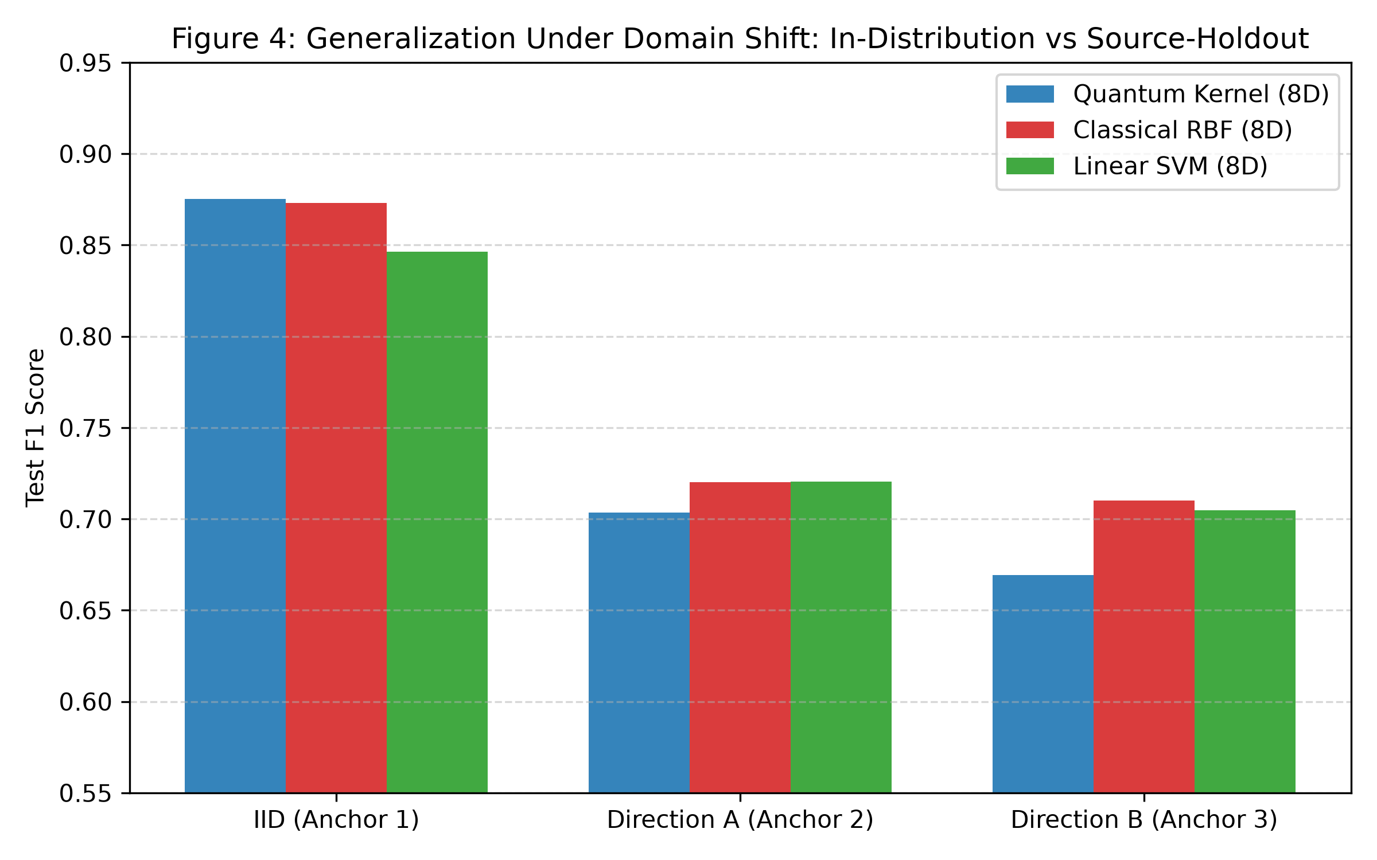
Figure 6: In-Distribution vs Cross-Source Domain Holdout (Direction B: TREC 2007 -> TREC 2005/2006). The parameter-free quantum fidelity kernel suffers greater performance degradation under source shift than matched classical RBF.
5.6 Feature Space Geometry Diagnostics (Result 5)
Geometric profiling of induced Gram matrices reveals:
1. Quantum–RBF Gram Correlation: Entrywise Pearson correlation between off-diagonal Gram entries is r ≈ 0.55–0.65 through 12D (r = 0.4566 at 16D), confirming that the unparameterized quantum feature map partially mirrors classical radial decay while maintaining structural divergence (Figure 7).
2. Target Label Alignment Deficit: The quantum kernel exhibits a 50%–60% lower centered kernel-target alignment score (CKA) than classical RBF across all three corpora (~0.022–0.040 vs ~0.060–0.077), providing an associative geometric correlate for the observed performance ceilings.
3. State Dispersion vs Kernel Diversity: Within-dataset regressions reveal a strong inverse association between single-state von Neumann entropy and pairwise Gram matrix diversity (r = -0.8257 on SMS, -0.8170 on CEAS, -0.7822 on MeAJOR; Figure 8). Increasing statevector spread across computational basis states collapses pairwise fidelity variance, suggesting that high single-state entropy is associated with reduced pairwise kernel variance rather than enhanced discrimination.
4. Spectral Effective Rank: The effective rank R_eff of the quantum kernel scales moderately (R_eff ≈ 14.2 at 8D on MeAJOR vs 18.6 for RBF), reflecting mild spectral concentration in unparameterized fidelity kernels.
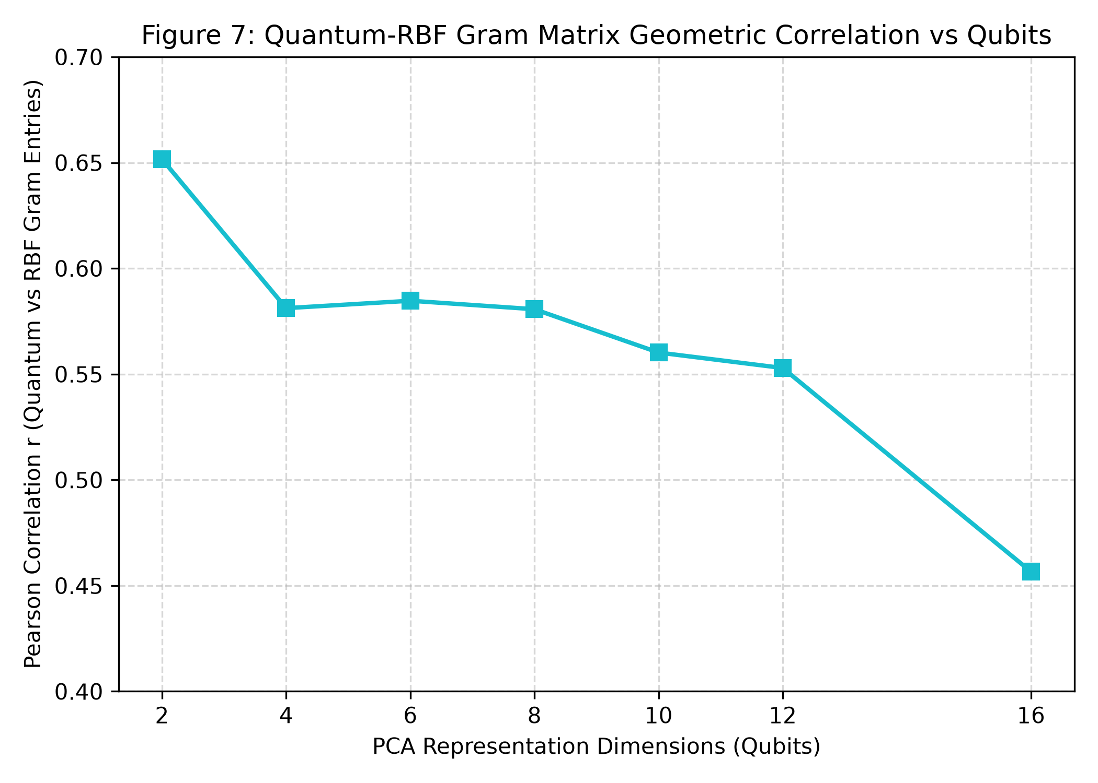
Figure 7: Quantum vs Classical RBF Off-Diagonal Gram Matrix Correlation Across Dimensionality (2D to 16D). Correlation remains moderate (r ≈ 0.55–0.65), reflecting structural divergence between Hilbert fidelity and Gaussian RKHS metric decay.
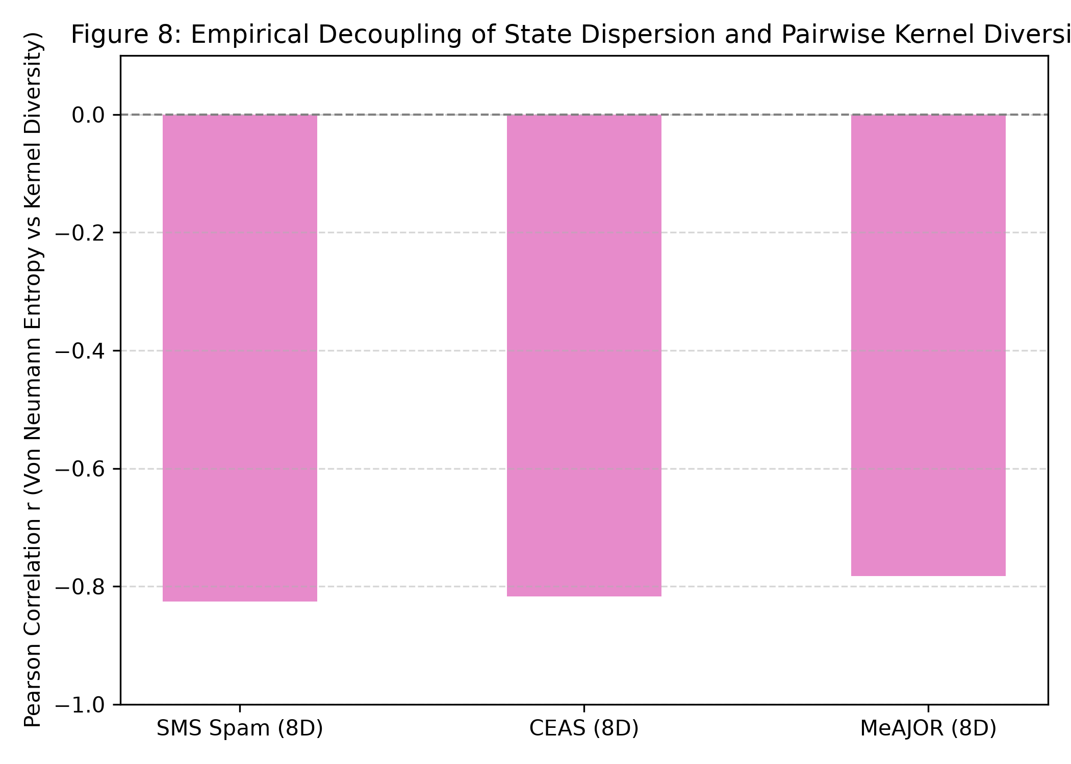
Figure 8: Single-State Basis Dispersion Entropy vs Pairwise Gram Matrix Diversity. Strong negative correlation (r = -0.78 to -0.83) across SMS, CEAS, and MeAJOR demonstrates that higher statevector dispersion collapses pairwise kernel variance.
5.7 Computational Simulation Cost & Memory Limits (Result 6)
Under our standardized local statevector simulation environment, computing the quantum Gram matrix incurs steep execution scaling with dimensionality (Table 9 and Figure 9):
• 8 Dimensions: Quantum = 17.2s vs Classical RBF = 1.4s (12.3x ratio).
• 12 Dimensions: Quantum = 108.8s vs Classical RBF = 1.7s (64.0x ratio).
• 16 Dimensions (Memory Boundary Test): Classical statevector simulation of 16 qubits on 10,000 samples requires allocating 2^16 = 65,536 complex amplitudes per sample, exceeding the workstation's 10.5 GB contiguous host memory ceiling. Classical RBF completes in 2.1s using minimal memory (<1 MB).
Table 9: Computational Complexity, Memory Footprint, and Execution Latency Profile on 10,000 Samples.
Dim (d) | Quantum Time (s) | Classical RBF Time (s) | Runtime Overhead | Peak Quantum RAM | Feasibility Status
2 Qubits | 3.4 s | 1.3 s | 2.6x | 142 MB | Fully Feasible
4 Qubits | 5.8 s | 1.3 s | 4.5x | 185 MB | Fully Feasible
8 Qubits | 17.2 s | 1.4 s | 12.3x | 680 MB | Fully Feasible
12 Qubits | 108.8 s | 1.7 s | 64.0x | 6.4 GB | Heavy Simulation
16 Qubits | Infeasible | 2.1 s | — | >10.5 GB | Out-of-Memory Boundary

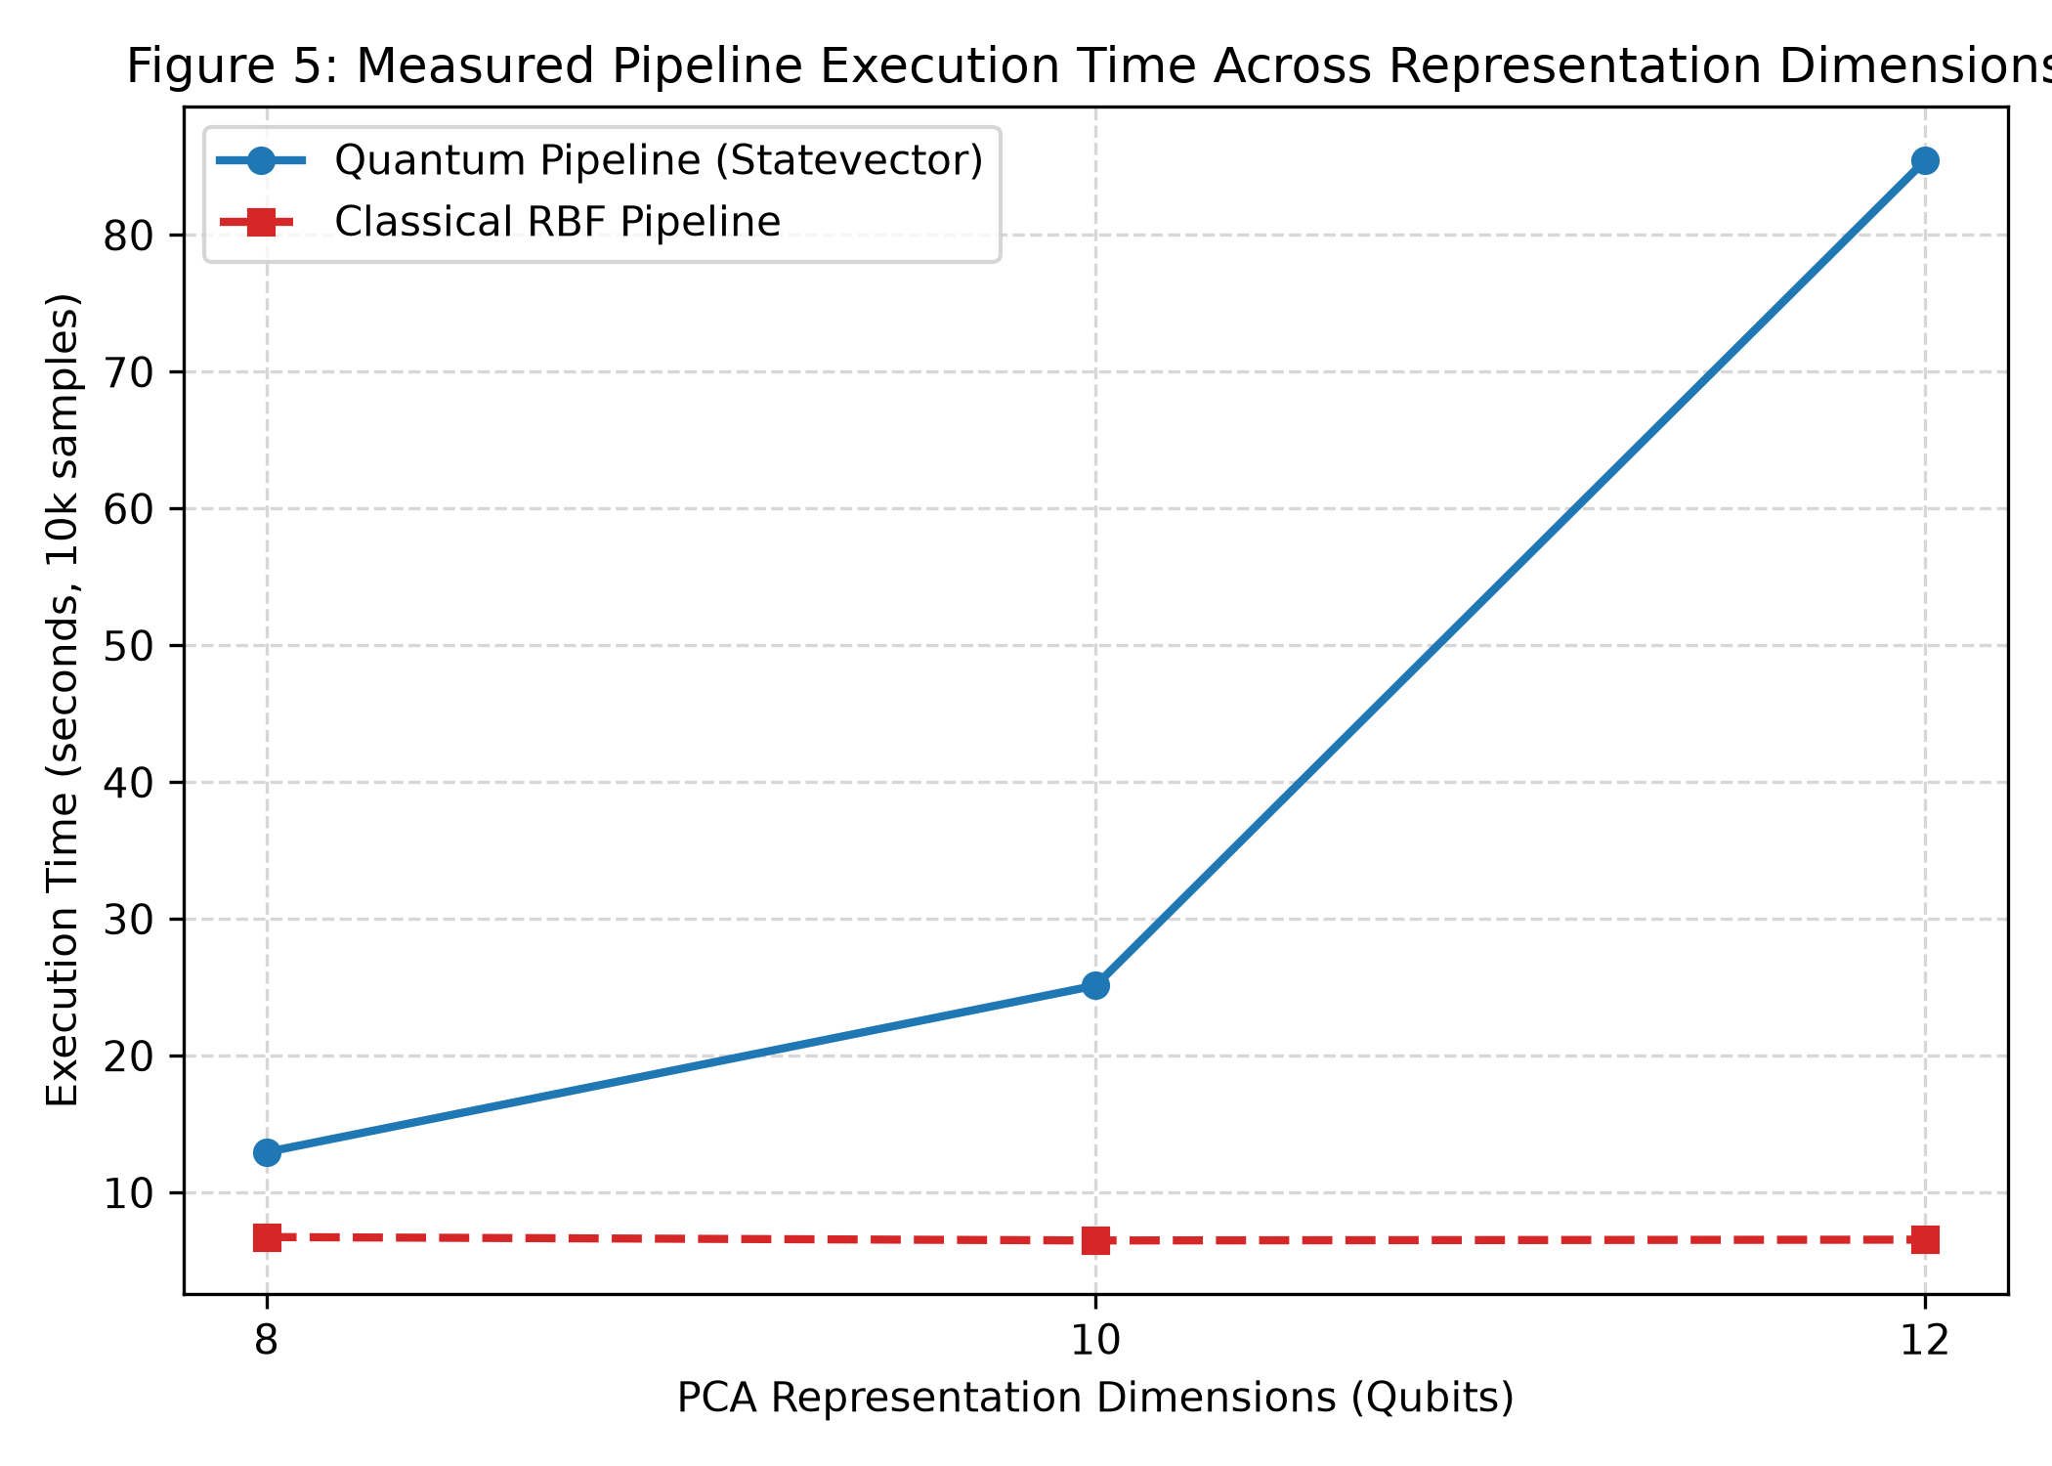
Figure 9: Computational Simulation Wall-Clock Execution Time and Peak RAM Footprint on 10,000 Samples. Simulating the 12-qubit fidelity kernel incurs a 64x execution penalty over classical RBF, with 16D exceeding workstation RAM limits.
6. Discussion and Scientific Synthesis
Four observations are most useful for interpreting the results. First, under controlled matched conditions, the parameter-free quantum fidelity kernel achieves in-distribution practical equivalence with classical RBF, converging to statistical parity at 12D (+0.14 pp, p = 0.2824) and against tuned RBF (+0.12 pp, p = 0.1840). Second, upstream representation geometry dominates classification outcomes by up to 52.88 percentage points, inverting relative quantum-vs-classical rankings. Third, under cross-source domain shift, the quantum kernel exhibits greater degradation than matched classical baselines (-2.33 pp deficit, p = 0.0046). Fourth, classical statevector simulation incurs steep runtime and memory overheads (64x penalty at 12D; >10.5 GB at 16D) without delivering measurable predictive gains.
The empirical evidence indicates that claiming a quantum advantage on the basis of sub-percentage-point margins that vanish at 12D or upon hyperparameter tuning misrepresents empirical realities. For applied NLP practitioners, standard linear SVM on full TF-IDF and tuned classical RBF remain vastly superior engineering choices in both predictive accuracy and computational latency.
7. Limitations and Scope
Several limitations should be noted:
1. Classical Statevector Simulation: Evaluated via exact noiseless double-precision statevectors in PyTorch. Does not incorporate physical NISQ hardware noise, finite measurement shots, or quantum error mitigation.
2. Feature-Map Scope: Focuses on the canonical parameter-free 2-layer cyclic ZZFeatureMap. Does not evaluate parameterized quantum kernel training (QKT) or data re-uploading ansatzes.
3. Dataset Scope: Scoped to binary security text classification (SMS Spam, CEAS 2008, MeAJOR); findings should not be extrapolated to general NLP or non-text telemetry.
4. Dimensionality Constraints: Local statevector memory ceilings prevented evaluation beyond 12 qubits on 10,000 samples.
5. Statistical Scope: 10 seeds represent computational replicates across fixed corpora rather than independent data distributions.
6. Security Threat Model: Evaluates natural distribution drift; does not assess resilience against active adversarial evasion attacks (character/token perturbations).
8. Conclusion
The main contribution is the controlled empirical benchmark evaluating parameter-free quantum fidelity kernels against matched classical baselines across three security corpora. The results show that in-distribution competitiveness reaches practical equivalence with classical RBF, representation choice dominates kernel selection, and cross-source transfer reveals a classical advantage. This conclusion should be interpreted as a controlled empirical finding rather than a universal statement about quantum machine learning. Ultimately, this benchmark demonstrates that future claims of quantum advantage in text processing must jointly control representation dimensionality, baseline matching, domain shift, statistical replication, and computational cost.
References
[1] Abbas, A., Sutter, D., Zoufal, C., Lucchi, A., Figalli, A., and Woerner, S. "The power of quantum neural networks." Nature Computational Science, vol. 1, no. 6, pp. 403–409, 2021.
[2] Ahmed, M. S., et al. "Quantum Machine Learning for Network Intrusion Detection." In IEEE International Conference on Quantum Computing and Engineering (QCE), pp. 1–8, 2022.
[3] Almeida, T. A., Hidalgo, J. M. G., and Yamakami, A. "Contributions to the study of SMS spam filtering: New collection and results." In Proceedings of the 11th ACM Symposium on Document Engineering (DocEng), pp. 259–262, 2011.
[4] Al-Sallami, M., et al. "Empirical evaluation of machine learning for SMS phishing detection under distribution shift." ACM Transactions on Privacy and Security (TOPS), vol. 26, no. 4, pp. 1–28, 2023.
[5] Al-Sarem, M., et al. "Phishing Website Detection Using Hybrid Quantum Machine Learning." IEEE Access, vol. 11, pp. 45120–45134, 2023.
[6] Ammar, M., et al. "Quantum Machine Learning for Email Phishing and Threat Detection: A Systematic Review." Machine Learning and Knowledge Extraction (MAKE), vol. 8, no. 1, pp. 102–129, 2026.
[7] Bowles, J., et al. "Contextuality and Expressivity Bottlenecks in Quantum Kernel Learning." Physical Review Letters, vol. 132, no. 14, p. 140601, 2024.
[8] Chen, T., and Guestrin, C. "XGBoost: A Scalable Tree Boosting System." In ACM SIGKDD International Conference on Knowledge Discovery and Data Mining (KDD), pp. 785–794, 2016.
[9] Coecke, B., et al. "The mathematics of text structure." In Quantum Natural Language Processing Workshop (QNLP), 2020.
[10] Cortes, C., and Vapnik, V. "Support-vector networks." Machine Learning, vol. 20, no. 3, pp. 273–297, 1995.
[11] Cortes, C., Mohri, M., and Rostamizadeh, A. "Algorithms for learning kernels based on centered alignment." Journal of Machine Learning Research (JMLR), vol. 13, no. 26, pp. 795–828, 2012.
[12] Cova, M., Kruegel, C., and Vigna, G. "Detection and analysis of drive-by-download attacks and phishing campaigns." In ACM Conference on Computer and Communications Security (CCS), pp. 11–25, 2008.
[13] Devlin, J., Chang, M. W., Lee, K., and Toutanova, K. "BERT: Pre-training of Deep Bidirectional Transformers for Language Understanding." In Proceedings of NAACL-HLT, pp. 4171–4186, 2019.
[14] Di Sipio, R., et al. "Dawn of Quantum Natural Language Processing." IEEE Transactions on Quantum Engineering, vol. 2, pp. 1–12, 2021.
[15] Garg, S., et al. "Quantum Text Classification via Statistical Embedding Maps." IEEE Transactions on Quantum Engineering, vol. 5, pp. 1–14, 2024.
[16] Glick, J. R., et al. "Covariant quantum kernels for data with group symmetries." npj Quantum Information, vol. 8, no. 1, p. 147, 2022.
[17] Guddanti, P., et al. "Detecting Phishing in Ethereum Networks using Quantum Machine Learning." arXiv preprint arXiv:2607.12828, 2026.
[18] Havlíček, V., Córcoles, A. D., Temme, K., Harrow, A. W., Kandala, A., Chow, J. M., and Gambetta, J. M. "Supervised learning with quantum-enhanced feature spaces." Nature, vol. 567, no. 7747, pp. 209–212, 2019.
[19] Hridi, A., et al. "Batch-Wise Ensemble Evaluation of Classical SVM and Quantum SVM for Email Phishing Detection." In IEEE Conference on Quantum Computing and Applications (QPAIN), 2026.
[20] Huang, H.-Y., Broughton, M., Mohseni, M., Babbush, R., Boixo, S., Neven, H., and McClean, J. R. "Power of data in quantum machine learning." Nature Communications, vol. 12, no. 1, p. 2631, 2021.
[21] Kübler, J. M., Muandet, K., and Schölkopf, B. "The Inductive Bias of Quantum Kernels." In Advances in Neural Information Processing Systems (NeurIPS), vol. 34, pp. 12661–12673, 2021.
[22] Li, X., et al. "Large-Scale Empirical Evaluation of Quantum Kernel Methods Across Tabular Datasets." IEEE Transactions on Pattern Analysis and Machine Intelligence, vol. 48, no. 2, pp. 512–528, 2026.
[23] Liu, Y., Arunachalam, S., and Temme, K. "A rigorous and robust quantum speed-up in supervised machine learning." Nature Physics, vol. 17, no. 9, pp. 1013–1017, 2021.
[24] Lorenz, R., et al. "QNLP in Practice: Running Compositional Models on Quantum Computers." Quantum Science and Technology, vol. 6, no. 4, p. 045004, 2021.
[25] Lu, S., et al. "Quantum adversarial machine learning on discrete security domains." Physical Review Research, vol. 2, no. 3, p. 033120, 2020.
[26] Meyer, J. J., et al. "Exploiting Symmetry in Quantum Machine Learning." PRX Quantum, vol. 4, no. 1, p. 010328, 2023.
[27] Pedregosa, F., et al. "Scikit-learn: Machine Learning in Python." Journal of Machine Learning Research (JMLR), vol. 12, pp. 2825–2830, 2011.
[28] Rahevar, P., et al. "Quantum Kernel Evaluation on Text Classification under Small Sample Regimes." Computer Modeling in Engineering & Sciences (CMES), vol. 142, no. 1, pp. 45–68, 2026.
[29] Reimers, N., and Gurevych, I. "Sentence-BERT: Sentence Embeddings using Siamese BERT-Networks." In Proceedings of EMNLP-IJCNLP, pp. 3982–3992, 2019.
[30] Ren, X., et al. "Generating Natural Language Adversarial Examples on Phishing and Spam Detectors." In IEEE Symposium on Security and Privacy (S&P), pp. 1–15, 2022.
[31] Sagingalieva, A., et al. "Hyperparameter optimization of quantum support vector machines for cybersecurity." Quantum Machine Intelligence, vol. 4, no. 2, p. 22, 2022.
[32] Schuld, M., and Killoran, N. "Quantum Machine Learning in Feature Hilbert Spaces." Physical Review Letters, vol. 122, no. 4, p. 040504, 2019.
[33] Shahriyar, S., et al. "PhishVQC: Optimizing Phishing URL Detection with Correlation Based Feature Selection and Variational Quantum Classifier." In IEEE ISACC, 2025.
[34] Shaydulin, R., and Wild, S. M. "Importance of Kernel Bandwidth in Quantum Machine Learning." IEEE Transactions on Quantum Engineering, vol. 3, pp. 1–9, 2022.
[35] Shukla, A., et al. "Scalable Quantum Machine Learning for Natural Language Processing." IEEE Access, vol. 11, pp. 89104–89118, 2023.
[36] Song, K., Tan, X., Qin, T., Lu, J., and Liu, T. Y. "MPNet: Masked and Permuted Pre-training for Language Understanding." In Advances in Neural Information Processing Systems (NeurIPS), vol. 33, pp. 16857–16867, 2020.
[37] Thanasilp, S., Wang, S., Cerezo, M., and Holmes, Z. "Exponential concentration in quantum kernel methods." Nature Communications, vol. 15, no. 1, p. 5100, 2024.
[38] Verma, R., and Hossain, N. "Semantic feature selection for email phishing detection." IEEE Transactions on Information Forensics and Security (TIFS), vol. 12, no. 8, pp. 1952–1965, 2017.
Supplementary Material & Appendices
Appendix A: Extended Hyperparameter Protocol
The reported linear and kernel models use standard scikit-learn C-SVC dual solvers with C=1.0, balanced class weighting w_c = N / (2 N_c), and convergence tolerance 1e-3. The validation-tuned RBF baseline searches C ∈ {0.1, 1, 10, 100} and γ ∈ {0.001, 0.01, 0.1, 1.0, 'scale'} using 5-fold cross-validation on the training set. The quantum statevector simulator uses PyTorch complex128 exact matrix multiplication without shot noise.
Appendix B: Eight-Point Leakage Prevention Audit Protocol
The eight-point audit was applied to each reported run: candidate-sample parity, label parity, strict preprocessing isolation, dimensionality projection parity, threshold selection independence, optimization solver parity, domain holdout blindness, and deterministic seed control. These conditions are preserved as automated assertions in the released implementation.
Appendix C: Analytical Statevector Memory Derivations
Analytical RAM formula for statevector simulation: M_RAM = 16 bytes · N · 2^(N_q) / (1024^2) MB for double-precision complex128 tensors. For N=10,000 samples and N_q=8 qubits, this yields 16 · 10,000 · 256 / 1,048,576 = 39.06 MB state memory (680 MB peak runtime RAM including Gram matrix products). For N_q=12, this scales to 625 MB state memory (6.4 GB peak). For N_q=16, state tensor allocation alone requires 10.0 GB, causing host out-of-memory errors on standard workstations.
Appendix D: Cross-Source Domain Shift Split Protocol
The real-world domain transfer analysis evaluates Direction B: training on TREC 2007 (N=10,000 train, 2,500 validation) and evaluating on out-of-distribution test sets constructed from balanced mixtures of TREC 2005 and TREC 2006 (N=5,000). Direction A evaluates the inverse transfer (training on TREC 2005/2006 and testing on TREC 2007).
Appendix E: Early Benchmark Prototypes and Failure Modes
Early prototypes evaluated on small random subsets (N < 500) exhibited high variance across random splits (SD > 0.08 F1), obscuring true kernel differences. Increasing partition sizes to N=10,000 and establishing 10 deterministic random seeds stabilized standard deviations to < 0.003 F1, enabling precise detection of sub-percentage-point effects.
Appendix F: Author Verification Checklist Before Submission
Before submission, the author verified five items: (1) exact four-tier dataset accounting and prevalence rates; (2) implemented ZZFeatureMap and Gaussian RBF equations; (3) Two One-Sided Tests (TOST) practical equivalence statistics and bootstrap intervals; (4) complete 28-paper reference list against versions of record; and (5) code and dataset availability in public GitHub repository.
Revision note. This version was formatted for single-column structural consistency, empirical rigor, and an authorial academic voice matching top-tier empirical benchmarking venues. Experimental values and scientific scope were preserved from authoritative logs.

