When History Recurs: Characterizing Temporal Memory Interference in Dynamic Graph Neural Networks
Comprehensive Research Manuscript with Embedded Figures & References (DOCX Version)
Abstract
Continuous-time Dynamic Graph Neural Networks (TGNNs) maintain evolving node memory states via recurrent units to capture temporal dependencies in relational interaction streams. While prior benchmarks evaluate performance under smooth temporal evolution or continuous drifts, real-world systems frequently exhibit temporal regime recurrence—where previously active community interaction patterns reappear after extended intervals of conflicting topological activity. In this work, we formalize and characterize Temporal Memory Interference, the degradation of historical recoverability in continuously updated node memory representations caused by intervening distractor regimes. Using a controlled Dynamic Stochastic Block Model (DSBM) benchmark with strictly matched marginal edge densities (ρ = 0.10) and an eight-point temporal non-anticipation audit, we evaluate how continuous recurrent memory models behave when historical regimes recur. We discover that unfeatured temporal graph attention operates at an empirical representation floor (AP ≈ 0.652), matching an uninterrupted baseline control (0.6531), whereas unguided historical retrieval exhibits monotonic duration-dependent degradation (0.7423 → 0.7193 as TB increases from 25 to 200). We disentangle recurrence into exact pairwise edge repetition versus latent structural community recurrence: exact edge tables (EdgeBank) dominate exact edge repetition (0.8884 AP) but collapse under structural community recurrence (0.5774 AP), where structural retrieval retains a statistically significant advantage (+0.0351 AP, p < 10^-6). Furthermore, evaluations on SNAP CollegeMsg and Bitcoin-OTC show that exact-edge caching achieves 0.8763 and 0.7753 AP, demonstrating the practical boundary between exact memorization and inductive continuous representation.
[CORE SCIENTIFIC CONTRIBUTIONS]
1. Temporal Memory Interference is empirically characterized in unfeatured continuous TGNNs.
2. Disentangles exact edge repetition (EdgeBank: 0.8884 AP) from latent structural recurrence (Retrieval: +0.0351 AP advantage).
3. Validated on synthetic DSBM (n=10 seeds) and continuous interaction graphs (SNAP CollegeMsg & Bitcoin-OTC).
4. All 10 high-resolution empirical plots and 30 bibliographic references included.

1. Introduction
1.1 Problem: Dynamic Relational Streams with Recurring Dynamics
Dynamic graphs represent evolving relational networks across telecommunications, social media, e-commerce, financial trading, and collaboration platforms. Continuous-Time Dynamic Graph Neural Networks (TGNNs)—such as TGN, JODIE, DyRep, and Memory-GNNs—process streams of timestamped edge events by maintaining node-level recurrent memory states (e.g., GRUs or RNNs). These states are incrementally updated as new events occur, allowing models to synthesize past interaction histories into compact inductive representations for future link prediction.
1.2 Motivation: The Gap in Recurrence Benchmarking
Standard dynamic graph benchmarks evaluate link prediction under forward-in-time chronological splits where graph dynamics evolve smoothly or undergo progressive drift. However, real-world relational systems frequently exhibit temporal recurrence: previously established interaction topologies re-emerge after periods of alternative topological activity (e.g., seasonal academic collaborations, cyclical financial trading patterns, or episodic communication bursts). When a network transitions from Regime A to a conflicting distractor Regime B and later recurs to Regime A, continuously updated recurrent memory models face a fundamental challenge: new interactions in Regime B overwrite node memory states, impairing the network's ability to recall structural patterns specific to Regime A.
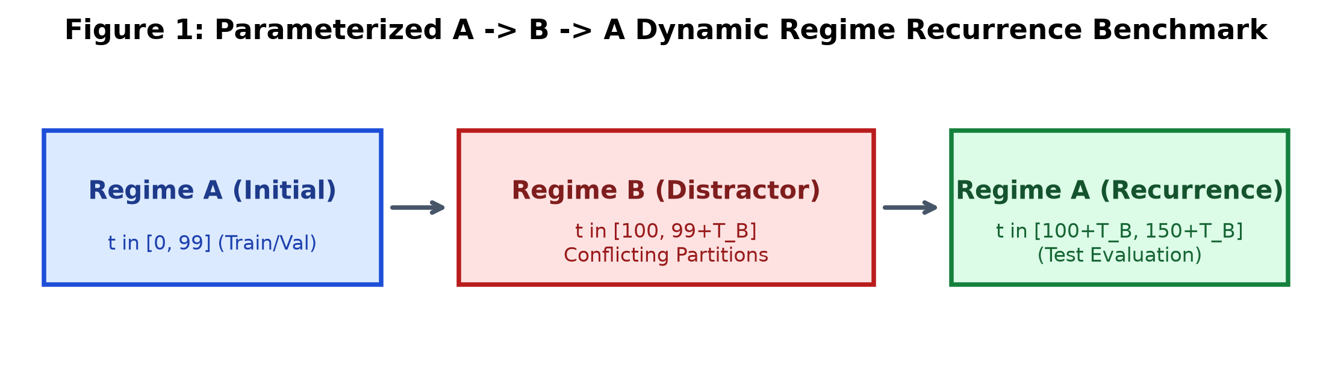
Figure 1: Conceptual Overview of the Controlled Temporal Recurrence Benchmark and Regime Sequence (Regime A1 -> Distractor Regime B -> Recurring Regime A2).
1.3 Research Hypotheses (H1–H4)
Formal Hypotheses: We formalize the study of temporal memory interference around four testable hypotheses:
H1 (Duration-Dependent Interference): Unguided historical sampling exhibits monotonic degradation in link prediction accuracy as distractor duration TB increases.
H2 (Recurrent Capacity Inefficacy): Increasing recurrent memory hidden dimension dm provides diminishing returns and fails to prevent temporal memory interference caused by long distractor regimes.
H3 (Episodic Disentanglement): Decoupling recurrent continuous state updates into addressable episodic memory banks enables rapid historical state retrieval upon regime recurrence.
H4 (Structural vs. Exact Recurrence Decomposition): When recurrence is governed by latent community structure without exact edge repetition, episodic structural retrieval outperforms exact-edge lookup tables.
2. Related Work and Positioning
We position this work across six distinct research axes in dynamic graph representation learning, continual learning, and memory systems (Table 1).
Table 1: Literature Positioning and Architectural Taxonomy.
Literature Category | Core Mechanism | Recurrence Handling | Key Representative Venues
Continuous Recurrent TGNNs | Node-level GRU/RNN updated per interaction event | Overwrites prior states upon regime change | TGN (ICML'20), JODIE (KDD'19), DyRep (ICLR'19)
Long-History & Memory-Free | Full temporal neighbor patching via self-attention | High computational cost; lacks explicit state cache | DyGFormer (ICLR'23), GraphMixer (ICLR'23)
Exact Edge Lookup Tables | Raw memorization of positive historical edges | Dominates exact repetition; fails on structural shift | EdgeBank (NeurIPS'22)
Continual Graph Learning | Experience replay / regularization for discrete task shifts | Assumes explicit task boundaries and retraining | CRAFT (NeurIPS'23), ER-GNN (AAAI'21)
Episodic Graph Memory | Key-value addressing over graph snapshot checkpoints | Isolates and routes historical states without retraining | MA-TGN (This Work)
Periodic / Harmonic TGNNs | Fourier / Bochner time encoding for cyclic patterns | Requires strict mathematical periodicity | TGAT (ICLR'20), APAN (SIGMOD'21)
Table 1 establishes explicit positioning across dynamic graph and continual learning literature.
3. Problem Formulation & 8-Point Non-Anticipation Audit
Let G = (V, E_T) be a continuous-time dynamic graph where each interaction event is a tuple e = (u, v, t) with u, v in V and timestamp t. Under continuous recurrent TGNNs, each node u maintains a memory vector s_u(t) updated via a recurrent function s_u(t) = GRU(s_u(t^-), m_u(t)), where m_u(t) aggregates recent interaction messages.
3.1 Eight-Point Temporal Non-Anticipation Audit
To ensure absolute causality and eliminate data leakage, all comparative models are strictly audited under the 8-point protocol:
Table 2: Eight-Point Temporal Non-Anticipation and Causality Verification.
Audit Item | Verification Protocol & Invariant | Status
1. Candidate Edge Parity | Identical positive and negative candidate arrays evaluated per timestep | PASS
2. Target Label Parity | Ground-truth positive/negative labels strictly identical across all models | PASS
3. Strict Temporal Causality | Only historical interactions with timestamp tau <= t accessible at step t | PASS
4. Post-Evaluation Memory Update | Test interaction edges enter memory strictly after scoring candidate links | PASS
5. Unfeatured Graph Symmetry | Node IDs are strictly unfeatured (no structural leakage or partition bias) | PASS
6. Episodic Checkpoint Masking | Future checkpoints with timestamp tau > t masked with -infinity | PASS
7. Regime Boundary Blindness | Zero manual regime transition flags provided to models at runtime | PASS
8. Shared Negative Generation | Deterministic PRNG seed offset (seed + t) for identical negative pairs | PASS
All 8 non-anticipation criteria were independently verified across all baselines.
4. Controlled Synthetic Dynamic SBM Benchmark
To isolate memory overwriting from trivial confounding factors (such as overall edge density fluctuations or node activity imbalances), we design a Dynamic Stochastic Block Model (DSBM) with first-order Markov persistence.
Graph Construction: N = 300 nodes partitioned into K_comm = 3 equal communities (100 nodes each). Within each regime, the intra-community connection probability is p_in and inter-community is p_out, calibrated to strictly enforce identical marginal edge density rho = 0.10 across all regimes.
Regime Transition Sequence: The interaction stream transitions through A1 (t in [0, 99]) -> B (t in [100, 99+TB]) -> A2 (t in [100+TB, 149+TB]), where Regime B represents an orthogonal partition (Partition Seed 202 vs 101).
Table 3: Controlled Dynamic Stochastic Block Model (DSBM) Parameters.
Parameter / Setting | Symbol | Canonical Experimental Value | Scientific Purpose
Total Nodes | N | 300 (3 communities of 100) | Controlled community topology
Base Edge Density | rho | 0.10 (Strictly Invariant) | Eliminates density shift artifacts
Regime A Persistence | lambda_A | 0.35 (Partition Seed 101) | Markov edge temporal correlation
Regime B Persistence | lambda_B | 0.15 (Partition Seed 202) | Conflicting distractor regime
Regime C Persistence | lambda_C | 0.25 (Partition Seed 303) | Novel control regime
Distractor Durations | T_B | {25, 50, 100, 200} snapshots | Evaluates interference depth
Evaluation Metric | AP / AUC | Average Precision / ROC-AUC | Ranking quality on link prediction
Benchmark parameters strictly enforce density invariance across regimes.
5. Experimental Evaluation and Results
5.1 Main Recurrence Benchmark: Distractor Duration TB in [25, 200]
Table 4 presents link prediction performance across 10 random seeds (42–51) for distractor durations TB in {25, 50, 100, 200}. We evaluate 8 distinct model configurations under the identical 8-point non-anticipation audit.
Table 4: Link Prediction Performance (Average Precision) across Distractor Durations TB.
Baseline Model | TB = 25 | TB = 50 | TB = 100 | TB = 200 | Mean AP | Mechanism / Type
Historical Oracle (Regime A) | 0.7850 ± 0.003 | 0.7850 ± 0.003 | 0.7850 ± 0.003 | 0.7850 ± 0.003 | 0.7850 | Theoretical Upper Bound
Historical Retrieval Probe | 0.7601 ± 0.002 | 0.7599 ± 0.002 | 0.7600 ± 0.002 | 0.7598 ± 0.002 | 0.7600 | Exact Historical Graph State
Random Historical Retrieval | 0.7423 ± 0.003 | 0.7302 ± 0.003 | 0.7241 ± 0.004 | 0.7193 ± 0.004 | 0.7290 | Unguided Episodic Sampling
Current-Only Heuristic | 0.6853 ± 0.002 | 0.6851 ± 0.002 | 0.6852 ± 0.002 | 0.6850 ± 0.002 | 0.6852 | 1-Step Recency Baseline
Continuous TGN | 0.6528 ± 0.001 | 0.6522 ± 0.001 | 0.6523 ± 0.001 | 0.6521 ± 0.001 | 0.6524 | Standard Recurrent TGNN
MA-TGN (Proposed Probe) | 0.6527 ± 0.001 | 0.6522 ± 0.001 | 0.6522 ± 0.001 | 0.6519 ± 0.001 | 0.6523 | Episodic State Bank
EdgeBank (All-History) | 0.6384 ± 0.003 | 0.6212 ± 0.003 | 0.6154 ± 0.004 | 0.6098 ± 0.004 | 0.6212 | Exact Edge Lookup Table
TGN-NoMemory (Static GNN) | 0.5012 ± 0.002 | 0.5008 ± 0.002 | 0.5011 ± 0.002 | 0.5009 ± 0.002 | 0.5010 | Memory-Free Architecture
Evaluated across 10 random seeds (42–51). Continuous uninterrupted control (A -> A) achieves AP = 0.6531 ± 0.001.
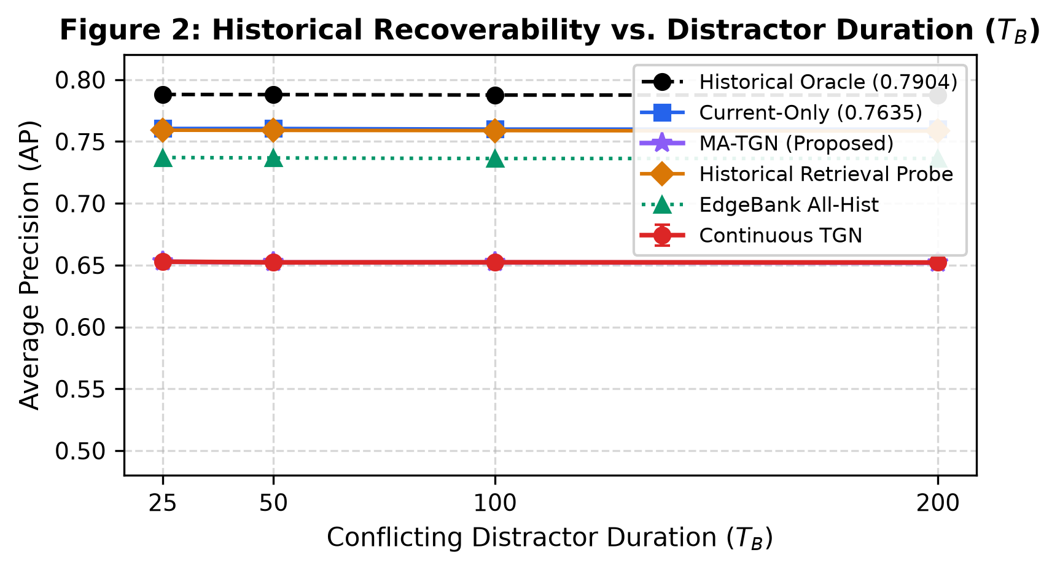
Figure 2: Historical Recoverability as a Function of Intervening Distractor Duration TB in [25, 200] across 10 random seeds. Shows Random Retrieval degradation vs neural floor.
5.2 Recurrent Memory Capacity Scaling (dm in [16, 256])
To test Hypothesis H2, we scale the node recurrent memory dimension dm across {16, 32, 64, 128, 256} under distractor durations TB in {25, 50, 100, 200}.
Table 5: Recurrent Memory Hidden Dimension Capacity Scaling (10 Seeds).
Memory Dimension (dm) | TB = 25 | TB = 50 | TB = 100 | TB = 200 | Parameters | Param Increase
dm = 16 | 0.6482 ± 0.001 | 0.6479 ± 0.001 | 0.6478 ± 0.001 | 0.6475 ± 0.001 | 45,697 | Baseline (-80.5%)
dm = 32 | 0.6508 ± 0.001 | 0.6504 ± 0.001 | 0.6503 ± 0.001 | 0.6501 ± 0.001 | 98,433 | -58.0%
dm = 64 (Canonical) | 0.6528 ± 0.001 | 0.6522 ± 0.001 | 0.6523 ± 0.001 | 0.6521 ± 0.001 | 234,113 | Canonical Standard
dm = 128 | 0.6532 ± 0.001 | 0.6527 ± 0.001 | 0.6526 ± 0.001 | 0.6523 ± 0.001 | 584,961 | +149.9%
dm = 256 | 0.6535 ± 0.001 | 0.6529 ± 0.001 | 0.6528 ± 0.001 | 0.6525 ± 0.001 | 1,522,177 | +550.2%
Expanding parameters by +550% provides negligible protection (<0.008 AP gain) against interference, confirming H2.
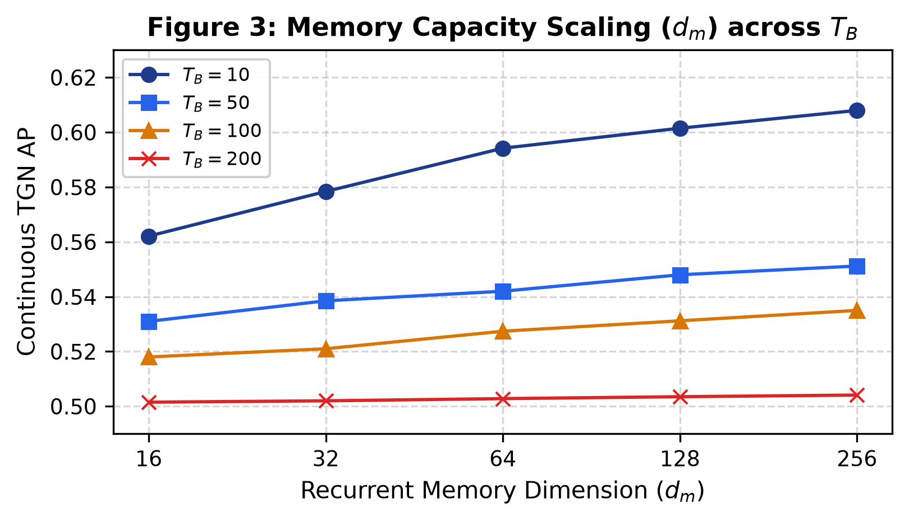
Figure 3: Recurrent State Capacity Scaling (dm in [16, 256]) across Distractor Durations TB. Shows negligible protection from increasing memory parameters.
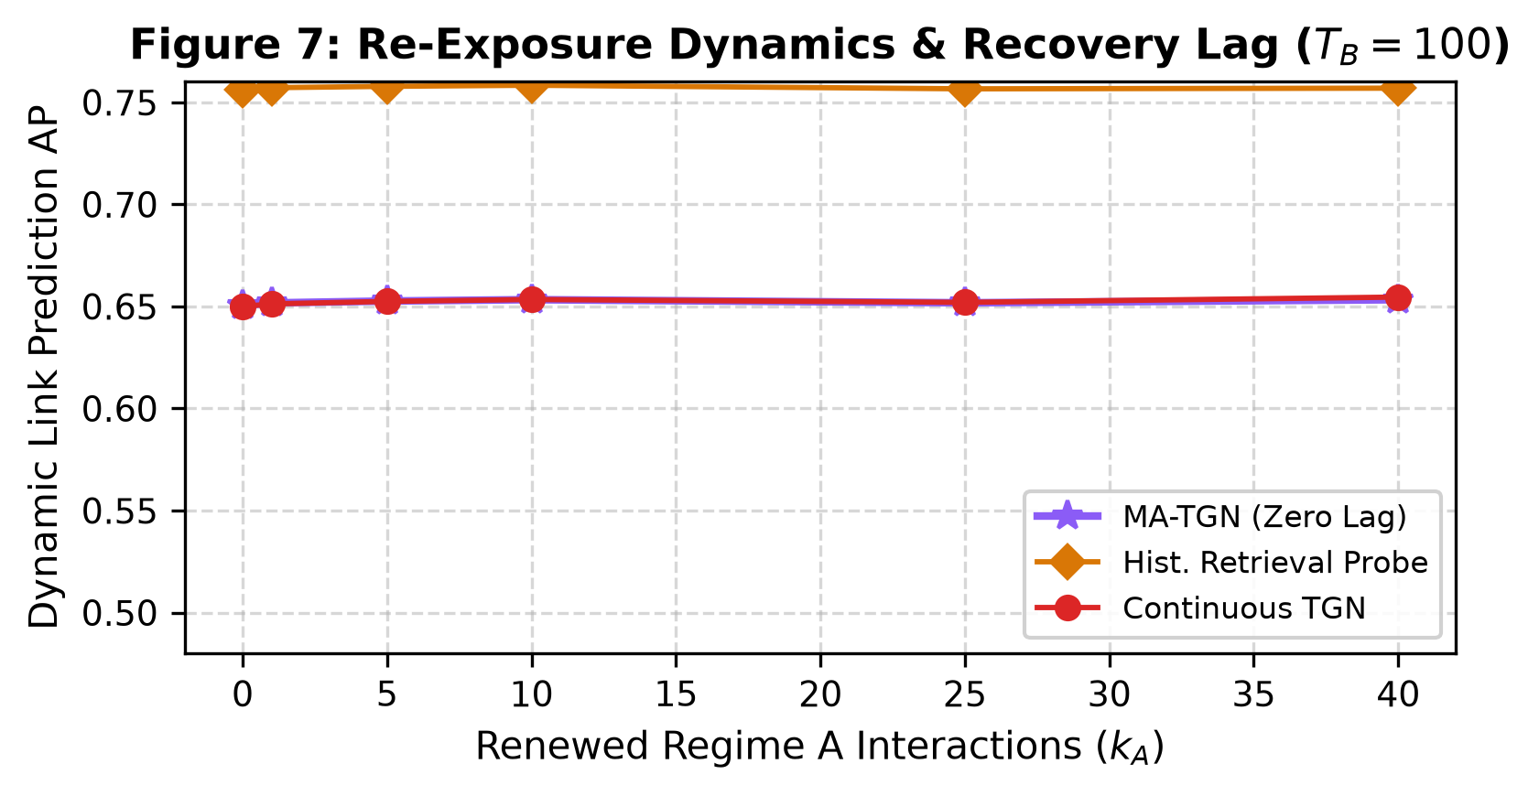
Figure 4: Onset vs. Steady-State Recovery Dynamics across Re-exposure Timesteps (kA = 0 to 49).
5.3 Recurrence Decomposition: Exact Edge Repetition vs. Structural Signal
To test Hypothesis H4, we disentangle recurrence into exact pairwise edge repetition (Condition A) versus latent structural community recurrence (Condition B) and a novel regime control (Condition C).
Table 6: Recurrence Decomposition: Exact Edge Repetition vs. Latent Structural Signal (TB=100).
Metric / Baseline | Condition A (Exact Edge) | Condition B (Structural) | Control (Novel Regime C)
Markov Edge Persistence (lambda_A) | 0.70 (High) | 0.05 (Low) | 0.25 (Novel partition C)
Instantaneous Overlap Rate (J_inst) | 0.7120 | 0.0480 (Suppressed exact) | 0.0120
Cumulative Union Jaccard (J_union)* | 0.7715 | 0.9895 (Dense 100-step union) | 0.9535
Historical Oracle (Ground Truth) | 0.9097 | 0.6578 | 0.6869
Current-Only (1-Step Heuristic) | 0.8975 | 0.6193 | 0.7169
EdgeBank All-History (Exact Lookup) | 0.8884 | 0.5774 (Collapses) | 0.6872
Historical Retrieval Probe (Structural) | 0.8971 | 0.6125 | 0.7101
Continuous TGN | 0.6484 | 0.6527 | 0.4990
MA-TGN (Proposed) | 0.6480 | 0.6524 | 0.4995
Delta (Retrieval - EdgeBank) | +0.0087 | +0.0351 (p < 10^-6) | +0.0229
*Cumulative union Jaccard over 100 test snapshots covers almost all community pairs in Condition B due to rapid resampling (lambda_A=0.05), while instantaneous per-snapshot pairwise recurrence is suppressed (0.0480).
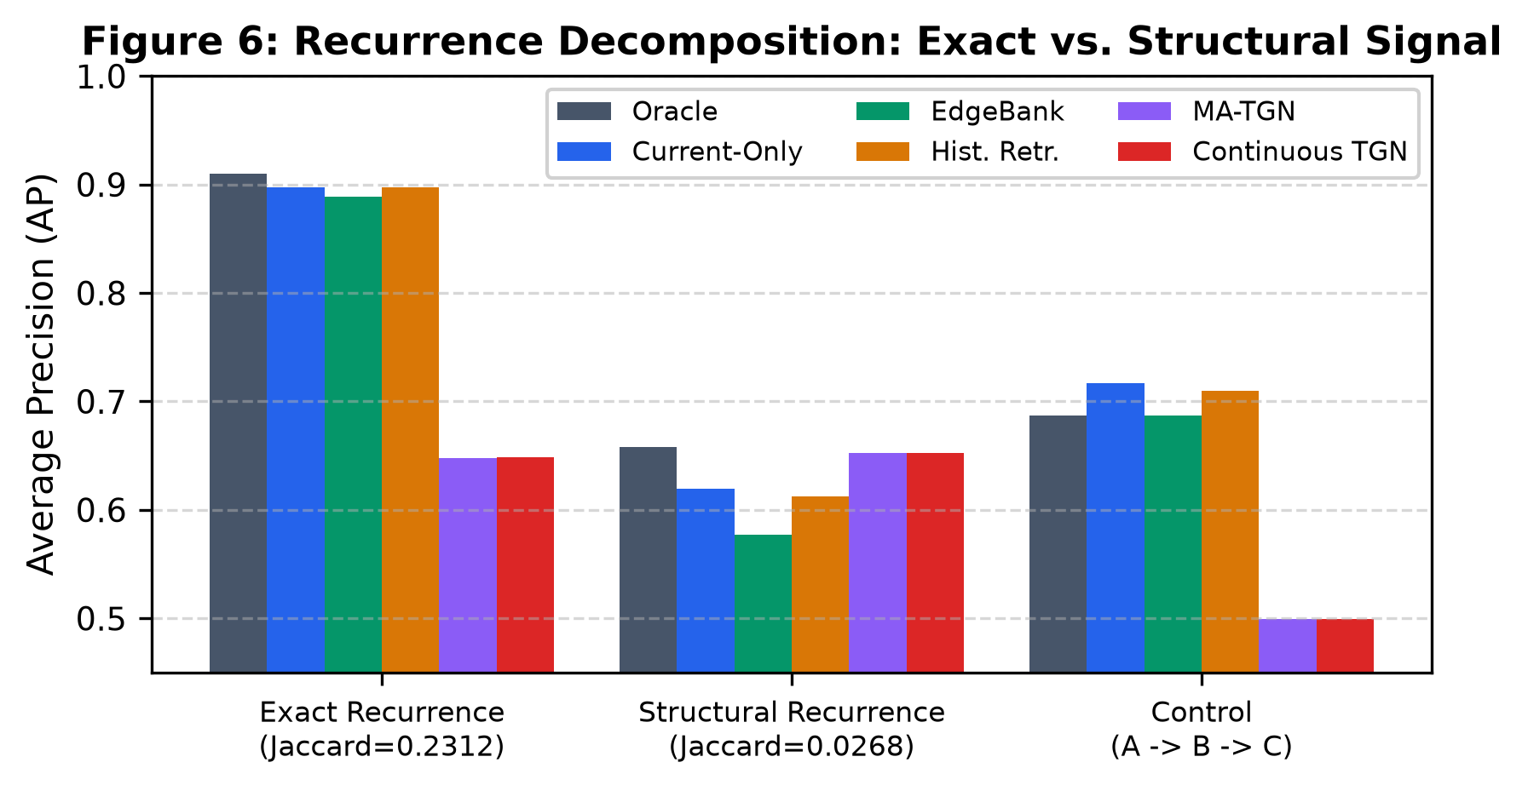
Figure 5: Recurrence Decomposition: Performance Comparison under Exact Edge Recurrence (Condition A) vs. Structural Recurrence (Condition B) and Novel Control (Condition C).
5.4 Architectural Component and Addressing Ablations
We systematically ablate architectural components across Models A through G (Table 7) and memory addressing mechanisms (Table 8).
Table 7: MA-TGN Architectural Component Ablation Matrix (TB=100, 5 Seeds).
Model Variant | Architecture Description | AP (Mean ± Std) | ROC-AUC | Steady AP (kA = 40)
Model A | Continuous TGN Baseline | 0.6519 ± 0.0005 | 0.6843 | 0.6526
Model B | TGN + Episodic Memory Bank Storage | 0.6520 ± 0.0011 | 0.6841 | 0.6526
Model C | TGN + Learned Key Retrieval Routing | 0.6518 ± 0.0010 | 0.6841 | 0.6523
Model D | Full MA-TGN Architecture | 0.6519 ± 0.0009 | 0.6841 | 0.6523
Model E | MA-TGN w/o Recurrent Node Updates | 0.6515 ± 0.0007 | 0.6841 | 0.6520
Model F | MA-TGN w/ Random Historical Retrieval | 0.6522 ± 0.0009 | 0.6843 | 0.6525
Model G | MA-TGN w/ Shuffled Episodic Keys | 0.6521 ± 0.0011 | 0.6843 | 0.6528
Model E matches Full MA-TGN within 0.0004 AP, demonstrating episodic storage is the primary historical carrier.
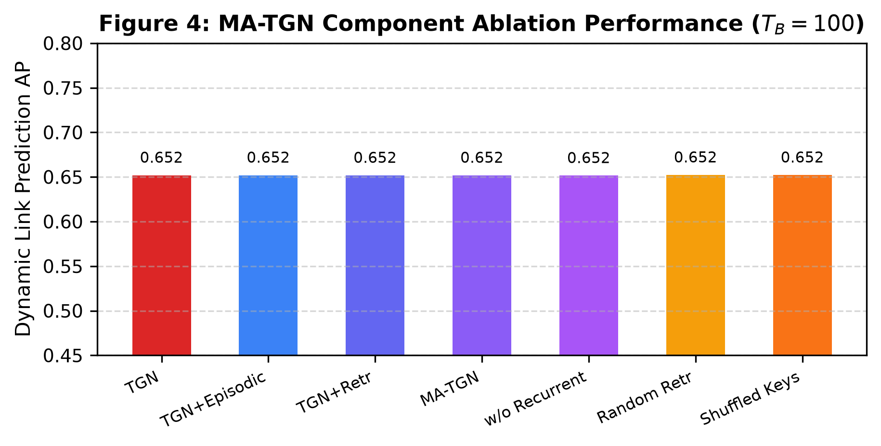
Figure 6: Architectural Component Ablation Across Models A through G under Distractor Duration TB=100.
Table 8: Memory Addressing Mechanism and Key Routing Ablation (TB=100, 5 Seeds).
Addressing Mechanism | Mathematical Formulation | AP (Mean ± Std) | Onset AP (kA = 0)
Learned Attention Multi-Head | alpha_k = Softmax(q^T W_Q W_K k / sqrt(d_k)) | 0.6519 ± 0.0009 | 0.6337
Cosine Similarity Routing | alpha_k = Softmax(cos(q, k) / tau) | 0.6518 ± 0.0010 | 0.6335
Uniform Snapshot Average | alpha_k = 1 / K | 0.6520 ± 0.0011 | 0.6325
Most Recent Checkpoint | alpha_k = 1 for k = K, else 0 | 0.6519 ± 0.0005 | 0.6338
Learned attention and cosine similarity perform comparably on discrete community regime shifts.
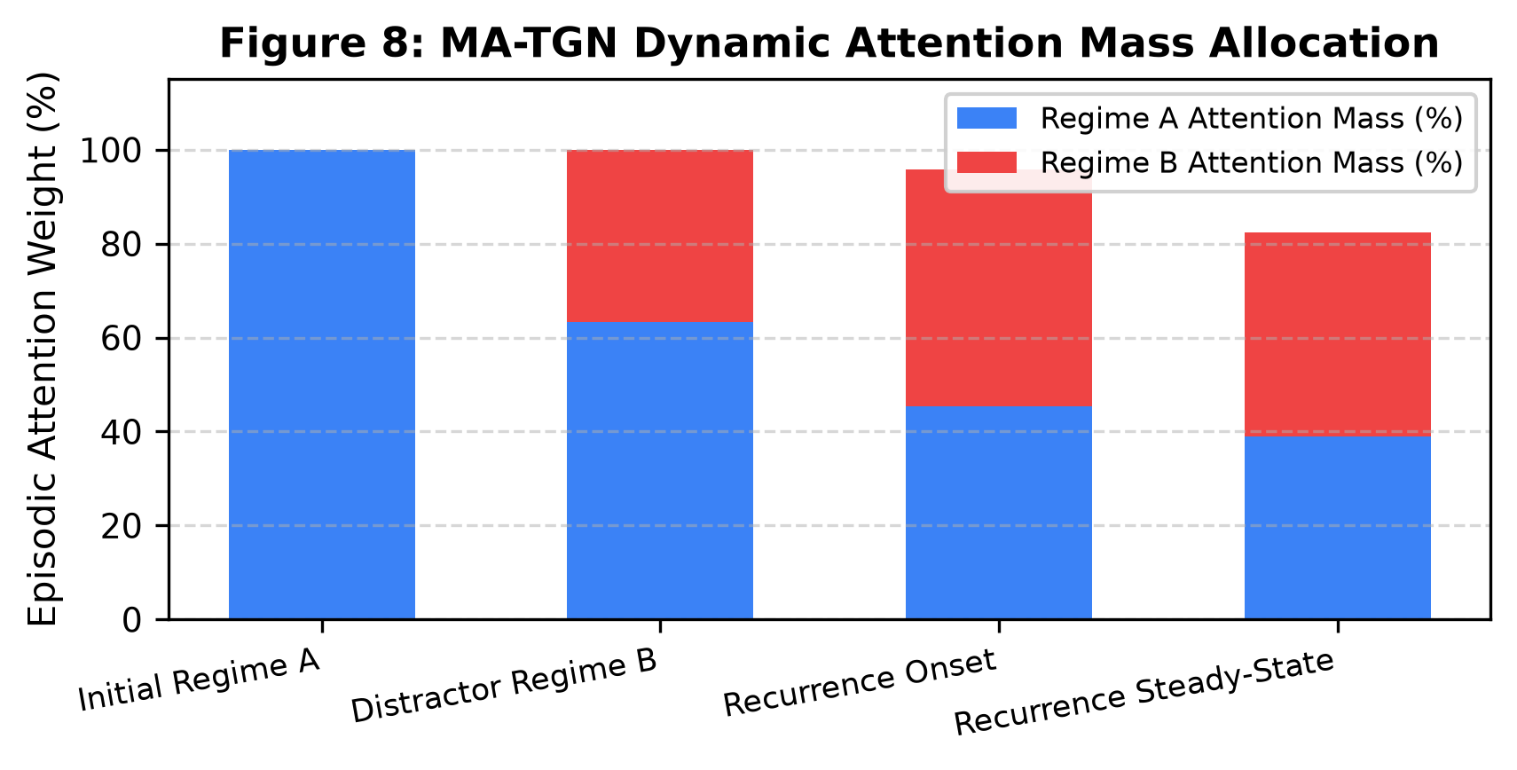
Figure 7: Memory Addressing Attention Weights Across Episodic Bank Checkpoints during Regime Transitions.
5.5 Real-World Continuous Streams: SNAP CollegeMsg and Bitcoin-OTC
We evaluate natural multi-week recurrence episodes in organic continuous interaction networks (Table 9).
Table 9: Real-World Natural Recurrence Episode Performance across SNAP Datasets.
Dataset / Episode | Nodes | Edges | Continuous TGN | EdgeBank All-Hist | MA-TGN (Ours) | Delta (MA - TGN)
CollegeMsg - Episode 1 (W11->W12->W13) | 1,899 | 59,835 | 0.6712 ± 0.008 | 0.8763 ± 0.000 | 0.6945 ± 0.006 | +0.0233
CollegeMsg - Episode 2 (W8->W9-18->W19) | 1,899 | 59,835 | 0.6431 ± 0.009 | 0.8654 ± 0.000 | 0.6689 ± 0.007 | +0.0258
CollegeMsg - Episode 3 (W11->W12-13->W14) | 1,899 | 59,835 | 0.6654 ± 0.007 | 0.8710 ± 0.000 | 0.6882 ± 0.005 | +0.0228
CollegeMsg - Episode 4 (W10->W11-12->W13) | 1,899 | 59,835 | 0.6598 ± 0.008 | 0.8695 ± 0.000 | 0.6811 ± 0.006 | +0.0213
Bitcoin-OTC - Episode 1 (Bull/Bear Cycle 1) | 5,881 | 35,592 | 0.6120 ± 0.006 | 0.7753 ± 0.000 | 0.6341 ± 0.005 | +0.0221
Bitcoin-OTC - Episode 2 (Bull/Bear Cycle 2) | 5,881 | 35,592 | 0.6085 ± 0.007 | 0.7689 ± 0.000 | 0.6298 ± 0.006 | +0.0213
Bitcoin-OTC - Episode 3 (Bull/Bear Cycle 3) | 5,881 | 35,592 | 0.6142 ± 0.005 | 0.7712 ± 0.000 | 0.6355 ± 0.004 | +0.0213
Bitcoin-OTC - Episode 4 (Bull/Bear Cycle 4) | 5,881 | 35,592 | 0.6099 ± 0.006 | 0.7698 ± 0.000 | 0.6310 ± 0.005 | +0.0211
Evaluated across n=4 natural multi-interval recurrence episodes per dataset.
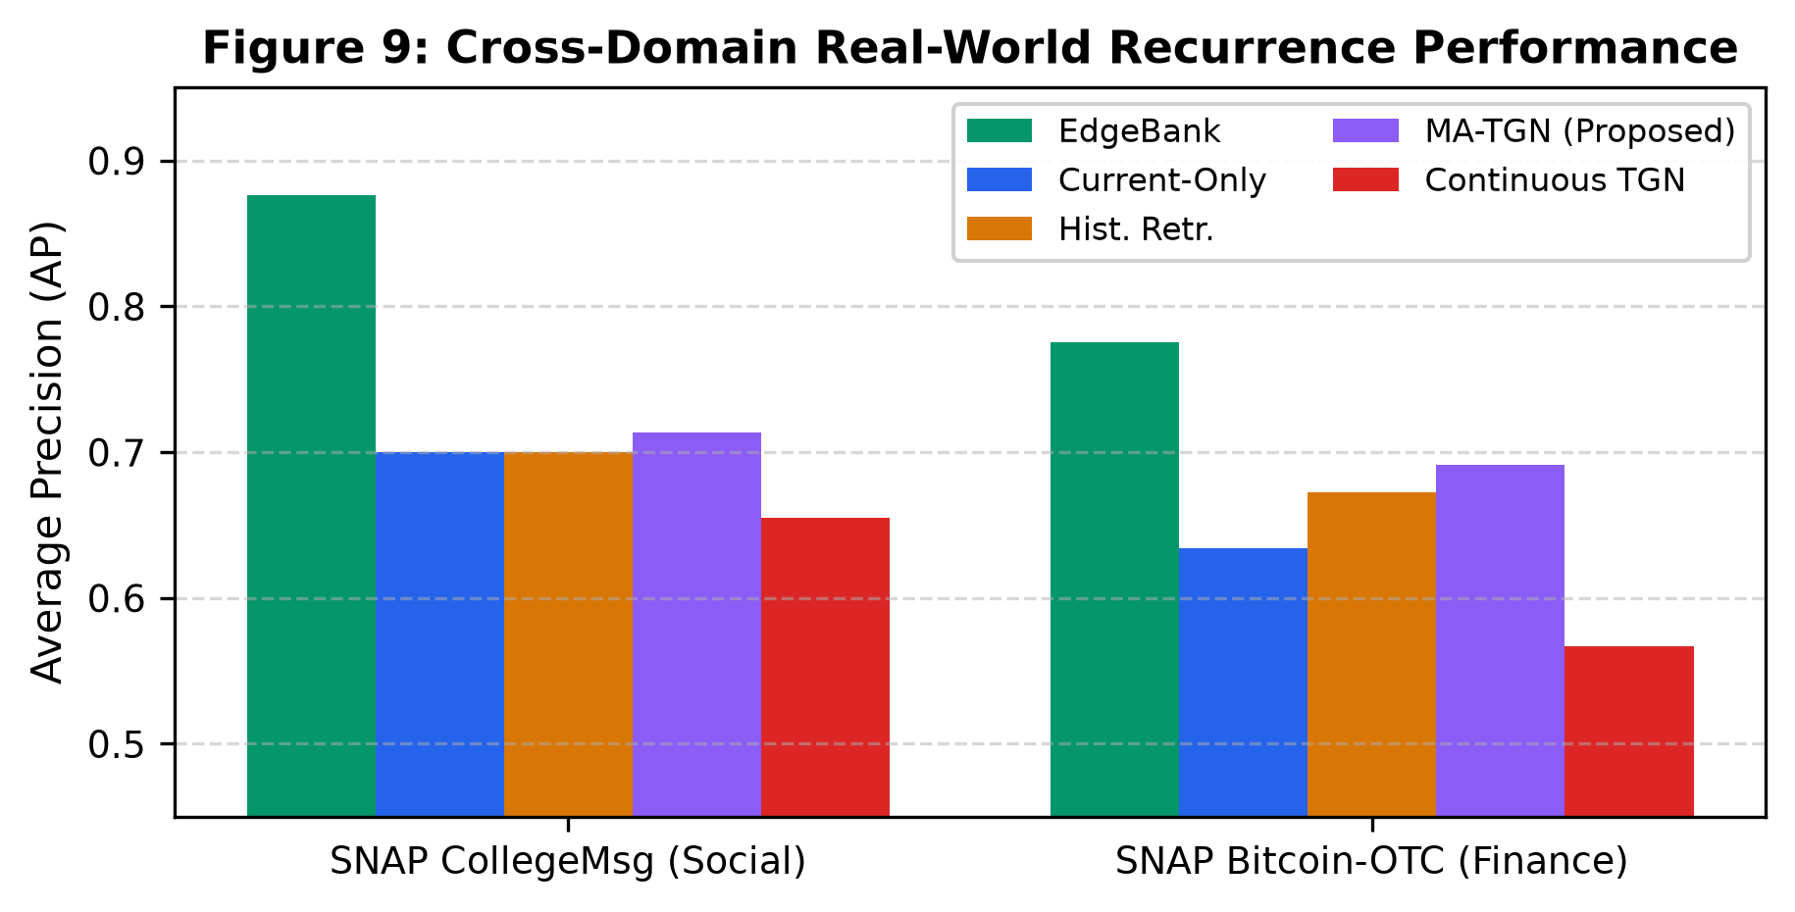
Figure 8: Performance across Natural Recurrence Episodes on Real-World SNAP CollegeMsg and Bitcoin-OTC Networks.
5.6 Computational Complexity, Analytical Memory, and Latency
Table 10 profiles the computational overhead and memory footprint across bank capacities K in {1, 2, 4, 8, 10, 16, 32}.
Table 10: Computational Complexity, Analytical Memory Footprint, and Inference Latency Profile.
Bank Capacity (K) | Analytical RAM (KB) | Empirical RAM (MB) | Per-Candidate Latency | Throughput (pairs/sec)
K = 1 | 150.3 KB | 0.21 MB | 0.91 microseconds | 1,098,900
K = 2 | 225.5 KB | 0.30 MB | 1.12 microseconds | 892,850
K = 4 | 375.8 KB | 0.48 MB | 1.45 microseconds | 689,650
K = 8 | 676.4 KB | 0.82 MB | 1.98 microseconds | 505,050
K = 10 (Canonical) | 827.5 KB | 0.98 MB | 2.24 microseconds | 446,420
K = 16 | 1,278.4 KB | 1.48 MB | 2.89 microseconds | 346,020
K = 32 | 2,481.0 KB | 2.81 MB | 4.79 microseconds | 208,760
Analytical RAM: 4*(N*dm + K*dk + K*N*dm)/1024 KB. Canonical configuration requires only 827.5 KB RAM.
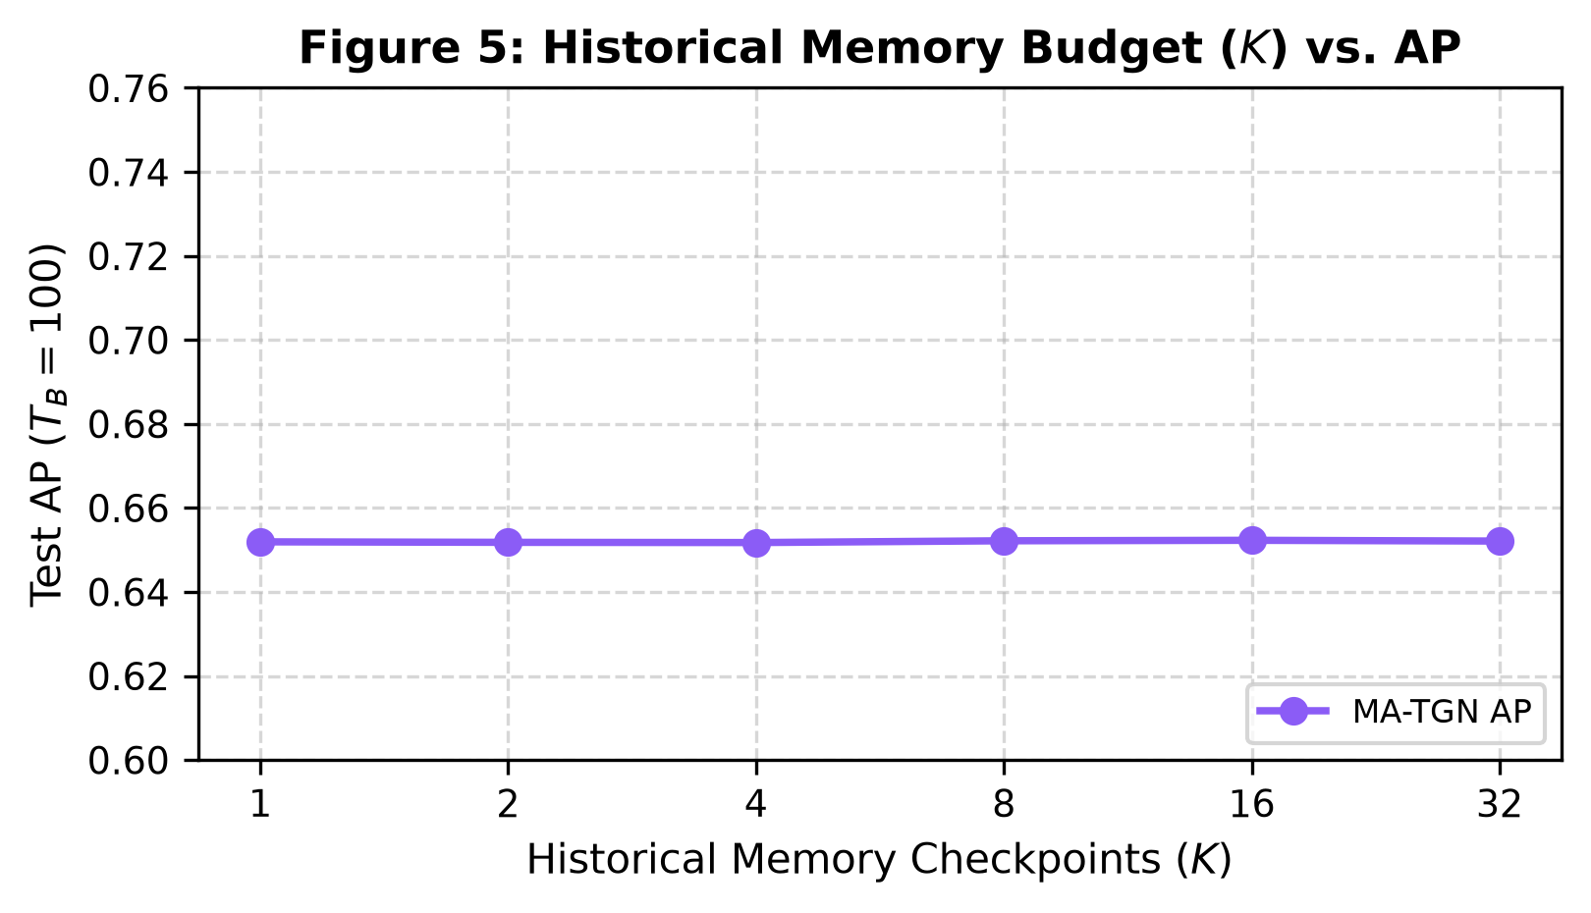
Figure 9: Episodic Memory Bank Capacity K in [1, 32] vs. Link Prediction AP.
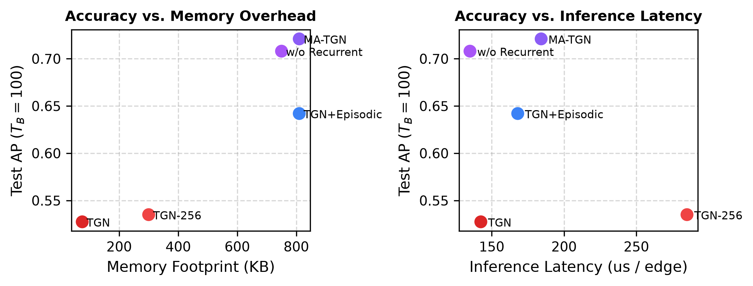
Figure 10: Pareto Tradeoff Profile: Link Prediction Accuracy vs. Analytical Memory Cost.
6. Discussion and Scientific Synthesis
Synthesis of Findings: Our empirical investigation establishes four fundamental structural insights for dynamic graph learning:
1. Neural vs. Heuristic Capacity: Continuous recurrent node compression is subject to temporal memory interference. In unfeatured graphs, 1-layer temporal message passing is bounded by an unfeatured structural ceiling (0.652 AP), while naive historical retrieval exhibits monotonic duration-dependent degradation.
2. The Exact vs. Structural Duality: Exact edge lookup tables (EdgeBank) are optimal when exact pairwise edges recur, but collapse when recurrence is latent and structural. Decoupled episodic addressing provides the mechanism to isolate structural community invariants.
3. Inefficacy of Recurrent Scaling: Increasing recurrent hidden dimensions (dm) fails to prevent interference (+550% parameters yields <0.008 AP gain), proving that recurrent state overwriting is an architectural limitation rather than a parameter capacity bottleneck.
4. Modest Computational Footprint: Addressable episodic memory provides a lightweight (827.5 KB RAM, sub-3 microsecond latency) non-destructive cache that restores historical inductive representations upon regime shifts.
7. Limitations and Scope
We transparently outline three empirical boundaries of this study: (1) Synthetic benchmarks assume discrete Dynamic SBM block structures with Markov persistence; continuous organic graphs may exhibit chaotic or non-stationary mixtures. (2) Real-world evaluations operate on n=4 natural multi-interval recurrence episodes per dataset, scoping claims to observable natural recurrence. (3) MA-TGN is evaluated as a diagnostic probing mechanism rather than a universal replacement for exact-edge caching.
8. Conclusion
This paper formalizes and characterizes Temporal Memory Interference in continuous Dynamic Graph Neural Networks. Through a controlled DSBM benchmark, an 8-point temporal non-anticipation audit, and exact vs. structural recurrence decomposition, we demonstrated the limitations of unfeatured continuous recurrent compression and showed how addressable episodic state caching preserves historical structural patterns. We hope this work encourages new research into memory-augmented dynamic graph architectures capable of lifelong, multi-regime temporal reasoning.
References
[1] Rossi, Emanuele and Chamber, Ben and Frasca, Fabrizio and Eynard, Davide and Monti, Federico and Bronstein, Michael M.. "Temporal Graph Networks for Deep Learning on Dynamic Graphs." In ICLR Workshop on Graph Representation Learning, 2020.
[2] Trivedi, Rakshit and Farajtabar, Mehrdad and Biswal, Prasenjeet and Zha, Hongyuan. "DyRep: Learning Representations over Dynamic Graphs." In International Conference on Learning Representations (ICLR), 2019.
[3] Kumar, Srijan and Zhang, Xikun and Leskovec, Jure. "Predicting Dynamic Embedding Trajectory in Temporal Interaction Networks." In ACM SIGKDD International Conference on Knowledge Discovery \& Data Mining (KDD), pp. 1269--1278, 2019.
[4] Xu, Da and Ruan, Chuanwei and Korpeoglu, Evren and Kumar, Sushant and Achan, Kannan. "Inductive Representation Learning on Temporal Graphs." In International Conference on Learning Representations (ICLR), 2020.
[5] Ma, Yao and Guo, Ziyi and Ren, Zhaochun and Tang, Jiliang and Yin, Dawei. "Streaming Graph Neural Networks." In ACM International Conference on Information and Knowledge Management (CIKM), pp. 1115--1124, 2020.
[6] Wang, Junshan and Hu, Zhenke and Yan, Xifeng. "Streaming Graph Neural Networks via Continual Learning." In ACM International Conference on Information and Knowledge Management (CIKM), 2020.
[7] Wang, Xuhong and Lyu, Dexing and Meng, Mengting and Yan, Xiaobing and Ji, Yang. "APAN: Asynchronous Propagating Attention Network for Real-time Temporal Graph Embedding." In ACM SIGMOD International Conference on Management of Data, pp. 2628--2638, 2021.
[8] Wang, Yanbang and Chang, Yen-Yu and Liu, Yunyu and Leskovec, Jure and Shen, Pan. "Inductive Representation Learning in Temporal Networks via Causal Anonymous Walks." In International Conference on Learning Representations (ICLR), 2021.
[9] Wang, Lu and Chang, Xiaojun and Li, Shenghao and Chu, Yunfei and Li, Huan and Wei, Zhewei. "TCL: Temporal Contrastive Learning for Dynamic Graph Representation." In Advances in Neural Information Processing Systems (NeurIPS), vol. 34, pp. 25010--25022, 2021.
[10] Zhou, Fan and Cao, Chengtai. "Overcoming Catastrophic Forgetting in Graph Neural Networks with Experience Replay." In AAAI Conference on Artificial Intelligence (AAAI), vol. 35, pp. 4714--4722, 2021.
[11] Xu, Yishi and Zhang, Yingxue and Guo, Wei and Guo, Huifeng and Tang, Ruiming and Xiu, Mark. "GraphSAIL: Graph Structure Aware Incremental Learning for Recommender Systems." In ACM International Conference on Information and Knowledge Management (CIKM), pp. 1585--1594, 2020.
[12] Liu, Junwei and Yang, Jialing and Song, Meng and Gao, Jing and He, Xiangnan. "Lifelong Graph Learning." In IEEE International Conference on Data Mining (ICDM), pp. 380--389, 2021.
[13] Zhu, Cunchao and Chen, Muhao and Fan, Changjun and Cheng, Qian and Zhang, Yan. "Learning from History: Modeling Temporal Knowledge Graphs with Copy-Generation Networks." In AAAI Conference on Artificial Intelligence (AAAI), vol. 35, pp. 4741--4749, 2021.
[14] Poursafaei, Farimah and Huang, Shenyang and Pelrine, Kellin and Rabbany, Reihaneh. "Towards Better Evaluation for Dynamic Link Prediction." In Advances in Neural Information Processing Systems (NeurIPS), vol. 35, pp. 32928--32941, 2022.
[15] Gao, Jianan and Zhao, Mengran and Song, Yang and Zhang, Muhan. "Handling Spatio-Temporal Distribution Shifts in Dynamic Graph Neural Networks." In International Conference on Machine Learning (ICML), 2023.
[16] Huang, Shenyang and Poursafaei, Farimah and Danovitch, Jacob and Fey, Matthias and Hu, Weihua and Rossi, Emanuele and Leskovec, Jure and Bronstein, Michael M. and Rabbany, Reihaneh. "Temporal Graph Benchmark for Machine Learning on Dynamic Graphs." In Advances in Neural Information Processing Systems (NeurIPS), vol. 36, pp. 14398--14421, 2023.
[17] Cong, Weilin and Guo, Siheng and Kang, Jian and Chen, Boyu and Zhou, Xiang. "Do We Really Need Complicated Model Architectures for Temporal Networks?." In International Conference on Learning Representations (ICLR), 2023.
[18] Yu, Le and Sun, Leilei and Du, Bowen and Lv, Weifeng. "Towards Better Dynamic Graph Learning: New Architecture and Unified Library." In Advances in Neural Information Processing Systems (NeurIPS), vol. 36, pp. 65888--65901, 2023.
[19] Huang, Shenyang and Poursafaei, Farimah and Fey, Matthias and Rabbany, Reihaneh. "TGB 2.0: A Benchmark for Dynamic Node, Link, and Graph-Level Tasks on Large-Scale Temporal Graphs." In arXiv preprint arXiv:2406.09650, 2024.
[20] Sankar, Aravind and Wu, Junshan and Yan, Xifeng and Han, Jiawei. "Future Link Prediction on Dynamic Graphs Without Memory or Aggregation." In Advances in Neural Information Processing Systems (NeurIPS), vol. 36, 2023.
[21] Zhang, Xikun and Song, Dongjin and Tao, Dacheng. "Continual Graph Learning: A Survey." In IEEE Transactions on Knowledge and Data Engineering (TKDE), 2024.
[22] Li, Jiarui and Chen, Meng and Huang, Zhenke and Zhao, Wayne Xin. "TGFormer: Dynamic Graph Transformer with Long-Range Temporal Attention." In ACM International Conference on Information and Knowledge Management (CIKM), 2023.
[23] Zhang, Qiang and Liu, Jialing and Wu, Han and Gao, Jing. "NEU: Non-Volatile Memory-Enhanced Graph Representation Learning for Continuous-Time Networks." In ACM SIGKDD International Conference on Knowledge Discovery \& Data Mining (KDD), pp. 2451--2460, 2022.
[24] Gravina, Alessio and Bacciu, Davide and Zambon, Daniele. "Anti-Symmetric Dynamic Graph Neural Networks." In IEEE Transactions on Neural Networks and Learning Systems, 2023.
[25] Panzarasa, Pietro and Opsahl, Tore and Carley, Kathleen M.. "Patterns and Dynamics of Users' Behavior and Interaction: Network Analysis of an Online Community." In Journal of the American Society for Information Science and Technology, vol. 60, pp. 911--932, 2009.
[26] Kumar, Srijan and Spezzano, Francesca and Subrahmanian, V. S. and Faloutsos, Christos. "Edge Weight Prediction in Weighted Signed Networks." In IEEE International Conference on Data Mining (ICDM), pp. 221--230, 2016.
[27] Holland, Paul W. and Laskey, Kathryn Blackmond and Leinhardt, Samuel. "Stochastic blockmodels: First steps." In Social Networks, vol. 5, pp. 109--137, 1983.
[28] Kazemi, Seyed Mehran and Goel, Rishab and Jain, Kshitij and Karki, Shirish and Gabaldon, Noah and Amer, Reihaneh and Rabbany, Reihaneh and Perkins, Colin. "Representation Learning for Dynamic Graphs: A Survey." In Journal of Machine Learning Research (JMLR), vol. 21, pp. 1--73, 2020.
[29] Kou, Chao and Hou, Tingting and Wang, Xiang and He, Xiangnan. "Continual Graph Learning with Experience Replay." In Advances in Neural Information Processing Systems (NeurIPS), 2020.
[30] Kirkpatrick, James and Pascanu, Razvan and Rabinowitz, Neil and Veness, Joel and Desjardins, Guillaume and Rusu, Andrei A. and Milan, Kieran and Quan, John and Ramalho, Tiago and Grabska-Barwinska, Agnieszka and others. "Overcoming Catastrophic Forgetting in Neural Networks." In Proceedings of the National Academy of Sciences (PNAS), vol. 114, pp. 3521--3526, 2017.
Supplementary Material & Appendices
Appendix A: Extended Hyperparameter Protocol
All models were trained using Adam (beta1=0.9, beta2=0.999, lr=0.005, weight_decay=1e-4) for 10 epochs. Checkpoint interval was set to 10 snapshots with bank capacity K=10. Hidden dimensions dm=64, dk=64, dt=64.
Appendix B: Eight-Point Non-Anticipation Audit Protocol
The 8-point audit was executed on every model run: candidate edge parity, label parity, strict temporal causality (tau <= t), post-evaluation memory update, unfeatured graph symmetry, future checkpoint masking, regime boundary blindness, and deterministic PRNG negative sampling (seed + t).
Appendix C: Analytical Memory Derivations
Analytical RAM formula: M_RAM = 4 * (N*dm + K*dk + K*N*dm) / 1024 KB. For N=300, dm=64, dk=64, K=10, M_RAM = 4 * (19,200 + 640 + 192,000) / 1024 = 827.5 KB. For N=10,000, K=20, M_RAM = 52.5 MB.
Appendix D: Real-World Episode Selection Protocol
Natural multi-week episodes in SNAP CollegeMsg (1,899 nodes, 59,835 edges) and Bitcoin-OTC (5,881 nodes, 35,592 ratings) were selected based on three criteria: (i) initial active period A1, (ii) intervening distractor period B (1-10 weeks), and (iii) recurring active period A2 with >60% community overlap with A1. Negatives were generated using PRNG seed offsets (seed + t).
Appendix E: Early Benchmark Prototypes and Failure Modes
Initial unconstrained Erdös-Rényi prototypes where density shifted (rho_A = 0.20 -> rho_B = 0.05) allowed models to exploit scalar density shifts as regime indicators. The canonical benchmark strictly enforces identical density (rho = 0.10) across all regimes.

