



KARNATAKA STATE COUNCIL FOR SCIENCE AND TECHNOLOGY
Indian Institute of Science campus, Bengaluru
Telephone: 080 -23600978, 23341652 || Email: spp@kscst.org.in
Website: www.kscst.org.in/spp.html or https://kscst.karnataka.gov.in/en
FORMAT FOR STUDENT PROJECT PROPOSAL FOR THE
48th SERIES OF STUDENT PROJECT PROGRAMME
(Handwritten proposals will not be accepted, please fill all the details in this MS word file, insert images / diagrams wherever necessary. Convert to pdf file, get it approved from the project guide / head of the department and principal of your institution. Keep ready the scanned pdf file of 1) Declaration and Endorsement 2) details of processing fees made and fill-up the Google Form.
https://forms.gle/ks2WxWB4ei1hgv9D9
Name of the College:
Canara Engineering college Bantwal
Project Title:
Autoencoders Based Adversarial Perturbation Detection in Machine Learning Systems Using Transfer Learning
Branch:
Computer Science and Engineering
Theme (as per KSCST poster):
Data Science, Cyber Security, Computing, Pattern Recognition and Image Processing, Signal Processing
Name(s) of project guide(s):
- Name: Mr. Shatananda Bhat P
Email id: shatananda.bhat@canaraengineering.in
Contact No.:9481769355

Name of Team Members:

Name: KUNAL SACHIN KITTUR
USN No.:4CB21CS047 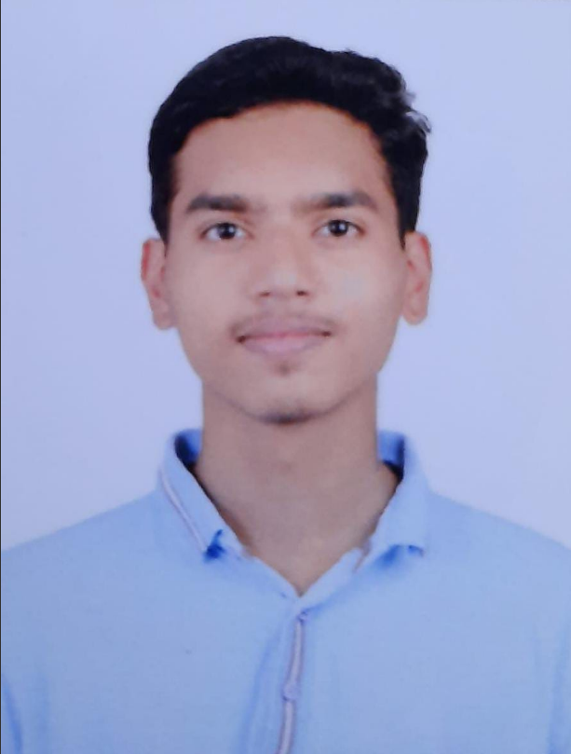
Email id: kunalkittur23@gmail.com
Mobile No:8668895548

Name: ADITHYA SHETTY B
USN No.:4CB21CS007 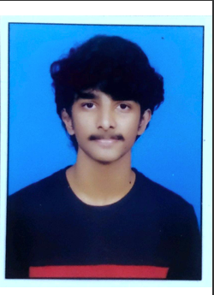
Email id: adithyashettyq2@gmail.com
Mobile No.:8792040567

Name: ADITYA MALLYA
USN No.: 4CB21CS009 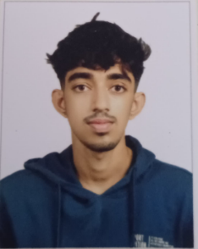
Email id: mallyaaditya14@gmail.com
Mobile No.: 9108054309

Name: MOHAMMED BILAL AHMED
USN No.:4CB21CS054 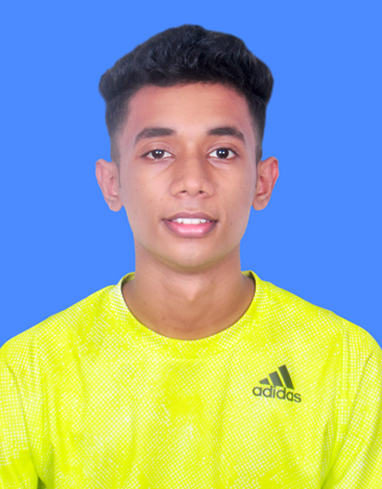
Email id: aaryanbilal3@gmail.com
Mobile No.:8217258139
Team Leader of the Project:
Name: KUNAL SACHIN KITTUR
USN No.:4CB21CS047
Email id: kunalkittur23@gmail.com
Mobile No:8668895548
Processing Fee Details (Through Online Payment only):
(processing fee of Rs. 1180/-)
Please furnish the payment details in the format provided in the last page of the proposal.
Date of commencement of the Project: 09-09-2024

Probable date of completion of the project: 20-12-2024

Scope / Objectives of the project: Data Integration and Analysis:
- Develop an adversarial detection framework that leverages autoencoders to identify and mitigate adversarial perturbations in datasets,ensuring model robustness.
- Utilize transfer learning techniques to enhance the performance and adaptability of the framework across diverse datasets and domains.
- Improve model security and accuracy by integrating adversarial defense mechanisms into the machine learning pipeline, protecting against potential attacks.

Methodology:
- The user inputs data, which is preprocessed to extract relevant features.
- An autoencoder is trained on normal data to learn typical patterns.
- The autoencoder detects deviations in data that may indicate tampering or adversarial perturbation.
- Transfer learning is applied to enhance detection capabilities across different datasets.
- The system provides insights into whether the data has been compromised and assesses the severity of tampering.
- Performance is evaluated based on accuracy, false positives, and robustness against attacks

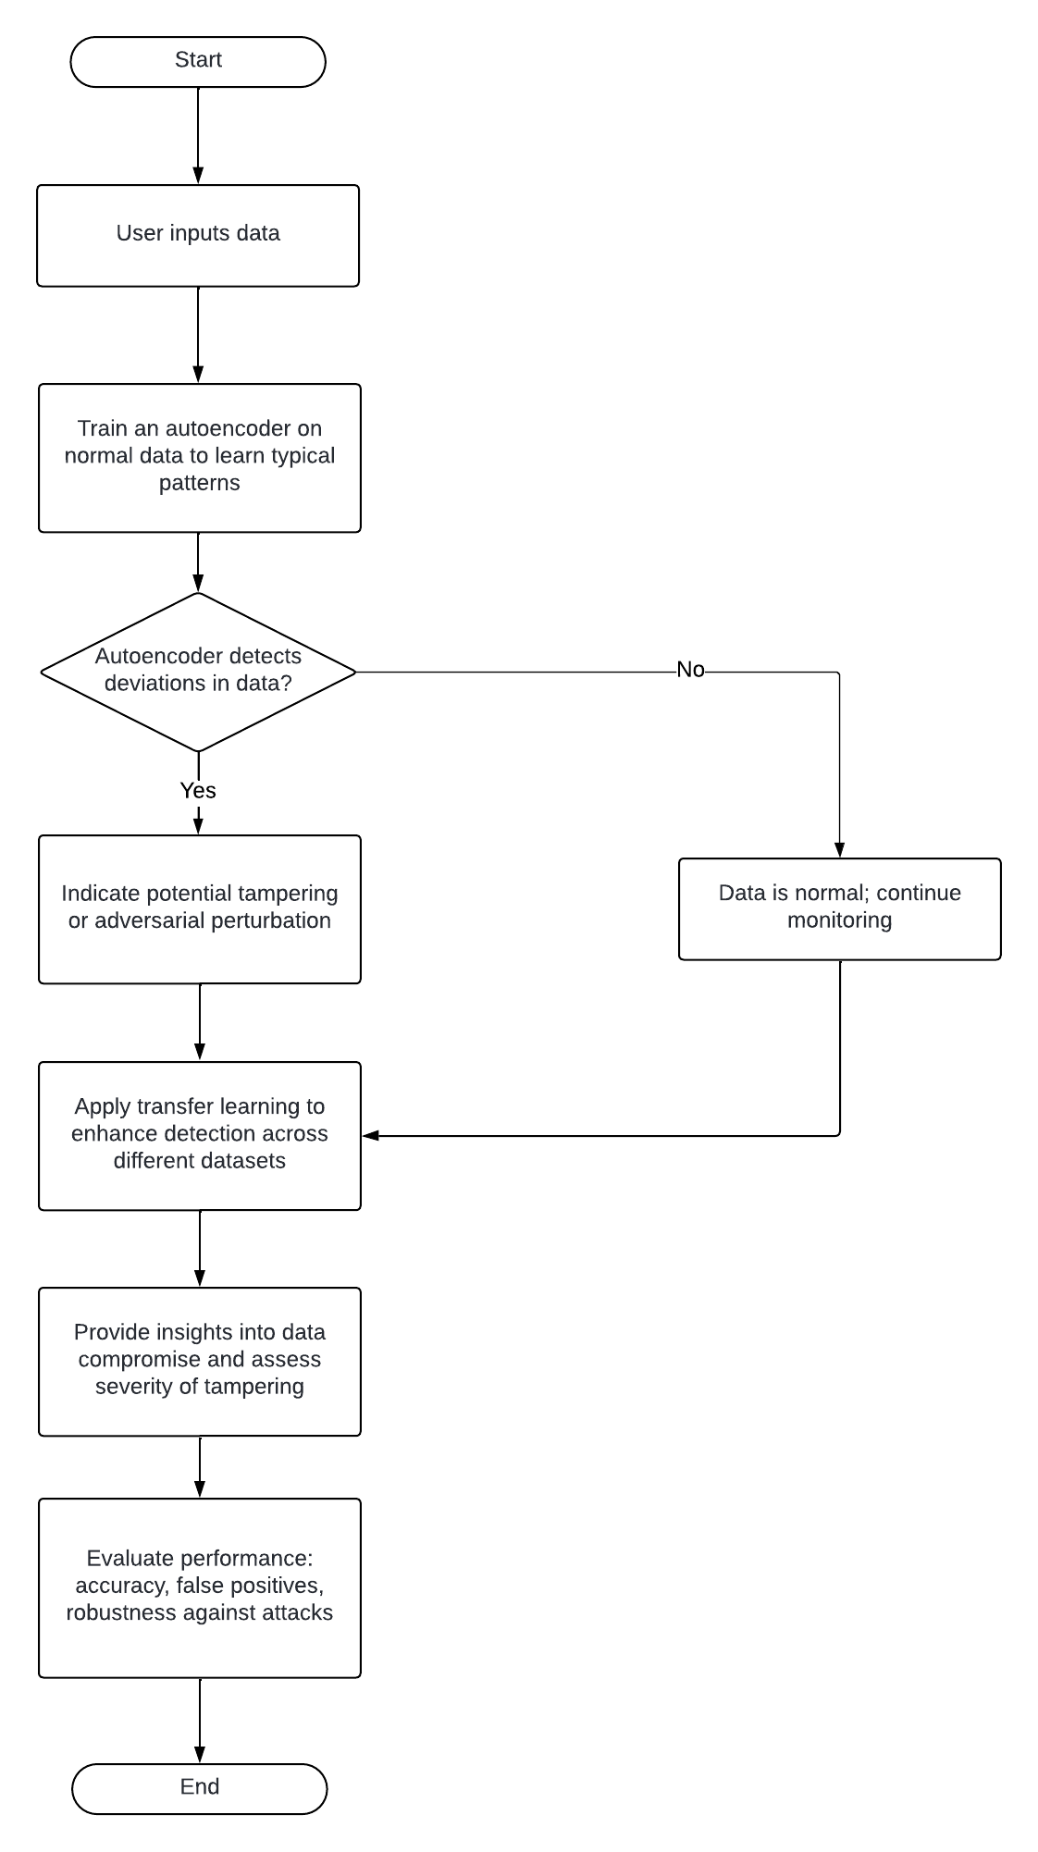
Note: In case of fabrication work in the project, an engineering drawing with dimensions / detailed design should be attached to the proposal.
Expected Outcome of the project:
A comprehensive framework leveraging autoencoders and transfer learning to detect adversarial perturbations in machine learning systems. This solution empowers users to identify and mitigate malicious modifications in their datasets, enhancing model robustness and ensuring the integrity of predictions. By combining the strengths of autoencoders for anomaly detection with transfer learning to generalize across diverse data distributions, this framework delivers a scalable, high-performance approach to safeguard machine learning models against adversarial attacks.

Is the project proposed relevant to the Industry / Society or Institution?
NO

(Note: Preference will be given to those projects relevant to the industry / institution. Hence be specific in giving detailed information). Is the industry extending support - technology / funds / use the final product, please specify.
Can the product or process developed in the project be taken up for filing a Patent?
No

Prior Art search done?
No

Note: If your answer is “Yes”, you may contact Patent Information Centre of KSCST. For more details, email: pic@kscst.org.in
Budget details (break-up details should be given):
Note: KSCST will provide nominal grant support for carrying out the project by students if selected by the project selection committee.
Budget | Amount
a) Materials / Consumables (Please specify) | 0.00
b) Labor (Describe) | 0.00
c) Travel (Describe) | 0.00
e) Miscellaneous (Please specify) | 0.00
Total | 0.00

Any other technical details (Please specify):
- We use autoencoders with transfer learning to detect adversarial attacks on machine learning systems.
- The autoencoder learns normal data patterns, so adversarial inputs lead to high reconstruction errors, signaling anomalies.
- This approach effectively detects common attacks and adapts well to various datasets.

SPP Coordinator (Identified by the college):
Note: To be identified by the principal of the institution. The project proposals must be submitted to KSCST through SPP coordinator designated by the principal.

Name: Dr. Sujatha M.
Email id:sujatham@canaraengineering.in
Contact No.:8088586029

Name of the Project Guide: Shatananda Bhat p | Name of the HOD: Udaya Kumar k  shenoy
Email id: shatananda.bhat@canaraengineering  .in | Email id: ukshenoy@canaraengineering.in
Contact No.: 9481769355 | Contact No.: 9448447617

DECLARATION
(From Project Students)
(To scan this page and enclose in the project proposal)

We, the project team hereby declare that the details enclosed in the project proposal (Title of the Project: Autoencoders Based Adversarial Perturbation Detection in Machine Learning Systems Using Transfer Learning Branch: Computer Science and Engineering, College: Canara Engineering College Bantwal) are true and correct to the best of our knowledge and belief. We undertake to inform the Karnataka State Council for Science and Technology (KSCST) of any changes to the project title or team members' names immediately through our project guide or the SPP Coordinator of our institution.
Additionally, we declare that the project work is original and not a result of copying or purchasing. We are committed to completing the project independently, with support from our faculty and project guide, while utilizing the facilities provided by the college. We will not engage in plagiarism and pledge to be sincere and dedicated in executing and completing the project as proposed.
We understand that if any of the above information is found to be false, untrue, or misleading, we may be held liable. We authorize the sharing of the project information contained in this proposal with KSCST, Bengaluru.
We acknowledge that the project team must exhibit and demonstrate the project, participate in the mid-term evaluation of sanctioned projects, and engage with experts. Additionally, we must exhibit the project at the Annual State-Level Poster Presentation and Exhibition, if selected. Should our team fail to participate in the mid-term evaluation or the Annual Exhibition (if selected), we understand that the supported project funds will be returned to KSCST.
We also enclose the endorsement form for KSCST, Bengaluru.
Name of the students with USN No. Signature with date
- ADITHYA SHETTY B 4CB21CS007
- ADITYA MALLYA 4CB21CS009
- KUNAL SACHIN KITTUR 4CB21CS047
- MOHAMMED BILAL AHMED 4CB21CS054
(Name & Signature of Project Guide with Seal) | (Name & Signature of HOD with Seal)
Email id: shatananda.bhat@canaraengineering.in | Email id: ukshenoy@canaraengineering.in
Contact No.: 9481769355 | Contact No.: 9448447617

ENDORSEMENT
(From College, endorsement to be taken in the institution / Department Letter head)
(To scan this page and enclose in the project proposal)

This is to certify that 1) Mr. Kunal Sachin Kittur , 2) Mr. Adithya Shetty B 3) Mr. Aditya Mallya, 4) Mr. Mohammed Bilal Ahmed, are bonafide students of Department of computer science and engineering , in the degree program of our institution. If the project proposal submitted by these students under the 48th series of Student Project Programme is selected by KSCST, we will provide the requisite laboratory / Computer / infrastructure support in our college / Institution. Further we also take necessary steps to see that the project team will exhibit / demonstrate their project in the mid-term evaluation of project and in the Annual State-Level Poster Presentation and Exhibition (if selected). If the student team fails to send the completed project report or fails to attend the evaluation in mid-term evaluation of sanctioned projects or fails to attend the Annual State-Level Poster Presentation and Exhibition (if selected), the supported project amount will be returned to KSCST.

(Name & Signature of  Project Guide with Seal) | (Signature of HOD with Seal) | (Signature of the Principal with Seal)
Email id:  Shatananda.bhat@canaraengineering.in | Email id:  ukshenoy@canaraengineering.in | Email id:  principal@canaraengineering.in
Contact No.:9481769355 | Contact No.:9448447617 | Contact No.:9448297353

DETAILS OF PROCESSING FEES MADE THROUGH
NEFT / UPI PAYMENT
(Note: Include this page in the softcopy of the student project proposal. The student team shall furnish the details in the Google Form. It is informed to the students to 1) keep ready the softcopy of the project proposal and other documents and 2) Furnish the payment made details as processing fees and 3) update the details in the Google Form on the same day of payment made to KSCST by NEFT / UPI payment).

- TITLE OF THE PROJECT | : | Autoencoders Based Adversarial Perturbation Detection in Machine Learning Systems Using Transfer Learning
- NAME OF THE TEAM LEADER | : | Kunal Sachin Kittur
- EMAIL ID | : | Kunalkittur23@gmail.com
- CONTACT MOBILE NO. | : | 8668895548
PAYMENT MADE DETAILS
- BANK REF. NO. / UTR NO. / UPI No. (12 digits) | :
- TRANSACTION ID | :
- NAME OF THE SENDER / ACCOUNT HOLDER and CONTACT NUMBER | :
- NAME OF THE BANK | :
- PROCESSING FEES | : | Rs. 1,180/- (Inclusive of 18% GST)
- DATE OF PAYMENT MADE | :
- TIME | :
- MODE OF PAYMENT MADE  (NEFT / UPI, PLEASE SPECIFY) | :

(Name & Signature of  the team leader) | (Name & Signature of  Project Guide or HOD with Seal)
KARNATAKA STATE COUNCIL FOR SCIENCE AND TECHNOLOGY
Indian Institute of Science campus, Bengaluru
48th SERIES OF STUDENT PROJECT PROGRAMME (SPP)
(Note: This page is for information about bank details of KSCST to the student team and college / institution and not to include this page in the project proposal softcopy)

BANK ACCOUNT DETAILS OF KSCST
Name and address of the Institution | Karnataka State Council for Science and Technology, IISc Campus, Bangalore -560012
Account holder’s name / Designation | Secretary, Karnataka State Council for Science and Technology
Bank Account No. & Name of the bank | Current A/C No. 0683201000024  Canara Bank, IISc Campus Branch, Bangalore-560012
IFSC Code | CNRB0000683
MICR Code | 560015023
Bank Branch Address | Canara Bank, Indian Institute of Science, Bangalore-560012

