ML ASSIGNMENT-2

Name: Pavan Gandavarapu
Student Id: 700741173

Question-1: Use a python code to display the following star pattern using the for loop

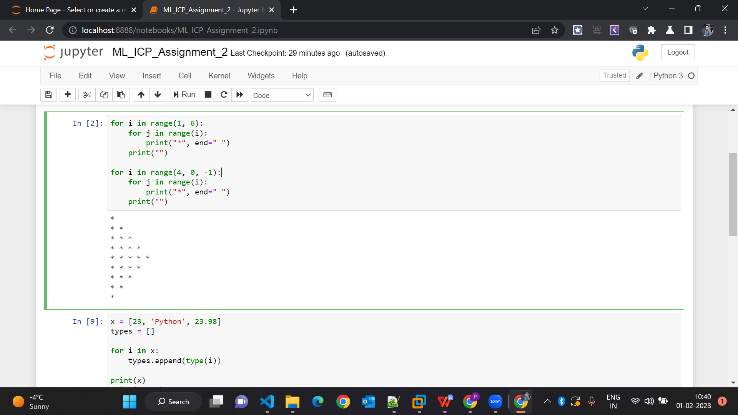

Question-2: Use looping to output the elements from a provided list present at odd indexes. my_list = [10, 20, 30, 40, 50, 60, 70, 80, 90, 100]

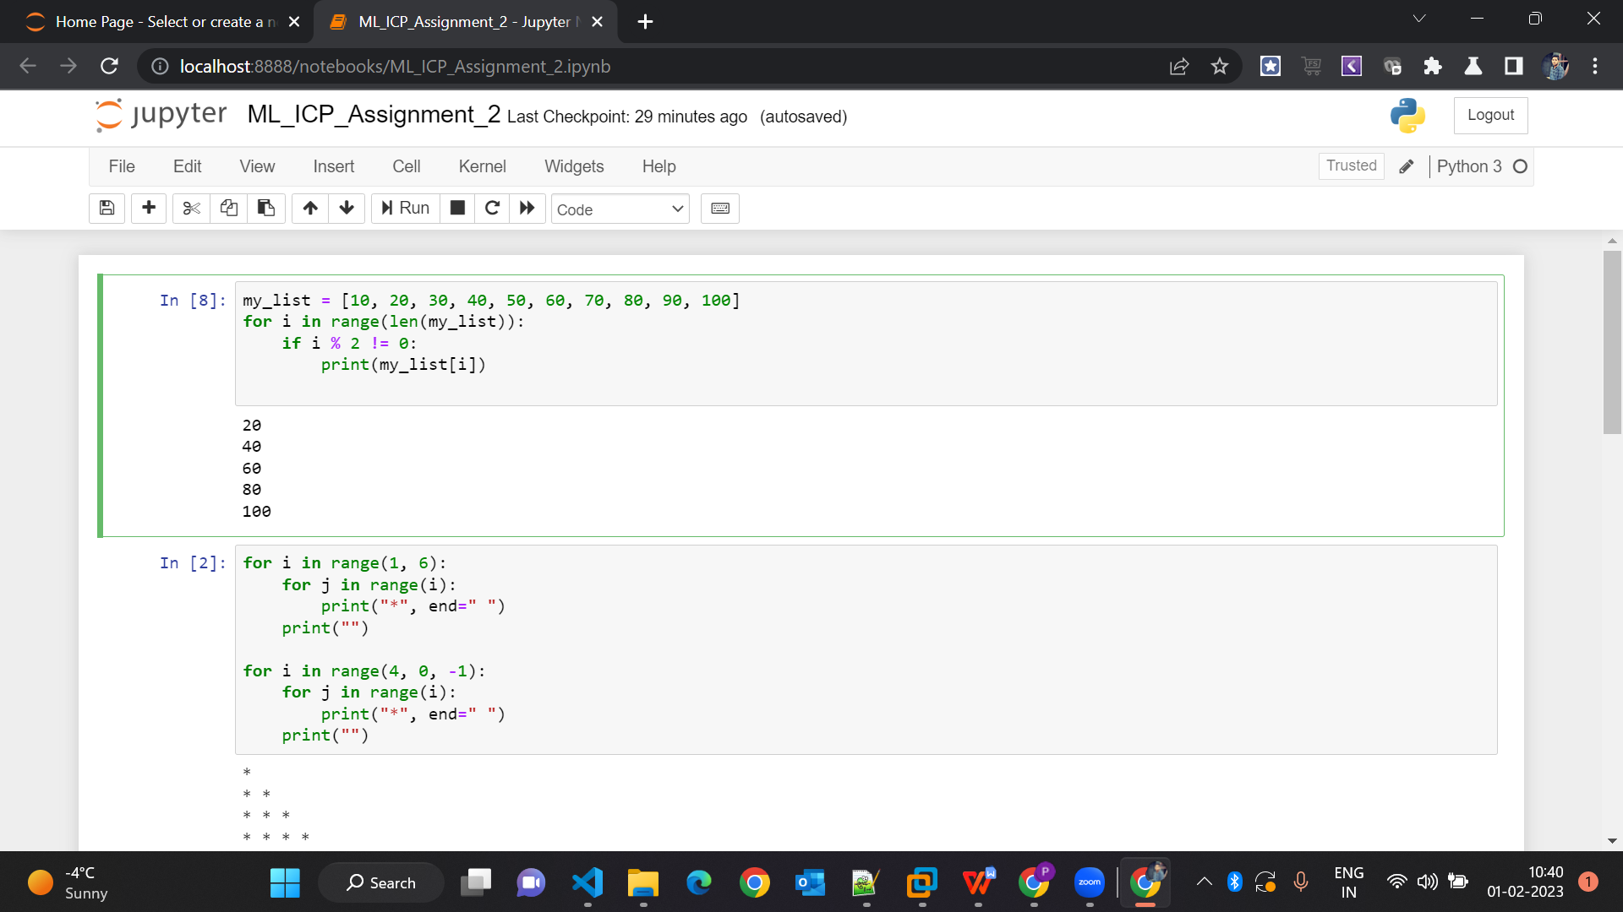

Question-3:

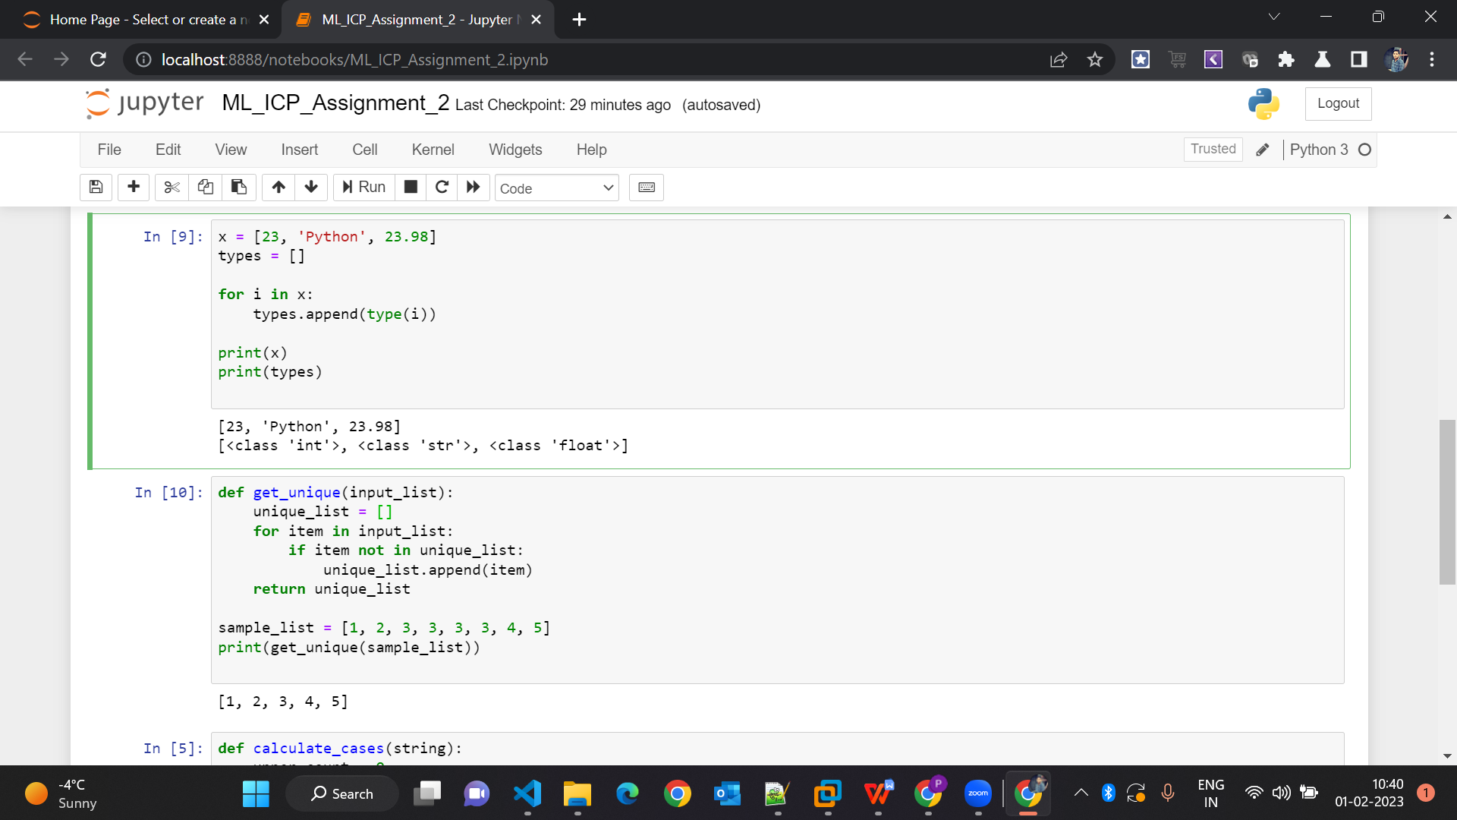

Question-4:

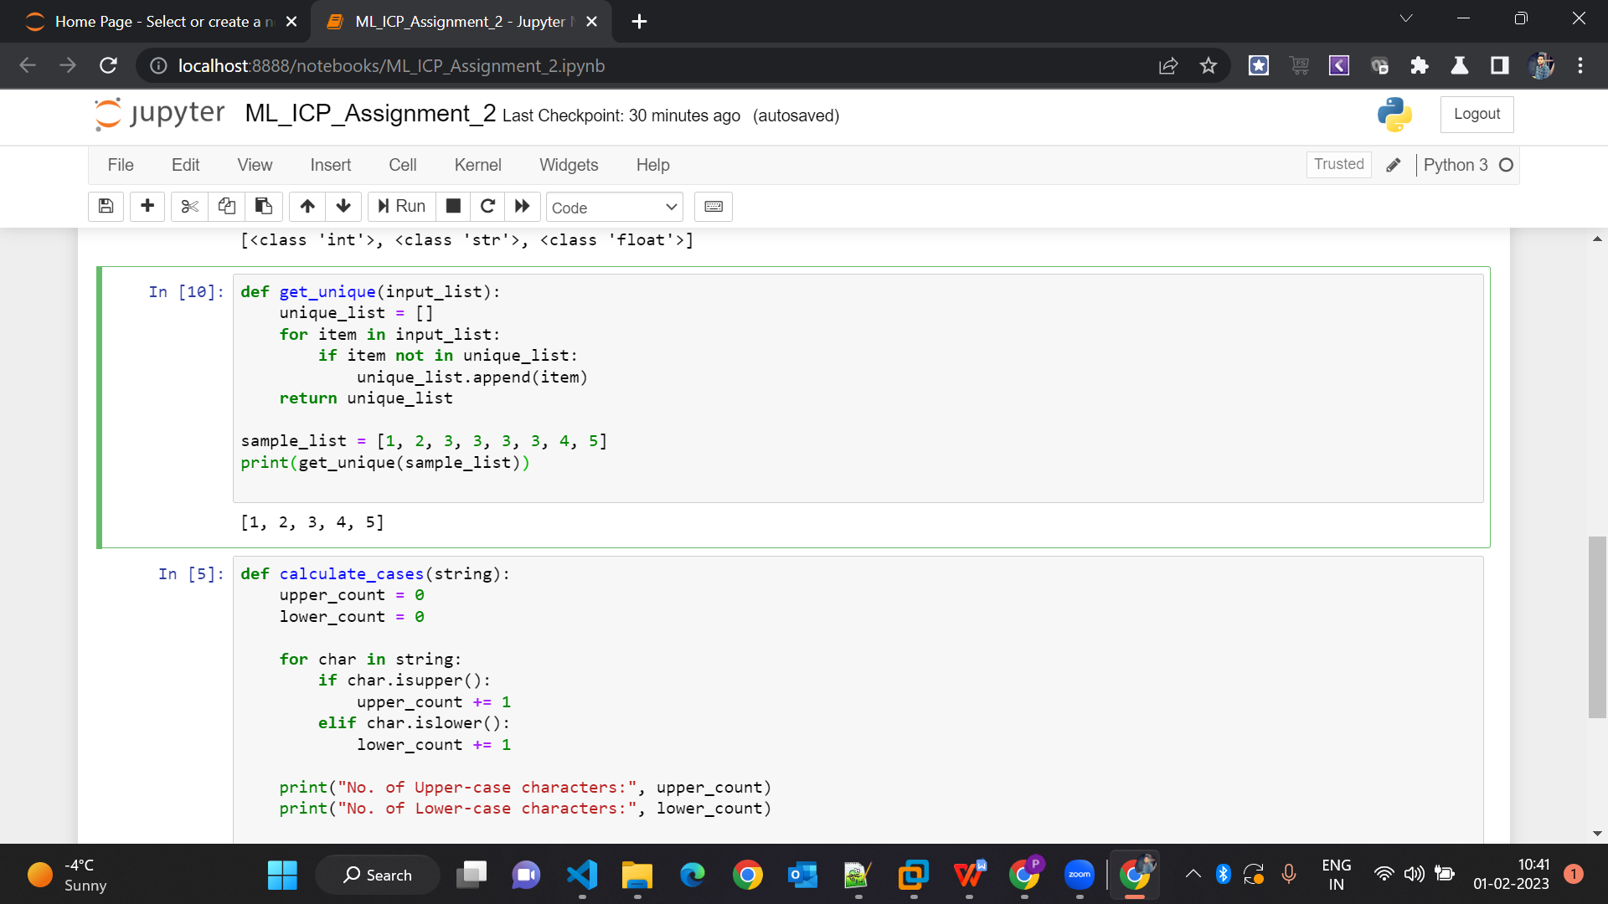

Question-5:

