

OhioHealth - Performance Metric Dashboard

Final Capstone Report
Submitted to
OhioHealth
by
University of Dayton Capstone Project Team
Pavan Kumar Gudimalla
Mani Vardhan Suru
Juhi Afreen
Sai Siddhardha Ponnaganti
Jashwanth Srinivas
University of Dayton
May 2026

Contents
Executive Summary 3
1. Business Background 3
2. Problem Statement 3
3. Project Objective 4
4. Project Evolution 5
5. Scope and Constraints 5
6. Data Overview 5
7. Methodology 8
7.1 Data Preparation 8
7.2 Baseline Trigger Review 8
7.3 Descriptive Review 8
7.4 Regression Testing 10
7.5 Pattern Testing 11
7.6 Control Panel Design 11
8. Key Findings 12
8.1 Overall Intervention Impact 12
8.2 Site-Level Variation 12
8.3 Conditions Where Interventions Performed Better 13
9. Recommendations 13
9.1 Shift from Reactive to Signal-Based Intervention 13
9.2 Add a Validation Step Before Action 14
9.3 Build a Learning System Around Intervention Outcomes 14
10. Risks and Implementation Considerations 14
11. Conclusion 15
Appendix 15
Appendix A. Hospital Sites 15
Appendix B. Control Panel Framework 16
Appendix C. Hospital Sites Included in Final Analysis 17
Appendix D. Excluded Metrics Note 18

Executive Summary
OhioHealth uses monthly performance dashboards to monitor hospital performance and trigger interventions when a metric falls below target and declines month over month. This project began as an evaluation of OhioHealth’s current trigger logic to determine whether the current process was creating unnecessary intervention work by reacting to routine variation. The scope expanded when historical intervention records became available, allowing the team to test whether interventions themselves led to measurable improvement.
We analyzed 1,296 site-metric-month observations across 17 months of performance and intervention data using regression, pattern testing, and decision-rule analysis. Across the full dataset, interventions generally moved performance in a positive direction, but the effect was small, inconsistent, and highly dependent on timing and context.
System-wide testing did not show a strong or repeatable intervention effect across sites and metrics. However, pattern testing showed that interventions performed better when performance was already close to target and when observed improvement exceeded the gap that triggered intervention. These results suggest that intervention value depends less on whether OhioHealth intervenes and more on when OhioHealth intervenes.
OhioHealth should replace uniform intervention triggers with a more selective, signal-based decision process. Using trend, distance from target, and historical variability to guide intervention timing will reduce unnecessary RCA effort and help leaders focus on the signals most likely to require action.
- Business Background
OhioHealth is a non-profit healthcare system that manages operational performance across 18 hospitals using a monthly executive dashboard. This dashboard tracks 47 metrics across four balanced scorecard quadrants: Quality, Service, Finance, and Culture. Leadership uses this system to review site-level results, identify underperforming metrics, and determine when corrective action is needed.
Each month, metric owners review site and metric results. When a metric falls below target and declines compared to the prior month, OhioHealth may initiate a formal intervention, referred to internally as a countermeasure. This process requires root cause analysis, corrective action planning, and follow-up monitoring through a standardized workflow.
The process creates a consistent response to underperformance, but it also requires time from operational leaders. Each intervention adds review time, documentation, and follow-up work for the teams involved. Client-validated estimates placed the average
countermeasure effort at 60 to 80 minutes, typically involving two leaders at an estimated labor cost of roughly $75 per hour.

OhioHealth asked whether this intervention process consistently identifies meaningful operational issues and whether the effort required to complete these interventions leads to measurable improvement.

Problem Statement
OhioHealth’s current intervention process is reactive. It triggers action when a metric falls below target and declines from the prior month, regardless of whether that change reflects meaningful operational deterioration or routine variation.
This creates two practical risks. First, teams may spend time responding to short-term fluctuation that would have corrected without formal intervention. Second, persistent underperformance may receive less attention when a metric remains below target but does not continue to decline.
OhioHealth needed a more reliable way to determine when intervention effort adds value, when continued monitoring is sufficient, and when performance issues require stronger action.

Project Objective
This project evaluated whether OhioHealth’s current intervention process leads to measurable and consistent performance improvement and whether intervention timing can be improved through more selective decision rules.
The analysis focused on four questions:
- Do interventions lead to measurable improvement in the months that follow?
- Is intervention impact consistent across sites, metrics, and time periods?
- Does the current trigger logic distinguish meaningful performance issues from routine variation?
- How can OhioHealth improve intervention timing while reducing unnecessary intervention effort?
The goal was to determine whether interventions create measurable value, identify where that value is more likely to appear, and recommend a more targeted intervention process.

Project Evolution
The project began as an evaluation of OhioHealth’s trigger logic and the administrative burden created by the current countermeasure process. The original scope focused on whether alternative trigger rules could better distinguish meaningful performance risk from routine month-to-month variation.
In February 2026, OhioHealth provided countermeasure records by site, metric, and month. This allowed the team to link intervention activity to post-intervention performance and evaluate whether interventions themselves led to measurable improvement.
That shift moved the project beyond trigger design and into intervention effectiveness testing. It allowed the analysis to answer a more practical business question: not only when OhioHealth intervenes, but whether those interventions consistently improve performance.

Scope and Constraints

This analysis focused on formal interventions captured in OhioHealth’s countermeasure records and monthly dashboard performance files.

Formal interventions recorded in the available countermeasure dataset were included in the analysis. Informal operational actions could not be consistently observed and were therefore excluded.

The evaluation focused on short-term operational response using performance movement in the months following intervention. It did not assess long-term strategic, financial, or clinical outcomes.

Interventions were treated as binary events. An intervention either occurred or it did not. The analysis did not distinguish intervention type, intervention quality, or differences in execution across teams.

This project evaluated whether OhioHealth’s intervention process supports effective operational decision-making. It did not assess whether every individual intervention was operationally justified or whether the underlying corrective action was the right one.

Data Overview
The final analysis combined three OhioHealth data sources into a single analytical
dataset.
The first two sources were OhioHealth’s FY25 and FY26 monthly performance dashboards. Together, these files captured site- and metric-level results from July 2024 through November 2025. The third source contained formal countermeasure activity recorded by site, metric, and month.
We merged all three sources using site, metric, and date as the common key. This allowed each intervention to be linked directly to the performance periods that followed.
The final unit of analysis was Site × Metric × Month. After cleaning, alignment, and filtering, the final modeling dataset contained 1,296 observations.
This structure allowed the team to evaluate intervention timing, measure short-term performance movement, and compare outcomes across sites, metrics, and time periods.

Table 1. Dataset Summary

Source | Record Type | Time Period | Use in Analysis
FY25 performance dashboard | Monthly performance data | July 2024-June 2025 | Site and metric performance history
FY26 performance dashboard | Monthly performance data | July 2025-November 2025 | Continuation of site and metric performance history
Countermeasure records | Formal intervention activity | Aligned by site, metric, and month | Linked interventions to post-intervention outcomes
Final modeling dataset | Site x Metric x Month panel | July 2024-November 2025 | 1,296 observations used for modeling

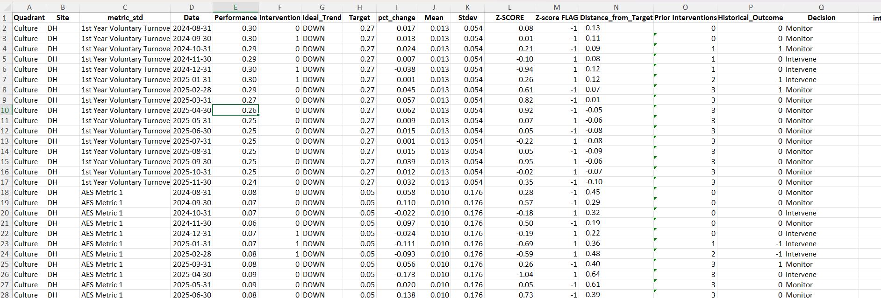
Figure 1. Final modeled dataset structure.

7. Methodology

7.1 Data Preparation

We combined the FY25 and FY26 dashboard files into a single monthly dataset. Metric names were standardized across years, aggregate summary rows were removed, and site-metric records were aligned so observations matched consistently across files.

The data was then converted from wide format to long format, so each row represented one site, one metric, and one month.

Next, countermeasure records were merged into the monthly dataset using site, metric, and month as the common key. Missing intervention values were coded as zero to indicate that no formal intervention occurred during that period.

To make results comparable across metrics, raw monthly values were converted into month-over-month percent change and direction-adjusted, so positive values always represented improvement.

Finally, lag variables were created from N+1 through N+5 to measure how results changed in the months following intervention. Metrics with inconsistent scales, limited intervention history, or insufficient usable observations were removed to produce a stable modeling dataset.

7.2 Baseline Trigger Review

We reconstructed OhioHealth’s current intervention rule to evaluate how the existing process behaved in practice.

Under the baseline rule, intervention is triggered when a metric falls below target and declines relative to the prior month. We rebuilt that logic across the historical dataset and compared modeled trigger behavior against observed countermeasure activity.

This established a baseline for how often the current process signaled intervention and how closely actual intervention behavior aligned with the intended rule.

7.3 Descriptive Review

We used descriptive analysis to understand baseline performance behavior before testing intervention impact.

Most month-to-month changes clustered near zero, which showed that routine movement was generally modest. A smaller number of observations showed much larger swings, indicating that most months were stable while a limited number experienced unusually high variation.

When intervention and non-intervention periods were compared, both groups centered near zero and overlapped substantially. This suggested that intervention periods did not produce a clear system-wide shift in short-term results.
Figure 2 compares the distribution of performance change during intervention and non-intervention periods.
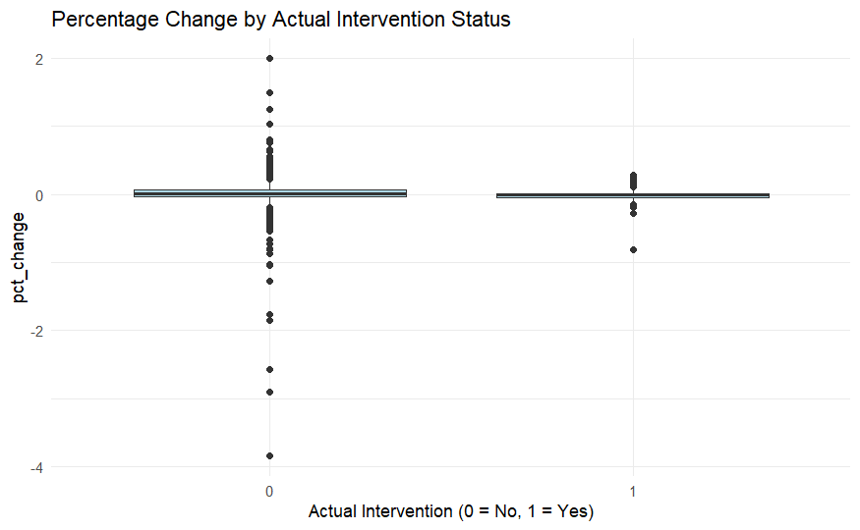
Figure 2. Performance change distribution - intervention vs. non-intervention months.

7.4 Regression Testing

We used lagged regression to test whether interventions were associated with measurable improvement in the months that followed.

The dependent variable was normalized month-over-month performance change. The primary independent variable was intervention status. Models were tested across N+1 through N+5 to measure whether intervention effects appeared immediately or with delay.

Controls for site, metric, and time were included to separate intervention effects from differences in operating context.

This allowed the analysis to test whether intervention itself explained measurable short-term improvement after accounting for differences across hospitals, metrics, and time periods.
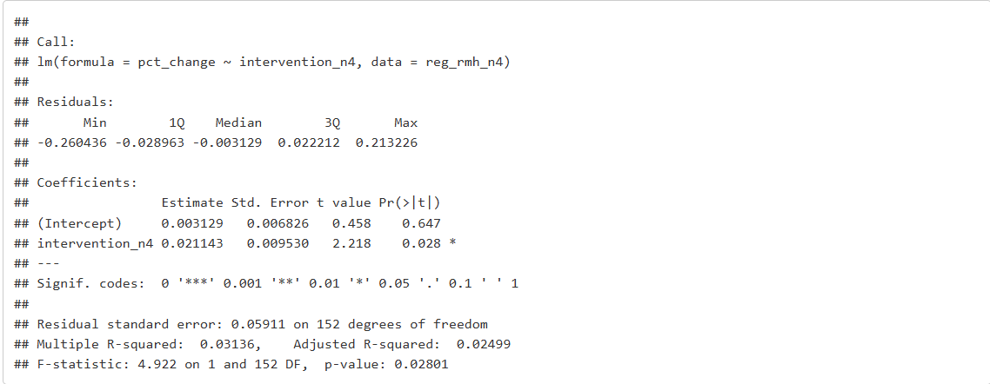
Figure 3. Regression summary for post-intervention performance testing.

7.5 Pattern Testing

Regression measured average intervention behavior across the full system, but it did not explain when interventions performed better or worse.

To address that gap, we tested intervention outcomes under different operating conditions.

First, interventions were grouped by distance from target to test whether outcomes differed when metrics were only slightly below target versus materially below target.

Second, we tested whether intervention outcomes improved when observed recovery exceeded the performance gap that triggered intervention.

These comparisons were made to identify the operating conditions where intervention was more likely to produce useful short-term improvement.
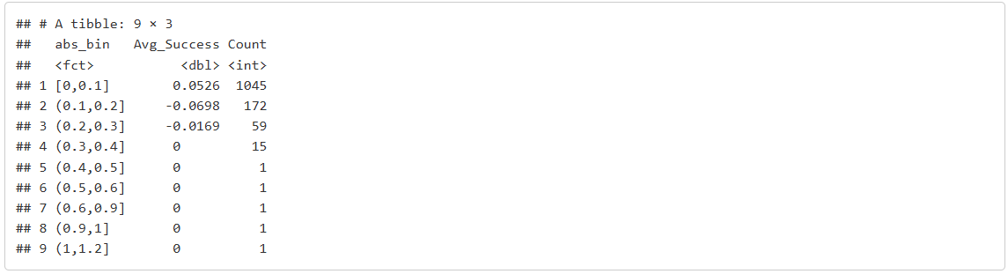Figure 4. Intervention outcomes by distance from target.

7.6 Control Panel Design

The final phase translated the analytical findings into a practical decision-support framework.

Rather than treat every below-target decline as equally urgent, the control panel evaluates multiple signals before recommending action.

The framework uses trend direction, distance from target, historical variability, and prior intervention history to classify each observation as Monitor, Intervene, or Escalate.

This keeps the tool practical for operational leaders while allowing the underlying logic to screen meaningful signals before assigning intervention work.

8. Key Findings

8.1 Overall Intervention Impact
Across the full dataset, interventions generally moved performance in the expected direction. In most periods, post-intervention results were slightly better than non-intervention periods.
However, that effect was small and not consistent enough to support a broad system-wide conclusion. While interventions were directionally helpful, the signal was not strong enough to treat every intervention trigger as equally actionable.
This suggests that interventions can create value, but the effect is too uneven to assume that every below-target decline requires the same response.

Table 2 shows that the regression results generally moved in the expected direction, while only the RMH N+4 result met conventional significance thresholds.

Lag Period | Direction of Effect | Statistical Result | Interpretation
N+1 | Positive | Not statistically significant | Interventions moved in the expected direction, but the effect was not reliable system wide.
N+2 | Positive/weak | Not consistently significant | The short-term signal remained too small to support a broad conclusion.
N+3 | Positive | Not statistically significant | The model did not isolate a stable intervention effect across sites and metrics.
N+4 | Positive | RMH significant: coefficient 0.0211, p = 0.028, R-squared = 0.0314 | The clearest measurable signal appeared at RMH four months after intervention.
N+5 | Positive | Not statistically significant | The effect did not remain strong enough to prove consistent system-wide impact.
Table 2. Regression Results Summary by Lag Period

8.2 Site-Level Variation
Intervention performance was not consistent across sites.
Most sites did not have enough intervention frequency to support stable modeling. Among the sites with sufficient intervention volume, RMH produced the clearest signal.
At RMH, intervention activity showed the clearest positive signal four months after intervention. This suggests that interventions at RMH were associated with measurable improvement four months after intervention.
However, this pattern did not repeat consistently across other sites or time periods. The effect was real, but isolated.
This suggests that intervention effectiveness depends heavily on local execution, operating context, or metric mix rather than on intervention alone.
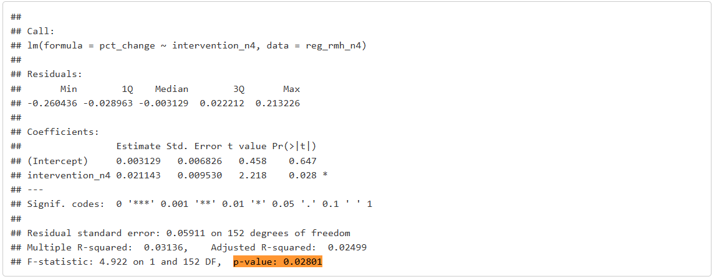Figure 5. RMH site-level N+4 regression signal.

8.3 Conditions Where Interventions Performed Better
Although system-wide intervention effects were inconsistent, pattern testing revealed clearer decision signals.
Interventions performed better when performance was already close to target. When metrics were only slightly below target, intervention outcomes were more favorable than when performance had already moved materially off target.
Interventions also performed better when observed recovery exceeded the performance gap that triggered intervention. In those cases, post-intervention outcomes were consistently stronger.
This was the clearest practical finding in the analysis. Intervention value depends less on whether OhioHealth acts and more on when OhioHealth acts.

9. Recommendations

9.1 Shift from Reactive to Signal-Based Intervention
OhioHealth should move away from intervention decisions based only on target attainment and month-over-month decline.
Intervention decisions should also account for trend direction, distance from target, historical variability, and prior intervention history. These signals provide better context for whether observed movement reflects routine variation or a meaningful operational issue.
A more selective trigger process will reduce unnecessary intervention work and improve the likelihood that formal intervention is used where it is most likely to create value.

9.2 Add a Validation Step Before Action
Before assigning intervention work, teams should validate whether the observed decline reflects a meaningful change in performance.
This review should confirm whether similar variation has occurred before, whether the metric has historically recovered without intervention, and whether the current decline differs meaningfully from normal behavior.
Adding this step will reduce unnecessary RCA effort by screening routine variation before teams commit time to formal countermeasure work.

9.3 Build a Learning System Around Intervention Outcomes
OhioHealth should track short-term post-intervention outcomes and use those results to refine intervention thresholds over time.
This creates a practical feedback loop that helps identify where interventions work best, where repeated intervention adds limited value, and which signals most reliably justify action.
A short pilot at RMH would provide a practical starting point because it showed the clearest repeatable intervention signal in the analysis.

10. Risks and Implementation Considerations
A more selective intervention process improves decision quality, but it also introduces implementation risk if thresholds are too narrow or applied too rigidly.
If thresholds are set too tightly, meaningful issues may be missed. If thresholds are too broad, the process will continue to generate unnecessary intervention work. The control panel should therefore be used as a decision-support layer, not as a rigid replacement for leadership judgment.
OhioHealth should test the framework alongside the current process before broader adoption. Running both approaches in parallel will allow teams to refine thresholds, evaluate operational fit, and confirm that the framework improves intervention quality without delaying response to meaningful issues.
The analysis relied on metrics with sufficient intervention history. As newer FY26 metrics accumulate additional history, threshold settings may require recalibration before broader use.

11. Conclusion
OhioHealth’s current intervention process creates directionally positive movement, but the effect is not consistent enough to treat every trigger as equally actionable.
Intervention value depends more on timing, operating context, and prior performance behavior than on trigger status alone. That makes the current reactive approach too broad to distinguish routine variation from signals that warrant formal action.
OhioHealth can improve intervention quality by using a more selective decision process that incorporates trend, distance from target, historical variability, and prior intervention history. This approach will reduce unnecessary RCA effort, improve intervention timing, and help leaders focus attention where formal action is most likely to create value.

Appendix

Appendix A. Hospital Sites
S.no | Abbreviation | Formal Site Name
1 | RMH | Riverside Methodist Hospital
2 | GMC | Grant Medical Center
3 | DH | Doctors Hospital
4 | GMH | Grady Memorial Hospital
5 | DMH | Dublin Methodist Hospital
6 | HMH | Hardin Memorial Hospital
7 | MGH | Marion General Hospital
8 | OBH | O’Bleness Hospital
9 | OHM | Mansfield Hospital
10 | OHS | Shelby Hospital
11 | GCMH | Grove City Methodist Hospital
12 | BH | Berger Hospital
13 | SMC | Southeastern Medical Center
14 | VW | Van Wert Hospital
15 | PMH | Pickerington Methodist Hospital
16 | FSED | Freestanding Emergency Departments
17 | OPG | OhioHealth Physician Group
18 | MCH | Mansfield - Cook Road (MedCentral)

Appendix B. Control Panel Framework

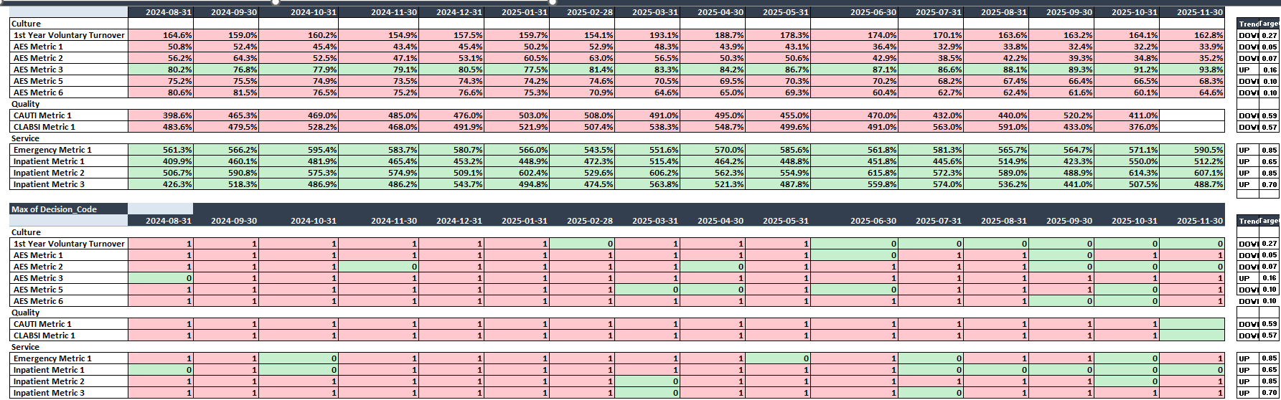

Baseline trigger logic reconstruction.
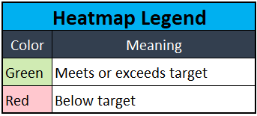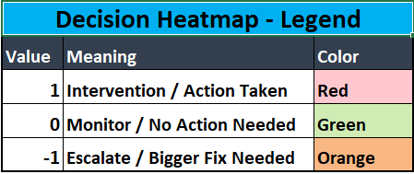
Baseline trigger comparison output.

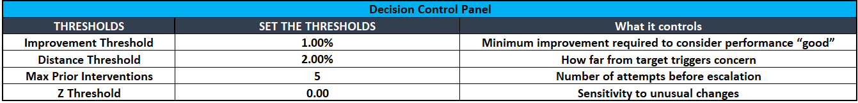Control panel decision framework

The control panel was designed as the practical output of this project. It translates the analytical findings into a decision-support tool that helps OhioHealth determine when to continue monitoring performance, when to assign formal intervention work, and when a stronger response may be needed.

Rather than treat every below-target decline the same way, the control panel evaluates multiple signals before recommending action. Its purpose is to help separate routine month-to-month variation from meaningful operational risk.

The framework uses four primary inputs:

Trend direction

Distance from target

Historical variability

Prior intervention history

Using these inputs, the control panel classifies each observation into one of three decision categories:

Monitor: Performance movement appears within expected variation and does not require immediate action.

Intervene: Performance decline is large enough to justify formal corrective action.

Escalate: Performance remains concerning despite prior intervention and may require stronger leadership response.

This structure helps reduce unnecessary intervention when movement appears routine and strengthens response when the signal is persistent or unresolved.

From a practical standpoint, leaders can use the control panel to review recent performance, identify metrics that require attention, and focus on the highest-priority issues. The panel also allows users to adjust threshold settings, including improvement sensitivity, distance from target, escalation limits, and signal sensitivity, without changing the underlying decision structure.

The control panel is intended to support leadership judgment, not replace it. It provides a more consistent and data-driven way to determine when formal action is most likely to add value.

Appendix C. Hospital Sites Included in Final Analysis

Site Code | Hospital Site
DH | Doctors Hospital
GMC | Grant Medical Center
MGH | Marion General Hospital
OHM | Mansfield Hospital
OHS | Shelby Hospital
PMH | Pickerington Methodist Hospital
RMH | Riverside Methodist Hospital

Appendix D. Excluded Metrics Note
Some metrics had blank values, inconsistent scales, limited intervention history, or insufficient usable observations. These records were excluded from stable modeling so the final regression and pattern tests reflected comparable site-metric-month observations.

