PAVAN GUPTA
Full Stack Developer | MERN | AWS

I am a Full Stack Developer skilled in HTML, CSS, JavaScript, TypeScript, ReactJS, NextJS, PayloadCMS, NodeJs, ExpressJs, MongoDB, and PostgreSQL. With a primary focus on backend architecture, I prioritize End-to-End Type Safety by maintaining a private NPM package to standardize Zod validation schemas across both client and server environments.
My backend workflow leverages Node.js and Express.js, utilizing Mongoose for MongoDB and Sequelize (TypeScript ORM) for PostgreSQL. I heavily use complex MongoDB aggregation pipelines for efficient data handling, alongside Redis as a high-performance caching layer and message broker. On the frontend, I manage server state and API interactions using TanStack Query and Axios, while handling global state with Zustand and useContext, useReducer and ensuring robust data entry using React Hook Form.
Regarding Cloud Infrastructure & DevOps, I strictly Dockerize applications and manage comprehensive AWS environments. My expertise includes orchestrating containers via EC2, ECR, and ECS, and designing serverless, event-driven architectures using Lambda, SQS, and SNS. I leverage Kafka as a distributed backbone alongside EventBridge for system observability, while managing secure package delivery via CodeArtifact and enforcing security standards using Secrets Manager, IAM, and Cognito. I am deeply passionate about building scalable applications from the ground up, turning raw ideas into fully deployed, production-ready products.

Personal Info
Madhapur, Hyderabad
+91 9966336255
uppalagupta123@gmail.com

Technologies
MERN Stack Developer
Lifemine Technologies / Webpipl Solutions | 07/2024 – Present
Managing workflows for both entities, I develop full-stack web applications using the MERN stack and TypeScript. My core responsibility is managing backend logic and production databases to ensure system stability. I actively optimize existing Webpipl codebases while building performant and interactive UIs for new Lifemine projects.
Full Stack Developer (Remote) (esop)
NewOwl AI | 03/2024 – 08/2024
Specialized in Node.js and Express.js to build robust server-side applications. I managed PostgreSQL databases, designing efficient schemas and writing complex SQL queries to ensure data integrity and performance.

EXPERIENCE
 HTML
 CSS
 JavaScript
 TypeScript
 SQL

Frameworks:
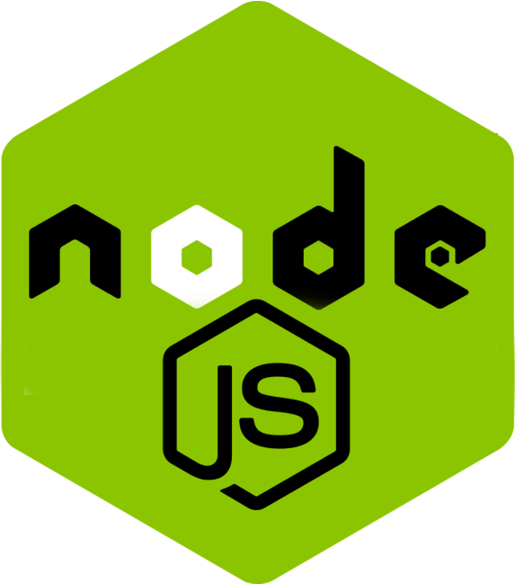 Node JS
 React JS
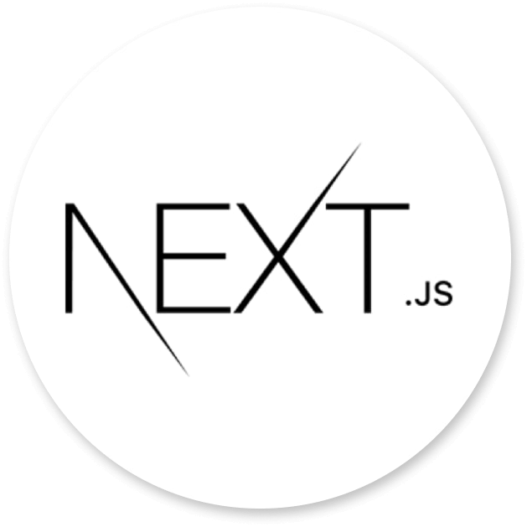 Next JS
 Payload CMS
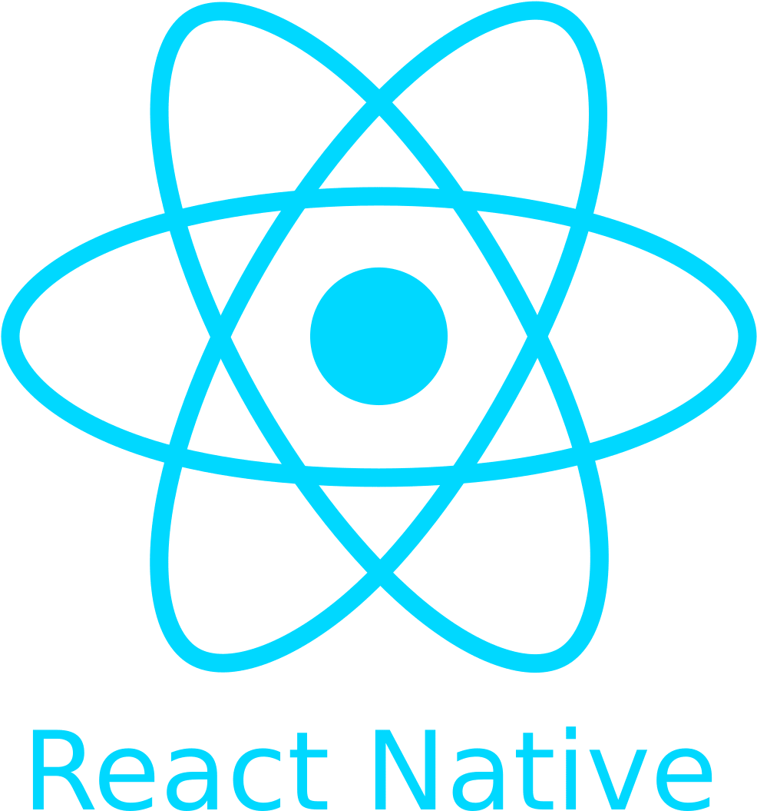 React Native

Databases:
 MongoDB
 PostgreSQL
 Redis

Containerization:
 Docker

Cloud:
 Amazon Web Services
Messaging / Streaming:
 Apache Kafka

UI/UX:
 Figma
 Photoshop

Bachelor of Engineering (B.E.) in Civil Engineering: S.R.K.R Engineering College, Andhra University — GPA: 6.76/10 (2016–2021)
Intermediate (M.P.C): Aditya Junior College, Andhra Pradesh — Total: 681/1000 (2014–2016)
Secondary School Certificate (SSC): Sri Kakatiya Merit School, Andhra Pradesh — GPA: 7.3/10 (2014)

EDUCATION

Skills

PROFESSIONAL SKILLS
Leadership skills
Teamwork
Strong mathematical abilities
Quick Learning & adaptability
Communications skills

- GitHub: Experienced with version control, including repository creation, cloning, committing changes, and pushing updates. Skilled in using Git submodules, tags, branching, and pull requests for team collaboration and project management.
- Visual Studio Code (VS Code): Proficient in using VS Code for editing and navigating code, utilizing extensions like ESLint and Prettier, and debugging. Comfortable with customizing settings to improve development workflows.
- Linux: Familiar with Linux systems, basic terminal commands, file management, and using package managers. Experienced in running Git and automating tasks with simple shell scripts.
- Attention to Detail: Careful and meticulous approach to coding, testing, and debugging, ensuring that work is error-free and meets high-quality standards.
- Advanced Excel Skills: Skilled in using advanced Excel functions, including data management, dynamic charts, PivotTables, VBA macros, and conditional formatting for efficient analysis and reporting.
- Document Creation & Formatting: Proficient in creating and formatting reports, proposals, presentations, and correspondence using Microsoft Word, PowerPoint, and Adobe Acrobat. Able to integrate multimedia elements to enhance presentations.
- Video & Image Editing: Experienced in using Adobe Photoshop and PowerDirector for image editing, color correction, resizing, and creating basic animations for multimedia content.
- Computer Skills & System Administration: Knowledgeable in troubleshooting software and hardware issues, Windows OS installation, and basic system administration tasks. Skilled in software maintenance and updates.
- Work Ethic & Professionalism: Demonstrates a strong commitment to quality, consistency, and ethical standards in all aspects of work.

Languages
English – Proficient
Telugu – Native
Hindi – Basic

Hobbies
Cricket, Tennis, Shuttle
Brushing up latest Technology
Video editor
Photography

Software
Microsoft Office – Excel, Word, PowerPoint etc.
Photoshop
Adobe illustrator
After effects
Premiere pro
Audacity
Cyberlink Power Director
GITHUB - https://github.com/PavanGuptaZ LinkedIn - https://www.linkedin.com/in/pavanguptaz

