Experiment 2: User-Interface Prototype for a Mobile Station

Question
Q2. Design a user interface prototype for a mobile station using Figma, considering connectivity and convenience.

Aim
To design a three-screen mobile-station interface in Figma that keeps network status visible and makes common tasks quick to reach.

Figma Design
design link: https://www.figma.com/design/zip7DN6lCDidnY5UlJulwN/Untitled?node-id=0-1&m=dev&t=IWRUWrTRgJKBh4pI-1

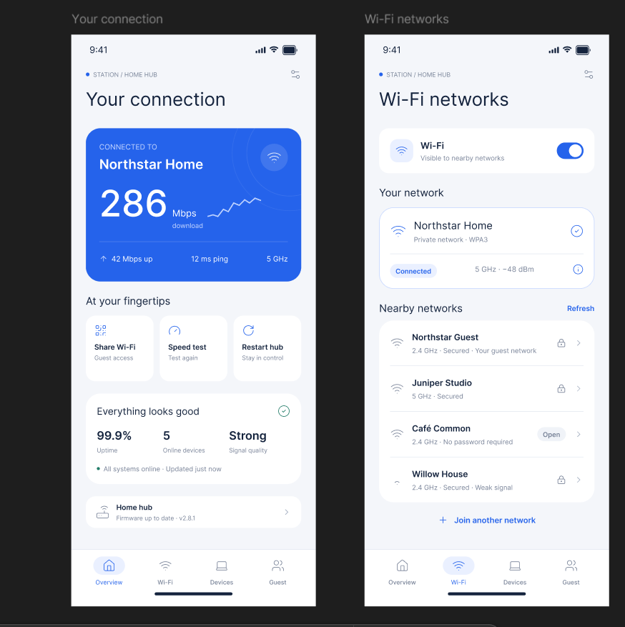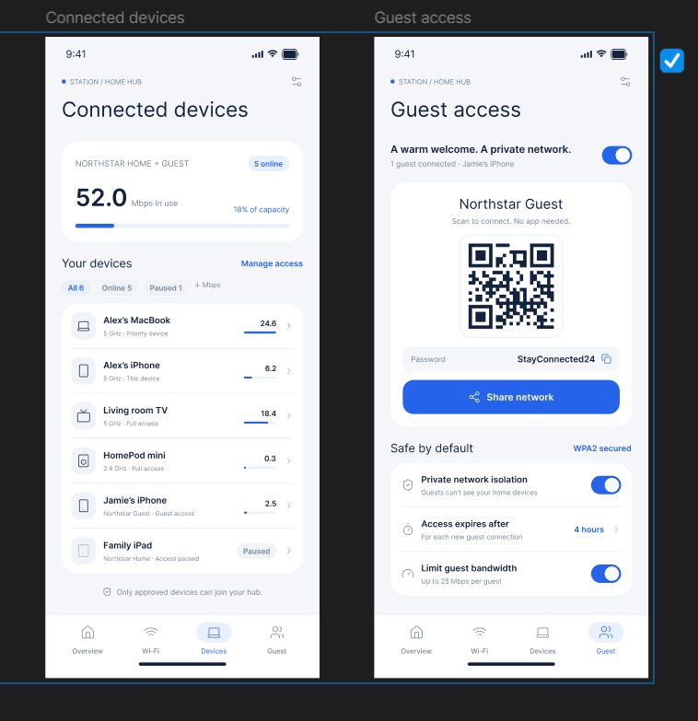

Figure 2: Mobile-station UI prototype – Home, Dialer and Network Settings screens

Design Considerations
Goal | Feature | Screen
Connectivity | Operator name, network type (4G LTE) and signal bars with dBm value | 1 · Home
Connectivity | One-tap toggles for Wi-Fi, mobile data, Bluetooth, airplane mode, hotspot and NFC | 1 · Home
Connectivity | Preferred network type, data roaming, automatic operator selection, cell information | 3 · Network
Convenience | Large keypad, SIM selector, HD Voice (VoLTE) and Wi-Fi calling shortcuts | 2 · Dialer
Convenience | Daily data-usage bar and a short signal-strength history | 1 · Home
Convenience | Bottom navigation (Home, Calls, Network, Settings) within thumb reach | All

Procedure
- Create three phone frames of 390 × 844 px (Frame tool → Phone) and name them Home, Dialer and Network.
- Set up a colour style and a text style (title, body, caption) and follow an 8 px spacing grid.
- Build reusable components: toggle tile, list row, radio button, key button and bottom-navigation bar. Use Auto layout (Shift+A) for rows and grids.
- Assemble the Home screen: network card with signal bars, six quick-toggle tiles, data-usage card and signal graph.
- Assemble the Dialer screen (number display, SIM and HD Voice chips, 12-key keypad, green call button) and the Network screen (SIM tabs, network-type radio list, roaming and auto-select switches, cell information card).
- In the Prototype tab connect the navigation items with On tap → Navigate to, using Smart animate. Set Home as the starting frame.
- Run Present, or open the file in the Figma mobile app, and test the flow on a phone-sized screen.
Result: A three-screen interactive prototype of a mobile-station interface was designed in Figma. The Home screen shows signal strength, network type, quick connectivity toggles and data usage. The Dialer provides SIM selection and HD Voice / Wi-Fi calling shortcuts. The Network screen controls network mode, roaming and automatic operator selection. The screens are linked so the flow can be tested in Present mode.

