Experiment 3: Flowchart of the Network Switching Subsystem

Question
Q3. Develop a flowchart in Figma depicting the operation of a Network Switching Subsystem in a mobile cellular system.

Aim
To draw a flowchart in Figma that shows how the NSS handles a mobile-originated call, from the call request to call release.

Figma Design
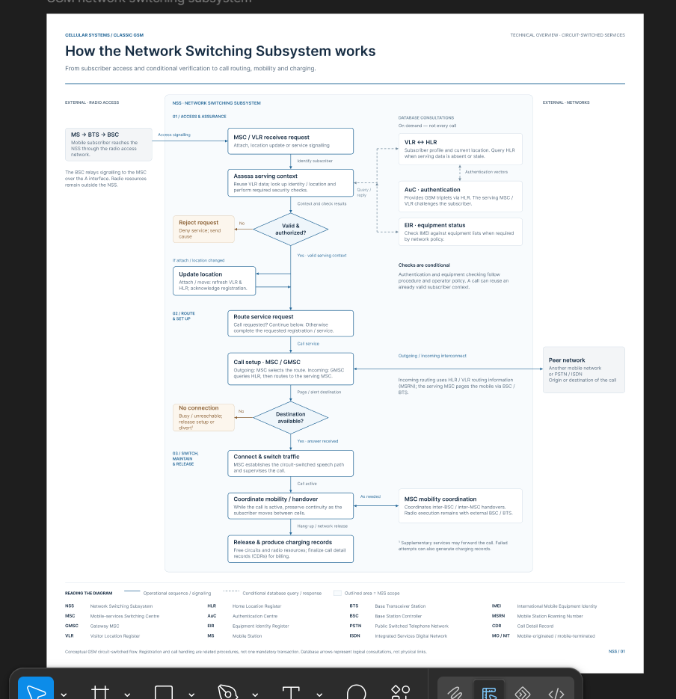
Figure 3: Flowchart of mobile-originated call handling in the NSS

Figma design link: https://www.figma.com/design/lcZRDFjUB5GaHvPtHh2vnm/Untitled?node-id=0-1&m=dev&t=jlQvp2A7eOQbcDSb-1

Theory

The NSS contains the MSC, VLR, HLR, AuC, EIR and, for external calls, the GMSC. It performs call switching, mobility management, subscriber authentication, equipment verification and call-record generation. Before a call is connected, the MSC checks the subscriber record, authenticates the SIM, verifies the handset, and then analyses the dialled number to decide how the call is routed.

Procedure
- Create a frame named NSS_Call_Setup_Flowchart (use a Design file or FigJam).
- Create three shape components: terminator (rounded pill) for start and end, rectangle for process steps, and diamond for decisions. Use a different colour for each.
- Place the steps in the order of the call flow and connect them with arrows. Label each decision branch Yes or No.
- Send all failure branches to a single red Reject block that releases resources and returns a cause code to the mobile station.
- Add a legend for the shapes, check alignment with Smart selection and distribute spacing evenly.

Explanation of the Flow
- The mobile station dials a number and requests a channel (RACH → SDCCH) from the BTS/BSC.
- The BSC passes a CM service request to the MSC over the A interface.
- The MSC checks the VLR. If the subscriber is not present, the profile and authentication triplets are fetched from the HLR/AuC.
- The network authenticates the SIM (RAND sent, SRES returned). A failure leads to Reject.
- The IMEI is checked against the EIR. A barred handset leads to Reject.
- Ciphering (A5 with key Kc) is started and the MSC analyses the dialled digits.
- If the called party is in the same PLMN, the HLR/VLR is queried and the called mobile is paged. Otherwise the call is routed through the GMSC to the PSTN or another PLMN.
- A traffic channel is assigned and the call is connected. On release, the call detail record (CDR) is sent for billing.

Result: A flowchart of NSS operation during a mobile-originated call was developed in Figma. It covers channel request, VLR lookup, authentication, equipment check, ciphering, digit analysis, routing (same PLMN or via GMSC) and call release with CDR generation, with all failure paths directed to a single Reject block.

