Experiment 5: Wireframe of a Mobile App with Localization Features

Question
Q5. Design a wireframe for a mobile application that incorporates localization features using Figma.

Aim
To design a low-fidelity wireframe in Figma for a mobile application that adapts its language, region settings and content to the user’s location
Figma Design:
Design link: https://www.figma.com/design/Ww377iT4xqMMyPdqxTz7hA/Untitled?node-id=0-1&m=dev&t=vMOrdoLwfQFdvapG-1

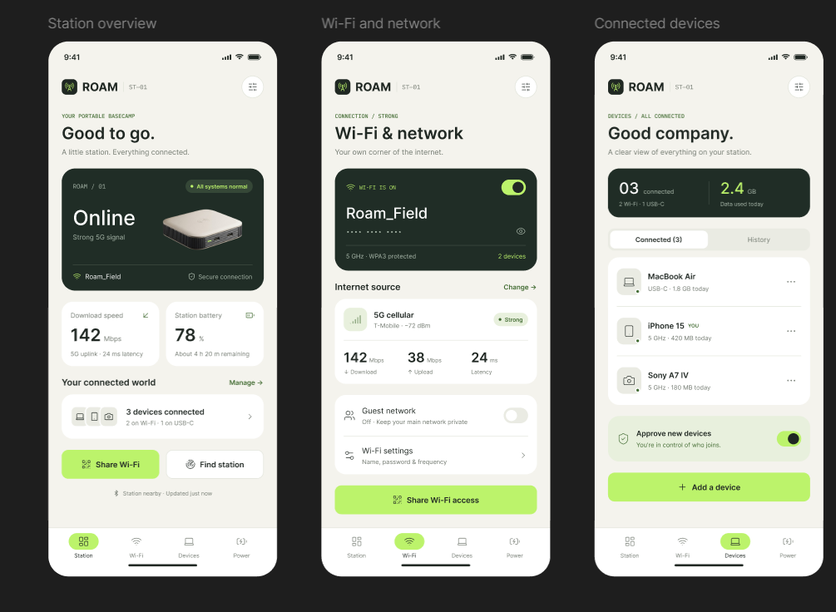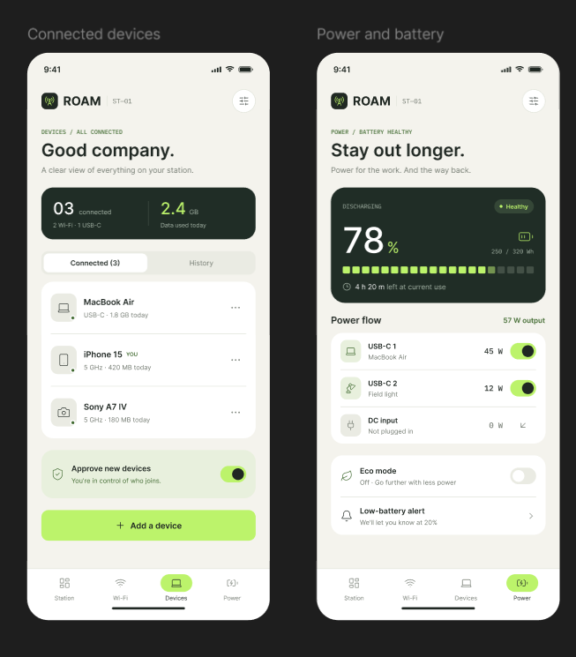

Figure 5: Wireframe of a mobile application with localization features

Theory
Localization has two parts. The first is location-based services, where the application finds the position of the device using GPS, Wi-Fi or the serving cell ID of the cellular network and shows nearby content. The second is adapting the interface to the user’s language and region, including date format, time zone, units and currency. A wireframe shows structure and flow only, so it uses grey tones, placeholder boxes and plain labels.

Localization Features Included
Feature | Screen | Purpose
Language selection with search | 1 · Language & Region | Lets the user choose English or an Indian language at first launch.
Region selection | 1 · Language & Region | Sets default formats and content for the chosen country.
Location permission request | 2 · Location Permission | Explains why location is needed and offers While using the app, Only this time and Don’t allow.
Position sources (GPS, Wi-Fi, Cell ID) | 2 and 3 | Shows that the position can come from several sources, including the cellular network.
Nearby map and list with distances | 3 · Nearby (Map) | Shows local places with distance in km, with accuracy rings around the user.
Regional formats | 4 · Regional Settings | Time zone, date format, units and currency can be changed later.
Auto-detect and offline maps | 4 · Regional Settings | Switches for automatic location and for use with poor coverage.

Procedure
- Create four phone frames of 390 × 844 px named Language, Permission, Nearby and Settings. Use grey fills only (low-fidelity).
- Build the Language screen with a search field, a radio list of languages, a Region drop-down and a Continue button.
- Build the Permission screen with a location icon placeholder, a short explanation, source chips (GPS, Wi-Fi, Cell ID) and three response buttons.
- Build the Nearby screen with a search bar, a map placeholder (rectangle with a cross), concentric accuracy circles around the user, and a list of nearby places.
- Build the Settings screen with rows for language, region, time zone, date format, units and currency, plus two switches.
- Use Auto layout with Hug contents for labels so longer translated text does not break the layout. Optionally create a Figma variable collection with a mode for each language to preview translated strings.
- Connect the screens in the Prototype tab (Continue → Permission → Nearby → Settings) and test the flow with Present.
Result: A four-screen low-fidelity wireframe for a mobile application with localization features was designed in Figma. It includes language and region selection, a location-permission request, a nearby-places map based on device position, and a regional-settings screen for time zone, date format, units and currency. The screens are linked into one flow that can be tested in Present mode.

