This Pie plot gives information about gender distribution of students, we can see that female population is slightly higher than male.

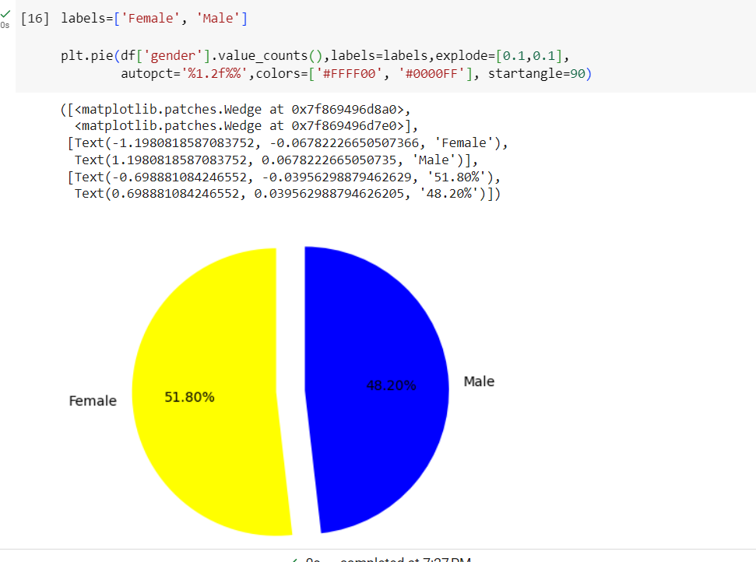

This bar plot gives information about male and female distribution.

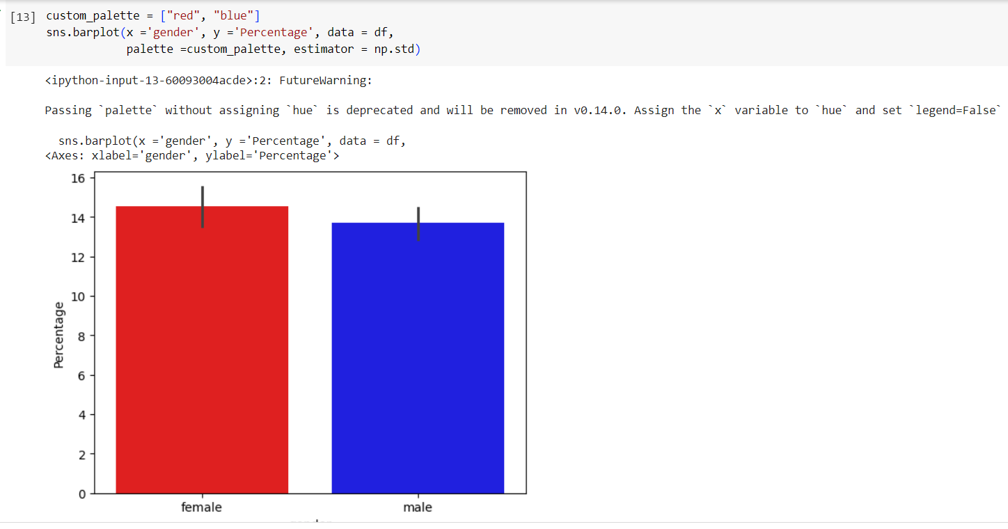

Below plot illustrates the distribution of average marks or percentage of score secured by all students.

We can see more students percentage between 50 to 80

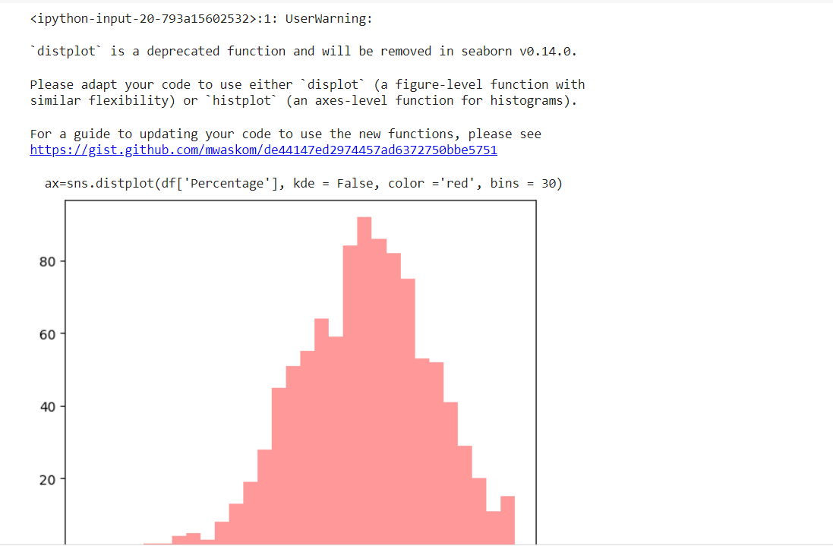

Below scatter plot illustrates how the relation between average score and math score and grouped by gender

