use mydb;

-- Product Table

CREATE TABLE product (product_id INT NOT NULL PRIMARY KEY,product_name VARCHAR(255) NOT NULL,product_price float NOT NULL);

INSERT INTO product (product_id, product_name, product_price)

VALUES

(101, 'T-shirt', 299),(102, 'Jeans', 399),

(103, 'Sneakers', 299),(104, 'Backpack', 599),

(105, 'Wristwatch', 499),(106, 'Headphones', 199),

(107, 'Smartphone', 9000),(108, 'Laptop', 29000),

(109, 'Desktop Computer', 30000),(110, 'Bluetooth Speaker', 499),

(111, 'Adidas Shoes', 1999),(112, 'Shoes', 199),

(113, 'sports shokes', 120);

select * from product;

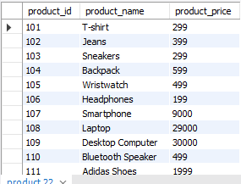

-- customer table

CREATE TABLE customer (customer_id INT NOT NULL PRIMARY KEY,customer_name VARCHAR(255) NOT NULL,country VARCHAR(255) NOT NULL,age INT NOT NULL, aadharcard_number BIGINT NOT NULL UNIQUE);

INSERT INTO customer VALUES

(401, 'ABC', 'USA', 30, 123456789012),(402, 'PQR', 'Canada', 25, 987654321098),

(403, 'SER', 'South Korea', 40, 345678901234),(404, 'TRE', 'Spain', 35, 789012345678),

(405, 'NHY', 'Egypt', 28, 567890123456),(406, 'HYT', 'Japan', 45, 234567890123),

(407, 'SOL', 'Sir Lanka', 32, 901234567890),(408, 'HYE', 'China', 38, 456789012345),

(409, 'TWS', 'UK', 27, 123409876543),(410, 'HUY', 'Australia', 30, 456712345678);

select * from customer;

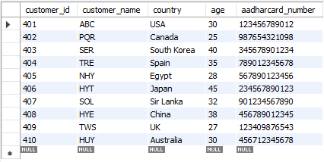

-- sales table

CREATE TABLE sales (sales_id INT NOT NULL PRIMARY KEY,customer_id INT NOT NULL,product_id INT NOT NULL,quantity INT NOT NULL,FOREIGN KEY (customer_id) REFERENCES customer(customer_id),FOREIGN KEY (product_id) REFERENCES product(product_id));

INSERT INTO sales (sales_id, customer_id, product_id, quantity) VALUES

(101, 401, 102, 2),(102, 403, 105, 1),

(103, 402, 101, 3),(104, 404, 107, 1),

(105, 405, 103, 2),(106, 401, 108, 1),

(107, 402, 106, 2),(108, 403, 109, 1),

(109, 404, 104, 2),(110, 405, 110, 1);

select * from sales;

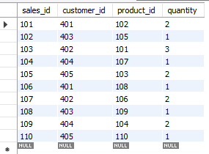

-- Show the product with maximum price

select max(product_price) as 'Max Price' from product;

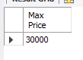

-- show thr sales with min quantity

select min(quantity)as 'Minmum sales' from sales;

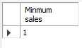

-- show all the product who start with A

select * from product where product_name like 'A_%';

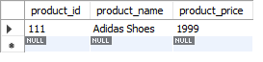

-- show all customers who are from Australia

select * from customer where country='Australia';



-- show all customers who are from Japan and have age greater than 30

select * from customer where country='Japan' and age>30;



-- show all product with price range in 200 to 500

select * from product where product_price between 200 and 500;

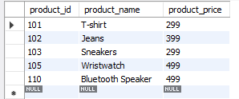

-- show all the sales product where you will list the price and also the total amount paid per sales

SELECT sales.sales_id, product.product_name, product.product_price, sales.quantity, (product.product_price * sales.quantity) AS 'total_amount_paid' FROM sales INNER JOIN product ON sales.product_id = product.product_id;

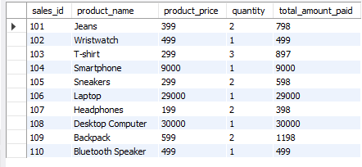

-- show all product which are having price less than 200 or have the name starting with savepoint

select * from product where product_price<200 or product_name like 'S%';

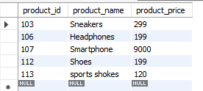

-- change the name of customer 402 to Shakti

update customer set customer_name='Shakti' where customer_id=402;

select * from customer;

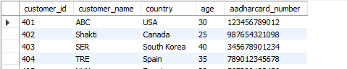

-- list down all the sales id,product id,product name,and quantity

select sales.sales_id,product.product_id,product.product_name,sales.quantity from sales inner join product on sales.sales_id=product.product_id;

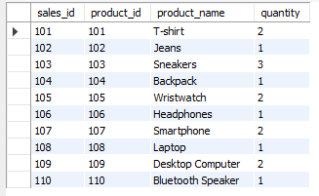

-- search for all the customers from UK , Japan and sir lanka

select * from customer where country in ('UK','Japan','Sir Lanka');

