**26/02/2019:**

**Template engine**

A template engine is a template processor that combines the HTML templates with data models for result documents.

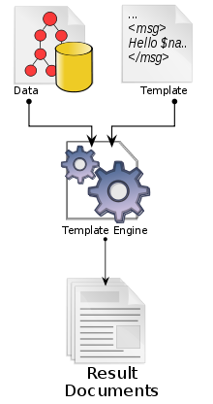

**API:**

API is a set of predefined functions and methods for doing a set of tasks.