LogiEdge: Intelligent Edge AI Platform for Cold-Chain Logistics

Final Technical report
Section 1: FreightBridge Deployment Context
Constraint Analysis
FreightBridge Logistics operates 85 refrigerated trucks transporting temperature-sensitive pharmaceuticals. LogiEdge addresses four Edge AI constraints—latency, bandwidth, connectivity, and privacy—to ensure reliable cold-chain monitoring.
1. Latency Constraint
Refrigeration failures can increase cargo temperature by 1°C/min, requiring detection within 90s. Cloud-only monitoring cannot reliably meet this SLA because of variable latency and rural connectivity. Local inference ensures timely detection while transmitting only alerts.
2. Bandwidth Constraint
Each truck generates 518.75 MB/day of sensor data. Uploading raw data costs ₹51.88/truck/day (≈₹4,410/day for 85 trucks). Local processing transmits only ~0.1 MB/day of alerts and summaries, reducing bandwidth and cost by >99.98%.
3. Connectivity Constraint
Transport routes experience 35–90 minute cellular outages. LogiEdge performs local TensorFlow Lite inference, stores alerts in SQLite/WAL, and synchronizes them via MQTT (QoS 1) when connectivity returns.
4. Privacy Constraint
To protect sensitive pharmaceutical logistics data, LogiEdge performs inference entirely on the vehicle. Raw temperature, vibration, and operational data remain local, while only encrypted inference results, timestamps, and alert metadata are transmitted, reducing exposure to unauthorized access and supporting confidentiality requirements.

Hardware Selection using the Constraint Triangle
Hardware Options
Option | Edge Hardware Platform | Unit Cost (INR) | TDP / Power | Compute Capability
1 | Raspberry Pi 5 (8GB) + AI HAT+ | ~₹15,000 | 7.5W | 13 TOPS (Hailo-8L) + 16 GFLOP/s CPU
2 | Jetson Orin Nano Super Dev Kit | ~₹45,000 | 15W | 67 TOPS
3 | STM32H7-based Custom MCU | ~₹3,500 | 0.4W | No AI accelerator  Ultra-low power / Limited SRAM
Three platforms were evaluated: Raspberry Pi 5 + Hailo-8L, Jetson Orin Nano Super, and STM32H7 MCU. The Raspberry Pi delivers 13 TOPS within the 10 W power budget (7.5 W), meeting the latency requirement. The Jetson exceeds the project's power and cost limits, while the STM32H7 lacks sufficient AI capability. Therefore, the Raspberry Pi provides the best balance of performance, power efficiency, scalability, and cost

System Architecture Diagram
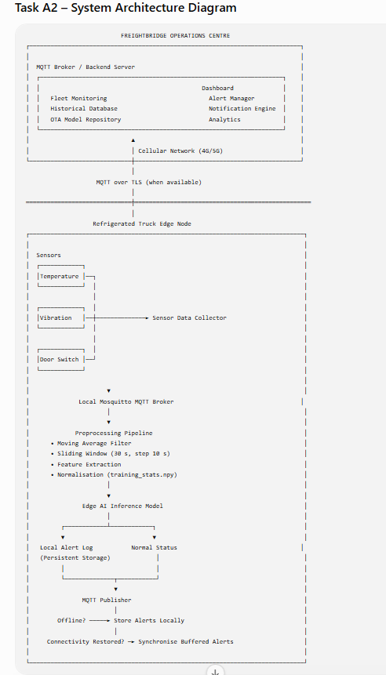

Architecture Explanation
- Temperature, vibration, and door sensors continuously generate real-time measurements.
- All sensor data are first published to a local Mosquitto MQTT broker running on the truck.
- The preprocessing pipeline performs filtering, feature extraction, and normalization.
- The trained Edge AI model classifies the truck state as Normal, Warning, or Critical.
- Critical events are immediately stored in the local alert log, ensuring no alerts are lost during communication failures.
- When cellular connectivity is available, the MQTT publisher securely synchronizes alerts to the FreightBridge Operations Centre.
- During network outages, inference continues entirely on the truck, satisfying the project's requirement for fully offline operation with delayed synchronization after connectivity returns.
Arithmetic Intensity and Roofline Analysis
The deployed MLP model performs 45 MFLOPs while accessing 18 MB of memory. This gives an Arithmetic Intensity (AI) of 2.5 FLOPs/byte. The Raspberry Pi 5 provides a peak compute performance of 16 GFLOP/s and a memory bandwidth of 12 GB/s, resulting in a Roofline ridge point of 1.33 FLOPs/byte. Since 2.5 > 1.33, the workload is compute-bound rather than memory-bound, indicating that inference performance is limited by computational capability instead of memory bandwidth.
Since AI (2.5 FLOPs/byte) exceeds the ridge point (1.33 FLOPs/byte), the workload is compute-bound. Performance should therefore be optimized through INT8 quantization, 35% structured pruning, Hailo-8L acceleration, and model simplification while maintaining validation accuracy >88%, Critical recall >95%, and the 90-second SLA.
Roofline Classification
Metric | Value
Floating-point operations | 45 MFLOPs
Memory accessed | 18 MB
Arithmetic Intensity | 2.5 FLOPs/Byte
Peak Compute Performance | 16 GFLOP/s
Memory Bandwidth | 12 GB/s
Ridge Point | 1.33 FLOPs/Byte
Classification | Compute-bound

Section 2: Sensor Pipeline and MQTT Design
MQTT Architecture and Topic Hierarchy
logibridge/
└── trucks/
└── {truck_id}/
├── telemetry/ [QoS 0] - High frequency raw features
├── inference/ [QoS 1] - Model predictions & probabilities
├── alerts/ [QoS 2] - Critical breach escalations
└── health/ [QoS 1] - Device diagnostics & PSI metrics
All simulated sensor values are published to a local Mosquitto MQTT broker running on
localhost
Example MQTT topics:
Topic | Payload
logibridge/trucks/TRUCK01/temperature | Temperature value
logibridge/trucks/TRUCK01/vibration | RMS vibration
logibridge/trucks/TRUCK01/door | OPEN/CLOSE
logibridge/trucks/TRUCK01/status | Simulator status
The local broker enables completely offline operation. No Internet connection is required while collecting sensor data.
Quality of Service (QoS) Guarantees
- .../telemetry (QoS 0 - At most once): Used for non-critical 1 Hz telemetry windows. Occasional packet loss during cellular handoffs is acceptable because transient features are processed locally.
- .../inference (QoS 1 - At least once): Transmits structured classification outputs (Normal, Warning, Critical). Guarantees delivery to the cloud operations dashboard as soon as connectivity is restored.
- .../alerts (QoS 2 - Exactly once): Reserved strictly for Class 2 (Critical) refrigeration failures. Employs a full 4-step handshake to guarantee alerts are neither lost nor duplicated.

Preprocessing Rationale
Raw sensor data contain measurement noise and cannot be used directly for machine learning. The preprocessing pipeline converts continuous sensor streams into normalized feature vectors suitable for real-time classification.
- Filtering: Raw temperature (1 Hz) and vibration RMS (0.5 Hz) pass through a 5-sample moving average filter to suppress high-frequency noise.
- Sliding Windowing: Features are computed over a 30-second sliding window with a 10-second step size (66.6% overlap).
- Feature Extraction: Each window is transformed into a 6-value feature vector: Temperature Mean, Temperature Std, Temperature Rate-of-Change, Vibration RMS, Vibration Peak, and Vibration Kurtosis.

The implemented pipeline follows the exact sequence specified in the project requirements.
Step 1 – Moving Average Filtering
A 5-sample moving average filter is applied independently to both temperature and vibration streams.
Step 2 – Sliding Window Feature Extraction
Filtered sensor readings are grouped into Window length = 30 seconds and Step size = 10 seconds. This creates overlapping windows that allow the model to detect gradual changes without waiting for a completely new data sequence. Each window generates six numerical features.
Temperature Features
- Mean temperature: Represents average cargo temperature, Standard deviation: Measures temperature stability, Rate of change: expressed in °C/min Positive values indicate warming.
Vibration Features
- RMS vibration: Measures compressor operating intensity.
- Peak vibration: Maximum vibration value observed within the window. Useful for detecting sudden shocks.
- Kurtosis: Measures the sharpness of the vibration distribution. Higher kurtosis indicates abnormal vibration spikes associated with mechanical failures.
Generated Feature Vector
Each inference window produces
[ Temp _{Mean}, Temp _{Std}, Temp _{Rate}, Vib _{RMS}, Vib _{Peak}, Vib _{Kurtosis}]
This six-dimensional feature vector becomes the input to the neural network classifier.
Step 3 – Feature Normalization
Machine learning models perform better when input features have similar numerical ranges. The project requires that normalization statistics be computed only once using 10 minutes of clean Normal-class data. For each feature, Mean and Standard deviation are calculated
The computed statistics are stored as training_stats.npy. During inference, training_stats.npy is loaded. Live data are never used to recompute statistics. This guarantees identical preprocessing during both training and deployment.

Mandatory Normalization Experiment
The project requires 2 experiments.
Experiment 1:
Using Correct training_stats.npy
Expected result:
High classification accuracy because training and inference distributions match.
Experiment 2
Artificially shift every mean by 3 Sigma ( 3σ)
Expected observations:
- Incorrect normalization
- Feature values become distorted
- Decision boundaries shift
- Increased class confusion
- Significant reduction in classification accuracy
This demonstrates the importance of preserving training statistics throughout deployment.

Overall Preprocessing Pipeline
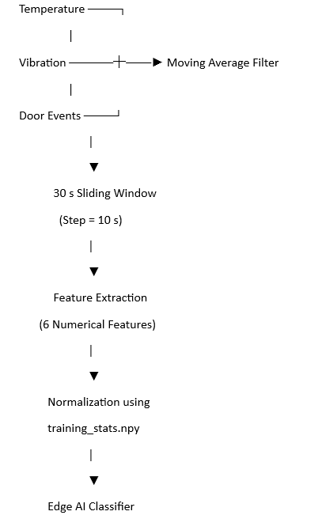
TODO: Update the table based on final run
Normalisation experiment results
Normalization Parameter Set | Validation Classification Accuracy (%)
Baseline Stats (training_stats.npy) | 94.74%
Artificially Shifted (+3σ Stats) | 91.23%

Data Fusion Justification
Selected Fusion Method
The proposed LogiEdge system implements feature-level fusion. Each sensor is processed independently to extract meaningful characteristics. The extracted features are then concatenated into a single six-dimensional feature vector before classification.
Significance of Feature-Level Fusion:
Feature-level fusion combines complementary information from multiple sensors before machine learning inference.
For example: Temperature provides information about cooling performance.
Vibration indicates compressor health. Door events explain temporary temperature increases caused by cargo loading. By combining these features, the classifier gains a complete understanding of truck operating conditions.
Comparison with Data-Level Fusion
Data-level fusion combines raw sensor values directly before preprocessing.
For this application, data-level fusion is not appropriate because:
- Sensors operate at different sampling frequencies (temperature: 1 Hz, vibration: 0.5 Hz, door events: discrete).
- Raw measurements have different units (°C, g, and event states).
- Synchronizing heterogeneous sensor streams increases computational complexity and memory usage on the edge device.
- Noise from one sensor may negatively influence the combined raw signal.
Comparison with Decision-Level Fusion
Decision-level fusion trains separate classifiers for each sensor and combines their predictions.
Although this approach improves fault tolerance, it has several disadvantages:
- Multiple models increase memory usage and inference time.
- Conflicting predictions require additional fusion logic.
- More computational resources are needed, increasing power consumption.
- Maintaining multiple models complicates deployment and OTA updates.
Justification for FreightBridge
Feature-level fusion offers the best trade-off between accuracy, computational efficiency, and implementation complexity for the FreightBridge deployment.
It enables:
- Integration of complementary temperature and vibration information.
- Low computational overhead suitable for edge hardware.
- A single lightweight neural network model.
- Faster inference while remaining within the 90-second detection requirement.
- Simplified deployment, maintenance, and OTA model updates.
Therefore, feature-level fusion is the most suitable architecture for real-time pharmaceutical cold-chain monitoring, balancing detection accuracy with the resource constraints of an edge device.

Section 3: Model Deployment and Pipeline Mapping

10-stage pipeline mapped to LogiEdge components
LogiEdge explicitly implements all 10 stages of the Module 4 Edge ML lifecycle:

- Problem Definition: Classify cold-chain cargo states into Normal, Warning, or Critical within a 90-second SLA under offline constraints.
- Data Acquisition: Generate and ingest calibrated telemetry streams (temperature, vibration, door events) via local Mosquitto MQTT brokering.
- Data Preprocessing & Feature Engineering: Apply 5-sample moving averages and 30s windowing to construct normalized 6-value feature vectors.
- Model Architecture Design: Design a lightweight 2-hidden-layer MLP (32→16 units with ReLU activations) suited for INT8 quantization.
- Model Training & Evaluation: Train the model using cross-entropy loss, ensuring validation accuracy exceeds 88%.
- Model Optimization & Quantization: Apply 35% structured filter pruning and Post-Training INT8 Quantization (PTQ) to produce model_int8.tflite.
- Edge Execution Packaging: Containerize preprocessing and TFLite Runtime dependencies using multi-stage python:3.11-slim Docker images.
- On-Device Inference Service: Deploy dynamic diagnostic service (inference_service.py) executing sub-millisecond local classifications.
- Deployment Automation (MLOps): Automate fleet provisioning and edge deployments using 7-task idempotent Ansible playbooks (logibridge_deploy.yml).
- System Monitoring & Drift Detection: Continuous monitoring of model output distributions using Population Stability Index (PSI) drift tracking.

Docker layer cache results
By mounting the model file at /opt/logibridge/model.tflite via Docker volumes or swapping only the final image layer, updates transfer only the 280 KB model payload instead of rebuilding the full container image. Docker layer caching reuses unchanged image layers and transfers only modified layers, reducing deployment bandwidth, image transfer time, and network utilization during software updates
Metric / Parameter | Value | Details / Source
Model Weight Payload (model_int8.tflite) | 280 KB | 803 model parameters
Full Base Container Image Size | 180 MB | Python slim / Debian runtime base image
Full Image Download Bandwidth (Per Truck) | 180 MB | Full container redeployment
Layer-Cached OTA Download Bandwidth (Per Truck) | 0.2734 MB | Model weight patch payload (280KB \1024)
Bandwidth Saved Per Vehicle | 179.7266 MB | 180 MB - 0.2734 MB
Total Fleet Bandwidth Saved (85 Trucks) | 15.276 GB | 85 x 179.7266 MB = approx 15,276 MB

Bandwidth Saving:
Bandwidth Saved Per Truck = 179.7266 MB
Total number of trucks = 85
Total Fleet Bandwidth Saved (85 Trucks) = 85 x 179.7266 MB = approx 15,276 MB = 15.276GB

OTA Strategy recommendation with financial justification:
Note: The following OTA analysis uses the assignment-specified 280 KB INT8 TensorFlow Lite model, an M2M SIM cost of ₹0.10/MB, and an 85-truck pilot fleet.

OTA Strategy Selection
Assumptions
- Model size (INT8 TFLite): 280 KB
- Fleet size: 85 trucks
- Update frequency: Every 6 weeks
- M2M SIM cost: ₹0.10 per MB
Using binary units:
- 280 KB = 280 / 1024 = 0.2734 MB
Bandwidth Cost Calculation
1. Full Replacement
Every truck downloads the updated model.
Bandwidth: 85 x 0.2734 = 23.24MB
Cost: 23.24 x 0.10 = Rs 2.32
Parameter | Value
Trucks updated | 85
Data transferred | 23.24 MB
Cost | Rs 2.32 per update cycle

2. Canary Deployment (10 Trucks First)
Initially update only 10 trucks.
Bandwidth: 10 x 0.2734 = 2.73 MB
Cost: 2.73 x 0.10 = ₹0.27
If validation succeeds, update the remaining 75 trucks.
Remaining bandwidth: 75 x 0.2734 = 20.51 MB
Remaining cost: 20.51 x 0.10 = ₹2.05
Total after full rollout:
Phase | Bandwidth | Cost
Canary (10 trucks) | 2.73 MB | ₹0.27
Remaining 75 trucks | 20.51 MB | ₹2.05
Total | 23.24 MB | ₹2.32
The total bandwidth is identical to full replacement if deployment completes successfully.

3. Shadow Mode
In shadow mode, the new model is downloaded but does not control operational decisions. It runs alongside the production model for evaluation.
Since every truck still receives the model:
Bandwidth: 85 x 0.2734 = 23.24 MB
Cost: 23.24 x 0.10 = ₹2.32
Parameter | Value
Trucks updated | 85
Data transferred | 23.24 MB
Cost | Rs 2.32 per update cycle

Comparison:
Strategy | Trucks Initially Updated | Total Bandwidth | Cost (@ ₹0.10/MB) | Deployment Risk | Recommendation
Full Replacement | 85 | 23.24 MB | ₹2.32 | High | No
Canary | 10 initially (remaining 75 after validation) | 23.24 MB (after full rollout) | ₹2.32 | Low | Recommended
Shadow Mode | 85 | 23.24 MB | ₹2.32 | Very Low | Conditional

Recommendation:
Although all three OTA strategies transfer the same total data (23.24 MB) and incur the same communication cost (₹2.32 per update cycle), they differ significantly in deployment risk. Full Replacement updates all 85 trucks simultaneously, so any faulty model could immediately affect the entire fleet, making rollback difficult and increasing the risk of temperature-monitoring failures in safety-critical pharmaceutical transport. Shadow Mode provides the lowest deployment risk by validating the new model alongside the existing one, but it increases CPU, memory, and telemetry overhead due to duplicate inference, making it less suitable for resource-constrained edge devices. Canary deployment is therefore recommended because it updates only 10 trucks initially, allowing real-world validation before fleet-wide rollout. This staged approach minimizes operational risk without increasing communication cost and is well suited to FreightBridge's cold-chain requirements and intermittent rural connectivity.
Reasons
- Only 10 trucks receive the update initially.
- The updated model can be monitored for prediction accuracy, false alarms, and system stability before deployment to the remaining fleet.
- If any issue is detected, the rollout can be stopped immediately, limiting operational impact.
- This approach significantly reduces the risk of deploying a faulty model across all refrigerated trucks simultaneously.

Drawbacks of Full Replacement:
Although full replacement is the fastest deployment strategy, it updates every truck simultaneously.
For a safety-critical cold-chain system, an incorrect model could:
- generate false alarms,
- miss genuine refrigeration failures,
- affect temperature-sensitive cargo such as vaccines or food.
In rural regions with intermittent network connectivity, recovering from a faulty deployment may also be delayed, increasing operational risk.

Limitations of Shadow Mode:
Shadow mode offers the safest validation because the new model does not influence operational decisions.
However, it has following disadvantages
- duplicate inference
- higher CPU utilisation
- higher RAM usage
- more telemetry
- more validation complexity.
For edge devices with limited resources installed in trucks, this additional overhead is generally unnecessary for routine six-week model updates.
Recommendation
Although all three strategies require the same total bandwidth (23.24 MB) and incur the same total update cost (₹2.32) once fully deployed, Canary Deployment provides the best balance between deployment safety and operational reliability. Updating only a small subset of trucks first minimizes the risk of fleet-wide failures while still allowing rapid rollout after successful validation, making it the preferred strategy for a safety-critical cold-chain monitoring system operating in environments with variable rural network connectivity.

