Project: deploying the app in eks cluster
Prerequites:
AWS cli installed-check in google
Kubectl check in google
Eksctl check in google how to install
After first we need to create a eks cluster in aws but normal we go into the aws console and create all things but that is not industry standard so we used this command
eksctl create cluster --name cd-cluster --region us-east-1 –fargate
important change the clusuter name from cd-cluster to any other it will create new cluster it will take upto 15 mins after go into the console and check it
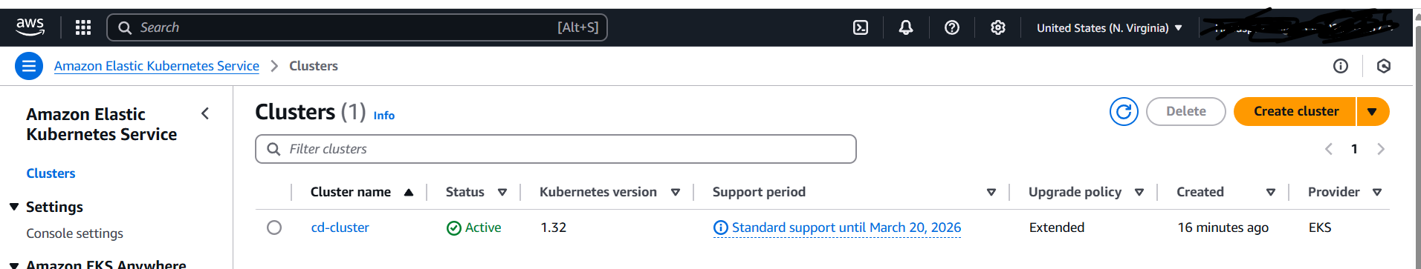
As a devops engineer we cannot go to everytime into console so we config my eks into the aws cli by using this command.
aws eks update-kubeconfig --name cd-cluster --region us-east-1
after doing you will get this like
Now we creating the 2048 application
First we need to use this command
Create Fargate profile
eksctl create fargateprofile \
--cluster demo-cluster \
--region us-east-1 \
--name alb-sample-app \
--namespace game-2048
What this command does it will create a new fargate profile which you will see in the console with name of alb-sample-app but make sure change the cluster name what you given.
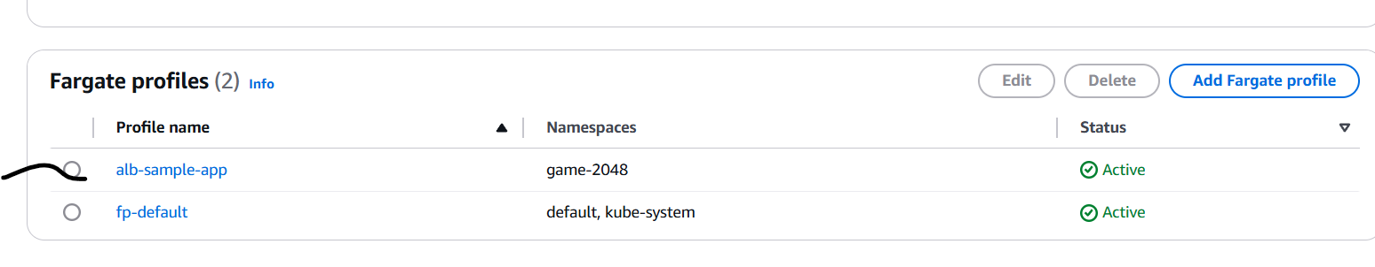
Next we going to create the Deploy the deployment, service and Ingress to my app to do we need to give this command.
kubectl apply -f https://raw.githubusercontent.com/kubernetes-sigs/aws-load-balancer-controller/v2.5.4/docs/examples/2048/2048_full.yaml
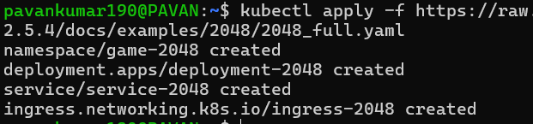
Now we created only the ingress we did not create the ingress controller without ingress controller athe above is useless to check we need to check by using this command.
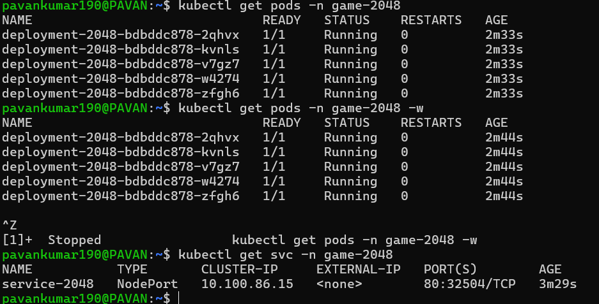
If some one need to access this pod by using the nodeport and cluster ip our goal is to outside of the world need to access thus why we need to do ingress to do we need to run this command.
kubectl get ingress -n game-2048
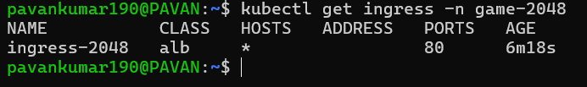
Ingress is created host is * means anyone can access. We need to have address we need to create the ingress controller it will create the load balancer.
Before doing the ingress controller we need to create iam oidc provider.
commands to configure IAM OIDC provider
export cluster_name=demo-cluster
oidc_id=$(aws eks describe-cluster --name $cluster_name --query "cluster.identity.oidc.issuer" --output text | cut -d '/' -f 5)
Check if there is an IAM OIDC provider configured already
- aws iam list-open-id-connect-providers | grep $oidc_id | cut -d "/" -f4\n
If not, run the below command
eksctl utils associate-iam-oidc-provider --cluster $cluster_name --approve
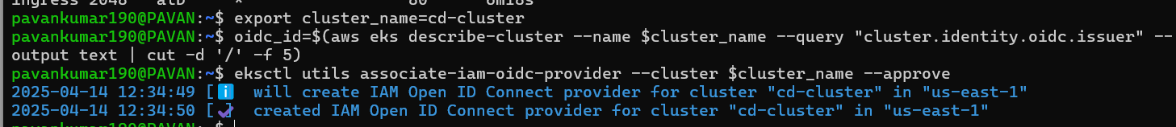
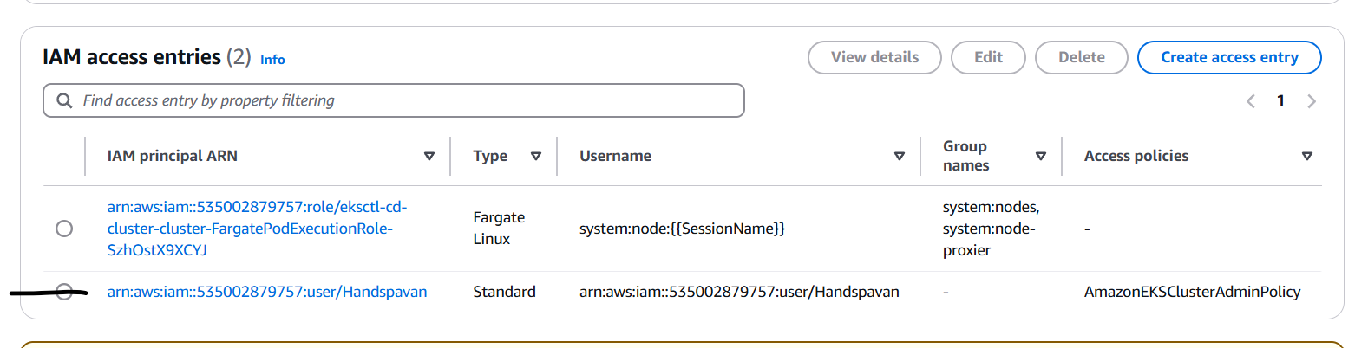
Final we need to create the alb controller is nothing but pod and it access to aws service such as alb
How to setup alb add on
Download IAM policy
curl -O https://raw.githubusercontent.com/kubernetes-sigs/aws-load-balancer-controller/v2.11.0/docs/install/iam_policy.json
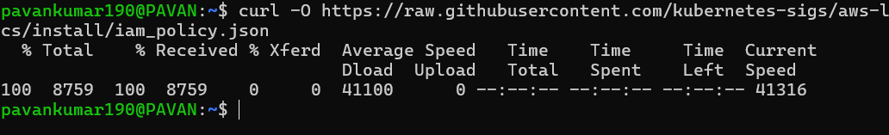
Next i will Create IAM Policy
aws iam create-policy \
--policy-name AWSLoadBalancerControllerIAMPolicy \
--policy-document file://iam_policy.json
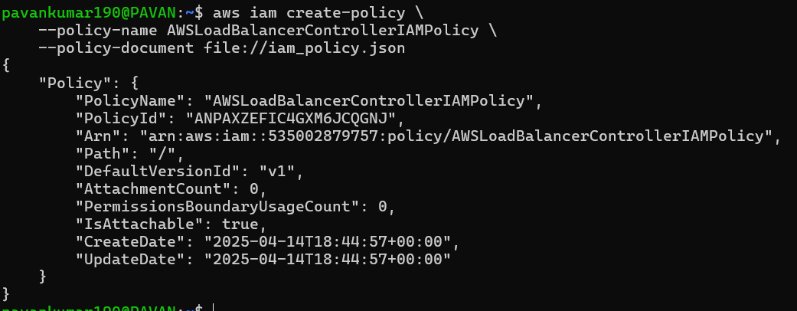
It created in the aws console under iam policy
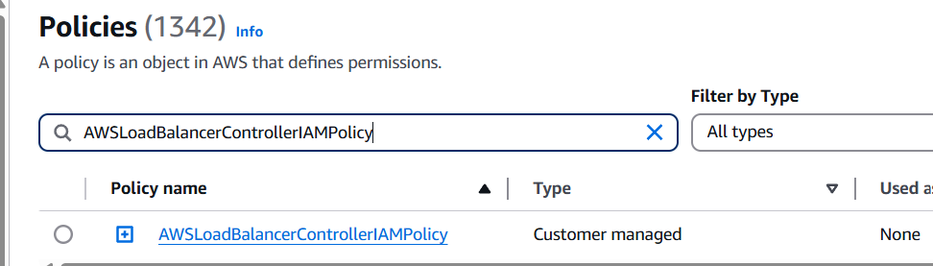
Create IAM Role
eksctl create iamserviceaccount \
--cluster=<your-cluster-name> \
--namespace=kube-system \
--name=aws-load-balancer-controller \
--role-name AmazonEKSLoadBalancerControllerRole \
--attach-policy-arn=arn:aws:iam::<your-aws-account-id>:policy/AWSLoadBalancerControllerIAMPolicy \
--approve
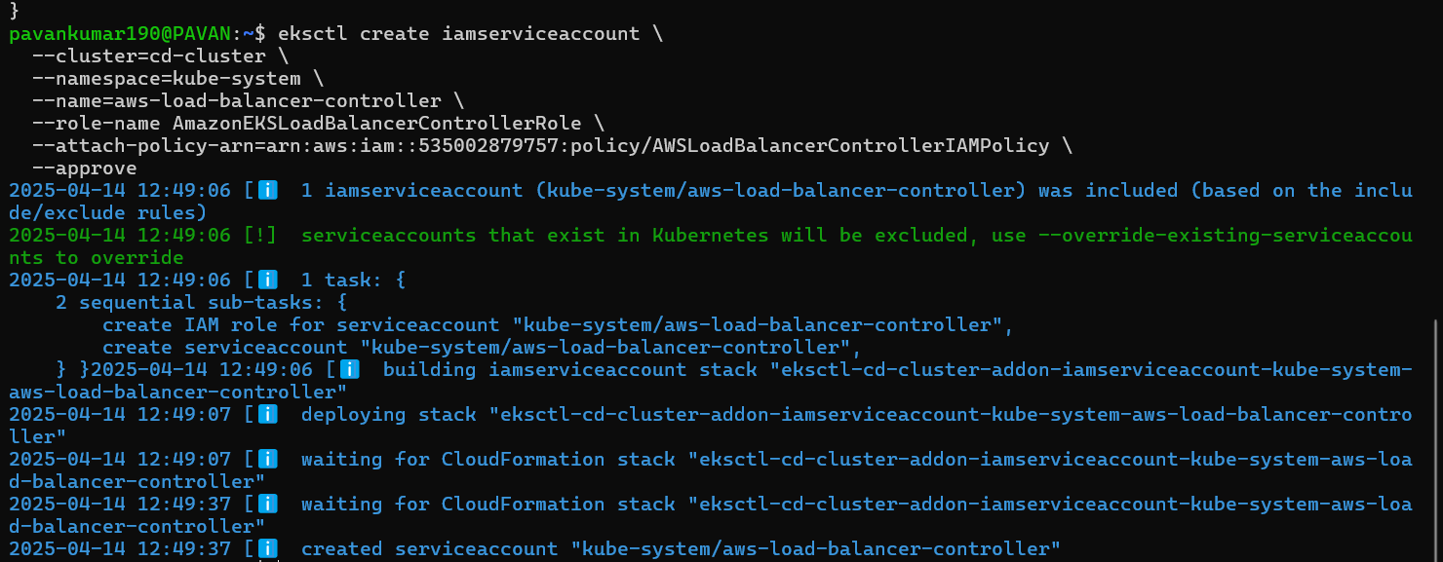
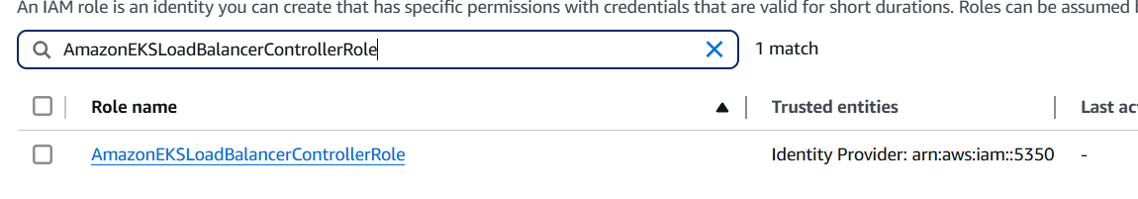
Deploy ALB controller
Add helm repo
helm repo add eks https://aws.github.io/eks-charts
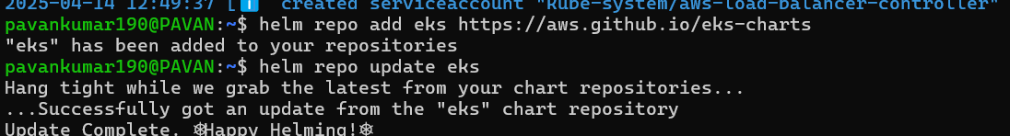 we added the helm and check update by running the helm repo update eks
Install
helm install aws-load-balancer-controller eks/aws-load-balancer-controller \
-n kube-system \
--set clusterName=cd-cluster \
--set serviceAccount.create=false \
--set serviceAccount.name=aws-load-balancer-controller \
--set region=us-east-1 \
--set vpcId=vpc-0a185d695ebf037e9 Verify that the deployments are running. You need to change the vpc id it will find under the networking tab in aws eks tab
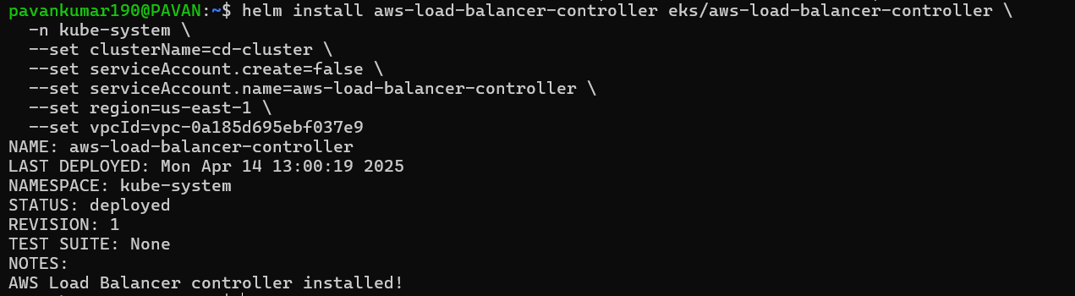
kubectl get deployment -n kube-system aws-load-balancer-controller
It will create a alb load balancer and it is up and running. If you get anyerror check in cloudformation template and delete it.or watch video again
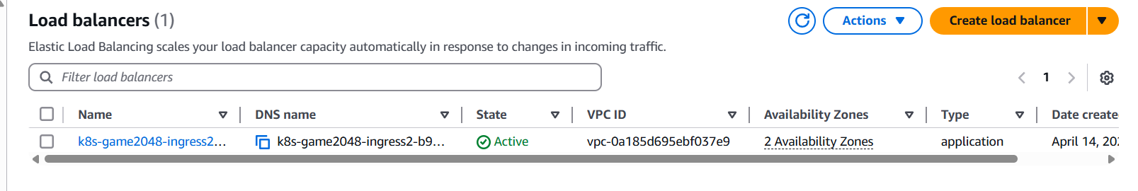
How did it created by using ingress resource
Next we use this command to check the address is come or not
kubectl get ingress -n game-2048
this address is the alb dns name copy and check it website is working or not
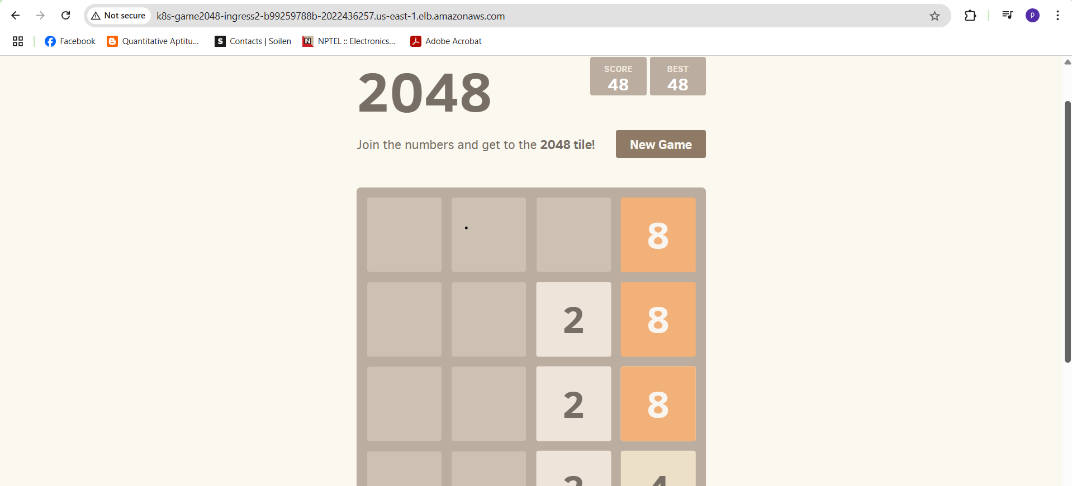

Question: https://raw.githubusercontent.com/kubernetes-sigs/aws-load-balancer-controller/v2.5.4/docs/examples/2048/2048_full.yaml how did they written this?
Ans:
Question: https://raw.githubusercontent.com/kubernetes-sigs/aws-load-balancer-controller/v2.11.0/docs/install/iam_policy.json how did they written this?
Ans:

