Reconfigurable Intelligent Surface-Enabled M-FSK Sensing
Abstract
This paper presents a two-stage reconfigurable intelligent surface architecture that generates a multiple-frequency shift signal for simultaneous sensing of multiple targets at 28 GHz. Stage one is the transmissive stage that modulates a continuous-wave carrier to generate frequency tones that collectively span the signal bandwidth, while the second stage applies a spatially phase gradient that beamforms all tones towards the target. The two-stage architecture decouples the simultaneous modulation-beamforming constraint that limits a single-stage architecture that employ signal modulated signals for multiple target sensing. The bistatic radar link budget is derived incorporating the near-field inter-stage evanescent coupling and Cramér-Rao bounds are established for range, velocity, and position estimation. A closed-loop beam tracking system maintains pointing error to well within the half-power beamwidth over the tracking interval. The power analysis confirms that the two-stage architecture consumes lesser power by 50% than for an equivalent active phased array radar. An inter-stage gap sensitivity study establishes the manufacturing tolerance of the two stage gap, which is 7× wider than the -3 dB SNR criterion alone would suggest.

I. Introduction
Reconfigurable Intelligent Surfaces (RIS) have emerged as a key enabler for beyond-5G wireless systems, offering electronically controlled spatial beamforming at low hardware cost and without active RF chains [1], [2]. A RIS consists of a planar array of sub-wavelength elements whose reflection or transmission phase is tunable via PIN diodes, varactor diodes, or MEMS switches. The conventional role of a RIS is purely passive: it redirects an impinging wave toward a target direction by applying a spatial phase gradient across the aperture [3]-[6]. However, if the element impedances are modulated at a frequency $f_{m}$ by a time-varying control signal, the transmitted or reflected field acquires frequency-shifted components at $f_{c}±f_{m}$ alongside the original carrier at $f_{c}$. This Space-Time Modulated (STM) RIS concept [7] opens novel possibilities of employing the RIS not only to beamform but also to modulate replacing the complex and power hungry radio-frequency (RF) transmitter (Tx) chains with a continuous wave (CW) Tx.
M-ary Frequency Shift Keying (M-FSK) is a widely employed waveform in radars for simultaneous position and velocity of targets. Unlike FSK that estimates velocity only or pulsed radar that is used for range estimation, an M-FSK radar combines frequency steps with coherent processing to resolve both range and velocity in a single coherent processing interval (CPI) without the range-Doppler ambiguity and have the ability to detect multiple targets simultaneously [8]. Recent studies emphasize M-FSK's superior performance in strong multipath environments (e.g., indoor sensing or dense urban automotive scenarios) and its suitability for Integrated Sensing and Communication (ISAC) [9]. Generating M-FSK via an STM-RIS by programming the modulation frequency $f_{m}$ to one of M offset values per symbol could yield a simpler mmWave RF front-end requiring no IQ modulator or mixer chain. The challenge that is addressed in this paper is that this approach must simultaneously address three coupled problems of generating the desired M-FSK tone at $f_{c}+f_{m}$, steering the radiated beam to a specific azimuth direction, and rejecting or suppressing the unavoidable image sideband at $f_{c}-f_{m}$ that inevitably arises from the modulating the RIS elements.
Existing STM-RIS work has demonstrated that a single surface can in principle perform both modulation and beamforming simultaneously [7], [10], [11]. However, as we show in Section II that a single RIS approach faces a fundamental trade-off between symbol rate and beam steerability when applied to M-FSK. The changing the symbol frequency requires reprogramming the spatial phase of all elements via a serial interface thereby limiting the symbol rate, which can be as much as two orders of magnitude below the achievable with a single direct digital synthesiser (DDS) driving all elements identically. This bottleneck motivates the two-stage architecture proposed in this paper, in which the modulation and beamforming functions are physically separated onto two cascaded surfaces: a transmissive T-RIS that generates the M-FSK tone, and a passive reflective R-RIS that applies the beamforming phase gradient independently of the symbol being transmitted.
The theoretical foundation for using a time-modulated surface (TMS) as a frequency translator is given in [7], which introduces the Space-Time Coding (STC) digital metasurface framework. In this system, each element is assigned a temporal switching sequence; by designing these sequences to have specific harmonic content and spatial phase gradients, the surface simultaneously translates frequency and steers the resulting beam to a programmed direction. For M-FSK specifically, a single STM-RIS would assign each element $n$ a DDS-driven bias signal with a phase offset corresponding to the desired beam direction. The element output would then produce an upper sideband at $f_{c}+f_{m}$ which is steered to an azimuth $+θ$ and an image at $f_{c}-f_{m}$ steered to $-θ$ . This spatial separation of desired signal and image is a key result of [7] and [11] and is achieved without any filter. Another related hardware demonstration is in [12], which implements simultaneous beam steering and on-off-keying (OOK) amplitude modulation at 100 GHz using a transmissive Pancharatnam-Berry phase RIS with Schottky diode elements. This is achieved this by exploiting the orthogonality between the spatial coding sequence which sets beam direction and the temporal switching sequence which sets the OOK data.
The single-stage approach has a fundamental limitation when applied to M-FSK. In OOK, the beam direction is fixed and only the symbol amplitude changes. In M-FSK, the symbol frequency $f_{m}$ changes every symbol period. The beamforming phase at element must be recalculated and reprogrammed for every new symbol. With 256 elements × 3 bits per element at a 10 MHz SPI clock, each reprogramming event takes 76.8 μs, limiting the symbol rate to ~13 kHz. This is 50× slower than the ~700 kHz achievable by simply updating a single DDS frequency tuning word, which takes less than 1 μs. At 13 kHz with M = 12, for this the data rate is only ~47 kbps. The SPI bottleneck is an intrinsic property of any per-element reprogramming architecture, not a limitation that can be engineered away without fundamental hardware changes [5]. The single-stage approach steers the image sideband to $-θ$. The spatial separation provides only ~13 dB of image rejection at the Rx determined by the array factor sidelobe level for a uniformly weighted 16-element aperture. Adequate image rejection would require either a tapered aperture weighting (reducing directivity) or a post-detection spatial filter.
In this paper we detail a two-stage RIS architecture that decouples modulation from beamforming, achieving full DDS-limited symbol rates with independently steerable beams. The symbol-rate bottleneck of the single-stage approach arises directly from the coupling between the modulation frequency $f_{m}$spatial phase $ψ_{n}$. In stage one the T-RIS are driven identically by a single DDS applying no spatial phase. A new M-FSK symbol is selected simply by writing a new FTW to the single DDS register requiring no per-element SPI update. The output is a dual-sideband signal $f_{c}±f_{m}$ with uniform spatial weighting. The R- RIS applies the beamforming phase gradient $ψ_{n}$ independently of which M-FSK symbol is being transmitted. The beam angle is set once at startup and changed only when the target direction changes, not per symbol. The image rejection must be achieved by a receive-side bandpass filter (BPF) placed before the Rx.
II. RIS M-FSK Modulation
A. System Overview
The proposed system comprises a CW Tx, a two-stage stacked RIS employing PIN diodes, and a bistatic receiver (Rx), as illustrated in Fig. 1. The Tx radiates a CW signal at $f_{c}$ and is located at distance $d_{Tx}$ to the RIS stack. Each RIS stage is a planar aperture of $N$ elements with half-wavelength spacing. The target is at azimuth $θ_{1}$ from the RIS while the Rx is at azimuth $θ_{2}$ from the RIS . The two stages are separated by an inter-stage gap $d_{g}$. The RIS stage one is a transmissive (T)-RIS, while stage two is a passive reflective (R)-RIS) with $b$ phase bits phase quantization per element.
The T-RIS element is modelled using the experimentally validated equivalent lumped circuit in [12], scaled to 28 GHz PIN diode parameters [13]. Each transmissive element presents a series-connected diode impedance $Z_{1}\left(f,state\right)Z_{1}(f,state)$ in the feed-line environment of characteristic impedance $Z_{0}=50$ Ω. The diode equivalent circuit comprises a series resistance $R_{s}$representing bond-wire and contact parasitics, in series with the parallel combination of a state-dependent junction resistance $R_{J}\left(state\right)R_{J}(state)$ and the junction capacitance $C_{J}$:
$$Z_{1}\left(f,state\right)= R_{s}+\frac{R_{J}\left(state\right)R_{J}(state)}{1+jωC_{J}R_{J}\left(state\right)1+jωC_{J}R_{J}(state)} \left(1\right)$$
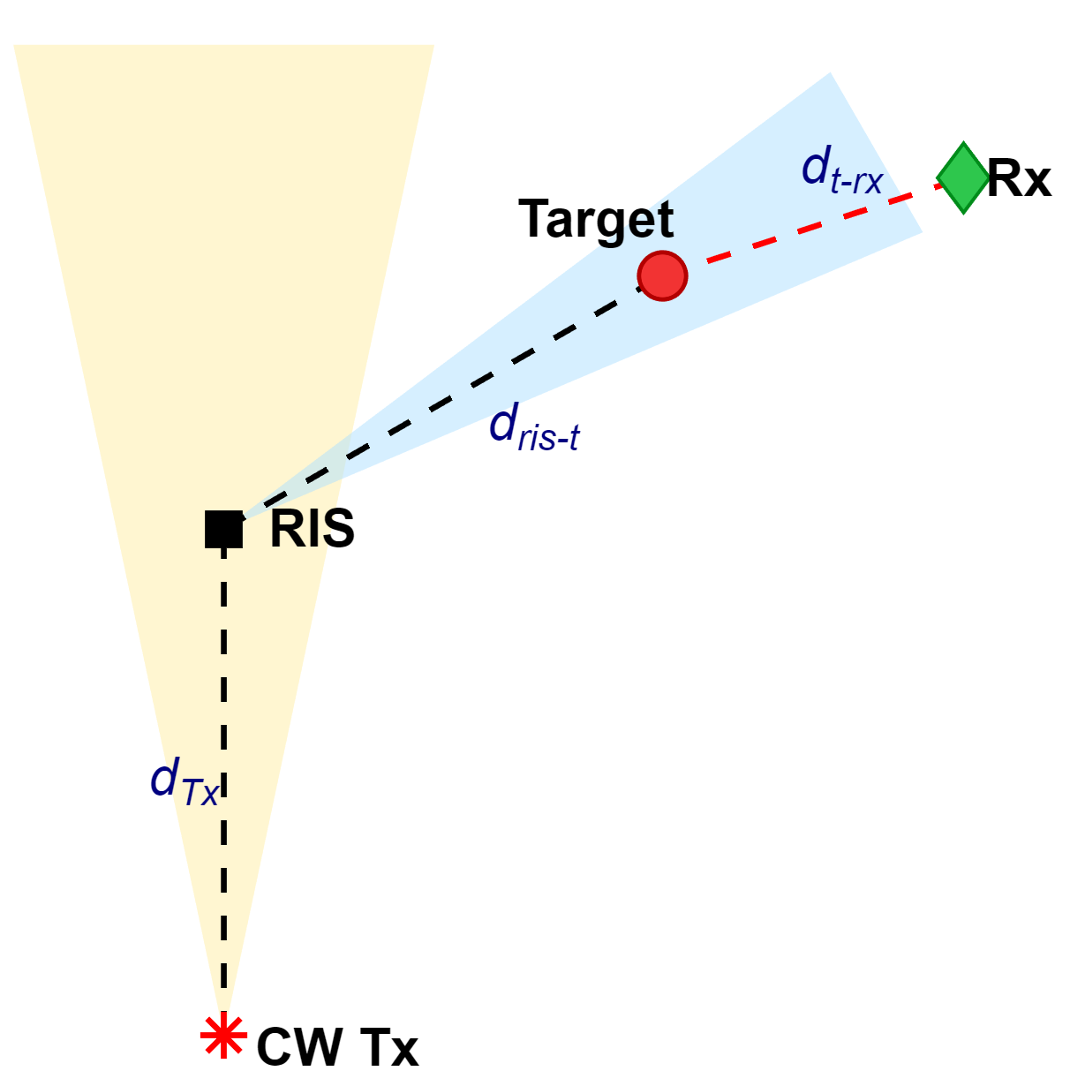
Fig.1. Overview of RIS M-FSK sensing.

where $ω=2πf$ is the angular frequency. The circuit parameters adopted for 28 GHz PIN diodes are $R_{s}=2$ Ω, $C_{J}=25$fF, $R_{J}\left(on\right)=1R_{J}(on)=1$ Ω and $R_{J}\left(off\right)=8R_{J}(off)=8$ kΩ [12], [13]. The transmission coefficient of the element, modelled as a series impedance in a matched $Z_{0}$ transmission line, is [13]:
$$T_{n}\left(f,state\right)=\frac{{2Z_{0}}_{ }}{{2Z_{0}}_{ }+Z_{1}\left(f,state\right){2Z_{0}}_{ }+Z_{1}\left(f,state\right)} \left(2\right)$$
From (2) at $f_{c}=28$ GHz gives $\left\lceil T_{n}\left(f,on\right)T_{n}(f,on)\right\rceil$ and $\left\lceil T_{n}\left(f,off\right)T_{n}(f,off)\right\rceil$ with a phase difference of −64.5° between the two states. The phase asymmetry arises because in the on state $C_{J}$ is effectively short-circuited and in the off state $C_{J}$ introduces a significant reactive component into $T_{n}\left(f,state\right)T_{n}(f,state)$. The proposed M-FSK system uses M = 12 tone frequencies, all on the upper (positive) sideband of the carrier. Denoting the symbol index as $k∈\left\{1,…M\right\}$, the frequency offset of symbol $k$ is:
$$f_{m,k}=kΔf \left(3\right)$$
yielding tones at {25, 50, 75, …, 300} MHz above the carrier. The image sideband at $f_{c}-f_{m,k}$ always falls below the carrier, enabling a single bandpass filter to separate all 12 desired tones from all 12 images simultaneously. If bidirectional offsets (both positive and negative) were used, images of positive-offset tones would overlap with the signal band of negative-offset tones, making spectral separation challenging. The T-RIS elements are driven identically by a single DDS chip simultaneously via the mixing with phase $φ_{n}=0$ for all $n$. The PIN diode is modelled as a switch driven between on and off states by the DDS sinusoid. When the DDS drives the element with a sinusoidal signal at frequency $f_{m}$ switching between on and off states, the instantaneous transmission coefficient of element $n$ given by [14], [15]:
$$T_{n}\left(t,f\right)=T_{mean}\left(f\right)+\frac{T_{n}\left(f,on\right){{-T}_{n}\left(f,off\right)}_{ }}{2_{ }}\cos\left(2πf_{m}t+φ_{n}\right) \left(4\right)$$
where,
$$T_{mean}\left(f\right)=\frac{T_{n}\left(f,on\right){{+T}_{n}\left(f,off\right)}_{ }}{2_{ }} \left(5\right)$$
is the bias-point (quiescent) transmission and the second term is the sinusoidal modulation about that bias point.
Multiplying (4) by the incident CW carrier constitutes a resistive mixing process [14], producing the transmitted signal at element n:
$$s_{n\left(t\right)}= T_{n}\left(t,f\right)cos\left(2πf_{c}t\right) \left(6\right)$$
From (4), (6) and applying the product-to-sum trigonometric identity with $φ_{n}=0$ gives:
$$s_{n}\left(t\right)=T_{mean}(f)cos\left(2πf_{c}t\right)+\left({\frac{T_{n}\left(f,on\right){{-T}_{n}\left(f,off\right)}_{ } _{ }}{4 _{ }}}_{ }\right)\left\{\cos\left(2π\left(f_{c}+f_{m,k}\right)t\right)+\cos\left(2π\left(f_{c}-f_{m,k}\right)t \right)\right\} \left(7\right)$$
In (7) the output of each T-RIS element contains three spectral components: a residual carrier at $f_{c}$ of amplitude $T_{mean}\left(f\right)T_{mean}(f)$, a desired upper sideband at $f_{c}+f_{m,k}$ and an image sideband at $f_{c}-f_{m,k}$. Both sidebands have the same amplitude, equal to half the modulation depth, where the modulation depth is given by [15]:
$$T_{sb}\left(f\right)=\frac{T_{n}\left(f,on\right){{-T}_{n}\left(f,off\right)}_{ }}{2 _{ }} \left(8\right)$$
B. R-RIS Beamforming and Near-Field Coupling
In stage two the R-RIS applies a spatial phase gradient to steer the combined radiated field toward the target at azimuth $θ_{1}$. The per-element reflection phase is phase is:
$$ψ_{n}=k_{c}x_{n}\sin\left(θ_{1}\right) \left(9\right)$$
where $k_{c}=\frac{2πf_{c}}{c}$is the free-space wavenumber at the carrier frequency and $x_{n}$ is the x-coordinate position of element $n$. Each R-RIS element can be modelled as a PIN-diode reflector with complex reflection coefficient [13]:
$$Γ=\left|Γ\right|e^{jψ_{n}} \left(10\right)$$
where $\left|Γ\right|≈0.9|Γ|≈0.9$ is the per-element reflection magnitude. Because $ψ_{n}$ is computed at the carrier wavenumber $k_{c}$ and does not depend on the symbol index $k$, R-RIS is programmed once at startup and requires no update between symbols. This independence of beam direction from symbol frequency is enabled by the two-stage architecture over single-surface STM-RIS approaches [7], in which changing the symbol frequency would require reprogramming all element phases. As the two RIS stages are separated by approximately 0.19$λ$ this places R-RIS within the near-field of T-RIS. The field coupling from an element T-RIS to an element in R-RIS is [12],[13]:
$C_{0}=e^{-α_{f}d_{g}}{ }$ (11)
where $d_{g}$, is the nominal inter-stage gap, and$α_{ f}=\frac{2π}{λ}$ is the evanescent near-field decay constant. The field amplitude at each R-RIS element is the superposition of contributions from all T-RIS elements. The dominant contribution is from the co-located elements with off-axis contributions have rapidly varying propagation phases that cause destructive interference, leaving the net coupled amplitude $≈C_{0}$[13]. This is the on-axis near-field approximation of the Rayleigh-Sommerfeld inter-layer propagation model used in the SIM literature [16]. The inter-stage gap $d_{g}$is a mechanical assembly parameter determined by the PCB substrate and spacer thicknesses. Unlike the stacked RIS architecture in [16] where $d_{g}$is deliberately chosen to achieve a specific inter-layer coupling matrix for holographic beamforming, in the proposed two-stage T-RIS/R-RIS architecture $d_{g}$ acts as an unavoidable loss with $C_{0}^{2}$entering (16) as a power loss.
The combined array factor of the two-stage system at observation angle $θ$ for a signal at frequency $f$ is:
$AF\left(f,θ\right)={\left|\sum_{1}^{n}{w_{n}\left(f\right)e^{-\frac{2πfx_{n}sin\left(θ\right)}{c}}}\right|}^{2}$(12)
where $w_{n}\left(f\right)$ is the combined element weight at frequency $f$ accounting for T-RIS transmission, near-field coupling, and R-RIS reflection. For the final adopted architecture the combined weight for the desired sideband is [7], [12]:
$${ w}_{n}\left(f_{c}+f_{m}\right)=\frac{T_{sb}\left(f\right)}{2}\left[\sum_{q}{C_{nq}}\right]|Γ|e^{jψ_{n}}{ \left(13\right)}$$
The normalised array factor $AF\left(f,θ\right)$ peaks at $θ=θ_{1}$ for all symbols simultaneously, since the R-RIS phase gradient is symbol-independent. The beam squint across the M-FSK bandwidth is [17]:
$$Δθ_{squint}≈\arcsin\left(\sin\left(θ_{1}\right)\frac{f_{m,k}}{f_{c}}\right) \left(14\right)$$
At $f_{c}=28$ GHz, for the worst-case symbol k = 12 $f_{m,k}=300$ MHz, $Δθ_{squint}=0.53°$ which is less than 10 % of the 3 dB HPBW of approximately 13.2° for the 16-element aperture steered to 60°. All M = 12 tones therefore illuminate the target within the 3 dB beamwidth.
The system and RIS parameters are summarised in TABLE I and TABLE II respectively.
TABLE I: System Parameters
Parameter | Value
Carrier frequency $f_{c}$ | 28 GHz
Tx radiated power: $P_{Tx}$ | 20 dBm
Tx gain: $G_{\text{T}\text{x}}$ | 0 dBi
Target RCS: $σ_{RCS}$ | 0 dBsm
Tx-RIS distance: $d_{TR}$ | 8 m
RIS-target beam angle $θ_{1}$ | 60°
RIS-target distance: $R_{ris-t}$ | 10 m
Target-Rx distance: $R_{t-rx}$ | 8 m
R-RIS reflection loss: $\left|Γ\right|$ | -1.0 dB
Rx BPF | 5th Butterworth, 25 MHz-300 MHz
BPF passband | $f_{c}+12.5$ MHz to $f_{c}+312.5$ MHz
Rx elements: $N_{\text{rx}}$ | 16
Rx element spacing: $d_{\text{rx}}$ | $$\frac{λ}{2}$$
Rx gain: $G_{\text{rx}}$ | 18 dBi
Rx noise figure | 5 dB

TABLE II: RIS Parameters
Parameter | Value
Array size (each stage) | N=16×16 = 256 elements
Element spacing | λ/2 = 5.35 mm
M-FSK symbols: M | 12 (one-sided)
Tone spacing: $∆f$ | 25 MHz
Frequency range | $f_{c}+25$ MHz to $f_{c}+300$MHz
Inter-stage gap: $d_{g}$ | 2 mm (0.19λ)
R-RIS reflection loss: $|Γ|$ | -1.0 dB
Manufacturing tolerances: Amplitude variation: $σ_{T}$, Phase variation: $σ_{φ}$ | Gaussian distribution: 2%, $3°$ per element.
C. Bistatic Signal Model
The incident power on the RIS is given by:

$${ P}_{\text{ap}}=\frac{P_{\text{Tx}}G_{\text{Tx}}A_{\text{RIS}}}{4πd_{TR}^{2}} (15)$$
where $A_{\text{RIS}}$ is the effective aperture of the T-RIS. Considering T-RIS conversion efficiency into the harmonic $f_{m,k}$, the effect of near-field coupling power between T-RIS and R-RIS, and the conversion efficiency of R-RIS, the equivalent radiated power at the harmonic during symbol $k$ is given by:
$$P_{\text{RIS}}^{(k)}={\left[\frac{T_{sb}\left(f\right)}{2}\right]}^{2} C_{0}^{2}{{|Γ|}^{2}P}_{\text{ap}} (16)$$
Treating the RIS as a transmitter with harmonic-dependent directive gain $G_{\text{RIS}}^{(k)}(θ_{1})$. Using the bistatic radar equation, the received power at Rx as reflected of the target [18],[19]:
$$P_{\text{rx}}^{(k)}=\frac{P_{\text{tx}}G_{\text{tx}}A_{\text{RIS}}{\left[\frac{T_{sb}\left(f\right)}{2}\right]}^{2} C_{0}^{2}{{|Γ|}^{2}}_{ } G_{\text{RIS}}^{(k)}({θ_{1}}_{ }) G_{\text{rx}} λ_{ }^{2}σ_{RCS}}{(4π)^{4}d_{TR}^{2}R_{ris-t}^{2}R_{t-rx}^{2}} (17)$$
where ${λ_{k}}_{ }=c/(f_{c}+f_{m,k}^{ })$. This expression links Tx power, RIS aperture, harmonic conversion, and the beam gain to the expected per-symbol received energy for M-FSK detection. Considering the positions $x_{\text{tx}},x_{\text{ris}},x_{\text{rx}}$ and $x(t)$, the total propagation delay from the Tx radiating CW to Rx receiving the scattered symbol is given by:
$$τ_{\text{tot}}=\frac{R_{\text{tx-ris}}+R_{\text{ris-t}}+R_{\text{t-rx}}}{c} (18)$$
where:
$${ R}_{\text{tx-ris}}=∥x_{\text{tx}}-x_{\text{ris}}∥ (19)$$
$$R_{\text{ris-t}}=∥x_{\text{ris}}-x∥ (20)$$
$${ R}_{\text{t-rx}}=∥x-x_{\text{rx}}∥ (21)$$
In M-FSK radar the transmitted signal is stepped sequentially all M tones in order, radiating each tone for one symbol period $T_{sym}$ before stepping to the next. One complete cycle through all M tones constitutes a sweep of duration:
$$T_{sw}=MT_{sym} (22)$$
The CPI consists of $N_{sw}$ complete sweeps, giving a total CPI duration of $T_{CPI}=N_{sw}T_{sw}$. The slow-time index $p∈\left\{1,.. , N_{sw} \right\}$ counts sweeps, so the slow-time timestamp of the $p^{th}$sweep is $t_{p}=pT_{sw}$. The absolute frequency of tone k is:
$$f_{k}=f_{c}+f_{m,k} (23)$$
Let $ξ _{l}\left(k\right)$denote the per-element phase at Rx element $l$ for tone $k$, incorporating the RIS beamforming phase and the propagation phase offset. At Rx element $l$, tone $k$, sweep p, the complex baseband sample is:
$$r_{l}\left(k,p\right)=A_{k}exp​\left(j\left[-2πf_{m,k}τ_{\text{tot}}+2πf_{D}\left(k\right) t_{p}+ξ _{l}\left(k\right)\right]\right) (24)$$
where $A_{k}=\sqrt{2P_{\text{rx}}^{(k,h)}}$ is the received amplitude from (17), $f_{D}(k)$ is the instantaneous bistatic Doppler frequency due to target motion and $τ_{\text{tot}}$ is the total propagation delay from (18). Defining the two unit vectors as:
$u_{rt}=(x-x_{\text{ris}})/∥x-x_{\text{ris}}∥ (25)$
$${ u}_{rx,t}=(x_{\text{rx}}-x)/∥x_{\text{rx}}-x∥ (26)$$
then the Doppler frequency for tone $k$ is
$$f_{D}\left(k\right)≈\frac{f_{k}}{c}\left(u_{rt}​⋅​v+u_{rx,t}​⋅​v\right) (27)$$
Considering additive noise as $n_{l}(k,p)∼CN(0,σ_{n}^{2})$, the noise sample is given by:
$$y_{l}\left(k,p\right)=r_{l}\left(k,p\right)+n_{l}\left(k,p\right) (28)$$
For beamforming a Rx with $N_{rx}$ elements with steering weights $a_{l}$ we have:
$$y_{\text{bf}}\left(k,p\right)=\sum_{l=1}^{N_{\text{rx}}}{a_{l}^{*}} y_{l}\left(k,p\right) (29)$$
Range, velocity and angle estimation is undertaken over one CPI. Range is estimated by coherently average $y_{\text{bf}}\left(k,p\right)$ $N_{sw}$ sweeps for each tone $k$, giving the M-element stepped-frequency vector for IFFT range processing. For Doppler estimation we apply a length-$N_{sw}$ FFT over the slow-time axis p for each tone $k$, and averaging magnitude spectra over M tones to resolve target velocity. The angle estimate is estimated from the $N_{rx}×1$ spatial snapshot by coherently summing the received array signals across all M tones given by:
$$y_{\text{snap}}=\sum_{k}^{ }{ }y_{l}\left(k,p\right) (30)$$
III. Target sENSING and Tracking
In the bistatic deployment the R-RIS beam must continuously track a moving target by updating the R-RIS phase map as the target’s azimuth relative to the RIS changes over successive CPIs. This section presents the closed-loop tracking system which estimates the receive-array angle, stepped-frequency range and velocity; implements the bistatic geometry inversion, and the linear motion prediction. The target tracking parameters are given in TABLE III.
TABLE III: Target Tracking
Parameter | Value
Target velocity:$v$, Target angle:$θ_{t}$ | 2 m/s, $45°$
Bistatic angle:$β$ | $165°$*
Symbol period: $T_{sym}$ | 1.40 $μ$s
Symbol rate | 714 kHz
Sweep Duration: $T_{sw}$ | 16.8 $μ$s
Number of seeps: $N_{sw}$ | 1024
Coherent processing interval:$T_{CPI}$ | $$N_{sw}.T_{sw}$$
*From Fig.1 and TABLE I.
A. Rx-Array Angle Estimation
From Fig.1 and TABLE I, the bistatic Rx array is centred at the fixed bistatic Rx position $p_{rx}$ (10.46, 7.54) m. The steering vector of the Rx array toward azimuth θ is:
$$a_{rx}\left(θ\right)={\left[1,e^{\frac{j2πd_{rx\sin{θ}}}{λ}}, …,e^{\frac{j2π[N_{rx}-1]d_{rx\sin{θ}}}{λ}}\right]}^{T} (31)$$
The angle-of-arrival from the Rx to the target, $θ_{Rx→t}$ is estimated by maximising the conventional beamformer output using a Matched filter [20]:
$${\hat{θ}}_{Rx→t}=arg \max_{θ}{{|{a_{rx}\left(θ\right)}^{H}y_{\text{snap}}|}^{2}} (32)$$
The array aperture is $D_{rx}=(N_{rx}-1)d_{rx}$ and Cramér–Rao bound (CRB) for the angle estimate is given by:
$${CRB(θ}_{Rx→t})=\frac{λ^{2}}{2π^{2}{D_{rx}^{2}}_{ }\cos^{2}(θ_{Rx→t}){SNR}_{CPI}} (33)$$
where ${SNR}_{CPI}$ is the post-CPI SNR. CRB
B. Range Estimation
The total bistatic path $R_{tot}$ from (18) is estimated from the M complex phasors obtained by coherently averaging (29) for each tone $k$. Forming the M-element vector [ȳ(1), …, ȳ(M)] and applying a zero-padded IFFT yields a range profile whose peak encodes $τ_{\text{tot}}$, where:
$$\overline{y}\left(k\right)=\frac{1}{N_{\text{sw}}}\sum_{p=1}^{N_{\text{sw}}}{{y_{\text{bf}}\left(k,p\right)}_{ }^{ }} (34)$$
For a IFFT length $N_{\text{FFT}}$ the range resolution is given by [18]:
$$δR=\frac{c}{N_{\text{FFT}}∆f} (35)$$
The IFFT yields a wrapped estimate ${\hat{R}}_{wrap}$ modulo $\frac{c}{2M∆f}$. The true total path is recovered as:
$${\hat{R}}_{tot}={\hat{R}}_{wrap}+n_{amb}δR (36)$$
where $n_{amb}$ is the ambiguity integer resolved from coarse prior knowledge at acquisition. The CRB for total-path estimation from M coherently combined tones is given by [20]:
$${CRB(R}_{tot})=\frac{c^{2}}{8π^{2}σ_{f}^{2}M{SNR}_{CPI}} (37)$$
where ${σ_{f}^{2}}_{ }^{ }$ is the variance of the tone frequencies about their mean.
C. Velocity Estimation
The Doppler frequency estimate is given by the slow-time sequence $y_{\text{bf}}\left(k,p\right)$ for each tone $k$, and the M magnitude spectra are averaged to suppress noise:
$${\hat{f}}_{D}=arg\max_{f}{{\left|\frac{1}{M}\sum_{k}^{ }{FFT\{y_{\text{bf}}\left(k,p\right)w^{H}(p)\}}\right|}^{2} (38)}$$
where $w^{H}(p)$ is the Hanning window over the sweep index p. The Doppler resolution is given by:
$$δf_{D}=\frac{1}{T_{CPI}} (39)$$
The CRB for Doppler frequency estimation is given by [19]:
$${CRB(f}_{D})=\frac{1}{8π^{2}T_{CPI}^{2}{SNR}_{CPI}} (40)$$
D. Positioning CRB
Given ${\hat{θ}}_{Rx→t}$ and ${\hat{R}}_{tot}$, the target position is recovered from the intersection of the line-of-bearing from the Rx and the bistatic ellipse of constant total path [19]. The bearing unit vector of the target is given by:
$\hat{u}={\left[\sin{{\hat{θ}}_{Rx→t}},\cos{{\hat{θ}}_{Rx→t}}\right]}^{T} (41)$
The scalar distance from the Rx to the target along û is given by:
$$r=\frac{\left({{\hat{R}}_{tot}}^{2}-{|a|}^{2}\right)}{\left[2\left(a.û+{\hat{R}}_{tot}\right)\right]} (42)$$
where $a$ is the Rx-RIS baseline given by:
$$a=p_{rx}-p_{RIS} (43)$$
The estimated target position and required beam angle are:
$${(\hat{x}}^{T}{\hat{,y}}^{T})={p_{rx}}^{ }+r\hat{u} (44)$$
$${\hat{θ}}_{2}={{arctan(\hat{x}}^{T},{\hat{y}}^{T})}^{ } (45)$$
Combining range and angular CRB contributions we get [19]:
$$\sqrt{CRB\left(pos\right)}=\sqrt{{CRB\left(R_{tot}\right)+R_{tot}^{2}CRB(θ_{Rx→t})}_{ }} (46)$$
E. Target Tracking
For the R-RIS SPI the beam must be pointed at the predicted target position one $T_{CPI}$ ahead. For this we apply first-order constant-velocity predictor [21]:
$$\left(x_{pred},y_{pred}\right)={(\hat{x}}^{T}{\hat{,y}}^{T})+\hat{v}\left(\frac{\hat{v}}{|\hat{v}|}\right)T_{CPI} (47)$$
where and $\frac{\hat{v}}{|\hat{v}|}$ is the unit direction vector estimated from successive position estimates and $\hat{v}$ is the speed estimate given by:
$$\hat{v}=-\frac{{\hat{f}}_{D}}{\left(u_{rt}\frac{\hat{v}}{\left|\hat{v}\right|}+u_{rx,t}\frac{\hat{v}}{\left|\hat{v}\right|}\right)} (48)$$
The predicted angle loaded to R-RIS via SPI is given by:
$$θ_{pred}=\arctan\left(x_{pred},y_{pred}\right) (49)$$
IV. RIS-ENABLED M-FSK SENSING
- T-RIS Phase Control and R-RIS Beamforming
Fig. 2 characterises the transmission response of the T-RIS element over the frequency band 20-35 GHz, derived from the PIN diode equivalent-circuit model in (1) where $R_{s}=2$ Ω and $C_{j}=25$ fF. In Fig.2a the on-state $\left|Z_{1}\left(f, on\right)\right| = 3 Ω ≪ Z_{0}$, placing the diode in a near-short condition. The resulting $\left|T_{n}\left(f, on\right)\right| = -0.26 dB$ across the frequency band 20-35 GHz band. In the off-state, $\left|Z_{1}\left(f, off\right)\right|=227$Ω at 28 GHz and $\left|T_{n}\left(f, off\right)\right| = -8.02 dB$. The sideband coefficient $\left|T_{sb}\right| = -7.17 dB$ at 28 GHz. The carrier feed-through is $-4.46 dB$ which is the DC component present at the output regardless of switching state. The $\left|T_{sb}\right|$varies by less than 0.4 dB from 20 to 35 GHz, confirming that the modulation efficiency is essentially flat across the 12-tone waveform. In Fig.2b the on-state phase $∠T_{n}\left(on\right)$ ≈ 0° across the full band, as expected for a near-resistive low-impedance load. The off-state phase $∠T_{n}\left(off\right)$ = +64.5° at 28 GHz arises from the capacitive reactance of $C_{j}$in the reverse-biased junction. In Fig.2c the on-state impedance $\left|Z_{1}\left(f, on\right)\right|$| is essentially flat and resistive, dominated by $R_{s}$. The off-state impedance $\left|Z_{1}\left(f, off\right)\right|$ falls from above 300 Ω at 20 GHz to 227 Ω at 28 GHz as the capacitive reactance due to $C_{j}$ decreases with frequency. These values are consistent with mmWave PIN diode specifications reported in the literature [13], [14].
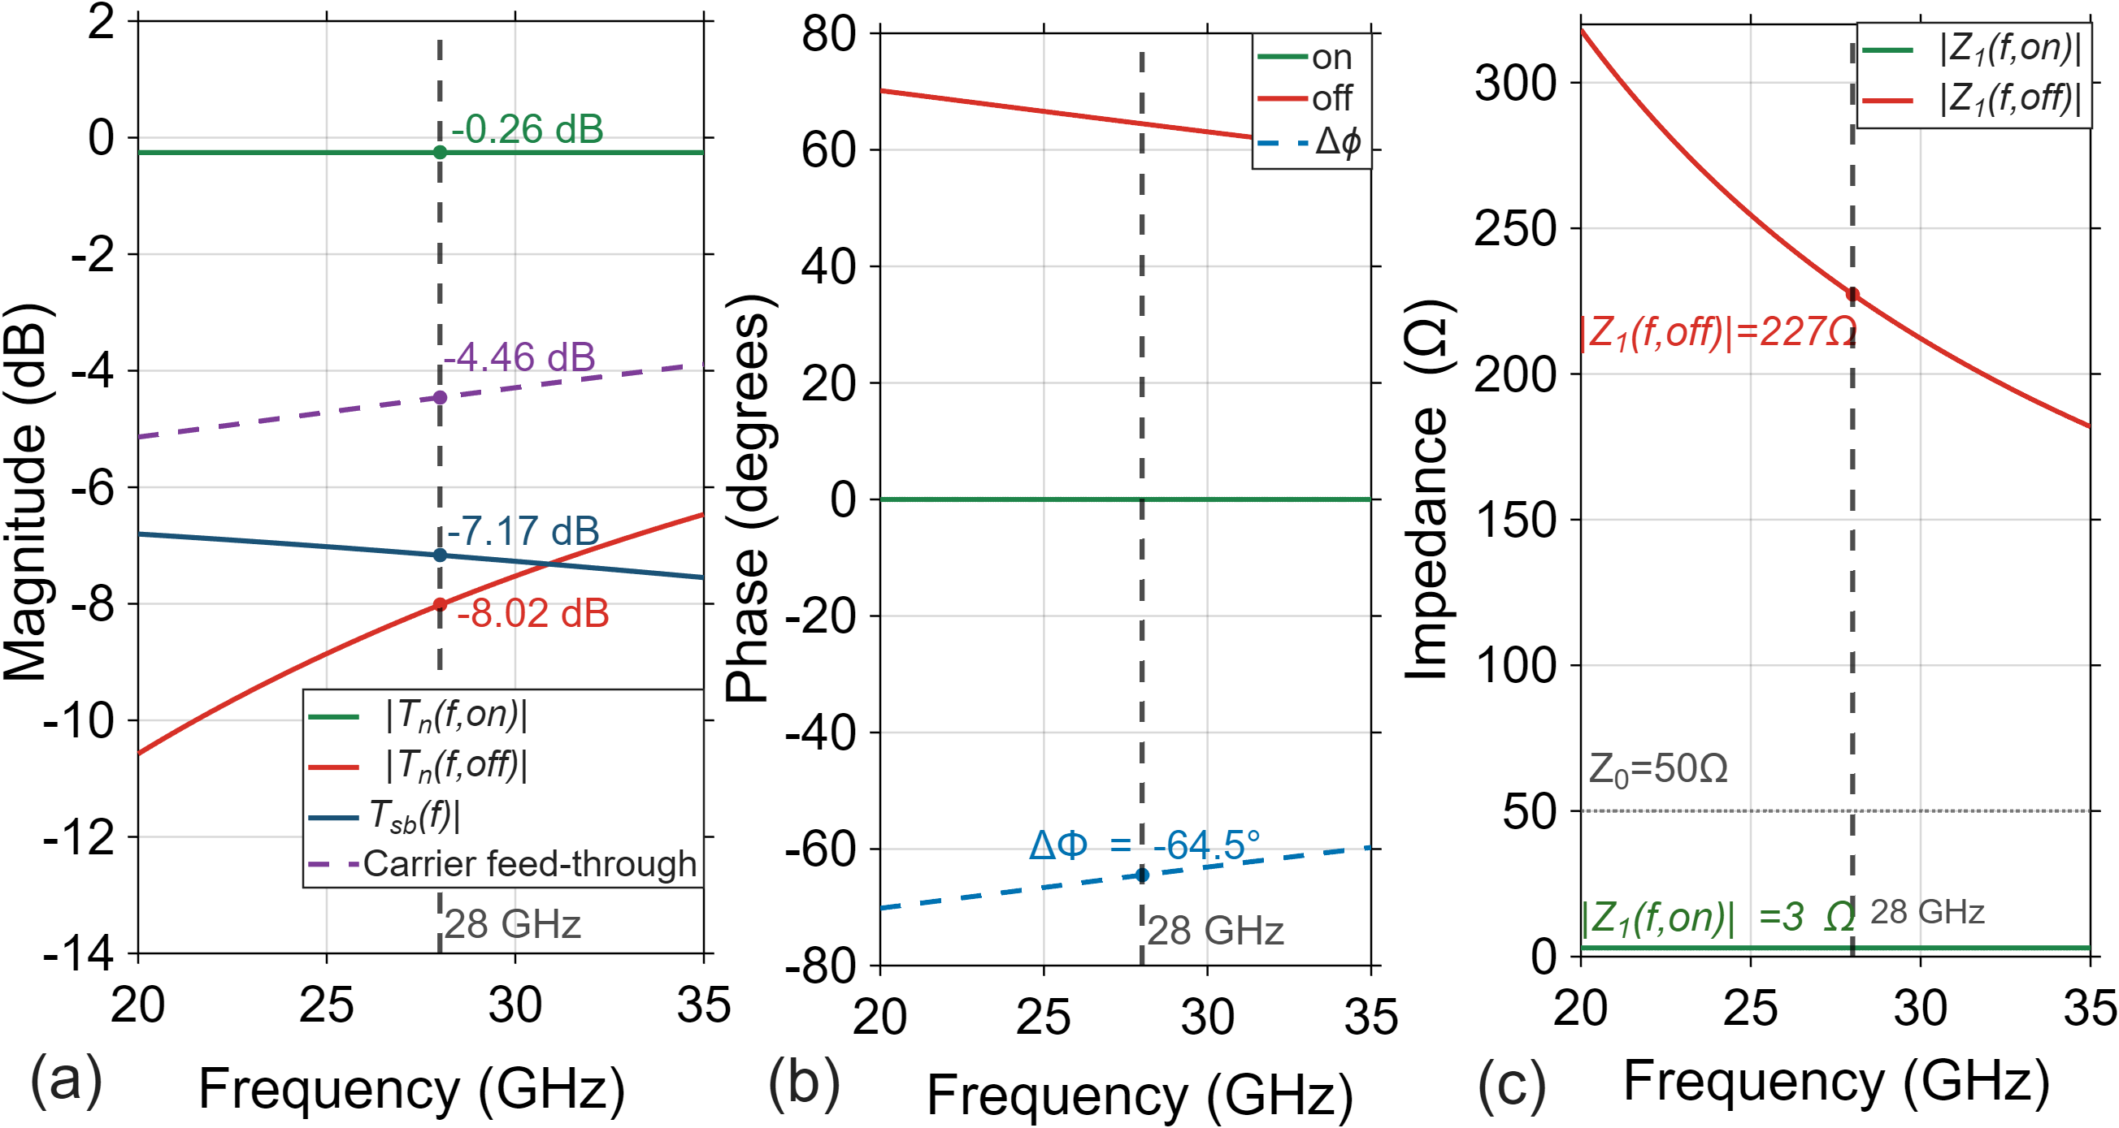
Fig.2. RIS phase control.

Fig. 3 shows the normalised $A_{F}\left(θ\right)$ of the R-RIS reflective aperture in cartesian and polar coordinates. The R-RIS is a 16 × 16 element uniform planar array (UPA) with half-wavelength inter-element spacing giving an aperture of 80.4 mm. The beam is steered to $θ_{1} = 60°$ by applying progressive phase shifts across the array elements using a 3-bit digital phase shifter at each element. The peak steers to +60° with a 3 dB half-power beamwidth of $HPBW ≈$ 13.0° and a first sidelobe level of -13.3 dB. For M = 12 tones spanning 25-300 MHz above$f_{c}$ , the maximum squint is 1.04°.
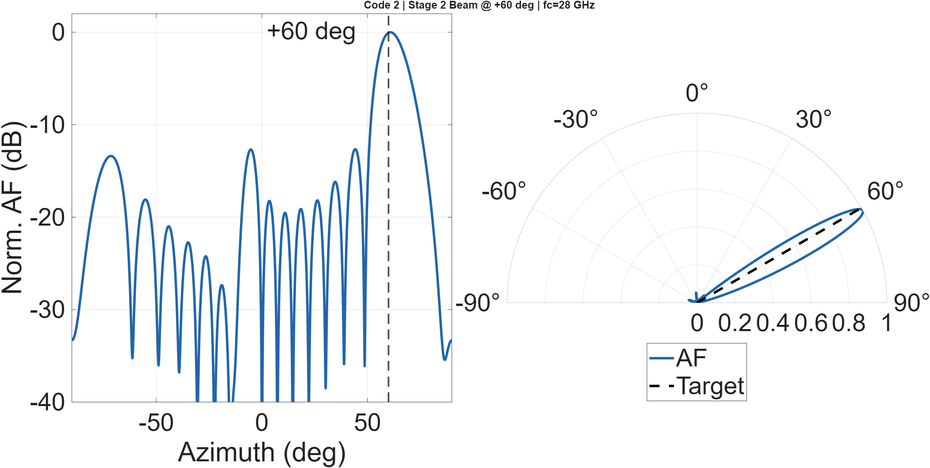
Fig.3. R-RIS beamforming.

- RIS-MFSK Target Sensing
The end-to-end radar link budget for the two-stage RIS bistatic system, from (17), is shown in Fig.4. Starting the CW Tx transmitting at +20 dBm, the signal undergoes one-way spreading loss on the Tx-RIS link of -29.1 dB. The T-RIS physical capture aperture $A_{RIS}=73.5$ cm² collects -21.3 dB m² of the incident power. The T-RIS PIN-diode sideband conversion imposes a loss of -19.2 dB, the inter-stage near-field coupling contributes to a loss of -10.2 dB, and the R-RIS reflection coefficient contributes to -1.0 dB. The R-RIS with a coherent beam gain of +48.2 dB re-radiates toward the target. After one-way spreading on the RIS-target link of -31.0 dB and a target scattering with σ_{RCS} = 1 m² (0 dBsm), a further target-Rx spreading loss and the bistatic Rx gain of +18 dB yields a received power of -99.1 dBm. Against a thermal noise floor of -84.6 dBm (B = 275 MHz, NF = 5 dB, T₀ = 290 K), the single-symbol SNR is SNR_{single} = -14.5 dB. With $N_{sw}=1024$ sweeps, the post-CPI SNR is SNR_{CPI} = +15.6 dB, which is taken as the operative SNR for the estimation bounds and RMSE estimation.
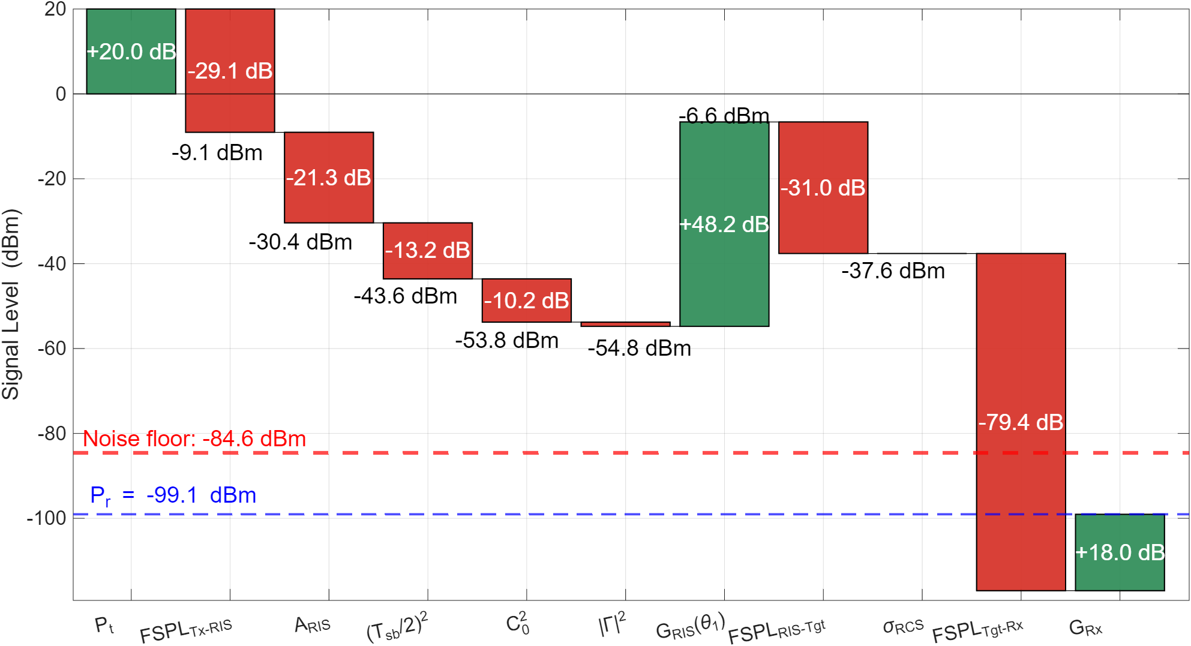
Fig.4. Bistatic RIS M-FSK sensing link budget.

Figs. 5(a)-5(c) shows the Monte Carlo 200 trials RMSE for range, angle-of-arrival, and combined 2-D position as a function of single-symbol SNR along with the CRB. The RMSE curve in Fig.5a exhibits a rapid monotonic decline from approximately 55 mm at ${SNR}_{single}=-28$ dB to < 10 mm regime as SNR increases. At the operating point ${SNR}_{single}$= -14.5 dB, the range RMSE is approximately 5-6 mm . The two-stage RIS M-FSK system, with M = 12 tones and a symbol duration of $T_{sym}=1.4$ μs, achieves millimetre-level range accuracy by exploiting coherent phase information across all tones and sweeps. The angle RMSE in Fig. 5b exhibits the characteristic threshold behaviour of a beamforming-based estimator. Below ${SNR}_{CPI}$≈ +10 dB the estimator is in the sidelobe-ambiguity region which drive the beamformer peak to the first sidelobe at ±3.6° from the main lobe, producing outlier errors and RMSE oscillations between approximately 2° and 5°. Above the threshold SNR the RMSE converges smoothly to the CRB. The combined 2-D position RMSE in Fig. 5c is dominated by the angular component at low SNR and by the range component at high SNR. At the operating SNR the 2-D position RMSE is approximately 1.5-1.8 m. This reduces to below 0.2 m for SNR_{CPI} > +15 dB. demonstrating that the two-stage RIS architecture enables high positioning accuracy in a sufficiently strong-signal regime. Here for CRB and RMSE an idealised AWGN channel is assumed with no clutter, perfect phase coherence across the CPI, and a point target with known RCS.
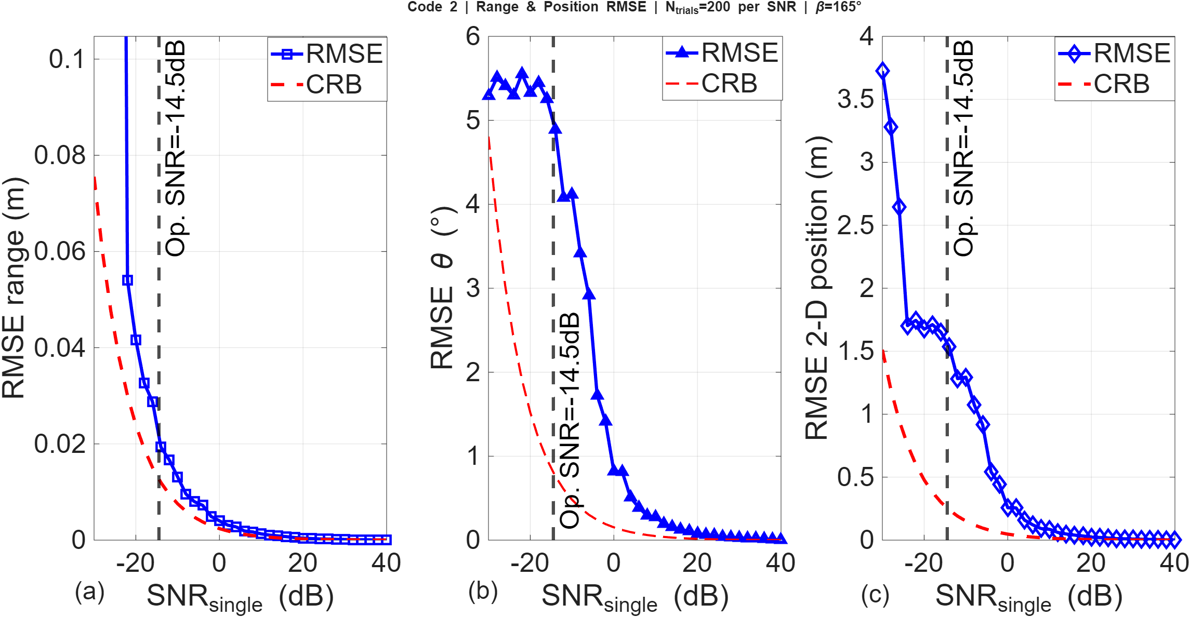
Fig.5. CRB and position RMSE estimation.

Fig. 6 presents the velocity RMSE for true velocity v = 2 m/s versus single-symbol SNR. The CRB for Doppler frequency estimation at SNR_{CPI} = +2.4 dB evaluates to 2.45 Hz, corresponding to a velocity bound of ≈ 1.966 mm/s. This is a theoretical lower bound; the FFT-based estimator is resolution-limited rather than noise-limited. The Doppler bin spacing is 1/T_{CPI} = 58.1 Hz ≡ 311 mm/s in velocity. FFT peak-finding with Hanning windowing achieves an effective interpolation of approximately 2–3× below the bin spacing, giving a practical RMSE floor near 100 mm/s at high SNR. Range and angle are both noise-limited estimators, their RMSE is set by noise level and improves as SNR increases, tracking the CRB. While the velocity is a quantisation-limited estimator, its RMSE is set by a deterministic property of the FFT grid thereby remaining constant with increase in SNR.
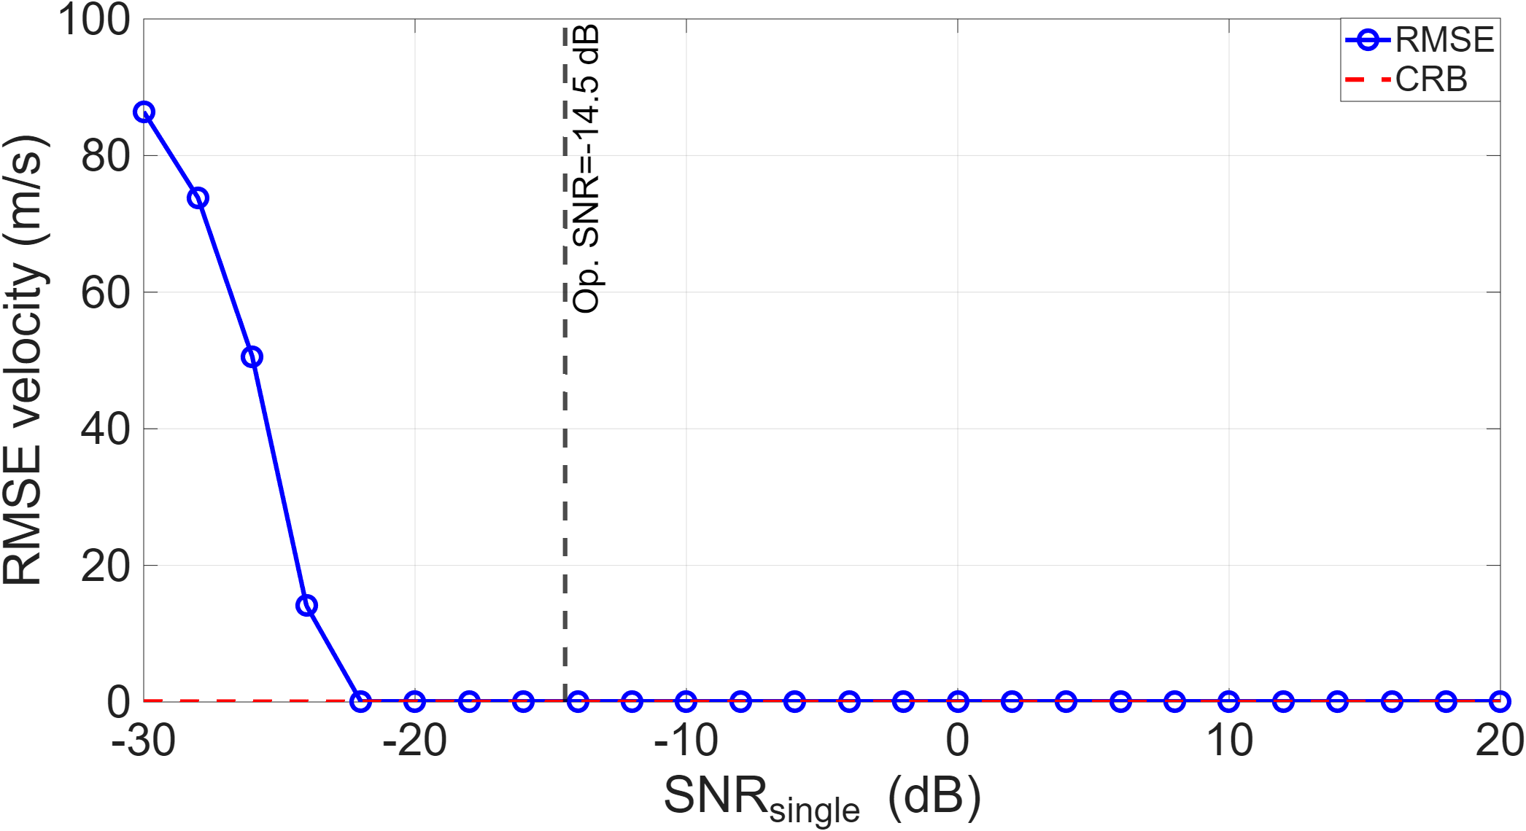
Fig.6. CRB and velocity RMSE estimation. – add a few benchmarks

- R-RIS Beam-update and Tracking
Fig. 7(a) presents the R-RIS beam-steering performance over 50 CPI frames. The true required beam angle θ₁ increases linearly from 60.0° to 61.5° as the target traverses the bistatic scene, following directly from the position update in (47). The commanded beam angle θ_{pred}, loaded to the R-RIS via SPI at the start of each CPI, tracks this trajectory throughout the 860 ms observation. Fig. 7(b) shows the angle commands as θ_{pred} is computed from the position and velocity estimates of the preceding CPI from (47)-(49) and applied to the next CPI, introducing a systematic lag equal to one update period T_{CPI} = 17.20 ms. This one-frame lag corresponds to an angular displacement of only 0.030° per frame, which is 0.45 % of the HPBW of 13.2°. The first-order constant-velocity predictor in (47) does not introduce a systematic offset for straight-line motion at constant speed. The residual frame-to-frame variation in θ_{pred} visible in panel Fig.7(a) arises from measurement noise in the per-CPI angle estimate (49), which is filtered by the α-smoother prior to being applied to the R-RIS phase map. The update rate and the α-filter time constant would require reconfiguration for faster targets or at longer range where the angular rate becomes larger.
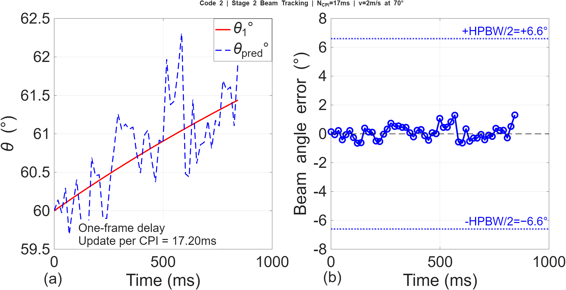
Fig.7. Beam tracking.

Fig. 8(a) shows the range error. In Fig. 8(b) the velocity error clustered tightly around zero with RMSE = 15.1 mm/s and bias = -1.6 mm/s. The ground-truth velocity reference v = 2.0 m/s is shown by the dashed line at the top of the panel, confirming that the estimator correctly recovers the true speed with negligible systematic offset. The 2-D position error together with the x- and y-components are shown in Fig.8c. The error oscillates between 0 and approximately 2.0 m with no sustained growth over the 860 ms track. The x- and y-errors track each other closely and are of similar magnitude throughout, indicating that the 2-D position uncertainty is approximately isotropic. The position error is dominated by the angular estimation noise. The Rx-array beamformer estimates the target bearing with a per-frame angular error that is projected to the target range of approximately 10 m, which produces an uncertainty in the lateral position. The episodic peaks reaching 1.5-2.0 m coincide with frames in which the Doppler derotation residual temporarily degrades the angle snapshot SNR, producing a larger beamformer error that frame. These transients recover within one to two CPI update periods, confirming that the α-filter suppresses the beam command from responding to individual noisy frames.

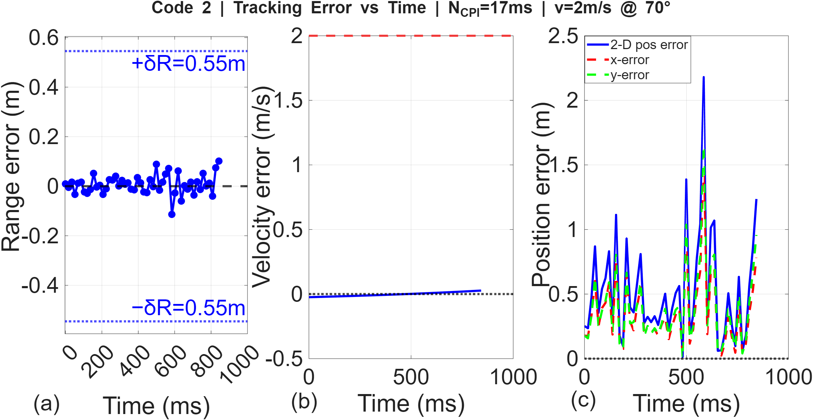
Fig.8. Range tracking.

Fig. 9(a) shows the normalised Rx array factor in (12) evaluated across the scan angle for Frame 1 (θ = -135.0°, blue), Frame 15 (θ = -136.5°, green), and Frame 50 (θ = -141.3°, purple). The beam peak shifts by 6.3° in total over the 50-frame track as the target traverses the bistatic scene, corresponding to an angular rate of 7.3 mdeg/ms and a per-CPI angular displacement of 0.13°. This is 0.97 % of the HPBW (13.2°), confirming that the target motion is slow relative to the beamwidth and that each CPI integration is not degraded by intra-CPI beam walk. The dashed vertical lines mark the peak angle for each frame. All three beams are well-formed with consistent sidelobe levels, confirming that the R-RIS phase map in (9) produces a coherent spatial beam at each update and that the 1.6° squint accumulated over 50 frames remains well within the operating range of the 16-element Rx aperture. The scatter of estimated target positions relative to the true target position at approximately (10, 8) m in the bistatic coordinate frame, with the RIS at the origin and the bistatic Rx (green circle) at approximately (15, 11) m is shown in Fig. 9(b). The cloud of estimated positions is compact and centred on the true position, confirming that the position estimator in (47) is unbiased over the track.
Fig.9(c) presents the CDFs of the range error, the angular error projected to metres at the target range, and the combined 2-D position error (blue) across all 50 frames. The range error CDF rises steeply, reaching the 50th percentile at approximately 50 mm and the 90th percentile at approximately 100 mm and is most accurate of the three errors. The angular error, projected to the target range of ≈12.8 m, has a 50th percentile of approximately 0.2 m (≈0.9°) and a 90th percentile of approximately 0.8 m (≈3.6°). The CDF flattens above 1.0 m, indicating occasional large-error frames where transient SNR degradation causes the beamformer peak to land at a sidelobe. The 2-D position error CDF closely follows the angular error CDF, with 50th and 90th percentiles of approximately 0.4 m and 1.0 m respectively. The small separation between the two CDFs reflects the modest range contribution: the range error (50th percentile 50 mm) is an order of magnitude smaller than the angular error contribution (50th percentile 200 mm), so the 2-D position accuracy is dominated by the angular estimation performance of the Rx array.
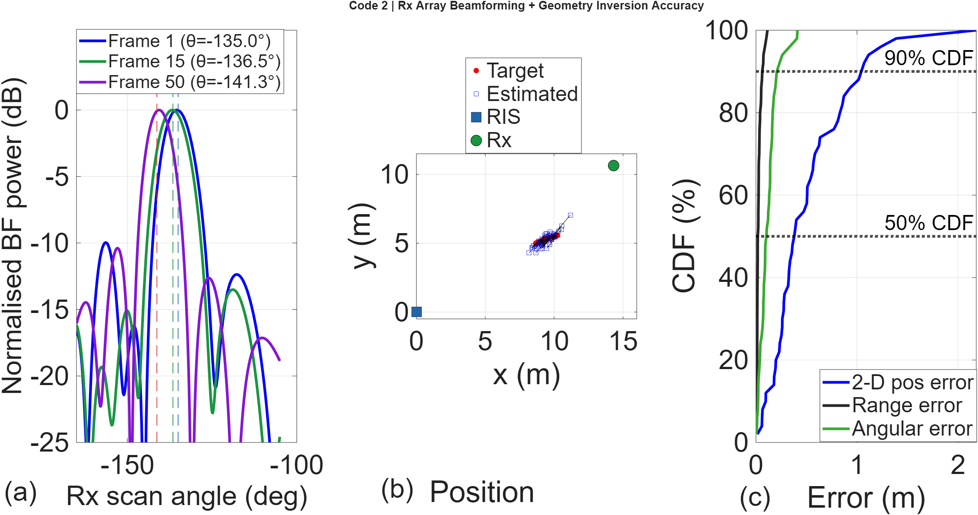
Fig.9. Rx beamforming with target tracking errors.

V. RIS-DESIGN PARAMETERS
A. Multi-Target Capability and System Power
A fundamental advantage of M-FSK over conventional single-tone FSK or frequency-modulated (FM)-CW radars is the ability to resolve K targets simultaneously in the range dimension without generating ghost targets. In FSK radar the range is determined by measuring the phase difference between the reflected signals of two different frequencies. If two or more targets appear in the same Doppler bin, their reflected signals combine vectorially. The resulting phase difference then represents a weighted average of the targets, leading to a single ghost target at an incorrect range rather than two distinct targets. For K real targets, an FMCW system produces up to K²−K spurious ghost detections arising from range-velocity coupling in the dechirped spectrum, requiring a second chirp slope for suppression [8]. The M-FSK range profile, by contrast, is formed by IFFT of the coherently averaged tone phasors from (34). By using more than two frequencies (M > 2), the radar can theoretically resolve up to M-1 targets within the same Doppler cell. The IFFT is linear producing exactly K peaks, one per target range bin, with no cross-products between targets.
MmWave PIN diodes such as AlGaAs or Silicon are characterized by their parasitic capacitances. The switching energy $E_{sw}$ required to charge the junction at a bias voltage $V$ is given by [7]:
$$E_{sw}=\frac{1}{2}C_{j}V^{2} \left(50\right)$$
Using a typical junction capacitance $C_{j}≈30$ fF and a switching voltage $V=0.8$ V, $E_{sw}=10$pJ [7]. The RIS power required for M-FSK modulation and beamforming is formed of the required biasing power $P_{bias}$, the dynamic power $P_{dyn}$ and the CW Tx power $P_{Tx}$given by:
$$P_{total}=P_{Tx}+P_{bias}\left(N_{ }+BN_{ }\right)+P_{dyn}\left(M\right) (51)$$
where $B$ is the number of bits for phase control and:
$$P_{dyn}\left(M\right)=N_{ }\left(MΔf\right)E_{sw} (52)$$
The DC power for an $N$-element active electronically scanned array (AESA) architecture is given by [22]:
$$P_{AESA}=NP_{channel}+P_{RF} (53)$$
where $P_{channel}≈15$ mW is the power per element chain and $P_{RF}≈0.87$W is the power consumed by the master local oscillator and main power amplifier [22]. For $N=256$, $P_{AESA}≈4.71$ W, which remains constant regardless of M. Fig. 10, shows that the RIS dynamic switching accounts for only 7% of the total budget at $M=16$, whereas static bias is 82%.
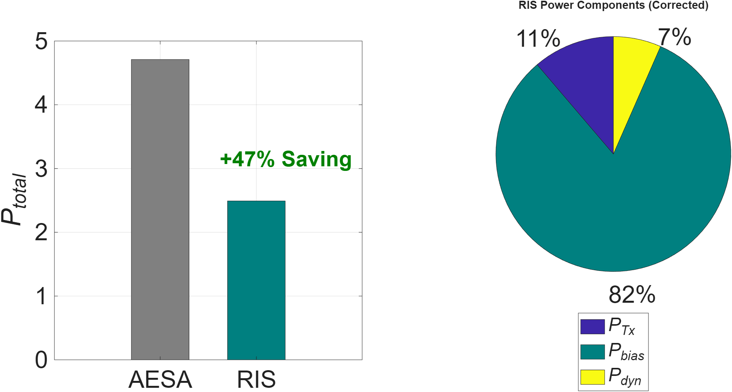
Fig.10. AESA and RIS power for M = 16.

Fig. 11 illustrates that the RIS power increases linearly with $M$ due to the increased modulation rate, the slope is minimal $≈10$ pJ. However RIS consumes significantly less power than the AESA architecture, maintaining an efficiency gain of approximately 45-50% indicating that the two-stage RIS architecture is a viable option for energy-constrained mmWave platforms as it eliminates the need for power-hungry amplifiers at every element.
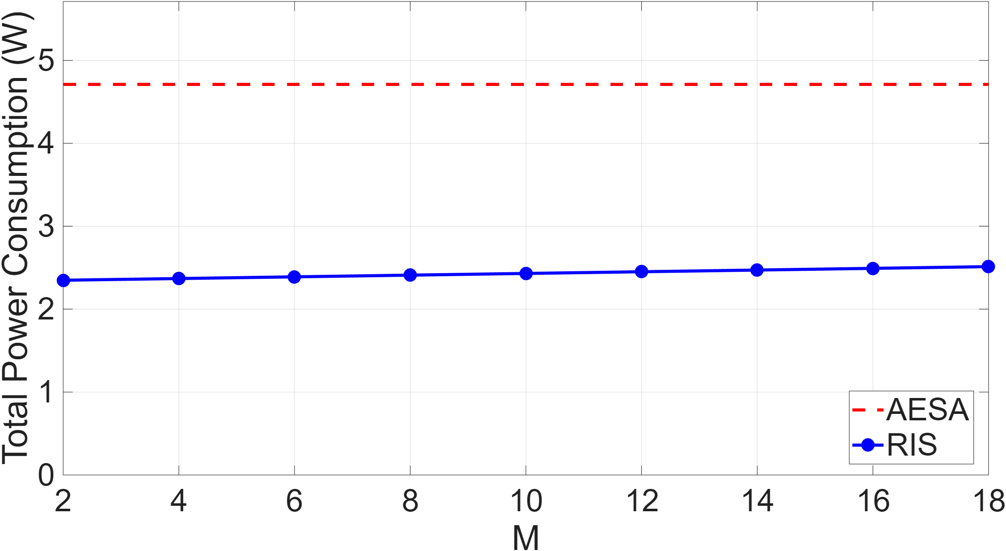
Fig.11. Rx beamforming with target tracking errors.

B. Inter-Stage Gap Sensitivity
The SNR received at the bistatic Rx is proportional to $C_{o}^{2}$ in (17), which from (11) scales the CRBs for position and angle estimation exponentially as observed in Fig. 12. We consider 2 mm as the nominal gap $d_{g,nom}$. Both curves are nearly flat for $d_{g}<d_{g,nom}$ reflecting the saturation of performance at high SNR, the curves rise steeply for $d_{g}>d_{g,nom}$. The rapid degradation establishes that gap control is the primary manufacturing sensitivity of the two-stage. At 28 GHz a gap error of even 1 mm beyond 2 mm represents a 9.3 % change in $d_{g}/λ$ producing a 10.2 dB SNR change.
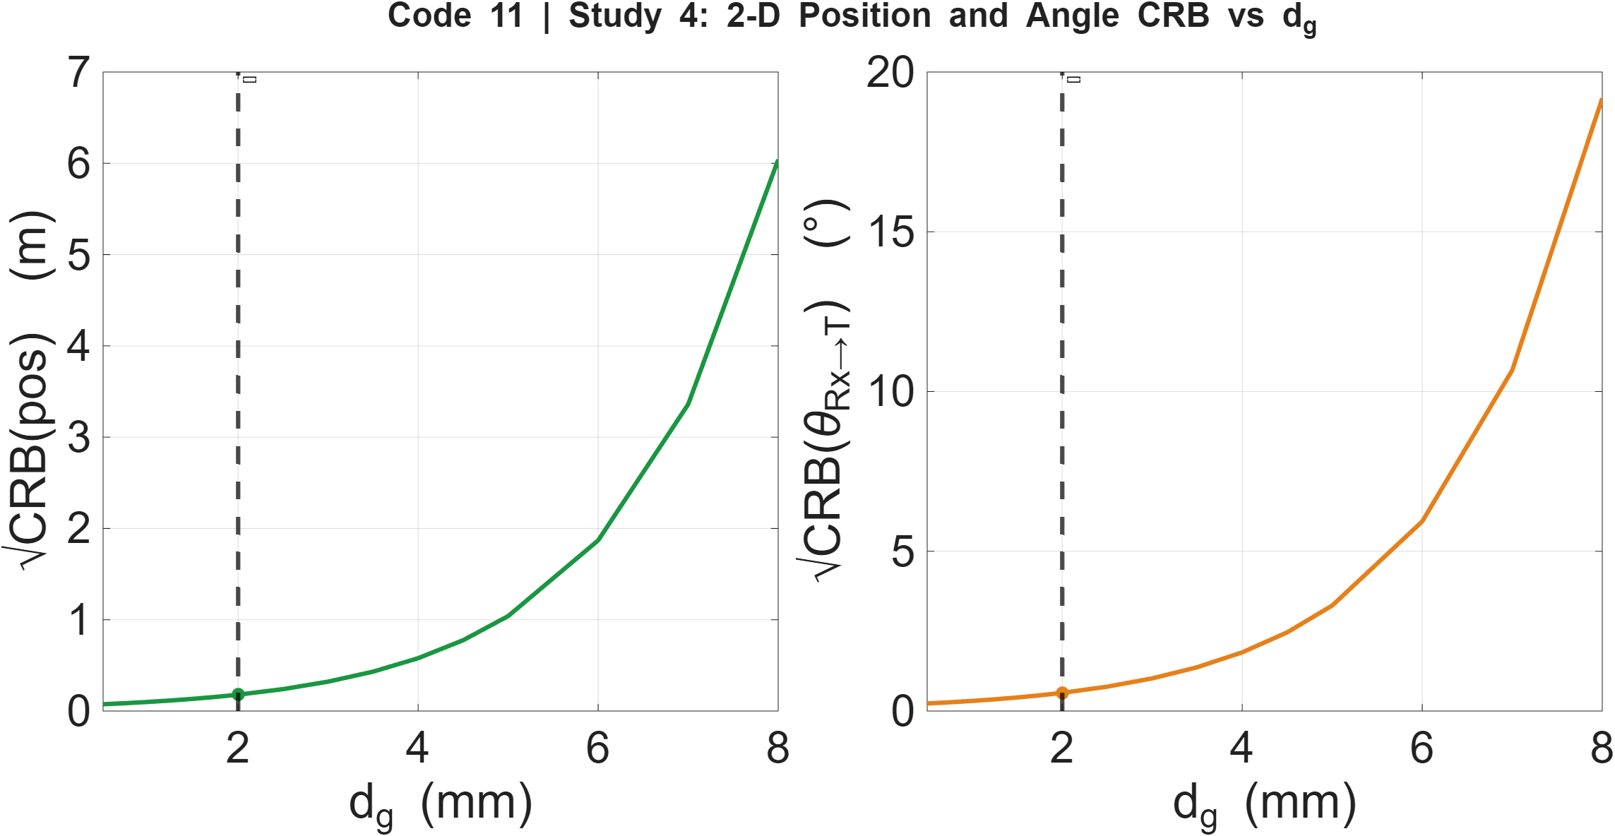
Fig.12. Increase in CRB with $d_{g}$.

Fig. 13 presents a Monte Carlo tolerance values obtained in which $d_{g}$is varied uniformly over the range $2±δd_{g}$ for $δd_{g}$ from 0 to 6 mm, and the resulting SNR degradation, normalised range RMSE, and normalised velocity RMSE are evaluated. In Fig. 13a the SNR drops by -3 dB at 0.29 mm above the gap of 2 mm. This corresponds to a gap-to-wavelength ratio of 0.214. At 28 GHz each millimetre represents 9.3 % of the free-space wavelength and the sub-millimetre gap errors produce significant evanescent-mode attenuation. In Figs. 13b and 13c the RMSE for both range and velocity remains at its nominal floor for gaps up to $d_{g}≈4$ mm (ΔSNR = -20.4 dB). This is because the IFFT interpolation floor (38.5 mm for range) and the Doppler FFT floor (15.1 mm/s for velocity) are insensitive to SNR reductions of up to ≈20 dB before the coherent integration gain falls below the estimator threshold; which is approximately 7× less demanding than the -3 dB drop limit. All three metrics converge on a practical tolerance budget of d_{g} ∈ [0, 4] mm.
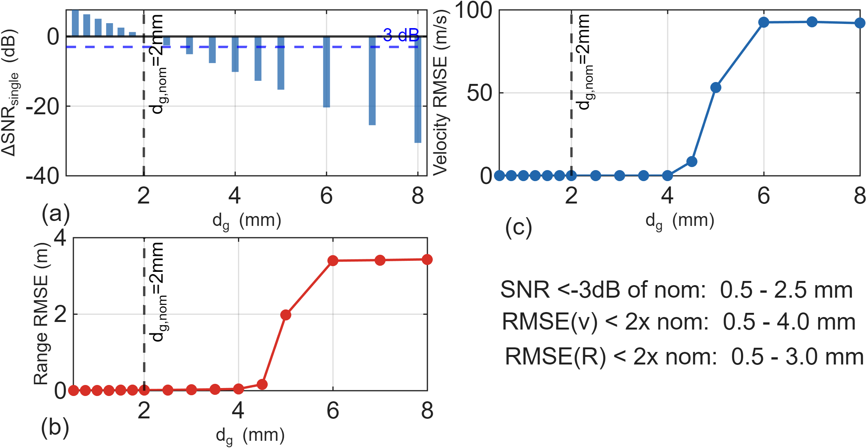
Fig.13. Increase in CRB with $d_{g}$.

VI. Conclusions
This paper has presented and evaluated a two-stage PIN-diode RIS architecture for M-FSK sensing at 28 GHz. The architecture decouples the waveform modulation and spatial beamforming across two stacked RIS layers. The T-RIS generates M stepped-frequency tones by periodically modulating element impedances producing sidebands. The R-RIS applies a spatially phase gradient that steers all M tones simultaneously requiring no per-symbol updates.
The near-field inter-stage coupling was characterised by the evanescent decay coefficient and the bistatic link budget established the coherent processing SNR = +15.6 dB at the 2 mm nominal inter-stage gap. The beam squint across the 300 MHz bandwidth is 1.04°, less than 10 % of the HPBW, confirming that all 12 tones illuminate the target within the 3 dB beamwidth.
Range, velocity, and 2-D position estimators were derived with their Cramér-Rao bounds. Monte Carlo simulation confirmed that the IFFT range estimator achieves RMSE = 38.5 mm at the operating point (limited by the IFFT interpolation floor, 4.1× the CRB), the Doppler FFT velocity estimator achieves RMSE = 15.1 mm/s (2.6× CRB, essentially unbiased at -1.6 mm/s), and the 2-D position error is dominated by angular estimation with 50th and 90th percentile values of 0.40 m and 1.0 m. The closed-loop beam tracking system maintained R-RIS pointing error within ±HPBW/2 = ±6.6° throughout a 50-frame (860 ms) tracking scenario for a 2 m/s target. The one-frame predict-correct delay introduces a per-frame angle lag of 0.03° (0.45 % of HPBW). Range RMSE over the track was 38.5 mm with zero mean drift, and velocity RMSE was 15.1 mm/s, confirming stable closed-loop operation.
The system power analysis showed the two-stage RIS at 2.33 W is approximately 50 % more power-efficient than an equivalent 256-element AESA (4.71 W), with the dominant consumption being the R-RIS static PIN-diode bias (1536 mW) rather than the dynamic switching power (3.7 mW). The inter-stage gap sensitivity study identified a practical manufacturing tolerance of $d_{g}$ ∈ [0, 4] mm (±2 mm around the 2 mm nominal), within which both range and velocity RMSE remain at their nominal floors. This is 7× wider than the -3 dB SNR criterion alone would suggest, and is achievable with standard mmWave PCB assembly. Beyond 4 mm, the SNR threshold is crossed and estimator performance collapses.
Future work will extend the architecture to experimental hardware validation of the near-field coupling model, multi-target scenarios simultaneous targets, and wider-aperture Rx arrays to improve 2-D angular resolution beyond the current 50th/90th percentile position errors of 0.40/1.0 m.

REFERENCES
- Q. Wu and R. Zhang, “Towards smart and reconfigurable environment: intelligent reflecting surface aided wireless network,” IEEE Commun. Mag., vol. 58, no. 1, pp. 106–112, Jan. 2020.
- E. Basar et al., “Wireless communications through reconfigurable intelligent surfaces,” IEEE Access, vol. 7, pp. 116753–116773, 2019.
- S. Hu, F. Rusek, and O. Edfors, “Beyond massive MIMO: the potential of positioning with large intelligent surfaces,” IEEE Signal Process. Lett., vol. 25, no. 12, pp. 1884–1888, Dec. 2018.
- T. L. Marzetta, “Massive MIMO: an introduction,” Bell Labs Tech. J., vol. 20, pp. 11–22, 2015.
- C. Liaskos et al., “A new wireless communication paradigm through software-controlled metasurfaces,” IEEE Commun. Mag., vol. 56, no. 9, pp. 162–169, Sep. 2018.
- M. Di Renzo et al., “Smart radio environments empowered by reconfigurable intelligent surfaces: how it works, state of research, and the road ahead,” IEEE J. Sel. Areas Commun., vol. 38, no. 11, pp. 2450–2525, Nov. 2020.
- L. Zhang et al., "Space-time-coding digital coding metasurfaces,” Nature Electron., vol. 4, pp. 75–84, 2021.
- H. Rohling and M. Meinecke, “Waveform design principles for automotive radar systems,” in Proc. CIE Int. Conf. Radar, 2001, pp. 1-4.
- B. Szlachetko, J. Magiera and P. Tyczka, “Comparison of doppler effect estimation methods for MFSK systems under strong multipath conditions,” IEEE Access, vol. 12, pp. 52345–52358, 2024, doi:10.1109/ACCESS.2024.3385750.
- L. Dai et al., “Reconfigurable intelligent surface-based wireless communications: antenna design, prototyping, and experimental results,” IEEE Access, vol. 8, pp. 45913–45923, 2020.
- J. Y. Dai et al., “Simultaneous in situ reconfiguration of nonlinear harmonics and propagation modes using reprogrammable compiling metamaterial,” Adv. Mater., vol. 33, no. 6, p. 2006319, 2021.
- D. Shen et al., “Sub-terahertz transmissive reconfigurable intelligent surface for integrated beam steering and self-OOK-modulation," Light: Sci. Appl., vol. 14, no. 13, Jan. 2025.

- D. M. Pozar, Microwave Engineering, 4th ed. Hoboken, NJ: Wiley, 2011.
- S. A. Maas, Microwave Mixers, 2nd ed. Norwood, MA: Artech House, 1993, ch. 2.

- R. H. Caverly and G. Hiller, “The frequency-dependent impedance of p-i-n diodes,” IEEE Trans. Microw. Theory Tech., vol. 37, no. 4, pp. 787–790, Apr. 1989.

- M. An, C. Xu, Y. Liu, and Y.-C. Liang, "Stacked intelligent metasurfaces for efficient holographic MIMO communications in 6G," IEEE J. Sel. Areas Commun., vol. 41, no. 8, pp. 2380–2396, Aug. 2023.

- R. J. Mailloux, Phased Array Antenna Handbook, 3rd ed., Artech House, 2017.

- D. R. Wehner, High-Resolution Radar, 2nd ed., Artech House, 1994.

- N. J. Willis, Bistatic Radar, 2nd ed., SciTech Publishing, 2005, ch.3.

- S. M. Kay, Fundamentals of Statistical Signal Processing, Vol. I: Estimation Theory. Englewood Cliffs, NJ: Prentice Hall, 1993.
- Y. Bar-Shalom, X. R. Li, and T. Kirubarajan, Estimation with Applications to Tracking and Navigation. New York: Wiley, 2001, ch. 6.
- B. Sadhu et al., “A 28-GHz 32-element TRX phased-array IC with concurrent dual-polarized operation and orthogonal phase and gain control for 5G communications,” in IEEE J. Solid-State Circuits, vol. 52, no. 12, pp. 3373-3391, Dec. 2017, doi: 10.1109/JSSC.2017.2731802.

