BCSE498J Project-II Capstone Project

Plant Leaf Disease Detection Using Hybrid Deep Learning Framework

22BCE2348 A. Venkata Sreeram Chandra Vardhan
22BCE2694 M. Yaswanth Sri Sai Venkat
22BCE3821 M. Sai Ranga Rama Pavan Kumar Raju

Under the Supervision of

Dr. DIVIYA M
Assistant Professor Senior Grade I
Department of Analytics

School of Computer Science and Engineering (Scope)

B.Tech.
in
Computer Science and Engineering (Core)

School of Computer Science and Engineering



2th February, 2026

ABSTRACT

Detection of plant leaf diseases is crucial for minimizing crop losses and ensuring global food security. While deep learning-based approaches have significantly improved automated plant disease identification, many existing models suffer from limited multi-scale feature representation, insufficient modeling of global contextual dependencies, and poor utilization of inter-class relationships among disease categories. To address these challenges, this project presents a novel and robust deep learning framework for accurate and efficient plant leaf disease detection by integrating multiscale convolutional, transformer-based, and graph-based learning paradigms.
A hybrid EfficientNetV2-S and MobileViTv2 architecture with Adaptive Token-Query Fusion is employed, combining the strong local feature learning capability of convolutional neural networks with the global contextual modeling strength of lightweight vision transformers. This fusion mechanism dynamically aligns spatial features with semantic tokens, improving discrimination between visually similar disease classes.
The proposed framework introduces a Multiscale Feature Pyramid Network (FPN) with Dynamic Scale Weighting to effectively capture disease characteristics across varying spatial resolutions, enabling enhanced detection of both fine-grained and coarse visual patterns in leaf images.
Furthermore, a Graph Neural Network (GNN) is incorporated to model relational dependencies between disease categories and feature embeddings, enabling structured reasoning and improving classification robustness by leveraging inter-class and intra-class relationships. The system is trained and evaluated on datasets consisting of Apple, Grape and so on using a comprehensive pipeline involving image preprocessing, extensive data augmentation, and transfer learning.
Experimental evaluation using standard performance metrics such as accuracy, precision, recall, confusion Matrix and specificity demonstrates that the proposed framework significantly outperforms previous hybrid CNN-based approaches, including the AlexNet–ShuffleNet and EfficientNetB0–MobileNetV2 models. The resulting system offers a scalable, accurate, and computationally efficient AI-powered solution providing valuable decision support for farmers and agricultural experts in plant disease diagnosis.

Sl. No. | Contents | Page No.
1. | ABSTRACT | 2
2. | INTRODUCTION
 | 2.1 Background | 4
 | 2.2 Motivations | 5
 | 2.3 Scope of the Project | 5
3. | PROJECT DESCRIPTION AND GOALS
 | 3.1 Literature Review | 6
 | 3.2 Research Gap | 8
 | 3.3 Objective | 11
 | 3.4 Problem Statement | 12
 | 3.5 Project Plan | 13
4. | REQUIREMENT ANALYSIS
 | 4.1 Hardware and Software Specification Workflow Model | 15
 | 4.2 Functional and Non-Functional | 16
5. | SYSTEM DESIGN
 | 5.1 Gantt Chart | 18
 | 5.2 Work Breakdown Structure (WBS) | 19
 | 5.3 WorkFlow Model | 22
 | 5.3 Module Design | 23
6. | Results | 23
7. | References | 26
TABLE OF CONTENTS

2.1 Background
Plant diseases significantly threaten global agricultural productivity and food security, resulting in major economic losses and reduced crop quality. Traditional disease detection methods depend on manual visual inspection by experts, which is time-consuming, labor-intensive, and prone to human error. These limitations are especially critical in large-scale farming and remote areas, get accurate diagnosis is difficult to achieve, often leading to delayed treatment and increased crop damage.
With the advancement of digital imaging and artificial intelligence (AI), deep learning (DL) has emerged as a powerful tool for automating plant disease detection. Convolutional Neural Networks (CNNs) have shown strong performance in classifying plant leaf images by learning discriminative spatial features. However, conventional CNN-based models often struggle to capture multi-scale disease patterns, long-range contextual information, and subtle visual differences among similar disease classes, limiting their robustness and generalization performance.
To address these challenges, this project proposes an advanced AI-based plant leaf disease detection framework that integrates multiscale, transformer-based, and graph-based learning. A Multiscale Feature Pyramid Network with Dynamic Scale Weighting is used to capture disease features at varying spatial resolutions, while a hybrid EfficientNetV2-S and MobileViTv2 model with Adaptive Token-Query Fusion combines local feature extraction with global contextual understanding. Additionally, a Graph Neural Network (GNN) models relational dependencies among disease classes, improving classification accuracy and reliability. The system is designed for datasets covering multiple crops, supporting disease diagnosis and sustainable farming practices.

2.2 Motivation
Plant diseases pose a serious threat to crop yield and global food security, accurate, and scalable disease detection essential. Traditional manual inspection methods are subjective, inconsistent, and labor-intensive, limiting their applicability for large-scale agricultural monitoring. Although recent deep learning-based hybrid models such as AlexNet–ShuffleNet achieved promising accuracy (~94%), they remain limited in handling multi-scale disease patterns, global contextual information, and inter-class relationships. Additionally, many existing models face challenges related to generalization and robustness when applied to complex datasets.
Motivated by these limitations, this project aims to design an advanced and intelligent plant leaf disease detection framework that combines multiscale feature learning, transformer-based global representation, and relational reasoning. The integration of a Multiscale Feature Pyramid Network (FPN) with Dynamic Scale Weighting enables effective learning of disease features at different spatial resolutions. A hybrid EfficientNetV2-S and MobileViTv2 architecture with Adaptive Token-Query Fusion is employed to balance high feature representation capability with computational efficiency, while a Graph Neural Network (GNN) is used to model relationships among disease classes. This unified framework is motivated by the need for a robust, accurate, and scalable solution suitable for environments and future intelligent farming systems for getting better results of accuracy.

2.3 Scope of Project
This project focuses on the development of an advanced deep learning-based plant leaf disease detection system using a hybrid architecture that integrates EfficientNetV2-S, MobileViTv2, Multiscale Feature Pyramid Network (FPN), and Graph Neural Networks (GNNs). The scope includes designing and implementing a multiscale feature extraction pipeline with dynamic scale weighting to capture both fine-grained and coarse disease patterns, followed by adaptive fusion of convolutional and transformer-based representations for improved classification performance.
The proposed system is evaluated on apple,grape,corn and soon datasets used in the base study, including the Apple dataset (4 classes), Grape leaf disease datasets and so on. The project involves comprehensive image preprocessing and data augmentation techniques such as rotation, shearing, zooming, flipping, and brightness adjustment to enhance model generalization. Performance evaluation is conducted using standard metrics including accuracy, sensitivity, specificity, and precision, with direct comparison against earlier hybrid CNN-based models.

3.1 Literature Review
Sno | Title | Authors | Year of Publication | Methodology/  Algorithm Used | Advantages | Disadvantages | Limitations
1 | Plant Leaf Disease Detection Using Hybrid AlexNet and ShuffieNet | Dinesh G, Janakiranan S Vinoth Kumar V | 2025, Springer | Hybrid model combining AlexNet and ror plant leaf image classification | High detection accuracy (-95%) using real-wort data dataset | Struggling with minor class differences Performance drops with noise images | Bounded model accuracy (-95%)
2 | Multi-class classification of plant leaf diseases using CNN + LBP | Hosny Khalid M. et al. | 2023 | Deep CNN + handcrafted LBP features on grape, tomato, and apple datasets | Extracts high-level hidden features and local texture information; good accuracy on multiple datasets | Handcrafted features increase complexity | Does not generalize well to other crops
3 | MaizeNet: Recognition of maize leaf diseases | Masood Momina et al. | 2023 | Faster-RCNN + ResNet-50 + attention | Robust under complex conditions; precise localization | Heavy architecture, higher resources | Limited to maize dataset
4 | PlantDet: Robust ensemble for plant disease detection | Shovon Md. Sakib Hossain et al. | 2023 | Ensemble (InceptionResNetV2, Xception, EfficientNetV2L) + Grad-CAM | Tackles overfitting/underfitting; high performance | High computation & training time | Less practical for real-time/low-resource settings
5 | Cardamom & grape plant disease detection | Sunil C. K. et al. | 2021 | U2-Net for background removal + EfficientNetV2 | Effective with noisy backgrounds; strong accuracy | Needs preprocessing (segmentation) step | Limited evaluation on only cardamom & grapes
6 | Real-time  apple leaf  disease  detection | Jiang Peng et al. | 2019 | INAR-SSD (GoogLeNet Inception + Rainbow concatenation) | Works on large dataset; real-time detection | Complex architecture | Did not include sensitivity/specificity in evaluation
7 | SE-VRNet  for mobile  -friendly  leaf  detection | Xiao Zhiyong et al. | 2023 | SE module + Variant Residual Network with attention | Lightweight; works on mobile devices; better lesion segmentation | Limited robustness for highly varied conditions | Not validated on very diverse datasets
8 | Corn leaf disease classification with feature fusion | Amin Hassan et al. | 2022 | DenseNet121 +  EfficientNetB0  (feature concate  nation) | Reduces computation; better accuracy than ResNet152/InceptionV3 | Fusion increases some complexity | Dataset-specific; feature fusion methods not fully explored
9 | Graph-Based Deep Learning for Plant Disease Classification | Wang et al. | 2022 | CNN + Graph Modeling | Graph modeling improved disease localization | It required complex graph construction. | Does not generalize well to other crops
10 | Multi _Scale Attention Network for Visual Recognition | Wang et al. | 2022 | Spatial and channel attention across multi-scale features | Improved discriminative capability | Complex architecture | Requires careful hyperparameter tuning

3.2 Research Gap
1. Dataset Bias
Observation:
A large portion of existing plant leaf disease detection research relies on laboratory-condition datasets, such as images captured with plain backgrounds and controlled lighting. These datasets fail to represent the visual complexity seen in natural agricultural environments, including background clutter, uneven illumination, and overlapping leaves.
Metric Gap:
- Limited variation in background and lighting conditions
- Insufficient representation of disease severity levels
AnalyticalInsight:
Models trained on simplified datasets often report high accuracy but struggle when exposed to visually diverse inputs. This indicates that current research does not adequately study robustness under varied conditions.
ResearchGap:
There is a lack of deep learning models evaluated on diverse and visually complex datasets, highlighting the need for architectures that can learn robust and discriminative features.

2. Limited Crop and Disease Coverage
Observation:
Most studies focus on a small number of widely cultivated crops and their common diseases, while many crops and disease categories remain insufficiently explored.
Metric Gap:
- Research coverage limited to a narrow set of plant species
- Imbalanced representation of disease classes
AnalyticalInsight:
Such limited scope reduces the ability of existing models to generalize across different crops and disease types.
ResearchGap:
Current research lacks systematic evaluation of plant disease detection models across multiple crops and diverse disease classes.

3. Inadequate Feature Representation in Existing Models
Observation:
Many existing approaches rely on conventional CNN-based architectures that primarily focus on local spatial features.
Metric Gap:
- Weak modeling of fine-grained and global visual patterns
- Limited use of attention mechanisms or hybrid architectures
AnalyticalInsight:
Plant disease symptoms can appear as small localized spots or large texture changes across the leaf. Single-scale feature extraction is often insufficient to capture such variability.
ResearchGap:
There is insufficient exploration of hybrid architectures that combine local feature extraction with global contextual modeling for plant disease detection.

4. Poor Generalization Across Visual Variations
Observation:
Existing models often demonstrate strong performance on training datasets but show reduced accuracy when evaluated on images with variations in leaf orientation, color intensity, and disease progression stages.
Metric Gap:
- Noticeable performance degradation under unseen visual conditions
AnalyticalInsight:
This indicates that many models learn dataset-specific patterns rather than disease-relevant features.
ResearchGap:
Current research does not adequately address the generalization capability of plant disease detection models across diverse visual conditions.
5. Limited Interpretability of Deep Learning Models
Observation:
Most deep learning-based plant disease detection systems operate as black boxes, providing predictions without insight into the features influencing the decision.
AnalyticalInsight:
Lack of interpretability makes it difficult to analyze model behavior and validate predictions, especially in critical agricultural scenarios.
ResearchGap:
There is limited focus on understanding and analyzing the decision-making behavior of deep learning models used for plant disease classification.

3.3 Objective
1. To design and implement an advanced hybrid deep learning architecture for plant leaf disease detection by integrating a hybrid EfficientNetV2-S and MobileViTv2 model with Adaptive Token-Query Fusion , Multiscale Feature Pyramid Network (FPN) with Dynamic Scale Weighting and a Graph Neural Network (GNN) to improve feature representation, contextual understanding, and relational reasoning among disease classes.
2. To leverage transfer learning by utilizing ImageNet pre-trained weights for EfficientNetV2-S and MobileViTv2, and to fine-tune the proposed model on crop plant leaf datasets including apple, grape, and other selected crops, ensuring improved generalization and fair comparison with earlier CNN-based approaches.
3. To develop a comprehensive image preprocessing and data augmentation pipeline involving resizing, normalization, rotation, shearing, zooming, flipping, brightness adjustment, and noise reduction techniques to enhance robustness against variations in lighting, background complexity, and disease appearance under field conditions.
4. To rigorously evaluate the performance of the proposed framework using standard metrics such as accuracy, precision, recall, specificity, and confusion Matrix and to conduct a comparative analysis against baseline and existing hybrid models to demonstrate improvements in detection accuracy, robustness, and generalization.
5. To analyze computational efficiency and practical applicability of the proposed model by assessing model complexity and inference performance, and to demonstrate its suitability for agricultural decision support systems through a prototype interface for plant leaf disease detection.

3.4 Problem Statement
1. Plant disease detection remains a critical challenge in agriculture, where traditional manual inspection methods are inadequate for large-scale monitoring due to subjectivity, labour intensity, and limited expert availability. Although deep learning-based approaches have demonstrated strong potential for automated plant disease detection.
2. Earlier hybrid convolutional models, such as the AlexNet–ShuffleNet framework, achieved promising classification accuracy; however, they primarily rely on single-scale feature extraction and local spatial learning. These limitations reduce their effectiveness in capturing complex disease patterns, global contextual information, and subtle visual differences among similar disease classes under any field conditions.
3. The core problem lies in the absence of a unified framework that simultaneously addresses multi-scale feature representation, global contextual understanding, relational reasoning between disease classes, and computational efficiency. Existing architectures struggle to generalize across diverse crops and environmental conditions while maintaining practical feasibility for large-scale agricultural applications.
4. To address these challenges, this project proposes an advanced plant leaf disease detection framework integrating a hybrid EfficientNetV2-S and MobileViTv2 architecture with Adaptive Token-Query Fusion, Multiscale Feature Pyramid Network with Dynamic Scale Weighting, a and a Graph Neural Network (GNN). The proposed solution aims to enhance detection accuracy, robustness, and generalization across multiple crops including apple, grape, and other selected plant species while supporting practical and scalable agricultural decision-making.

3.5 Project Plan
Phase 1: Literature Review and Dataset Preparation
1.1 Comprehensive review of existing plant leaf disease detection techniques, including CNN-based, hybrid CNN–Transformer, and graph-based learning approaches
1.2 Collection and organization of plant leaf disease datasets covering multiple crops such as apple,grape, and other selected crops
1.3 Image preprocessing including resizing, normalization, noise reduction, and background consistency enhancement
1.4 Development and application of data augmentation techniques such as rotation, shearing, zooming, flipping, and brightness adjustment to improve dataset diversity and generalization

Phase 2: Architecture Design and Implementation
2.1 Design of a Multiscale Feature Pyramid Network (FPN) with Dynamic Scale Weighting for effective multi-resolution feature extraction.
2.2 Implementation of a hybrid EfficientNetV2-S and MobileViTv2 architecture with Adaptive Token-Query Fusion to combine convolutional and transformer-based representations.
2.3 Integration of a Graph Neural Network (GNN) to model relational dependencies among disease classes and feature embeddings.
2.4 Configuration of transfer learning using ImageNet pre-trained weights and development of the end-to-end training pipeline.

Phase 3: Model Training and Optimization
3.1 Training of the proposed hybrid framework on the prepared multi-crop datasets.
3.2 Hyperparameter tuning including learning rate scheduling, batch size optimization, and regularization-techniques.
3.3 Implementation of cross-validation strategies to ensure robustness and reduce overfitting.
3.4 Continuous performance monitoring, error analysis, and iterative model refinement.

Phase 4: Evaluation and Comparative Analysis
4.1 Comprehensive evaluation using standard performance metrics including accuracy, precision, recall, specificity and confusion matrix.
4.2 Comparative analysis with baseline and existing hybrid CNN-based models to demonstrate performance-improvements.
4.3 Computational complexity analysis including model size, inference time, and efficiency assessment.
4.4 Statistical validation of performance gains through appropriate significance testing.

Phase 5: Application Development and Documentation
5.1 Documentation of system architecture, experimental methodology, results, and comparative-evaluation.
5.2 Preparation of the final project report, presentation, and supporting materials.

4 Hardware and Software Specification
4.1 Hardware Specification
Component | Minimum Requirement | Recommended Requirement
Processor (CPU) | Quad-core 2.5 GHz (Intel i5 / AMD) | Octa-core 3.0 GHz or higher (Intel i7/i9 / Ryzen 7/9)
RAM | 8 GB | 16 GB or higher
Storage | 20 GB free disk space (SSD preferred) | 100 GB SSD
GPU | Optional for small-scale AI inference | NVIDIA CUDA-enabled GPU (e.g., RTX 3060/3080 or A100)
Network | Stable Internet (10 Mbps) | High-speed Internet (>100 Mbps)

4.1 Software Specification
Component | Original Specification | Modified / Final Specification
Programming Language | Python 3.8+ | Python 3.8 or higher
Deep Learning Framework | TensorFlow 2.x / Keras | TensorFlow 2.x with Keras API
Libraries | NumPy, Pandas, Matplotlib, Seaborn, Scikit-learn, OpenCV | NumPy, Pandas, Matplotlib, Seaborn, Scikit-learn, OpenCV, TensorFlow Addons
Development Environment | Jupyter Notebook, Google Colab, or VS Code | Jupyter Notebook, Google Colab, or Visual Studio Code (VS Code)
Model Architectures | EfficientNetB0, MobileNetV2 (ImageNet pre-trained) | EfficientNetV2-S, MobileViTv2 (ImageNet pre-trained), Multiscale Feature Pyramid Network (FPN), Graph Neural Network (GNN)
Data Handling | TensorFlow Data API for efficient loading and augmentation | TensorFlow Data (tf.data) API for efficient data loading, preprocessing, and augmentation
Version Control | Git / GitHub | Git and GitHub for source code and experiment tracking
Documentation Tools | MS Word / Google Docs, PowerPoint / Google Slides | MS Word or Google Docs, PowerPoint or Google Slides

4.2 Functional Requirements
1.Image Input:
The system shall allow users to upload plant leaf images obtained from benchmark datasets captured images for analysis.

2.Data Preprocessing and Augmentation:
The system shall preprocess input images by resizing, normalization, and noise reduction, and apply data augmentation techniques such as rotation, zooming, flipping, shearing, and brightness adjustment to improve robustness.

3.Multiscale Feature Extraction:
The system shall employ a Multiscale Feature Pyramid Network (FPN) with Dynamic Scale Weighting to extract disease features at different spatial resolutions.

4.Disease Detection and Classification:
The system shall classify plant leaf images into healthy or diseased categories and further identify the specific disease type across multiple crops such as apple, grape, and other selected plant species.

5.ModelTraining and Testing:
The system shall train and validate the proposed EfficientNetV2-S and MobileViTv2 hybrid model with Adaptive Token-Query Fusion, utilizing transfer learning from ImageNet pre-trained weights.

6.Relational Reasoning:
The system shall incorporate a Graph Neural Network (GNN) to model relationships between disease classes and improve classification consistency.

7.Performance Evaluation:
The system shall compute standard evaluation metrics including accuracy, precision, recall, sensitivity, specificity.

8.ResultVisualization:
The system shall display predicted disease labels along with confidence scores and provide visualizations of training and validation accuracy and loss curves.
9.ComparativeAnalysis:
The system shall compare the performance of the proposed framework with baseline and existing hybrid models to demonstrate improvements in accuracy and robustness.

Non-Functional Requirements
1.Performance:
The system should provide disease classification results within an acceptable response time suitable for practical agricultural usage.

2.Accuracy:
The system should achieve reliable and consistent classification performance, targeting high accuracy across multiple crops and disease categories.

3.Scalability:
The system should support expansion to additional plant species and disease classes without requiring complete architectural redesign.

4.Usability:
The system interface should be user-friendly and accessible to non-technical users, including farmers and agricultural practitioners.

5.Portability:
The system should be deployable across multiple platforms such as desktop, web, or cloud-based environments.

6.Reliability:
The system should maintain stable performance under varying conditions such as changes in lighting, leaf orientation, and background complexity.

7.Security:
Uploaded images and prediction results should be securely handled, ensuring data privacy and protection.

8.Efficiency:
The system should balance classification accuracy with computational efficiency by leveraging lightweight hybrid architectures and optimized feature extraction techniques.

5 System Design

5.1 GANTT CHART
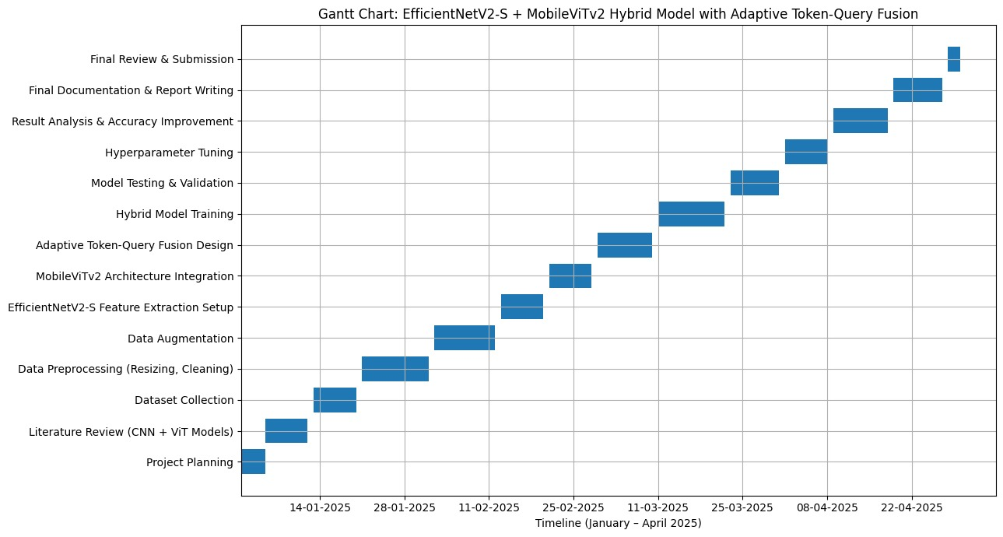

5.2 Work Breakdown Structure (WBS)

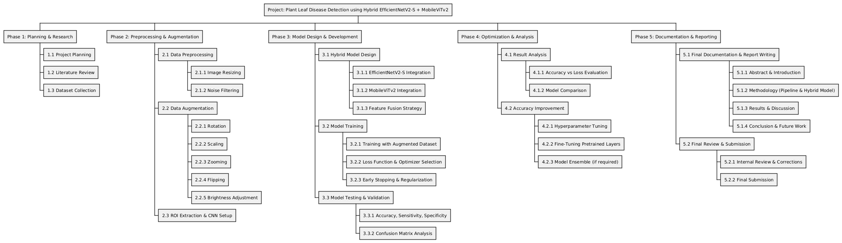

1. Project Initiation & Planning
1.1 Problem Identification
1.2 Requirement Analysis
1.3 Project Planning and Scheduling
1.4 Tool and Resource Identification
2. Research & Dataset Preparation
2.1 Literature Review
2.1.1 Review of CNN-based Disease Detection Models
2.1.2 Review of Hybrid CNN–Transformer Models
2.1.3 Review of Graph Neural Network Applications
2.2 Dataset Collection
2.2.1 Apple Leaf Disease Dataset
2.2.2 Grape Leaf Disease Dataset
2.2.3 Other Selected Crop Datasets
2.2.4 Dataset Inspection and Class Distribution Analysis
3. Data Preprocessing & Augmentation
3.1 Data Preprocessing
3.1.1 Image Resizing and Normalization
3.1.2 Noise Reduction using Median Filtering
3.2 Data Augmentation
3.2.1 Rotation
3.2.2 Shearing
3.2.3 Zooming
3.2.4 Flipping
3.2.5 Brightness Adjustment
3.3 ROI Extraction and Feature Preparation
4. Model Design & Development
4.1 Multiscale Feature Learning
4.1.1 Feature Pyramid Network (FPN) Design
4.1.2 Dynamic Scale Weighting Implementation
4.2 Hybrid Feature Extraction Model
4.2.1 EfficientNetV2-S Integration
4.2.2 MobileViTv2 Integration
4.2.3 Adaptive Token–Query Feature Fusion
4.3 Relational Learning
4.3.1 Graph Construction for Disease Relationships
4.3.2 Graph Neural Network (GNN) Integration

5. Model Training & Validation
5.1 Transfer Learning Configuration
5.2 Training with Augmented Dataset
5.3 Loss Function and Optimizer Selection
5.4 Regularization and Early Stopping
5.5 Model Testing and Validation
6. Performance Evaluation & Analysis
6.1 Evaluation Metrics Computation
6.1.1 Accuracy
6.1.2 Precision
6.1.3 Recall
6.1.4 Sensitivity and Specificity
6.2 Confusion Matrix and Error Analysis
6.3 Comparative Analysis with Baseline Models
6.4 Computational Complexity and Inference Time Analysis
7. Optimization & Performance Improvement
7.1 Hyperparameter Tuning
7.2 Fine-Tuning Pre-trained Layers
7.3 Performance Refinement and Model Improvement
8. Application Development
8.1 Prototype Interface Design
8.2 Image Upload and Prediction Module
8.3 Result Visualization with Confidence Scores
9. Documentation & Reporting
9.1 Report Writing
9.1.1 Abstract and Introduction
9.1.2 Literature Review
9.1.3 Methodology and Architecture
9.1.4 Results and Discussion
9.1.5 Conclusion and Future Work
9.2 Presentation Preparation
10. Final Review & Submission
10.1 Internal Review with Guide / Panel
10.2 Corrections and Refinements
10.3 Final Project Submission

5.3 WORKFLOW MODEL

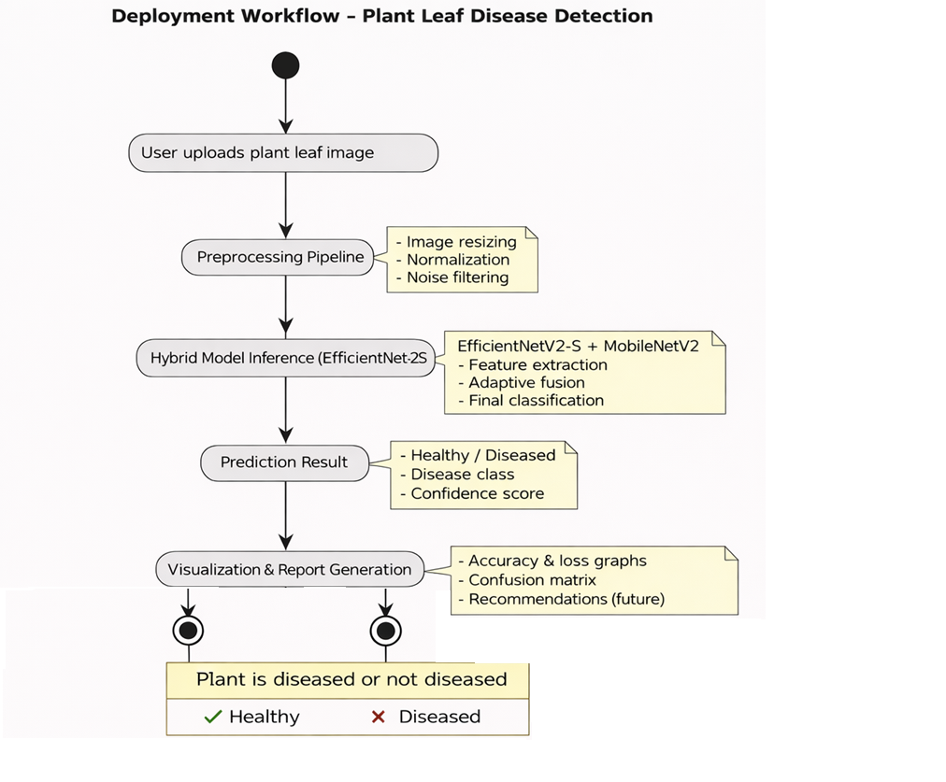

5.4 Module Design

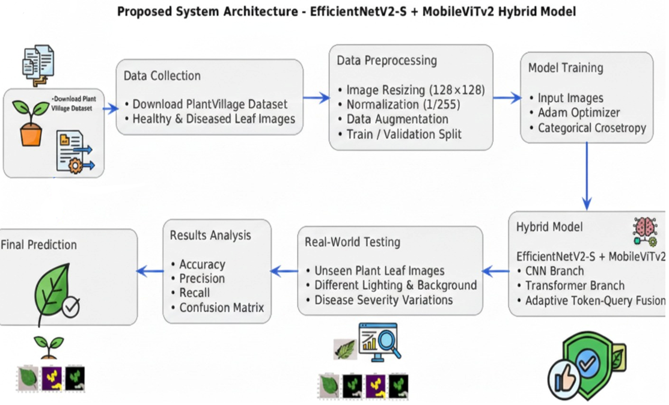

6 Results:
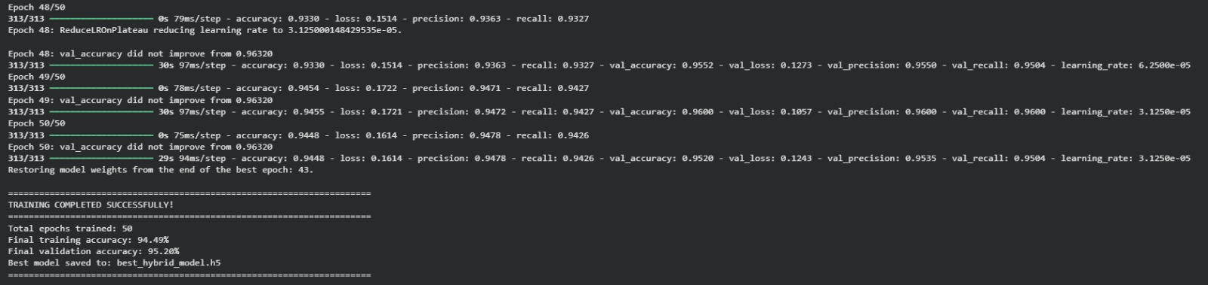

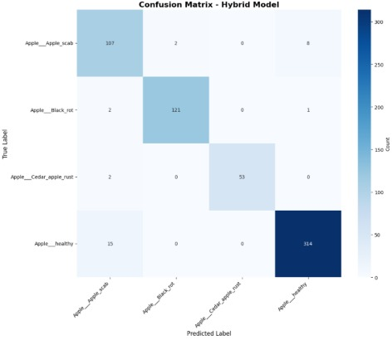
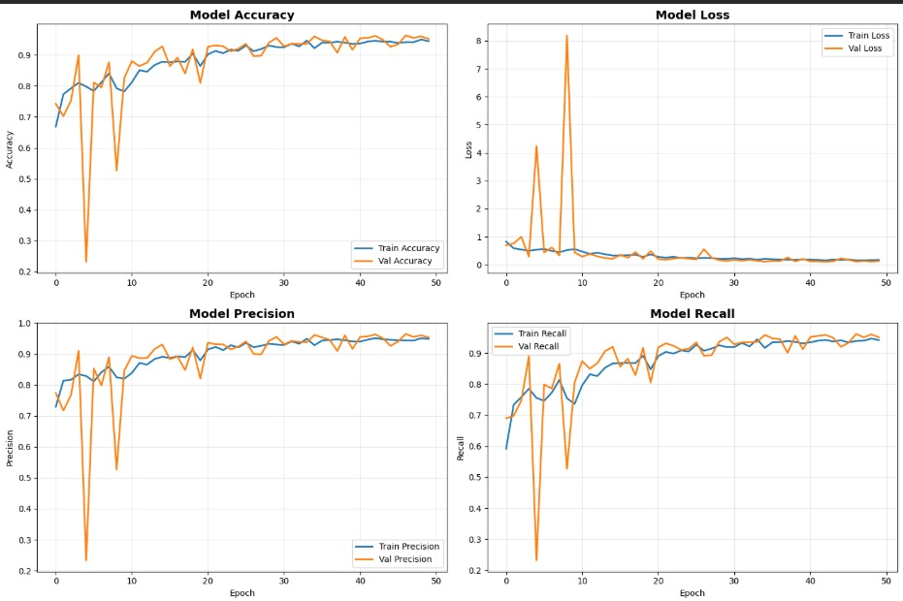
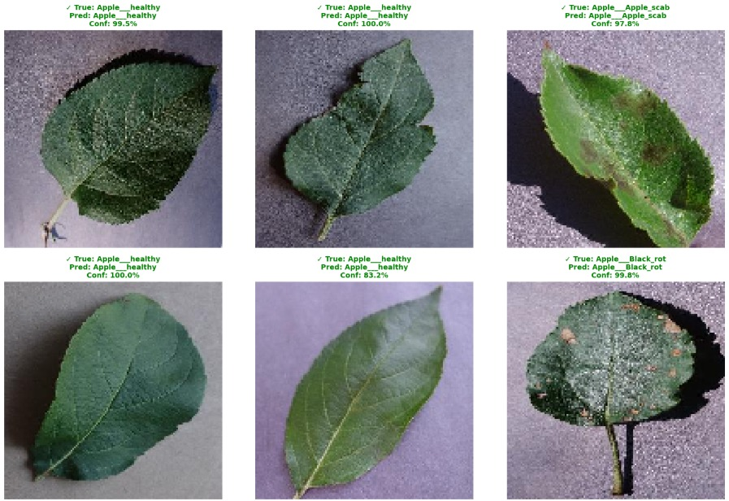

7 REFERENCES
- Sunil CK, Jaidhar CD, Patil N (2021) Cardamom plant disease detection approach using Efficient NetV2. IEEE Access 10:789–804
- Shovon MSH, Mozumder SJ, Pal OK, Mridha MF, Asai N, Shin J (2023) PlantDet: a robust multi-model ensemble method based on deep learning for plant disease detection. IEEE Access 11:34846–34859
- Hosny MK, El-Hady WM, Samy FM, Vrochidou E, Papakostas GA (2023) Multi-class classification of plant leaf diseases using feature fusion of deep convolutional neural network and local binary pattern. IEEE Access 11:62307–62317
- Jiang P, Chen Y, Liu B, He D, Liang C (2019) Real-time detection of apple leaf diseases using deep learning approach based on improved convolutional neural networks. IEEE Access 7:59069–59080
- Annabel LSP, Annapoorani T, Deepalakshmi P (2019) Machine learning for plant leaf disease detection and classification–a review. In: 2019 International conference on communication and signal processing (ICCSP), IEEE, pp 0538–0542
- Amin H, Darwish A, Hassanien AE, Soliman M (2022) End-to-end deep learning model for corn leaf disease classification. IEEE Access 10:31103–31115
- Sajid M, Ali N, Dar SH, Ratyal NI, Butt AR, Zafar B, Shafique T, Baig MJA, Riaz I, Baig S (2018) Research article data augmentation-assisted makeup-invariant face recognition. Math Probl Eng 2018:1–10
- Xiao Z, Shi Y, Zhu G, Xiong J, Wu J (2023) Leaf disease detection based on lightweight deep residual network and attention mechanism. IEEE Access 11:48248–48258
- Joshi MB, Bhavsar H (2020) Plant leaf disease detection and control: a survey. J Inf Optim Sci 41(2):475–487
- Hosny MK, Kassem MA, Fouad MM (2020) Classification of skin lesions into seven classes using transfer learning with AlexNet. J Digit Imaging 33:1325–1334
- Sharma P, Berwal YPS, Ghai W (2020) Performance analysis of deep learning CNN models for disease detection in plants using image segmentation. Inf Process Agric 7(4):566–574
- Masood M, Nawaz M, Nazir T, Javed A, Alkanhel R, Elmannai H, Dhahbi S, Bourouis S (2023) Mai zeNet: a deep learning approach for effective recognition of maize plant leaf diseases. IEEE Access 11:52862–52876

