**NGO MANAGEMENT SYSTEM**

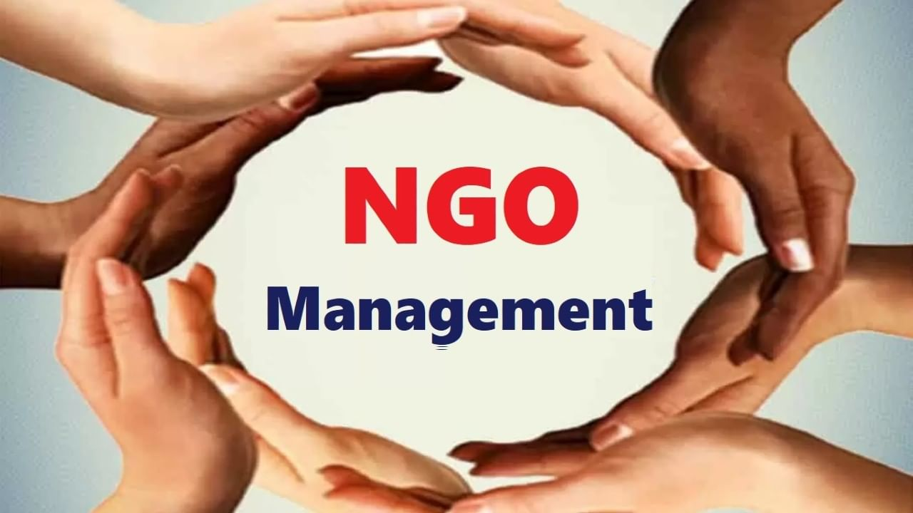

**Motivation:**

An NGO is a non-profit organization that functions outside of government control and is made up of volunteers, community members, social activists, and other individuals committed to social development and welfare. Donations are typically used to finance NGOs. Around the world, there are numerous NGOs that operate on a variety of projects. Our primary area of interest in this endeavor is NGOs serving children. An organization that supports the daycare system primarily concentrates on nurturing activities and initiatives that will benefit the most vulnerable and impoverished children in our community. Our goal is that children, who represent the bright future of our nation, should not be denied access to even the most basic amenities, such as school and housing. Therefore, we are emphasizing both the health and education of children.

**Overview of the Project**

CardLayout: It handles every element within the container as a card. The container functions as a stack of cards, with just one card shown at a time.

Email Support: Open-source object database for Java and.NET applications is called the Java Mail API DB4O Database.

Enterprise 1: ChildCare NGO

organization 1: NGO

Role 1: NGO Admin

Role 2: Care Taker

organization 2: Charity

Role 1: Fund Manager

Role 2: Person

Enterprise 2: Education

organization 1: School

Role 1: School Admin

Role 2: Principal

organization 2: Educators

Role 1: Teachers

Role 2: Applicants

Enterprise 3: Hospital Management

organization 1: Hospital

Role 1: Hospital Admin

Role 2: Doctor

Role 3: Patient

Enterprise 4: Medical Store

organization 1: Pharmacy

Role 1: Med Store Admin

Role2: Storekeeper

Role3: Delivery Man