# Big Data Hadoop Training

Session 12 Assignment 3 Solution:

Task

**Import AcadGild VM into Virtual box and start all the Spark daemons and take the screen shot.**

Steps followed:

1. Import Acadgild_Spark VM into Oracle Virtual Box

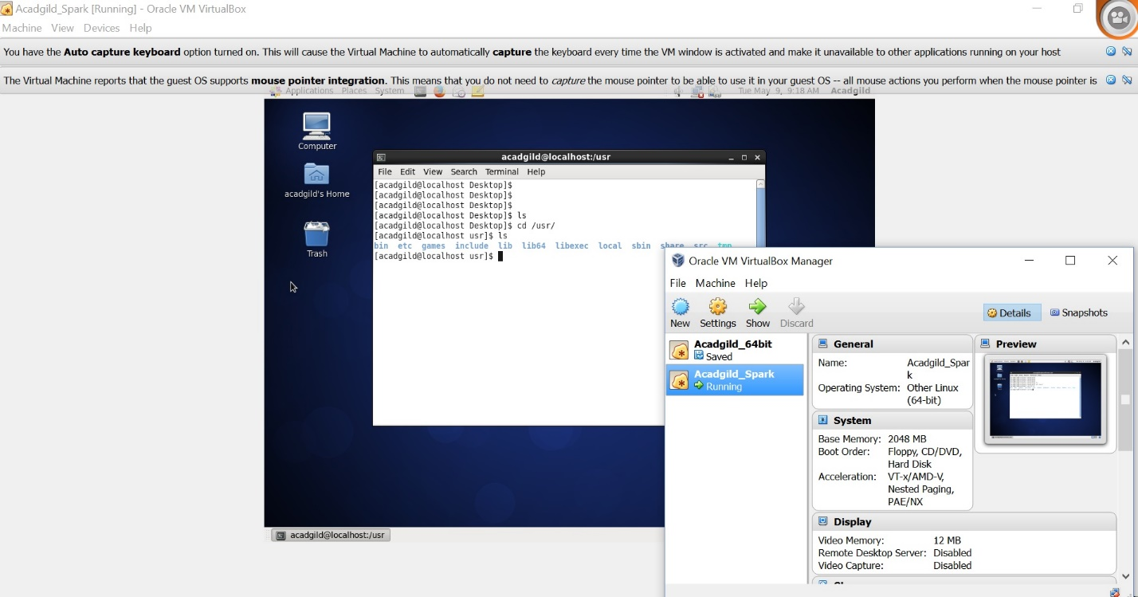

1. Start all Hadoop Daemons by using below commands in the screenshot and type ‘jps’ to see all hadoop daemons running or not.

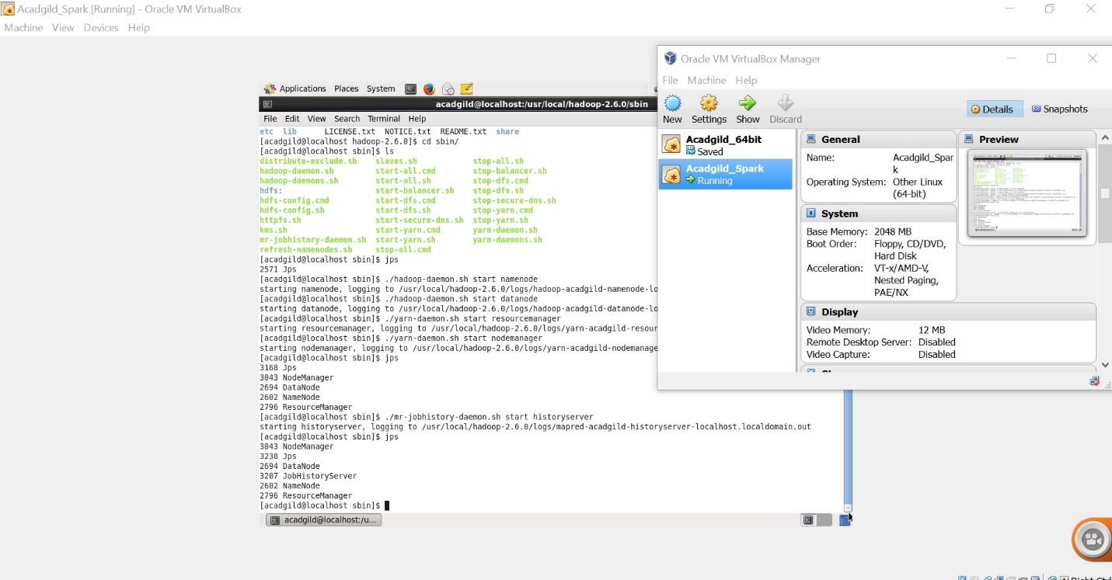

1. Finally, start Spark Daemons and now, we can see Master and Worker (Spark Daemons) running.

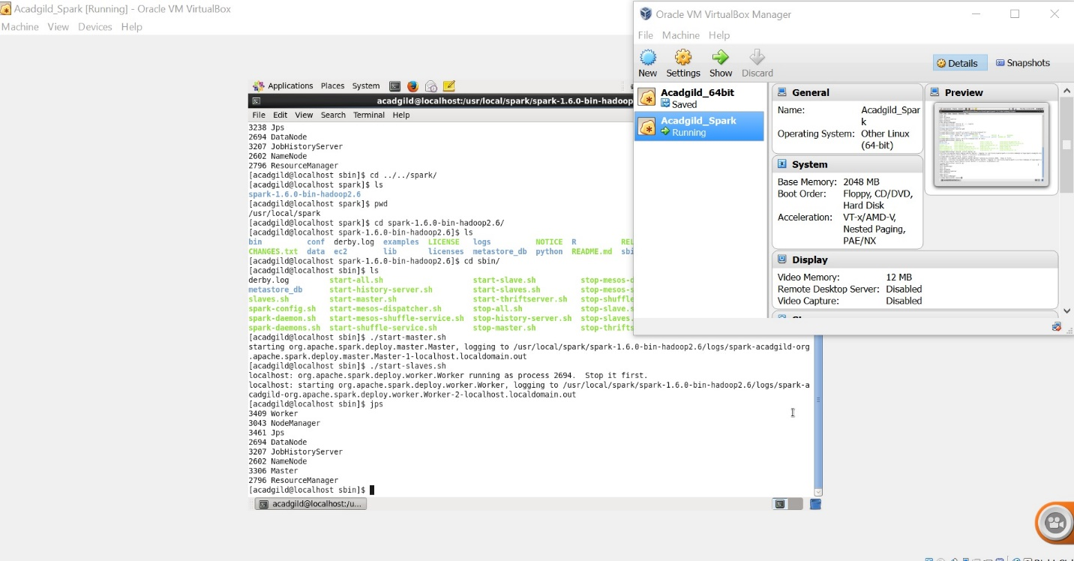

Thus, we have imported AcadGild VM into Virtual box and started all the Spark daemons.