# Big Data Hadoop Training

Session 2 Assignment 1 Solution:

**Task 1:**

**Q) Check whether /user/acadgild directory exists or not in the HDFS**.

A) By typing cmd : **“hadoop fs –ls /user/acadgild”** there is **no error** message: No such file or directory and also we can see the list of files and directories inside /user/acadgild/ directory as shown in the screenshot. **Therefore, directory exists.**

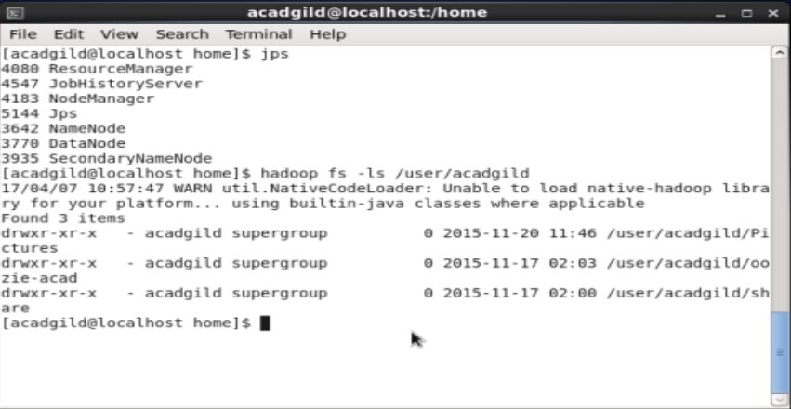

**Q) If it doesn't exist, then create this. Create a directory /user/acadgild/hadoop.**

A) Since, there is no hadoop directory inside acadgild/ we create the directory using the cmd: **“hadoop fs –mkdir /user/acadgild/hadoop”** as shown in the screenshot.

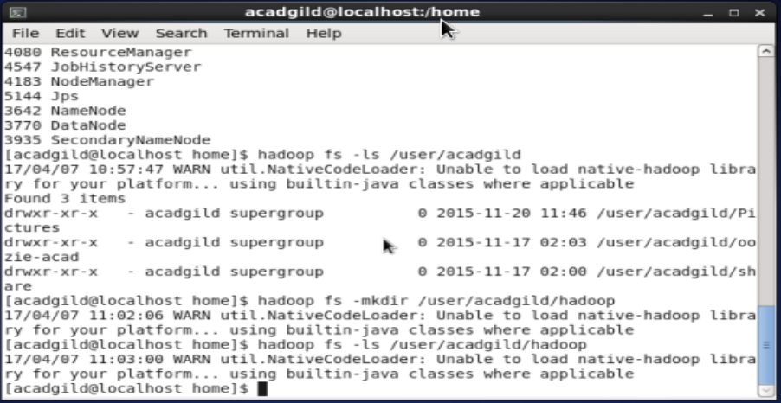

**Task 2:**

**Q) Create a file in HDFS under directory /user/acadgild/hadoop, with name wordcount.txt.**

A) For this, at first an empty file is created in the local file system and then we put the file into HDFS using the cmd : **“hadoop fs –put wordcount.txt /user/acadgild/hadoop/”** as shown in the screenshot.

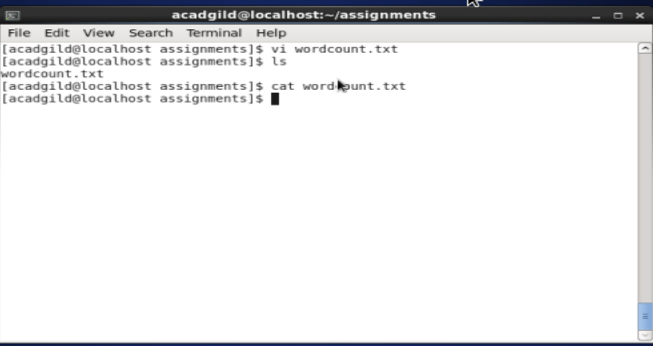

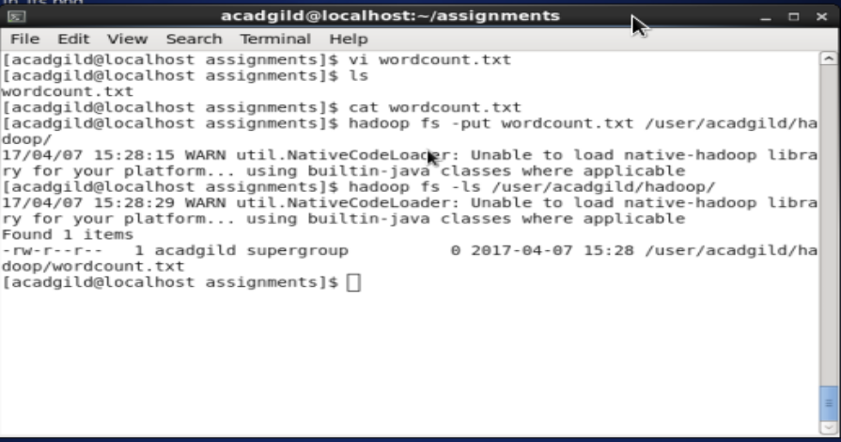

**Q) Whatever we type on screen should get appended to the file. Try to type (on screen) few lines from any online article or textbook.**

A) I took some material from a book and inserted it into wordcount.txt file in local file system.

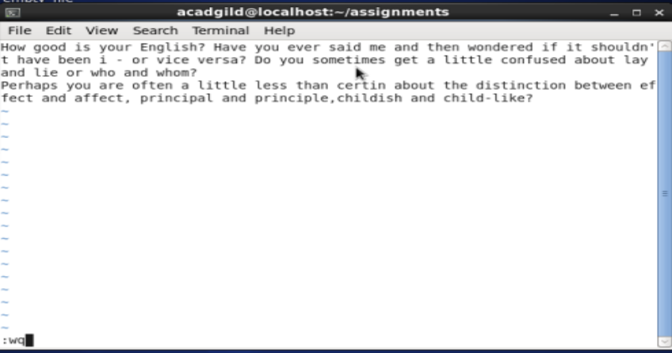

Then using cmd : **“hadoop fs –appendToFile wordcount.txt /user/acadgild/hadoop/wordcount.txt”** the text got inserted into the HDFS wordcount.txt file. We can view the content in HDFS wordcount.txt using the cmd: **“hadoop fs –cat /user/acadgild/hadoop/wordcount.txt”** as shown in the screenshot.

