Big Data Hadoop Training

  - Session 4 Assignment 2 Solution:
  - Task: 2

Q) Write a Map Reduce program to calculate the total units sold for each Company.

A) Java Program: Takes HDFS Path of filtered records of television.txt as input and calculates the total units sold for each company and stores the result in output path as a part-file.
The result of Session 4 Assignment 1 – filtered output is now used as input for this task
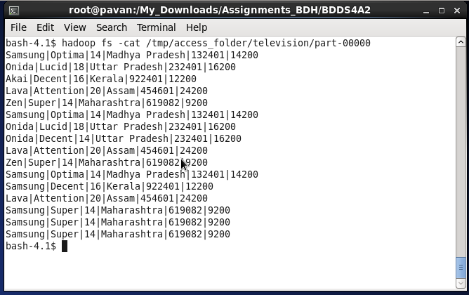
Note: Input file is in HDFS @ /tmp/access_folder/television/part-00000
Output path provided: /tmp/access_folder/total_units_per_company

Java Program:

import java.io.IOException;
import java.util.Iterator;

import org.apache.hadoop.fs.Path;
import org.apache.hadoop.io.IntWritable;
import org.apache.hadoop.io.LongWritable;
import org.apache.hadoop.io.Text;
import org.apache.hadoop.mapred.FileInputFormat;
import org.apache.hadoop.mapred.FileOutputFormat;
import org.apache.hadoop.mapred.JobClient;
import org.apache.hadoop.mapred.JobConf;
import org.apache.hadoop.mapred.MapReduceBase;
import org.apache.hadoop.mapred.Mapper;
import org.apache.hadoop.mapred.OutputCollector;
import org.apache.hadoop.mapred.Reducer;
import org.apache.hadoop.mapred.Reporter;
import org.apache.hadoop.mapred.TextInputFormat;
import org.apache.hadoop.mapred.TextOutputFormat;

public class total_units_sold{

public static class Map extends MapReduceBase implements Mapper<LongWritable, Text, Text, IntWritable> {
private final static IntWritable one = new IntWritable(1);
private Text word = new Text();

public void map(LongWritable key, Text value, OutputCollector<Text, IntWritable> output, Reporter reporter) throws IOException {
String line = value.toString();
String[] elements = line.split("\\|"); // Delimiter "|" to separate words
word.set(elements[0]);
output.collect(word, one);
}
}

public static class Reduce extends MapReduceBase implements Reducer<Text, IntWritable, Text, IntWritable> {
public void reduce(Text key, Iterator<IntWritable> values, OutputCollector<Text, IntWritable> output, Reporter reporter) throws IOException {
int sum = 0;
while (values.hasNext()) {
sum += values.next().get();
}
output.collect(key, new IntWritable(sum));
}
}

public static void main(String[] args) throws Exception {
JobConf conf = new JobConf(total_units_sold.class);
conf.setJobName("filter");

conf.setOutputKeyClass(Text.class);
conf.setOutputValueClass(IntWritable.class);

conf.setMapperClass(Map.class);
conf.setReducerClass(Reduce.class);

conf.setInputFormat(TextInputFormat.class);
conf.setOutputFormat(TextOutputFormat.class);

FileInputFormat.setInputPaths(conf, new Path(args[0]));
FileOutputFormat.setOutputPath(conf, new Path(args[1]));

JobClient.runJob(conf);
}

}
Input format: “hdfs://<hostname>:<port_no>/<HDFS_Input_File_Path>” “hdfs://<hostname>:<port_no>/<HDFS_Output_File_Path>”

Running in Eclipse:
- Input given in Run Configurations Argument Tab as : "hdfs://pavan:8020/tmp/access_folder/television/part-00000" "hdfs://pavan:8020/tmp/access_folder/total_units_per_company"
Note: Here Hostname: pavan and Port no:8020 is required since files are in HDFS
- Become HDFS user and filtered Output can be seen with the help of :
hadoop fs –cat /tmp/access_folder/total_units_per_company/part-00000 command
Running in Command Line:
- Make the folder structure BDDS4A2/src/main/java/total_units_sold.java
- Then in BDDS4A2 folder, open terminal
- Create the Jar file target/BDDS4A2.jar using Maven as root user # mvn clean install
- Now , become HDFS user # su hdfs
- Run the Hadoop Job : “hadoop jar <jar_file_path> <class_name> <input_hdfs_file_path> <output_hdfs_file_path>”
- In our case : hadoop jar target/BDDS4A2.jar total_units_sold /tmp/access_folder/television/part-00000 /tmp/access_folder/total_units_per_company
- Note: Here both input and output present in HDFS, so no Hostname and Port No specification required.
- Filtered Output can be seen with the help of :
hadoop fs –cat /tmp/access_folder/total_units_per_company/part-00000 command
  - Screenshots
Eclipse Java code and Input provided in Run Configurations:
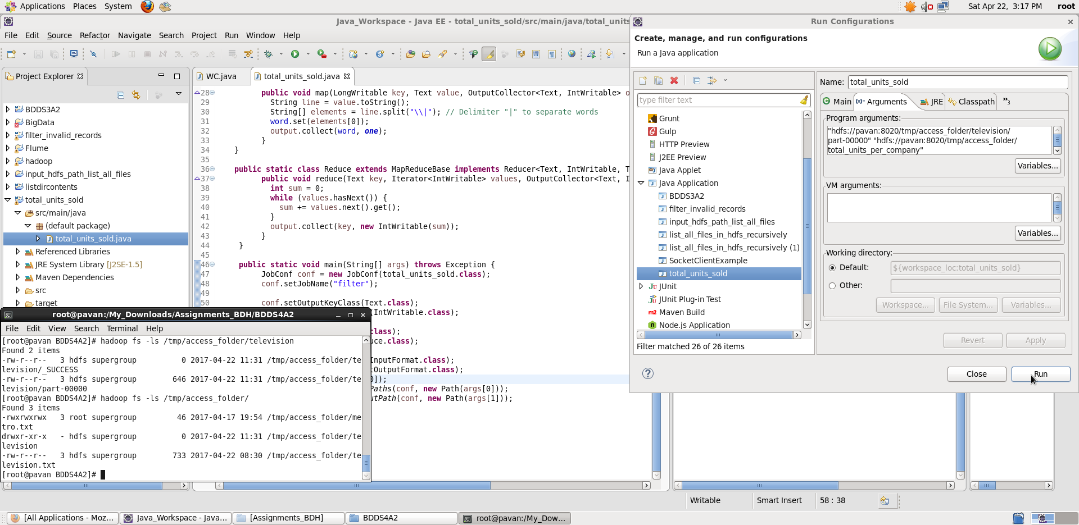
Once we Run, we see a part-file generated. Displaying filtered output using hadoop fs –cat command:
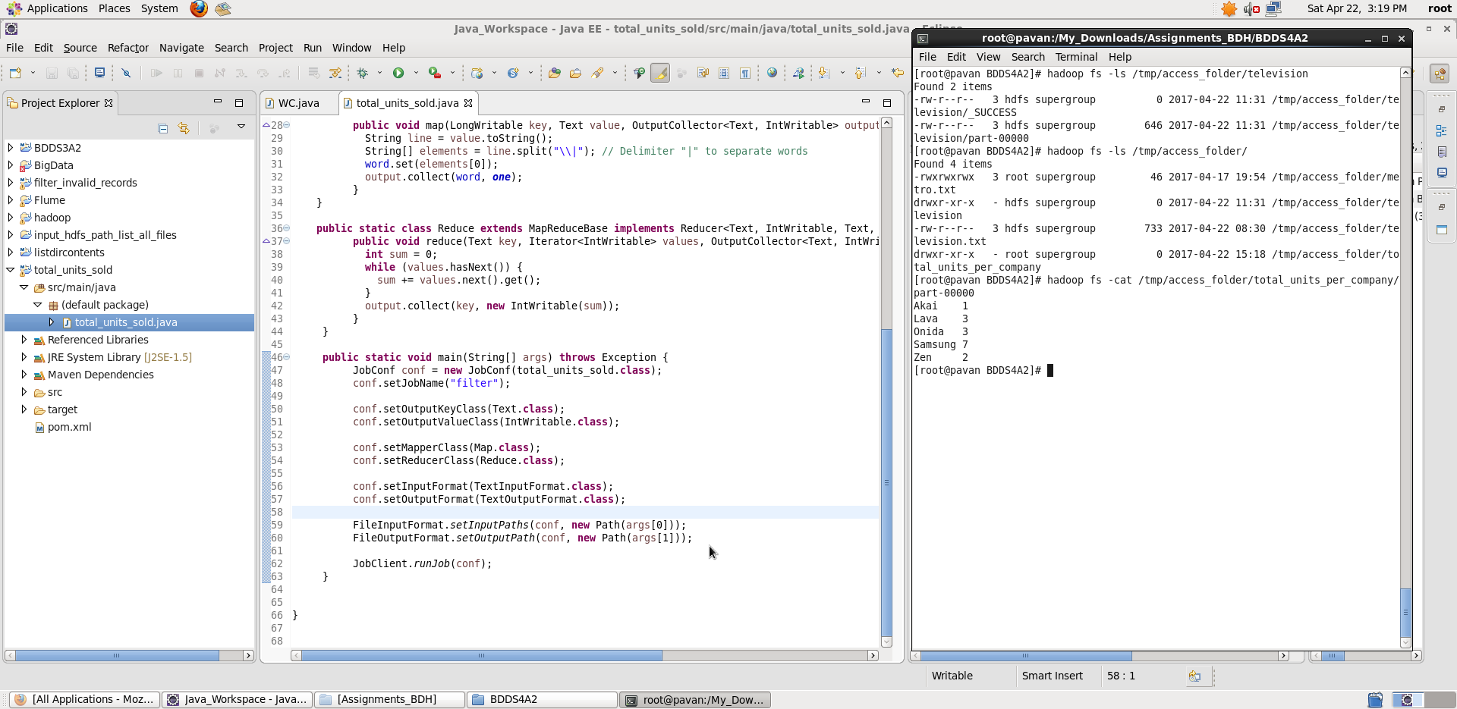

Submitting Job as HDFS user:
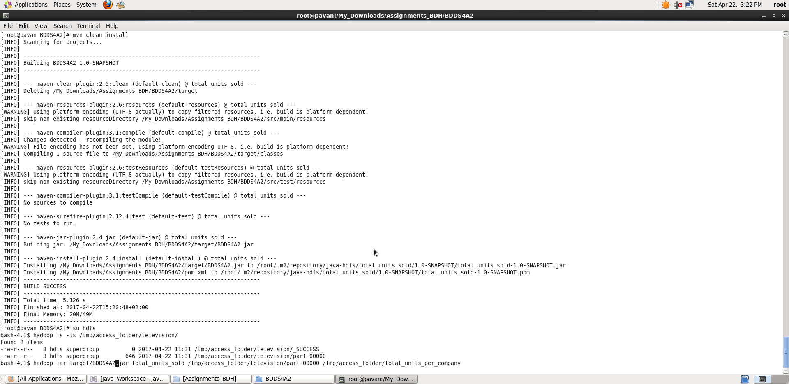

Once we Run the Hadoop Job, we see a part-file generated. Displaying filtered output using hadoop fs –cat command:

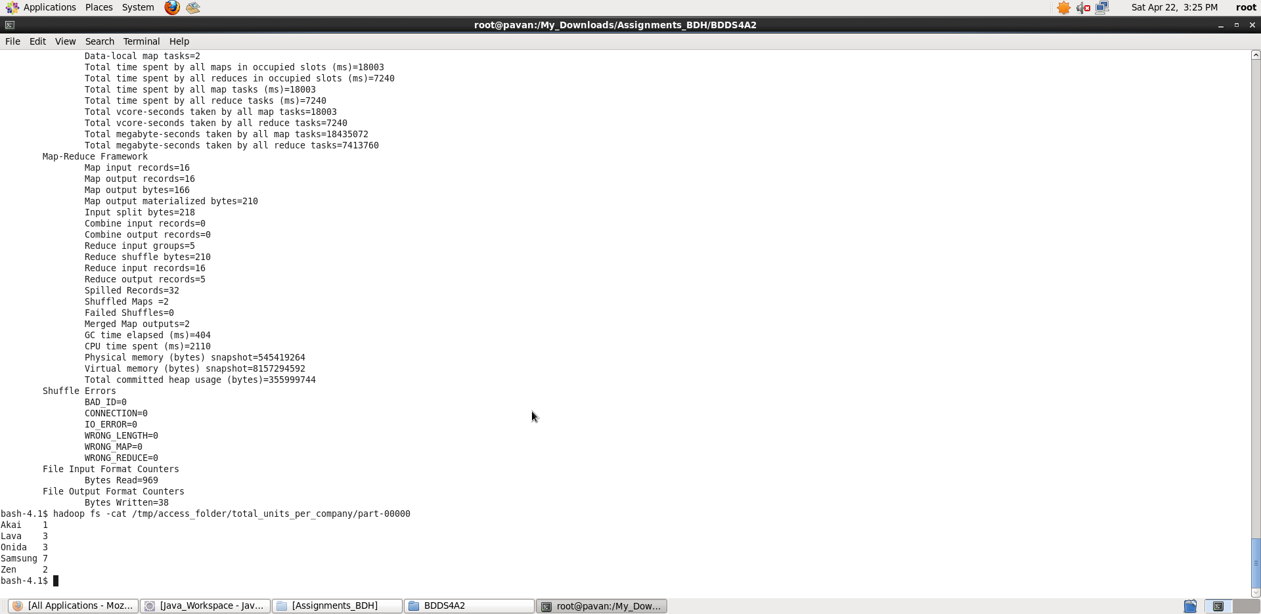

Thus, we calculated the total units sold by each Company:
Output <company_name> <total_units_sold>

  - Task: 3

Q) Write a Map Reduce program to calculate the total units sold in each state for Onida Company.

A) Java Program: Takes HDFS Path of filtered records of television.txt as input and calculates the total units sold in each state for Onida company and stores the result in output path as a part-file.
The result of Session 4 Assignment 1 – filtered output is now used as input for this task
Note: Input file is in HDFS @ /tmp/access_folder/television/part-00000
Output path provided: /tmp/access_folder/total_units_per_state_for_Onida

Java Program:

import java.io.IOException;
import java.util.Iterator;

import org.apache.hadoop.fs.Path;
import org.apache.hadoop.io.IntWritable;
import org.apache.hadoop.io.LongWritable;
import org.apache.hadoop.io.Text;
import org.apache.hadoop.mapred.FileInputFormat;
import org.apache.hadoop.mapred.FileOutputFormat;
import org.apache.hadoop.mapred.JobClient;
import org.apache.hadoop.mapred.JobConf;
import org.apache.hadoop.mapred.MapReduceBase;
import org.apache.hadoop.mapred.Mapper;
import org.apache.hadoop.mapred.OutputCollector;
import org.apache.hadoop.mapred.Reducer;
import org.apache.hadoop.mapred.Reporter;
import org.apache.hadoop.mapred.TextInputFormat;
import org.apache.hadoop.mapred.TextOutputFormat;

public class total_units_sold{

public static class Map extends MapReduceBase implements Mapper<LongWritable, Text, Text, IntWritable> {
private final static IntWritable one = new IntWritable(1);
private Text word = new Text();

public void map(LongWritable key, Text value, OutputCollector<Text, IntWritable> output, Reporter reporter) throws IOException {
String line = value.toString();
String[] elements = line.split("\\|"); // Delimiter "|" to separate words
// Working only on Onida Company Records
if(elements[0].equals("Onida")) {
word.set(elements[3]); // State Name
output.collect(word, one); // Adding value 1 to the Key value - state
}
}
}

public static class Reduce extends MapReduceBase implements Reducer<Text, IntWritable, Text, IntWritable> {
public void reduce(Text key, Iterator<IntWritable> values, OutputCollector<Text, IntWritable> output, Reporter reporter) throws IOException {
int sum = 0;
while (values.hasNext()) {
sum += values.next().get();
}
output.collect(key, new IntWritable(sum));
}
}

public static void main(String[] args) throws Exception {
JobConf conf = new JobConf(total_units_sold.class);
conf.setJobName("filter");

conf.setOutputKeyClass(Text.class);
conf.setOutputValueClass(IntWritable.class);

conf.setMapperClass(Map.class);
conf.setReducerClass(Reduce.class);

conf.setInputFormat(TextInputFormat.class);
conf.setOutputFormat(TextOutputFormat.class);

FileInputFormat.setInputPaths(conf, new Path(args[0]));
FileOutputFormat.setOutputPath(conf, new Path(args[1]));

JobClient.runJob(conf);
}

}

Input format: “hdfs://<hostname>:<port_no>/<HDFS_Input_File_Path>” “hdfs://<hostname>:<port_no>/<HDFS_Output_File_Path>”

Running in Eclipse:
- Input given in Run Configurations Argument Tab as : "hdfs://pavan:8020/tmp/access_folder/television/part-00000" "hdfs://pavan:8020/tmp/access_folder/total_units_per_state_for_Onida"
Note: Here Hostname: pavan and Port no:8020 is required since files are in HDFS
- Become HDFS user and filtered Output can be seen with the help of :
hadoop fs –cat /tmp/access_folder/total_units_per_state_for_Onida/part-00000 command
Running in Command Line:
- Make the folder structure BDDS4A2/src/main/java/total_units_sold.java
- Then in BDDS4A2 folder, open terminal
- Create the Jar file target/BDDS4A2.jar using Maven as root user # mvn clean install
- Now , become HDFS user # su hdfs
- Run the Hadoop Job : “hadoop jar <jar_file_path> <class_name> <input_hdfs_file_path> <output_hdfs_file_path>”
- In our case : hadoop jar target/BDDS4A2.jar total_units_sold /tmp/access_folder/television/part-00000 /tmp/access_folder/total_units_per_state_for_Onida
- Note: Here both input and output present in HDFS, so no Hostname and Port No specification required.
- Filtered Output can be seen with the help of :
hadoop fs –cat /tmp/access_folder/total_units_per_state_for_Onida/part-00000 command
  - Screenshots
Eclipse Java code and Input provided in Run Configurations:
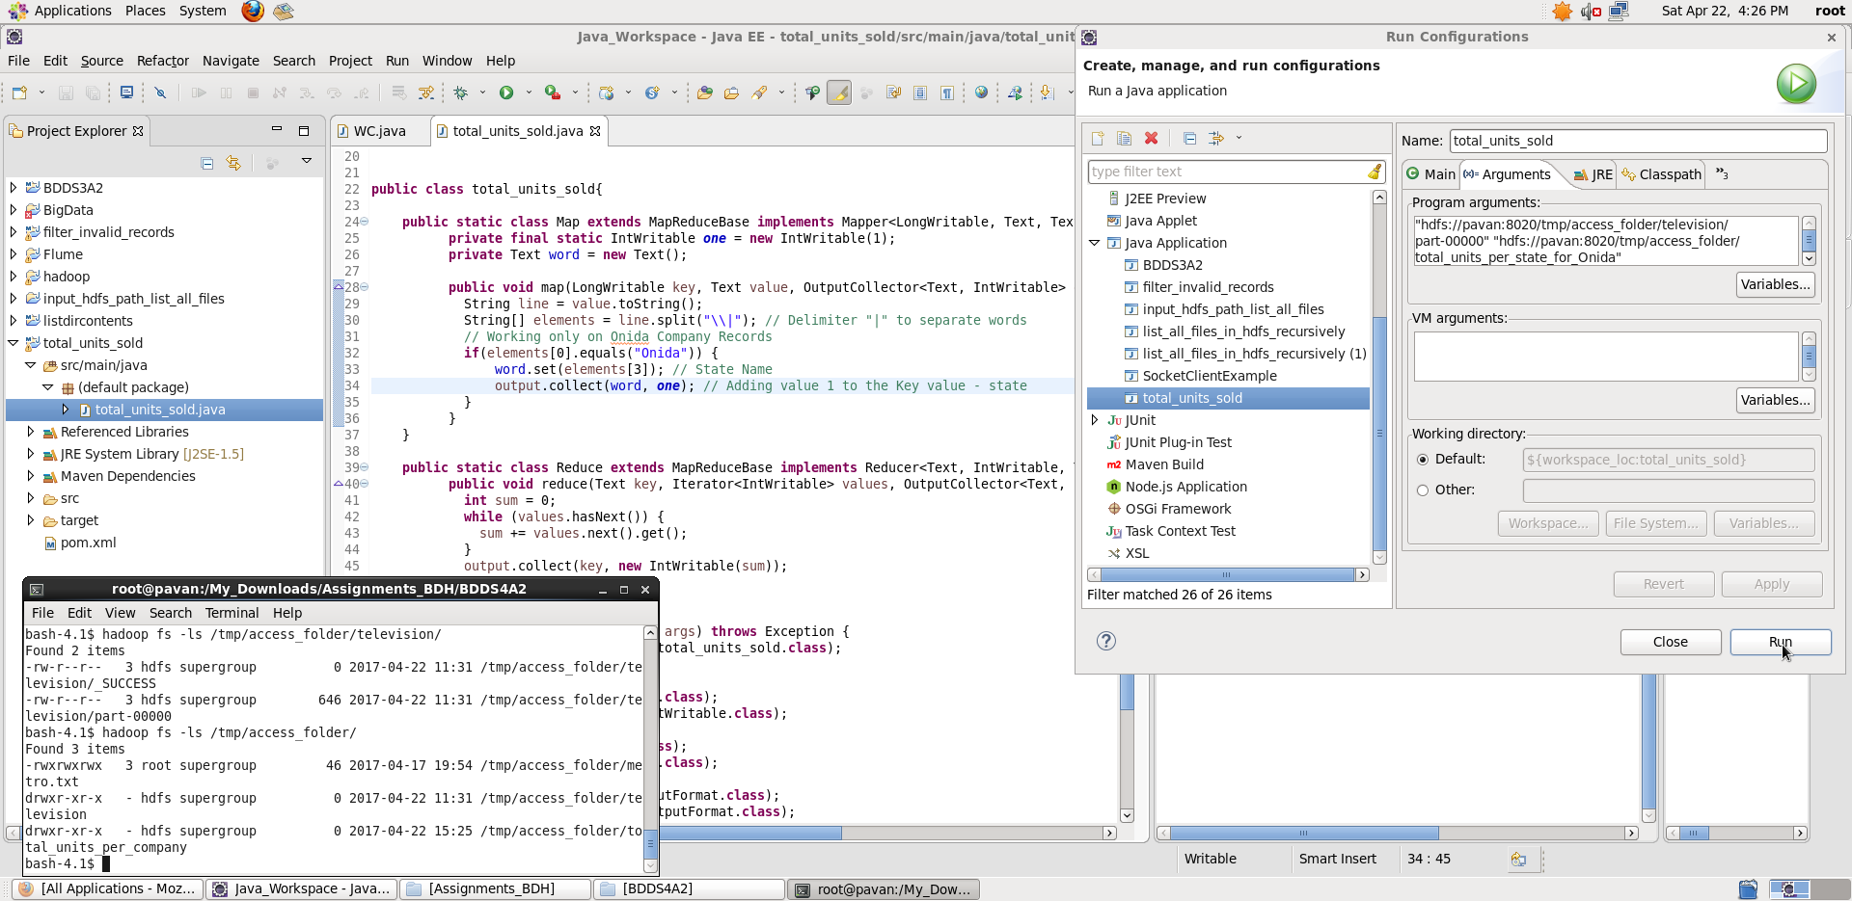
Once we Run, we see a part-file generated. Displaying filtered output using hadoop fs –cat command:
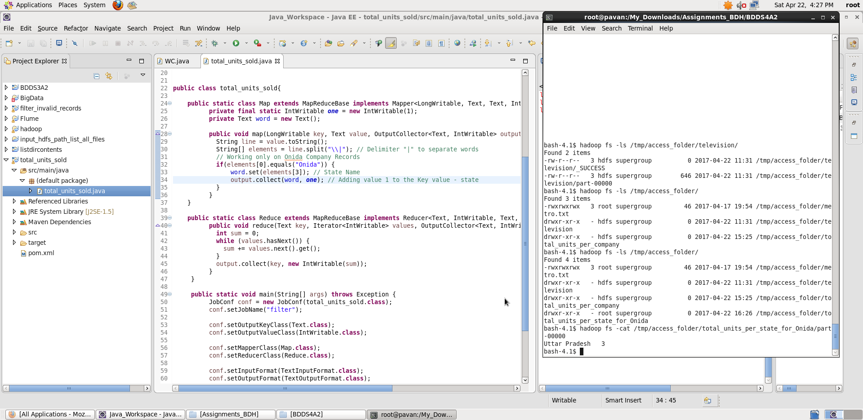

Submitting Job as HDFS user:
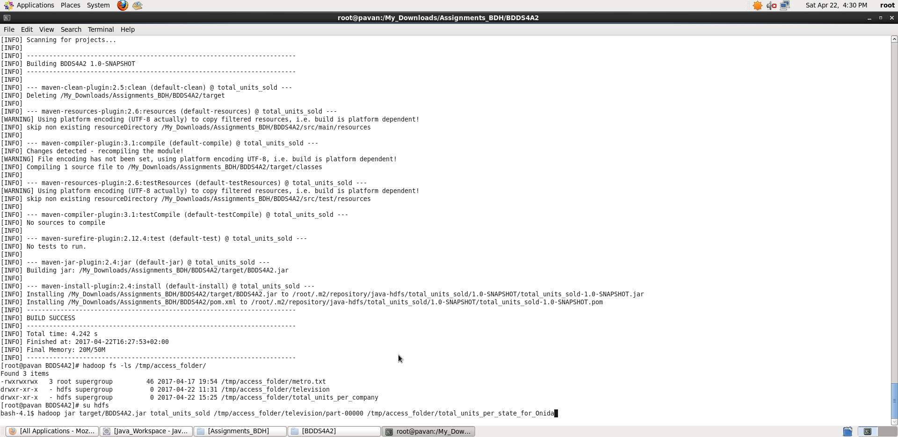

Once we Run the Hadoop Job, we see a part-file generated. Displaying filtered output using hadoop fs –cat command:

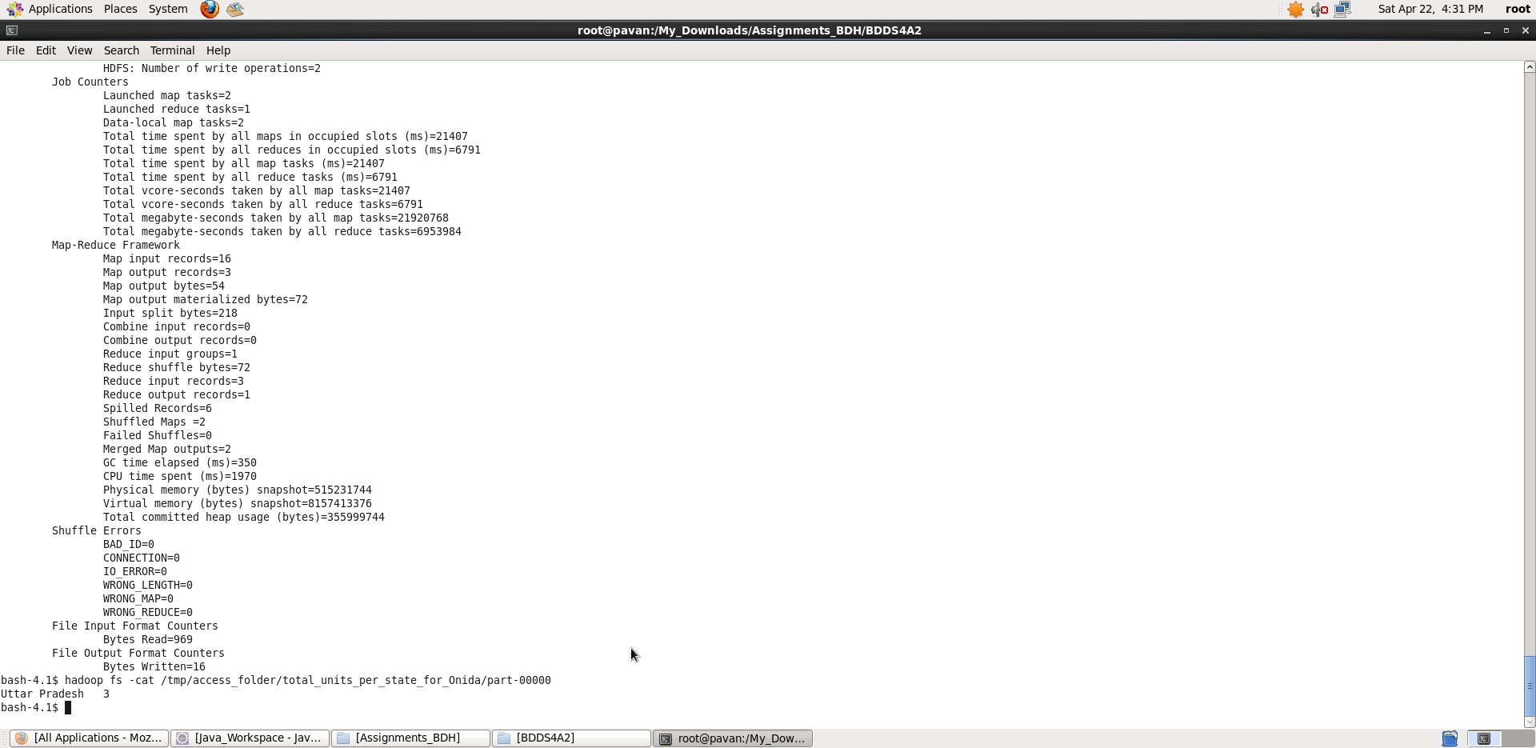

Thus, we calculated the total units sold in each state for Onida Company:

Output <state_name> <total_units_sold>

Note : For both Task 2 and task 3 I have used filtered records output that we generated in Session 4 Assignment 1 task.

