# Big Data Hadoop Training

Session 7 Assignment 2 Solution

**We have employee_details and employee_expenses files. Use local mode while running Pig and write Pig Latin script to get below results:**

**Input files stored in HDFS:**

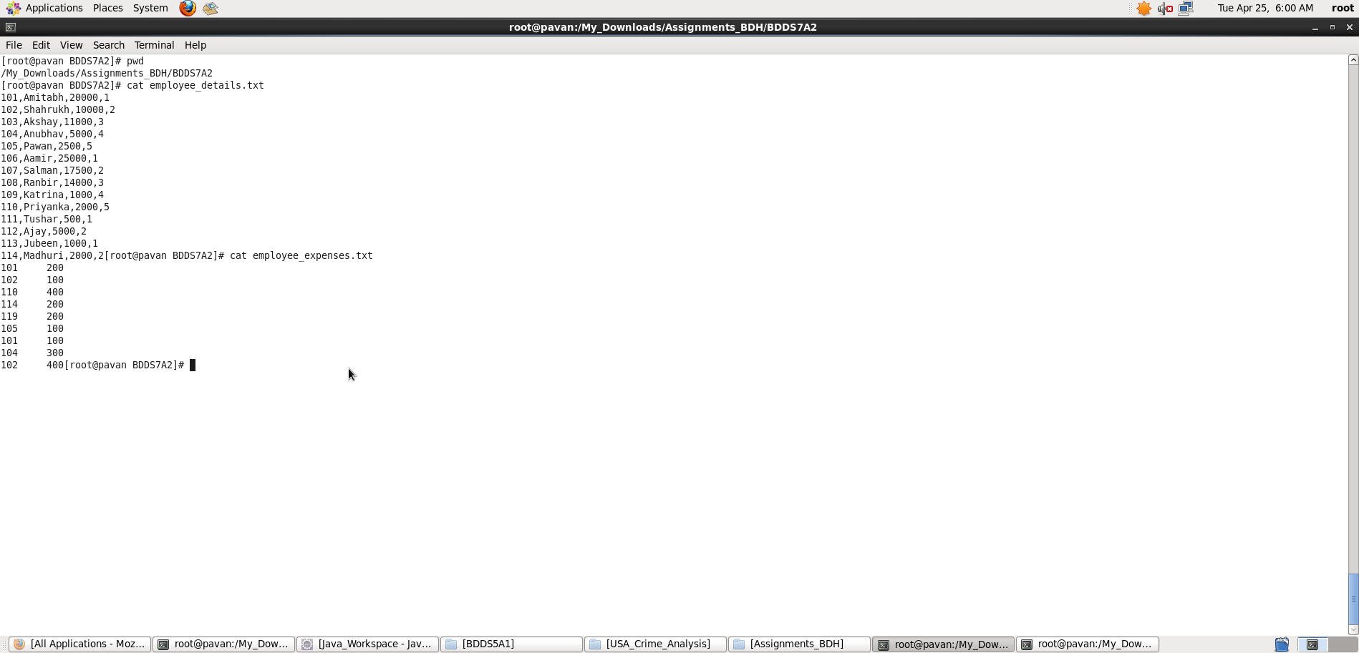

**(a) Top 5 employees (employee id and employee name) with highest rating.**

**(In case two employees have same rating, employee with name coming first in dictionary should get preference)**

A) **Pig Latin Script**:

emp_details = load './employee_details.txt' USING PigStorage(',') AS (empId:int, empName:chararray, salary:int, rating:int);

grpall = GROUP emp_details ALL;

out = FOREACH grpall {

sort = ORDER emp_details BY rating DESC, empName ASC;

top = LIMIT sort 5;

GENERATE FLATTEN(top);

}

top5empId_empName = FOREACH out GENERATE empId,empName;

dump top5empId_empName;

**Explanation :**

* Loaded data from employee_details.txt into “emp_details” relation. Here ‘,’ is the delimiter and schema is provided as mentioned in the question
* Then, all records are grouped together
* Now, iterating over tuples inside the group I have sorted the emp_details by rating in descending order and then those with same rating are sorted in ascending order according to the employee with name coming first in dictionary.
* Limiting my output to top 5 records
* Then flattening the tuples inside group
* **Outputting only “the employee id and employee name” with top rating in descending order as per Question using dump command.**

Screenshots

Running **Pig Latin Script in Local Mode** inside /My_Downloads/Assignments_BDH/BDDS7A2/ directory

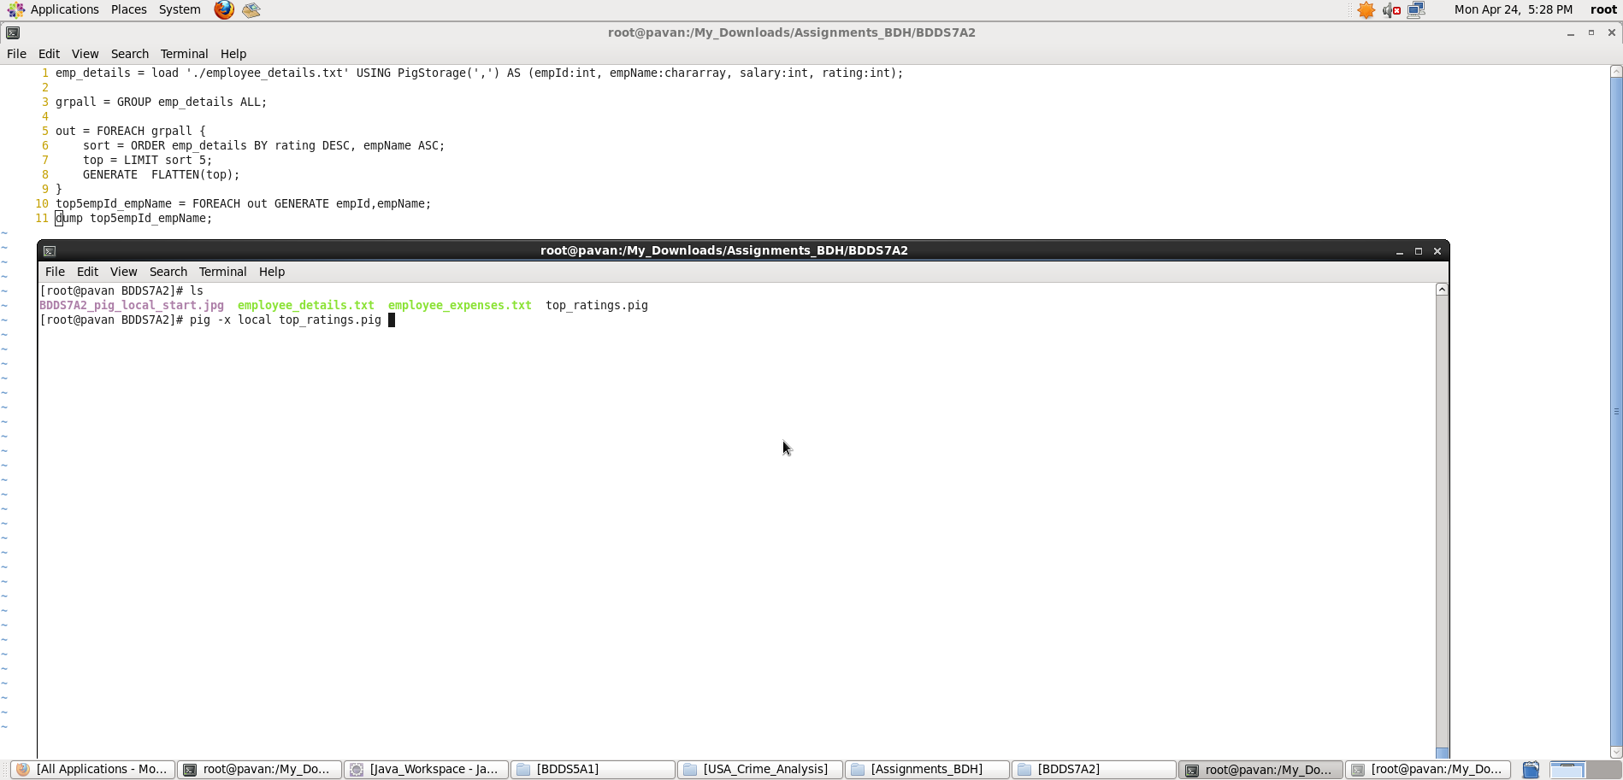

Output displayed: **<employee_id> <employee_name>**

**Note : We can store the output if required in a file using “store” command.**

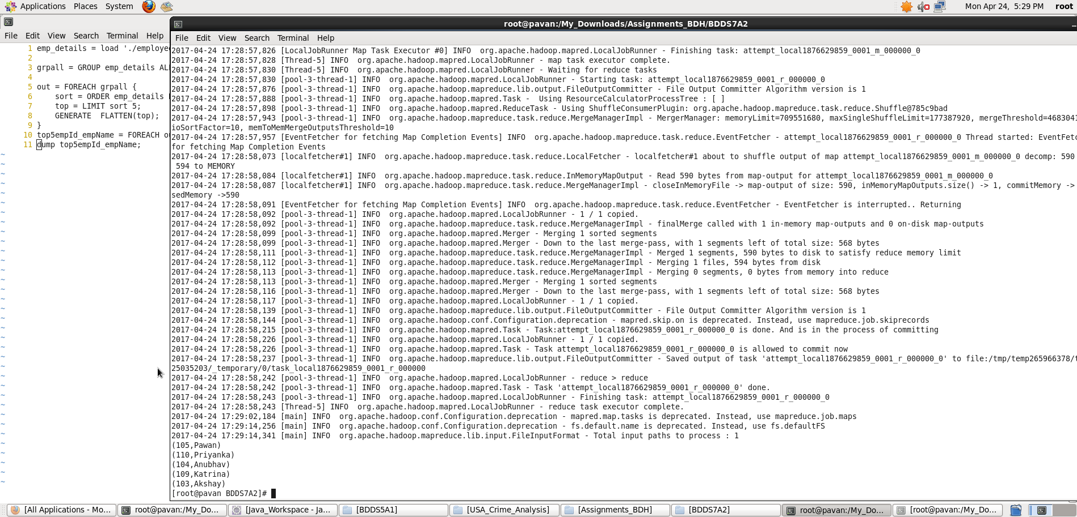

**b) Top 3 employees (employee id and employee name) with highest salary, whose employee id is an odd number.**

**(In case two employees have same salary, employee with name coming first in dictionary should get preference)**

1. **Pig Latin Script:**

emp_details = load './employee_details.txt' USING PigStorage(',') AS (empId:int, empName:chararray, salary:int, rating:int);

grpall = GROUP emp_details ALL;

out = FOREACH grpall {

sort = ORDER emp_details BY salary DESC, empName ASC;

Id_odd = FILTER sort BY (empId%2)==1;

top3 = LIMIT Id_odd 3;

GENERATE FLATTEN(top3);

}

top3empId_empName = FOREACH out GENERATE empId,empName;

dump top3empId_empName;

**Explanation :**

* Loaded data from employee_details.txt into “emp_details” relation. Here ‘,’ is the delimiter and schema is provided as mentioned in the question
* Then, all records are grouped together
* Now, iterating over tuples inside the group I have sorted the emp_details by salary in descending order and then those with same salary are sorted in ascending order according to the employee with name coming first in dictionary.
* Then, filtered the list such that empId is odd.
* Limiting my output to top 3 records
* Then flattening the tuples inside group
* **Outputting only “the employee id and employee name” with highest salary in descending order as per Question using dump command.**

Screenshots

Running **Pig Latin Script in Local Mode** inside /My_Downloads/Assignments_BDH/BDDS7A2/ directory

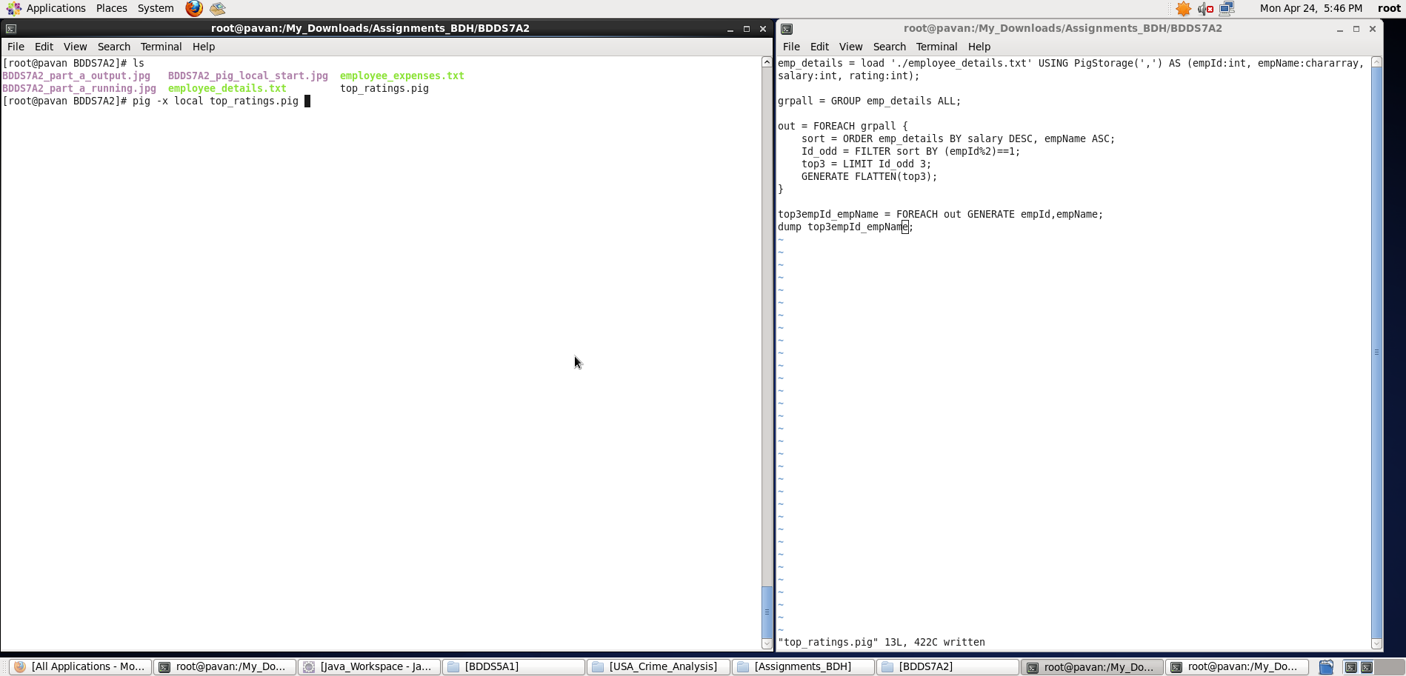

Output displayed: **<employee_id> <employee_name>**

**Note : We can store the output if required in a file using “store” command.**

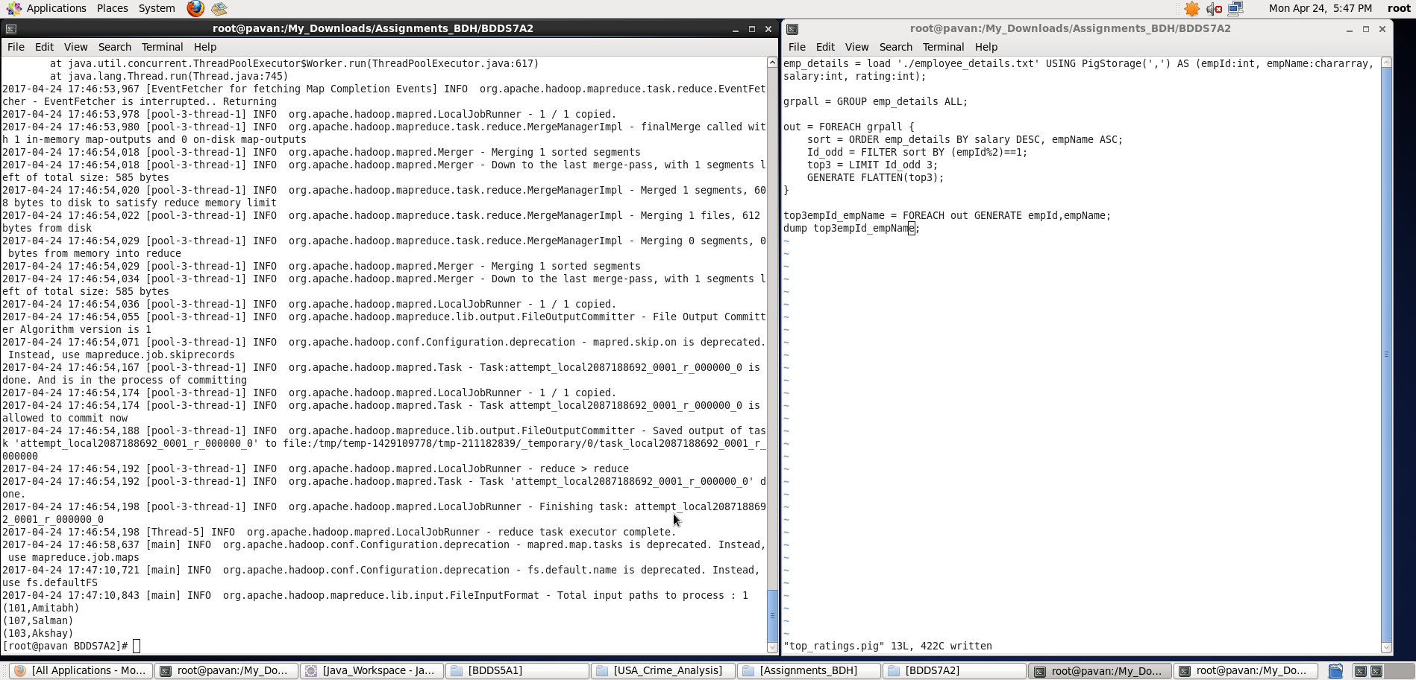

c) **Employee (employee id and employee name) with maximum expense**

**(In case two employees have same expense, employee with name coming first in dictionary should get preference)**

**Pig Latin Script:**

emp_details = load './employee_details.txt' USING PigStorage(',') AS (empId:int, empName:chararray, salary:int, rating:int);

emp_expenses = load './employee_expenses.txt' USING PigStorage() AS (empId:int, expenses:int);

emp_joined_data = JOIN emp_details BY empId, emp_expenses BY empId;

grpall = GROUP emp_joined_data ALL;

out = FOREACH grpall {

sort = ORDER emp_joined_data BY emp_expenses::expenses DESC, emp_details::empName ASC;

topexp = LIMIT sort 1;

GENERATE FLATTEN(topexp);

}

topexpempId_empName = FOREACH out GENERATE emp_details::empId,emp_details::empName;

dump topexpempId_empName;

**Explanation :**

* Loaded data from employee_details.txt into “emp_details” relation. Here ‘,’ is the delimiter and schema is provided as mentioned in the question
* Loaded data from employee_expenses.txt into “emp_expenses” relation. Here, schema is provided as mentioned in the question
* Both the relations are joined with the same key empID.
* Then, all records are grouped together
* Now, iterating over tuples inside the group I have sorted the emp_joined_data by expenses (from emp_expenses) in descending order and then those with same expenses are sorted in ascending order according to the employee with name coming first in dictionary.
* Limiting my output to top 1 record
* Then flattening the tuples inside group
* **Outputting only “the employee id and employee name” with maximum expense as per Question using dump command.**

Screenshots

Running **Pig Latin Script in Local Mode** inside /My_Downloads/Assignments_BDH/BDDS7A2/ directory

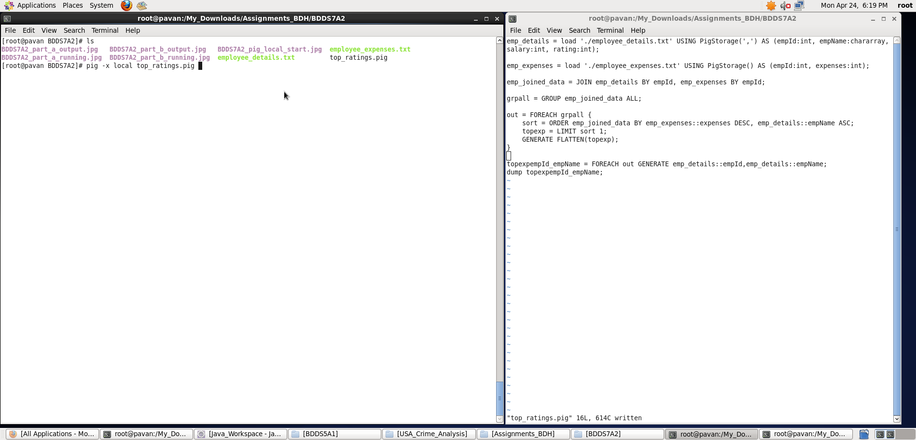

Output displayed: **<employee_id> <employee_name>**

**Note : We can store the output if required in a file using “store” command.**

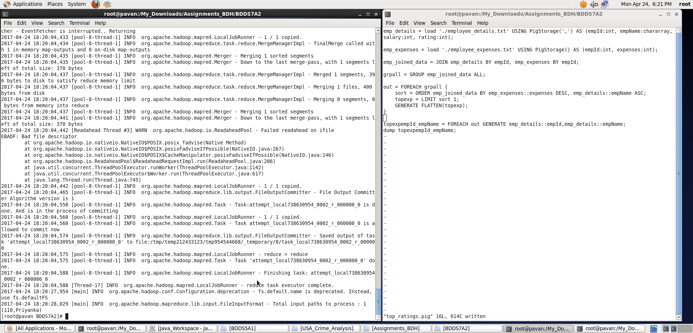

d) **List of employees (employee id and employee name) having entries in employee_expenses file**

**Pig Latin Script:**

emp_details = load './employee_details.txt' USING PigStorage(',') AS (empId:int, empName:chararray, salary:int, rating:int);

emp_expenses = load './employee_expenses.txt' USING PigStorage() AS (empId:int, expenses:int);

emp_joined_data = JOIN emp_details BY empId, emp_expenses BY empId;

out = FOREACH emp_joined_data GENERATE emp_details::empId,emp_details::empName;

list_emp_with_expenses = DISTINCT out;

dump list_emp_with_expenses;

**Explanation :**

* Loaded data from employee_details.txt into “emp_details” relation. Here ‘,’ is the delimiter and schema is provided as mentioned in the question
* Loaded data from employee_expenses.txt into “emp_expenses” relation. Here, schema is provided as mentioned in the question
* Both the relations are joined with the same key empID
* **Outputting only the list of employees: “the employee id and employee name” who have entries in expenses as per Question using dump command.**
* **Note: since expenses are provided twice for two employees, I have used DISTINCT to get the exact list without redundancy.**

Screenshots

Running **Pig Latin Script in Local Mode** inside /My_Downloads/Assignments_BDH/BDDS7A2/ directory

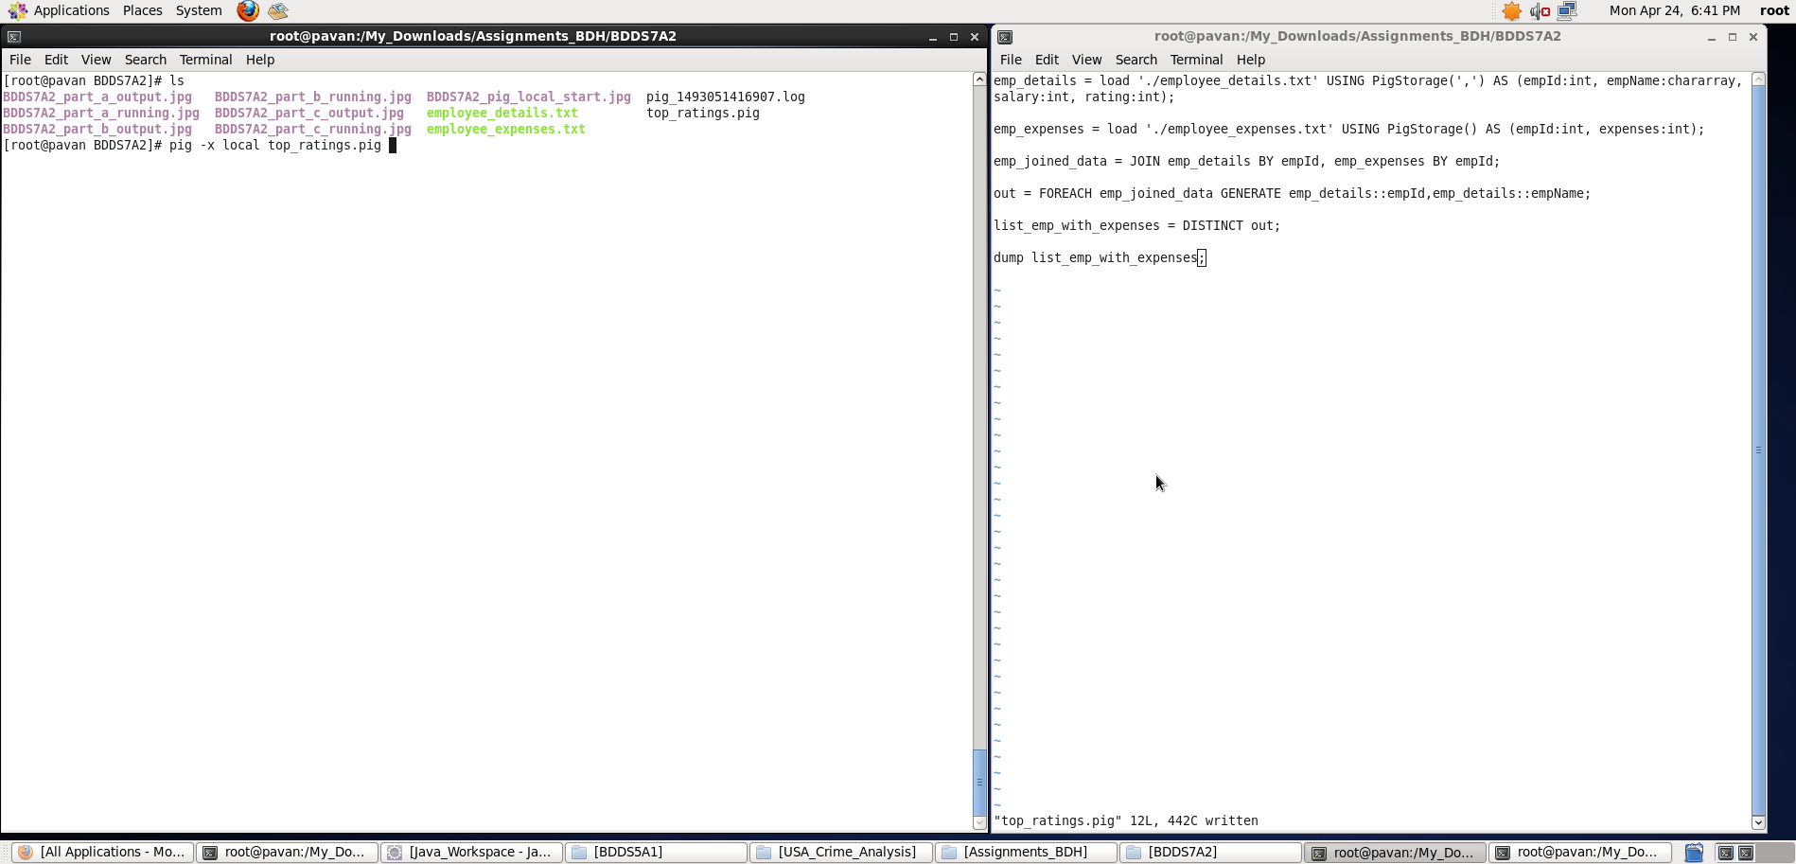

Output displayed: **<employee_id> <employee_name>**

**Note : We can store the output if required in a file using “store” command.**

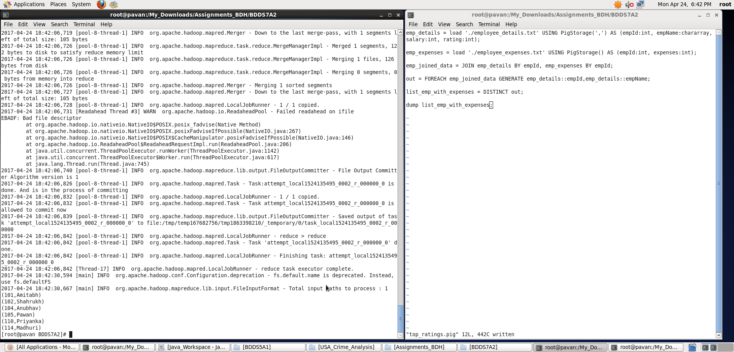

e) **List of employees (employee id and employee name) having no entry in employee_expenses file.**

**Pig Latin Script:**

emp_details = load './employee_details.txt' USING PigStorage(',') AS (empId:int, empName:chararray, salary:int, rating:int);

emp_expenses = load './employee_expenses.txt' USING PigStorage() AS (empId:int, expenses:int);

emp_joined_data = JOIN emp_details BY empId LEFT OUTER, emp_expenses BY empId;

dump emp_joined_data;

leftover = FILTER emp_joined_data BY emp_expenses::empId is null;

list_emp_no_expenses = FOREACH leftover GENERATE emp_details::empId,emp_details::empName;

dump list_emp_no_expenses;

**Explanation :**

* Loaded data from employee_details.txt into “emp_details” relation. Here ‘,’ is the delimiter and schema is provided as mentioned in the question
* Loaded data from employee_expenses.txt into “emp_expenses” relation. Here, schema is provided as mentioned in the question
* Both the relations are joined with the same key empID
* Note: Here emp_details relation is **LEFT OUTER Joined**
* **Now, filtering out those employees whose expenses field is NULL , we get the desired output**
* **Outputting only the list of employees: “the employee id and employee name” who don’t have entry in expenses as per Question using dump command.**

Screenshots

Running **Pig Latin Script in Local Mode** inside /My_Downloads/Assignments_BDH/BDDS7A2/ directory

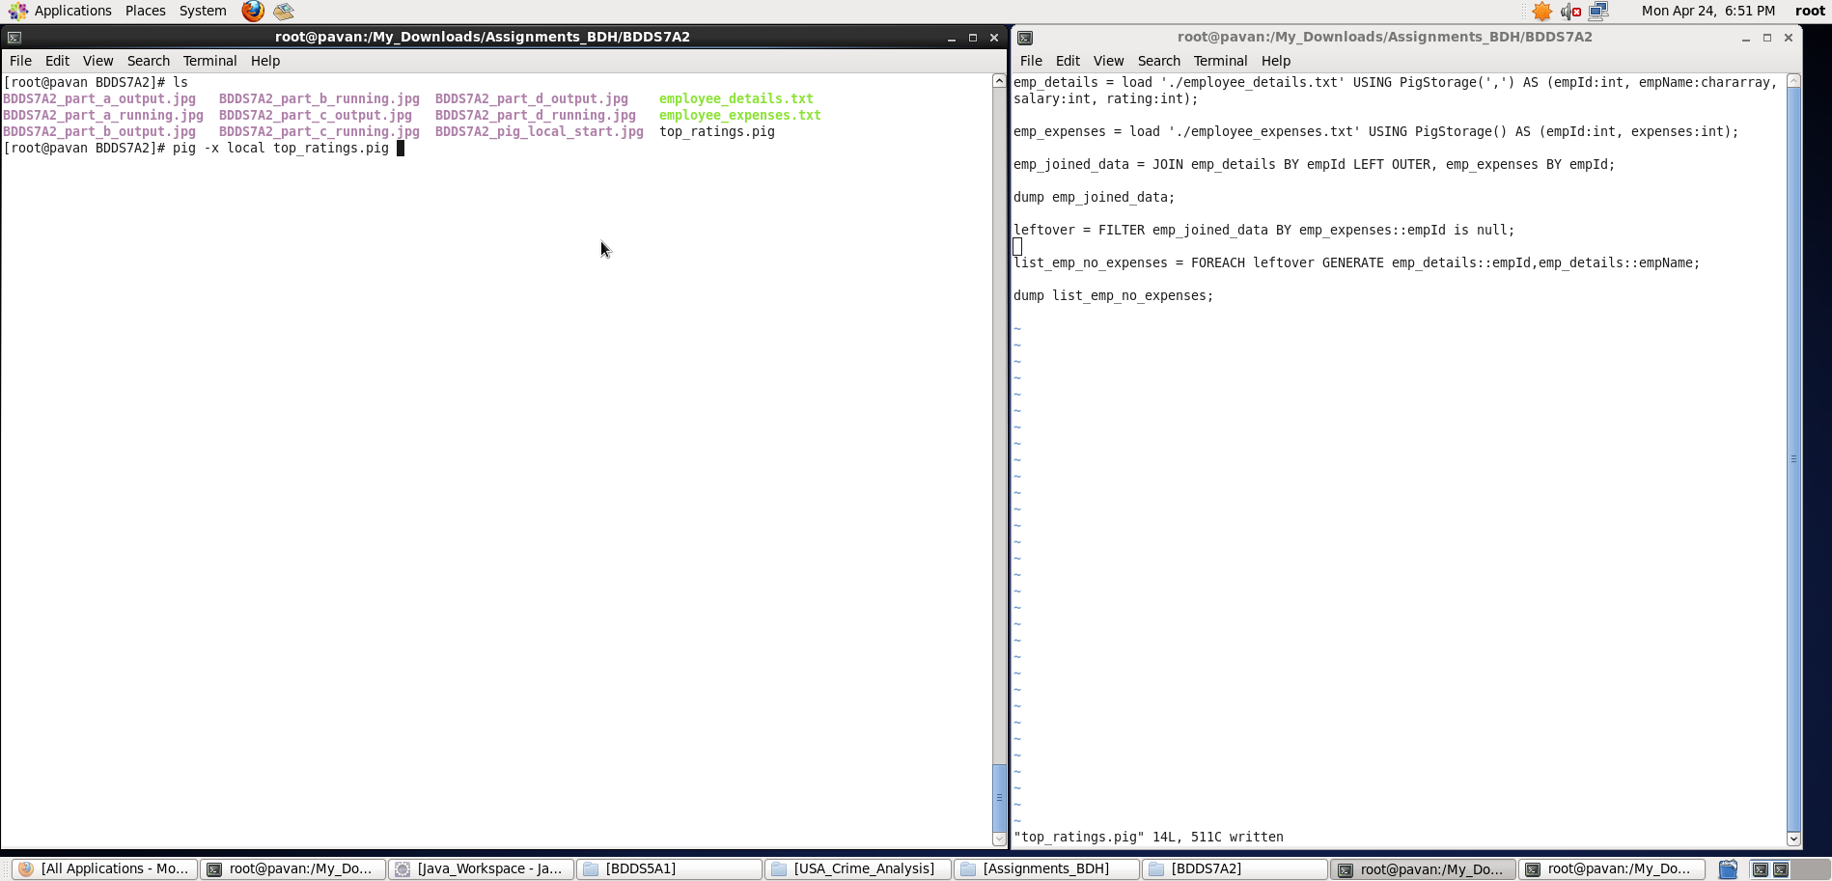

Output displayed: **<employee_id> <employee_name>**

**Note : We can store the output if required in a file using “store” command.**

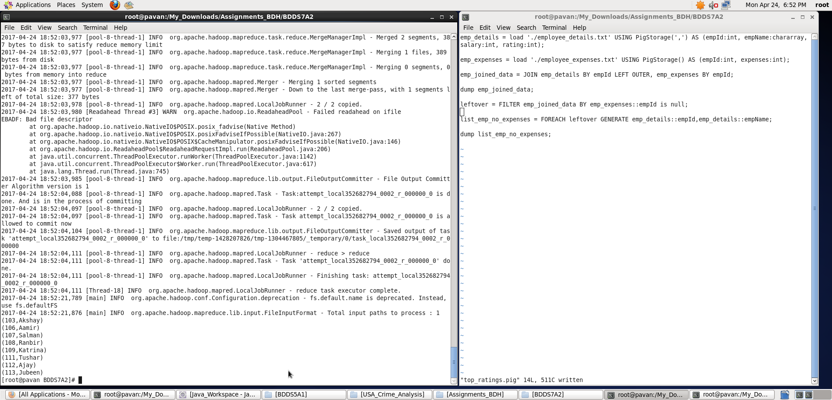

Thus, with the help of Pig Latin script , I have displayed the results for all the 5 tasks.