# Big Data Hadoop Training

Session 8 Assignment 1 Solution:

Task:

**Write a wordcount program to implement wordcount using Pig.**

**Sample dataset (used) –**

/My_Downloads/Assignments_BDH/BDDS8A2/data_set.txt

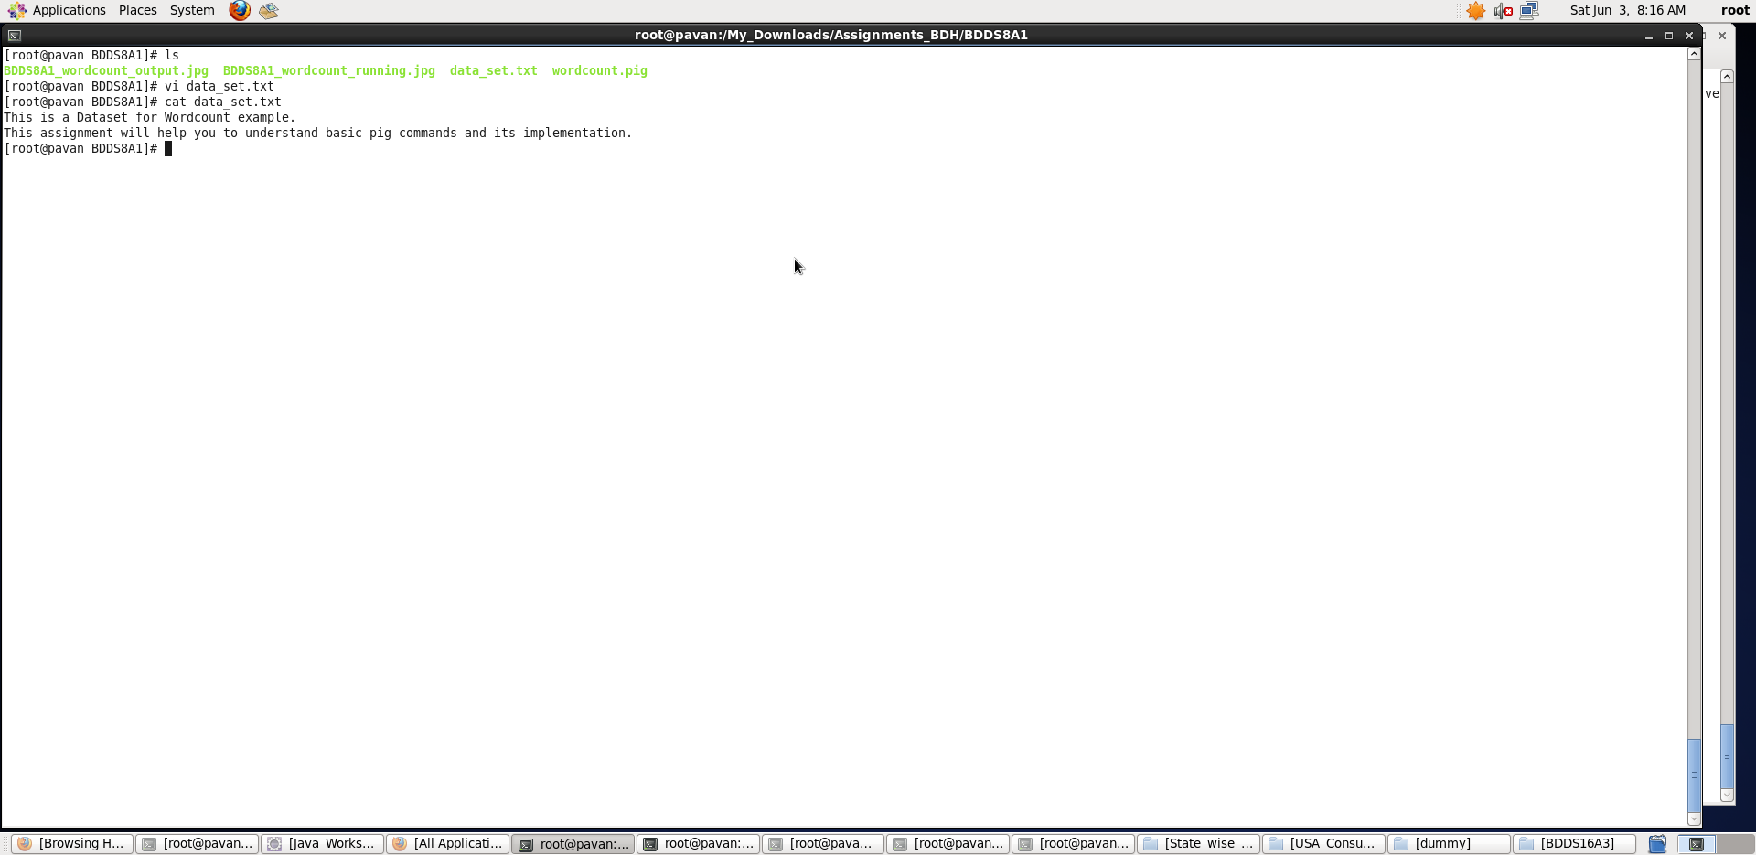

A) **Pig Latin Script**:

data_input = LOAD './data_set.txt' AS (line:chararray);

words = FOREACH data_input GENERATE FLATTEN(TOKENIZE(line,' ')) AS word;

grpallwords = GROUP words BY word;

wordcount = FOREACH grpallwords GENERATE group, COUNT(words);

dump wordcount;

**Explanation:**

* Loaded data from data_set.txt into “data_input” relation. Here the entire line is taken as one record – chararray.
* Then, foreach record, I have flattened the record and tokenized it with ‘ ’(space) as delimiter into words .
* Now, I have grouped all the words based on the word as key.
* Foreach group, I have counted the number of occurrences of that particular word – key using COUNT function.
* Outputting the word and its number of occurrences in the given entire file.

**Screenshots**

Running **Pig Latin Script in Local Mode** inside /My_Downloads/Assignments_BDH/BDDS8A1/ directory

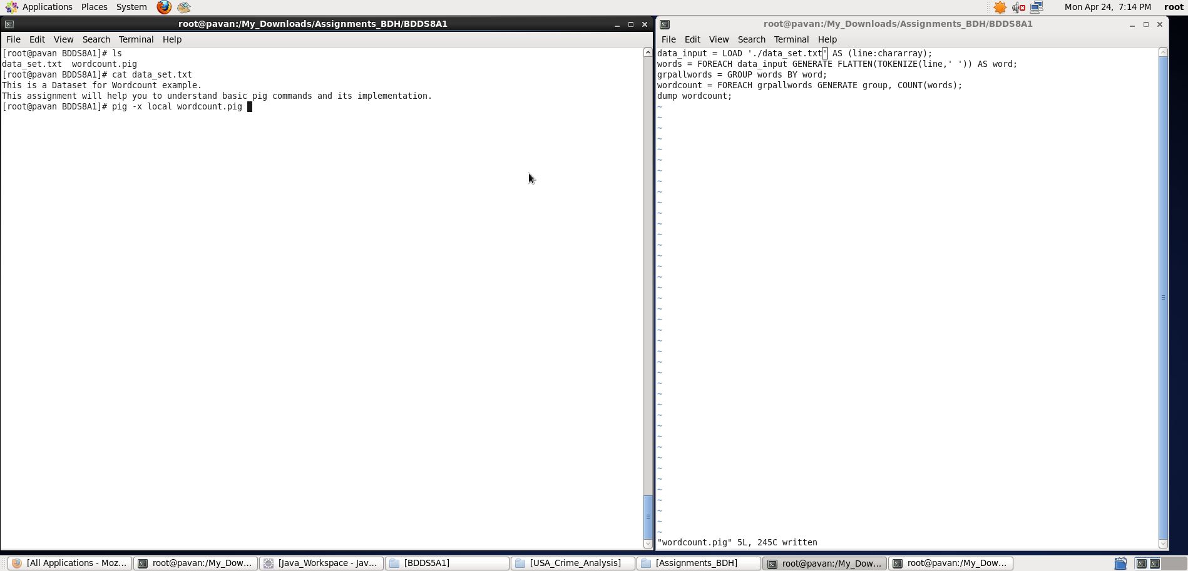

Output displayed: **<word> <number_of_occurrences>**

**Note: We can store the output if required in a file using “store” command.**

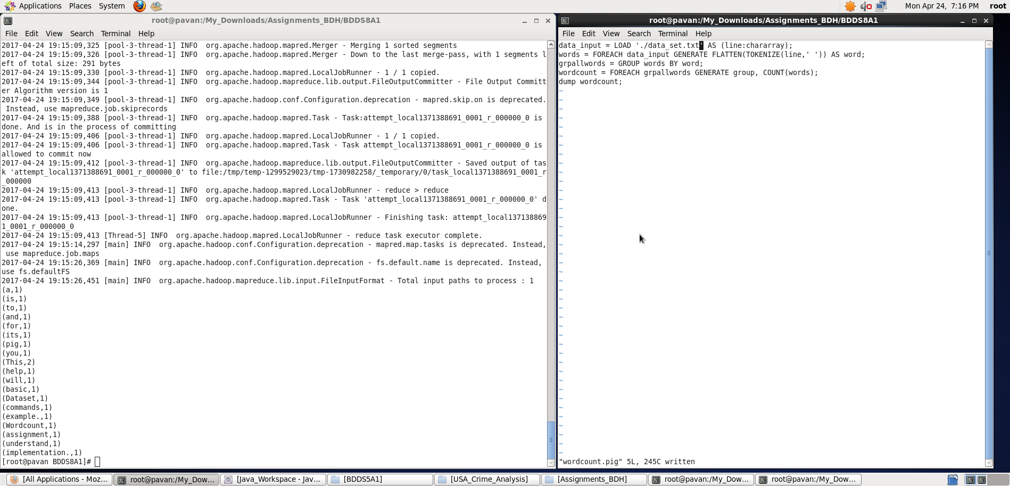

**Thus, a wordcount program implemented using Pig.**