# Big Data Hadoop Training

Session 9 Assignment 1 Solution

**DATA SET DESCRIPTION**

Column1: District.ID I4N 1M1 varchar

Column2: ,Distributer name shell varchar

Column3: Buy rate (million) $957.70 varchar

Column4: Sell rate(million) $5779.92 varchar

Column5: volumeIN(millioncubic litter) 933, int

Column6: volume OUT(millioncubic litter) 843, int

Column7: Year 1624 int

**Input file stored in HDFS @ /My_Downloads/Assignments_BDH/BDDS9A1 folder:**

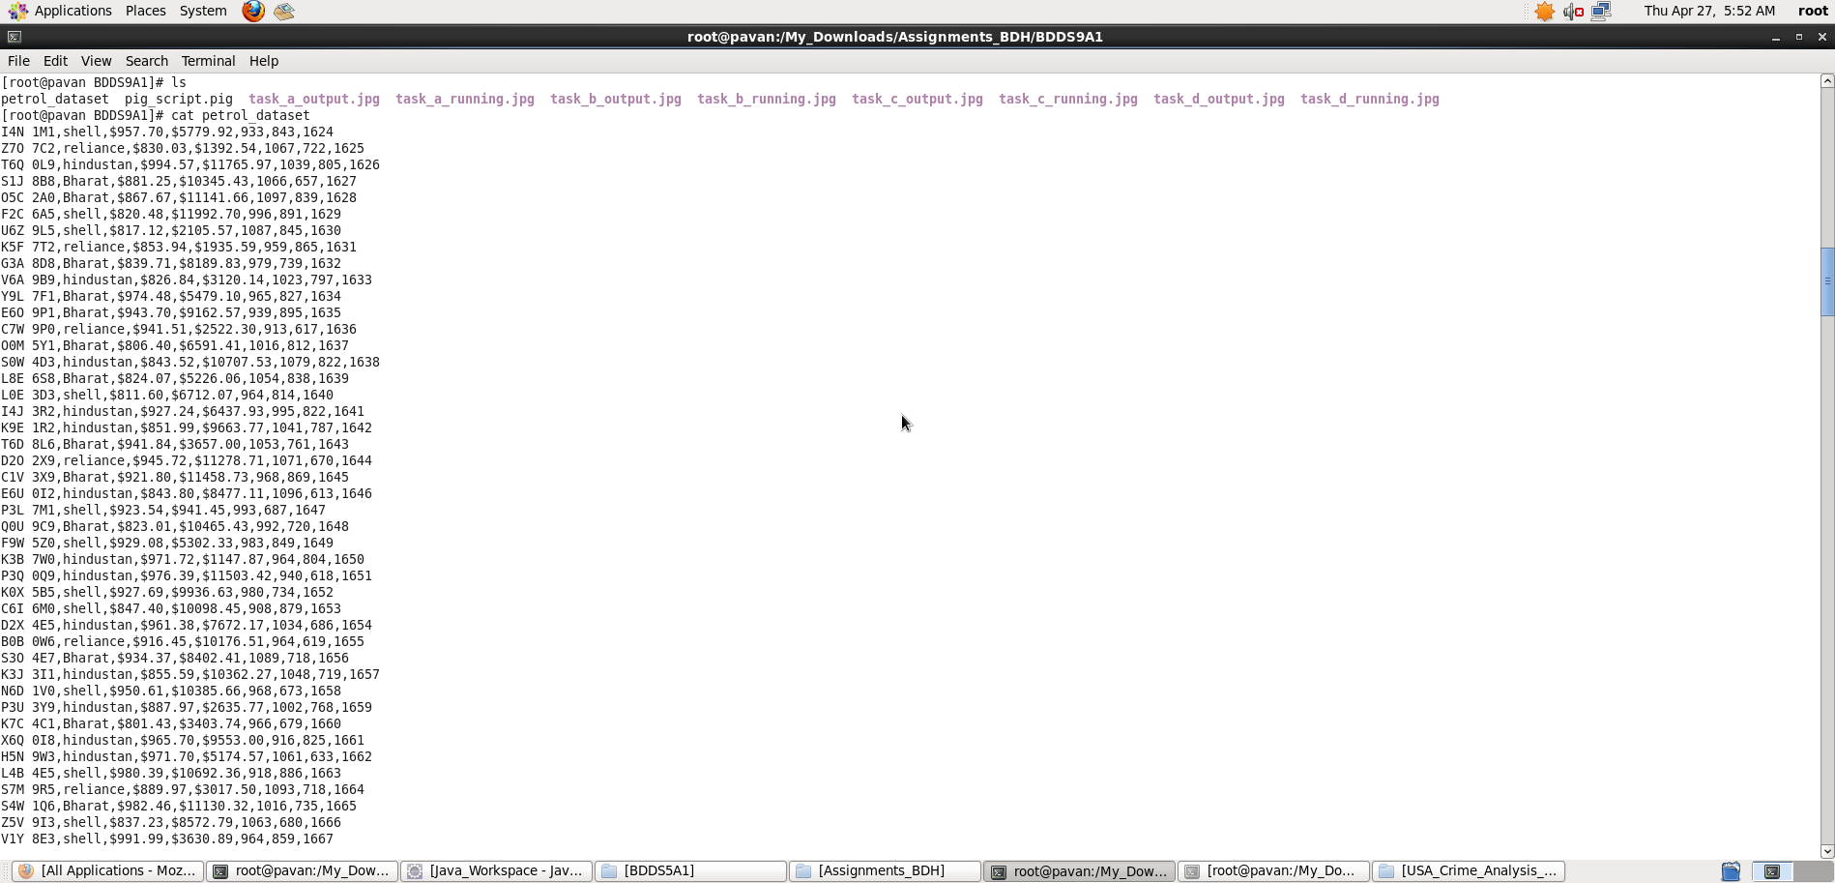

**(a) What is the total amount of petrol in volume sold by every distributer?**

A) **Pig Latin Script**:

petrol_dataset = LOAD './petrol_dataset' USING PigStorage(',') AS (district_ID:chararray, distributor_name:chararray, buy_rate:chararray, sell_rate:chararray, vol_in:int, vol_out:int, year:int);

distributor_group = GROUP petrol_dataset BY distributor_name;

out = FOREACH distributor_group GENERATE group, SUM(petrol_dataset.vol_out);

dump out;

**Explanation :**

* Loaded data from petrol_dataset into “petrol_dataset” relation. Here ‘,’ is the delimiter and schema is provided as mentioned in the question
* Then, all records are grouped together by the key – distributor name
* Now, foreach key inside the group, I have generated a relation with distributor_name and sum of ‘vol_out’ of each tuples that belong to this key.
* **Outputting “distributor_name, total_petrol_sold_in_vol” as per Question using dump command.**

Screenshots

Running **Pig Latin Script in Local Mode** inside /My_Downloads/Assignments_BDH/BDDS9A1/ directory

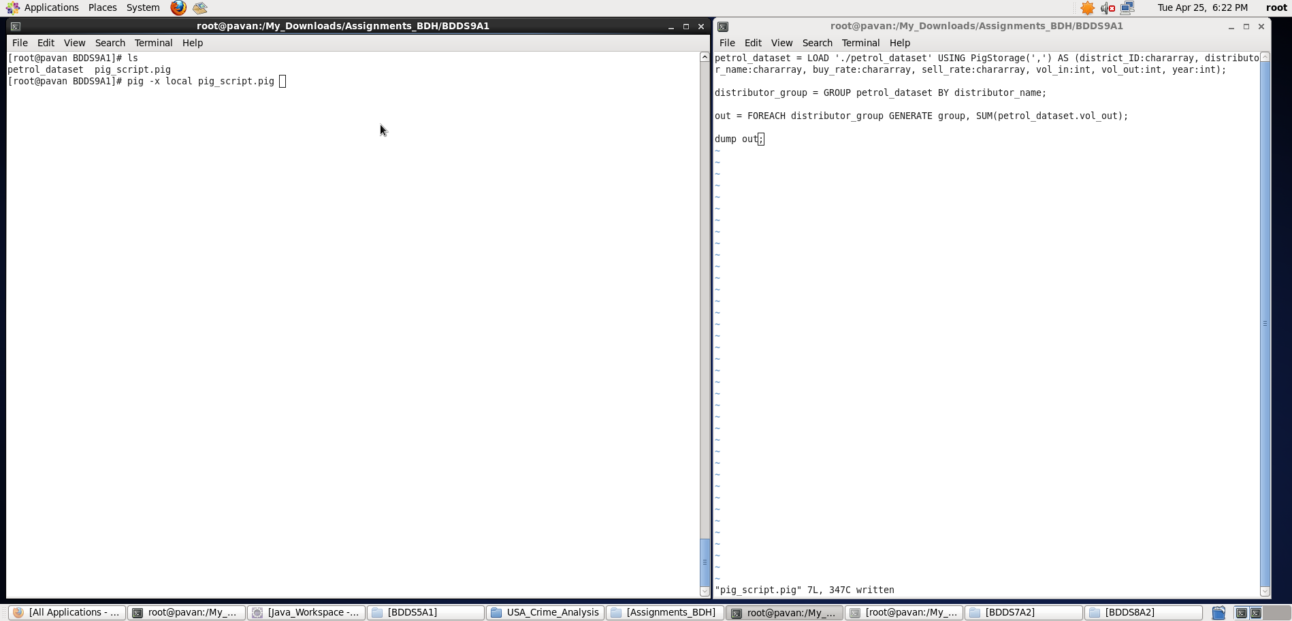

Output displayed: **<distributor_name> <total_petrol_sold_in_volume>**

**Note : We can store the output if required in a file using “store” command.**

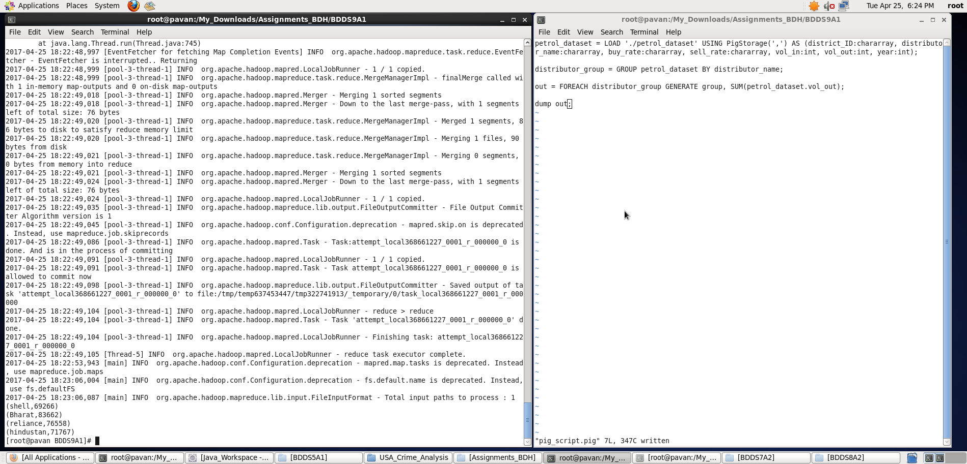

**b) Which are the top 10 distributers ID's for selling petrol? Also display the amount of petrol sold in volume.**

**Pig Latin Script:**

petrol_dataset = LOAD './petrol_dataset' USING PigStorage(',') AS (district_ID:chararray, distributor_name:chararray, buy_rate:chararray, sell_rate:chararray, vol_in:int, vol_out:int, year:int);

order_distributors_with_amt_petrol_sold = ORDER petrol_dataset BY vol_out DESC;

top10_distributors = LIMIT order_distributors_with_amt_petrol_sold 10;

out = FOREACH top10_distributors GENERATE district_ID, vol_out;

dump out;

**Explanation :**

* Loaded data from petrol_dataset into “petrol_dataset” relation. Here ‘,’ is the delimiter and schema is provided as mentioned in the question
* Now, for ordering the tuples in the relation, I have sorted the petrol_dataset by vol_out in descending order.
* Limiting my output to top 10 records
* **Outputting only “the distributor’s id and petrol_sold_in_volume” with highest seller first in descending order as per Question using dump command.**

Screenshots

Running **Pig Latin Script in Local Mode** inside /My_Downloads/Assignments_BDH/BDDS9A1/ directory

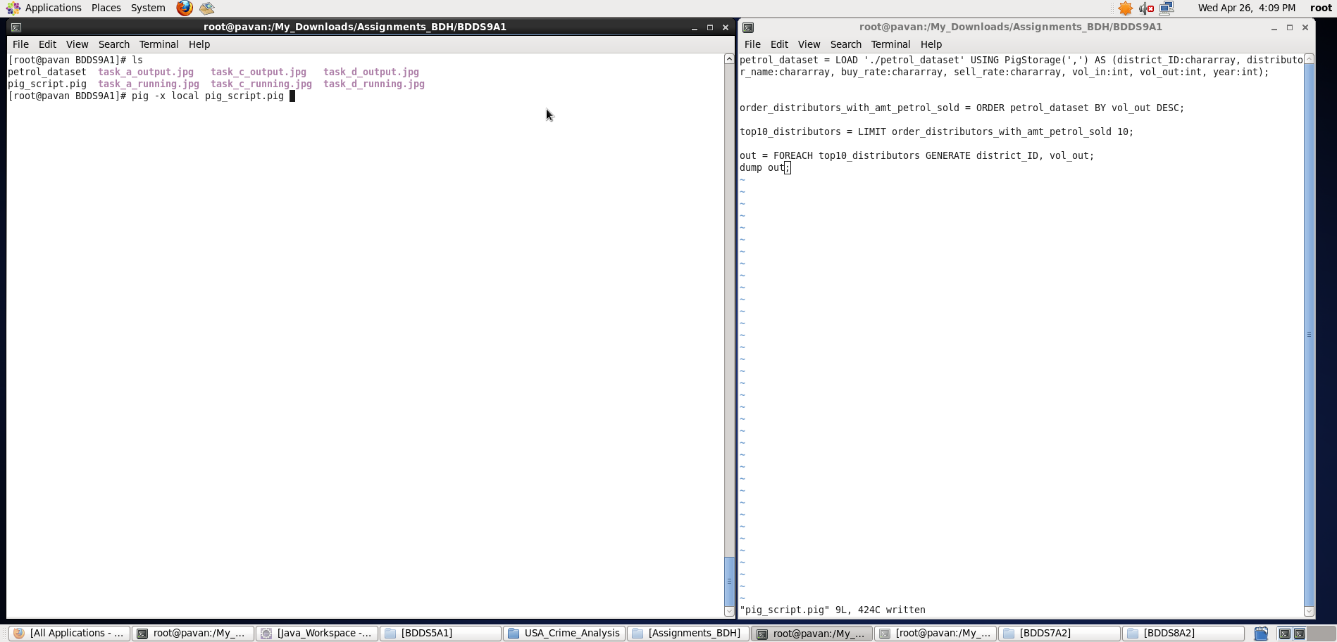

Output displayed: **<distributor_id> <petrol_sold_in_volume>**

**Note : We can store the output if required in a file using “store” command.**

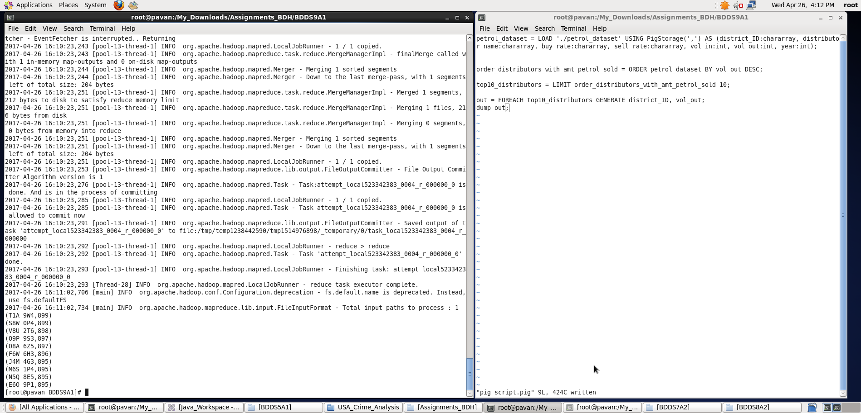

c) **List 10 years where consumption of petrol is more with the distributer id who sold it.**

**Pig Latin Script:**

petrol_dataset = LOAD './petrol_dataset' USING PigStorage(',') AS (district_ID:chararray, distributor_name:chararray, buy_rate:chararray, sell_rate:chararray, vol_in:int, vol_out:int, year:int);

filtering_more_consumption_entries = FILTER petrol_dataset BY (vol_in>vol_out);

list_only_ten = LIMIT filtering_more_consumption_entries 10;

out = FOREACH list_only_ten GENERATE year,district_ID;

dump out;

**Explanation :**

* Loaded data from petrol_dataset into “petrol_dataset” relation. Here ‘,’ is the delimiter and schema is provided as mentioned in the question
* Now, filtering the tuples in the relation in which consumption is more i.e. vol_in is greater than vol_out.
* Limiting my output to 10 records – **Note: Ordering is not asked in question – just list 10 entries**
* **Outputting only “year and distributor ID” whose consumption is more per Question using dump command.**

Screenshots

Running **Pig Latin Script in Local Mode** inside /My_Downloads/Assignments_BDH/BDDS9A1/ directory

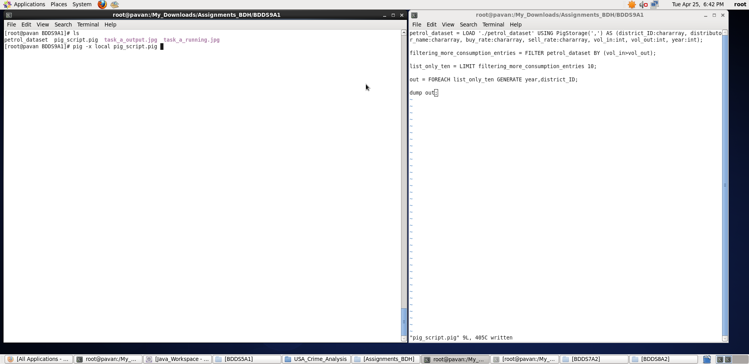

Output displayed: **<year> <distributor_id>**

**Note : We can store the output if required in a file using “store” command.**

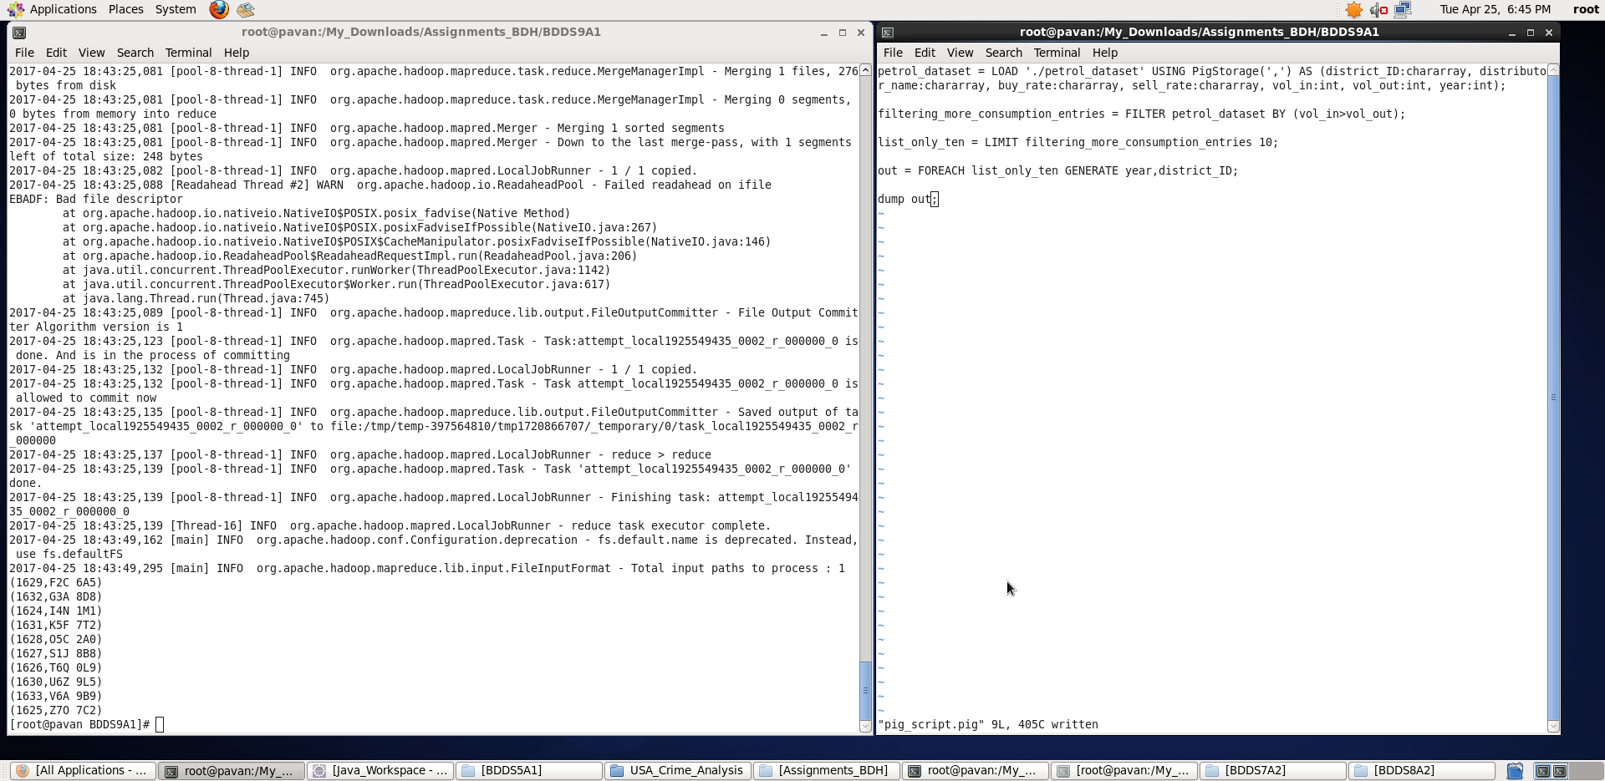

d) **Find the distributer name who sold petrol in least amount.**

**Pig Latin Script:**

petrol_dataset = LOAD './petrol_dataset' USING PigStorage(',') AS (district_ID:chararray, distributor_name:chararray, buy_rate:chararray, sell_rate:chararray, vol_in:int, vol_out:int, year:int);

order_distributors_with_amt_petrol_sold = ORDER petrol_dataset BY vol_out ASC;

distributor_with_least_petrol_sold = LIMIT order_distributors_with_amt_petrol_sold 1;

dump distributor_with_least_petrol_sold;

**Explanation :**

* Loaded data from petrol_dataset into “petrol_dataset” relation. Here ‘,’ is the delimiter and schema is provided as mentioned in the question
* Now, for ordering the tuples in the relation, I have sorted the petrol_dataset by vol_out in ascending order.
* Limiting my output to top 1 record i.e. the distributor who sold petrol the least.
* **Outputting only: “entire info of distributor” who sold least petrol as per Question using dump command.**

Screenshots

Running **Pig Latin Script in Local Mode** inside /My_Downloads/Assignments_BDH/BDDS9A1/ directory

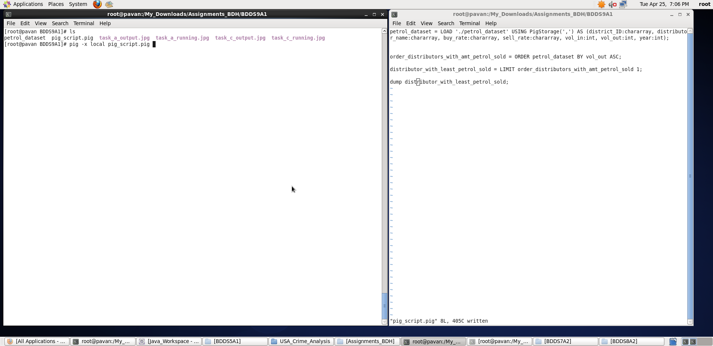

Output displayed: <**district_ID> <distributor_name> <buy_rate> <sell_rate> <vol_in> <vol_out> <year>**

**Note : We can store the output if required in a file using “store” command.**

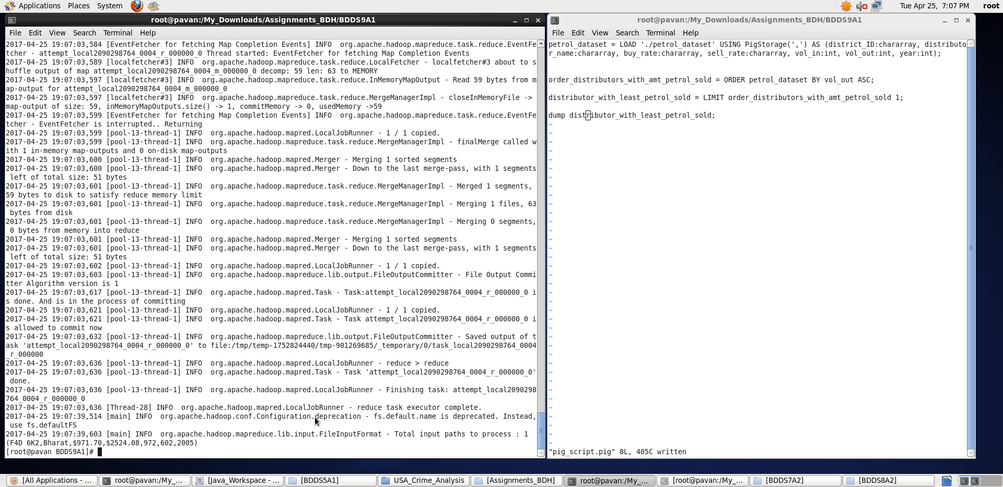

Thus, with the help of Pig Latin script, I have displayed the results for all the 4 tasks.