CAMPUS EVENT MANAGEMENT SYSTEM

A PROJECT REPORT

Submitted by
P Harshitha | Reg.no:221801340021
M Mounika Rathnam | Reg.no: 22180138013
G Amrutha | Reg.no:221801380006
Y Chenna Pavan Reddy | Reg.no:221801340008
Y Uday Raju | Reg.no:221801380027
Ch Vamsi Sivamani | Reg.no:221801380036
G Karthik Srinivas | Reg.no:221801340012
Under the esteemed guidance of

Siddharth Kumar
in partial fulfillment for the award of the degree of
BACHELOR OF TECHNOLOGY
in

COMPUTER SCIENCE AND ENGINEERING

DEPARTMENT OF COMPUTER SCIENCE AND ENGINEERING SCHOOL OF ENGINEERING AND TECHNOLOGY
VIZIANAGARAM CAMPUS
CENTURION UNIVERSITY OF TECHNOLOGY AND MANAGEMENT

ANDHRA PRADESH 2024 - 2025

BONAFIDE CERTIFICATE

Certified that this project report Campus Event Management System is the bonafide work of “P.Harshitha (221801340021), M.MounikaRathnam(221801380013), G.Amrutha
(221801380006),Y.ChennaPavanReddy(221801340008),Y.UdayRaju(221801330027), Ch.VamsiSivamani(221801380036),G.KarthikSrinivas(221801340012)” who carried out the project work under my supervision. This is to further certify to the best of my knowledge, that this project has not been carried out earlier in this institute and the university.

SIGNATURE
Siddharth Kumar

Certified that the above mentioned project has been duly carried out as per the norms of the college and statutes of the university.

SIGNATURE
Dr. P. SUBRAT KUMAR
HOD, Associate Professor

HEAD OF THE DEPARTMENT / DEAN OF THE SCHOOL
Professor of Computer Science and Engineering DEPARTMENT SEA

DECLARATION

We hereby declare that the project entitled “Campus Event Management System” submitted to the fulfillment of the award of the degree of B.Tech(CSE) in Centurion University of Technology and Management, Vizianagaram. This project work in original has not been submitted so far in any part or full for any other university or institute for the award of any degree or diploma.

P.Harshitha | 221801340021
M.Mounika Rathnam | 221801380013
G.Amrutha | 221801380006
Y.Chenna Pavan Reddy | 221801340008
Y.Uday Raju | 221801380027
Ch.Vamsi Sivamani | 221801380036
G.KarthikSrinivas | 221801340012

ACKNOWLEDGEMENT

We wish to express my profound and sincere gratitude to Siddharth Kumar , Department of Computer Science and Engineering, SoET Centurion University, Vizianagaram Campus, who guided me into the intricacies of this project nonchalantly with matchless magnanimity.

We thank Dr. Subrat Kumar Parida, Head of the Dept. of Department of Computer Science and Engineering, SoET, Centurion University, Vizianagaram Campus for extending their support during Course of this investigation.

We extend deep appreciation to Dr. P.A. Sunny Dayal, the Dean of SoET, Centurion University, Vizianagaram Campus for his help, leadership, and the conducive academic environment fostered at our institution. Their unwavering commitment to excellence had set a benchmark for all.

I thank Dr. P. Pallavi, Registrar, CUTM, Vizianagaram Campus for their assistance and cooperation in facilitating the necessary resources and administrative support essential for the successful execution of this project.

Special gratitude is extended to Dr. P.K. Mohanty, the Vice Chancellor of Centurion University, Vizianagaram, for providing a conducive and inspiring educational ecosystem.

A heartfelt note of appreciation goes to all staff members who, in various capacities, contributed to the success of our project. Dedication and collective effort have been indispensable, and we sincerely thank them for their collaboration.

I express my deepest gratitude to my parents for their unwavering support, encouragement, and the countless sacrifices they made, which played an integral role in the success of this project.

ABSTRACT

Campus Event Management System (CEMS) is a comprehensive digital platform designed to enhance the efficiency and effectiveness of organizing and managing events within educational institutions. With the increasing complexity and diversity of campus events, ranging from academic seminars to cultural festivals, there arises a need for a centralized system to streamline the entire event lifecycle, from planning and promotion to execution and feedback collection. CEMS offers a user-friendly interface accessible to both event organizers and participants, facilitating seamless communication and collaboration. Organizers can create and customize event profiles, manage registrations, allocate resources, and track attendance through intuitive dashboards. Moreover, the system provides robust marketing tools, including email campaigns, social media integration, and personalized notifications, to maximize event visibility and engagement among the campus community. For attendees, CEMS offers a centralized platform to discover upcoming events, register with ease, access event details, and provide feedback post-event. Integration with calendar applications ensures that users stay informed about their registered events and receive timely reminders. Additionally, interactive features such as live polling, Q&A sessions, and feedback surveys enhance participant involvement and enable organizers to gather valuable insights for future improvements.

INDEX

ACKNOWLEDGEMENTS I
ABSTRACT 2
INDEX…………………………………………………………………………………..3
CHAPTER 1: INTRODUCTION 4
  - PURPOSE 4
  - INTENDED AUDIENCE 5
  - SCOPE 5
CHAPTER 2: LITERATURE SURVEY 6
2.1 Specifications…………………………………………………………..7
CHAPTER 3: OVERALL DESCRIPTION 8
3.1 Existing system 8
3.1.1 Proposed system…………………………………………………………….9
3.1.2 Operational Environment……………………………………………………10
3.1.3 User Characteristics…………………………………………………………11
3.1.5 Functional requirements…………………………………………………….12
3.1.6 Non -Functional Requirements……………………………………………….13
3.1.7 Hardware Requirements…………………………………………………….14
3.1.8 Software Requirements…………………………………………………….15
3.2 BENEFITS 16
CHAPTER 4: RESULT AND DISCUSSION 17
  - Visualization 18
  - Prediction and Outputs 29
CHAPTER 5: IMPLEMENTATION 32
5.1 CODE IMPLEMENTAION……………………………………………………33
5.2 OUTPUTS……………………………………………………………………..50
CHAPTER 6.CONCLUSIONS 54
REFERENCES 55
APPENDIX…………………………………………………………………………….56
GITHUB LINK………………………………………………………………………..56

INTRODUCTION

In the bustling landscape of educational institutions, events serve as vibrant hubs of learning, cultural exchange, and community engagement. From academic symposiums to lively student festivals, these occasions play a pivotal role in shaping the dynamic fabric of campus life. However, orchestrating these events seamlessly amidst the myriad of logistical challenges and diverse participant expectations is no small feat. Recognizing this need for efficiency and innovation, the Campus Event Management System (CEMS) emerges as a transformative solution poised to revolutionize event organization within universities and colleges.

CEMS represents a paradigm shift in how institutions approach event planning and execution. Gone are the days of cumbersome spreadsheets, scattered communication channels, and manual registration processes. Instead, CEMS offers a centralized digital platform that empowers organizers with the tools and insights necessary to orchestrate successful events with precision and ease. By leveraging cutting-edge technology, intuitive interfaces, and data-driven analytics, CEMS streamlines every facet of the event lifecycle, from initial planning to post-event evaluation.

1.1 Purpose:

A campus event management system serves as the central hub for organizing and coordinating various events within an educational institution. Its purpose is multifaceted, aiming to streamline the entire event planning process while enhancing communication and engagement among students, faculty, and staff. Such a system facilitates efficient scheduling of events, allocation of resources, and coordination of logistics, ensuring smooth execution from planning to post-event evaluation. Additionally, it fosters community involvement by providing a platform for promoting events, gathering feedback, and fostering collaboration among different campus groups. Ultimately, a well-designed campus event management system enhances the overall campus experience, enriching student life, academic discourse, and institutional culture.

1.2 Intended Audience

The intended audience for a campus event management system comprises various stakeholders within the educational institution, including students, faculty, staff, and administrators. Students benefit from such a system by gaining access to a comprehensive calendar of events, enabling them to stay informed about campus activities and opportunities for involvement. Faculty members can utilize the system to schedule academic events, seminars, and workshops, fostering intellectual exchange and enhancing the learning experience. Staff members responsible for event planning and logistics benefit from the system's organizational tools, facilitating efficient coordination and resource allocation. Administrators use the system to oversee campus-wide event planning, monitor engagement metrics, and ensure alignment with institutional goals. By catering to the diverse needs of these stakeholders, a campus event management system serves as a vital tool for fostering community engagement, enriching campus life, and promoting institutional objectives.

1.3 Scope:

The scope for a Campus Event Management System (CEMS) is broad, encompassing various aspects of event planning, coordination, and execution within an educational institution. At its core, a CEMS facilitates the scheduling and management of a wide range of events, including academic conferences, workshops, student club activities, cultural performances, sports tournaments, and administrative functions. It provides features for event creation, registration, ticketing, and promotion, allowing organizers to efficiently plan and advertise their events to the campus community. Additionally, a CEMS typically includes tools for managing event logistics, such as venue booking, equipment rental, catering services, and volunteer coordination. Beyond event planning, CEMS often integrates features for post-event evaluation, feedback collection, and data analysis, enabling organizers to assess the success of their events and make informed decisions for future planning. The scope of a CEMS extends to enhancing campus engagement, fostering community connections, and promoting a vibrant and inclusive campus culture. Overall, a well-implemented CEMS serves as a comprehensive platform for optimizing the entire event management process and enriching the overall campus experience for students, faculty, staff, and visitors alike.

RELATED WORK

2.1 Specifications of the Campus Event Management System Project about CUTM, Andhra Pradesh , Bhubaneswar , Parlakhemundi

Introduction to CEMS Websites:

Campus Event Management System (CEMS) websites serve as centralized platforms for organizing and coordinating various events within educational institutions. These websites are designed to streamline the event planning process, making it easier for students, faculty, staff, and administrators to create, manage, and attend events.

Website Design and User Experience:

CEMS places a strong emphasis on user-centric design, prioritizing simplicity and clarity in its layout and interactions. Whether it's event discovery, registration, or feedback submission, each step is designed to be intuitive and friction less, minimizing barriers to engagement and maximizing user satisfaction. Visual elements such as color schemes, typography, and imagery are carefully curated to enhance readability, accessibility, and aesthetic appeal, creating an immersive and enjoyable browsing experience for users.

Content Strategy:

To effectively manage campus events across three campuses, a comprehensive content strategy is essential. This strategy should focus on clear communication, engaging content creation, and efficient dissemination. Firstly, establish a centralized platform, such as a dedicated website or app, to serve as the primary hub for event information. This platform should feature intuitive navigation, detailed event listings, and interactive features for user engagement. Secondly, leverage various communication channels, including social media, email newsletters, and campus bulletin boards, to promote events and engage the campus community. Tailor content for each channel to maximize reach and relevance.

Functionality and Interactivity:

A comprehensive campus event management system for three campuses should prioritize functionality and interactivity to streamline organization and engagement. This system would integrate features such as event scheduling, venue reservation, attendee registration, and communication channels. Each campus would have its dedicated portal accessible to students, faculty, and administrators.

Impact on Student Recruitment and Engagement:

Implementing a campus event management system across three campuses can significantly impact student recruitment and engagement. By centralizing event organization and promotion, the system can showcase the diverse range of activities available, highlighting the vibrancy of campus life. Prospective students gain insight into the dynamic community they could join, leading to increased interest and enrollment.

Challenges and Future Directions:

As campus event management systems evolve to encompass multiple campuses, several challenges and future directions emerge. One challenge is ensuring seamless integration and synchronization across campuses, considering variations in scheduling, resources, and organizational structures. Coordination among campus administrators and stakeholders becomes crucial to maintain consistency and efficiency.

Conclusion:

Implementation of a campus event management system across three campuses presents a transformative opportunity to enhance student engagement, streamline organization, and foster a vibrant campus community. By centralizing event planning, promotion, and communication, the system facilitates seamless coordination and accessibility for students, faculty, and administrators alike. Challenges such as integration and scalability are met with innovative solutions, leveraging emerging technologies and prioritizing inclusivity.

Overall Description

3.1 Proposed System

The proposed campus event management system for Centurion University's three campuses aims to revolutionize the organization and coordination of events while fostering community engagement and participation. This comprehensive system will serve as a centralized platform accessible to students, faculty, staff, and administrators across all campuses, facilitating seamless communication and collaboration. Its primary purpose is to streamline the event planning process by providing intuitive tools for event creation, scheduling, and management. Through features such as automated venue booking, resource allocation, and logistics management, organizers will be able to plan a diverse range of events efficiently, from academic conferences to cultural festivals and sports tournaments. Additionally, the system will enhance communication and promotion efforts through integrated channels such as email notifications, social media integration, and event calendars, ensuring maximum visibility and participation. Attendees will benefit from user-friendly interfaces for event registration, ticketing, and feedback collection, as well as mobile accessibility for on-the-go access to event information and updates. Furthermore, robust data analytics capabilities will enable organizers to track attendance, gather feedback, and evaluate event success metrics, providing valuable insights for future planning and decision-making. Ultimately, the proposed campus event management system will play a pivotal role in fostering a vibrant and inclusive campus culture across all Centurion University campuses, enriching the overall student experience and strengthening community bonds.

3.1.1 Functional Requirements

➢ Event Creation and Scheduling:
- Allow authorized users to create new events.
- Specify event details such as title, description, date, time, duration, and location.
- Enable recurring events for regular meetings or activities.
- Set event visibility (public, private, or restricted access).
➢ Communication Tools:
- Support event promotion through email notifications, social media integration.
- Enable communication between organizers, attendees.
- Provide customizable templates for event invitations, reminders, and follow-ups.

➢ Feedback Collection:
- Offer surveys or feedback forms for attendees to provide post-event evaluations.
- Collect feedback on various aspects of the event including content, organization.
- Analyze feedback to identify areas for improvement and gauge event success.
➢ Calendar Integration:
- Sync event schedules with popular calendar applications (e.g., Google Calendar, Outlook).
- Enable users to subscribe to event calendars for automatic updates.
- Ensure consistency and accuracy between the event management system and external calendar platforms.
-By incorporating these features, a campus event management system can streamline the planning, execution, and evaluation of events while enhancing the overall experience for organizers, attendees, and administrators alike.

- 3.1.2 Non- Functional Requirements:

- Usability:

Requirement 1: The system should have an intuitive and user-friendly interface, ensuring ease of navigation and minimizing the learning curve for users.
Requirement 2: All user interactions within the system should be intuitive and require minimal effort from the user to complete tasks such as event creation, registration, and attendance tracking.
Requirement 3: The system should support customization and professionalization features, allowing users to tailor their experience based on their preferences and requirements.
- Performance:
Requirement 1: The system should provide fast response times for user interactions, ensuring that users can perform tasks quickly and efficiently without experiencing delays or latency.
Requirement 2: System components should be optimized for performance, with efficient algorithms and data structures to handle large volumes of data and concurrent user activity.
Requirement 3: The system should be able to handle peak loads and spikes in user activity without degradation in performance or loss of functionality.
- Scalability:
Requirement 1: The system architecture should be designed to scale horizontally and vertically to accommodate growth in the number of users, events, and data volume over time.
Requirement 2: Provisioning mechanisms should be in place to allocate additional resources (e.g., servers, storage) dynamically to meet increased demand during peak periods.
Requirement 3: The system should support distributed computing and caching strategies to distribute workload and improve scalability across multiple servers or data centers.
- Security:
Requirement 1: The system should implement robust authentication mechanisms to verify the identity of users and prevent unauthorized access to sensitive data and functionalities.
Requirement 2: Data encryption should be used to protect sensitive information such as user credentials, personal data, and event details stored in the system's database.
Requirement 3: Access controls and permissions should be enforced to ensure that users can only access data and perform actions appropriate to their roles and responsibilities.

3.2 SYSTEM REQUIREMENT SPECIFICATION

3.2.1 Minimum Hardware Requirements

RAM | 8gb or above
Hard disk
processor (NULL BORDER)

3.2.2 Software Requirements

Frontend Framework (HTML, CSS, JAVASCRIPT) ,
Backend - PHP, MYSQL

3.3 UML DIAGRAMS ( Usecase , Sequence)

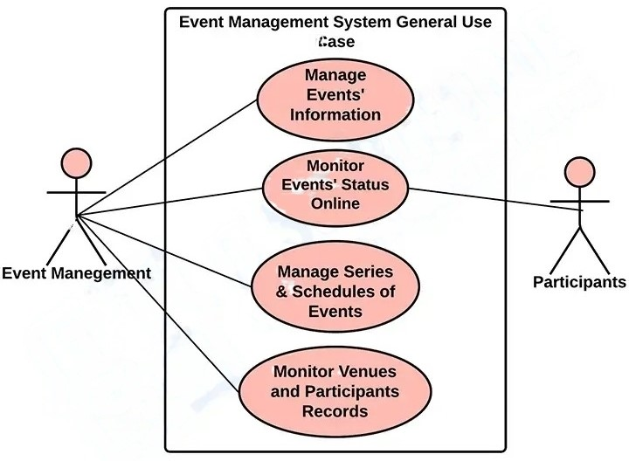

3.4 Flow Chart

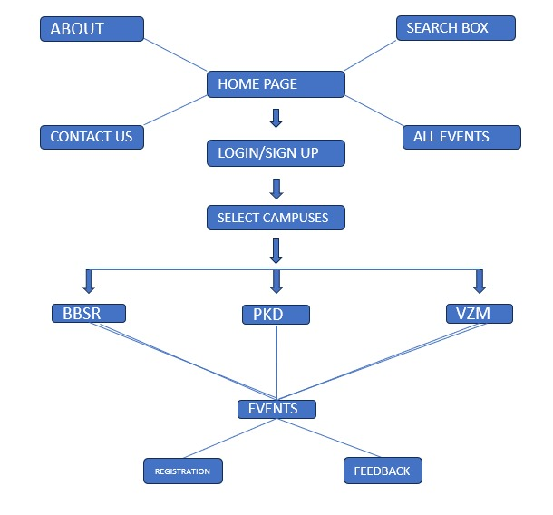

Technology Description

Overview of Languages and Technologies Used in whole website

HTML (HyperText Markup Language)
HTML is the foundational language for creating web pages. It defines the structure and layout of the web content through various elements such as headings, paragraphs, images, links, and sections. In this case, HTML is used to structure the entire home page, including the header, navigation bar, carousel, club sections, and footer, forms, div tags.

CSS (Cascading Style Sheets)
CSS is used to style and layout web pages. It allows for the separation of content from design by providing various styling options for HTML elements. This page uses CSS for:

Custom Styles: Specific styles defined within a <style> tag to tailor the look and feel of the page, including colors, fonts, and layout adjustments.
External CSS Frameworks:
Font Awesome: A library used to include scalable vector icons that can be customized with CSS.
Internal CSS Frameworks:
CSS saves a lot of work. It can control the layout of multiple web pages all at once.
Bootstrap: A popular CSS framework that simplifies the design of responsive and mobile-first web pages. It provides pre-defined classes for grid layouts, components, and utilities.
JavaScript:
JavaScript is a programming language that enables interactive and dynamic content on web pages. For this webpage:

Libraries:
jQuery: A fast, small, and feature-rich JavaScript library that simplifies HTML document manipulation, event handling, and animation.
Bootstrap JS: The JavaScript part of Bootstrap, providing interactive components like modals, tooltips, and carousels.
Custom Scripts: Custom JavaScript functions are used to toggle the side navigation menu's visibility, enhancing user interaction.
Images
Images play a crucial role in enhancing the visual appeal of the webpage. They are used for:

Logo: To display the college logo prominently.
Carousel: To showcase various slides in a rotating banner.
Clubs: To visually represent different student clubs with icons.
Links
Hyperlinks are essential for navigation and connectivity within the web page and to external resources. They are used to:

Navigate to other pages within the website (like "Home," "About," and "Contact Us").
Direct users to sign-up forms and club information.
Connect to external social media platforms, enhancing the web page’s reach and engagement.

IMPLEMENTATION CODE

A campus event management software project coordination, and execution of campus events, providing tools for scheduling events and feedback system.

<!DOCTYPE html>
<html lang="en">
<head>
<meta charset="UTF-8">
<meta name="viewport" content="width=device-width, initial-scale=1.0">
<title>College Home Page</title>
<!-- Include Font Awesome CSS -->
<link rel="stylesheet" href="https://cdnjs.cloudflare.com/ajax/libs/font-awesome/5.15.4/css/all.min.css">
<!-- Include Bootstrap CSS -->
<link rel="stylesheet" href="https://stackpath.bootstrapcdn.com/bootstrap/4.5.2/css/bootstrap.min.css">
<style>
body {
margin: 0;
padding: 0;
font-family: Arial, sans-serif;
background-color: #000; /* Black background */
color: #fff; /* White text color */
min-height: 100vh; /* Ensure page fills viewport */
position: relative; /* Needed for absolute positioning */
}
.header {
position: relative;
display: flex;
justify-content: space-between;
align-items: center;
padding: 20px;
background-color: #000; /* Black background */
}
.logo-container {
text-align: center;
}
.logo {
max-width: 150px;
max-height: 150px;
margin-bottom: 10px;
}
.nav-links {
display: flex;
align-items: center;
}
.nav-links a {
color: #fff;
text-decoration: none;
margin-right: 20px;
font-size: 18px;
}
.container {
position: relative;
width: 80%;
margin: 20px auto 50px; /* Add margin-bottom: 50px; */
padding: 20px;
text-align: center;
background: linear-gradient(to bottom, #333333, #000000);
color: #fff;
border-radius: 10px;
box-shadow: 0px 0px 20px rgba(0, 0, 0, 0.2);
z-index: 1;
}

.signup-btn {
position: absolute;
top: 20px;
right: 20px;
background: linear-gradient(to bottom, #007bff, #0056b3);
color: #fff;
padding: 10px 20px;
border: none;
border-radius: 5px;
cursor: pointer;
font-size: 16px;
z-index: 2;
}
.menu-bar {
position: fixed;
top: 5px;
left: 10px;
z-index: 10;
cursor: pointer;
color: #fff;
font-size: 23px;
}
.side-nav {
position: fixed;
top: 50%;
left: 0;
transform: translateY(-50%);
background-color: #d3cbcb;
padding: 20px 10px;
border-radius: 0 10px 10px 0;
display: none;
flex-direction: column;
align-items: center;
z-index: 2;
}
.nav-item {
color: #fff;
font-size: 18px;
margin-bottom: 20px;
display: flex;
flex-direction: column;
align-items: center;
cursor: pointer;
position: relative;
}
.tooltip {
display: none;
position: absolute;
top: 100%;
left: 50%;
transform: translateX(-50%);
background-color: rgba(0, 0, 0, 0.8);
color: #fff;
padding: 5px 10px;
border-radius: 5px;
z-index: 3;
}
.club-link {
margin: 0 10px;
position: relative;
transition: transform 0.3s ease;
}
.club-link:hover {
transform: scale(1.1);
}
.club-link img {
border-radius: 50%;
border: 2px solid #fff;
transition: border-color 0.3s ease;
}
.club-link:hover img {
border-color: #007bff;
}
.club-link .tooltip {
display: block;
position: absolute;
top: -30px;
left: 50%;
transform: translateX(-50%);
background-color: #000;
color: #fff;
padding: 5px 10px;
border-radius: 5px;
z-index: 1;
transition: opacity 0.3s ease;
opacity: 0;
}
.club-link:hover .tooltip {
opacity: 1;
}
.clubs {
display: flex;
justify-content: center;
margin-top: 20px;
}
.social-icons {
margin-top: 20px;
text-align: center;
position: relative; /* Change absolute to relative */
bottom: 0; /* Remove bottom: 10px */
width: 100%;
}

.social-icons a {
display: inline-block;
margin: 0 10px;
color: #fff;
font-size: 24px;
text-decoration: none;
transition: opacity 0.3s;
}
.social-icons a:hover {
opacity: 0.7;
}

/* Carousel Effects */
.carousel-item img {
transition: transform 1s ease, opacity 1s ease;
}
.carousel-item img:hover {
transform: scale(1.05);
opacity: 0.9; /* Adjust opacity as needed */
}
</style>
</head>
<body>
<div class="header">
<div class="logo-container">
<a href="home_page.html">
<img src="./eventlogo.jpg" alt="Your Logo"class="logo" width="150" height="150">

</a>
</div>
<div class="menu-bar" onclick="toggleNav()">
<i class="fas fa-bars"></i>
</div>
<a href="signup.html" class="signup-btn">Sign Up</a>
<div class="nav-links">
<a href="home_page.html">Home</a>
<a href="about.html">About</a>
<a href="contact_us.html">Contact Us</a>
</div>
</div>
<!-- Side Navigation -->
<div class="side-nav" id="sideNav">

<div class="nav-item">
<a href="about.html">About</a>
</div>
<div class="nav-item">
<a href="signup.html">signup</a>
</div>
<div class="nav-item">
<a href="events.html">Events</a>
</div>
</div>

<div id="carouselExampleControls" class="carousel slide" data-ride="carousel">
<div class="carousel-inner">
<div class="carousel-item active">
<img src="./vzm(1).jpg" class="d-block w-100" alt="Slide 1">
</div>
<div class="carousel-item">
<img src="./pkd.jpg" class="d-block w-100" alt="Slide 2">
</div>
<div class="carousel-item">
<img src="./bbsr.jpg" class="d-block w-100" alt="Slide 3">
</div>
<!-- Add more carousel items as needed -->
</div>
<a class="carousel-control-prev" href="#carouselExampleControls" role="button" data-slide="prev">
<span class="carousel-control-prev-icon" aria-hidden="true"></span>
<span class="sr-only">Previous</span>
</a>
<a class="carousel-control-next" href="#carouselExampleControls" role="button" data-slide="next">
<span class="carousel-control-next-icon" aria-hidden="true"></span>
<span class="sr-only">Next</span>
</a>
</div>

<div class="container">
<h2>Welcome to Centurions Events Portal</h2>
<div class="clubs">
<a href="https://cutm.ac.in/download-pdf/?pname=/wp-content/uploads/About/csar/culture/2.%20Dance%20Club&catID=144" class="club-link">
<img src="./dance.jpg" alt="Dancing" width="100" height="100">
<span class="tooltip">Dance Club</span>
</a>
<a href="https://cutm.ac.in/download-pdf/?pname=/wp-content/uploads/About/csar/culture/1.%20MUSIC%20Club&catID=144" class="club-link">
<img src="./music.jpg"alt="Music" width="100" height="100">
<span class="tooltip">Music Club</span>
</a>
<a href="https://cutm.ac.in/download-pdf/?pname=/wp-content/uploads/About/csar/culture/9.%20Designer%20Club%20&catID=144" class="club-link">
<img src="./desginer.jpg" alt="Designer" width="100" height="100">
<span class="tooltip">Designer Club</span>
</a>
<a href="https://cutm.ac.in/download-pdf/?pname=/wp-content/uploads/About/csar/culture/9.%20Designer%20Club%20&catID=144" class="club-link">
<img src="./drama.png" alt="Drama" width="100" height="100">
<span class="tooltip">Drama club</span>
</a>
<a href="https://cutm.ac.in/download-pdf/?pname=/wp-content/uploads/About/csar/culture/9.%20Designer%20Club%20&catID=144" class="club-link">
<img src="./creativity.jpg" alt="creativity" width="100" height="100">
<span class="tooltip">creativity club</span>
</a>
<a href="https://cutm.ac.in/download-pdf/?pname=/wp-content/uploads/About/csar/culture/9.%20Designer%20Club%20&catID=144" class="club-link">
<img src="./painting.png" alt="painting" width="100" height="100">
<span class="tooltip">painting club</span>
</a>
<a href="https://cutm.ac.in/download-pdf/?pname=/wp-content/uploads/About/csar/culture/9.%20Designer%20Club%20&catID=144" class="club-link">
<img src="./fashion.jpg" alt="Fashion" width="100" height="100">
<span class="tooltip">Fashion club</span>
</a>
<a href="https://cutm.ac.in/download-pdf/?pname=/wp-content/uploads/About/csar/culture/5.%20Movie%20Club&catID=144" class="club-link">
<img src="./movieclub.png" alt="Movie " width="100" height="100">
<span class="tooltip">Movie Club</span>
</a>
<!-- Your club links -->
</div>
</div>

<div class="social-icons">
<a href="https://www.instagram.com/cutmap_galaxy?igsh=MWZwejZvY3ZiNmt1Zw==" target="_blank"><i class="fab fa-instagram"></i></a>
<a href="https://www.youtube.com/@centurionamigos6266" target="_blank"><i class="fab fa-youtube"></i></a>
<a href="https://www.linkedin.com/school/centurion-university-of-technology-and-management/" target="_blank"><i class="fab fa-linkedin"></i></a>
</div>

<!-- Include Bootstrap JS -->
<script src="https://code.jquery.com/jquery-3.5.1.slim.min.js"></script>
<script src="https://cdn.jsdelivr.net/npm/@popperjs/core@2.5.4/dist/umd/popper.min.js"></script>
<script src="https://stackpath.bootstrapcdn.com/bootstrap/4.5.2/js/bootstrap.min.js"></script>
<script>
function toggleNav() {
var sideNav = document.getElementById("sideNav");
if (sideNav.style.display === "block") {
sideNav.style.display = "none";
} else {
sideNav.style.display = "block";
}
}
</script>
</body>
</html>

OUTPUTS

Fig:6.1 Signup

This HTML code creates a responsive, centered sign-up form with fields for first name, last name, email, and password, styled with a black-to-grey gradient background, white text, and a blue submit button that changes color on hover.

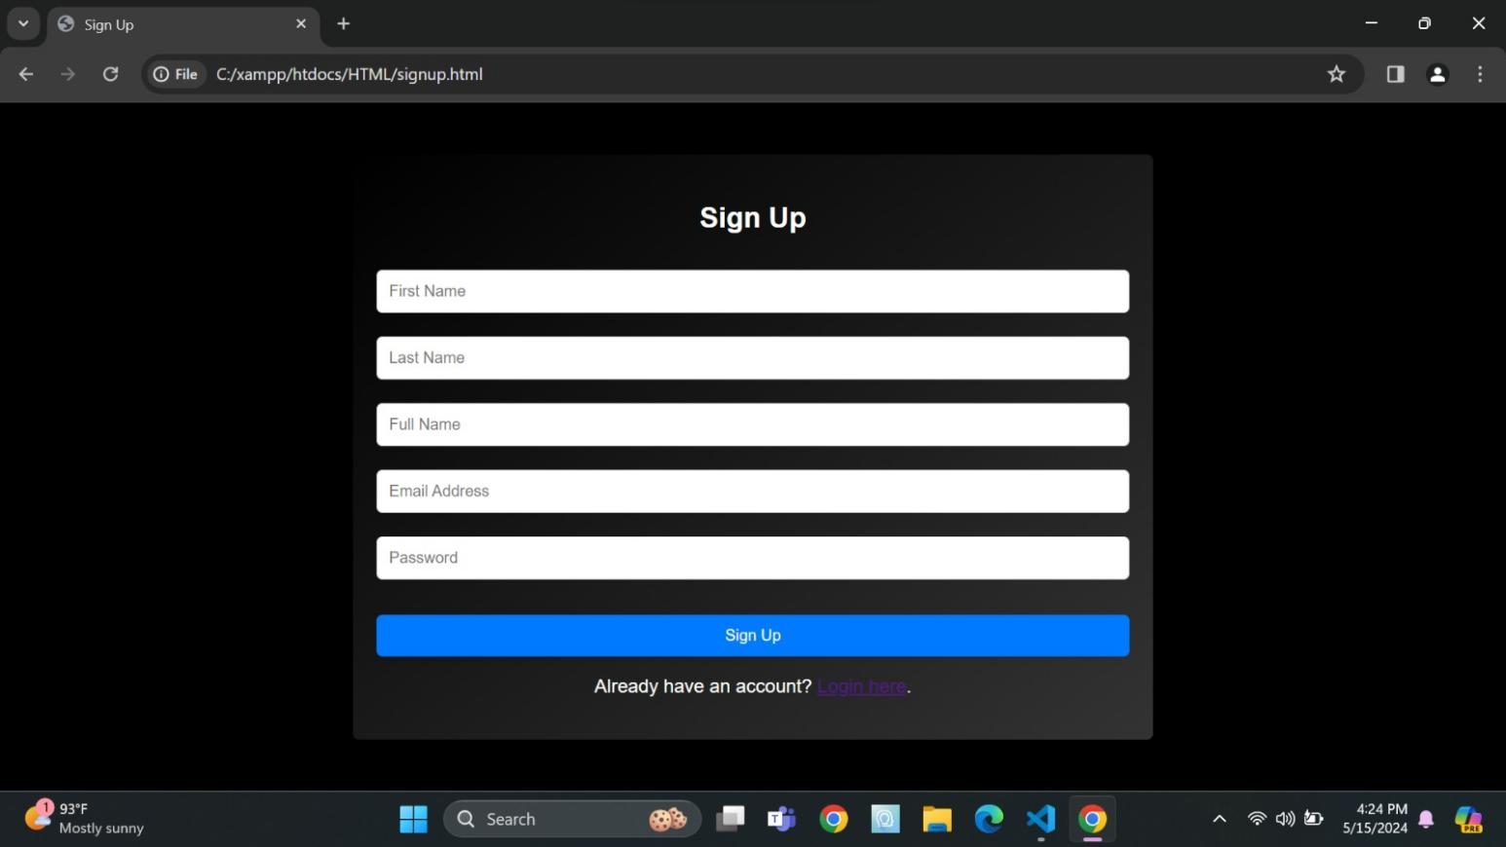

Fig:6.2 Login

This HTML code creates a stylish, centered login form with fields for username and password, featuring gradient backgrounds, white text, and blue submit button, with responsive design.

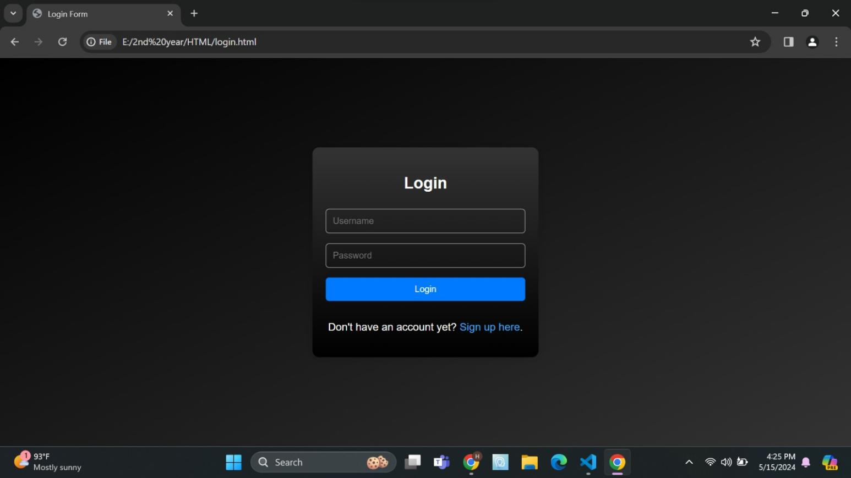

Fig:6.3 Select Campuses

This HTML code creates a responsive campus selection interface with toggleable side navigation and clickable campus tiles, each leading to a different events page, featuring gradient backgrounds and tooltip hover effects.

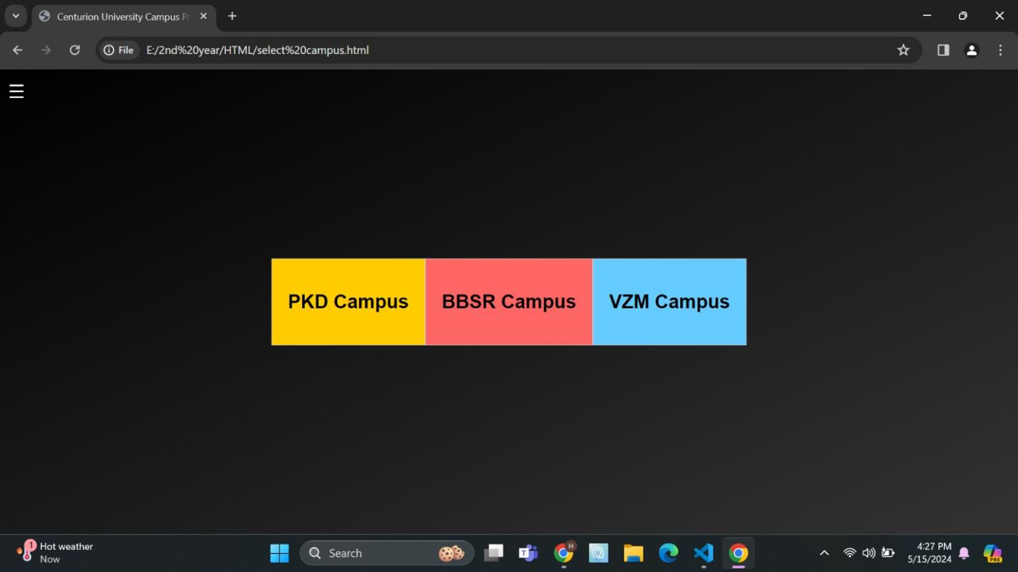

Fig:6.4 Home Page

This HTML code constructs a responsive college homepage featuring a header with navigation links, a side navigation menu, a carousel of images, and a section showcasing various clubs with their respective tooltips.

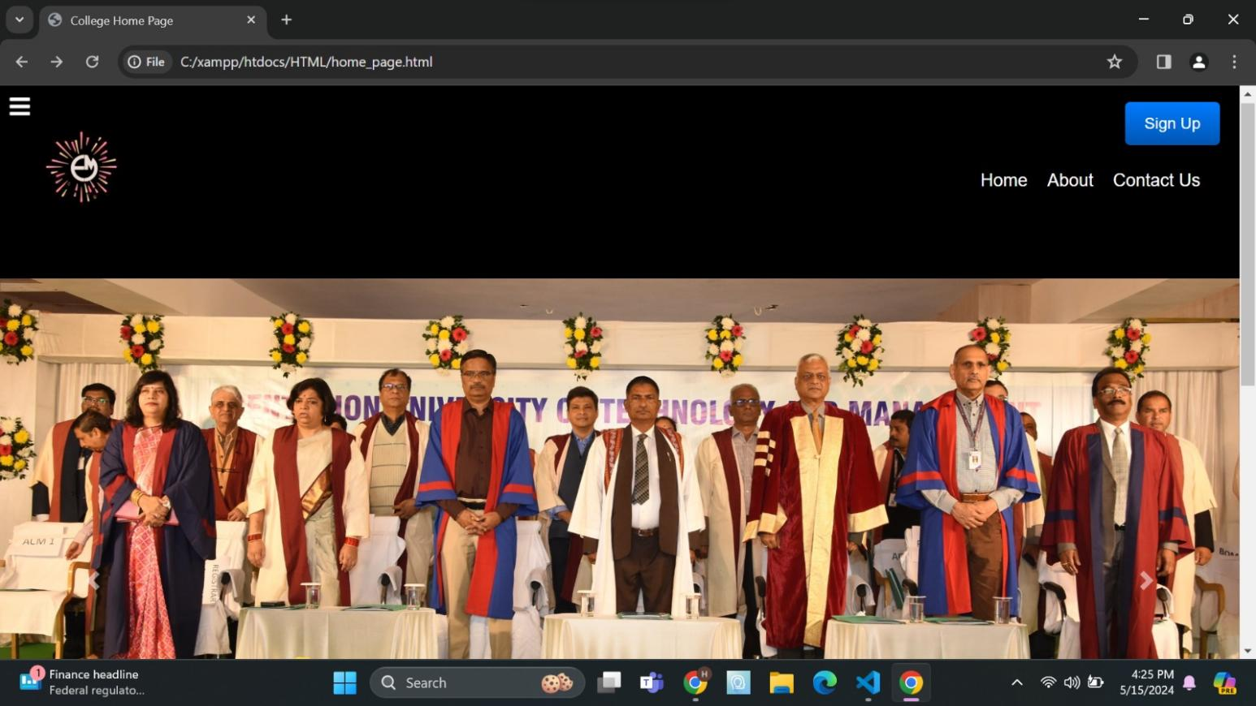

Fig:6.5 Events

This HTML code creates a webpage displaying events, with a search bar to filter events and dynamically generated event cards with details like title, location, description, and a button to view more information.

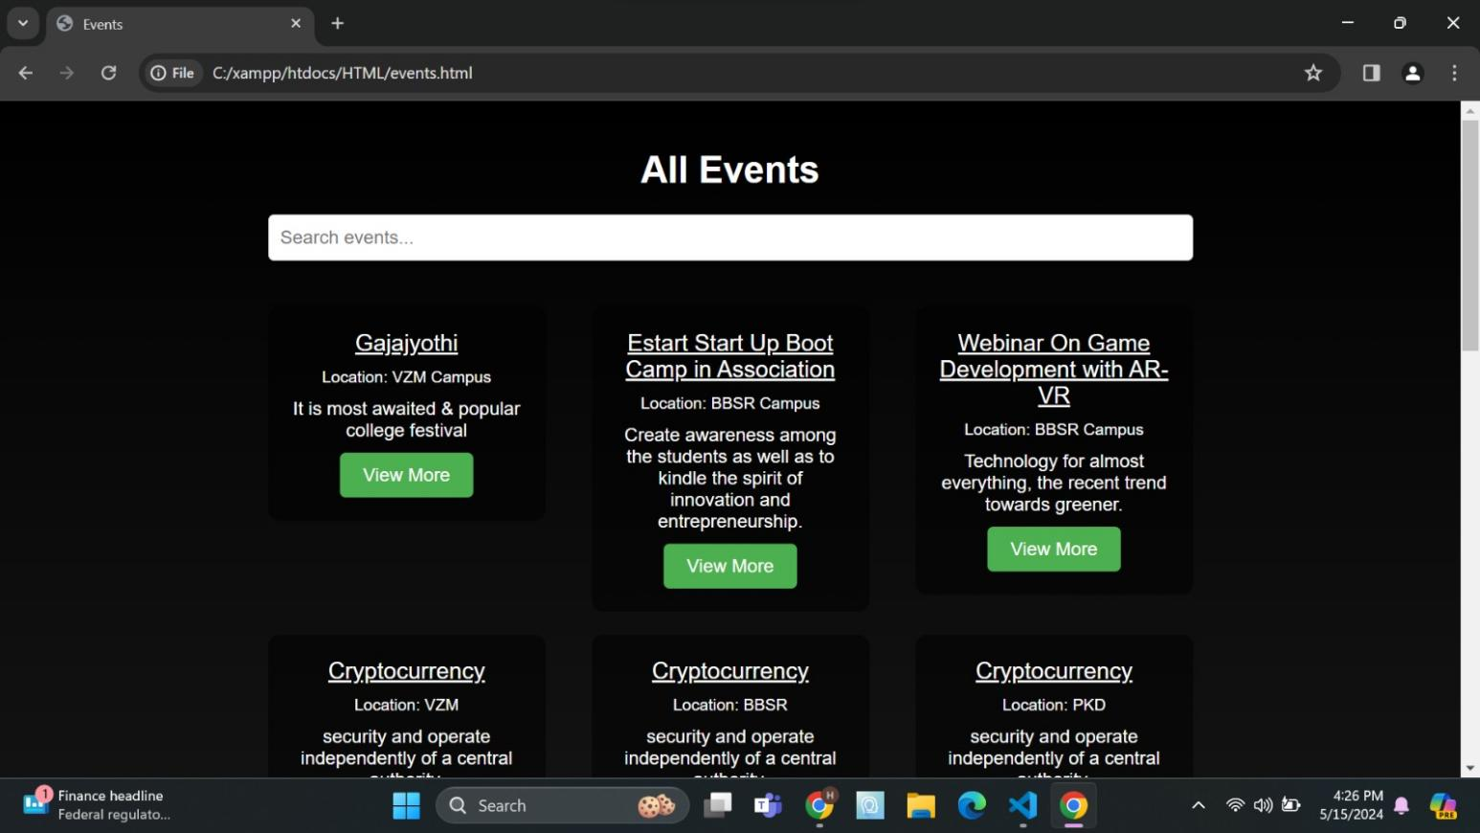

Fig:6.6 Contact Us

This HTML code creates a webpage for a contact form and includes a chatbot widget that responds to user messages with predefined responses.

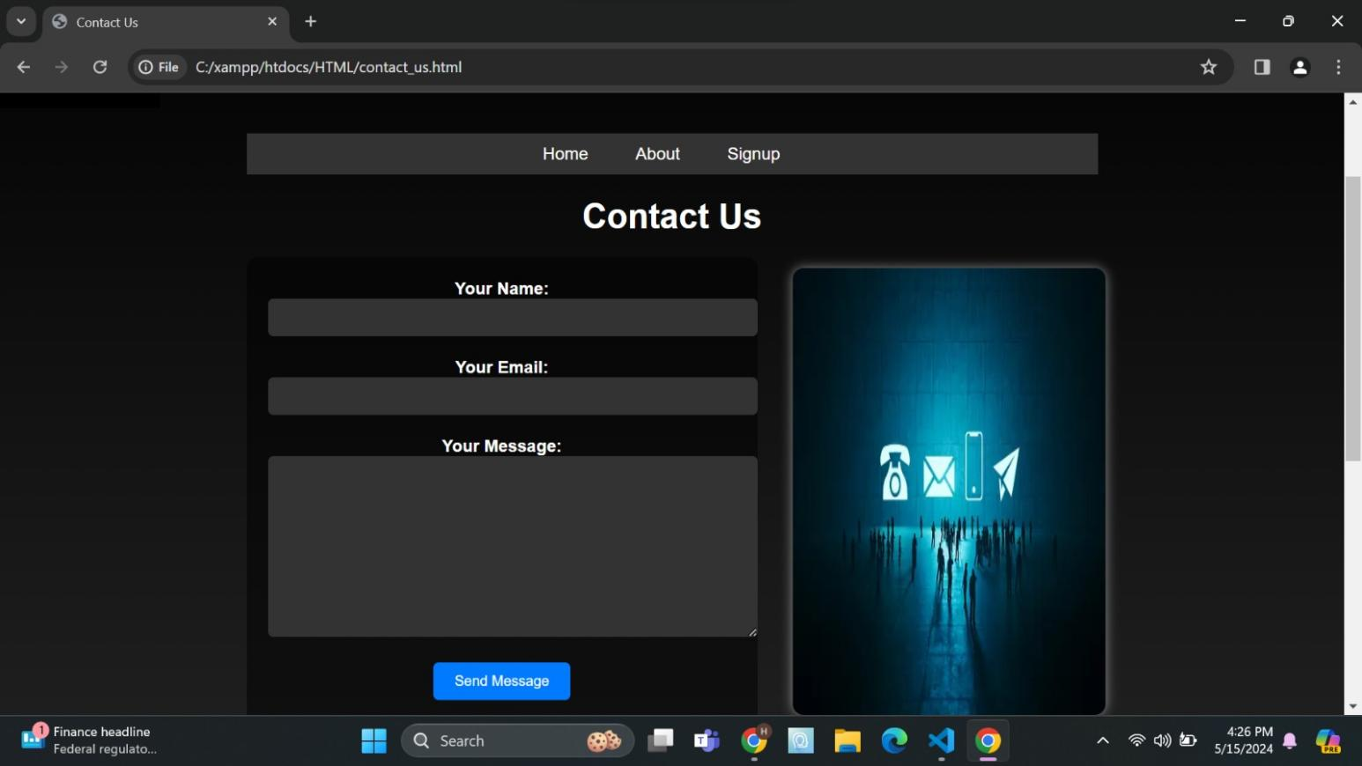

CONCLUSION

The implementation of a campus event management system across all three Centurion campuses signifies a significant advancement in optimizing the organization, coordination, and execution of events within the university community. This system, designed to cater to the diverse needs and interests of students, faculty, staff, and administrators, brings about a multitude of benefits that profoundly impact the campus experience.Firstly, the event management system streamlines the entire event planning process. By providing intuitive tools and centralized platforms for event creation, scheduling, and management, organizers can efficiently navigate through logistical challenges, such as venue bookings, resource allocations, and equipment rentals. This not only saves time and effort but also ensures that events are executed seamlessly and without unnecessary delays.Secondly, the system fosters enhanced communication and collaboration among campus stakeholders. Through integrated communication channels such as email notifications, social media integration, and centralized event calendars, organizers can effectively promote events and engage with the broader campus community. This facilitates greater participation and attendance at events, thereby strengthening campus connections and promoting a sense of belonging among students, faculty, and staff.Moreover, the system significantly improves the attendee experience. User-friendly interfaces for event registration, ticketing, and feedback collection make it easier for individuals to participate in events that interest them. Mobile accessibility ensures that users can access event information and updates anytime, anywhere, further enhancing engagement and participation rates. Additionally, features such as personalized event recommendations and interactive event elements contribute to a more immersive and enjoyable experience for attendees.

Bibliography

- https://mdbootstrap.com/docs/standard/content-styles/hover-effects/
- https://www.geeksforgeeks.org/html-tags-a-to-z-l
- https://www.w3schools.com/css/css3_animations.asp
- https://www.w3schools.com/php/php_functions.asp
- https://chatgpt.com/c/fcc26f9d-7090-4fef-8f93-0d84a41
- https://www.w3schools.com/tags/tag_img.asp#:~:text=The%20tag%20is%20used,space%20for%20the%20referenced%20image
- https://www.w3schools.com/tags/tag_style.asp#:~:text=Definition%20and%20Usage,head%3E%20section%20of%20the%20document
- https://getbootstrap.com/docs/4.0/getting-started/introduction/#:~:text=Bootstrap%20is%20developed%20mobile%20first,tag%20to%20your%20

COURSE OUTCOME (COs) ATTAINMENT

    - Expected Course Outcomes (COs):
(Refer to COs Statement in the Syllabus)

Course Outcome Attained:










How would you rate your learning of the subject based on the specified COs? LOW HIGH
3
4
5
6
8
7
9
10
1
2

Learning Gap (if any):

    - Books / Manuals Referred:

Date: Signature of the Student

    - Suggestions / Recommendations:
(By the Course Faculty)

Date: Signature of the Faculty

