**Port Authority Project**

**Executive Summary:**

We have used Excel and PowerBi to anticipate the date at which the weekly passenger departures and bus departures cross the 125k and 3.9k milestones, respectively, after fine-tuning the data provided by the Port authority.

In March 2025, the weekly passenger departures are expected to surpass 125k.

In October 2030 it is predicted that there will be 3.9k weekly bus departures.

**Data Exploration:**

The Port Authority provided weekly bus and passenger departure data from November 2020 to September 2023, as well as information on departure variation and comparisons to prior weeks. The data consists of 12 bus terminals.

We have generated a new Excel file containing the necessary data for the forecasts using this data. The year, week, date (which is the Monday of that week), bus departures, and passenger departures for that week are listed in the Excel sheet.

A total of 148 rows of data, or 148 weeks over four years of information about bus and passenger departures, are gathered.

In addition, we have collected information for the aforementioned period on the external factors such as gas prices and temperature that affect the departures.

Upon compiling the necessary information, the Excel document is imported into the PowerBi for further analysis. The data is carefully inspected once more to look for any errors or null values. Following the required data-cleaning procedures, the columns' data types are examined to ensure they are the right type.

The weekly bus departures have been forecast using the Forecast tool in PowerBi. The data set contains 148 data points; thus, the seasonality is fixed at 39 points or one-fourth of the total data points.

Bus departure values are predicted up to December 2030. They are expected to surpass 3.9k weekly departures in October 2030.

The below graph can be found with the name Bus Departures Forecast in the attached Project.pbix PowerBi file.

The weekly passenger departures have been forecast using the Forecast tool in PowerBi. The data set contains 148 data points; thus, the seasonality is fixed at 39 points or one-fourth of the total data points.

Passenger departure values are predicted up to December 2030. They are expected to surpass 125k weekly departures in March 2025. By the end of 2030, the weekly passenger departures are expected to be around 255815.

The below graph can be found with the name Passenger Departures Forecast in the attached Project.pbix PowerBi file.

To determine whether there is a relationship between the average monthly gas price and passenger departures, we have collected data over four years.

We plotted a line graph between the average monthly gas price and monthly passenger departures and using the Trend Line feature in PowerBi, we found out that as the gas price increases, the passenger departures also increase.

As Gas is a naturally found product, as time goes on, gas prices will also increase with the usage, the passenger departures will also increase with it. So, we recommend to increase the number of buses in the near future.

The below graph can be found with the name Gas Price Effect in the attached Project.pbix PowerBi file.

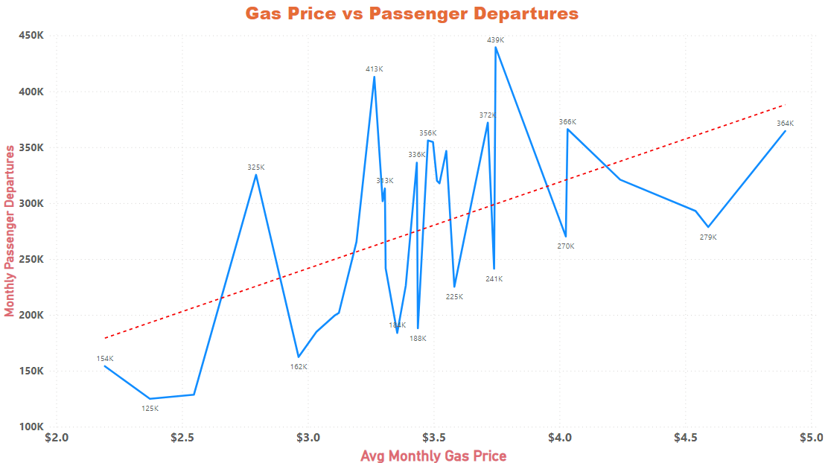

Excel Sheet with the Data – ProjectData.xlsx

PowerBi file with Forecast visuals – Project.pbix