**Thumati Pavan Venkata Narendra Kumar**

**EMP-ID-289219**

**BASH-Assignment-1**

**1.Arithmetic Operators:**

* 1. To use of double parentheses for arithmetic operations in a Bash shell script.

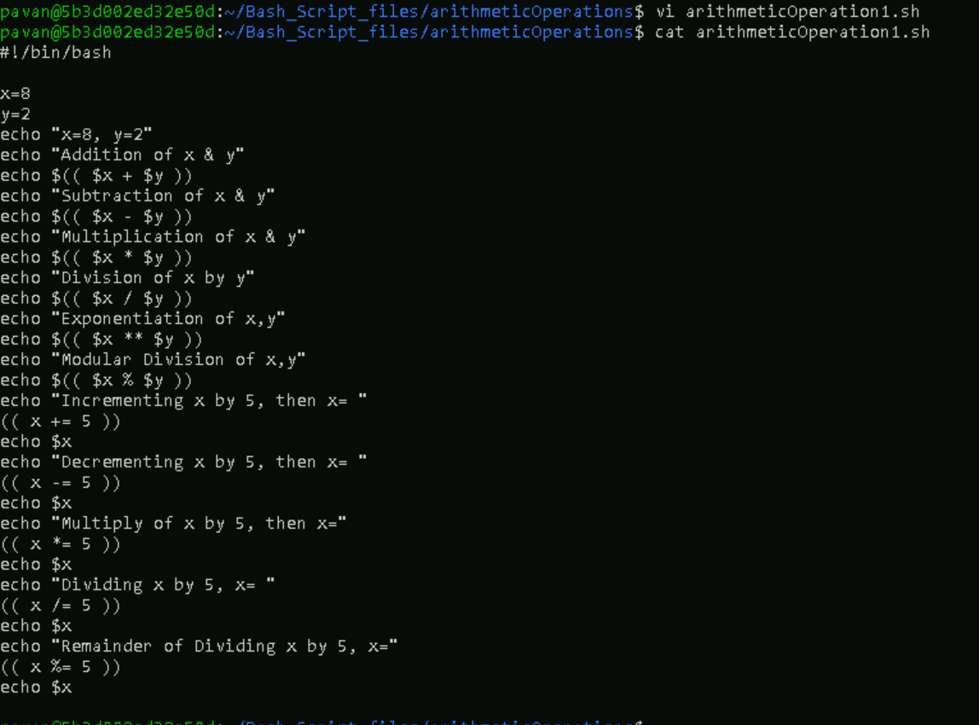

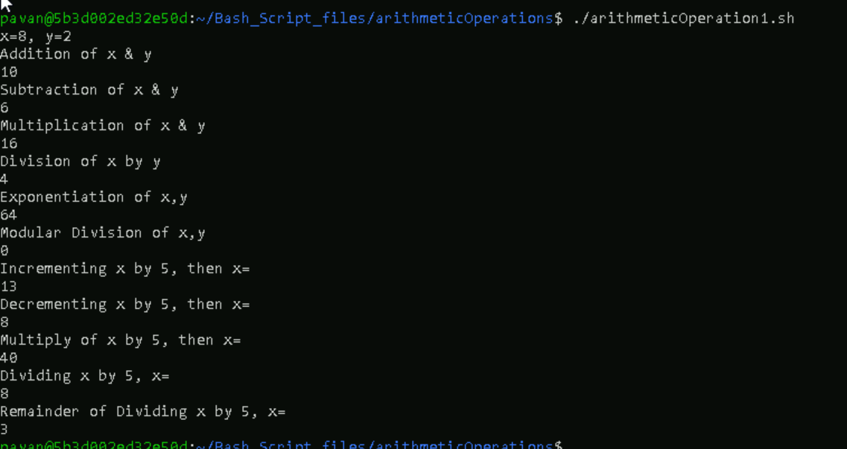

* 1. To use let command in a Bash script.

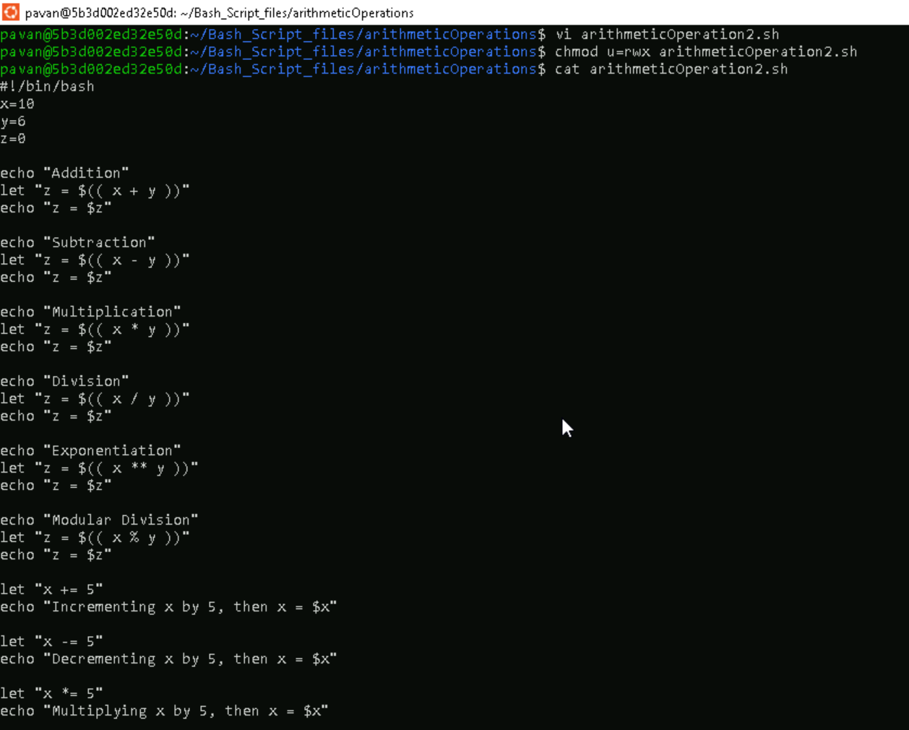

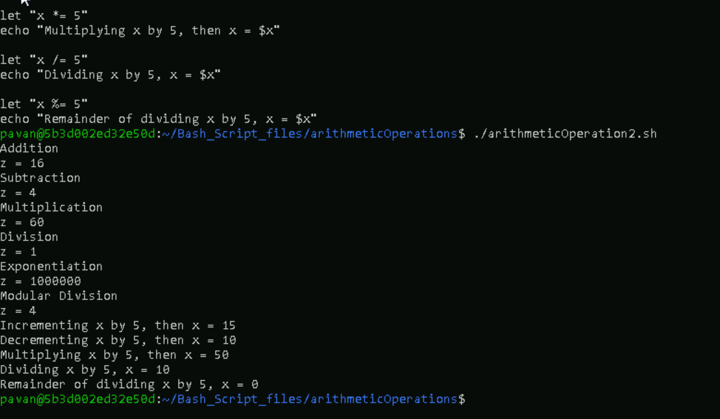

* 1. To use backticks and expr in a Bash script.

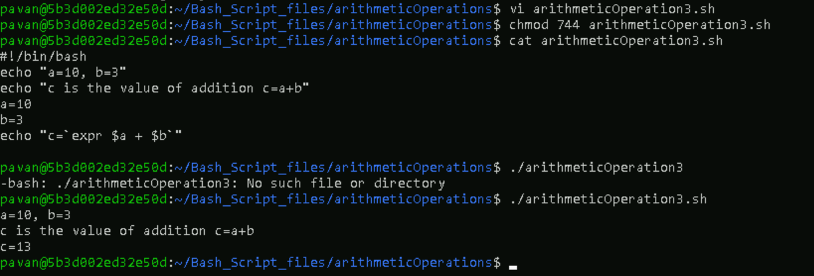

**2.IF Statements**

1. To take a user-input of any number and check if the value is greater than 125.

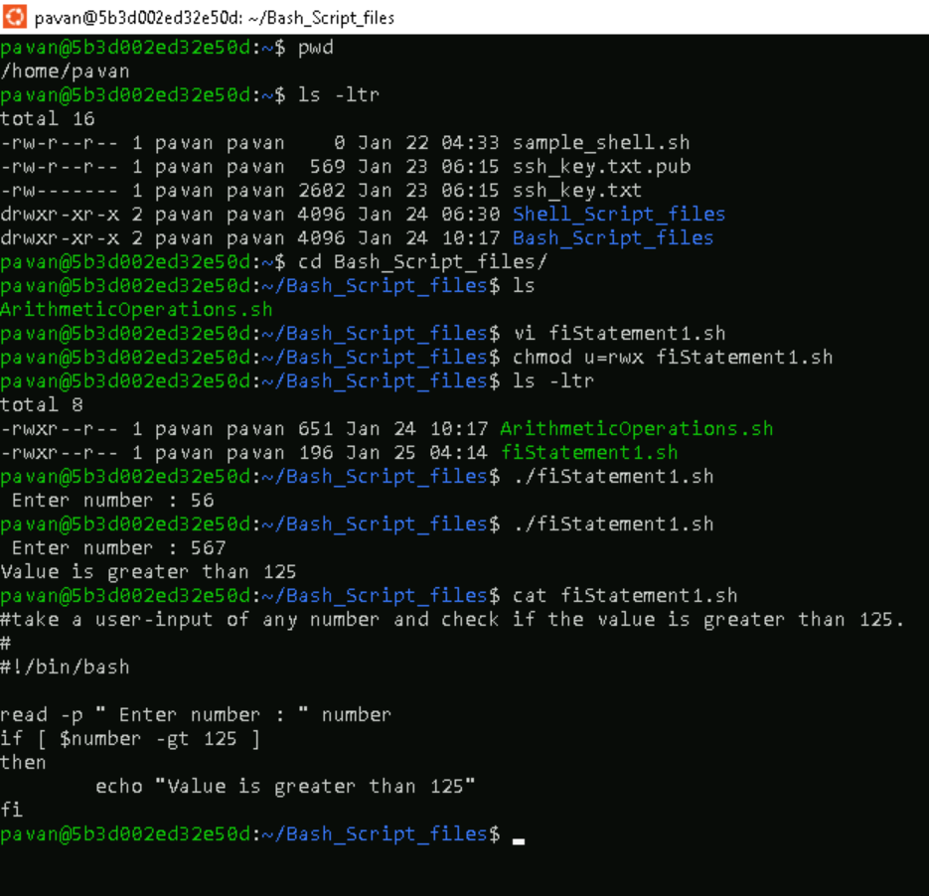

1. To use of if statement with a simple scenario of comparing two strings.

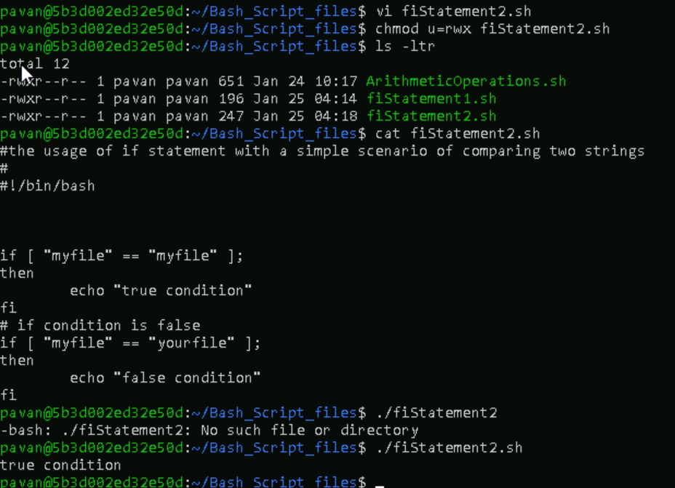

1. To compare numbers by using the if statement.

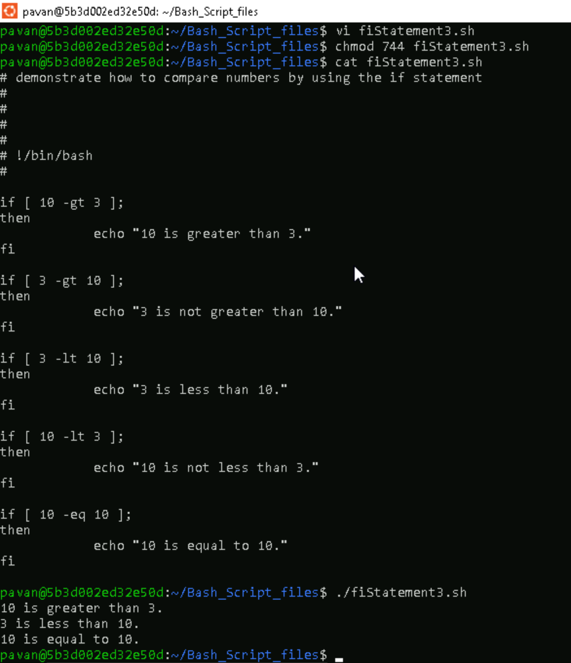

1. To use AND operator to include multiple conditions in the if expression.

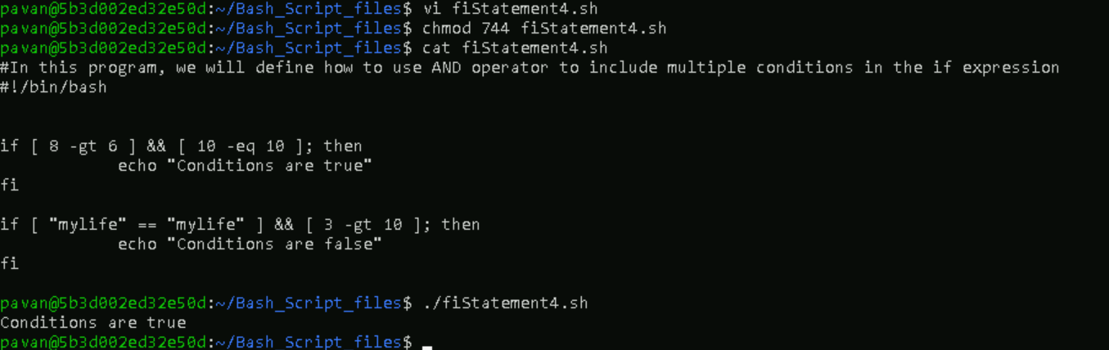

1. To use OR operator to include multiple conditions in the if expression.

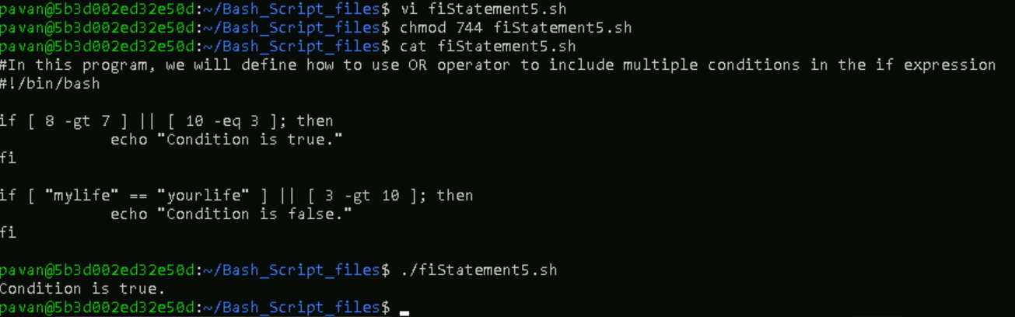

1. To use AND and OR to include multiple conditions in the if expression.

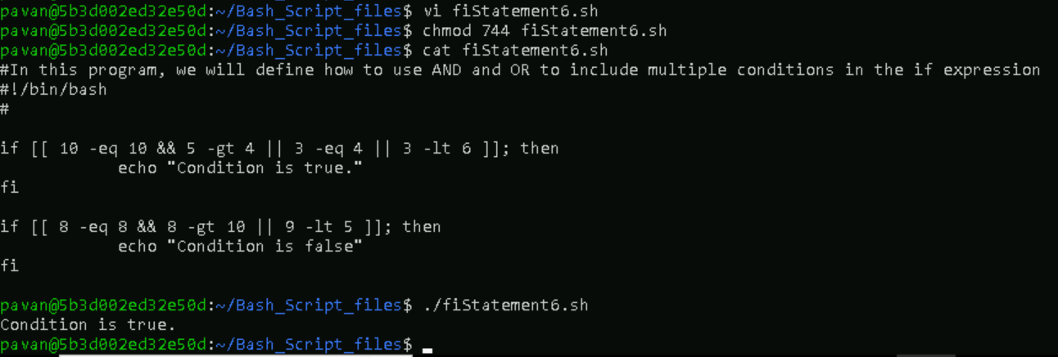

**3.IF ELSE Statements**

1. To use IF-ELSE statement.

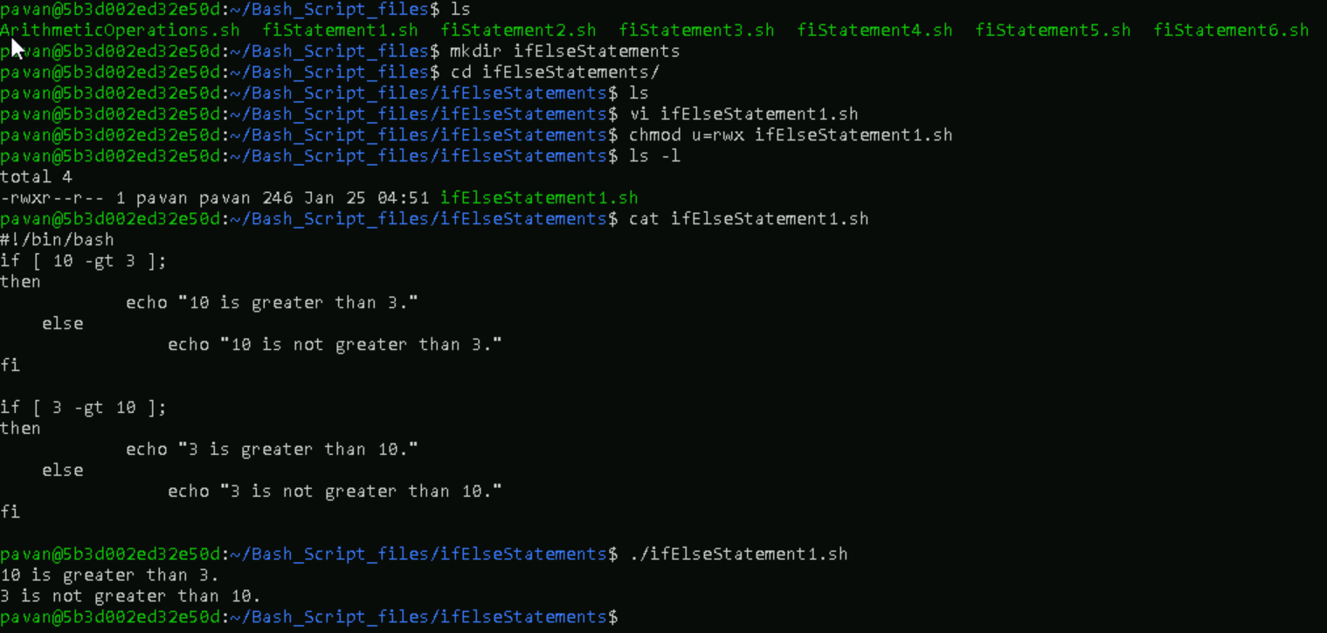

1. To use IF-ELSE statement and bash logical operators to join multiple conditions.

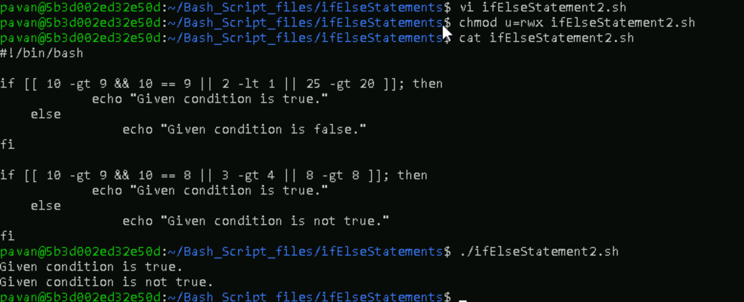

1. To use IF-ELSE statement along with “-gt” operator.

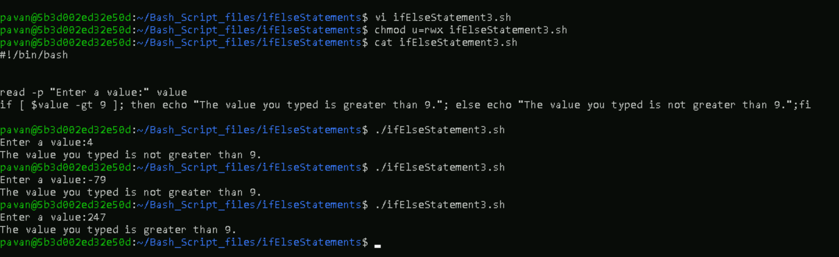

1. To use NESTED IF-ELSE statements in bash.

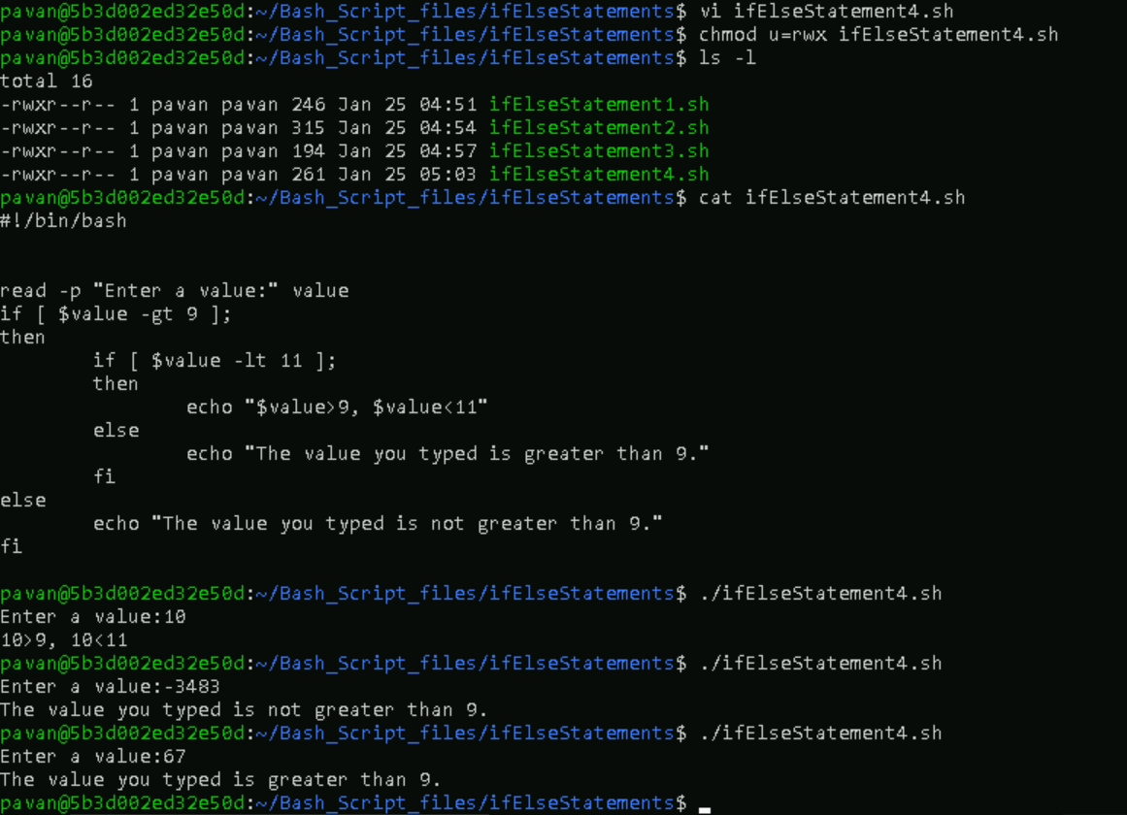

**4. ELSE-IF Statements**

1. To use ELSE-IF statement.

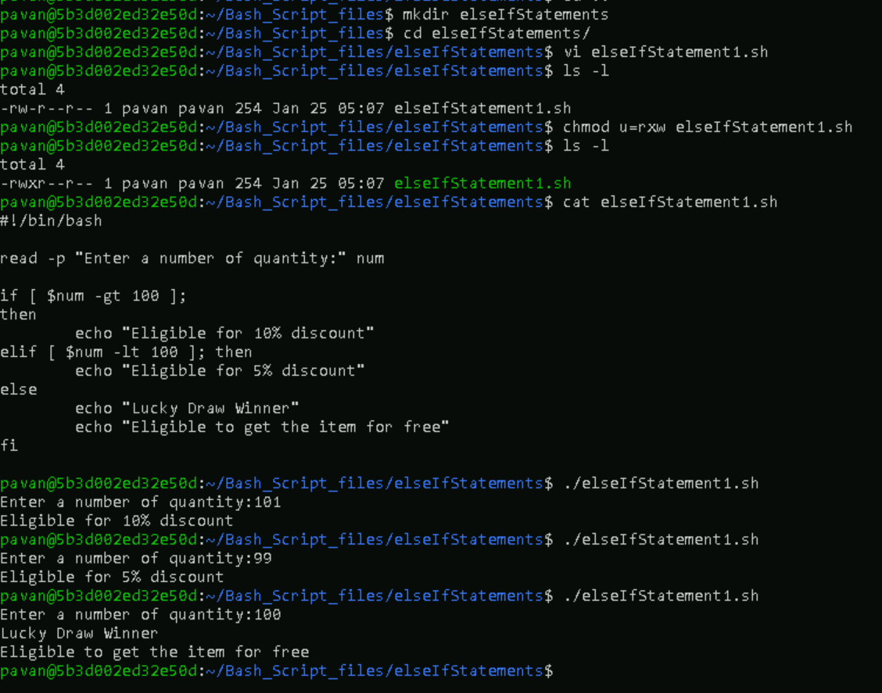

1. To use ELSE-IF statement along with bash logical operators.

