**Thumati Pavan Venkata Narendra Kumar**

**EMP-ID-289219**

**BASH-Project-1**

1. **Bash CASE Statements.**
2. To demonstrate the use of the case statement.

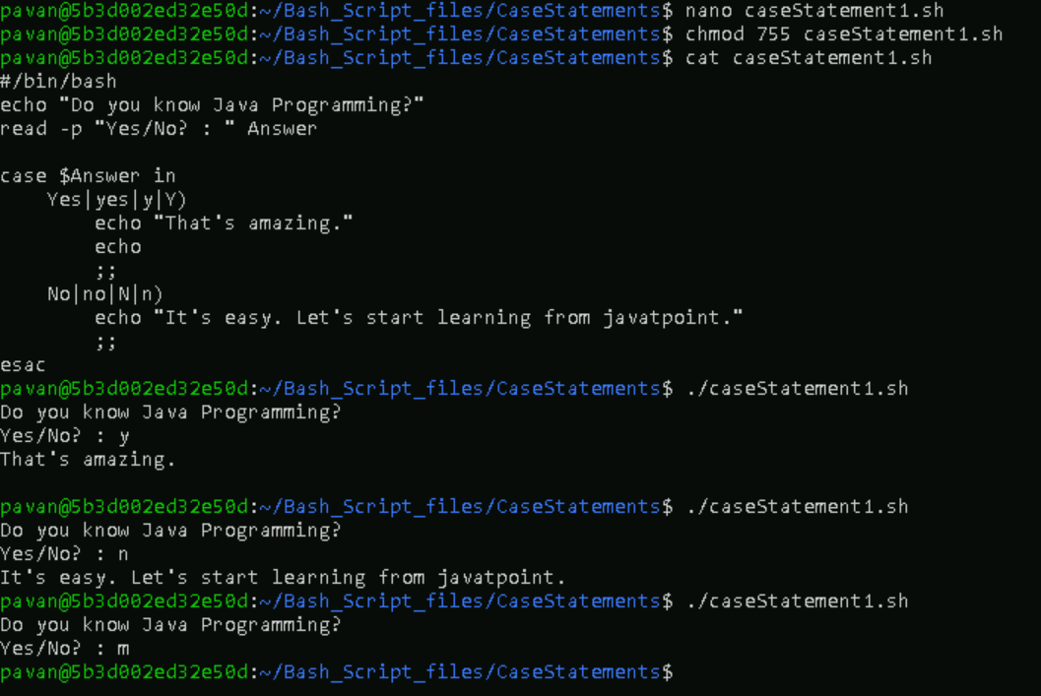

1. To demonstrate combined scenario where there is also a default case when no previous matched case is found.

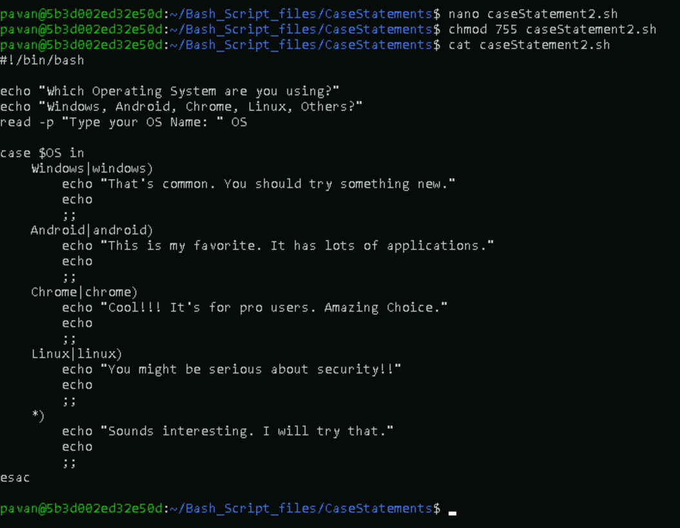

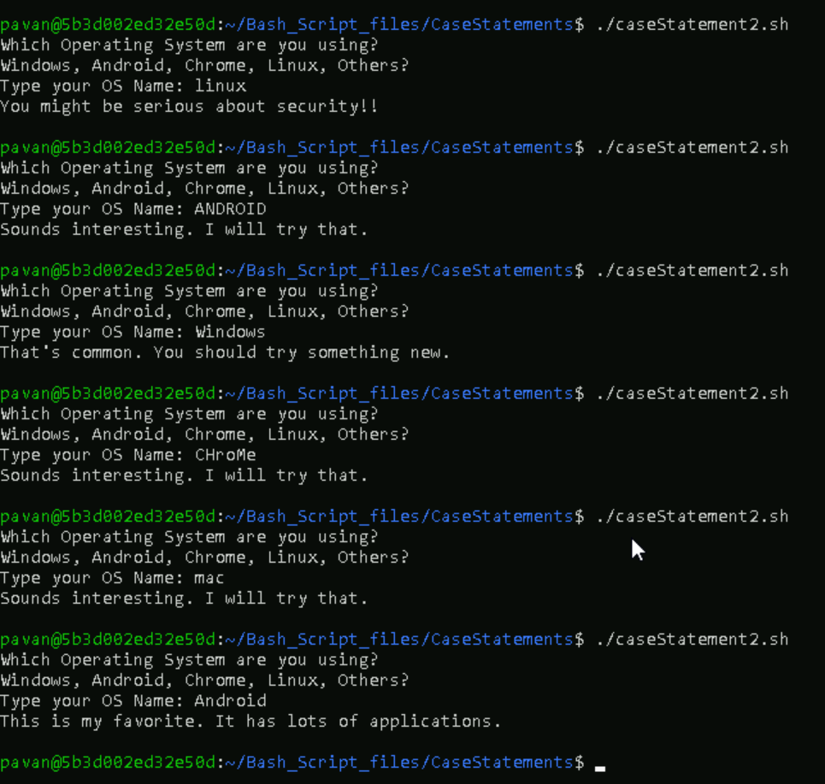

1. **Bash FOR loop.**
2. Basic example of 'for loop'.

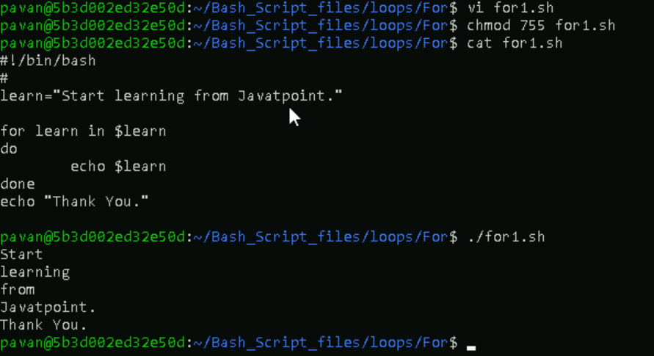

1. Basic example to print a series of numbers from 1 t o 10.

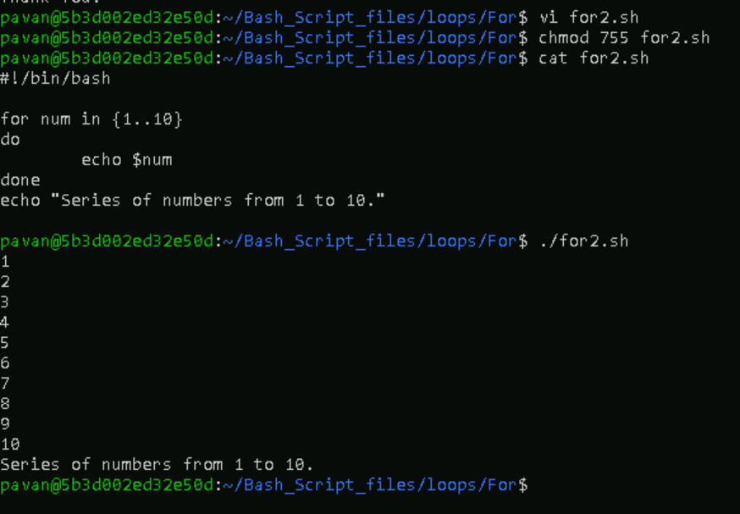

1. For Loop to Read a Range with Increment.

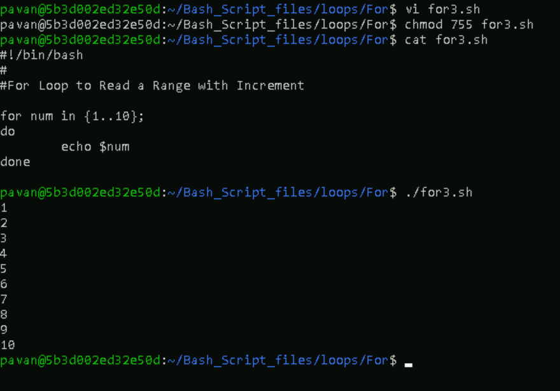

1. For Loop to Read a Range with Decrement.

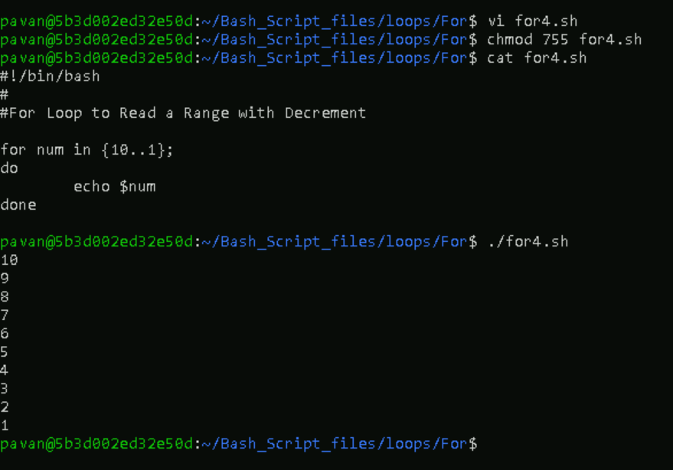

1. Array Declaration.

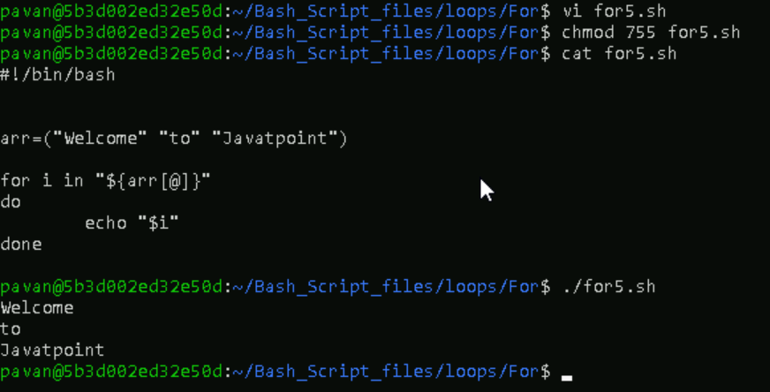

**3.BASH WHILE Loop.**

1. To get specified numbers using BASH WHILE Loop.

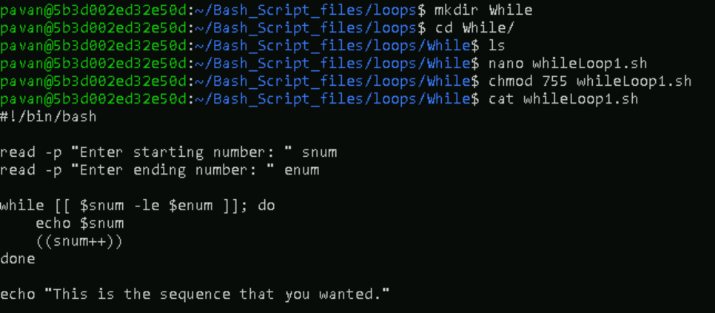

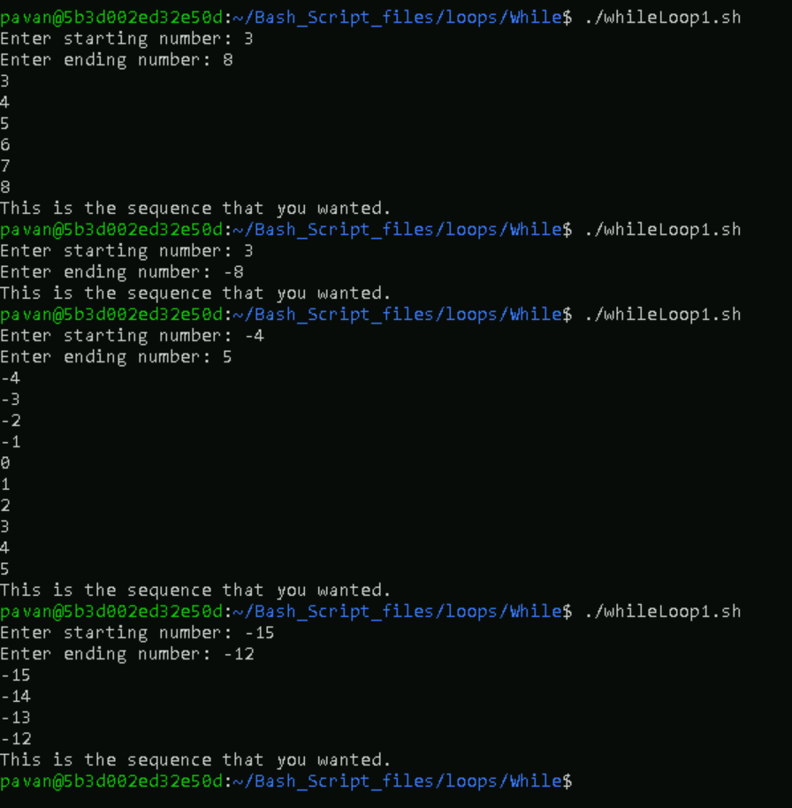

1. To get specified numbers using BASH WHILE Loop with Multiple Conditions.

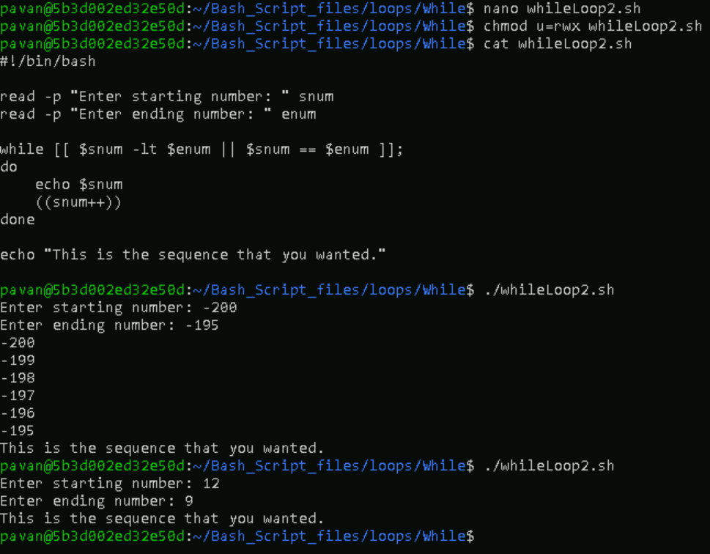

1. An infinite while loop in single line & using CTRL + C to forcefully stop the execution.

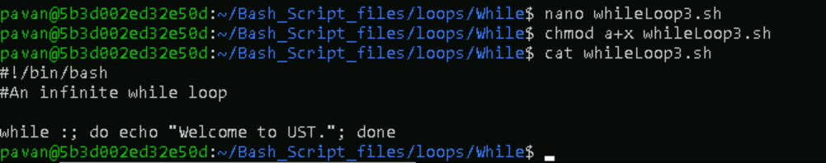

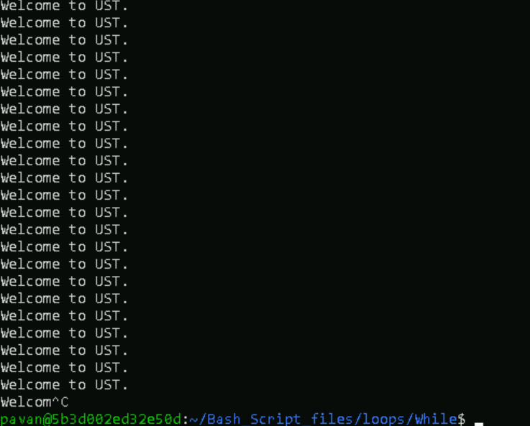

1. To use Break Statement in BASH WHILE Loop.

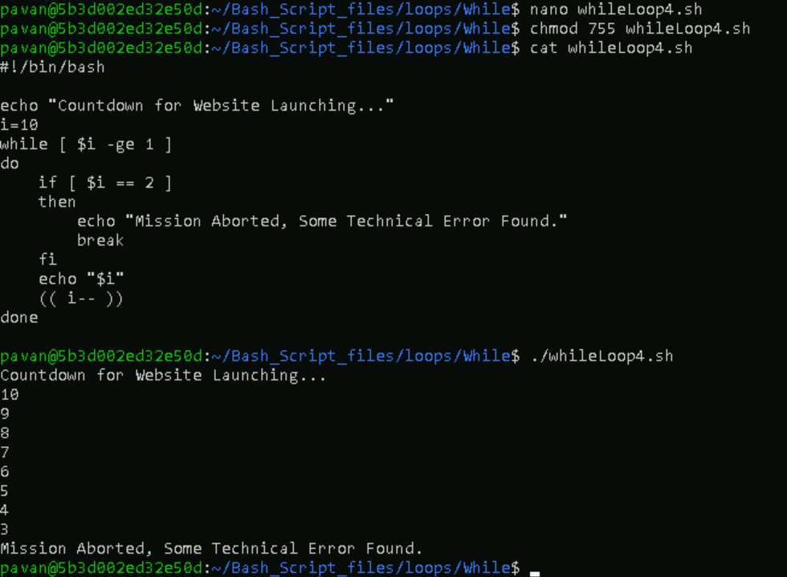

1. To use Continue Statement in BASH WHILE Loop.

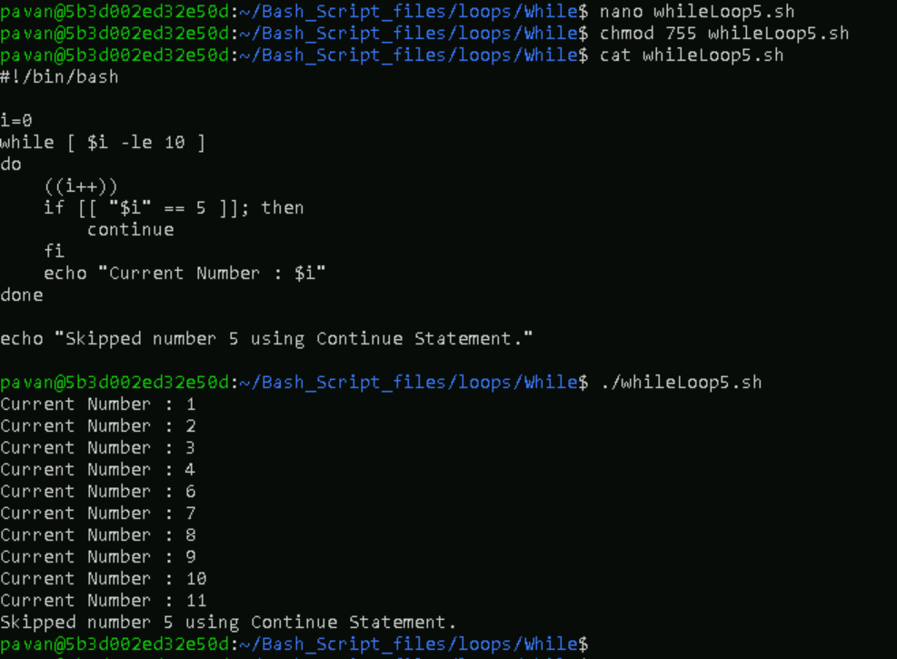

1. To use BASH WHILE Loop in C-Style (C programming language).

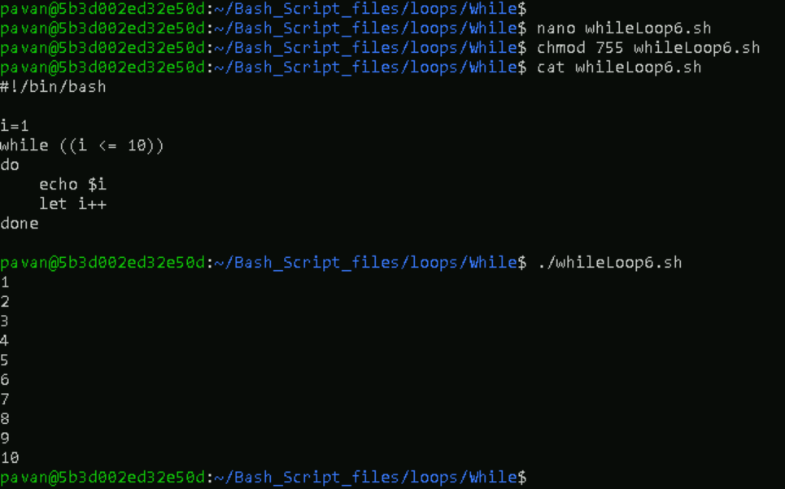

**4.BASH UNTIL Loop**

1. Bash Until Loop with a single condition.

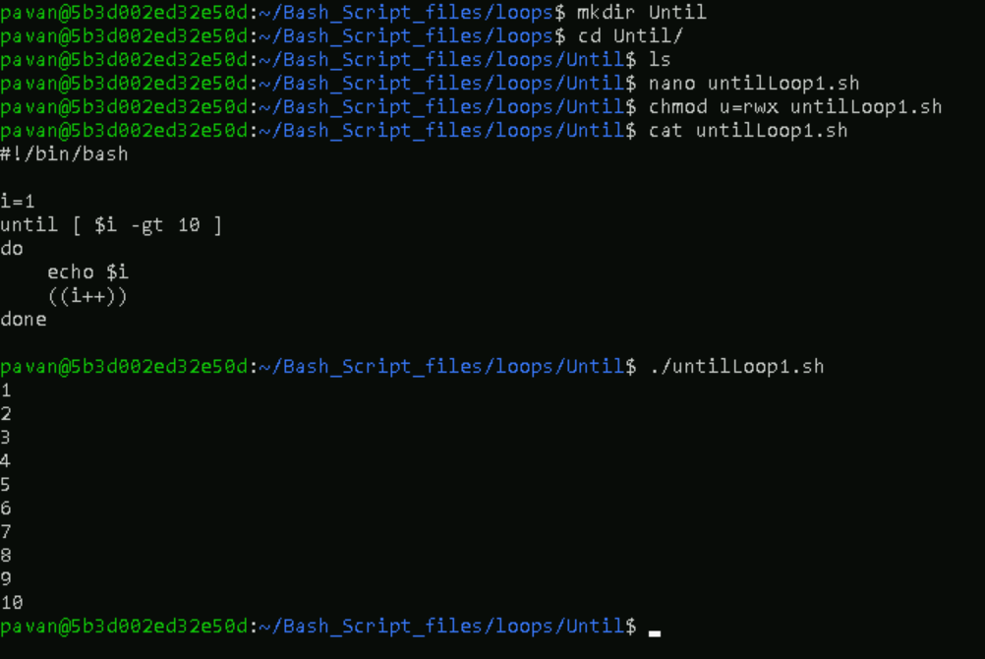

1. Bash Until Loop with multiple conditions.

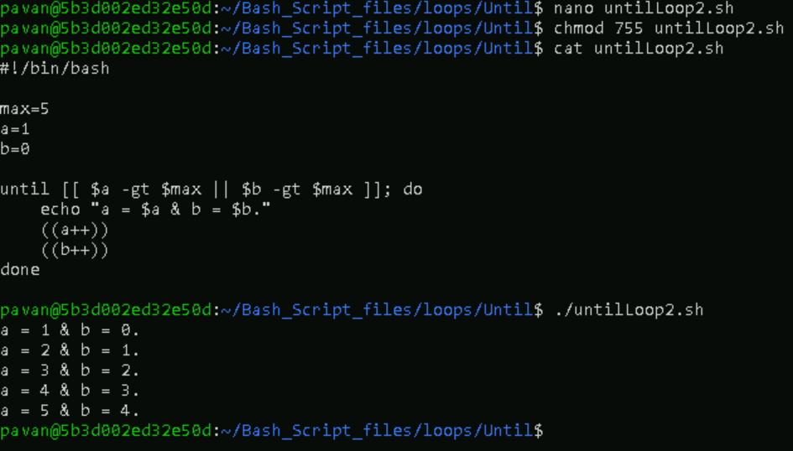

**5.BASH Strings**

1. To check whether two strings are equal using “=” operator.

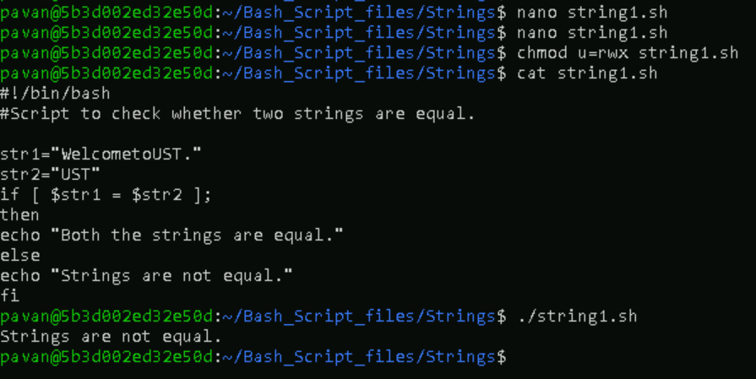

1. To check whether two strings are equal using “!=” operator

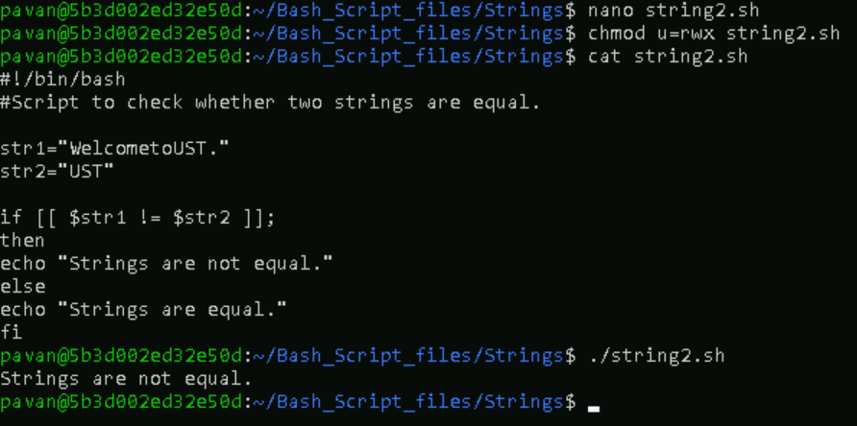

1. To check if string1 is less than string2 equal using “” operator.

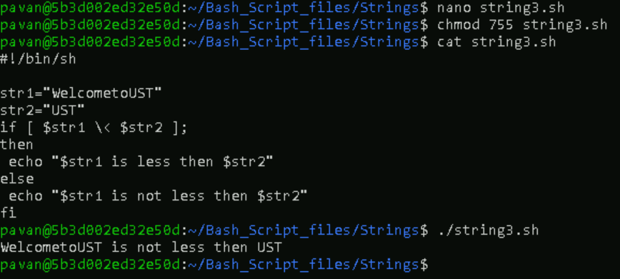

1. To check if string1 is greater than string2.

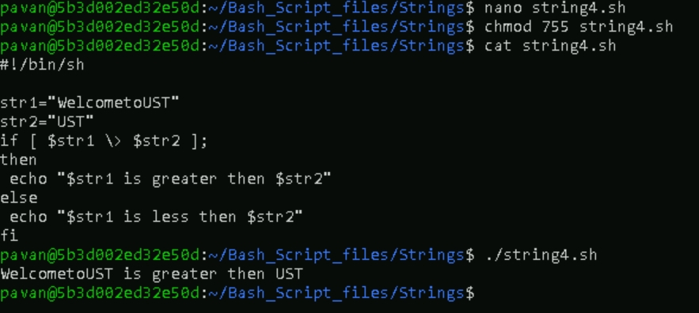

1. To check if the string is zero or greater than zero.

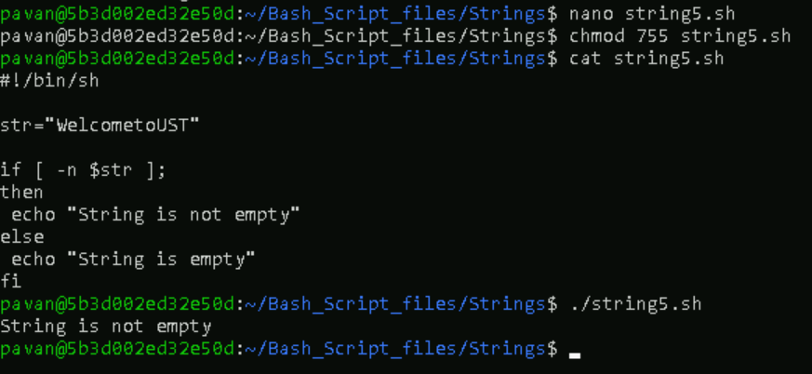

1. To check if the string is empty or equal to zero.

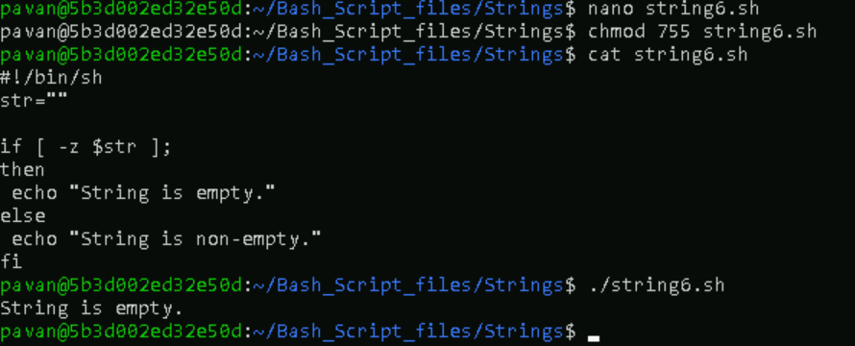

**6.BASH FIND String Length**

1. To find the length of a string using $[#string_variable_name}.

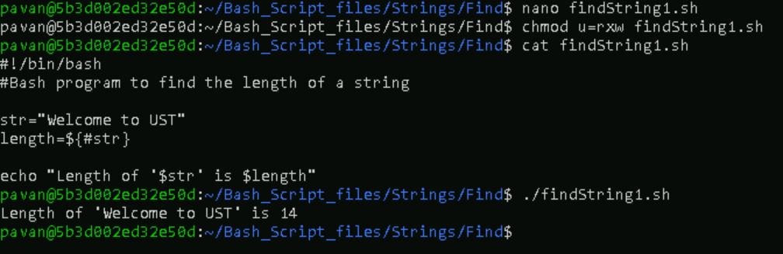

1. To find the length of a string using `expr length "$str"`.

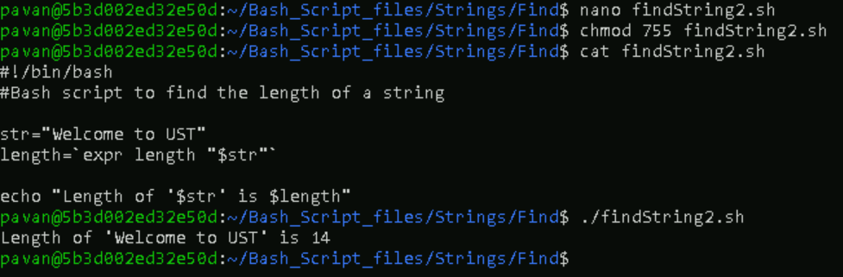

1. To find the length of a string using `expr "$str": ' .*'`.

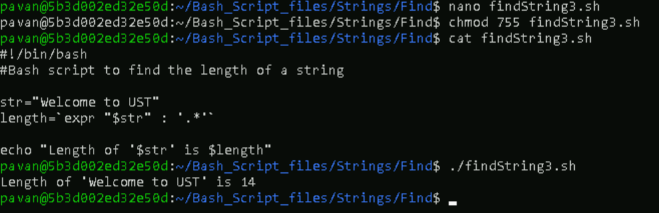

1. To find the length of a string using `wc` command.

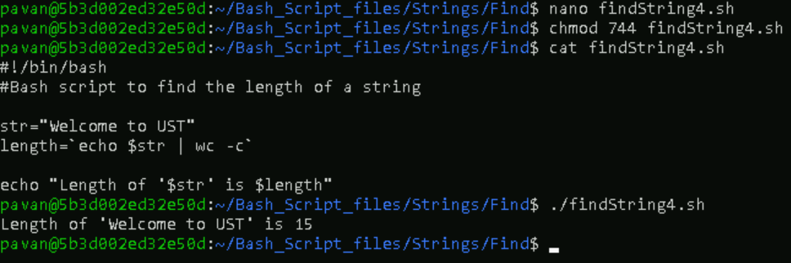

1. To find the length of a string using `awk` command.

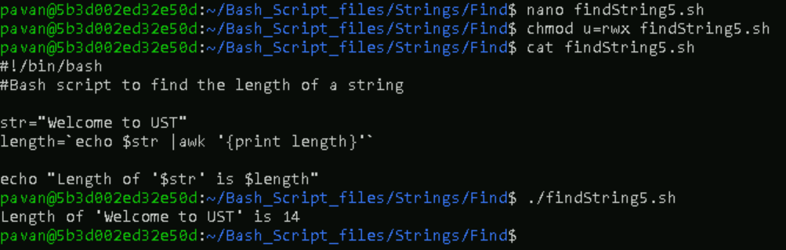

**7.** **Bash Split String**

1. Bash Split String by Space.

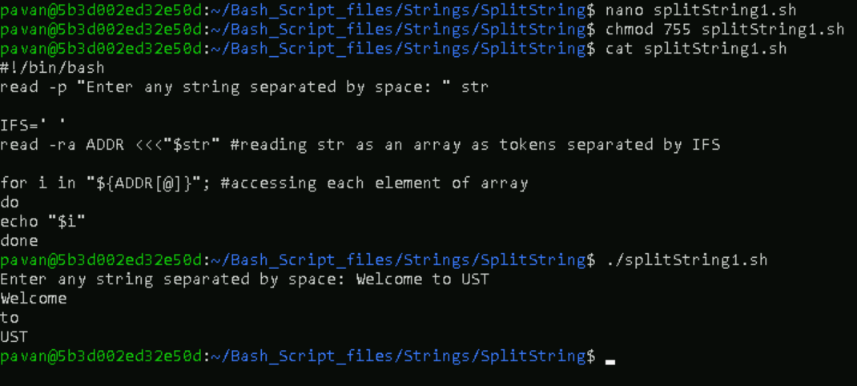

1. Bash Split String by Symbol.

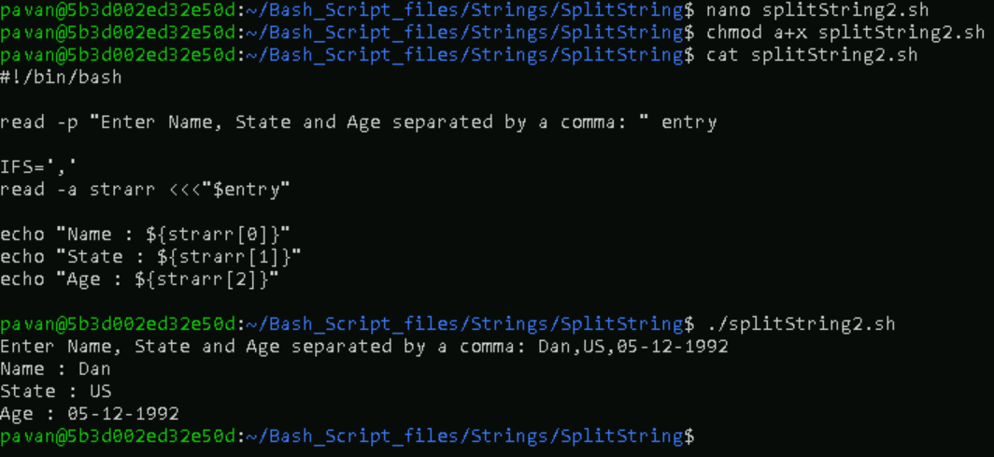

1. Bash Split String by Symbol without $IFS variable.

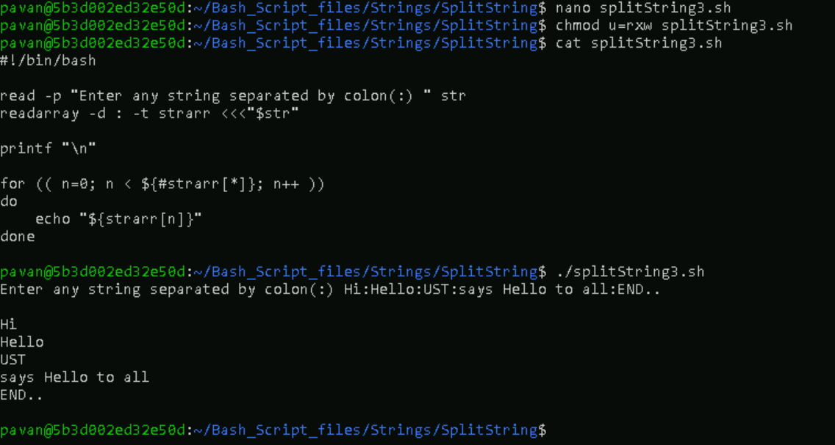

1. Bash Split String by another string without $IFS variable.

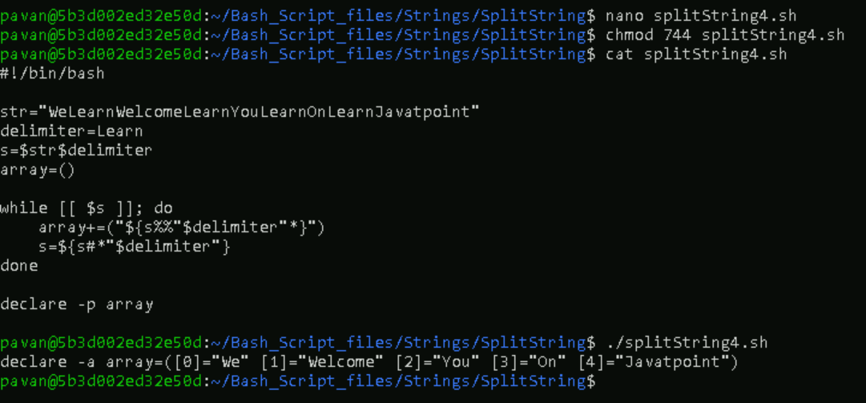

1. Bash Split String using Trim Command.

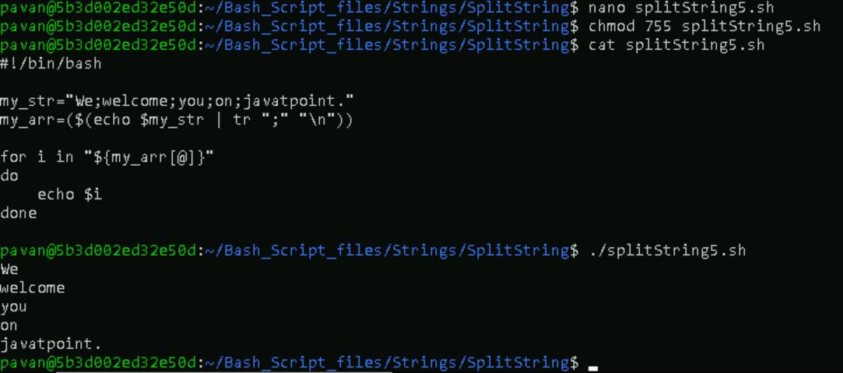

**8.** **Bash Substring**

1. To Extract till Specific Characters from Starting.

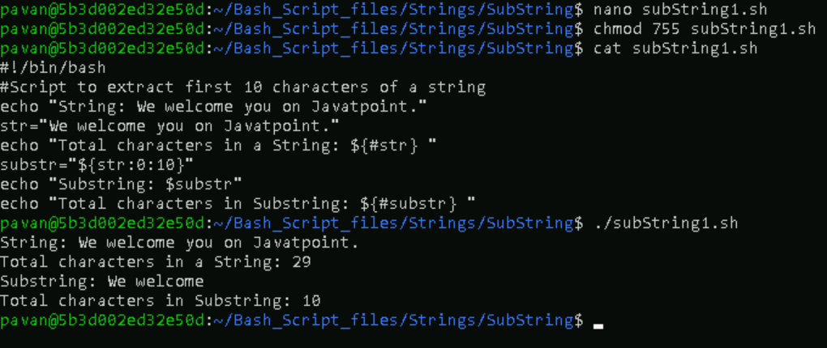

1. To Extract from Specific Character onwards.

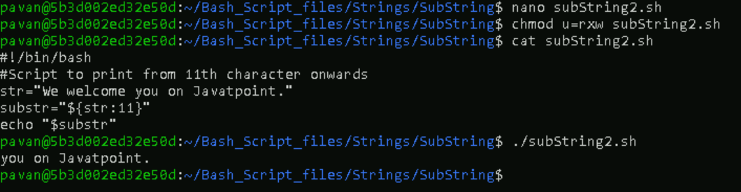

1. To Extract a Single Character.

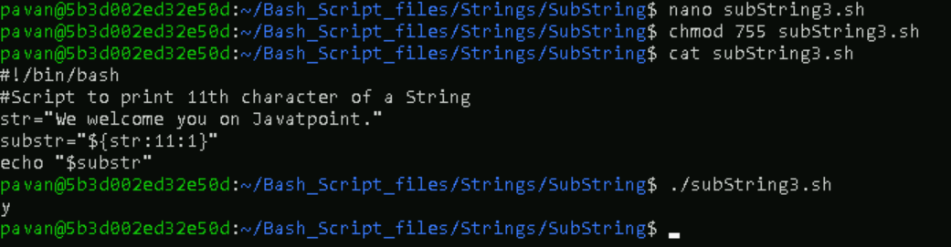

1. To Extract the specific characters from last.

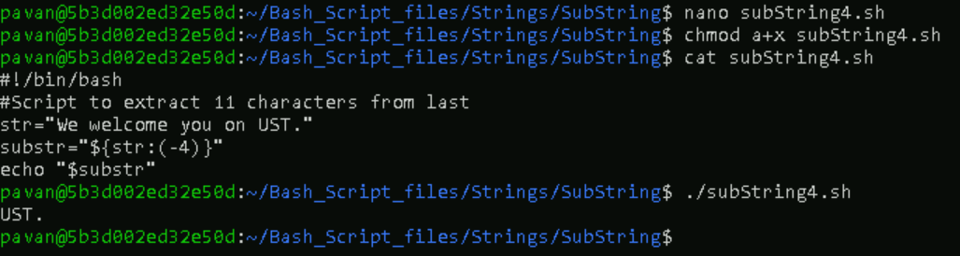

**9.** **Bash Concatenate String**

1. Write Variables Side by Side.

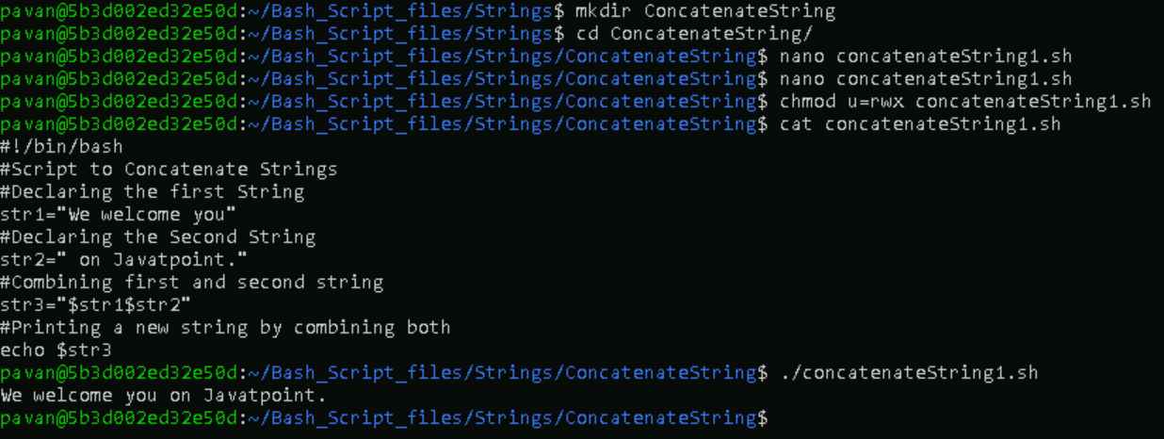

1. Using Double Quotes.

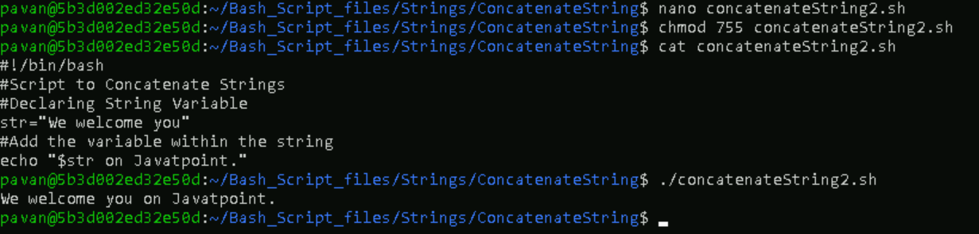

1. Using Append Operator with Loop.

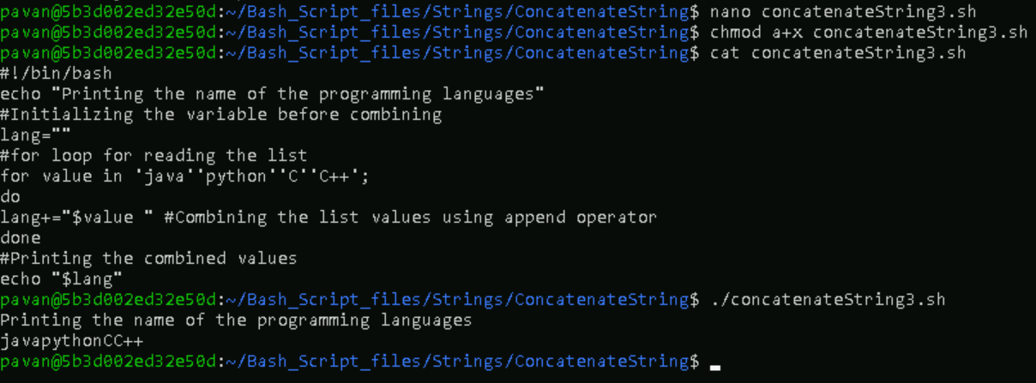

1. Using the Printf Function.

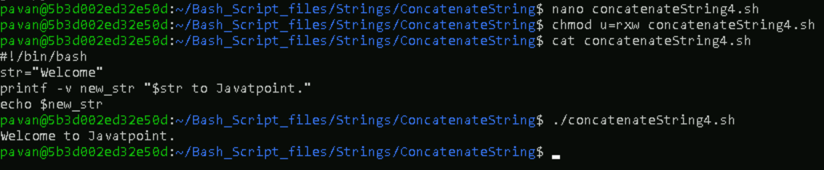

1. Using Literal Strings.

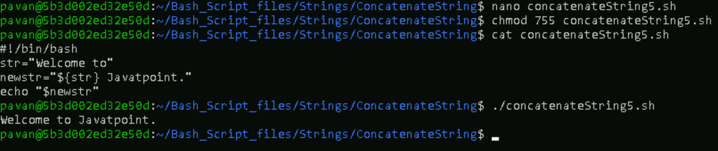

1. Using Underscore.

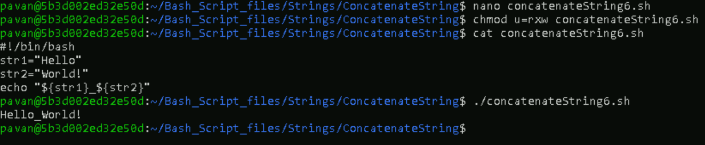

**10. Bash Functions**

1. To declare functions.

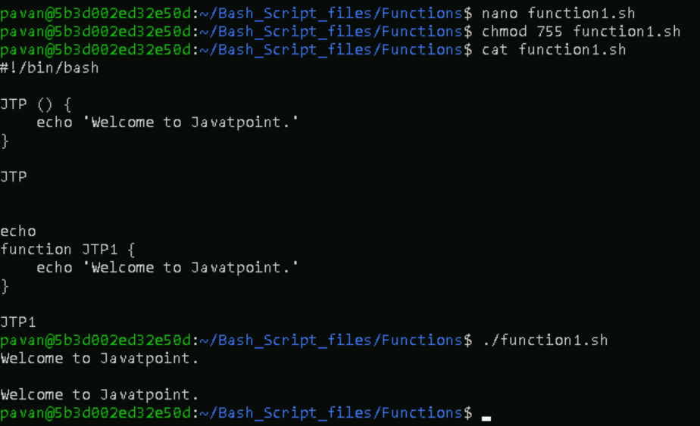

1. To pass arguments to functions.

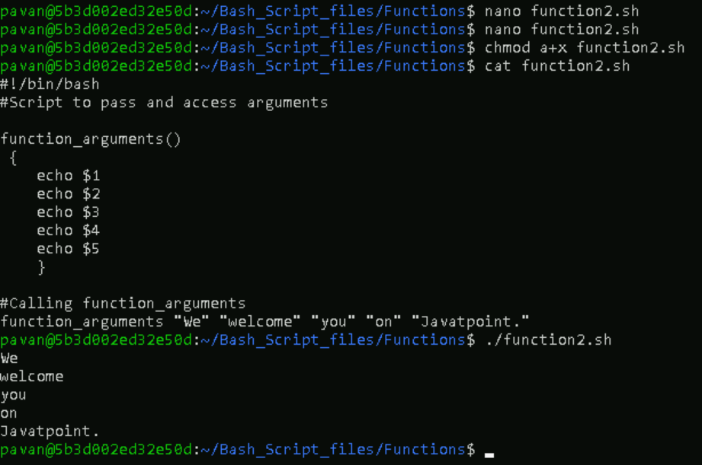

1. To understand how variables scope works.

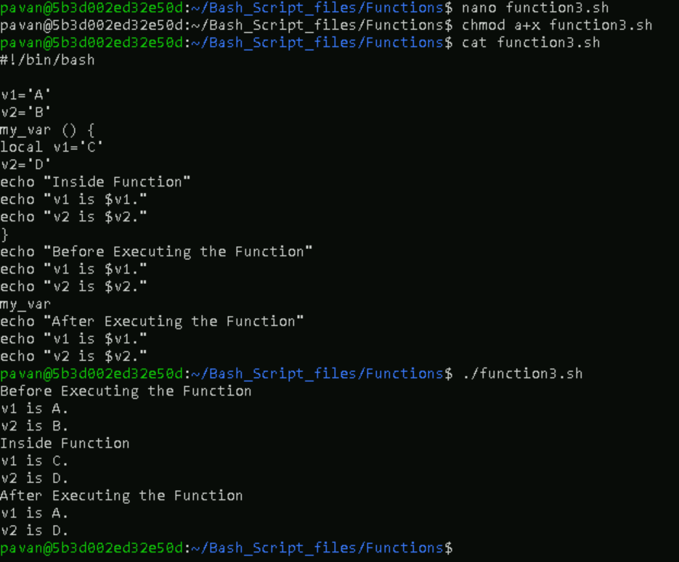

1. To setup a return status for a function.

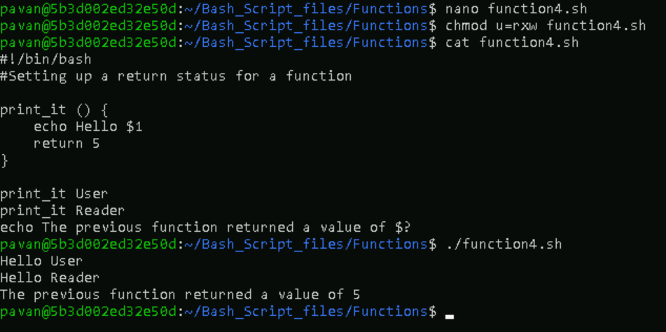

1. To send the value to stdout using echo or printf commands.

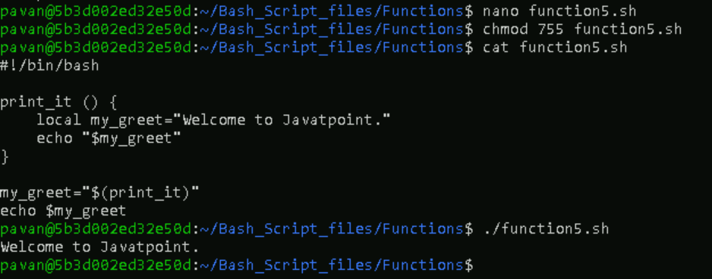

1. To override command using function.

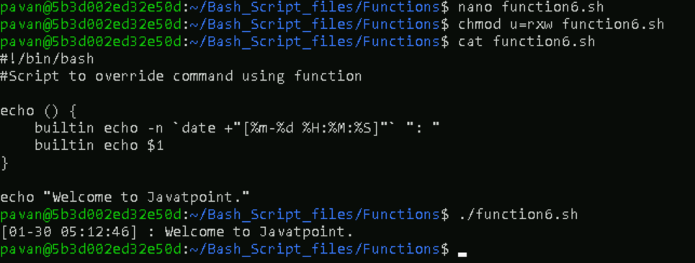

**11.** **Bash Array**

1. To print an element of an array with an index of 2.

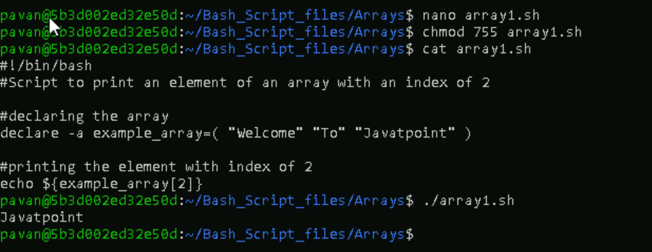

1. To print all the elements of the array.

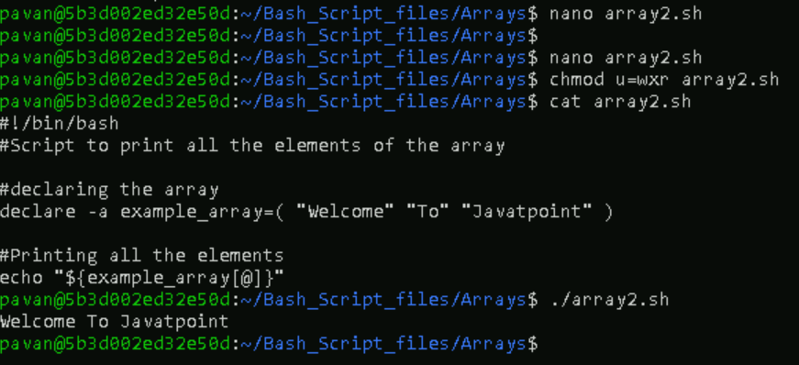

1. To print the keys of the array.

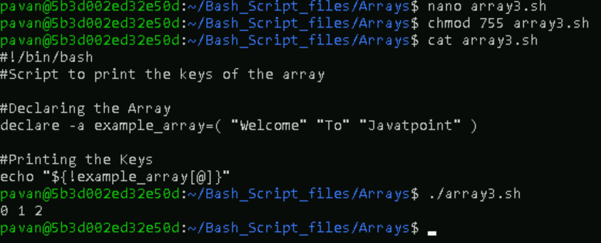

1. To print all keys and values using loop through the array.

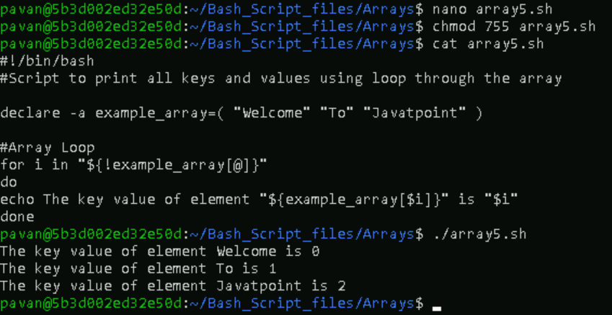

1. To loop through an array in C-style.

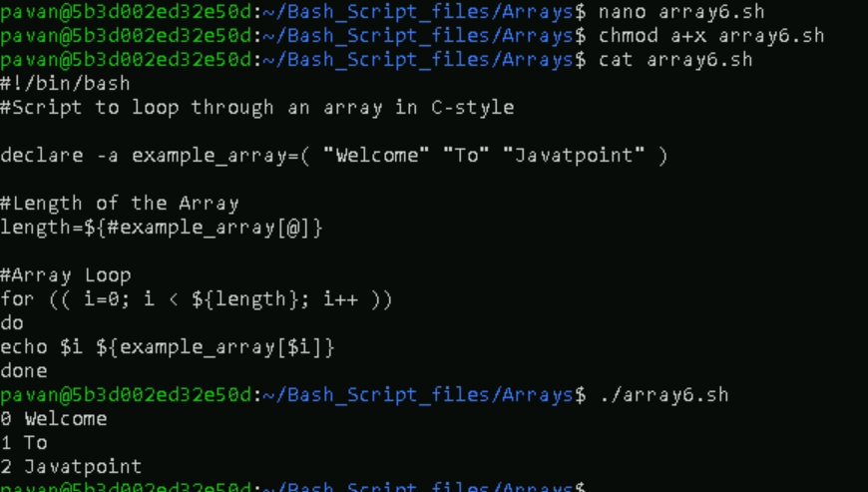

1. To add elements to an Array.

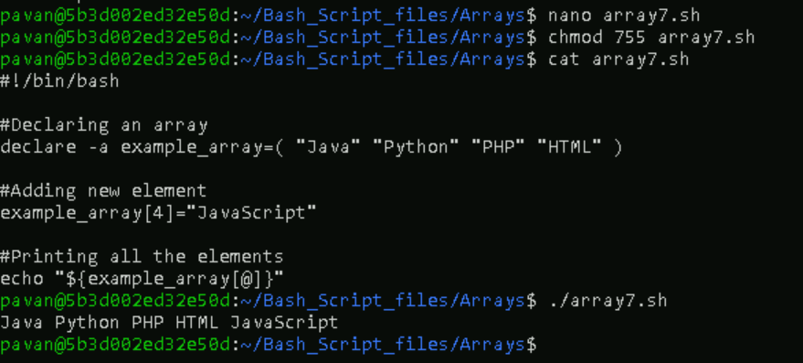

1. To update array element.

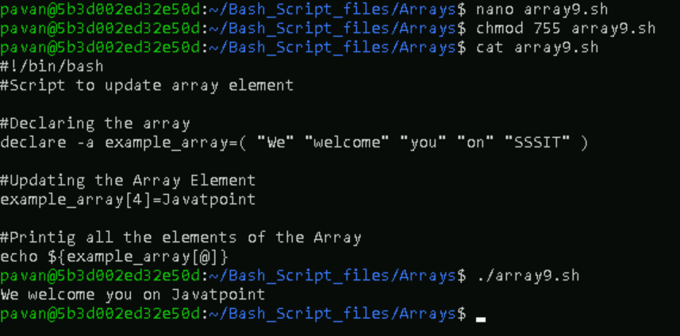

1. To delete the element from the array.

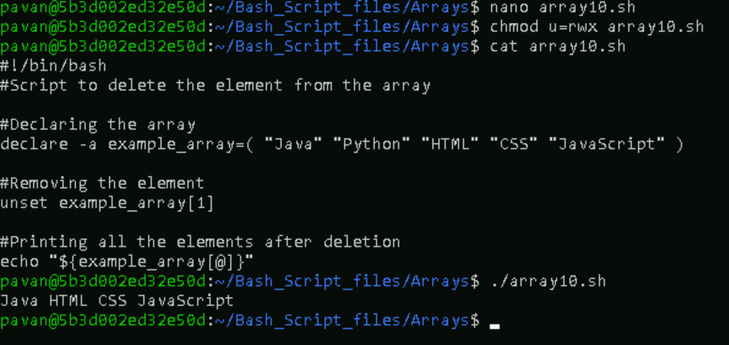

1. To delete the entire Array.

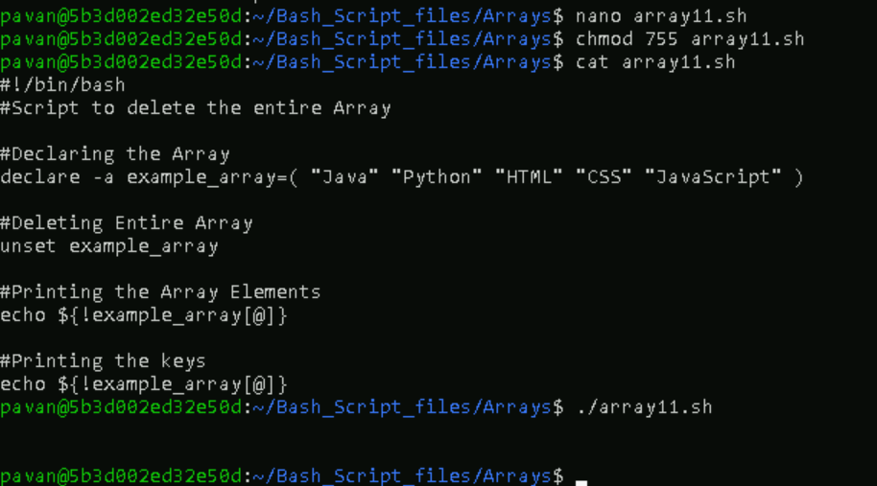

1. To slice Array Element from index 1 to index 3.

