**Thumati Pavan Venkata Narendra Kumar**

**EMP-ID-289219**

**CASE_STUDY 1**

1. Check the present working directory.
2. To create the SVN repository install the required tools (Git, Subversion, and Git-svn) installed.

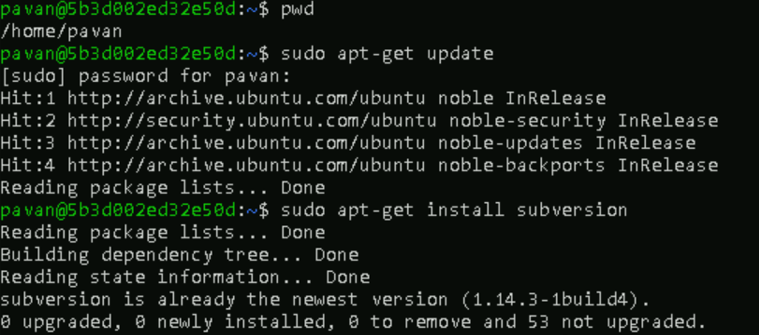

1. Before migrating from SVN to Git create a SVN repository using “svnadmin create repo_name”.
2. Create a repository structure in a folder and import then into SVN repository.

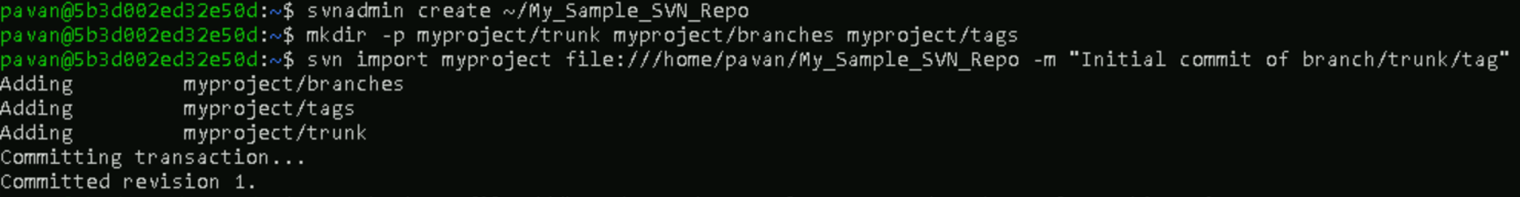

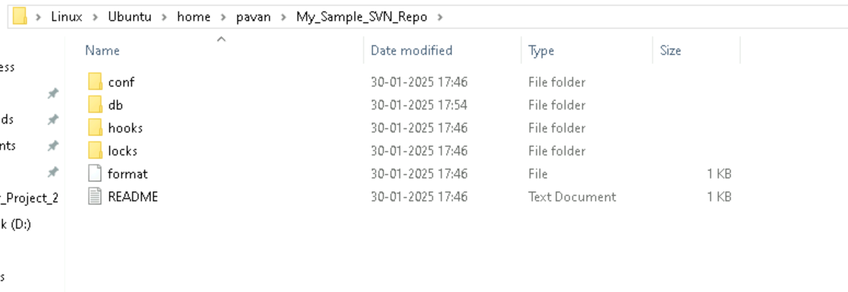

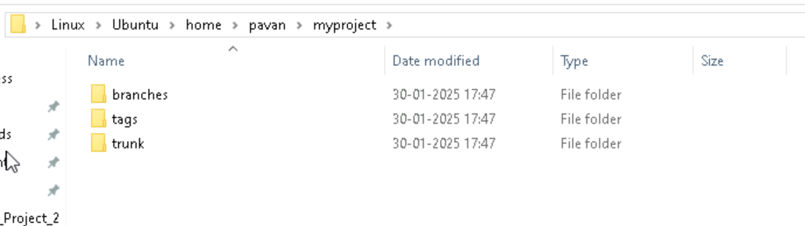

1. Create a working copy (separate directory) of SVN repository(from trunk) using “**svn checkout path/to/svn_repo/trunk working_copy_dir_name**”
2. In working copy add new files or update the required files.
3. Check the status, add, and commit using “**svn status**”, “**svn add file_name**”, and “**svn commit -m “message”** “ commands respectively.

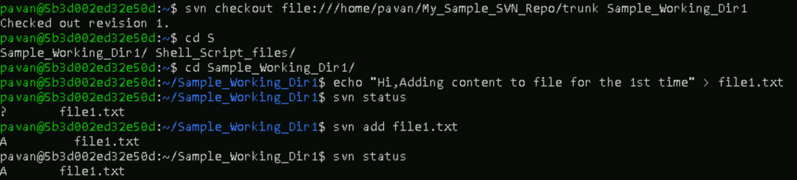

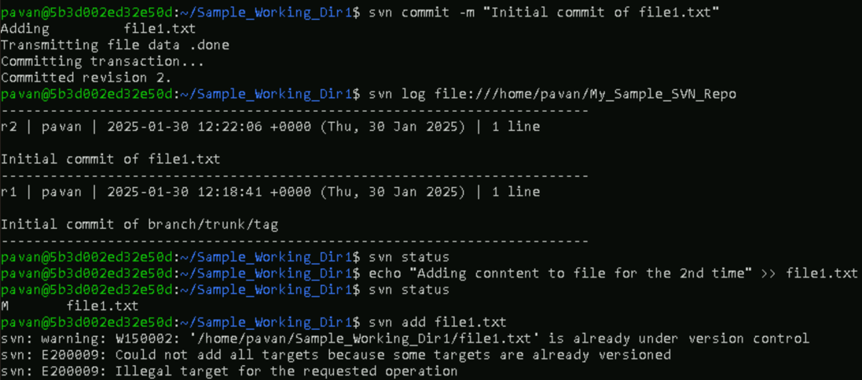

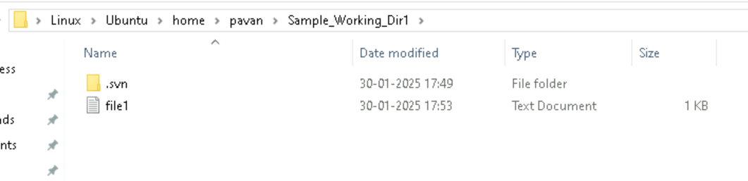

1. Check the commit history using “**svn log command**”.

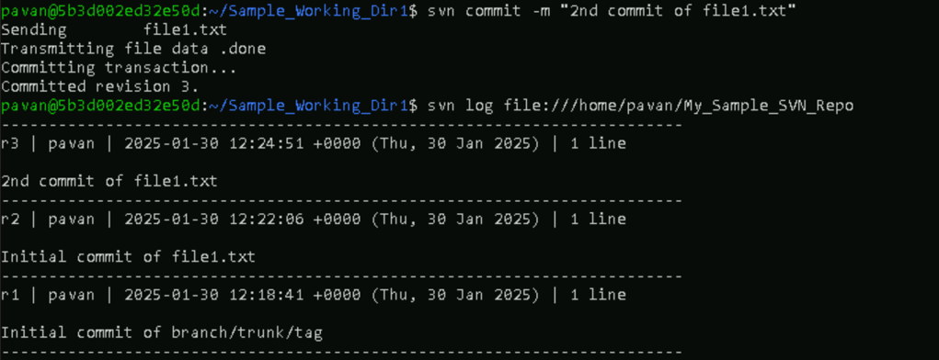



1. Before cloning the SVN repo to Git repo add the authors.txt file which contains the mapping of SVN repo author with Git repo authors.

Format of author names in authors.txt

SVN user/author name = GIT user name <usermailId>

1. Clone the SVN repository to Git repository.

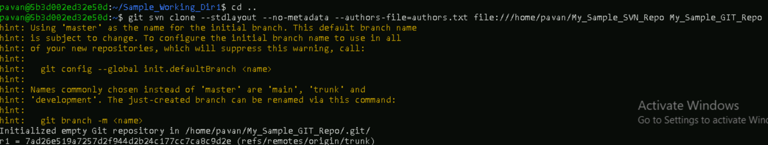

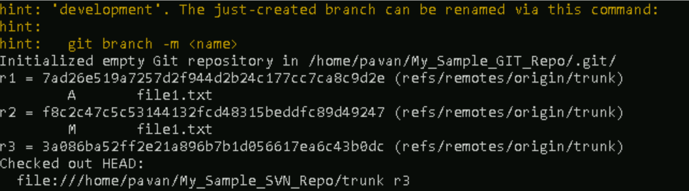

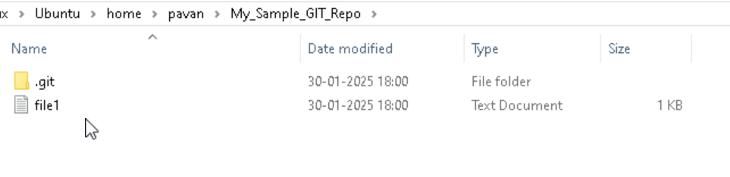

1. In Git repo directory check the log history which is same as the SVN repo log history with mapped author names.

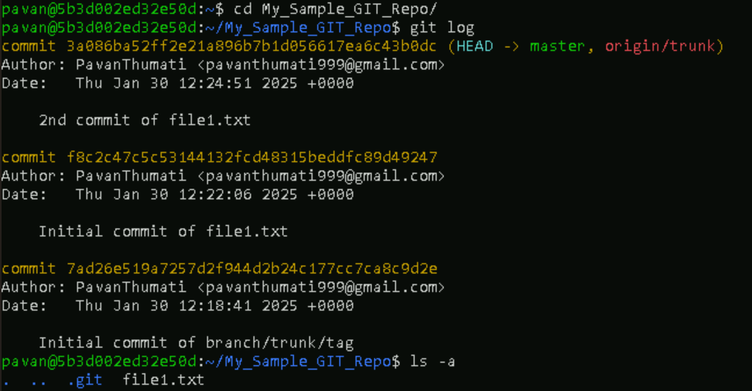

1. Before setting up the remote URL, generate the token in GitHub.
2. Now set the remote URL with GitHub repository.
3. Push the committed changes to the GitHub using “**git push -u origin1 –all**”.