Thumati Pavan Venkata Narendra Kumar

EMP-ID-289219

INTERMEDIATE PROJECT – 1

STEP – 1 : First Create and deploy a project

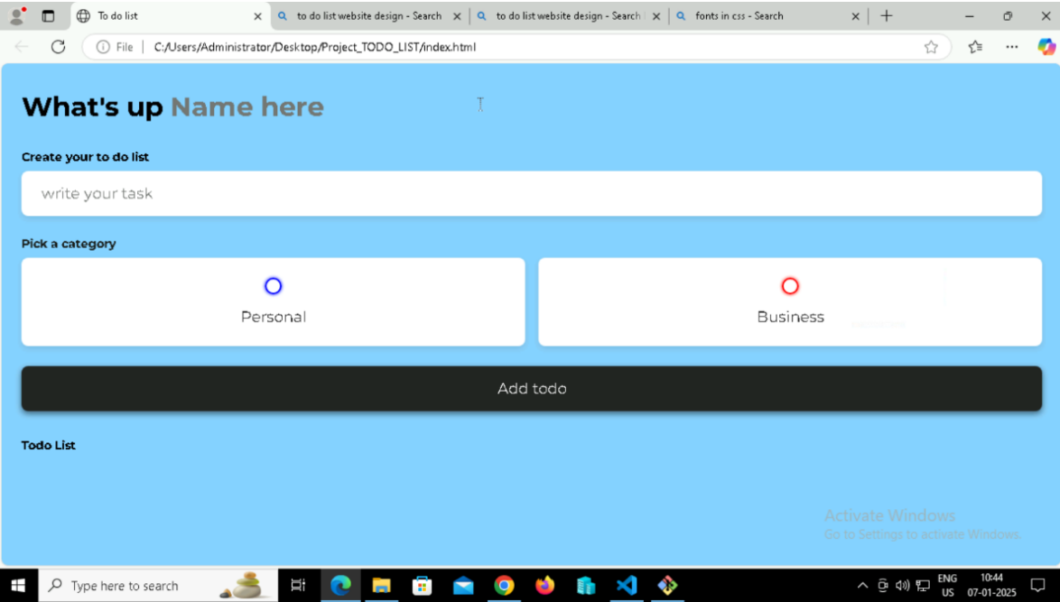

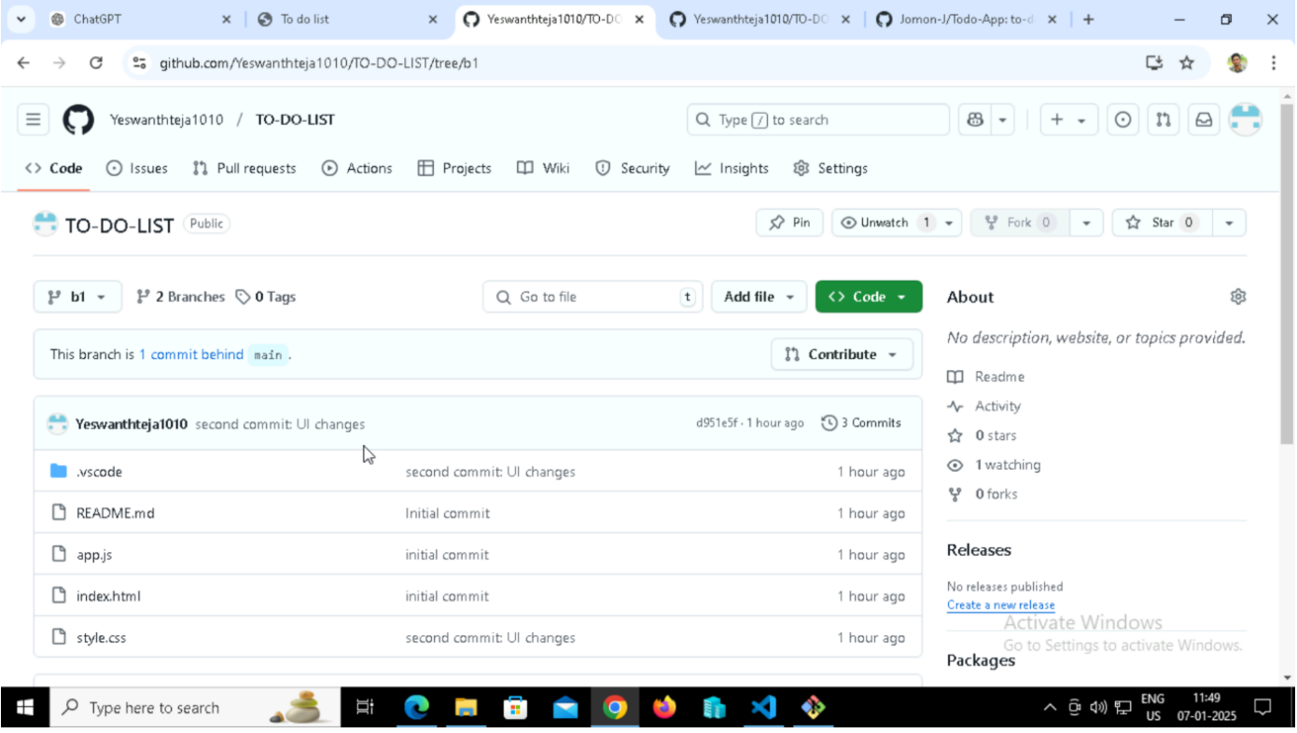

Step 2 : Look for any **issues** created by anyone in this repository

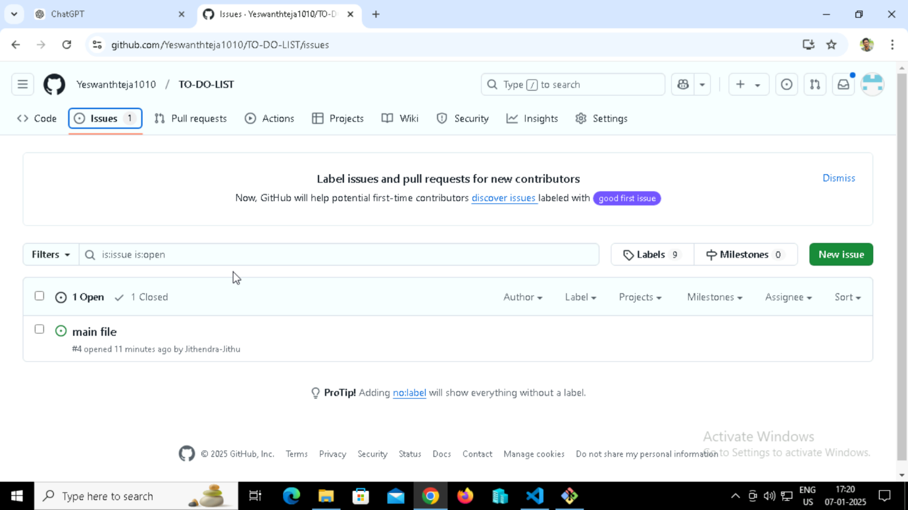

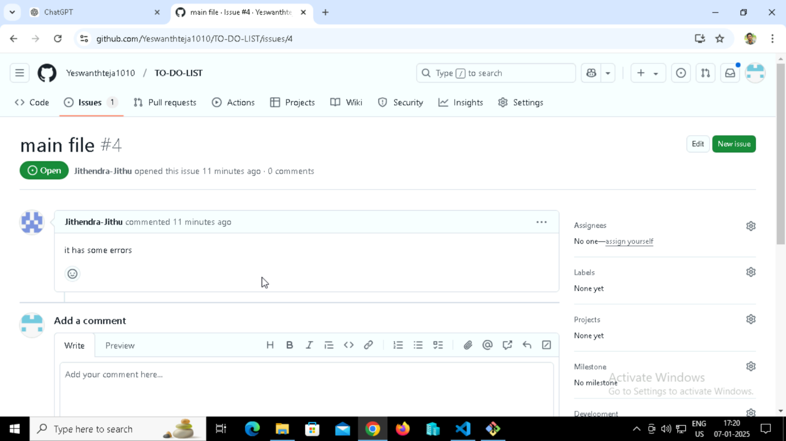

Step 3 : Collaboration

First go to settings in your repository and click on collaborators. Then click on add people button and search for your collaborator using username. Send request to the collaborator and wait for them to accept.

Now they had become a collaborator for your project.

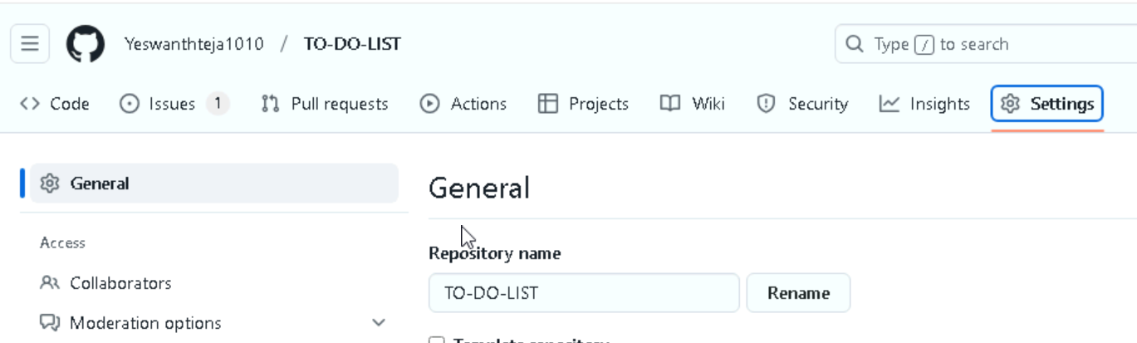

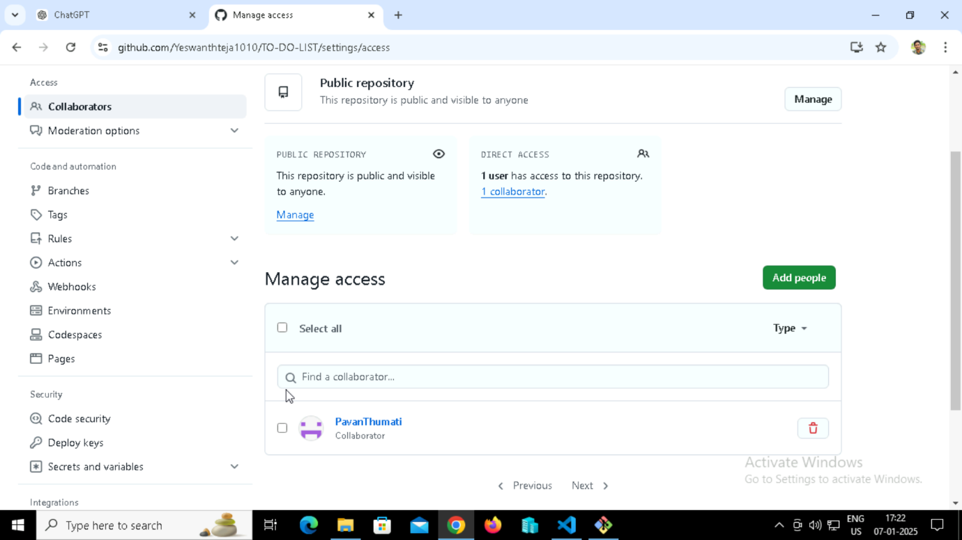

Now even collaborator can make changes to your project directly. Collaborator can commit changes using 2 methods

1. Makes changes directly to main branch – this will make changes to your project without your acceptance
2. Create a new branch and a pull request – this will send pull request to the owner. they need to accept and merge the pull request to merge the collaboartors changes. 