**Thumati Pavan Venkata Narendra Kumar**

**EMP-ID-289219**

**GROOVY-PROJECT-1**

**1.STRINGS**

**1.Single quoted strings**

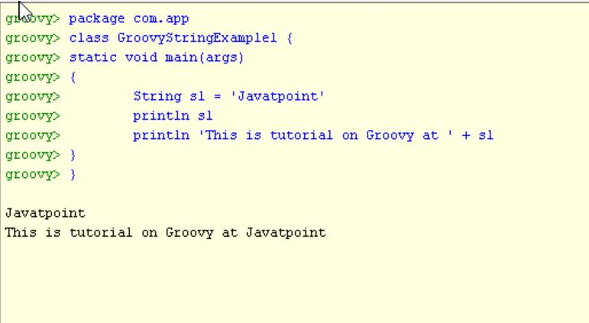

**2.Double quoted strings:**

**Example 1:**

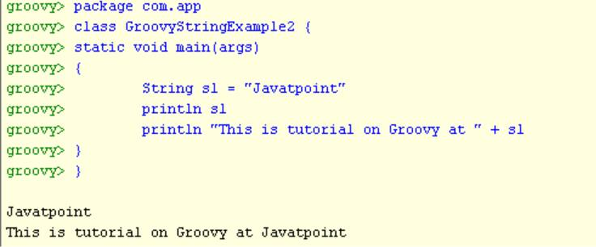

**Example 2:**

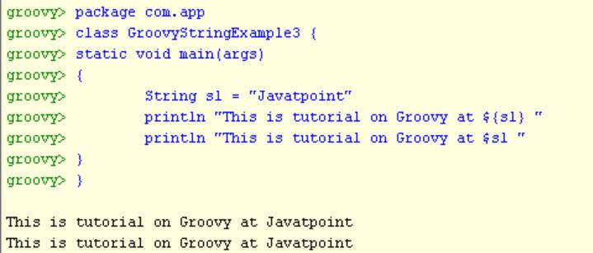

**3.Triple-single-quoted string:**

**Example 1:**

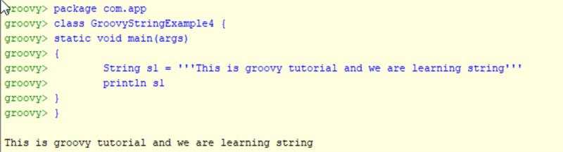

**Example 2:**

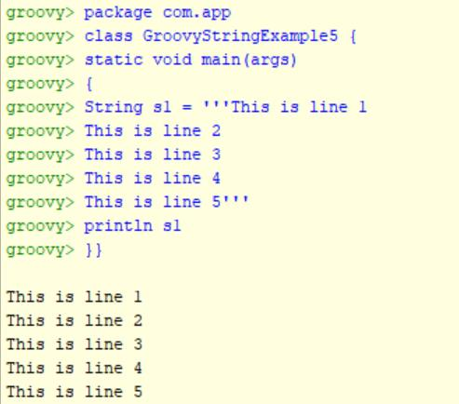

**4.Triple-double-quoted string:**

**Example 1:**

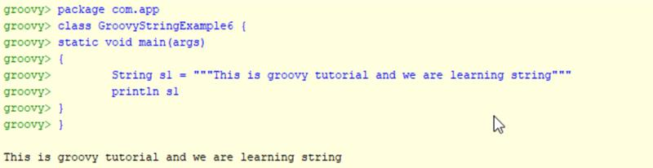

**Example 2:**

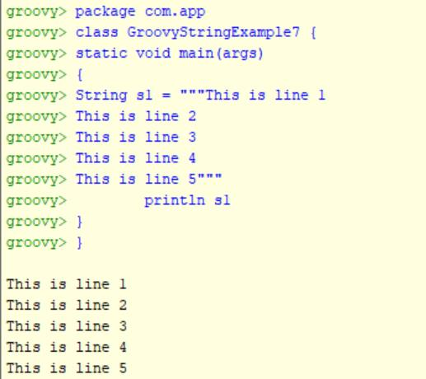

**Example 3:**

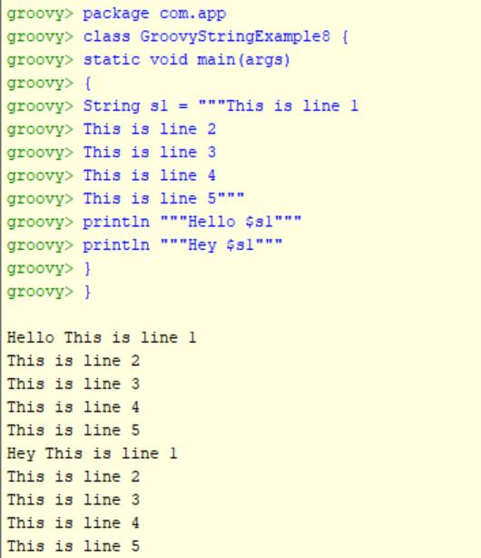

**5.** **Slashy string:**

**Example 1:**

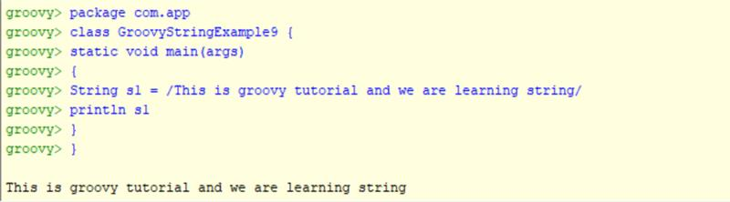

**Example 2:**

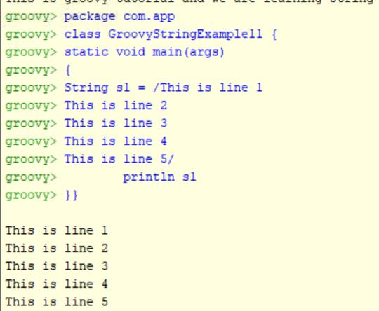

**Example 3:**

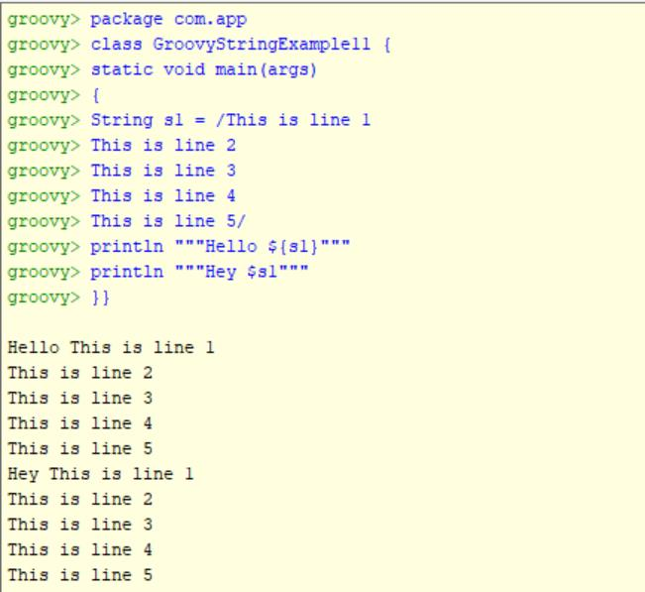

**DECISION MAKING:**

**1. IF Statement:**

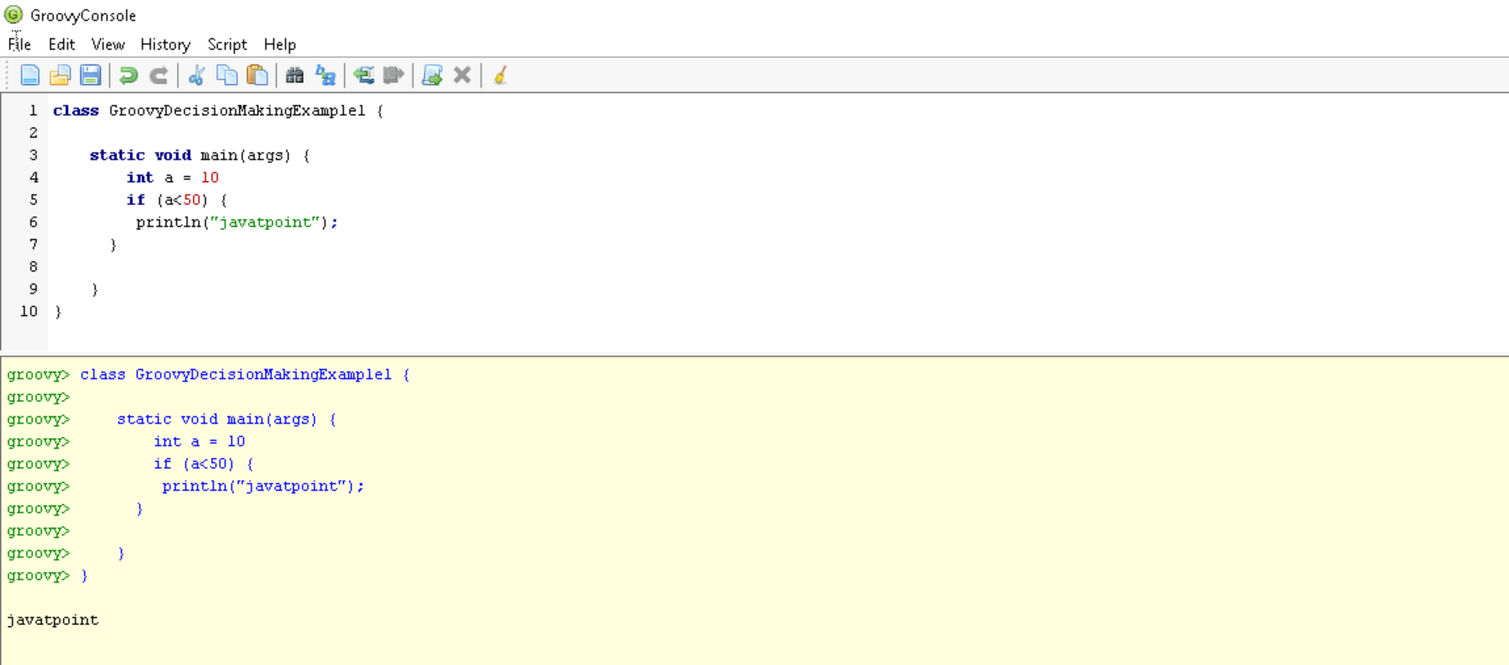

**2. IF- ELSE:**

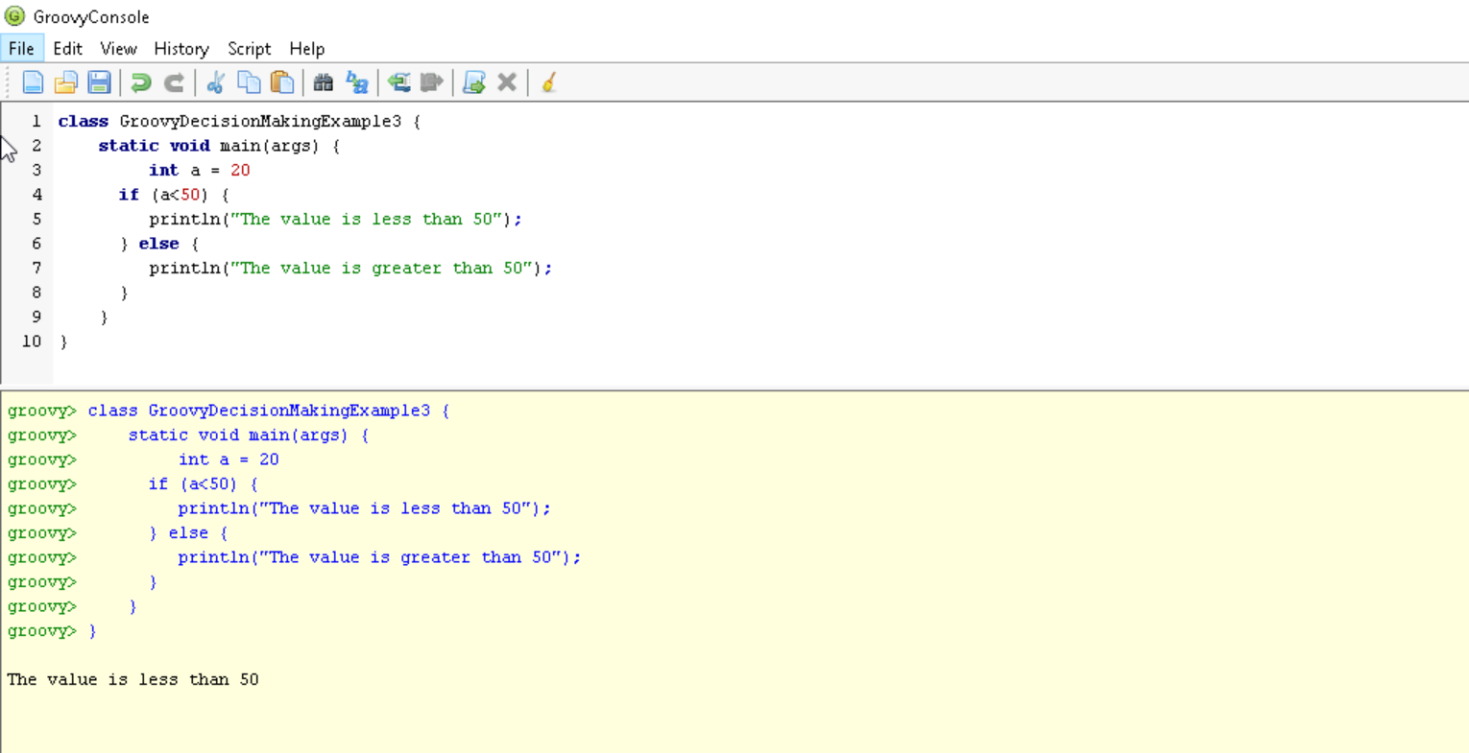

**3.NESTED – IF:**

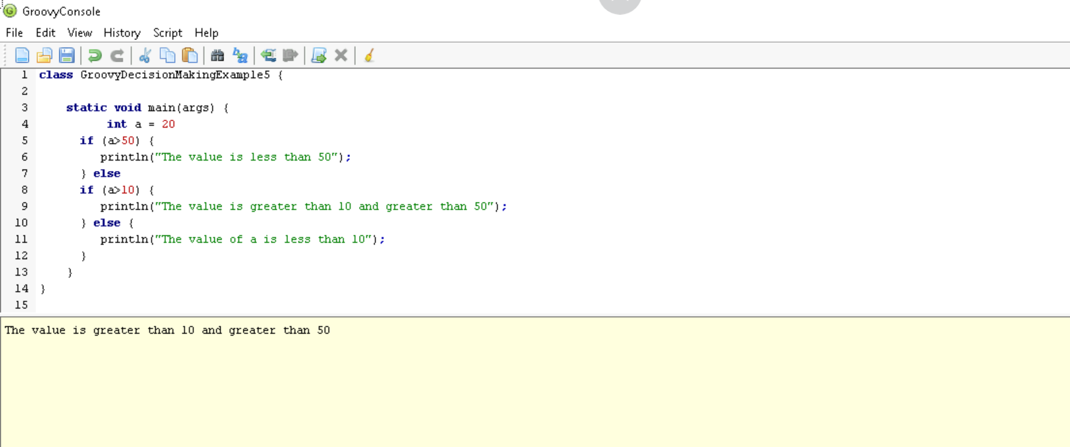

**4. SWITCH STATEMENTS:**

