**Thumati Pavan Venkata Narendra Kumar**

**EMP-ID-289219**

**GROOVY-CASE STUDIES**

1. **Log File Analysis & Monitoring with Groovy.**

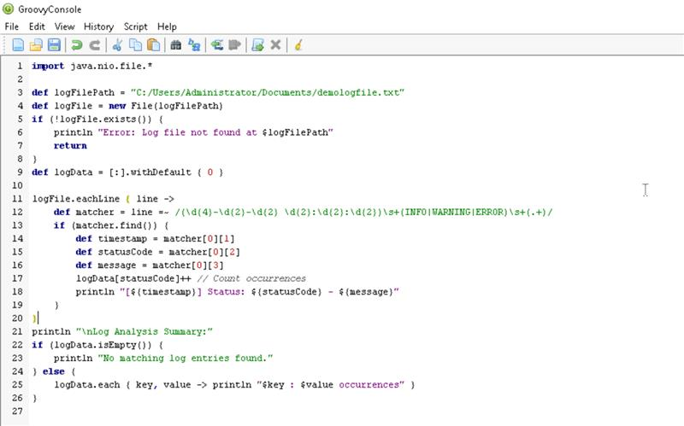

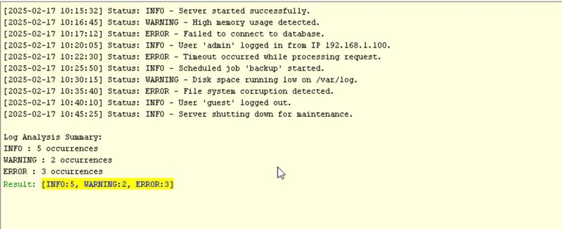

1. **Web Scraping & Data Extraction with Groovy & Jsoup.**

