**Thumati Pavan Venkata Narendra Kumar**

**EMP-ID-289219**

**PYTHON-BASICS-ASSIGNMENTS-1**

**1.Operators in python.**

1. **Arithmetic Operators.**

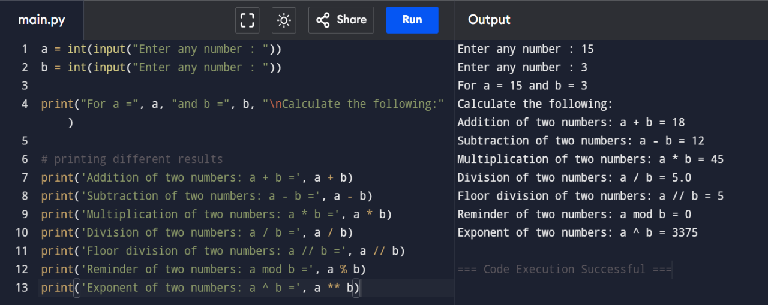

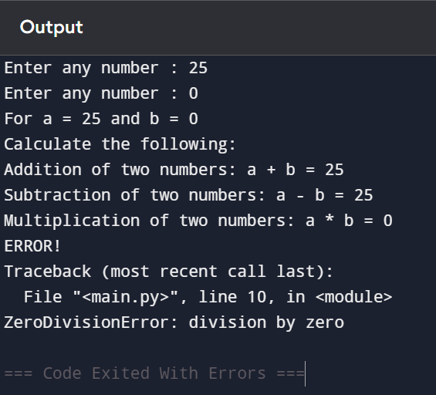 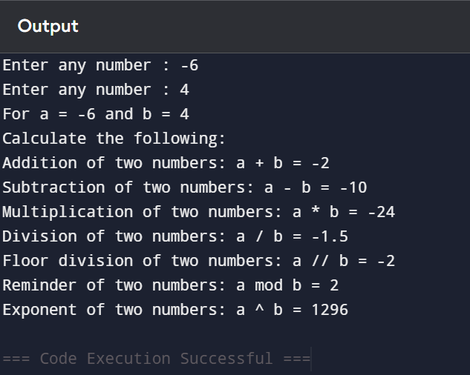

1. **Comparison Operators.**

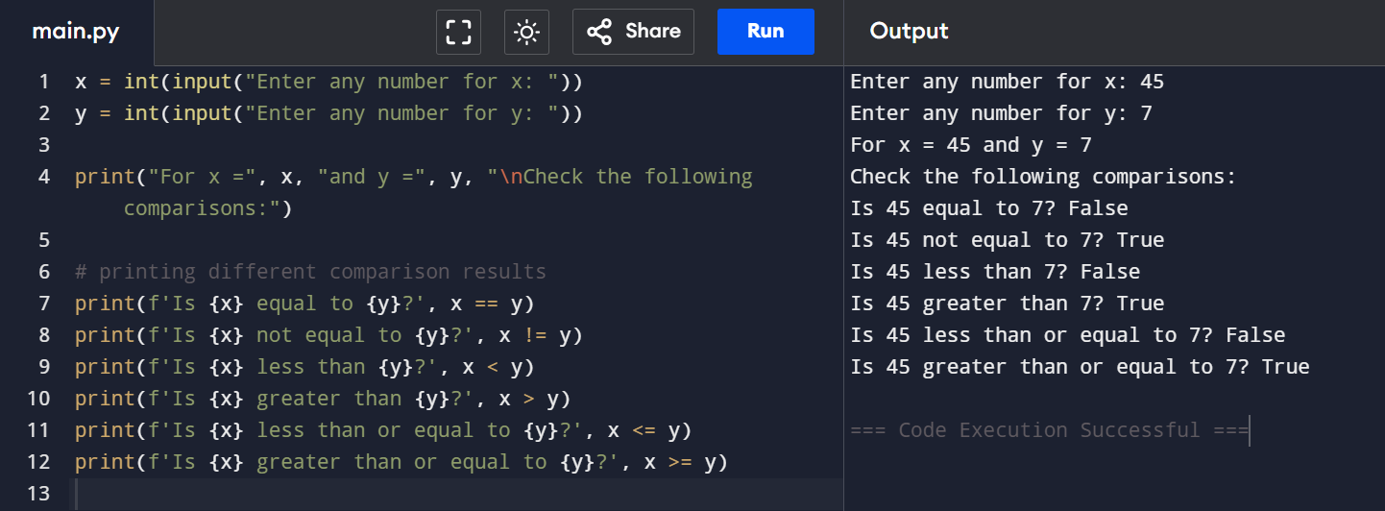

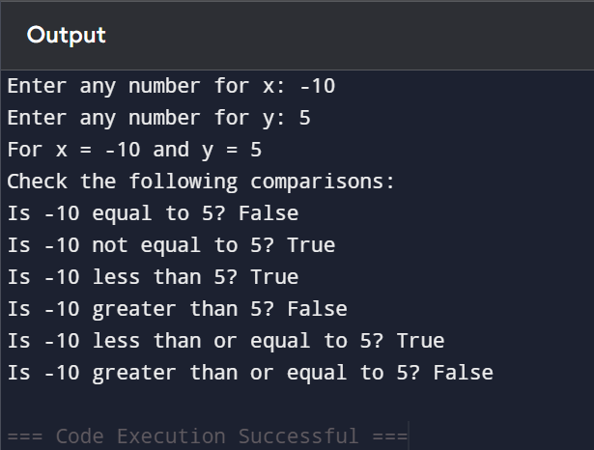 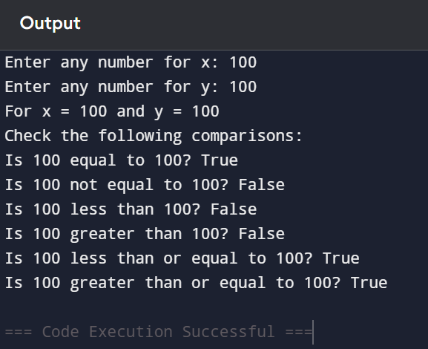

1. **Assignment Operators.**

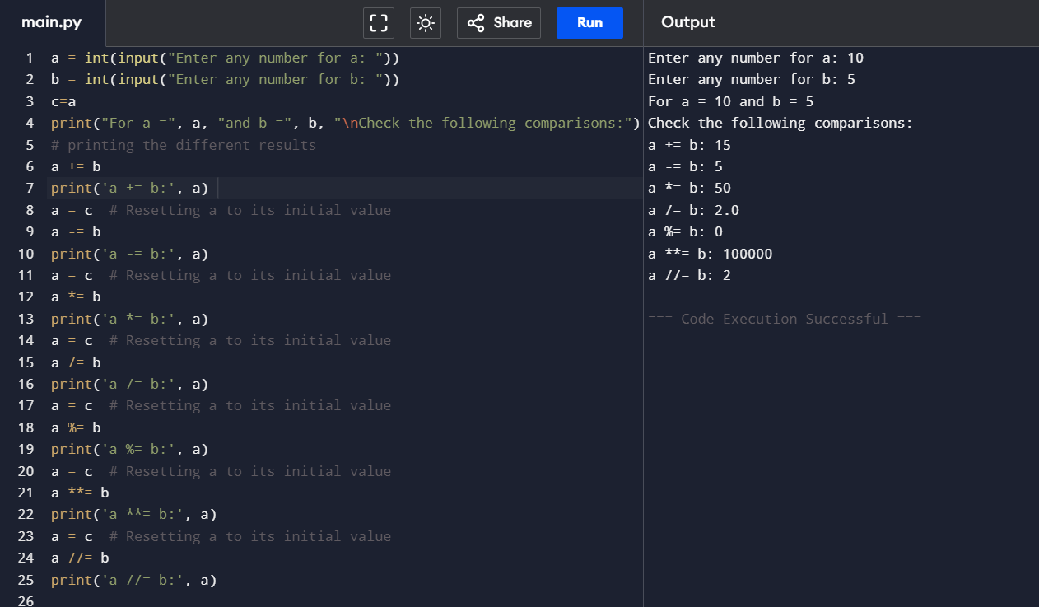

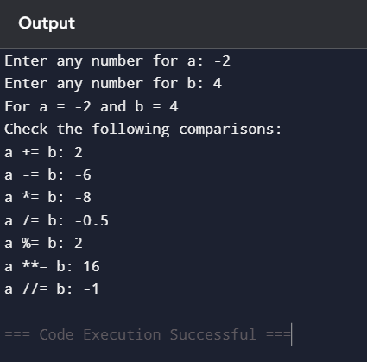 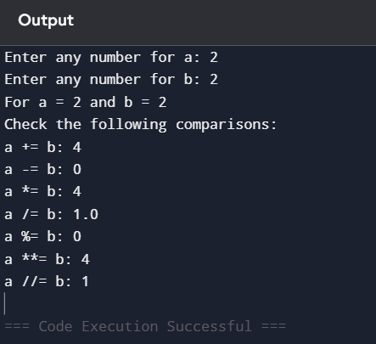

1. **Logical Operators.**

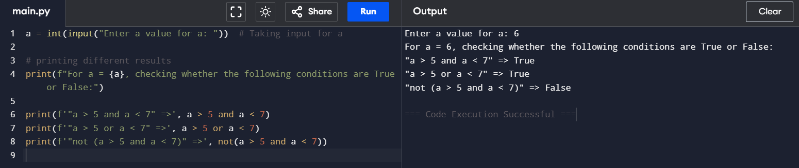

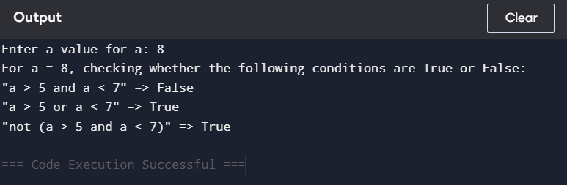 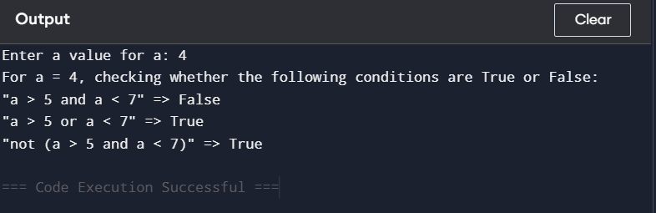

1. **Bitwise Operators.**

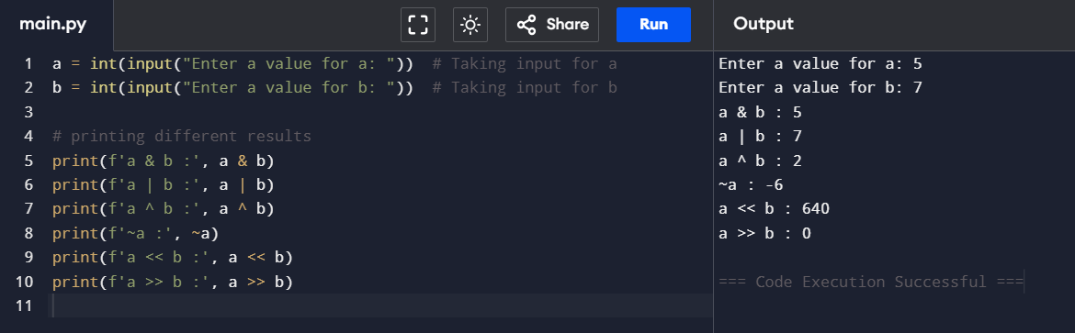

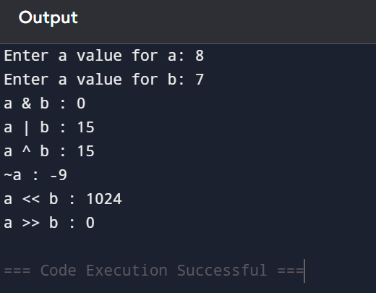 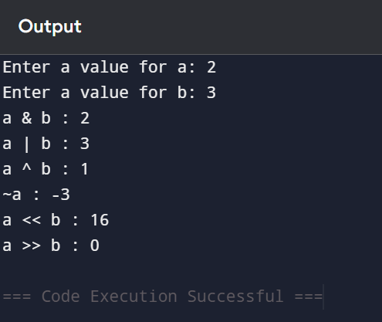

1. **Membership Operators.**

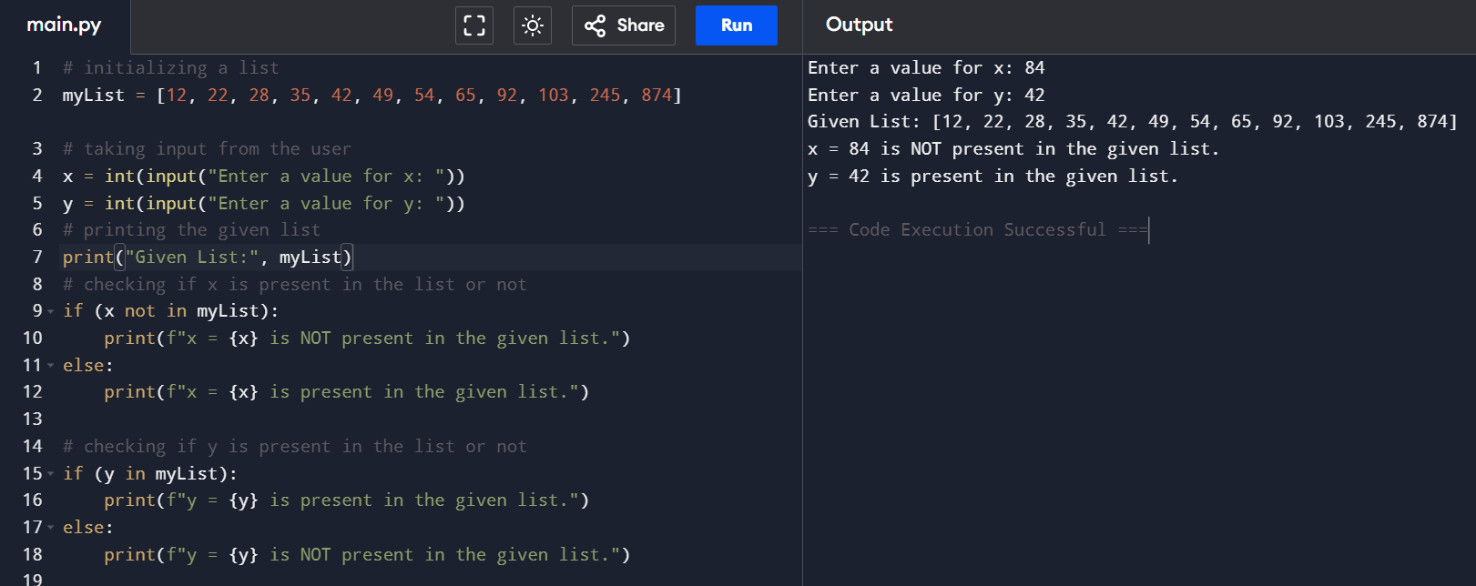

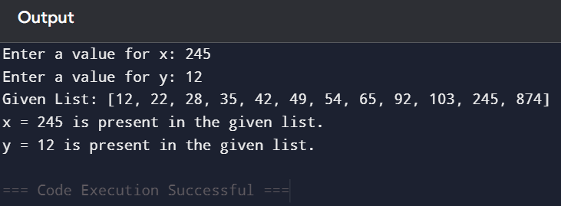 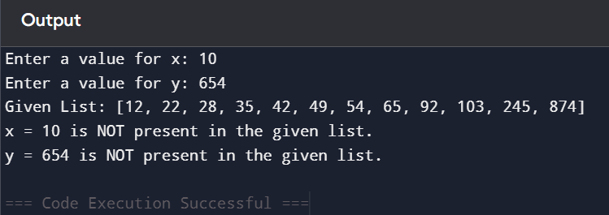

1. **Identity Operators.**

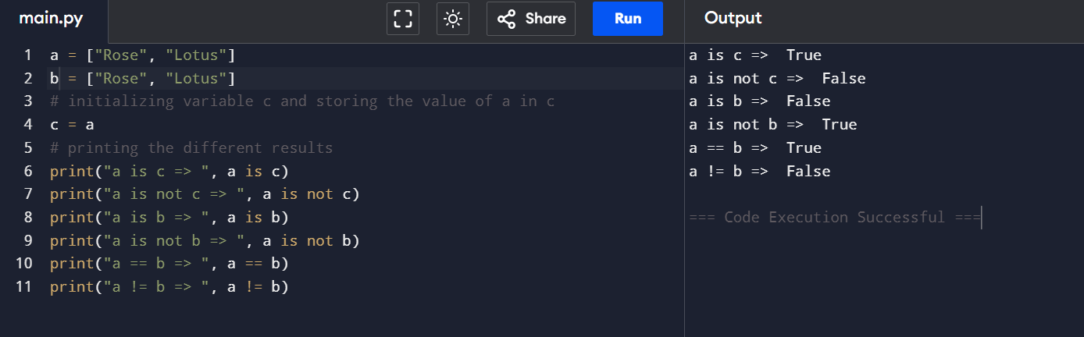

**2.** **Reversing a string in Python**

1. **Using for loop.**

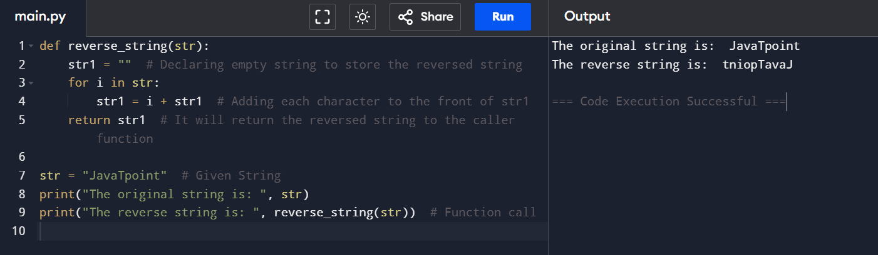

1. **Using while loop.**

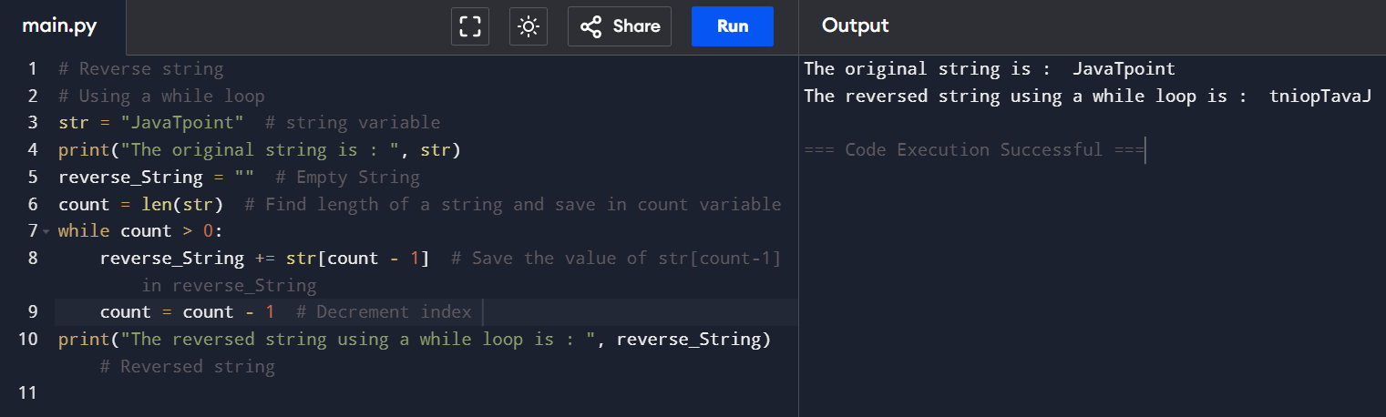

1. **Using the slice operator.**

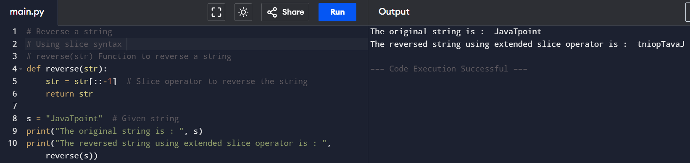

1. **Using the reversed() function.**

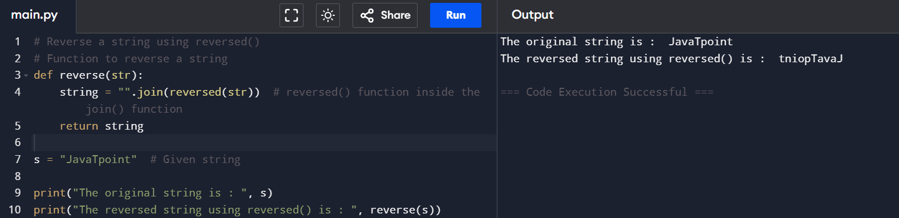

1. **Using the recursion.**

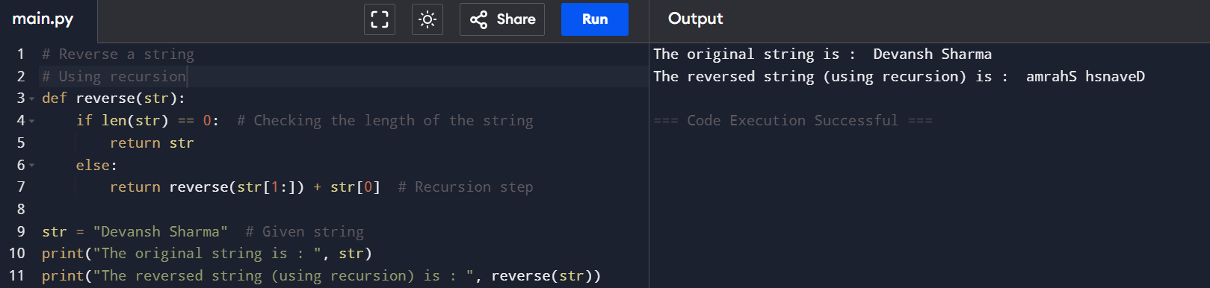

**3.** **Reading CSV file in Python:**

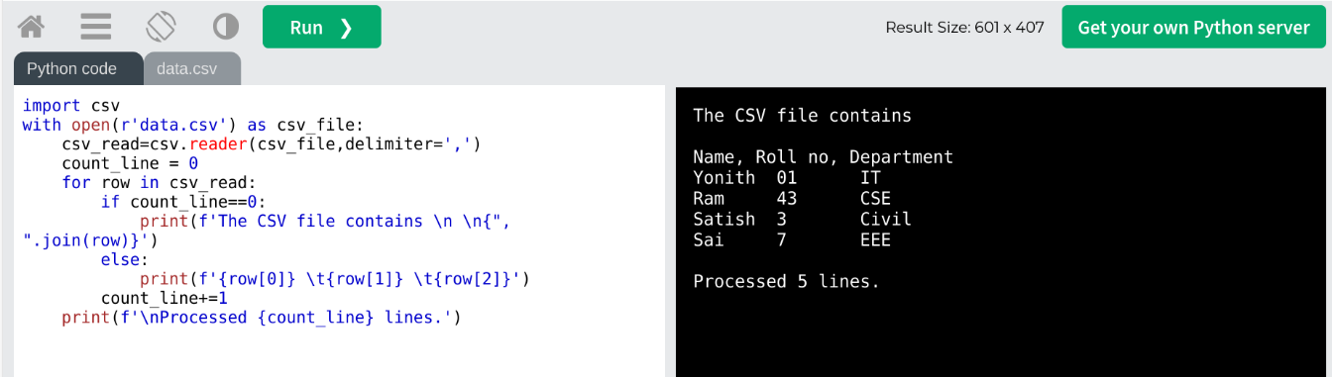

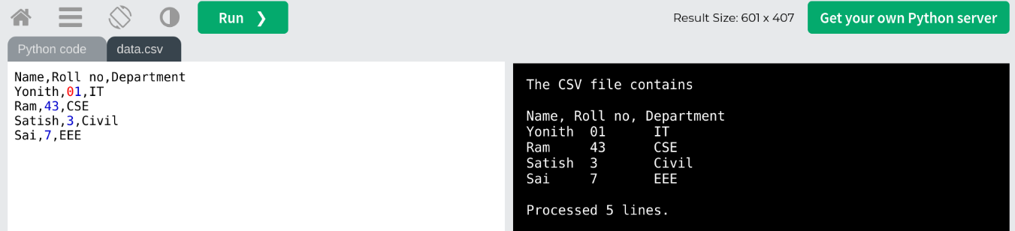

**4.Python If Statement:**

**

**2.Checking either a number EVEN or not.**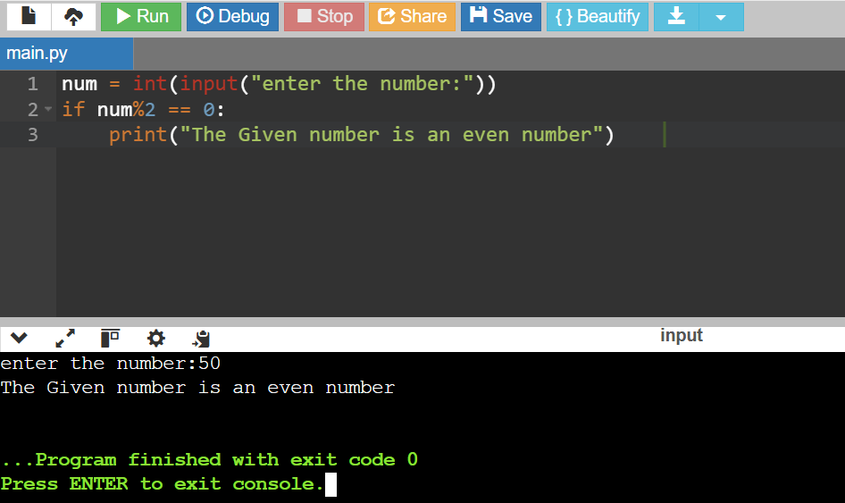

**Python If-Else Statement:**

**1.Checking either a person eligible to vote or not.**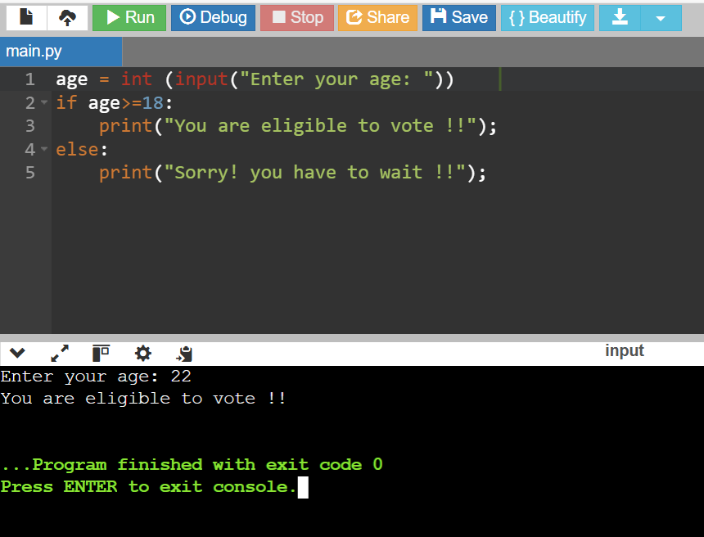

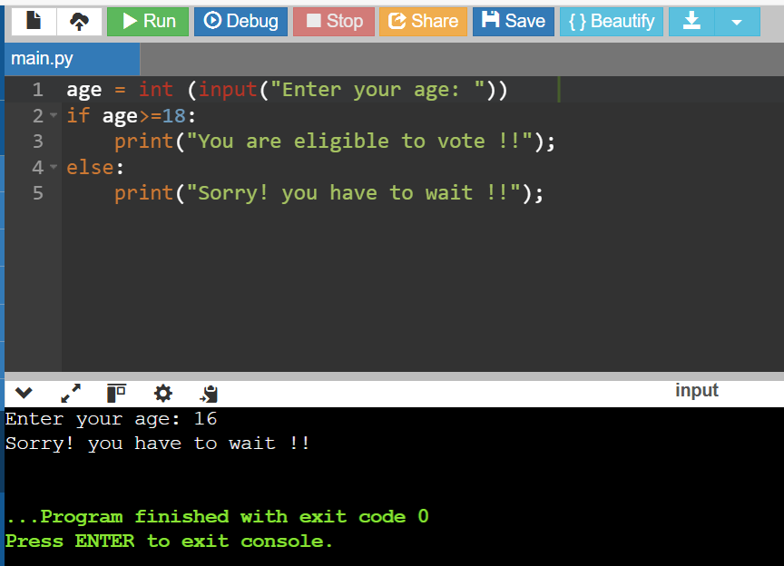

**Python Elif Statement:**

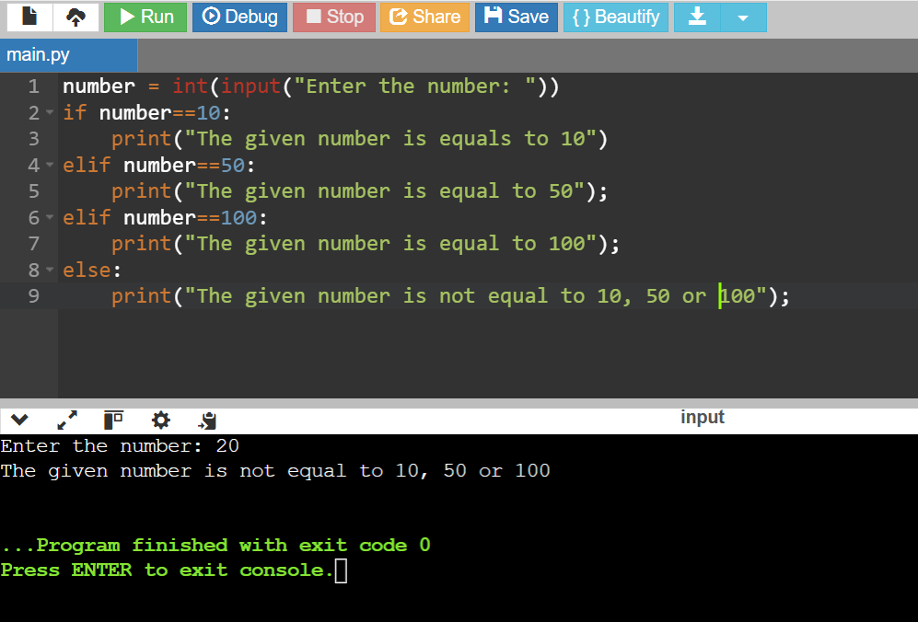

**5.Python Loops:**

**5.1 For loop:**

1. **Iterating by using index of sequence**

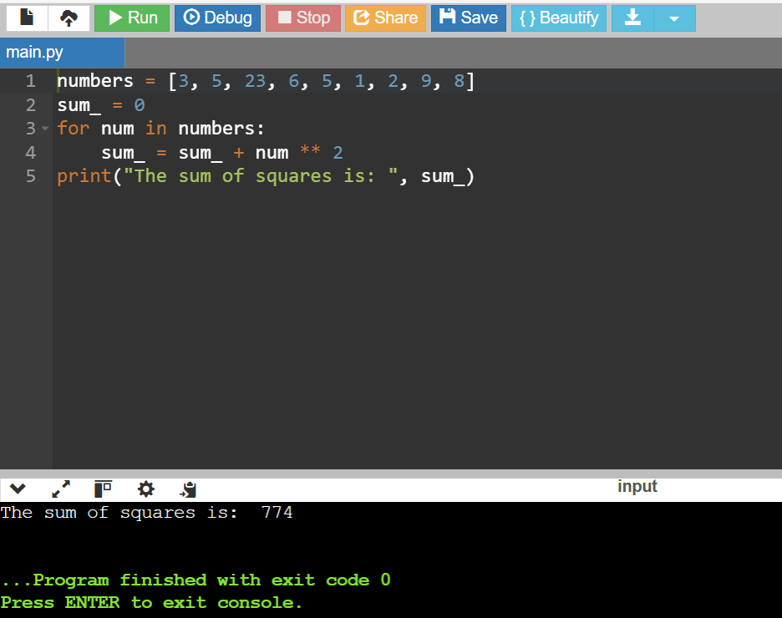

1. **Using Range ()**

1. **Using else statement with For loop**

1. **Nested For loop**

**5.2 While loop:**

1. **Sum of squares**

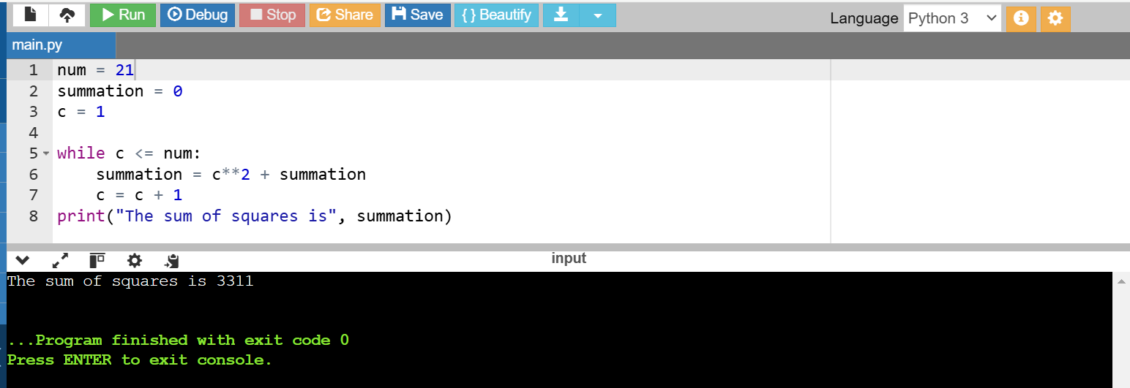

1. **To check whether given number is Prime or not**

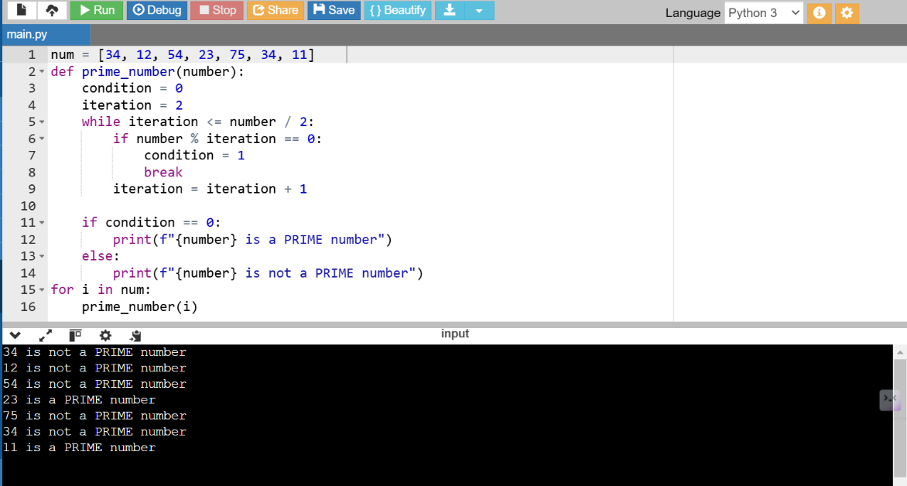

1. **Armstrong number**

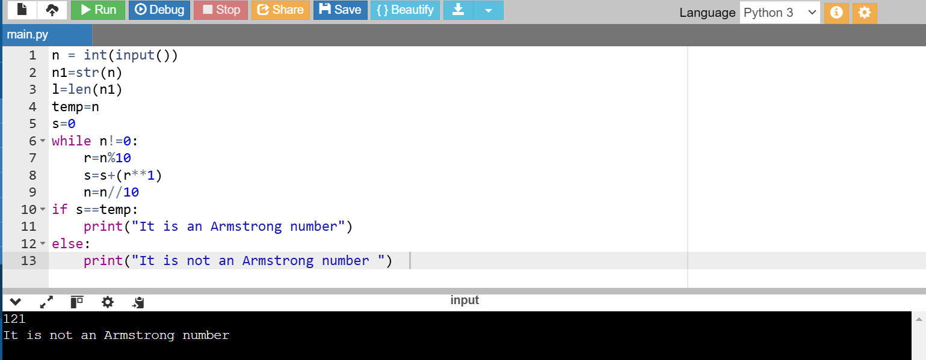

1. **Multiplication Table**

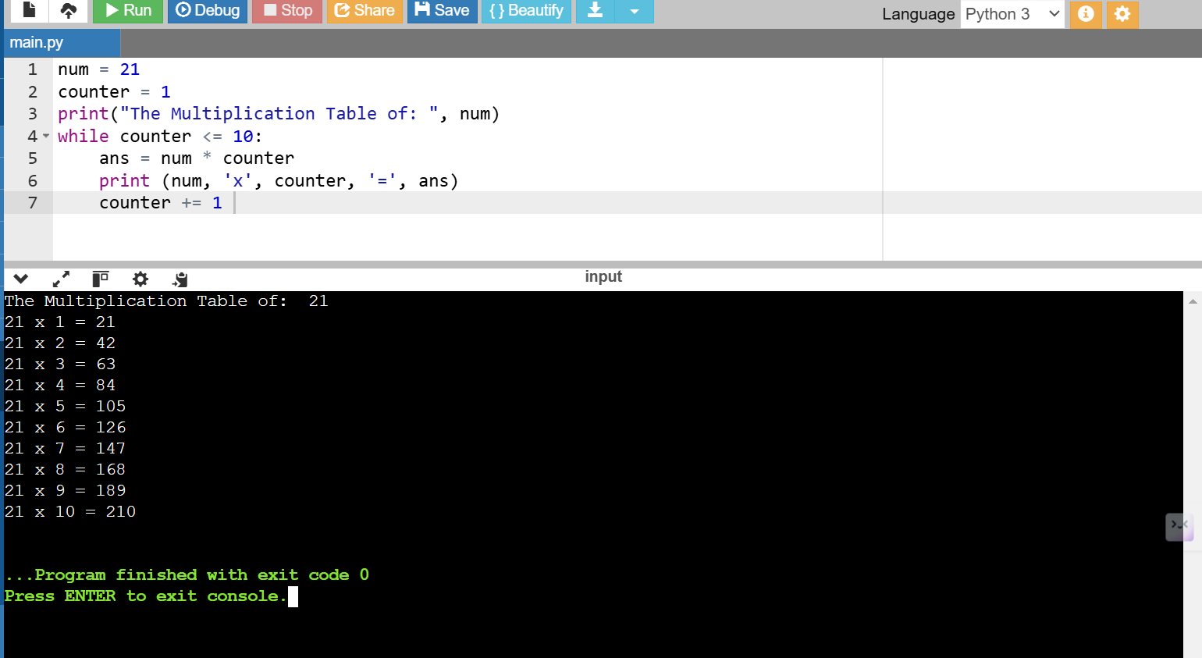

1. **BREAK Statement**

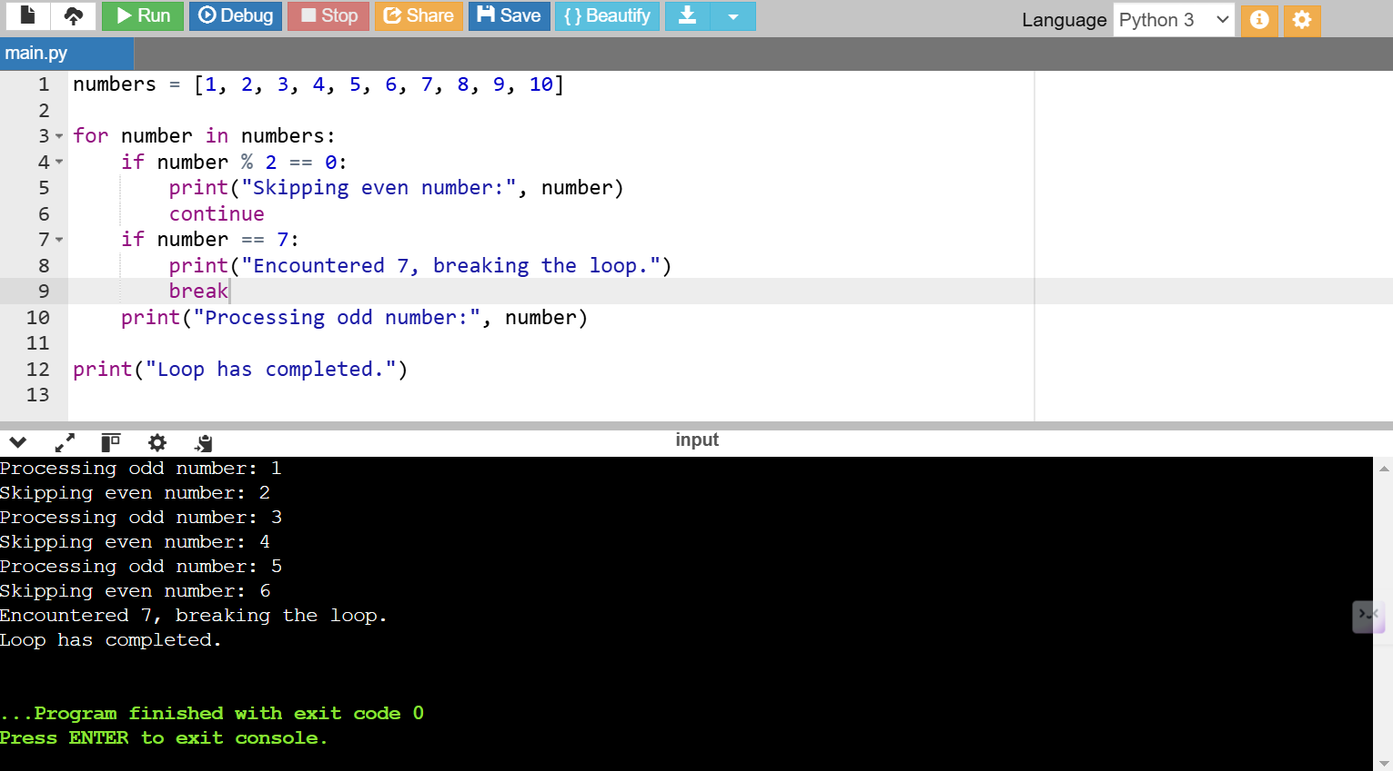

**6. PYTHON STRINGS**

1. **Creating String in Python**

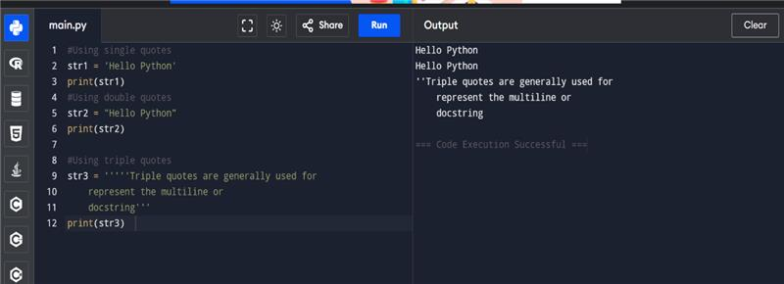

1. **Strings indexing and splitting**

Example 1:

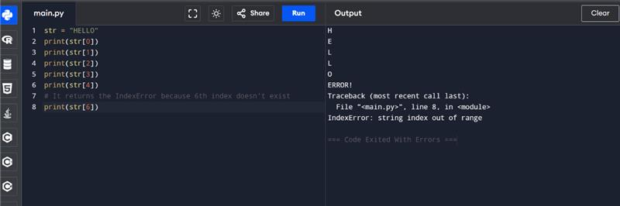

Example 2

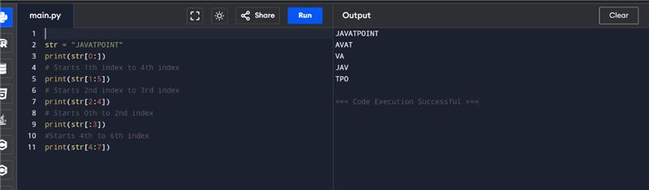

1. **Strings Operators**

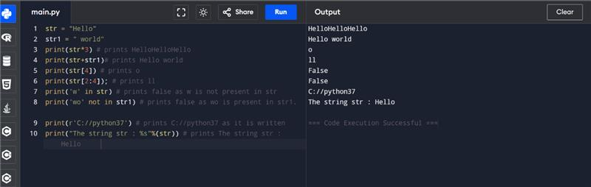

1. **String formatting**

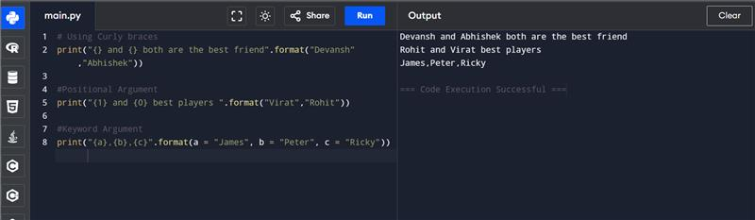

**7.Lists and Tuples**

1. **List and Tuple Syntax Differences**

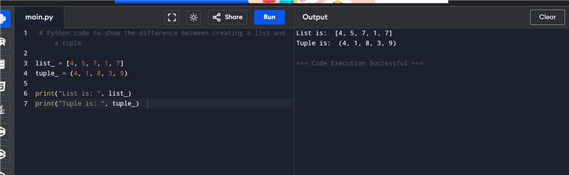

1. **Updating the element of list and tuple at a particular index**

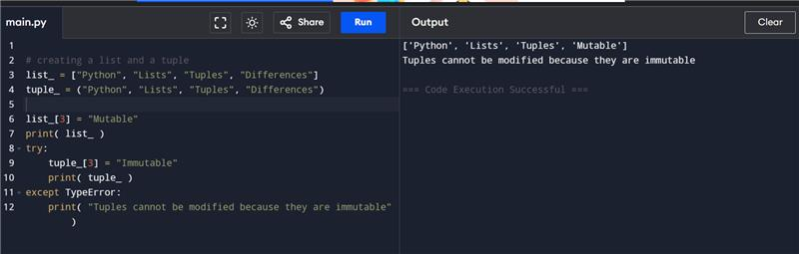

1. **Code to show the difference in the size of a list and a tuple**

