**Thumati Pavan Venkata Narendra Kumar**

**EMP-ID-289219**

**PYTHON-PROJECT-1**

**1.Python Functions.**

* 1. **Example Python Code for User-Defined function**

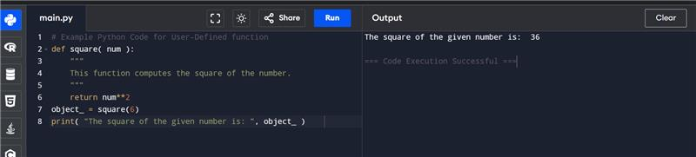

* 1. **Example Python Code for calling a function**

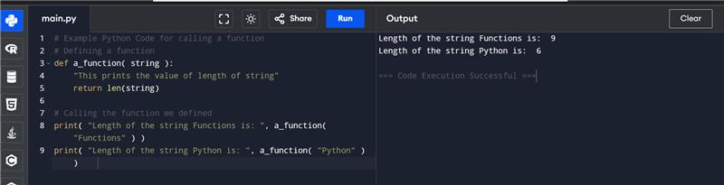

* 1. **Example Python Code for User-Defined function**



* 1. **Example Python Code for calling a function**



* 1. **Pass by Reference vs. Pass by Value**

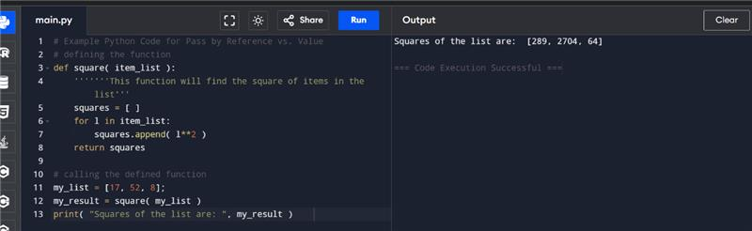

* 1. **Default Arguments**

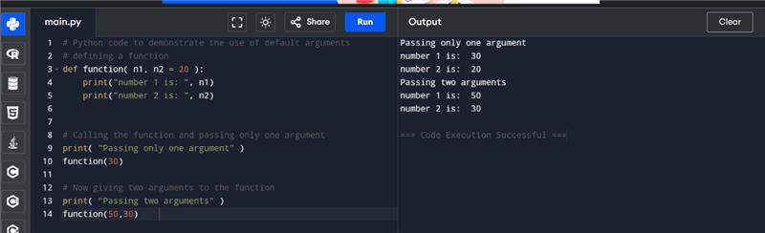

* 1. **Keyword Arguments**

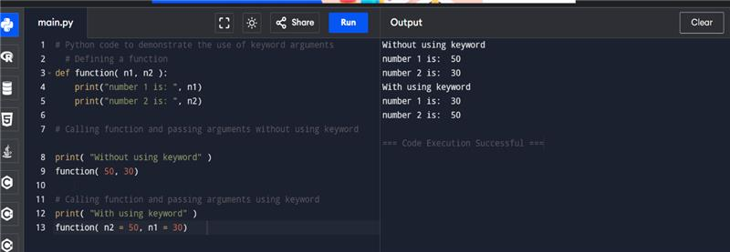

* 1. **Required Arguments**

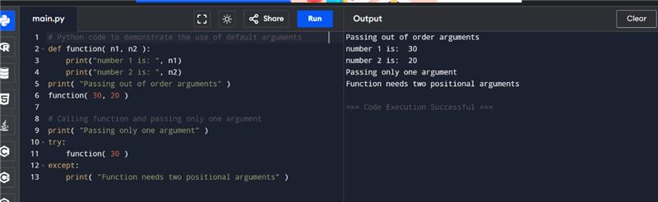

* 1. **Variable-Length Arguments**

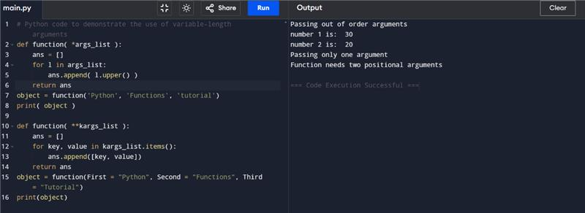

* 1. **Return statement**

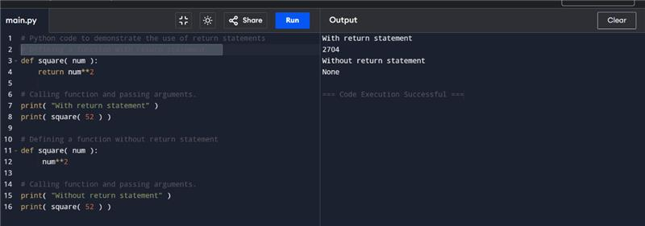

* 1. **The Anonymous Functions**

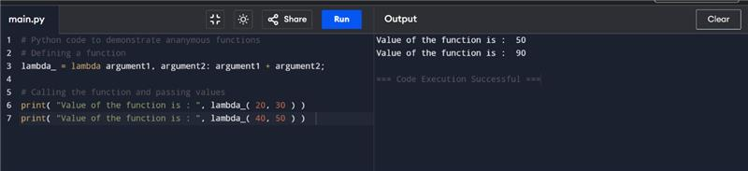

* 1. **Scope and Lifetime of Variables**

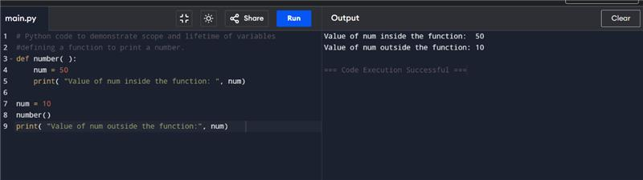

* 1. **Python abs() Function**

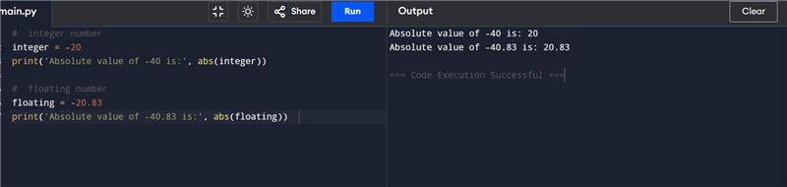

* 1. **Python bin() Function**

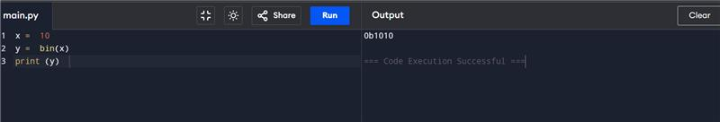

* 1. **Python all() Function**

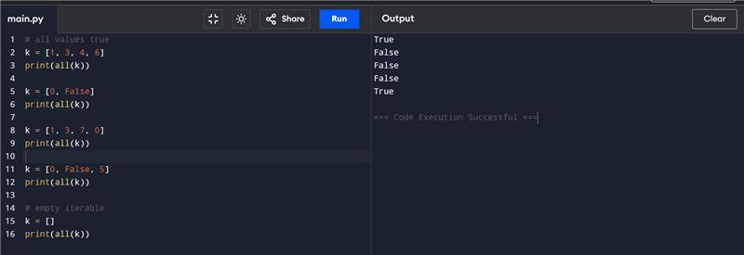

* 1. **Python bool()**

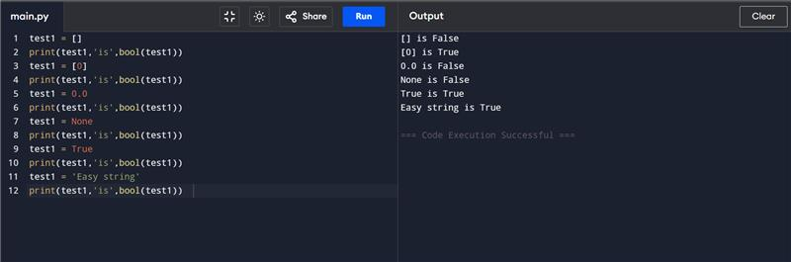

* 1. **Python bytes()**

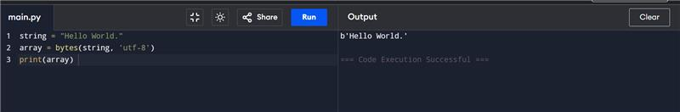

* 1. **Python compile() Function**

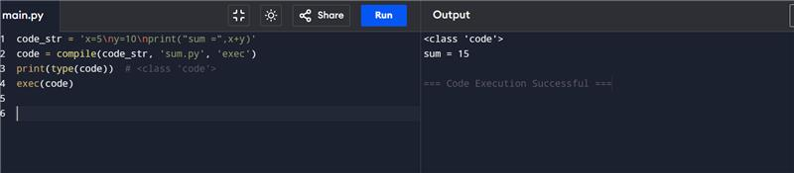

* 1. **Python exec() and sum() Function Example**

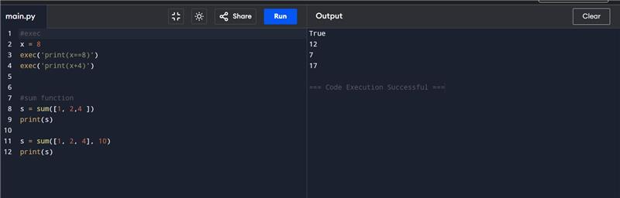

* 1. **Any() function**

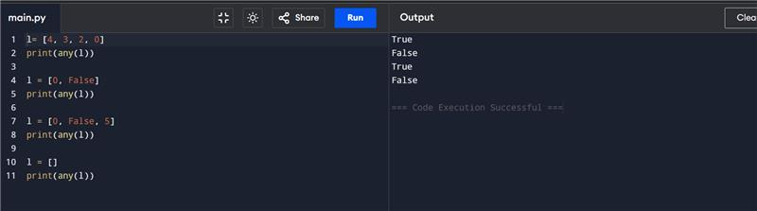

* 1. **ASCII() function**

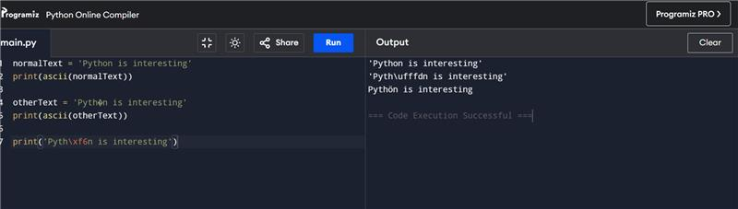

* 1. **Byte array() and eval() functions**

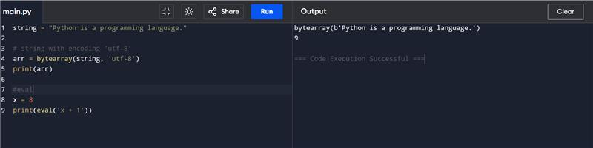

* 1. **Float() function**

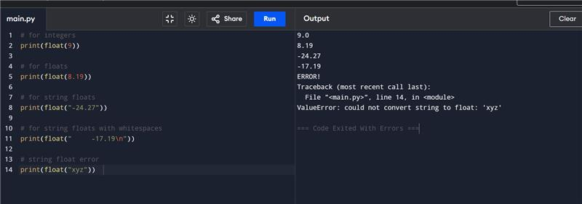

* 1. **Frozen set() and format() fucntion**

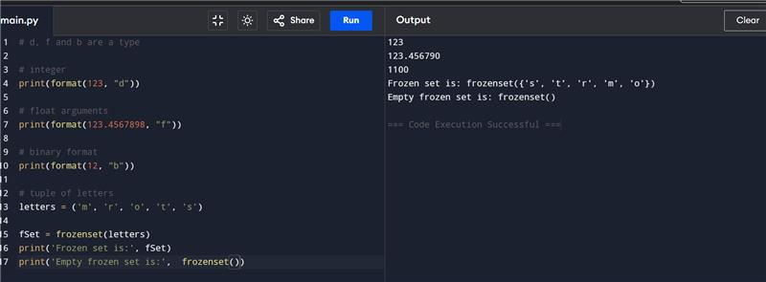

* 1. **Gloabls() and getattr() function**

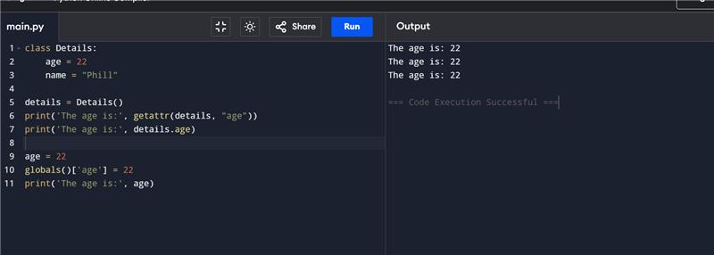

* 1. **Python iter() Function**

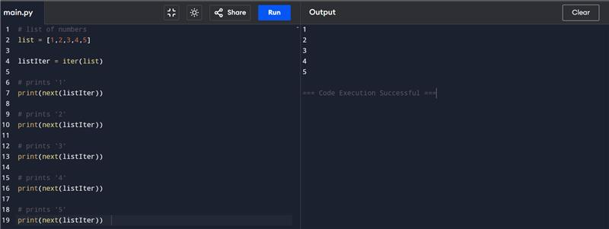

* 1. **Python list()**

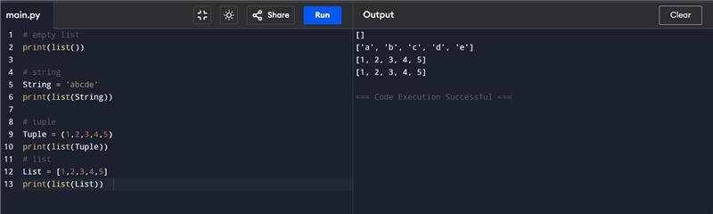

* 1. **Python locals() Function Example**

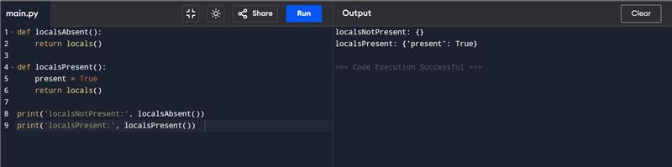

* 1. **Map() function**

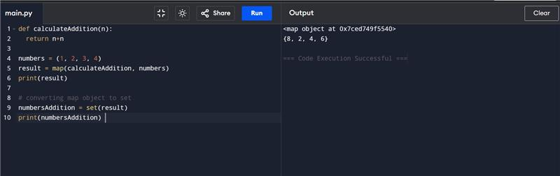

* 1. **Python memoryview() Function**

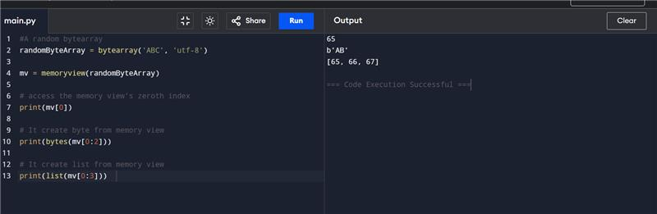

* 1. **Python chr() Function**

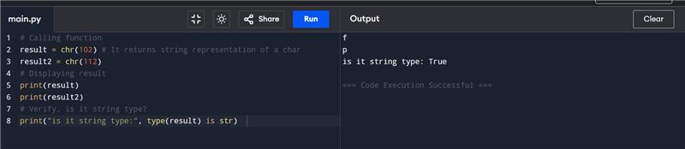

* 1. **Python complex fun()**

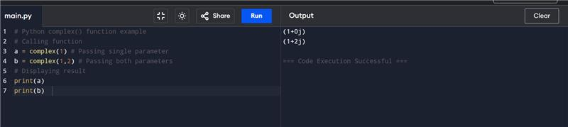

* 1. **Python delattr() Function**

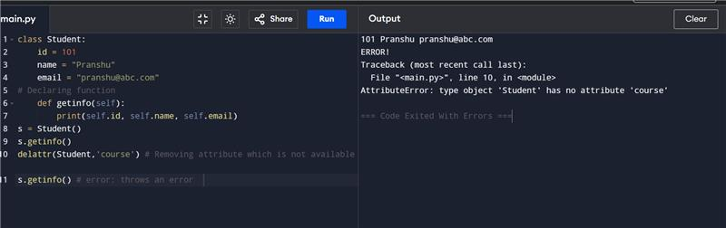

* 1. **Python enum()**

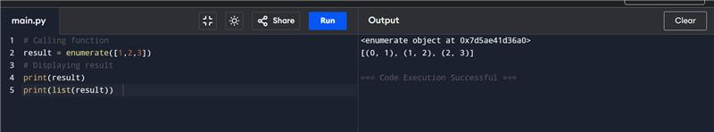

* 1. **Python dict()**

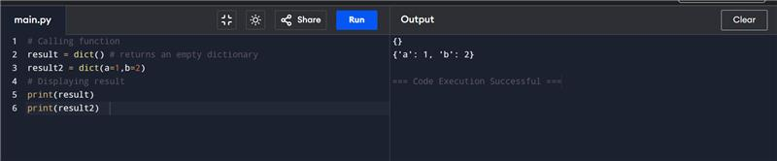

* 1. **Python filter ()**

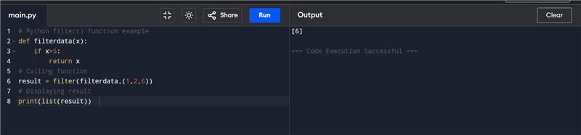

* 1. **Python hash()**

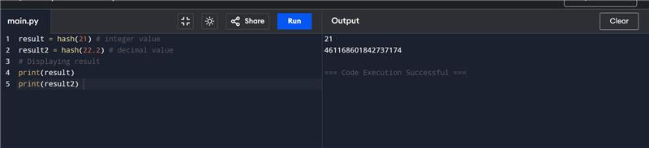

* 1. **Python min()**

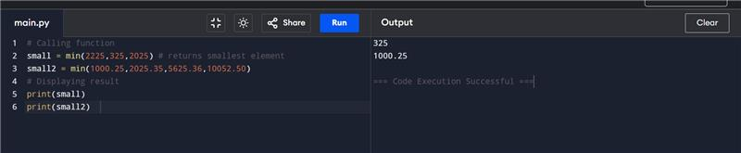

* 1. **Python hex() and set() function**

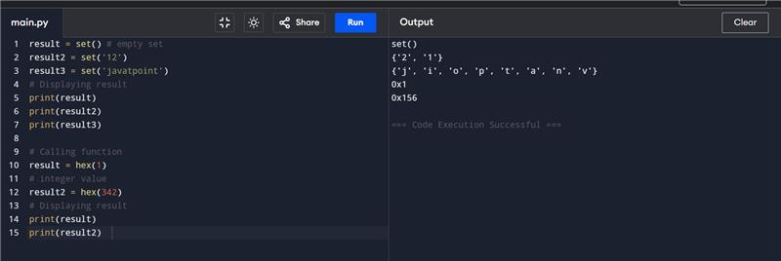

* 1. **Python Id()**

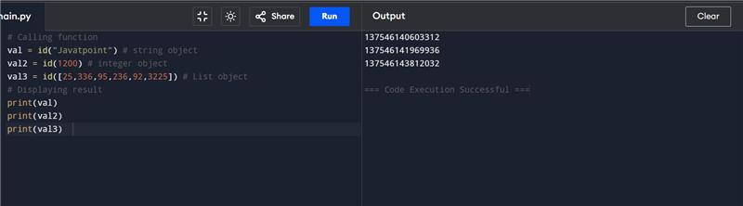

* 1. **Python setattr()**

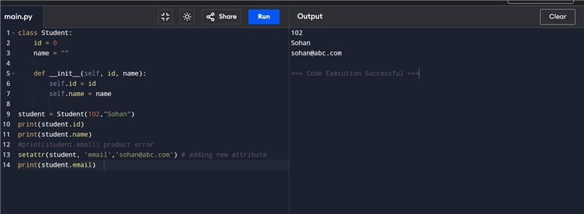

* 1. **Python slice() and sorted()**

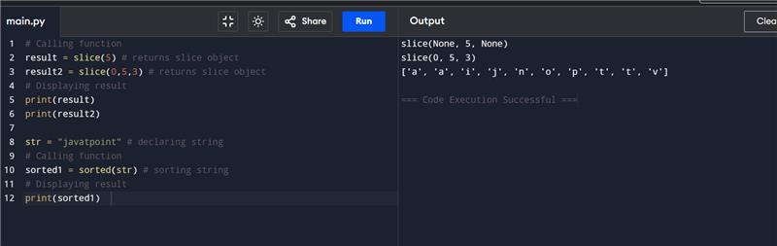

* 1. **Python next()**

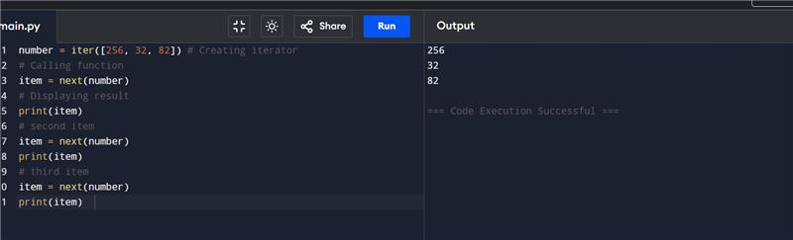

* 1. **Python input()**

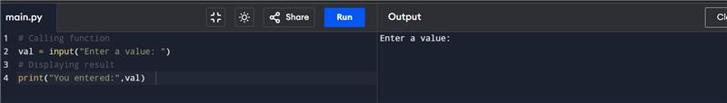

* 1. **Python int()**

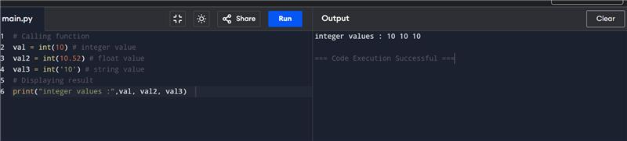

* 1. **Python instance()**

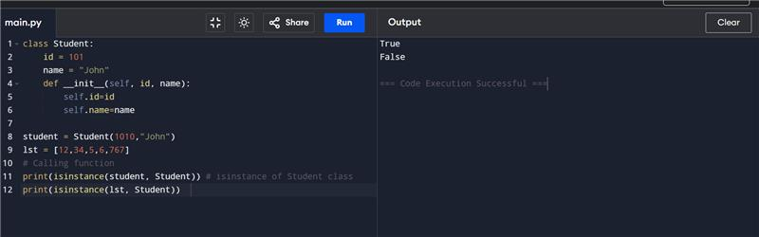

* 1. **Python ord() and pow() function**

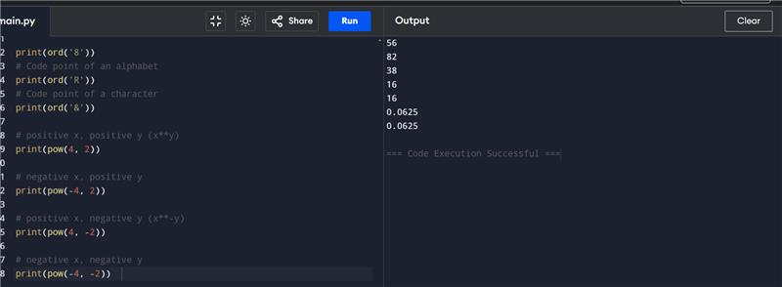

* 1. **Python reversed()**

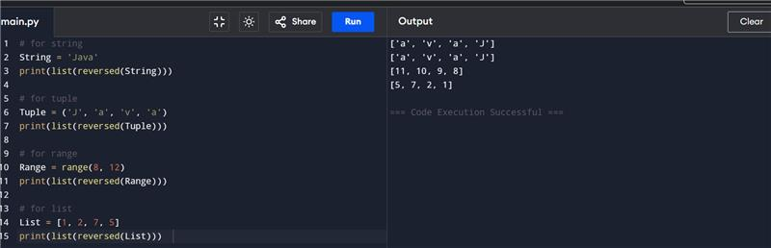

* 1. **Python round() and var()**

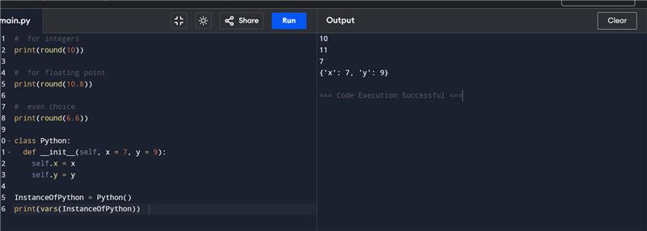

* 1. **Python type() fucntion**

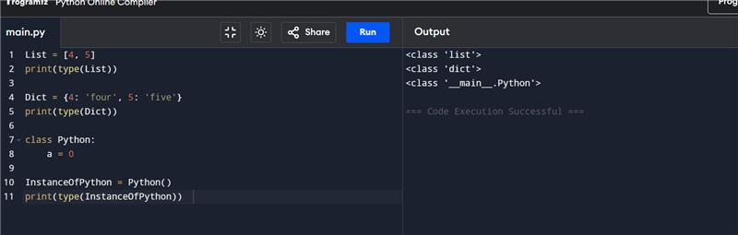

* 1. **Python issubclass()**

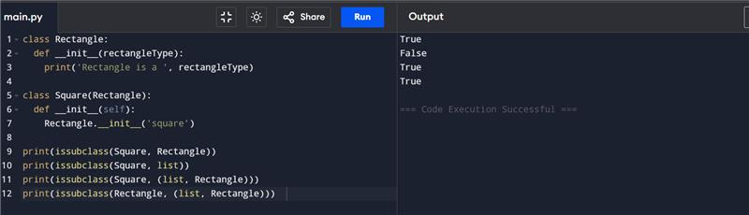

* 1. **Python zip()**

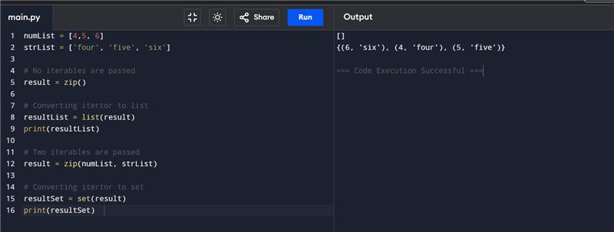

* 1. **Python lambda()**

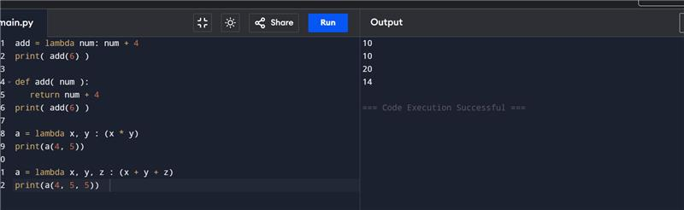

* 1. **Def vs lambda difference**

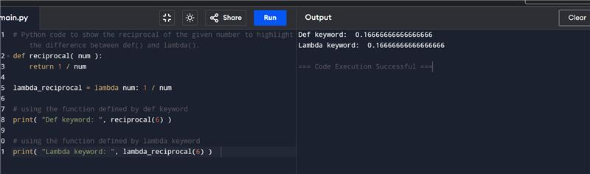

* 1. **Using Lambda Function with filter(),map(),list comprehension()**

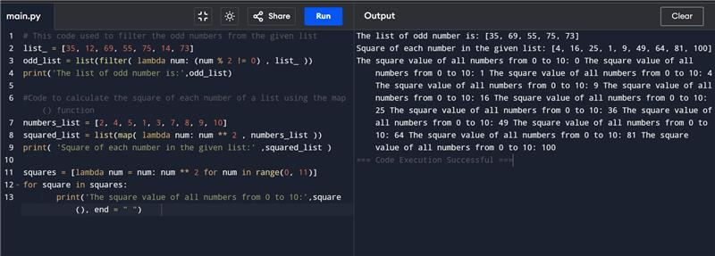

* 1. **Lambda function with multiple statement and if else**

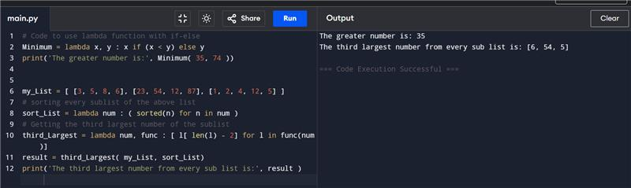

**2.MODULES**

**2.1. Importing modules**

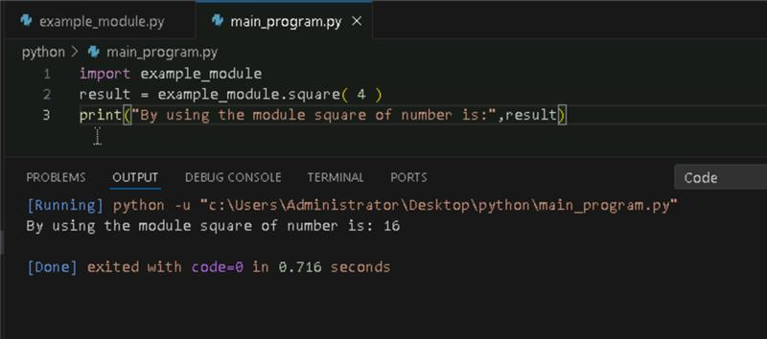

**2.2. Importing and also Renaming:**

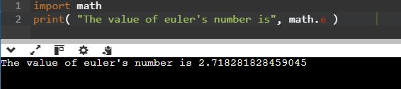

**2.3. Python from...import Statement:**

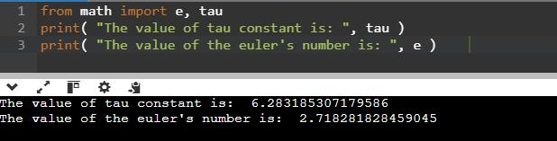

**2.4. Import all Names - From import * Statement:**

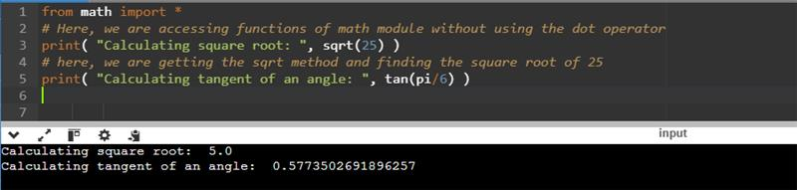

**2.5. Locating Path of Modules:**



**2.6. The dir() Built-in Function:**

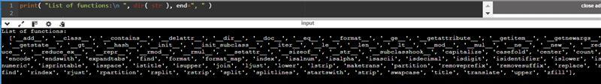

**2.7. Namespaces and Scoping:**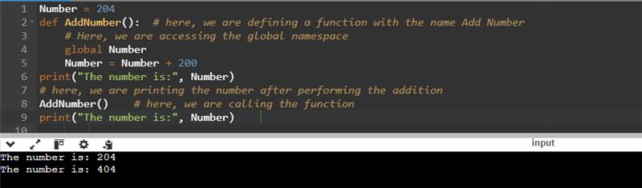

**3) PYTHON ARRAYS**

**3.1. Accessing array elements:**

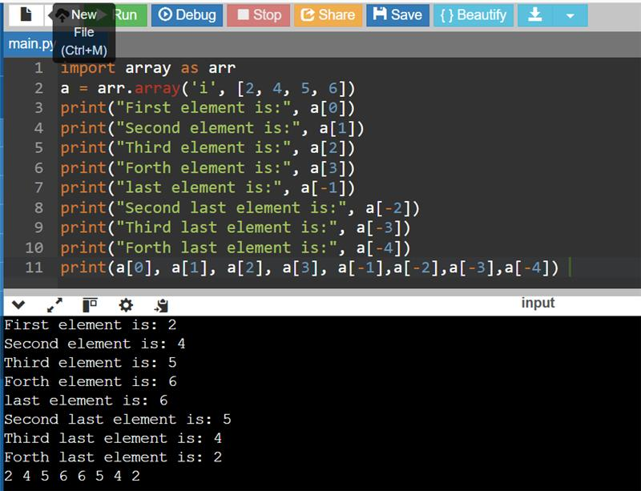

**3.2. Deleting the elements from Array**

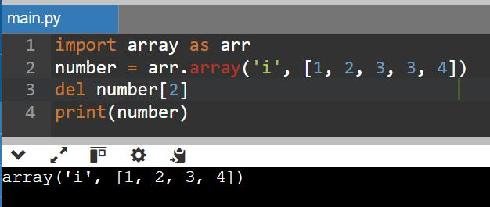

**3.3. Adding or changing the elements in Array**

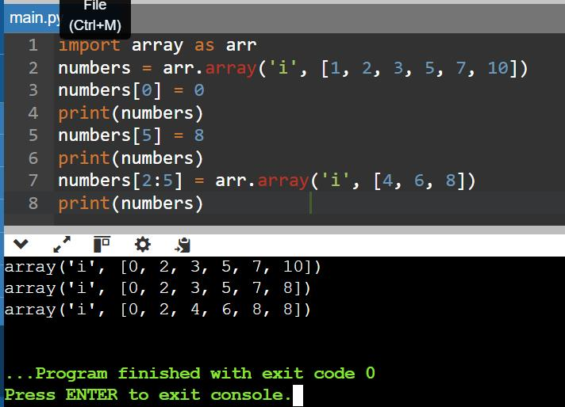

**3.4. To find the length of array**

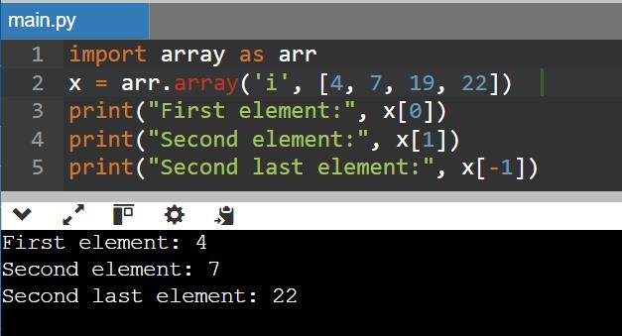

**4) PYTHON DECORATOR**

**4.1**

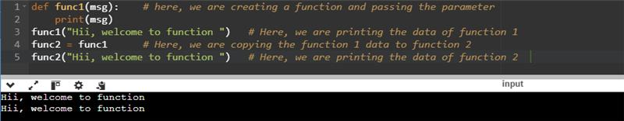

**4.2 Inner Function**

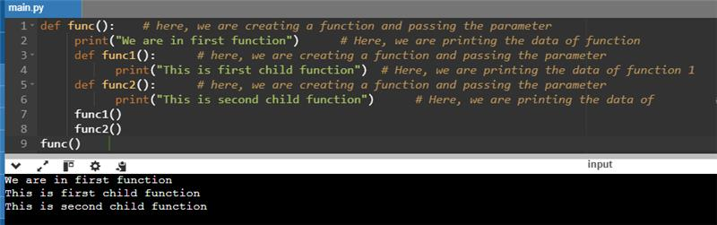

**4.3.**

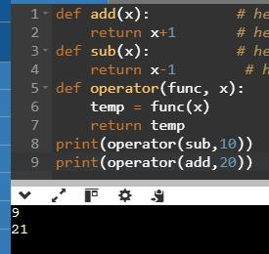

**4.4.**

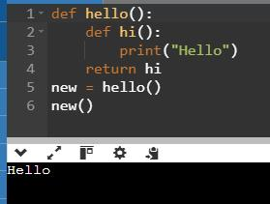

**4.5.Decorating functions with parameters:**

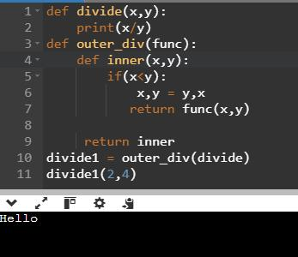

**4.6.Syntactic Decorator:**

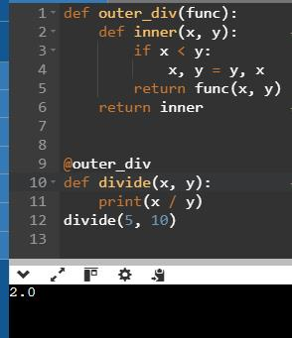

**4.7.Reusing Decorator**

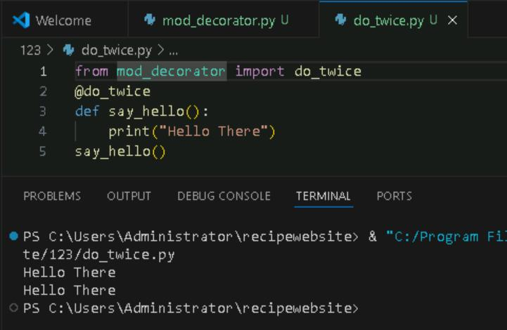

**4.8.Python Decorator with Argument**

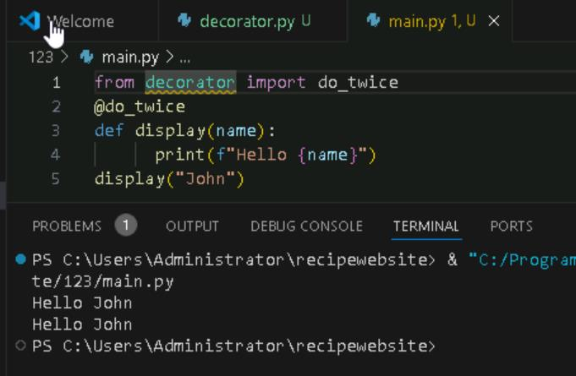

**4.9.Returning Values from Decorated Functions**

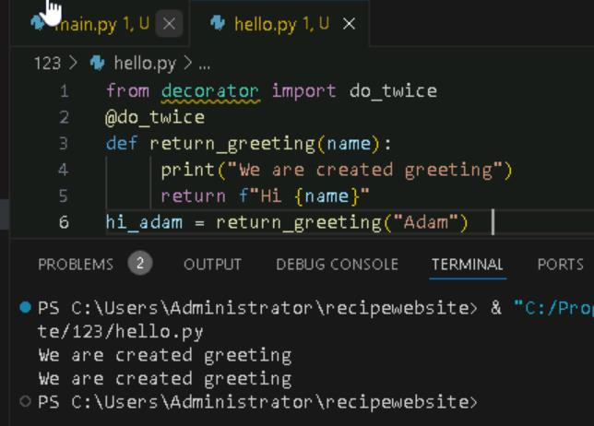

**4.10.Fancy Decorators**

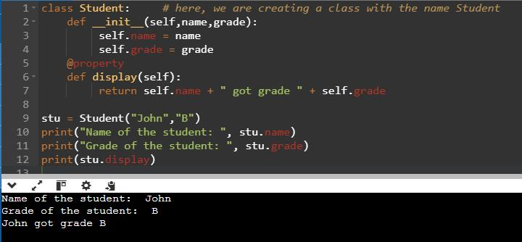

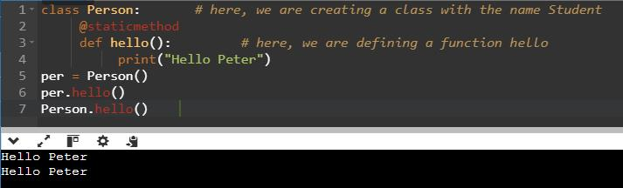

**4.11.Decorator with Arguments**

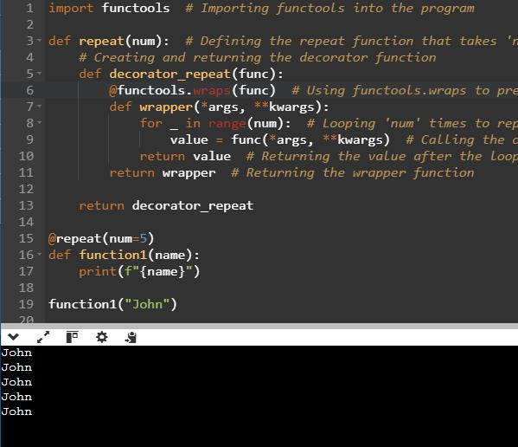

**4.12.Stateful Decorators**

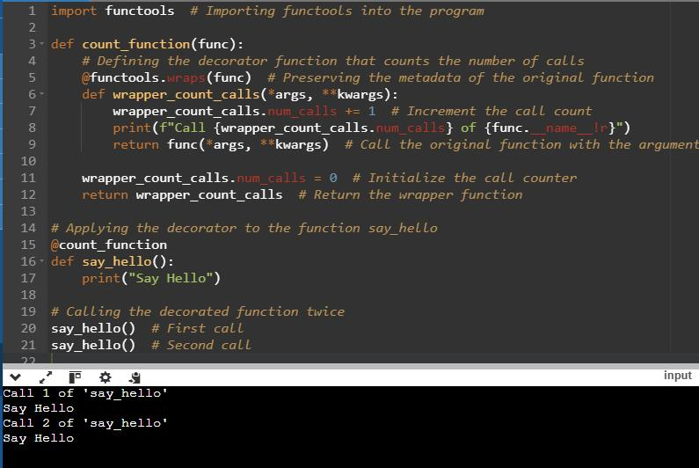

**4.13.Classes as Decorators**

