**Thumati Pavan Venkata Narendra Kumar**

**EMP-ID-289219**

**Shell Scripting Project-1**

1. **Greeting the user with User’s input:**

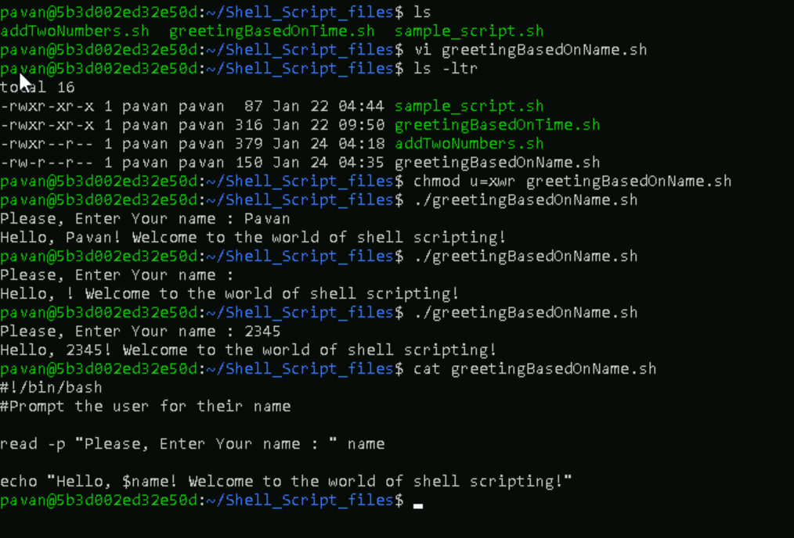

1. **Addition of Two numbers:**

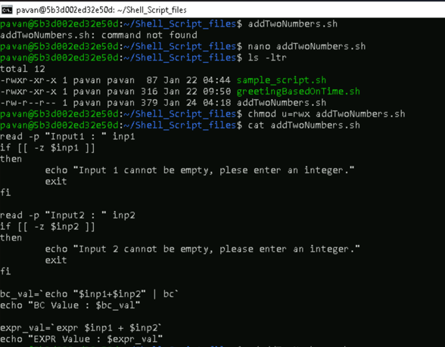

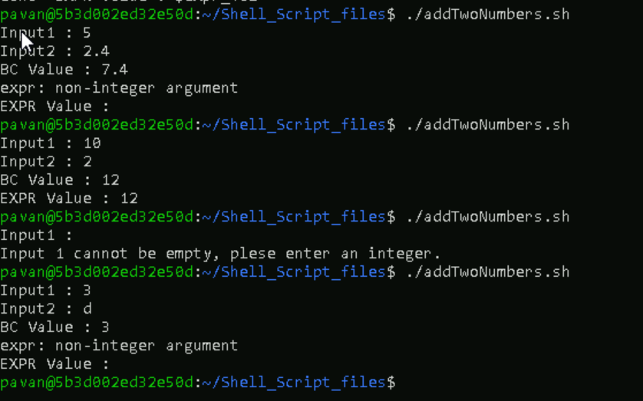

1. **Total sum of the array:**
   1. **Fixed array sum:**

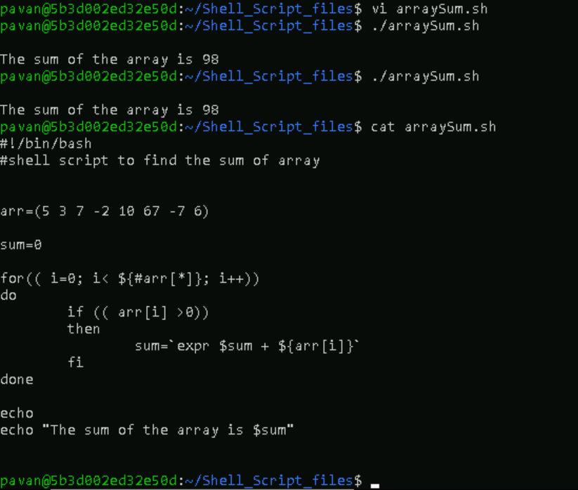

* 1. **Array sum:**

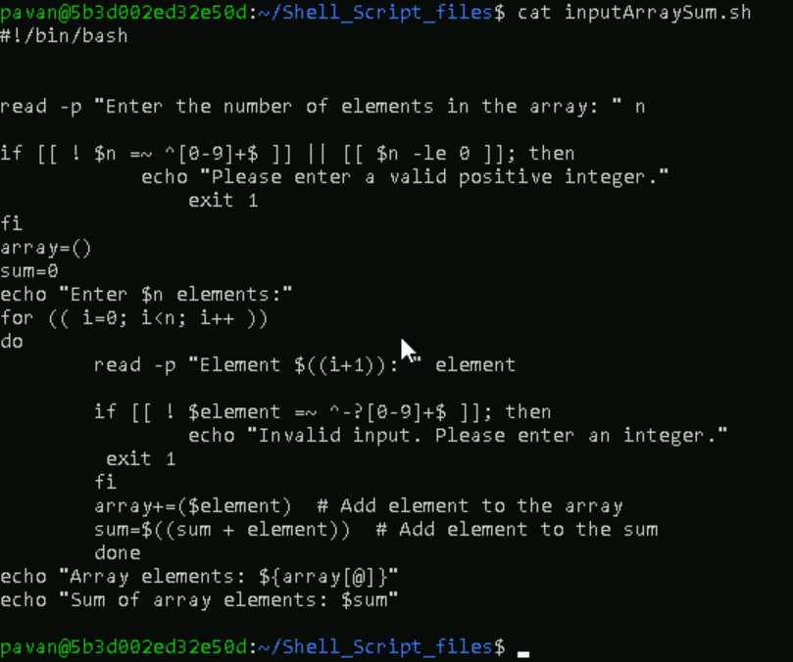

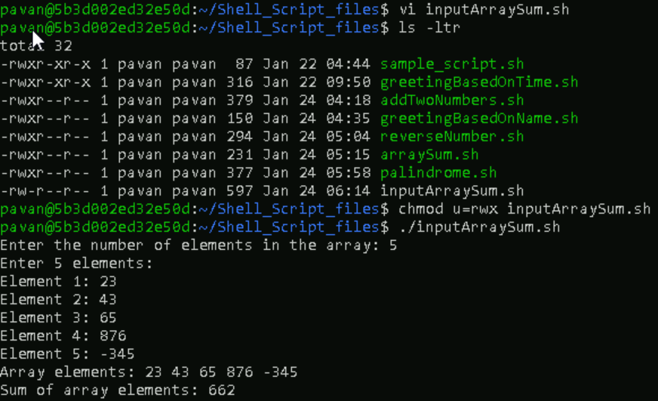

1. **Reverse a number:**

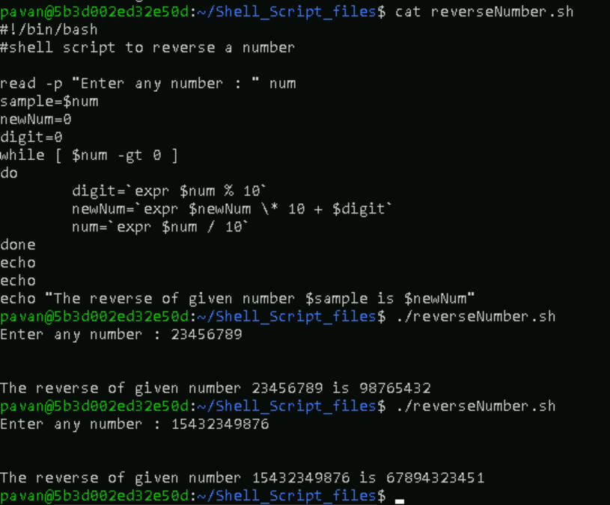

1. **Palindrome:**

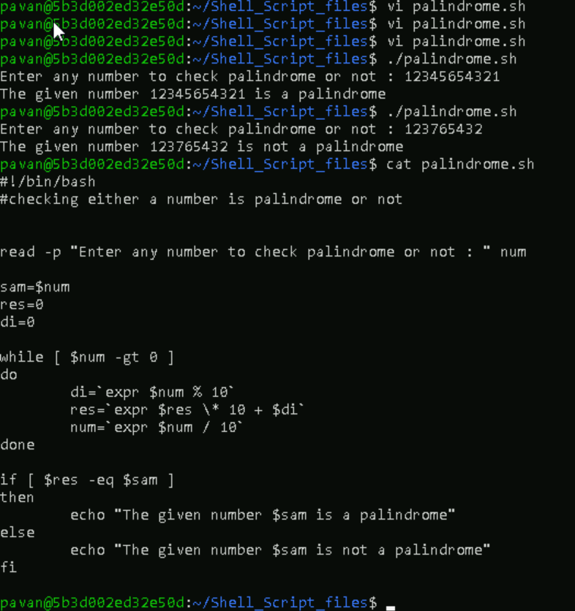

1. **Bubble Sort:**

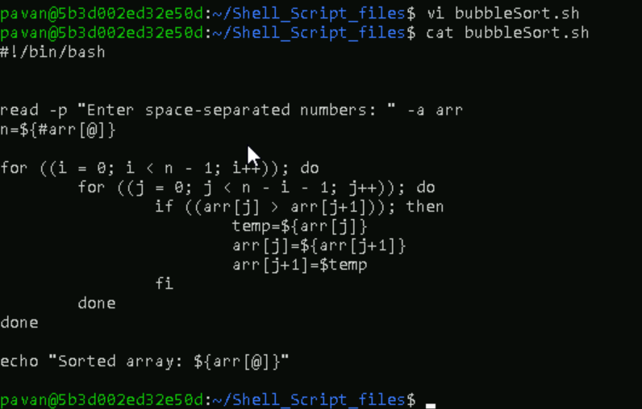

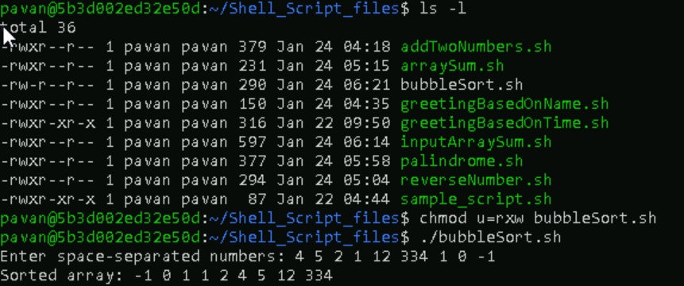

1. **Pascal’s Triangle:**

