**Experimentation and Visualization Analysis**

In this experiment, we employed RadViz visualizations to explore the relationships between multiple attributes in two different datasets, 'cars.csv' and 'cars93.csv'. The objective was to understand how various predictor attributes influence the distribution and clustering of data points.

Order of Dimensions for Visualizations (Dataset 1 - 'cars.csv')

**Visualization 1:** 'weight_lb' as Predictor Attribute

●This visualization explores 'weight_lb’' as the predictor attribute. The color scheme is based on 'weight_lb'.

●The radial position of each data point on the plot represents its attributes concerning ‘weight_lb'.

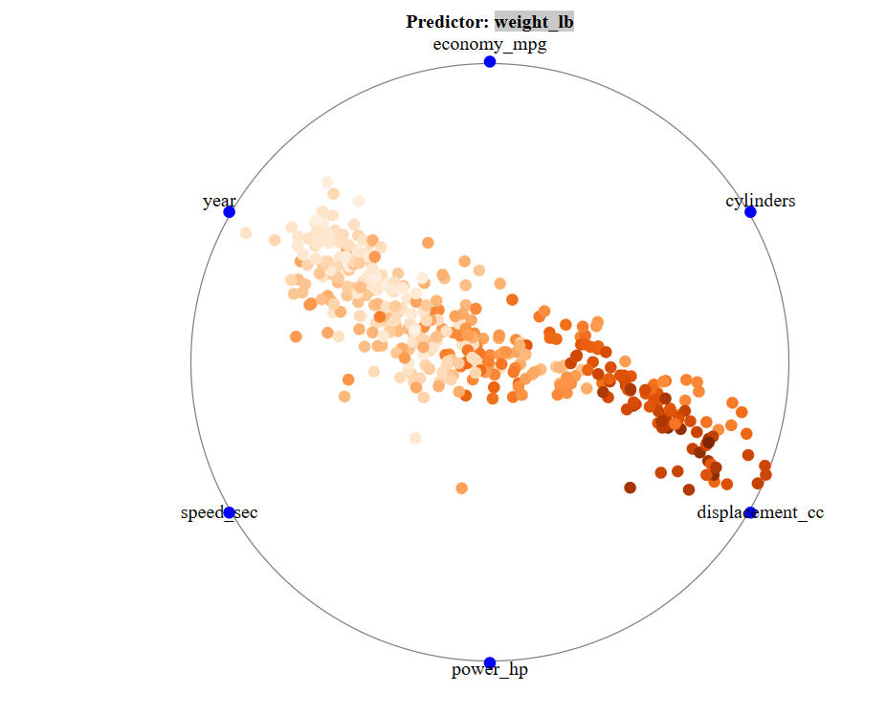

**Visualization 2:** 'economy_mpg' as Predictor Attribute

●economy_mpg' serves as the predictor attribute in this visualization. The color scheme is based on 'economy_mpg'.

●The radial position of data points reflects their 'economy_mpg' attribute.

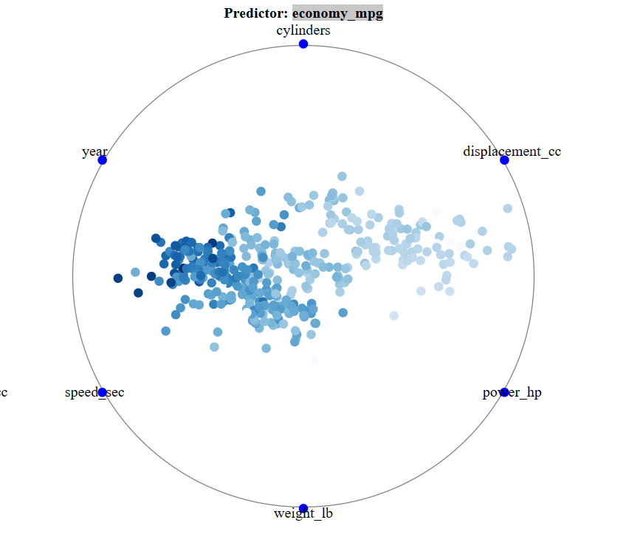

**Visualization 3:** 'power_hp’' as Predictor Attribute

●This visualization uses 'power_hp’' as the predictor attribute. The color scheme is based on 'power_hp'.

●The radial positions of data points convey information about 'power_hp'.

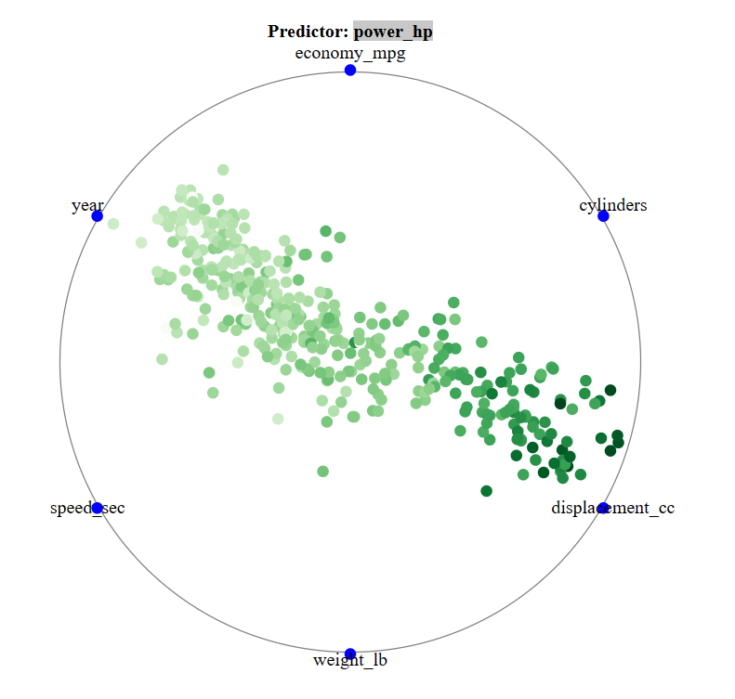

**Visualization 4:** 'speed_sec' as Predictor Attribute

●'speed_sec' is the predictor attribute in this visualization. The color scheme is based on 'speed_sec'.

●The radial positions represent the attributes concerning 'speed_sec'.

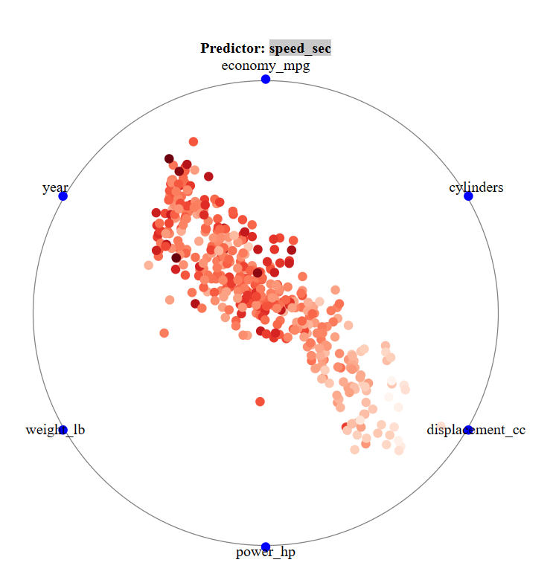

**Methodology**

●The experiment employed D3.js for creating RadViz visualizations.

●The data was loaded from a CSV file ('cars.csv'').

●Data normalization was applied to ensure that attributes were within the same scale for fair comparison.

●RadViz plots were created for each predictor attribute, illustrating how the attribute influences the distribution and clustering of data points.

●The color of data points was customized based on the selected predictor attribute, providing insights into the variations in that attribute.

**Conclusion**

The RadViz visualizations offer valuable insights into the relationships between attributes in the datasets. By using different predictor attributes, we gain a deeper understanding of how specific factors impact the distribution and clustering of data points. The color schemes further enhance our ability to identify patterns and variations in the selected predictor attributes.

This experimentation underscores the power of visualization in data analysis and exploration, facilitating the discovery of meaningful insights in complex datasets.