**Topics: Normal distribution, Functions of Random Variables**

1. The time required for servicing transmissions is normally distributed with *μ* = 45 minutes and *σ* = 8 minutes. The service manager plans to have work begin on the transmission of a customer’s car 10 minutes after the car is dropped off and the customer is told that the car will be ready within 1 hour from drop-off. What is the probability that the service manager cannot meet his commitment?
2. 0.3875
3. 0.2676
4. 0.5
5. 0.6987

**Answer:- B) 0.2676**

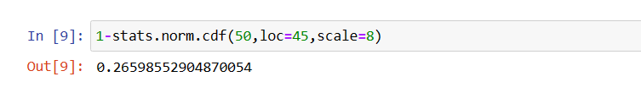

1. The current age (in years) of 400 clerical employees at an insurance claims processing center is normally distributed with mean *μ* = 38 and Standard deviation *σ* =6. For each statement below, please specify True/False. If false, briefly explain why.
2. More employees at the processing center are older than 44 than between 38 and 44.

**False**

**44 has an z value of 1. 38 has an z value of 0. 68% values lies between -1 and 1 z scores. Therefore 34% data points lies between 0 and 1. 32% values lies outside (-1,1). Therefore 16% lies above an z score of 1. Therefore more employees are between 38 and 44 than above 44.**

1. A training program for employees under the age of 30 at the center would be expected to attract about 36 employees.

**True**

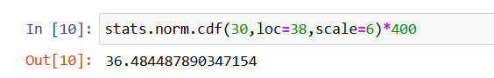

1. If *X1* ~ *N*(μ, σ2) and *X*2 ~ *N*(μ, σ2) are *iid* normal random variables, then what is the difference between 2 *X*1 and *X*1 + *X*2? Discuss both their distributions and parameters.

**Answer: -**

**Since X1 and X2 are independent E(X1+X2)=E(X1)+E(X2)**

**=µ+ µ**

**=2µ**

**Since X1 and X2 are independent E(2X1)=2E(X1)=2µ**

**Variance(X1+X2)=V(X1)+V(X2)+2Cov(X1,X2)**

**Since X1 and X2 are independent, Cov(X1,X2)=0**

**Therefore Var(X1+X2)=V(X1)+V(X2)=2 σ2**

**V(2X1)=22V(X1)**

**=4V(X1)**

**=4 σ2**

**Therefore 2X1 follows a normal distribution with mean 2 µ and variance 4 σ2**

**And X1+X2 follows a normal distribution with mean 2µ and variance 2 σ2**

**Therefor X1+X2 ~ N(µ, 2σ2)**

**and 2X1 ~ N(µ, 4σ2)**

1. Let X ~ N(100, 202). Find two values, *a* and *b*, symmetric about the mean, such that the probability of the random variable taking a value between them is 0.99.
2. 90.5, 105.9
3. 80.2, 119.8
4. 22, 78
5. 48.5, 151.5
6. 90.1, 109.9

**Answer: - D) 48.5, 151.5**

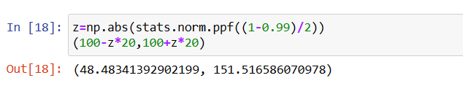

1. Consider a company that has two different divisions. The annual profits from the two divisions are independent and have distributions Profit1 ~ N(5, 32) and Profit2 ~ N(7, 42) respectively. Both the profits are in $ Million. Answer the following questions about the total profit of the company in Rupees. Assume that $1 = Rs. 45
2. Specify a Rupee range (centered on the mean) such that it contains 95% probability for the annual profit of the company.

**Answer:-**

**Since the profits of 2 are independent, Profit1+Profit2 ~ N(5+7,32+42)**

**Profit1+Profit2  ~ N(12,25)**

**Therefore the new Profit distribution mean = 12**

**standard deviation=250.5=5**

**95% of the the values lies between the z values(-1.6,1.6)**

**Therefor 95% of the values lies between (2.20, 21.80)**

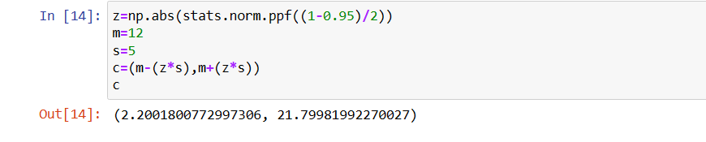

1. Specify the 5th percentile of profit (in Rupees) for the company

**Answer:-**

The 5th percentile value of the company = 3.78

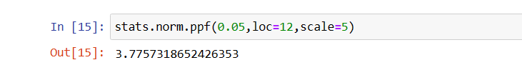

1. Which of the two divisions has a larger probability of making a loss in a given year?

**Answer:-**

For the 2nd division, the chance of loss=4.01%

Therefor the first division has a higher chance of making profit.

