

END SEMESTER ASSESSMENT (ESA) B.TECH. (CSE)
III SEMESTER

UE25CS251A
DIGITAL LOGIC AND COMPUTER DESIGN LABORATORY

PROJECT REPORT
ON
“16-BIT BARREL SHIFTER”

SUBMITTED BY
NAME SRN
- Pavana G [PES2UG25CS363]
- Priyal Singh [PES2UG25CS901]
- Rakshita Kamarthi [PES2UG25CS900]
- Prarthana N [PES2UG25CS395]

AUGUST – DECEMBER 2026
DEPARTMENT OF COMPUTER SCIENCE & ENGINEERING
ELECTRONIC CITY CAMPUS,
BENGALURU – 560100, KARNATAKA, INDIA

TABLE OF CONTENTS
Sl.No | TOPIC | PAGE No
 | PROBLEM STATEMENT | 3
 | CIRCUIT DIAGRAM | 4
 | FSM | 6
 | LITERATURE SURVEY | 7
 | MAIN VERILOG CODE | 8
 | TEST BENCH FILE | 10
 | SCREEN SHOTS OF THE OUTPUT | 15
 | REFERENCES | 17

PROBLEM STATEMENT
Title: Design and implementation of a 16-bit barrel shifter in Verilog using a staged multiplexer (MUX) architecture.
In a processor, shifting a word by n positions one step at a time would take n clock cycles. A barrel shifter is a combinational circuit that shifts or rotates a word by any amount in a single step, with no clock and no state machine. It is used inside the ALU of almost every CPU.
The task is to design a shifter that shifts or rotates a 16-bit word by any amount from 0 to 15 positions, with the operation chosen by a 2-bit MODE input, and to verify it completely.
Signal | Width | Direction | Meaning
DIN | 16 | input | Data to be shifted
SHAMT | 4 | input | Shift amount, 0 to 15
MODE | 2 | input | Operation select
DOUT | 16 | output | Shifted or rotated result

Table 1: Input and output signals
MODE | Operation | Abbrev. | Behaviour
00 | Logical left shift | SLL | Zeros enter from the right
01 | Logical right shift | SRL | Zeros enter from the left
10 | Arithmetic right shift | SRA | Sign bit DIN[15] is replicated on the left
11 | Rotate left | ROL | Bits shifted out on the left re-enter on the right

Table 2: Required operations
Constraints: the design must be purely combinational (no clock, no FSM), must use four stages of sixteen 2:1 multiplexers that shift by 1, 2, 4 and 8 and are controlled by the four bits of SHAMT, and must be written in synthesisable Verilog-2001.
Objectives: (1) build a working four-stage core, (2) extend it to all four operations, (3) verify it with a self-checking testbench and an exhaustive test of all 4,194,304 input combinations, and (4) show the hardware structure and justify the architecture.
CIRCUIT DIAGRAM
The design is purely combinational. Because 16 = 2^4, four stages are enough. Stage k shifts by 1, 2, 4 or 8 when SHAMT[k-1] = 1 and passes the data through when it is 0, so any shift from 0 to 15 is built from the binary value of SHAMT (for example 13 = 8 + 4 + 1, so stages 1, 3 and 4 are on). Each stage is a row of sixteen 2:1 multiplexers (if S = 0 then Y = A, if S = 1 then Y = B), so the basic core uses 4 x 16 = 64 multiplexers.
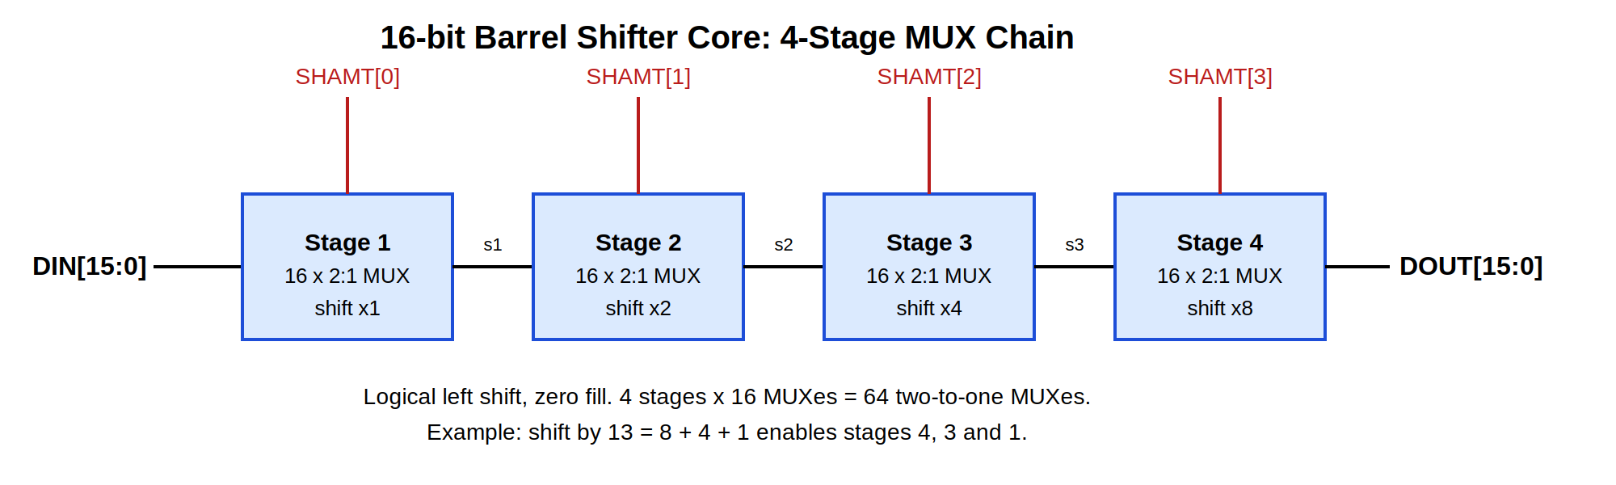
Figure 1: Basic four-stage core (logical left shift, zero fill)
The complete circuit keeps the same four stages and the same SHAMT mapping, but each stage is now mode-aware. The 2-bit MODE input is decoded once into three control signals that are shared by all four stages: right (shift right), rot (rotate) and fill (the bit that enters from the left on right shifts, which is the sign bit DIN[15] for SRA).
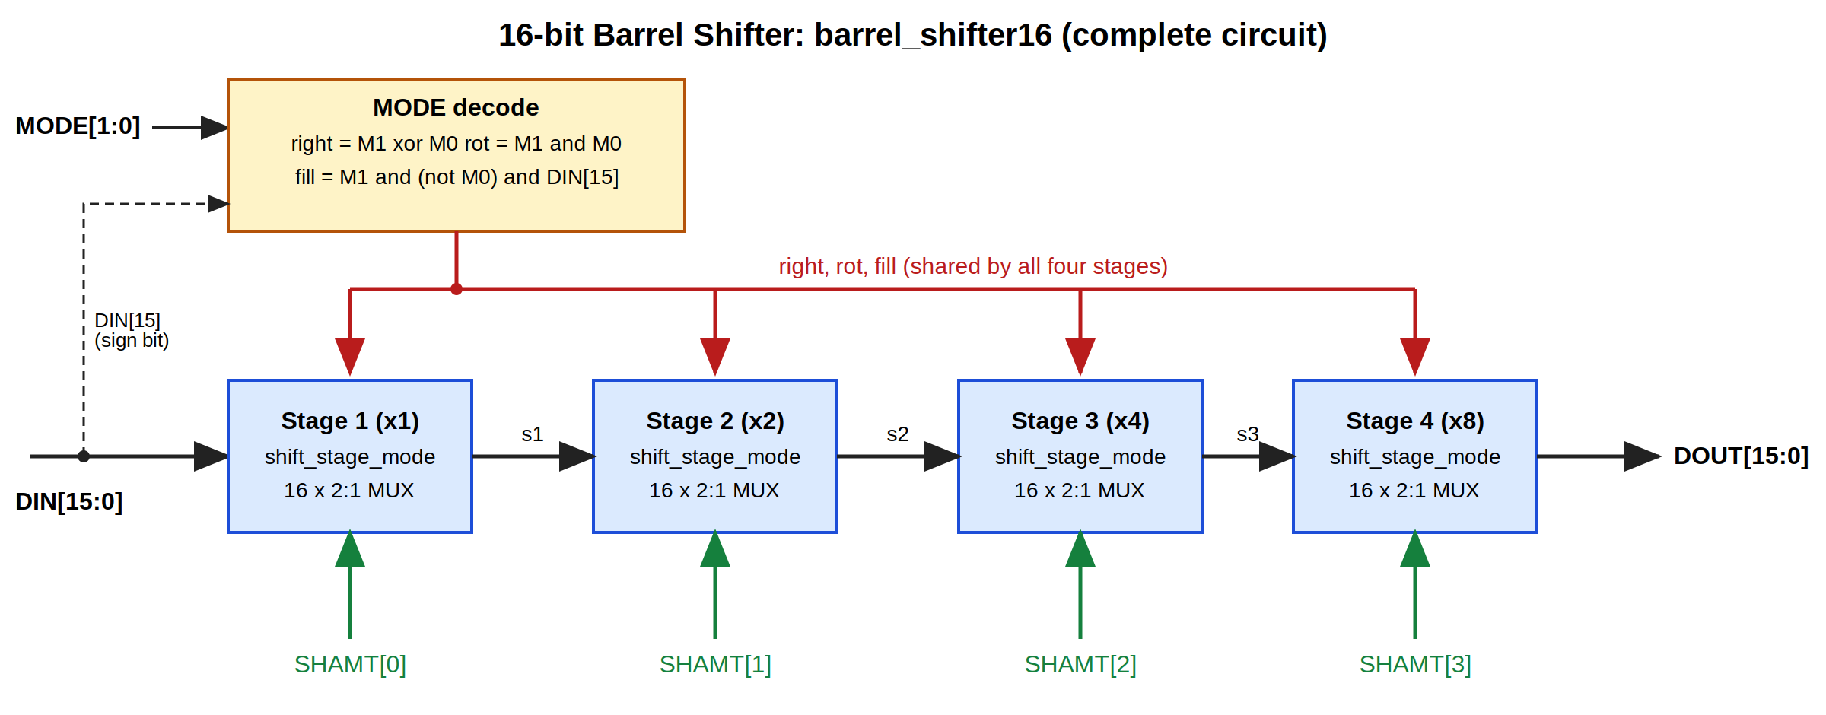
Figure 2: Complete circuit of barrel_shifter16
Truth table of the MODE decode (M1, M0 = MODE[1], MODE[0]; right = M1 xor M0, rot = M1 and M0, fill = M1 and (not M0) and DIN[15]):
MODE | Operation | right | rot | fill
00 | SLL | 0 | 0 | 0
01 | SRL | 1 | 0 | 0
10 | SRA | 1 | 0 | DIN[15]
11 | ROL | 0 | 1 | 0 (unused)

Table 3: MODE decode and control signals
DIN | SHAMT | SLL (00) | SRL (01) | SRA (10) | ROL (11)
0x8001 | 1 | 0x0002 | 0x4000 | 0xC000 | 0x0003
0xF0F0 | 4 | 0x0F00 | 0x0F0F | 0xFF0F | 0x0F0F

Table 4: Example results for all four operations
Synthesised structure. The Yosys RTL view shows the MODE decode feeding four shift_stage_mode instances in series. After synth -flatten, Yosys 0.33 reports 128 multiplexer cells plus 21 other gates (149 cells) for the complete design, and 49 + 17 = 66 cells for the basic core. These counts were generated on a separate Linux machine. A single large-multiplexer design would need 16 x 15 = 240 two-input multiplexers for the left-shift core, against 64 here.
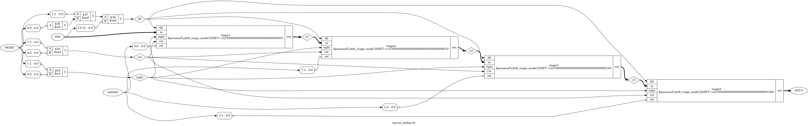
Figure 3: RTL schematic of barrel_shifter16 generated by Yosys (full-resolution image in docs/diagrams/rtl_top.png)
FSM
Not applicable. The barrel shifter is purely combinational: its output depends only on the present values of DIN, SHAMT and MODE. It has no clock, no registers and no stored state, so no finite state machine is required.
LITERATURE SURVEY
A barrel shifter is a combinational circuit that shifts or rotates a data word by any number of positions in one operation, without a clock or repeated steps. It is a standard part of the ALU in processors and digital signal processors. The concept behind this project is the logarithmic (staged) shifter: an n-bit shifter needs only log2(n) stages, and the binary digits of the shift amount select which stages are active [1]. For 16 bits this gives four stages that shift by 1, 2, 4 and 8, so any shift from 0 to 15 is a combination of them.
Multiplexer-based implementation. Each stage is a row of 2:1 multiplexers, one per bit. Mano and Ciletti present multiplexers as basic combinational components and show how to describe them in Verilog [2]. In our design each stage is a visible multiplexer row written structurally, not with a behavioural shift operator.
Processor applications. Shift and rotate operations are part of the instruction set of nearly every processor, so the ALU must provide them. Patterson and Hennessy describe logical and arithmetic shifts as core operations of the processor datapath [3]. Our four modes (SLL, SRL, SRA, ROL) correspond to these operations, and the arithmetic right shift replicates the sign bit so that signed values keep their meaning.
Area and delay trade-offs. Pillmeier, Schulte and Walters compare four barrel shifter designs on area and delay for different operand sizes [4]. Their results show that data-reversal shifters need less area, while mask-based data-reversal shifters are faster, so supporting several shift and rotate types in one shifter forces a trade-off. Our design faces the same trade-off, since it combines left shifts, right shifts and rotation in one four-stage structure.
MAIN VERILOG CODE:
The final design is barrel_shifter16, built from the mode-aware stage shift_stage_mode. The files shift_stage.v and barrel_core.v form the basic left-shift core and are kept unchanged as the regression base.
1. shift_stage.v (one stage of the basic core)
`timescale 1ns/1ps
// shift_stage.v
// One stage of the barrel shifter: 16 x 2:1 MUX.
// sel = 0 : out = in (pass through)
// sel = 1 : out = in << SHIFT (logical left shift, zero fill)
// Written as visible MUXes (conditional expressions), not with the << operator.

module shift_stage (in, sel, out);
parameter SHIFT = 1;

input [15:0] in;
input sel;
output [15:0] out;

genvar i;
generate
for (i = 0; i < 16; i = i + 1) begin : bit_mux
if (i >= SHIFT) begin : shifted
// MUX: choose own bit (sel=0) or bit SHIFT places lower (sel=1)
assign out[i] = sel ? in[i - SHIFT] : in[i];
end else begin : zero_fill
// No bit to take from below: zero enters here when sel=1
assign out[i] = sel ? 1'b0 : in[i];
end
end
endgenerate
endmodule

2. barrel_core.v (four stages in series)
`timescale 1ns/1ps
// barrel_core.v
// 16-bit barrel shifter core: 4 stages chained in series.
// Logical left shift by SHAMT (0-15), zero fill.
// Stage 1: shift by 1, select = SHAMT[0]
// Stage 2: shift by 2, select = SHAMT[1]
// Stage 3: shift by 4, select = SHAMT[2]
// Stage 4: shift by 8, select = SHAMT[3]

module barrel_core (DIN, SHAMT, DOUT);
input [15:0] DIN;
input [3:0] SHAMT;
output [15:0] DOUT;

wire [15:0] s1, s2, s3;

shift_stage #(.SHIFT(1)) stage1 (.in(DIN), .sel(SHAMT[0]), .out(s1));
shift_stage #(.SHIFT(2)) stage2 (.in(s1), .sel(SHAMT[1]), .out(s2));
shift_stage #(.SHIFT(4)) stage3 (.in(s2), .sel(SHAMT[2]), .out(s3));
shift_stage #(.SHIFT(8)) stage4 (.in(s3), .sel(SHAMT[3]), .out(DOUT));
endmodule

3. shift_stage_mode.v (mode-aware stage used by the final design)
`timescale 1ns/1ps
// shift_stage_mode.v (P2)
// Mode-aware version of P1's shift_stage: one stage = 16 x 2:1 MUX with
// direction, rotate and fill control. Written as visible conditional
// expressions, not with the shift operators.
// sel = 0 : out = in (pass through)
// sel = 1, left : out[i] = in[i-SHIFT] (SLL / ROL)
// low SHIFT bits: 0 (SLL) or wrapped bit (ROL, rot = 1)
// sel = 1, right : out[i] = in[i+SHIFT] (SRL / SRA)
// top SHIFT bits: fill (0 for SRL, DIN[15] for SRA)

module shift_stage_mode (in, sel, right, rot, fill, out);
parameter SHIFT = 1;

input [15:0] in;
input sel; // stage enable (a SHAMT bit)
input right; // 1 = shift right, 0 = shift left
input rot; // 1 = rotate (only meaningful for left)
input fill; // bit entering from the left on right shifts
output [15:0] out;

genvar i;
generate
for (i = 0; i < 16; i = i + 1) begin : bit_mux
if (i >= SHIFT && (i + SHIFT) <= 15) begin : both_sources
assign out[i] = sel ? (right ? in[i + SHIFT] : in[i - SHIFT]) : in[i];
end else if (i >= SHIFT) begin : top_bits
// right shift: nothing above, so fill enters here
assign out[i] = sel ? (right ? fill : in[i - SHIFT]) : in[i];
end else begin : low_bits
// left shift: nothing below, so 0 (SLL) or wrapped bit (ROL)
assign out[i] = sel ? (right ? in[i + SHIFT]
: (rot ? in[i - SHIFT + 16] : 1'b0))
: in[i];
end
end
endgenerate
endmodule

4. barrel_shifter16.v (top-level module)
`timescale 1ns/1ps
// barrel_shifter16.v (P2)
// Final top-level: 16-bit barrel shifter, 4 operations selected by MODE.
// MODE 00 SLL logical left shift, zero fill
// MODE 01 SRL logical right shift, zero fill
// MODE 10 SRA arithmetic right shift, fill = DIN[15]
// MODE 11 ROL rotate left, bits leaving the left re-enter on the right
// Purely combinational (no FSM). Same 4-stage structure as P1's core:
// SHAMT[0] -> x1, SHAMT[1] -> x2, SHAMT[2] -> x4, SHAMT[3] -> x8.

module barrel_shifter16 (
input [15:0] DIN,
input [3:0] SHAMT,
input [1:0] MODE,
output [15:0] DOUT
);
// Control decode from MODE
wire right = MODE[1] ^ MODE[0]; // 01 or 10 -> right shift
wire rot = MODE[1] & MODE[0]; // 11 -> rotate
wire fill = MODE[1] & ~MODE[0] & DIN[15]; // 10 -> sign bit

wire [15:0] s1, s2, s3;

shift_stage_mode #(.SHIFT(1)) stage1 (.in(DIN), .sel(SHAMT[0]), .right(right), .rot(rot), .fill(fill), .out(s1));
shift_stage_mode #(.SHIFT(2)) stage2 (.in(s1), .sel(SHAMT[1]), .right(right), .rot(rot), .fill(fill), .out(s2));
shift_stage_mode #(.SHIFT(4)) stage3 (.in(s2), .sel(SHAMT[2]), .right(right), .rot(rot), .fill(fill), .out(s3));
shift_stage_mode #(.SHIFT(8)) stage4 (.in(s3), .sel(SHAMT[3]), .right(right), .rot(rot), .fill(fill), .out(DOUT));
endmodule

TEST BENCH FILE:
Three levels of testing are used, each keeping the previous one passing, plus a small directed run that writes the waveform.
Test bench | Cases | Purpose
tb_core.v | 128 | Basic core: directed shifts and a sweep of all 16 shift amounts
tb_barrel_shifter.v | 972 | Self-checking: hand-computed values, edge cases for all 4 modes, 256 random
tb_exhaustive.v | 4,194,304 | Every input x every shift amount x every mode, independent reference model
tb_waveform.v | 12 | Directed run that writes the VCD file for GTKWave

1. tb_core.v
// tb_core.v
// Basic testbench for barrel_core (logical left shift, zero fill).
// Reference model: the behavioural << operator.

`timescale 1ns/1ps

module tb_core;
reg [15:0] DIN;
reg [3:0] SHAMT;
wire [15:0] DOUT;

reg [15:0] expected;
integer pass_count;
integer fail_count;
integer total_count;
integer k;
integer p;
reg [15:0] pattern;

barrel_core dut (.DIN(DIN), .SHAMT(SHAMT), .DOUT(DOUT));

// Apply one case, compare with the << operator, print PASS/FAIL
task check;
input [15:0] d;
input [3:0] s;
input verbose;
begin
DIN = d;
SHAMT = s;
#10;
expected = d << s;
total_count = total_count + 1;
if (DOUT === expected) begin
pass_count = pass_count + 1;
if (verbose)
$display("PASS: din=%h shamt=%0d dout=%h", d, s, DOUT);
end else begin
fail_count = fail_count + 1;
$display("FAIL: din=%h shamt=%0d got=%h exp=%h", d, s, DOUT, expected);
end
end
endtask

initial begin
pass_count = 0;
fail_count = 0;
total_count = 0;

$display("---- Directed: key shift amounts on 0x0001 ----");
check(16'h0001, 4'd0, 1);
check(16'h0001, 4'd1, 1);
check(16'h0001, 4'd2, 1);
check(16'h0001, 4'd4, 1);
check(16'h0001, 4'd8, 1);
check(16'h0001, 4'd15, 1);

$display("---- Directed: different patterns ----");
check(16'h8000, 4'd1, 1);
check(16'hA5A5, 4'd4, 1);
check(16'h5555, 4'd3, 1);
check(16'h1234, 4'd8, 1);
check(16'h1234, 4'd13, 1);

$display("---- Directed: all-zero and all-one inputs ----");
check(16'h0000, 4'd0, 1);
check(16'h0000, 4'd15, 1);
check(16'hFFFF, 4'd0, 1);
check(16'hFFFF, 4'd7, 1);
check(16'hFFFF, 4'd15, 1);

$display("---- Sweep: all 16 shift amounts for several patterns ----");
for (p = 0; p < 7; p = p + 1) begin
case (p)
0: pattern = 16'h0001;
1: pattern = 16'h8000;
2: pattern = 16'hA5A5;
3: pattern = 16'h5555;
4: pattern = 16'h1234;
5: pattern = 16'h0000;
default: pattern = 16'hFFFF;
endcase
for (k = 0; k < 16; k = k + 1)
check(pattern, k, 1);
end

$display("----------------------------------------");
$display("Total tests : %0d", total_count);
$display("Passed : %0d", pass_count);
$display("Failed : %0d", fail_count);
if (fail_count == 0)
$display("RESULT: ALL TESTS PASSED");
else
$display("RESULT: SOME TESTS FAILED");
$finish;
end
endmodule

2. tb_barrel_shifter.v
`timescale 1ns/1ps
// tb_barrel_shifter.v (P2)
// Self-checking testbench for barrel_shifter16.
// Reference model: behavioural operators. Also checks hand-computed values.

module tb_barrel_shifter;
reg [15:0] DIN;
reg [3:0] SHAMT;
reg [1:0] MODE;
wire [15:0] DOUT;

reg [15:0] expected;
reg [15:0] pattern;
reg [31:0] rnd;
integer pass_count;
integer fail_count;
integer total_count;
integer p;
integer m;
integer s;
integer r;

barrel_shifter16 dut (.DIN(DIN), .SHAMT(SHAMT), .MODE(MODE), .DOUT(DOUT));

// Reference model using Verilog operators
function [15:0] model;
input [15:0] fd;
input [3:0] fs;
input [1:0] fm;
reg signed [15:0] sd;
begin
case (fm)
2'b00: model = fd << fs;
2'b01: model = fd >> fs;
2'b10: begin
sd = fd;
model = sd >>> fs;
end
default: begin
if (fs == 0) model = fd;
else model = (fd << fs) | (fd >> (16 - fs));
end
endcase
end
endfunction

// Apply one case, compare DOUT with the model
task check;
input [15:0] d;
input [3:0] sh;
input [1:0] mo;
input verbose;
begin
DIN = d; SHAMT = sh; MODE = mo;
#10;
expected = model(d, sh, mo);
total_count = total_count + 1;
if (DOUT === expected) begin
pass_count = pass_count + 1;
if (verbose)
$display("PASS: mode=%b shamt=%0d din=%h got=%h exp=%h", mo, sh, d, DOUT, expected);
end else begin
fail_count = fail_count + 1;
$display("FAIL: mode=%b shamt=%0d din=%h got=%h exp=%h", mo, sh, d, DOUT, expected);
end
end
endtask

// Apply one case, compare with a hand-computed value
task check_known;
input [15:0] d;
input [3:0] sh;
input [1:0] mo;
input [15:0] known;
begin
DIN = d; SHAMT = sh; MODE = mo;
#10;
total_count = total_count + 1;
if (DOUT === known) begin
pass_count = pass_count + 1;
$display("PASS: (known) mode=%b shamt=%0d din=%h got=%h exp=%h", mo, sh, d, DOUT, known);
end else begin
fail_count = fail_count + 1;
$display("FAIL: (known) mode=%b shamt=%0d din=%h got=%h exp=%h", mo, sh, d, DOUT, known);
end
end
endtask

initial begin
pass_count = 0;
fail_count = 0;
total_count = 0;

$display("---- Hand-computed values (spec table + edge cases) ----");
check_known(16'h8001, 4'd1, 2'b00, 16'h0002);
check_known(16'h8001, 4'd1, 2'b01, 16'h4000);
check_known(16'h8001, 4'd1, 2'b10, 16'hC000);
check_known(16'h8001, 4'd1, 2'b11, 16'h0003);
check_known(16'hF0F0, 4'd4, 2'b00, 16'h0F00);
check_known(16'hF0F0, 4'd4, 2'b01, 16'h0F0F);
check_known(16'hF0F0, 4'd4, 2'b10, 16'hFF0F);
check_known(16'hF0F0, 4'd4, 2'b11, 16'h0F0F);
check_known(16'h8000, 4'd4, 2'b10, 16'hF800);
check_known(16'h7FFF, 4'd4, 2'b10, 16'h07FF);
check_known(16'hFFFF, 4'd15, 2'b10, 16'hFFFF);
check_known(16'h8000, 4'd1, 2'b11, 16'h0001);

$display("---- Directed: all 4 modes x all 16 shifts x edge patterns ----");
for (p = 0; p < 11; p = p + 1) begin
case (p)
0: pattern = 16'h0000;
1: pattern = 16'hFFFF;
2: pattern = 16'h8000;
3: pattern = 16'h7FFF;
4: pattern = 16'hAAAA;
5: pattern = 16'h5555;
6: pattern = 16'hF0F0;
7: pattern = 16'h8001;
8: pattern = 16'h0001;
9: pattern = 16'h1234;
default: pattern = 16'hA5A5;
endcase
for (m = 0; m < 4; m = m + 1)
for (s = 0; s < 16; s = s + 1)
check(pattern, s, m, 1);
end

$display("---- Random: 256 cases (only FAILs are printed) ----");
for (r = 0; r < 256; r = r + 1) begin
rnd = $random;
check(rnd[15:0], rnd[19:16], rnd[21:20], 0);
end

$display("----------------------------------------");
$display("Total tests : %0d", total_count);
$display("Passed : %0d", pass_count);
$display("Failed : %0d", fail_count);
if (fail_count == 0)
$display("RESULT: ALL TESTS PASSED");
else
$display("RESULT: SOME TESTS FAILED");
$finish;
end
endmodule

3. tb_exhaustive.v
`timescale 1ns/1ps
// tb_exhaustive.v (P3)
// Exhaustive self-checking testbench for barrel_shifter16:
// 65,536 inputs x 16 shift amounts x 4 modes = 4,194,304 cases.
// Reference model is INDEPENDENT of the DUT and of P2's testbench:
// it shifts ONE bit position at a time, SHAMT times (no <<, >>, >>> operators).
// Define INJECT_BUG (iverilog -DINJECT_BUG) to corrupt one case on purpose and
// prove that this testbench really detects failures.

module tb_exhaustive;
reg [15:0] din;
reg [3:0] shamt;
reg [1:0] mode;
wire [15:0] dout;

reg [15:0] got;
reg [15:0] expected;
integer i, s, m;
integer total, passed, failed;
integer fail_mode0, fail_mode1, fail_mode2, fail_mode3;

barrel_shifter16 dut (.DIN(din), .SHAMT(shamt), .MODE(mode), .DOUT(dout));

// One-bit-at-a-time reference model
function [15:0] ref_model;
input [15:0] d;
input [3:0] sh;
input [1:0] md;
integer k;
reg [15:0] r;
begin
r = d;
for (k = 0; k < sh; k = k + 1) begin
case (md)
2'b00: r = {r[14:0], 1'b0}; // SLL
2'b01: r = {1'b0, r[15:1]}; // SRL
2'b10: r = {r[15], r[15:1]}; // SRA
default: r = {r[14:0], r[15]}; // ROL
endcase
end
ref_model = r;
end
endfunction

initial begin
total = 0; passed = 0; failed = 0;
fail_mode0 = 0; fail_mode1 = 0; fail_mode2 = 0; fail_mode3 = 0;

for (m = 0; m < 4; m = m + 1)
for (s = 0; s < 16; s = s + 1)
for (i = 0; i < 65536; i = i + 1) begin
din = i; shamt = s; mode = m;
#1;
got = dout;
`ifdef INJECT_BUG
// deliberate fault: SRA with shamt = 5 gets its LSB flipped
if (mode == 2'b10 && shamt == 4'd5) got = dout ^ 16'h0001;
`endif
expected = ref_model(din, shamt, mode);
total = total + 1;
if (got === expected) passed = passed + 1;
else begin
failed = failed + 1;
case (mode)
2'b00: fail_mode0 = fail_mode0 + 1;
2'b01: fail_mode1 = fail_mode1 + 1;
2'b10: fail_mode2 = fail_mode2 + 1;
default: fail_mode3 = fail_mode3 + 1;
endcase
if (failed <= 20)
$display("FAIL: mode=%b shamt=%0d din=%h got=%h expected=%h",
mode, shamt, din, got, expected);
end
end

$display("======================================");
$display("Exhaustive test: 65536 inputs x 16 shifts x 4 modes");
$display("Total tests : %0d", total);
$display("Passed : %0d", passed);
$display("Failed : %0d", failed);
$display(" failures by mode: SLL=%0d SRL=%0d SRA=%0d ROL=%0d",
fail_mode0, fail_mode1, fail_mode2, fail_mode3);
$display("======================================");
if (failed == 0) $display("RESULT: ALL TESTS PASSED");
else $display("RESULT: SOME TESTS FAILED");
$finish;
end
endmodule

4. tb_waveform.v
`timescale 1ns/1ps
// tb_waveform.v (P3)
// Small directed run that writes a VCD for GTKWave screenshots.
// (Not the exhaustive run: that would create a gigantic VCD.)

module tb_waveform;
reg [15:0] din;
reg [3:0] shamt;
reg [1:0] mode;
wire [15:0] dout;

barrel_shifter16 dut (.DIN(din), .SHAMT(shamt), .MODE(mode), .DOUT(dout));

initial begin
$dumpfile("simulation/waveforms/barrel.vcd");
$dumpvars(0, tb_waveform);
$monitor("t=%0t mode=%b shamt=%0d din=%h dout=%h", $time, mode, shamt, din, dout);

// 0x8001 shifted by 1: expect 0002, 4000, C000, 0003
din = 16'h8001; shamt = 4'd1; mode = 2'b00; #20;
mode = 2'b01; #20;
mode = 2'b10; #20;
mode = 2'b11; #20;

// 0xF0F0 shifted by 4: expect 0F00, 0F0F, FF0F, 0F0F
din = 16'hF0F0; shamt = 4'd4; mode = 2'b00; #20;
mode = 2'b01; #20;
mode = 2'b10; #20;
mode = 2'b11; #20;

// Edge cases
din = 16'h8000; shamt = 4'd15; mode = 2'b10; #20; // SRA: FFFF
din = 16'h8000; shamt = 4'd15; mode = 2'b01; #20; // SRL: 0001
din = 16'hFFFF; shamt = 4'd0; mode = 2'b11; #20; // shift 0: FFFF
din = 16'h1234; shamt = 4'd13; mode = 2'b00; #20; // 13 = 8+4+1: 8000
$finish;
end
endmodule

SCREEN SHOT OF THE OUTPUT:
All simulations were run with Icarus Verilog 12.0 on Windows 11.
1. tb_core: 128 tests, all passed
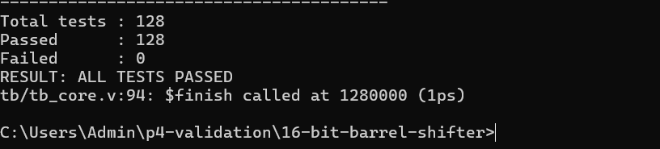
Figure 4: Output of tb_core
2. tb_barrel_shifter: 972 tests, all passed
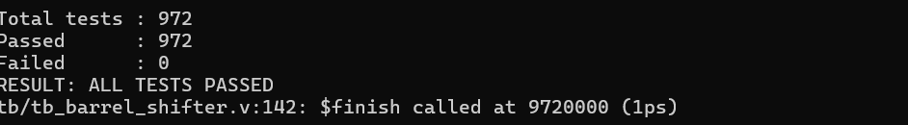
Figure 5: Output of tb_barrel_shifter
3. tb_exhaustive: 4,194,304 tests, 0 failed
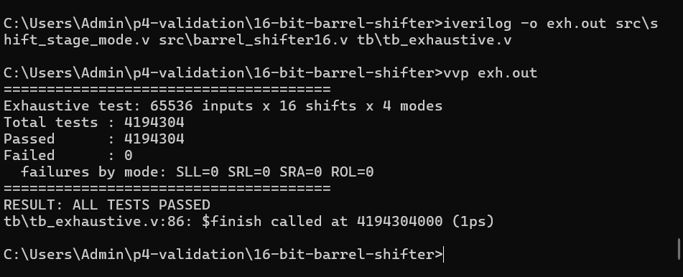
Figure 6: Output of tb_exhaustive (all four modes, 0 failures)
4. Proof that the testbench can fail (bug injection)
The design was compiled with -DINJECT_BUG, which flips the last output bit for SRA with SHAMT = 5. The testbench reported 65,536 failures, all in SRA, so it does detect faults.
FAIL: mode=10 shamt=5 din=0000 got=0001 expected=0000
FAIL: mode=10 shamt=5 din=0001 got=0001 expected=0000
FAIL: mode=10 shamt=5 din=0002 got=0001 expected=0000
...
======================================
Exhaustive test: 65536 inputs x 16 shifts x 4 modes
Total tests : 4194304
Passed : 4128768
Failed : 65536
failures by mode: SLL=0 SRL=0 SRA=65536 ROL=0
======================================
RESULT: SOME TESTS FAILED
tb\tb_exhaustive.v:86: $finish called at 4194304000 (1ps)

5. Waveform (GTKWave)
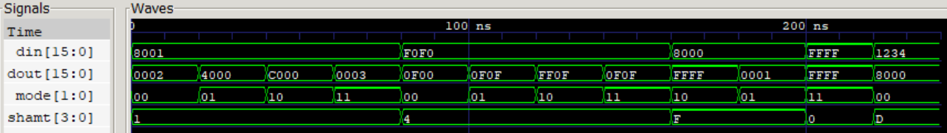
Figure 7: Waveform of din, dout, mode and shamt (0 to 240 ns)
Console output of the same run (time in ps):
t=0 mode=00 shamt=1 din=8001 dout=0002
t=20000 mode=01 shamt=1 din=8001 dout=4000
t=40000 mode=10 shamt=1 din=8001 dout=c000
t=60000 mode=11 shamt=1 din=8001 dout=0003
t=80000 mode=00 shamt=4 din=f0f0 dout=0f00
t=100000 mode=01 shamt=4 din=f0f0 dout=0f0f
t=120000 mode=10 shamt=4 din=f0f0 dout=ff0f
t=140000 mode=11 shamt=4 din=f0f0 dout=0f0f
t=160000 mode=10 shamt=15 din=8000 dout=ffff
t=180000 mode=01 shamt=15 din=8000 dout=0001
t=200000 mode=11 shamt=0 din=ffff dout=ffff
t=220000 mode=00 shamt=13 din=1234 dout=8000

REFERENCES
[1] D. M. Harris and S. L. Harris, Digital Design and Computer Architecture, 2nd ed. Morgan Kaufmann, 2012.
[2] M. M. Mano and M. D. Ciletti, Digital Design: With an Introduction to the Verilog HDL, 5th ed. Pearson, 2012.
[3] D. A. Patterson and J. L. Hennessy, Computer Organization and Design: RISC-V Edition. Morgan Kaufmann, 2017.
[4] M. R. Pillmeier, M. J. Schulte and E. G. Walters III, "Design alternatives for barrel shifters," Proc. SPIE, vol. 4791, pp. 436-447, 2002. doi:10.1117/12.452034
Links
- Paper [4]: https://pure.psu.edu/en/publications/design-alternatives-for-barrel-shifters/
- Paper [4] DOI: https://doi.org/10.1117/12.452034
- Icarus Verilog for Windows (installer used): https://bleyer.org/icarus/
- Project repository: https://github.com/Pavana123-2007/16-bit-barrel-shifter

