PES University, EC Campus
Department of Computer Science and Engineering

Digital Logic and Computer Design (DLCD)
Level-2 Problem Statement

Problem 1: Traffic Light Controller Built from
K-map-Derived Flip-Flop Equations

Team 1

# | Name | SRN
1 | Rakshita Kamarthi | PES2UG25CS900
2 | Priyal Singh | PES2UG25CS901
3 | Prarthana N | PES2UG25CS395
4 | Pavana G | PES2UG25CS363

Section: F

1. Aim
To design a traffic light controller with three states RED, GREEN and YELLOW, cycling forever in that order with one clock tick per state. The next-state equations are derived from K-maps and implemented in Verilog with a 2-bit register, without using a case statement.
Item | Value
Inputs | clk, reset (synchronous, active high, goes to RED)
Outputs | red, green, yellow (one-hot: only one high at a time)
State bits | S1 S0
Encoding | RED = 00, GREEN = 01, YELLOW = 10, 11 = unused
Machine type | Moore (outputs depend only on the current state)

2. State Transition Truth Table (Task 1)
Current state: S1 S0. Next state: S′1 S′0, given to the flip-flop inputs D1 D0. The unused state 11 is treated as a don't care (X).
State | S1 | S0 | D1 (S′1) | D0 (S′0)
RED | 0 | 0 | 0 | 1
GREEN | 0 | 1 | 1 | 0
YELLOW | 1 | 0 | 0 | 0
unused | 1 | 1 | X | X

3. K-map for D1 (Task 2)
S1 \ S0 | S0 = 0 | S0 = 1
S1 = 0 | 0 | 1
S1 = 1 | 0 | X

Group: the S0 = 1 column (cells 01 and 11), a pair of 2 cells. S0 stays 1 in the group, S1 changes, so S1 is dropped.
Don't care (X) taken as: 1 (used to make a group of 2)

D1 = S0

Verification
State | S1 | S0 | D1 from equation | D1 from truth table
RED | 0 | 0 | 0 | 0
GREEN | 0 | 1 | 1 | 1
YELLOW | 1 | 0 | 0 | 0

4. K-map for D0 (Task 2)
S1 \ S0 | S0 = 0 | S0 = 1
S1 = 0 | 1 | 0
S1 = 1 | 0 | X

Don't care (X) taken as: 0 (no grouping needed)

D0 = NOT(S1) AND NOT(S0)

Verification
State | S1 | S0 | D0 from equation | D0 from truth table
RED | 0 | 0 | 1 | 1
GREEN | 0 | 1 | 0 | 0
YELLOW | 1 | 0 | 0 | 0

5. Moore Output Equations (Task 3)
State | S1 | S0 | red | green | yellow
RED | 0 | 0 | 1 | 0 | 0
GREEN | 0 | 1 | 0 | 1 | 0
YELLOW | 1 | 0 | 0 | 0 | 1
unused | 1 | 1 | 0 | 0 | 0

red = NOT(S1) AND NOT(S0)
green = NOT(S1) AND S0
yellow = S1 AND NOT(S0)

One-hot check
State | red + green + yellow | Equals 1?
RED | 1 | Yes
GREEN | 1 | Yes
YELLOW | 1 | Yes

6. State Diagram
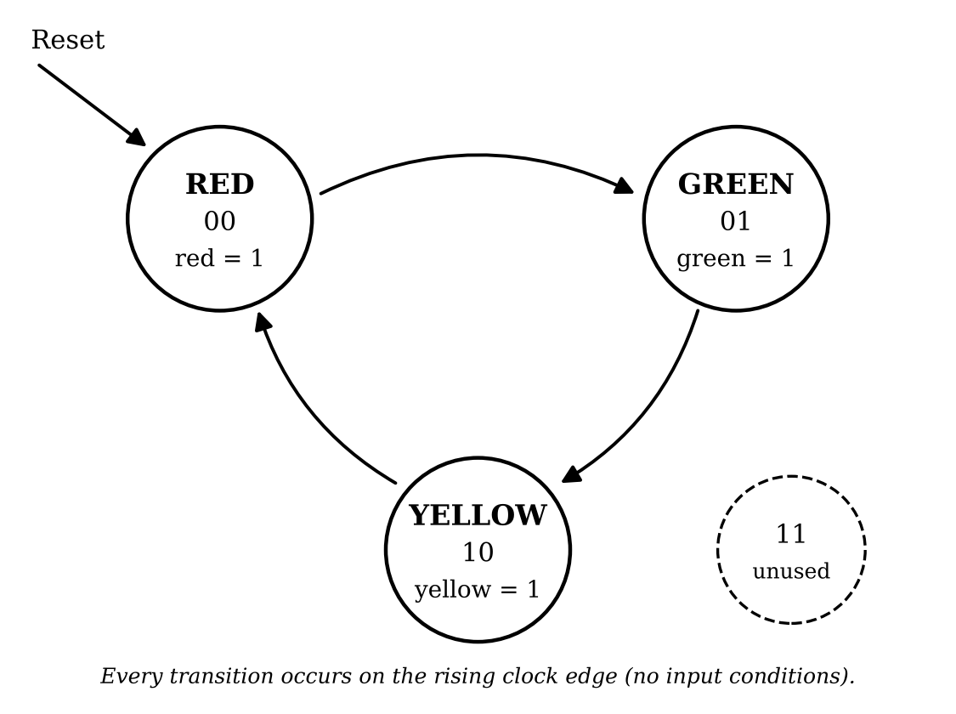

The FSM is a Moore machine: the output is written inside each state. Reset (synchronous, active high) takes the machine to RED. The unused state 11 is shown dashed.

7. Unused State (11) Analysis
Quantity | Value at S1 S0 = 11 | Meaning
D1 | 1 | Next-state MSB
D0 | 0 | Next-state LSB
Next state | 10 (YELLOW) | Recovers in one clock
red, green, yellow | 0, 0, 0 | All outputs LOW

Conclusion: State 11 transitions to YELLOW (10) on the next clock edge. The FSM does not remain stuck in the unused state.

8. Verilog Design Module (Task 4)

9. Testbench (Task 4)

10. Simulation Output

10.1 Console log

10.2 Waveform

10.3 Waveform: unused state test

11. Result
______________________________________________________________________
______________________________________________________________________
______________________________________________________________________

