**Git Assignment Question 1**

**CAN_ID:CAN_33885241**

**Name:Pavan GN**

1. **Configure your Git with your name and email.**

* git config --global user.name Pavanappu07
* git config --global user.email appupavan412@gmail.com

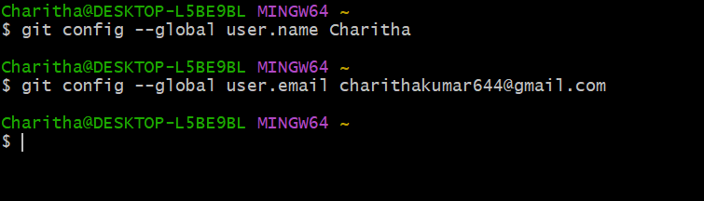

1. **Clone the project repository from GitHub.**

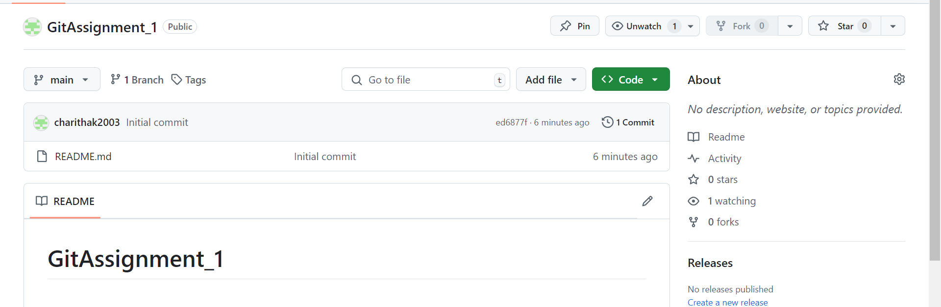

* git clone <https://github.com/appupavan412/GitAssignment_1.git>

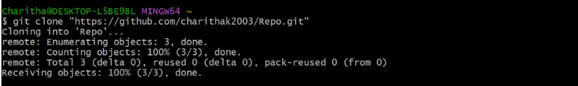

1. **Create a new feature branch.** 🌿

* **cd GitAssignment_1**
* **git checkout –b new-feature**

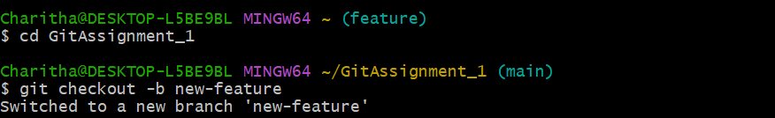

1. **Add a new file called**feature.py**to your branch.** 📂

* **touch feature.py**

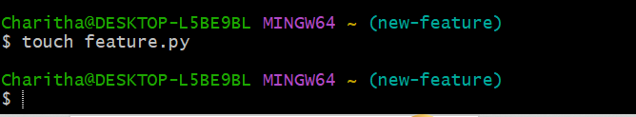

1. **Commit your changes with a message.** 💬

* git add .
* git status
* git commit –m”Add new feature implementation”

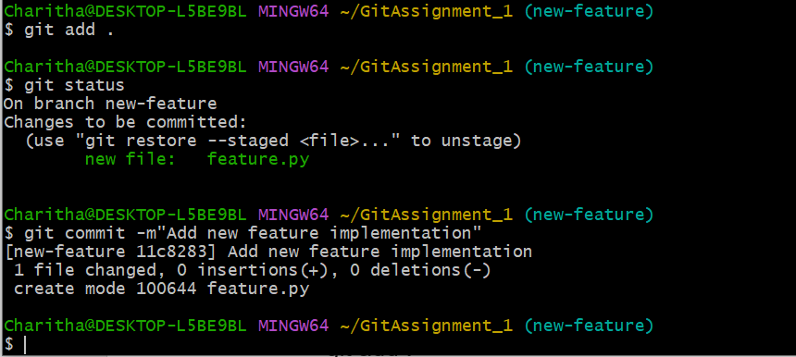

1. **Push your changes to the remote repository.** 🚀

* **git branch**
* **git push –u origin new-feature**
* **git staus**

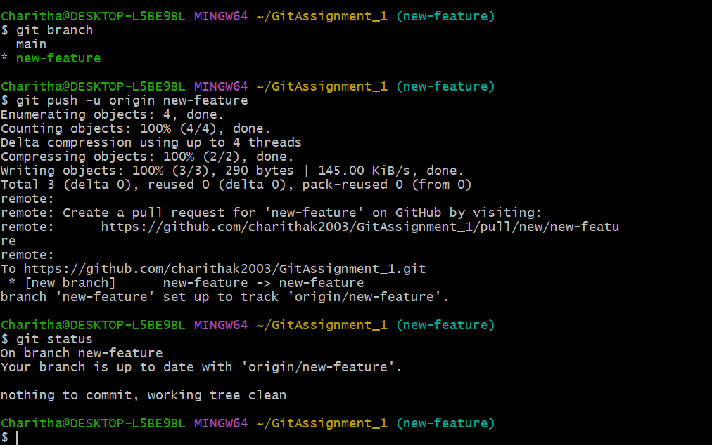

1. **Pull the latest changes from the main branch.** ⬇️

* **git checkout main**
* **git pull origin main**

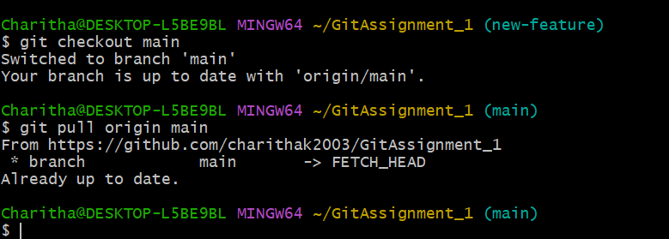

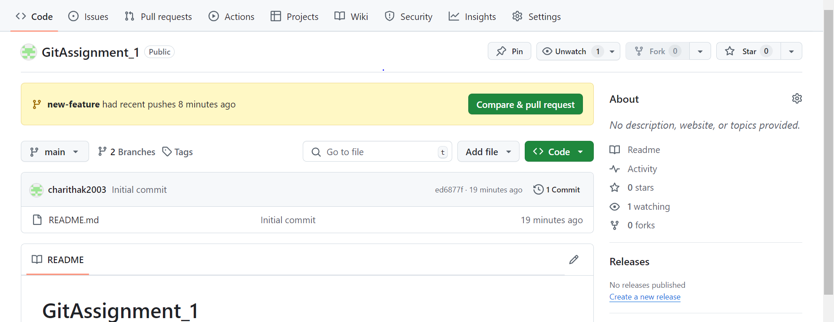

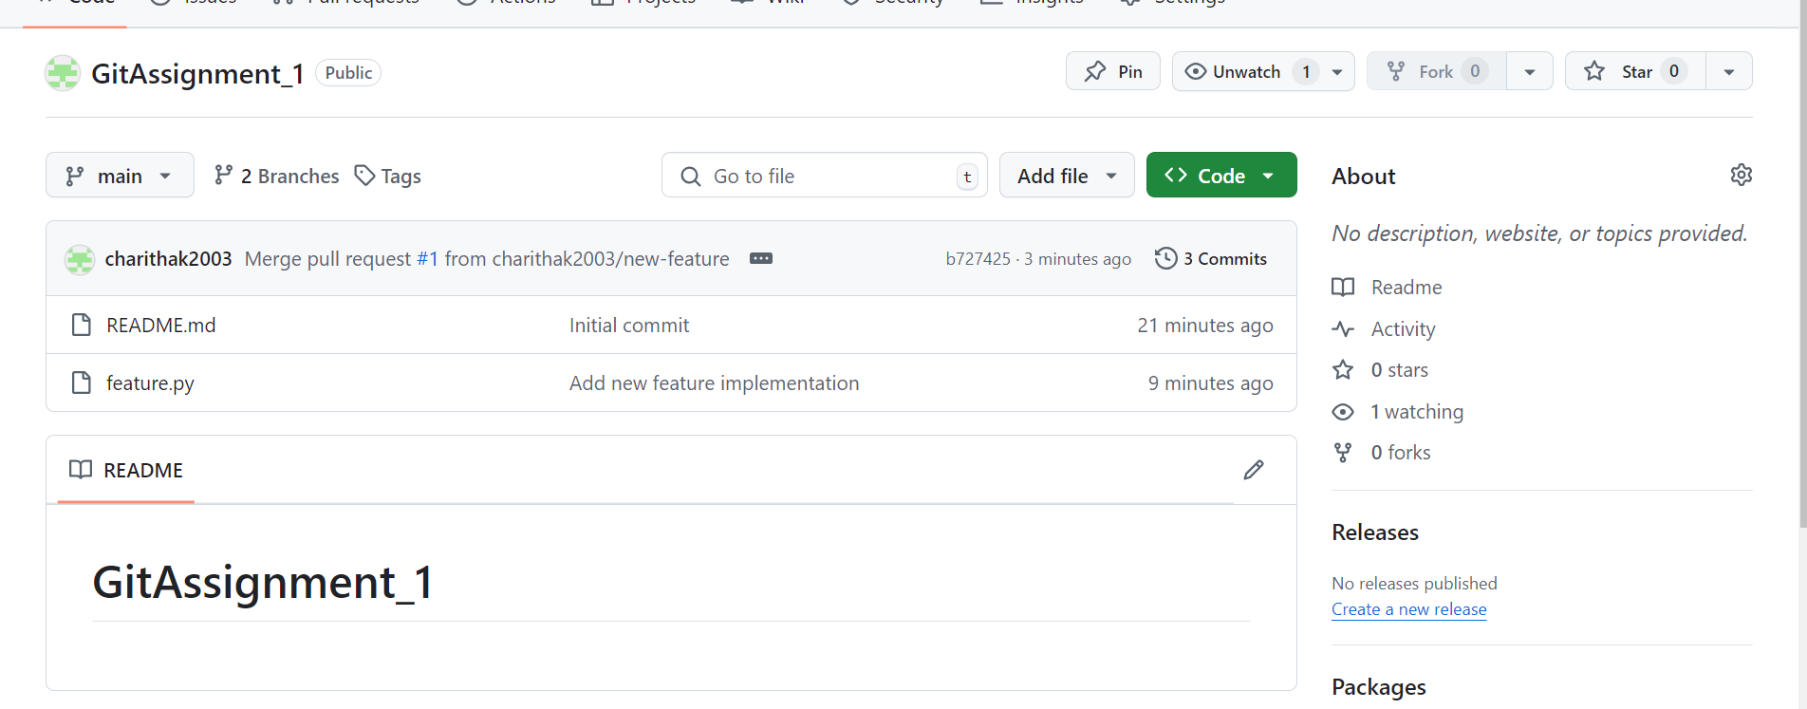

1. **Remove the**feature.py**file from your branch.** ❌

* **git checkout new-**feature
* git rm feature.py

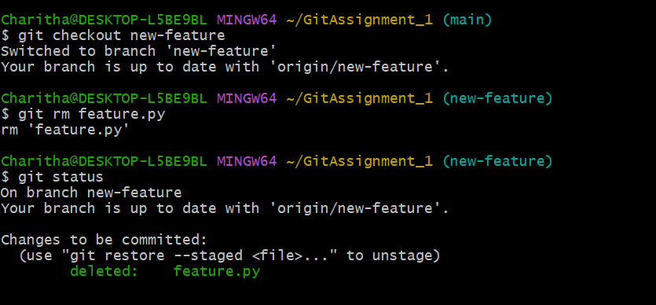

1. **Commit the removal of the file and push the changes.** 📤

* **git add .**
* git commit –m”Remove new feature implementation”
* git status
* git push –u origin new-feature
* git checkout main
* git pull origin main

