CHAPTER 1
INTRODUCTION
There is an enormous quantity of textual material and it just grows every minute. Think about the multi-web network, status, blogs, movies, articles and much more. The data are unstructured and the most we can do is browse the documents and search and skim the results. Nowadays Human beings have limited cognitive capacity for performing certain tasks. Like in these days many people aren’t fond of reading large amounts of text anymore. For this reason, summarizing texts from a large document is quite important: when studying for exams, reading self-help books, novels or simply reading the news, today’s world is becoming so accelerated that time is of the absolute essence for everyone. Indeed, an IDC study has been carried out and predicts that the entire quantity of digital data flowing across the globe will increase from 4.4 zettabytes in 2012 to 180 zettabytes in 2025.
We use the text synopsis which refers to the method by which lengthy chunks of text are reduced in a succinct and accurate summary. The primary purpose is to provide a fluid and understandable summary that simply specifies the key elements which should be addressed in the text. Automated overview is the technique of computationally reducing a collection of textual material to produce a subset that is the most important information in the original contents, without altering their real significance. Text synopsis method enables the user to quickly grasp the key concept. If the user receives a more effective summary, it helps to comprehend the text at a glance without scrutinising it fully, and saves time and effort. Resume is the job to condense big text material into a shorter version, reduce the size of the original text while maintaining essential information and the significance of original content. Most research has focused on document summary, which is particularly useful for news sites when documents are accessible from many news items. Since the summary of handwritten texts is a more time demanding job, the automation of the summering of texts is becoming more popular and is thus a significant incentive in academic research.
In addition to the fast development of the internet and big data, the huge number of information and documents on the internet overwhelms individuals. This drives many academics' desire to create a system that can automatically summarise texts. The Automatic Text Summary method produces a big text resumé with key phrases and contains all relevant information from the source document. It is extremely essential that the summary is fluid, shows the meaning and continues. The information therefore comes rapidly over a short period of time and does not lose its original purpose or meaning. Since the mid-20th century the area of text summary research has been explored. Many up-to-date methods have been developed. Based on the document number, there are two kinds of summaries which are single and multi-documents.
A single document generates the summary from a single source document, whereas multiple documents produce the summary from a multiple document from a separate document but with the same subject. Meanwhile, the extractive and abstractive outcomes are based on the summary results.
- Extraction –based summarization: Extractive method is the traditional methods which was developed first. In extractive method, the content is extracted from the original text but the extracted text is not modified in any way. The primary goal is to detect and summarise the key phrases in the input file.
- Abstractive-based summarization: It is most sophisticated techniques and still adds updates. Abstractive techniques provide an internal semantic representation of the text's original meaning, and utilise the corresponding words or phrases to produce a summary that is closer to the understanding of a person. Abstraction may be transformed by parts wise of the original material into a text that has greater effect than extraction. This technique is used mostly for text analysis.
The key technique in the text summary is to grist the text before processing, then tokenize the phrases and conduct the stemming processes. Scoring the phrases using various text characteristics.

1.1 Aim/Objective
Aim: There is a great need to reduce large textual data to shorter, focused summaries that capture the main points that is outlined in the documents.
Objective:
- To extract the sentences or words from any articles or web pages.
- To assign a frequency to each sentence or words and maintaining an average score to generate summarized data.
- Then dividing the sentences and assigning the sentence scores for each sentence.
- To combine the sentence with the threshold more than average score.
- Finally, getting the summarized text from the articles or any document.
Applications
- Newsletters.
- Internal document workflow.
- Financial research.
- Social media marketing.
- E-learning and class assignments.
- Email overload.

CHAPTER 2
LITERATURE SURVEY
In my project I have used three different types of summarizing algorithms which are efficiently being used in many IT industries till now, researches and studies are still carried on with the abundant amount of materials available through blogs, articles, research papers and so on. So, that it can make human work much easier.
As a part of my project I have gone through some research papers and articles which describes the different technologies and have mentioned some of them in this section.
[1]. “ Overview of Text Summarization Techniques”, Narendra Andhale and L.A. Bewoor,
Here, the article discussed how the text summary method would evaluate the significance of the phrases between them. It is a process in which a composite form of a document is created, which preserves important information and general meaning of the source text. Automatic summary is an essential method of accurately discovering significant information in big texts in a short time with minimal effort. This article provides a thorough examination of the techniques in the text resume, i.e. extractive methods and abstract ways.
Introduction :
This article conducts an experimental investigation on several types of text summarising. The quantity of information on the web is growing quickly every day in many formats, such as text, video, pictures etc. It has become very challenging for people to discover useful information on their interest in this huge amount of information. Suppose a person requests some information on the internet and he may get thousands of results that are not necessarily related to his concern. In order to locate the right information, a user has to go through the whole data, resulting in overloading information, which leads to waste of time and effort. Automatic text summary method plays a key part in tackling this issue. The automatic summary condenses a source material to relevant text that represents key aspects of the document without changing the true information. Automatic text summarising will be an essential method to locate the key information accurately and with little effort in a big text in a short period. This enables users to capture the core concept in a short time. Text summary methods are usually classified in two types: extractive and abstract summary. Extractive summary takes key phrases from the source texts and organise them in order to create summaries without altering their meaning. The abstractive summary, however, involves comprehending the original material utilising the linguistic technique to analyse and analyse the content by adding extra words to make the overview understandable. The abstract summary aims at producing a broad summary that briefly provides information.
Observation of summarization methods :
- The summary may include redundant information.
- The flow of summary derived from the text content is missing. Since the document has been chosen from various parts.
- Some time abstractive method does not consider the semantics relationship between the documents.
Conclusion :

This article covers both extractive and abstractive methods for summarization. The summary techniques should be able to generate an efficient summary in a quick time with minimal duplication, without modifying the true meaning, having grammatically accurate phrases. The extractive and abstractive techniques provide correct results depending on the environment in which they are employed.
[2]. “The Simple but an Tough-to-beat Baseline for Sentence Embedding’s”, Sanjeev Arora, Yingyu Liang, Tengyu Ma Princeton University.
The article described how neural network techniques are used to calculate word embedding, inspiring various summaries of semantine embedding, such as sentences and paragraphs, for larger chunks of text. Surprisingly, Weiting et al. have demonstrated that such complex techniques are not good enough and revealed the output of simple methods like text embedding retrain and basic linear regression methods, particularly in the out-of-domain environment. This thesis extends considerably farther, demonstrating that the present methods are totally uncontrolled penetration, which is a wonderful starting point: Using word embedding calculated using one of the most common unlabeled dictionary techniques, it represents the sentence by a weighted average of the text vectors in each phrase, and is adjusted by PCA or SVD. The proposed work additionally integrates central characteristics such as the sentence location, cue phrases and sentence length, etc. It helps to improve the efficiency of the extraction-based summary technique. This paper also explains a theoretical explanation for the success and use of the uncontrolled method, which uses latent variable generative model for text materials. The model is a simple extension with new, more comprehensible terms which make words out of the actual context possible. What is wonderful about the sentences.
Experiments :
- Textual similarity tasks: here, they evaluated 22 textual similarity datasets in various techniques, encompassing all semantical textual similarity data sets. The aim of these tests is to predict the similarity of two phrases provided in the text. The criteria assessed is the Pearson coefficient between the forecast values and the ground-truth values.
- Supervised tasks: our approach may utilise sentence embedding as a feature for upstream supervised tasks. To show the strength of the phrases that are embedded, we fix the embedding and train the classifier alone. In particular, supervised tasks are designed to enable fair comparison, i.e. a linear projection of the classifier followed by the classifier in. The linear projection maps the penalty in 2500 dimensions and is learnt during training.
- c) the impact of the sentence sequence of words: An important characteristic of our approach is that the word order is ignored. This is contrary to the fact that RNN's And LSTM may benefit from the word order.
Conclusions :
This study provides a straightforward method to the integration of sentences based on the discourse vectors in the random model for text generation. Simple and unchecked, it gets substantially higher performance than baselines for many textual similarity tasks and can even execute advanced supervised techniques such as certain RNN and LSTM models. The Embedding sentence produced may be utilised as an advanced task, which also leads to better or similar outcomes compared to complex techniques.

[3]. “Automatic Text Summarization of Wikipedia Articles”,
Natural languages may be generally characterised as casual, readily learned by anybody. They vary from formal languages, such as computer languages with a correct structure and grammar. Natural Language Processing (NLP) understands the context of these natural languages and produces a natural language text.
Introduction :
The aim of automated text synthesis is to reduce the text to a lower number of penalties without losing the essential concepts of the original text. The architecture of a synthesis system includes interpretations, transformations and generations. The text summary is divided into four areas. The first category is a traditional method, mostly based on the selection of important information such as frequency, phrases and title. The second category is a method based on the corpus which utilises the notion of statistics and then chooses in a traditional manner on the right combination of characteristics. The 3rd category is an exploitative discourse structure that uses discourse models while retaining a largely domain-independent and poor approach to knowledge. A reasonably rich structured representation was created in this category, where the summary method is used as an input. The two first categories concentrate mostly on interpretation, while the last method focuses on the transformation and creation of this summary algorithm, which detects word frequencies in the documents concerned and shows a proportion with better scored sentences.
Conclusion :
Similar terms are assigned equal weights in this suggested approach. Therefore, regardless of their use and significance, the primary concept of phrase is evaluated. The system also uses specific quotations in the input document file. Sentences containing quotations are assigned a larger summary weight.
[4]. “An Automatic Single Document Text Summarization Using Key Concepts in Documents”, Kamal Sarkar.
Several research studies on key sentence extraction have identified text resuming, automated indexing, etc as key sentence extraction application areas. The approach in this article analyses important sentences as key ideas and integrates key concepts into search results. In contrast to the previous studies focusing on only the key phrase extraction job, our suggested system examines the applications of the key phrases generated by a key phrase extraction system for more accurate summary performance.
Introduction :
Automatic text synthesis may be used to manage huge amounts of online content. Summaries or abstracts let the reader get a quick overview of the content and save time. Automatically resuming text may be useful for document indexing, questioning, and document classification. The automated or semi-automatic summary for commercial abstract services may allow them to scale up the amount of published texts they can evaluate quickly. Depending on the amount of documents allowed as input, automated text resumes may be classified as single document or multi-document. A single document text summary is entered, and a sequence of text documents is entered as a multi-document summary.
The first work on text summary utilises sentence extraction as the primary component, with phrase location, word importance, title information, and sentence length as ranking criteria. Although centroid resumed methods compute sentence scores based on similarities between sentences in the centroid document, multi-word keyword phrases for text resumption are ignored. Moreover, essential terms are not utilised in the summary. The suggested summary technique thus differs from the centroid summary approach. In this suggested technique of summary analysis, key words are used that are regarded as key ideas to modify significant variables which maximise the difference but which are of relevance to the summary.
Preprocessing :
The preprocessing phase involves removing the stopword and splitting the input text document file into a phrase collection by allocating sentence scores.

Keyphrase extraction:
The primary focus of this essay is on using significant sentences in the text summary assignment. The suggested summary system's keyphrase extraction component uses a two-stage basic keyphrase extraction approach:
1. Extract potential key sentences by taking punctuations into account and stop words as the sentence limit.
2: Further reduce the sentences chosen in step 1 into smaller sentences, depending on their significance.
Summary generation :
They extracted the important words in a text as the first abstraction level. The key ideas in a text may be seen as the essential words or phrases a document develops. In addition to maximising essential ideas, a summary should include varied material, since the treatment of just one significant concept should not be exhausted if a document has several important concepts. The most important words and phrases will go into the summary first, then the second most important concept. A summary phrase may contain one or more important input document concepts. If the words' essential ideas are found in the document's global list of significant concepts, they are removed.
Conclusion :
This article explains how a single document summary approach utilises important ideas derived from a summary document. The performance of our suggested summary method is similar and occasionally better than a few solutions that have been claimed to function best in the DUC data set. Our query-based algorithm method is similarly simple and easy to implement.

CHAPTER 3
DESIGN AND IMPLEMENTATION

3.1 Tools and Technology
The instruments and technologies utilised are described below.
Machine learning is an application of artificial intelligence, which allows the system to learn and develop automatically without being designed directly. Machine learning is very helpful in the creation of computer systems that access and utilise data for their own learning purposes.
Natural language processing (NLP) is a computer science and artificial intelligence topic that describes how computers may be taught to process and analyse large amounts of natural language input. The goal is for the computer to "understand" the papers' content, including the language used within them. In turn, this technology can properly extract and categorise the information and insights included in the texts.
NLTK is a prominent framework for Python applications to use human language data. It offers user-friendly interfaces such as Word Net with a range of libraries to classify, tokenize, tag, parse and semanticize, stem wrapper for industry-friendly NLP libraries and an active discussion board.
Common NPL tasks are common:
- Voice and text recognition:
  - Optical characters identification: Determines the appropriate text which corresponds to a picture depicting a specific text.
  - Speech recognition: This is the reverse of conversion from text to voice. A sound clip of a speaker or singer is provided here, and the textual data of that speech need to be analysed and identified.
  - Text to speech: A text is transformed into units and a spoken representation or voice form of the supplied text is produced. Speech text may be used to help individuals with visual impairment and make it more helpful.
  - Word segmentation: Splitting the gives sentences into words.
- Morphological analysis
- Stemming: The act of reducing inflected words to basic forms and making them more useful.
- Lemmatization: Lemmatization is a means to reduce words to their normalised form, thus the change utilises a preset lexicon to map words to their real format.
- sHigher-level NPL operation :
- Automatic Text summarization: Producing a readable summary from a large document.
- Book generation: the task of NPL is the creation of full-fledged books the creation of full-fledged books.
- Grammatical error correction :
- Machine translation: Automatically converting one human language to another language.
- Natural language generation: Transforming or converting information from a stored computer databases to human readable and understandable language.
- Question answering: Given human question and determining the answer for that question.
3.1.1 Python
Python is an object-oriented high-level language. Rapid application development and scripting to connect existing components are made possible by its high degree of integration into dynamically tailored data structures. Python's simple syntax improves readability and reduces software maintenance costs. Python offers modules and packages to enhance application modularity. The Python interpreter and substantial standard libraries are freely accessible in source or binary form on all major platforms.
The following points illustrate the NLTK python libraries:
3.1.1.1 Porter Stemmer: It strips a word down to its stem, which connects to suffixes, prefixes, or lemma roots. For instance: words such as "walks," "walks," "walked" after stemming are reduced to "walks."
3.1.1.2 Word Tokenizer: The method word_tokenize() is used to split a sentences into words. The output of this method can be converted to data frames for better text understanding in deep learning applications.

3.1.1.3 Sentence_Tokenizer: The Sub-module available for the division of senteces is sent_tokenize. It is mainly used to assign the values to the sentence which can be used in the future to rank the sentences.
3.1.1.4 Stop words: Text or text may include stop words such as "a," "an," "the," "is." Stop words may be deleted from the text to be processed or filtered. In the nlp study there is no uniform list of stop words, however the nltk module includes a list of stop words to remove them from the text.
3.1.1.5 Numpy : It means numerical python, Numpy. Numpy is a Python package used for array operations. It is intended to deliver an array object 50 times quicker than conventional Python lists. Arrays are utilised quite often when performance and resources are very essential.
3.1.1.6 Netwokx : NetworkX is a Python module that supports structure, dynamics and functions development, modification, and analysis of complicated network functions. It is also used for graphics and networks research.
3.1.1.7 Pandas: Pandas is a Python data handling and analysis tool. It provides data structures and procedures for manipulation of numerical tables and time series in particular.
3.1.1.8 Tensorflow: TensorFlow acts as a computer library for the development of novel algorithms involving several tensor activities, since neural grids may be simply represented as computer graphs that can be used for TensorFlow operations. In addition, N-dimensional matrices representing your data are tensors. It is more versatile and easier to train.
3.1.1.9 gTTs : gTTs means Google Speech Text Translator is a python library and a tool to interact with Google Speech API Text Translate. Customizable phrase tokenizer that enables limitless text lengths to be read while maintaining the correct intonation, shortcuts, decimals and much more. Customizable pre-processor texts that may make pronunciation adjustments, for example. The gTTS API supports a wide range of English, Hindi, Tamil, French, German and many more languages. The speech may be delivered quickly or slowly in any of the two possible audio rates. However, with the current version, the voice of the produced audio cannot be changed.

3.2 Design
The entire system block diagram is as follows:
3.2.1 General model
In this Text summarization system at first the text file is taken as input file then these input file preprocessed to remove all the unwanted spaces, stop words and punctuations.
The classification technique is then used to extract significant words or phrases from the text file. The summary method is then used on this input text file. Finally based on the ranking or sentence scores the final summary is generated with which it retains the actual meaning of the input text file.
The figure 3.1 describes the overall working of the Text summarization method.

Sentence 1
Sentence 2
Sentence 3
Pre-processing
Feature Extraction
Paragraphs
Sentence, words
Feature
Classification
Text input

Summarization Method
Summarization

Summary

Figure 3.1: Block diagram of the proposed Text summarization System.
A text input file is chosen which need to be summarized, the first step is the preprocessing where all the unwanted words, punctuation’s and spaces will be removed. Then the text will be divided into words or sentences by using built-in functions such as word-tokenize and sentence-tokenize. Scoring the sentences based on the importance of words present in the text. Using a certain classification method summary will be generated.

CHAPTER 4:
TEXT-RANK ALGORITHM
Text- Rank algorithm is extractive and unsupervised text summarization technique. It is a text summarization technique which is used in Natural Language Processing to generate Document Summaries. A graph-based ranking model is the fundamental concept applied in text rank, with voting as its foundation. When one vertex connects to another, it is essentially casting a vote in favour of the vertex that has been linked to. The more votes a vertex receives, the more significant it is considered.
Articles
Text
Sentences
Vector
Combine
Split

Similarity matrix

Summary
Graph
Sentence Ranking

Figure 5.1 : Overall working process of Text rank algorithm.
The figure 5.1 shows working procedure of text rank algorithm, where certain set of documents with a same topic are selected to generate a summary.
Text-rank includes two NLP tasks,
- Keyword extraction task - It automatically identifies the set of terms that best describes the text document. It is unsupervised methods there is no need for training. The simple approach is to use frequency criterion.
- Sentence extraction task – This Algorithm is suitable for applications with finished sentences since it enables a rating of text units based on information that is retrieved from the whole text.
The steps involved in Text-rank algorithm are as follows:
- Text Pre-processing: Getting rid of the stop words present in the sentences. These stop words can be removed by using built-in function called nltk stop word in Natural language processing. Then changing the text into lower case. Removing the extra and unwanted spaces in the document.
- Vector representation of sentences : Here we utilise GloVe word embedding that is used for word vector representation. These word embeddings are used to generate sentence vectors. The Word Bag may also be used to construct functions for our phrases, however these techniques disregard the order of words in the supplied phrases. This provides the outcome as a learning model that usually leads to improved word integration.
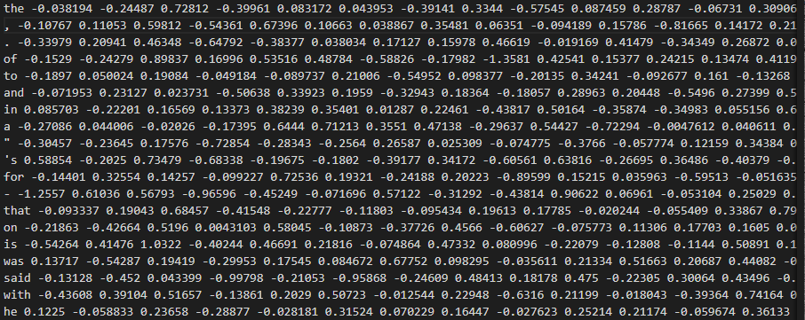
Figure 5.2 : Glove word embedding
- Similarity matrix preparation : The similarity matrix is a representation of pair combination. Here, in text summarization it will help in finding the similarities between the sentences.
- Applying the Page rank algorithm : Page rank algorithm is used primarily for the search engine ranking of the web sites. It is way of identifying the importance of the text in the given document. It is the first and the best algorithm used by many companies till date and it is the best known. Steps in Page rank algorithm are :
  - Extracting all the sentences from the text document, either by splitting at the whitespaces or at the full stops or any other way by fixing the index lengths to define the sentences.
  - Here, a graph is created from these sentences which are extracted in previous step.
  - Nodes indicate the phrases and the edges reflect the similitude inside the phrases. To this graphic algorithm the sentence ratings are applied.
  - Then, sentences are arranged according to the sentence score in a decreasing order.
- Summary extraction : Here, the top N sentences will be chosen as the part of the summary without leaving the actual content of the document.
5.1 Results of Text- Rank algorithm:
5.1.1 : Text-rank sentence similarity matrix:
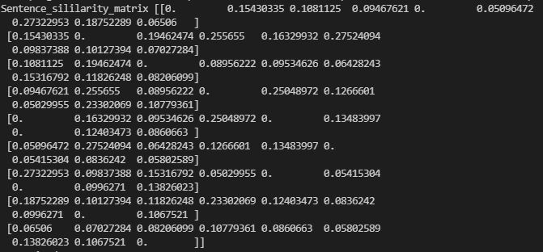
Figure 5.3 : Snapshot of sentence similarity matrix.
The figure 5.3 describes how the sentences are related or finding the similarities between the sentences. So it helps in two sentences are inter-related to each other , it also helps in identifying the relation between the sentences.
5.1.2 Page-rank scores :
Figure 5.4: Snapshot of Page rank.
The figure 5.4 describes application of page rank algorithm onto the given input text file, and its showing the rank from first to last but here the rank four has more importance compared to rank one.
5.1.3 Top ranked sentences :
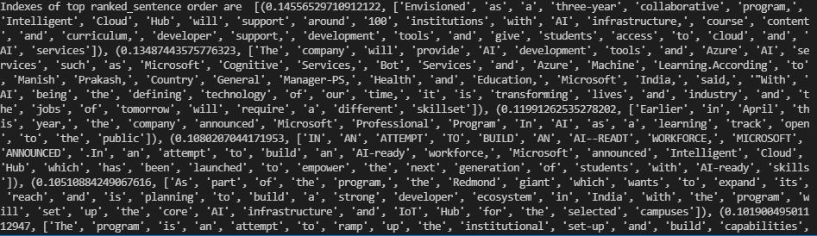
Figure 5.5: Snapshot of Top N sentences.
The figure 5.5 describes the indexes which are ordered based on their ranks which are obtained from the page rank algorithm.
5.1.4 : Summary generated using Text rank algorithm
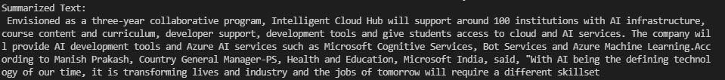
Figure 5.6: Snapshot of output of Text rank algorithm.
The figure 5.6 shows the summary generated using text rank algorithm where long text is summarized.

CHAPTER 7:
CONCLUSION AND FUTURE WORK
Conclusion:
This field of study has a lot of fascinating work going on. However, we have decided to create text summary methods that we believe will be helpful or important to research, even if they are not comprehensive synthesis systems. Given that our suggested synthesis approach relies on important ideas in text papers, we may anticipate to increase the synthesis performance even more. Therefore, we should simultaneously attempt to avoid employing an advanced key sentence extraction technique since it may reduce the pace of the summary system.

Future work:
In future, more complex algorithm can be used that may bring lesser modification in the system which can given more accurate result. For example the system should be able to identify the differences between the words having same spelling but with a different meaning like bat , one time bat can referred as cricket bat and other time it may be referred as mammal, so our system should be capable of identifying these kind of differences also. Thus the future automatic system can produce much more accurate summary from the text.

REFERENCE
[1] “A An Overview of Text Summarization Techniques”, Narendra Andhale, Department of Computer Engineering Vishwakarma Institute of Information Technology Pune, India L.A. Bewoor, Department of Computer Engineering Vishwakarma Institute of Information Technology Pune, India.
[2] “Automatic Text Summarization of Wikipedia Articles”, Dharmendra Hingu1, Deep Shah, Sandeep S. Udmale Department of Computer Engineering and Information Technology Veermata Jijabai Technological Institute Mumbai, India
[3] “A Simple But Tough-to-beat Baseline for Sentence Embeddings”, Sanjeev Arora, Yingyu Liang, Tengyu Ma Princeton University farora,yingyul,tengyug@cs.princeton.edu
[4] “Automatic single document text summarization using key concepts in documents”, by Kamal Sarkar, Manuscript received January 16, 2013; first revision June 11, 2013; accepted August 25, 2013.Corresponding Author: Kamal Sarkar (jukamal2001@yahoo.com) Dept. of Computer Science and Engineering, Jadavur University, Kolkata, India (jukamal2001@yahoo.com)

[5] “Implementation and Evaluation of Evolutionary Connectionist Approaches to Automated Text Summarization”, Rajesh Shardanand Prasad and 2Uday Kulkarni Department of Computer Engineering, VIIT, Kondhwa, Pune-411048, India Department of Computer Engineering, SGGS, Vishnupuri, Nanded, India.

[6] “Text summarization using natural language processing and google text to speech api “, subash voleti, chaitan raju, teja rani mugada swetha eight semester, dept of cse, lendi institute of engineering and technology, vizianagarm. Asst.professor, dept of cse, lendi institute of engineering and technology, vizianagaram.
[7] “Improvement of query-based text summarization using word sense disambiguation”,
Nazreena Rahman · Bhogeswar Borah Received: 2 December 2018 / Accepted: 24 June 2019 / Published online: 20 July 2019.

TABLE OF CONTENT
Title Page No
CHAPTER 1: INTRODUCTION
1.1 Aim/Objective 2
CHAPTER 2: LITERACTURE SURVEY 4
CHAPTER 3:DESIGN AND IMPLEMENTATION 11
  - Tools and Technology 11
3.1.1 Python 12
3.1.1.1 Porter stemmer 13
3.1.1.2 Word tokenize 13
3.1.1.3 Sentence tokenize 13
3.1.1.4 Stop word 13
3.1.1.5 Numpy 13
3.1.1.6 NetworkX 13
3.1.1.7 Pandas 14
3.1.1.8 Tensorflow 14
3.1.1.9 gTTS 14
3.2 Design 14
3.2.1 General model 14
CHAPTER 4 : TEXT RANK ALGORITHM 15
4.1 Results of Word frequency algorithm 17
4.1.1 Sentence similarity matrix 17
4.1.2 Page rank scores 18
4.1.3 Top ranked sentences 18
4.1.4 Summary generated using text rank algorithm 19
CHAPTER 7: Conclusion and future work 33
REFERENCES

LIST OF FIGURES
Figures Page No
Figure 3.1: Block diagram of the proposed Text summarization system 14
Figure 4.1: Overall working process of Text rank algorithm 15
Figure 4.2: Glove word embedding 16
Figure 4.3: Snapshot of sentence similarity matrix 17
Figure 4.4: Snapshot of Page rank scores 18
Figure 4.5: Snapshot of Top N sentences 18
Figure 4.6: Snapshot of output of Text rank algorithm 19

